**GROUP MEMBERS**

Amirul Syafiq Bin Mohd Qisti

Hamzeh Wahed Bajbouj

Nadiah Binti Mohd Hanim

Yasmeen Binti Abu Bakar

Youtube Video: <https://youtu.be/CYmgrmPGlag>

**ABSTRACT**

Networking supports communication between at least two programs running on machines that are out of each other’s reach, physically. Computer networks have turned out to be progressively universal. In this modern world, a computer network is much more than just a collection of interconnected devices. Computer networks are a system of interconnected computers to share computerized data. It is a collection of computers, which are associated to such an extent that they can trade information among themselves and other computers on the network. A network is made when at least two computers are connected to share data and resources. A computer network is basically computers wired together such that gives them a chance to share data and devices. Communication device is any type of hardware capable of transmitting data, instructions and information between a sending device and a receiving device. For instance, modem, router and hub. These devices will be connected with transmission media either physical or wireless in the network.

**EMPATHY**

In order to empathize Internet users and understand the problem the problems they face, we interviewed two students regarding communication and network. The first interview was held by Amirul Syafiq Bin Mohd Qisti whereas Muhammad Haziq Bin Sulaiman (Haziq), a first-year student of Computer Networks and Security became the interviewee. Another first-year student majoring in Civil Engineering, Siti NurSyamira Binti Salleh (Syamira) was interviewed by Yasmeen Binti Abu Bakar.

Question 1: Do you use the internet often?

Haziq: Yes, I use it every day.

Syamira: Yes, because I am using social media, searching using Google. This generation uses the Internet a lot.

Question 2: What do you always do on the Internet?

Haziq: I use the Internet to play video games.

Syamira: Studying and socialize with my friends.

Question 3: Do you think it is easier to communicate using the network?

Haziq: Yes, network is much faster than doing it physically.

Syamira: Yes, of course because we don’t have to meet them and we can communicate even though we are far from each other.

Question 4: As a college student, do you prefer to submit your confidential documents during registration online or in a physical form?

Haziq: I prefer to send it in physical form because if it is online, there is a risk of it getting leaked.

Syamira: I prefer physical form because it is safer than submitting it online.

Question 5: Do you shop online often?

Haziq: I shop online quite often.

Syamira: Yes, I do.

Question 6: Do you use public wifi often?

Haziq: Yes.

Syamira: No, because I feel unsafe.

Question 7: What are you afraid of when using public wifi?

Haziq: I heard there is a lot of risk of being hacked when using wifi.

Syamira: I am afraid that my personal information or what I am surfing is being leaked or hacked by outsiders.

Question 8: Have you had any issues with your information being leaked or hacked before?

Haziq: Yes, a few years back my Facebook account was hacked. My information got spread out.

Syamira: My Instagram was once hacked. I suddenly received an e-mail from Instagram, saying that someone is attempting to access my account from Sarawak.

After the interview, we noticed that both of the interviewees had the same trouble, that is, feeling insecure when using the Internet. Therefore, we conducted a survey to confirm whether other students feel the same way. These are charts of the responses.

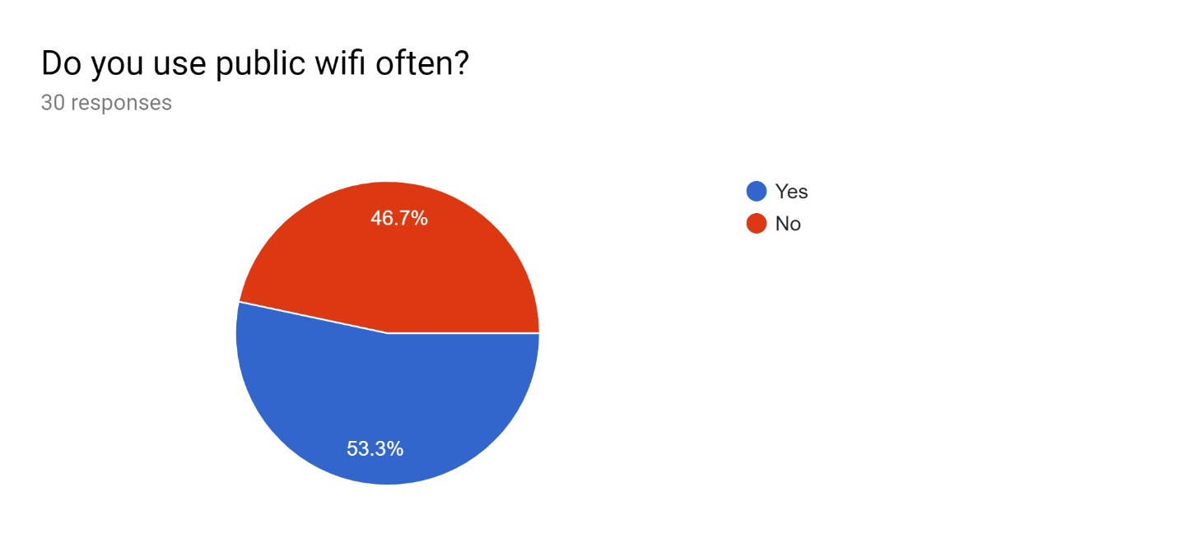

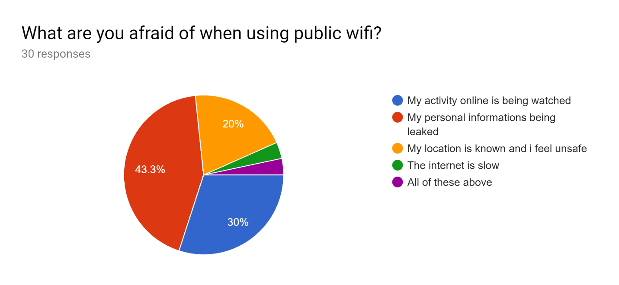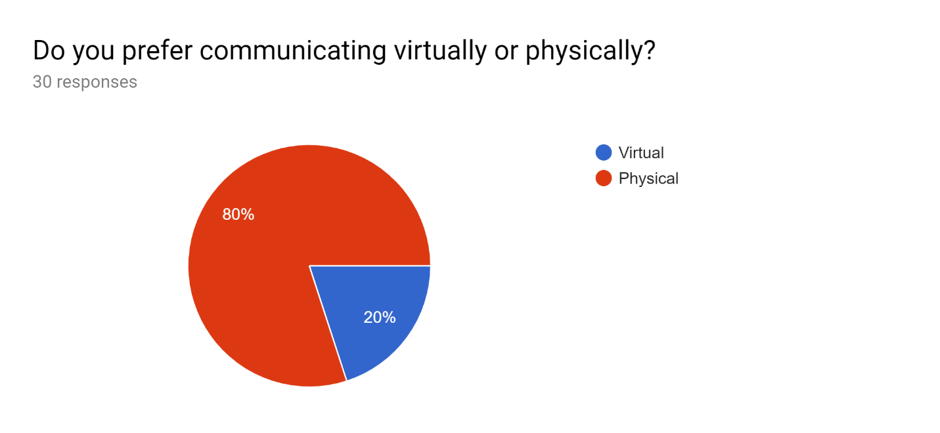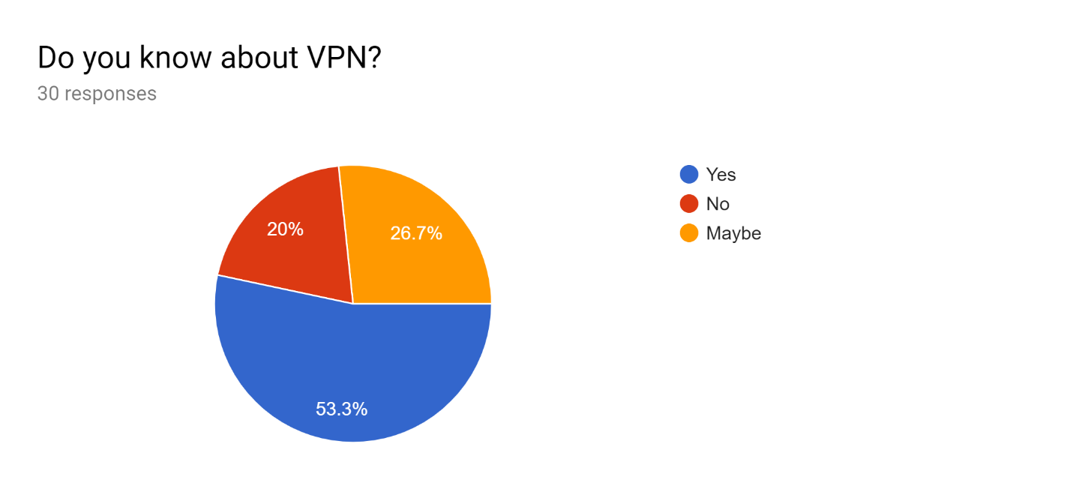

According to the results of the survey, almost half of the responders tell that they do not use public wifi (46.7%) whereas the other half uses them (53.3%). When asked why they are afraid of using public wifi, majority of them states that it is because their personal information might be leaked. Some says that they feel as if their activity online is being watched. A minor group also says that they feel unsecure especially because their location might be known. When asked if they prefer communicating virtually or physically, surprisingly, 80% of the responders prefer to do physical communication although communicating virtually is faster and more convenient. The results to the question regarding VPN shows that there are still people living in this era who are not aware of the usage of it.

**DEFINE**

After interviewing a few students and conducting surveys, we could finally sum up the problem to why people are always reluctant to use the network to communicate or do works even when the modern technology has obviously made things easier for mankind. It is mainly because they feel unsafe when using unknown or public networks. Since a lot of public networks have been using a wireless transmission media, the data that is being transferred through the network is vulnerable to the malicious threats especially in a wide area network.

**IDEATE**

From the problems we collected, we have come up with a solution to solve the problems. According to the survey conducted, majority of the students say that they are afraid of having their personal information leaked. Thus, it is suitable if a software was made to ensure the safety of the public’s use of network.

Virtual Private Network or also known as VPN is a network that provides the mobile user with a secure connection to the company network server as if the user has a private line. It also helps ensure data is safe from being intercepted by unauthorized people by encrypting data as it transmits from a laptop, smart phone or other mobile devices. In other words, VPN improves encryption and decryption (cryptography) security to exchange documents. It also affects the economic development by offering global networking opportunities as companies are able to communicate with companies from other countries without worrying that their confidential information is being snooped by outsiders. Money is not an issue since it does not require any physical communication device to build it, making VPN cost effective and scalable. The most important part is that our safety is ensured. VPN hides our IP address as well as our virtual location.

**PROTOTYPE**

The physical prototype is a simple model made out of cut-out cardboards to convey how VPN works. There are pathways for data and information to travel through in order to send it to users. This way, users could understand better how VPN does its’ work. A user could be the hacker, waiting to steal your valuable information. But, with the implementation of VPN, there is as if a protective barrier to ensure your information would not be received by a random user. The lock signifies the protected path. It encrypts the information, making sure the security is at its’ best.

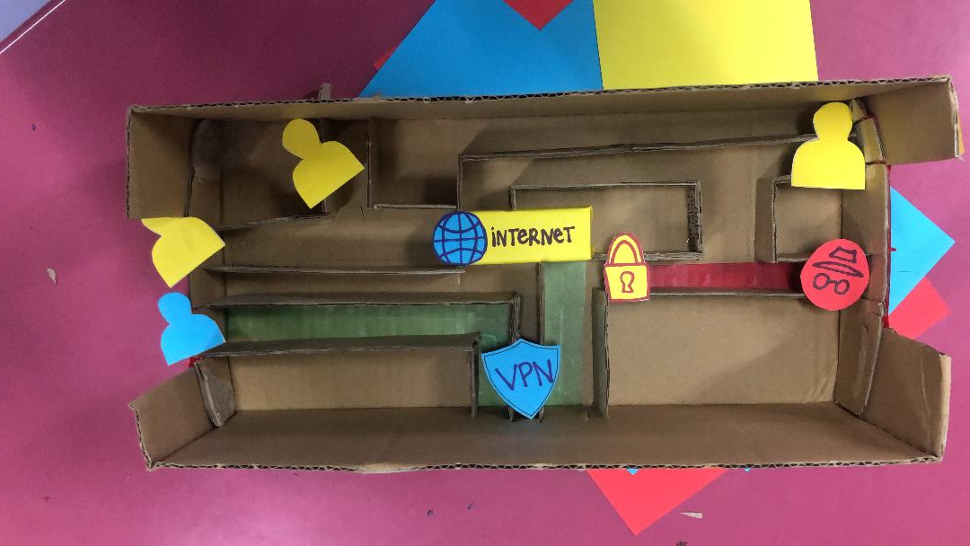

**TEST**

VPN stands for virtual private network. The main concept of VPN is to give the network user privacy online. But, how does it work?

When you want to go to a website, let’s say Facebook. You will type in [www.facebook.com](http://www.facebook.com). This is the domain name. Domain name is basically a nickname for IP address, that will be translated by the server. When you send the data to the server, a lot of other information like your location will be sent to the server. When you send the data through the network, hackers can intercept your information. However, with VPN, when you send information online VPN will create a tunnel or more likely a private line. The tunnel will make it impossible for the hackers to intercept our data. As soon as the data reaches VPN, it will encrypt your data. Encrypt means it will convert the data into a code that will eventually be decoded by the server. Let’s say a hacker wants to get your data, they won’t be able to access it.

**REFLECTIONS**

*What is your goal/dream with regard to your course/program?*

Our dream is to be able to change the world for a better by widen our knowledge and understanding clearly how technology information system works. That way, we are able to invent something related to this course that will benefit users.

*How does this design thinking impact on your goal/dream with regard to your problem?*

This design thinking project helped us a lot in understanding the flow or steps that needs to be followed in order to create a new innovation. It gives us the chance to become more innovative and develop some critical thinking which could be the catalyst to our success in future projects. Moreover, it also helps us understand better on what we may not know much on. In this case, it helps us acknowledge that there are people, including ourselves who are insecure of making full use of the network only because of the issues created by malicious people.

*What is the action/improvement/plan necessary for you to improve your potential in the industry?*

We believe that we have to read a lot to know the issues influencing technology throughout the world and that we must try to be more open minded and listen to the users’ concern regarding technology to be able to relate to them and create a solution. Our potential can be improved if we participate in a lot of activities related to this course to gather more knowledge and experience. Participating and organizing various kind of events could definitely help us develop skills that can easily fit us into the industry.