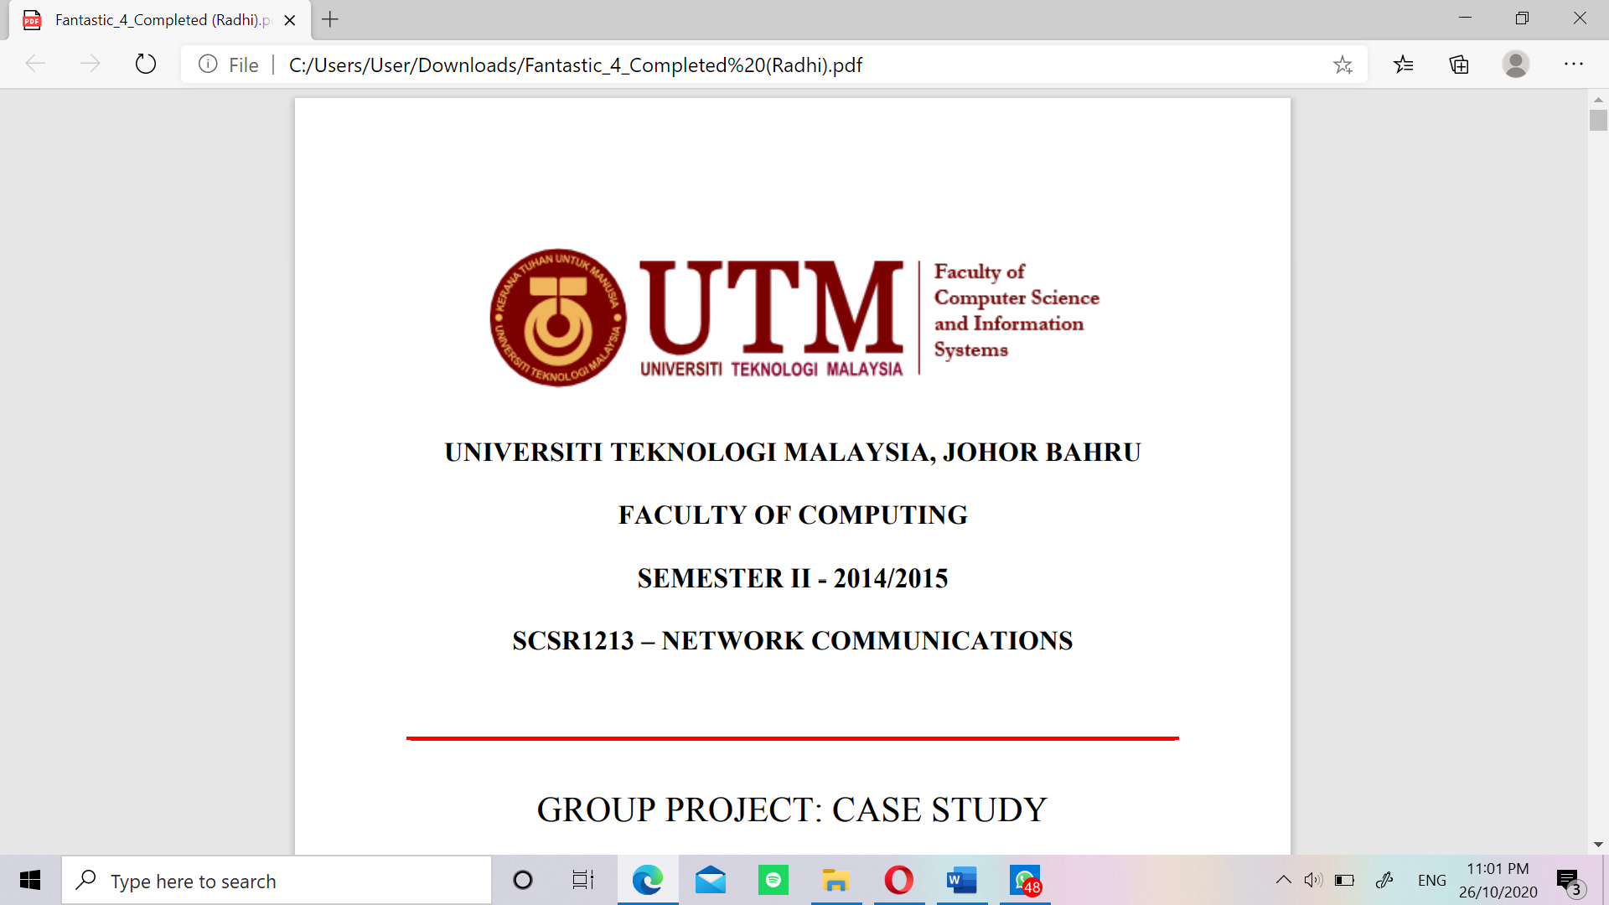

SECR1213-10 KOMUNIKASI RANGKAIAN (NETWORK COMMUNICATIONS)

TASK 1: PROJECT SETUP

**Due date – 28 October 2020**

**Group - Sunflower**

**Nurul Syamira binti Amat Jifri (A19EC0145)**

**Khaireennur Khaliesha Binti Mohamad Jais (A19EC0300)**

**Sarah Chintya Rachmi (A19EC0283)**

**Lecturer: Dr. Syed Hamid Hussain Madni**

**Table of Contents**

The purpose of the floor plan 2

Floor plan layout:

First floor……………………………………………………………... 3-5

Second floor…………………………………………………………... 6-8

Labels……………………………………………………………………….. 9,10

Overall floor plan explanation………………………………………………... 11

Reflection……………………………………………………………………... 12

Conclusion……………………………………………………………………. 12



**The purpose of the floor plan**

The floor plan is made by a request and hopefully fulfill the need that costumer wish. This floor plan based on the 2-storey building that will be build. Which is, the first floor is fit with the second floor. Imagine if this is the real building, and it may have some sketch if want to build it. The floorplan make costumer know how if the sketch can already be realized.

The costumer's opinion makes it very easy to describe sketches in order to fulfill the costumer's own desires. With good communication between costumer and sketchmaker is needed for maximum results.

We apologize if there are any errors or shortage.





**Floor plan layout**

1. First Floor

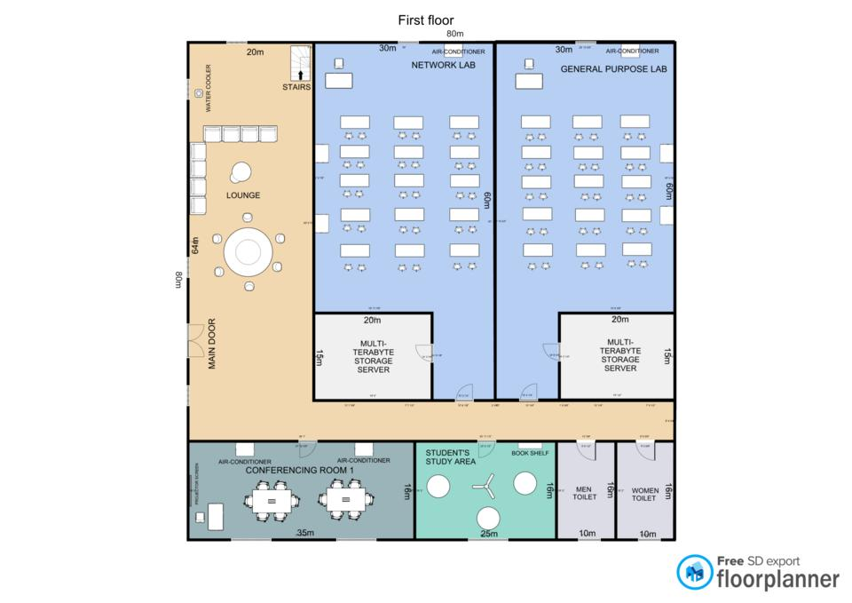

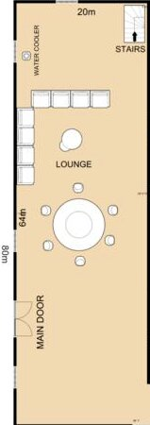 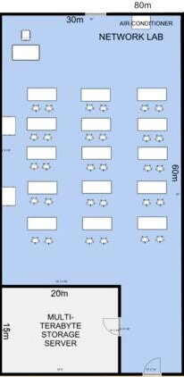



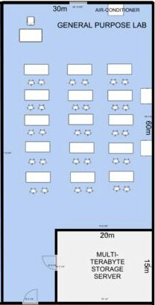

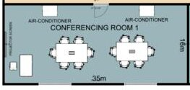 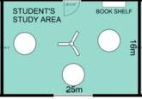 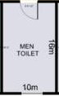 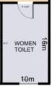

2.Second Floor

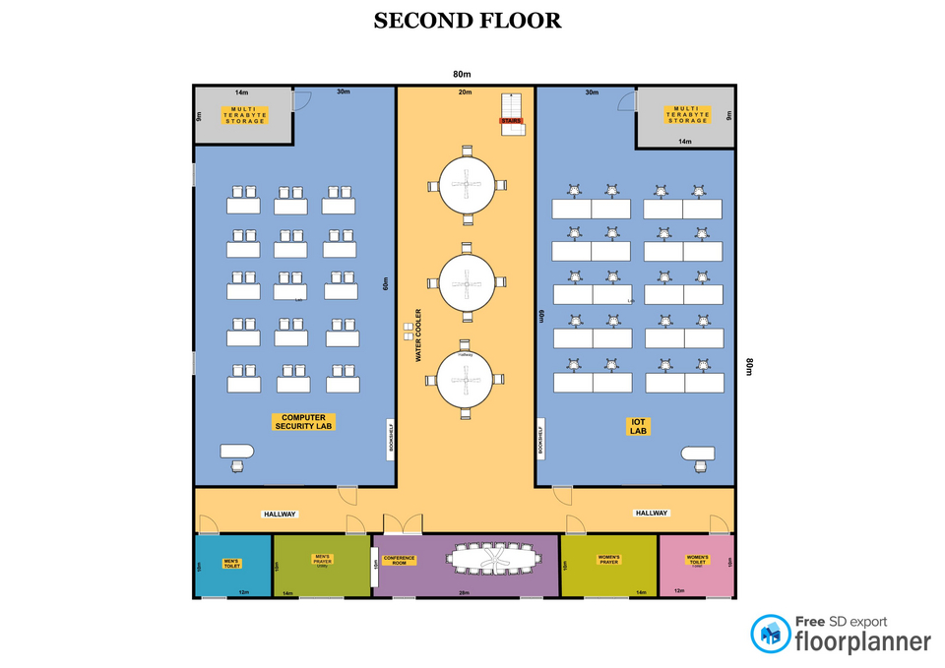

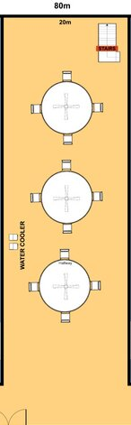 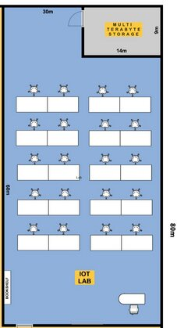 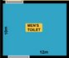 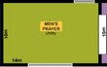

 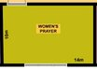 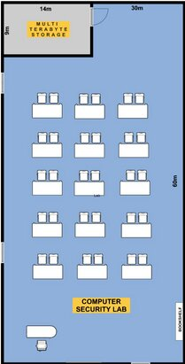 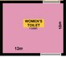 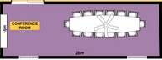

**Labels**

 *> Chair*

 *> Small Circle Table*

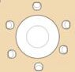 *> Conference Circle Table*

 *> Stairs*

 *> Air Conditioner*

 *> Chair and Table*

 *> Two seat and one table*

 *> Rectangle Conference Table*

 *> Single Circle Study Set*

 *> Door*

 *> Water Cooler*



*> Long Rectangle Conference Table and Fan*

 **>** *Chair and table IOT LAB*



**Overall Floor plan Explanation**

From the floorplan that has been created, there are the following rooms:

Lounge - as a gathering place or meeting place between students and visitors.

Network Lab - As a place to do a lab in the subject of network

General Purpose Lab - Used as a lab used in any subject

Conferencing Room - Used for meetings, discussion venues, and more.

Student's Area - Used for students to study or just sit down to read the subject materials.

Toilets - Used for people who want to use the toilet according to the room that has been shared, namely male or female.

Computer Security Lab - Used for lab or use in security computers. Where, usually in this room is always equipped with the facilities needed for computer security.

Multi Terabyte Storage - Usually used for large-scale data storage that can no longer be stored in a computer's memory. This is used to store the backup of the data you still want to keep.

IOT Lab - Used for research and other purposes.

Prayer Room – This room is used for anyone who wants to pray.

Conference Room – Usually used for meeting and any gathering.



**Reflection**

Sarah Chintya Rachmi: I do this for the first time. Design is the must known-knowledge we had learn. This is the beginning for the Start looking forward if we already in a Job. Because, this project is purpose to fit the costumer needs.

Nurul Syamira: To read the study case and did a floor plan layout for the first task is quite exciting. As this is the first time I have done this since in the first year the subjects are not focused on network also the building that build with all network equipments.

Khaireennur Khaliesha: I enjoying do this floor plan as well. But it’s a bit hard then I thought. But it’s help us to know how the network will be used in the building. Beside this is my first time I Know about the network communatication.

**Conclusion**

In conclusion, we should try to design as realistic as possible. As we must fits the scale and also fits the requirements in the study case. In the study case, we must focus on the new system that they required for the new building. From the picture, we can actually imagine the scale with the real-life scale. And it make us easier if we want to build this sketch.

