

**SKAA 2922**  
**WASTE WATER ENGINEERING  
REPORT ON ENVIRONMENTAL INNOVATIONS**

LECTURER’S NAME : ASSOC. PROF. DR. AZMI BIN ARIS  
STUDENT’S NAME : SITI HAMIZAH BINTI SHAIFUL YAZAN  
SECTION : 2  
MATRIC’S NO : A11KA0177

**TABLE OF CONTENT**

1) The Innovations

* 1. Xeros Waterless Washing Machine 3
  2. Gravity Lamp 5
  3. Nanotech Tea ag Purifies Drinking Water 7

1. References 9
2. **XEROS WATERLESS WASHING MACHINE**

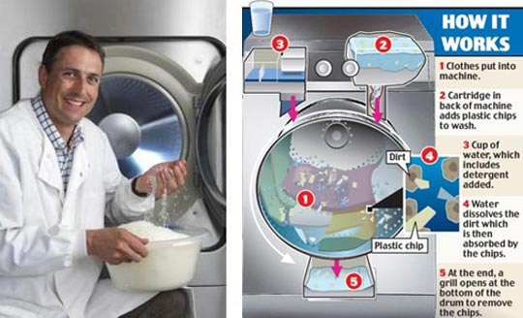

As we all known that, the washing machine is a usually automatic machine for washing clothes. Almost now, I do not know about this machine’s problem until I should do this report.

* **Problems**:

With an ordinary washing machine adds a surprising amount to your carbon footprint but tumble drying them racks up even more emission. Carbon footprint is a total amount of greenhouse gases produced to directly and indirectly support human activities, usually expressed in equivalent tons of carbon dioxide (CO2).

Other than that, water consumption is other problem for the ordinary washing machine. The average washing machine uses 151 to 208 litres of water per load. It takes too many amount of water to wash cloths and not an efficient machine if there use a lot of water.

* **Solution**:

In order to save water, energy, and money every time, we can use *Xeros Waterless Washing Machine.* Only a cup of water is needed in order to create humid conditions for the nylon polymer beads to work. As a matter of fact, this machine is projected to use 90% less water compared to traditional washing machines.

The use of a waterless washing machine can also reduce carbon footprints. This is because a waterless washing machine uses less energy, electricity, and detergent. If less and less people use tumble drying because of a waterless washing process for clothes, consumers can enjoy a total of 40% energy savings. And because nylon polymer beads can be recycled over and over again, the carbon footprint of this kind of washing machines is less compared to traditional washers.

1. **GRAVITY LIGHT**

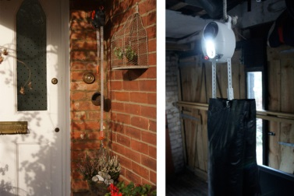

There are currently over 1.5 billion people in over the world who have no reliable access to mains electricity. These people rely, instead, on kerosene lamp for lighting once the sun goes down.

Kerosene is a liquid fossil fuel that was once the most-used kind of fuel for lighting before the introduction of electricity. It is still used in parts of the world that occasionally suffer a shortage of electricity such as rural areas.

* **Problems**:

The problem is it does emit some poisonous gases such as nitrogen dioxide, sulfur dioxide and carbon monoxide. All three of these can cause damage to the body if breathed in and also cause eye infections and cataracts. Moreover, the kerosene lamp usually set up in a small space or house and it more danger to people’s health.

* **Solution:**

One startup's solution is to tap another, greener resource, and use stored potential energy of the weight, gravity by converted into kinetic energy so that it in turn the dynamo. This device gets power from the slow lowering of a weight. All it takes is enough elbow grease to hoist the bag, and you can light a space or room with nothing but a bag of sand.

As an attached weight falls, it pulls a cord through the center of the light, powering a dynamo. That dynamo converts the energy from the falling weight into power for the light. The weight can be set in a few seconds and enough energy is generated to keep a light working for 30 minutes. To make it continuously provides light you room, just set it every 30 minutes and we don’t need the sun to shine, or to store up enough power for use at evening.

1. **NANOTECH TEA BAG PURIFIES DRINKING WATER**

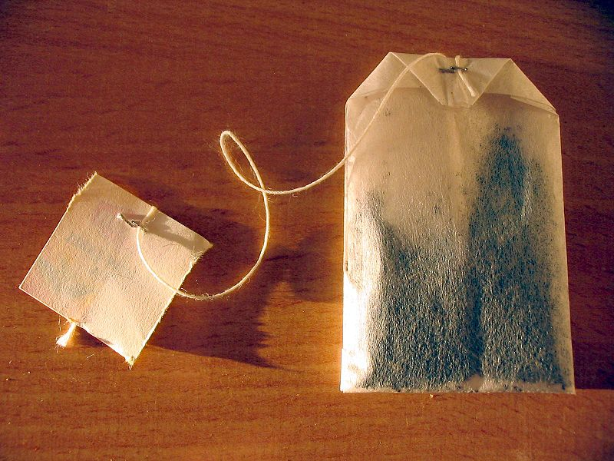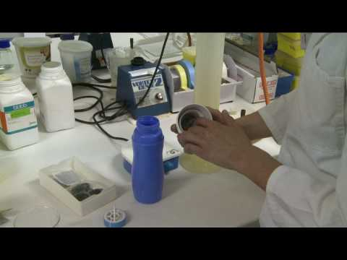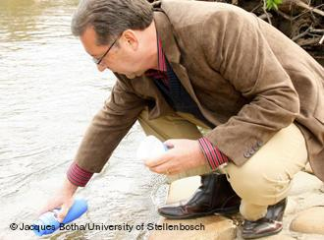

Not all water such as sea, river or waterfall is safe to drink. So, we needed product in areas of the world where people are still otherwise forced to drink contaminated water.

* **Problem :**

Roughly [1 billion people](http://www.who.int/water_sanitation_health/mdg1/en/index.html) in the world have no access to safe drinking water, and contaminated [water](http://inhabitat.com/water/) kills more people worldwide than all forms of violence combined. It is simply impossible to build purification infrastructure at every polluted stream

* **Solution :**

Seeking to provide a solution to this problem, South African researchers have created a water-purifying [nanotech](http://inhabitat.com/index.php?s=nanotechnology) tea bag that costs half a cent. Portable, instantly effective and with no chance of recontamination, the tea bag sounds like the best idea since sliced bread.  
  
Here’s how the nanotech teabag works: it combines ultra-thin nanoscale [fibers](http://inhabitat.com/2010/08/05/nz-company-creates-revolutionary-nanofibres-from-fish-skins/) to filter harmful contaminants, while grains of activated carbon to kill bacteria. Simply put the tea bag in the neck of a [water bottle](http://inhabitat.com/index.php?s=water+bottles) and drink the water through it.

Marelize Botes, a microbiology researcher at [South Africa](http://inhabitat.com/2010/07/12/pitch-africa-is-a-soccer-field-that-also-produces-clean-drinking-water/)‘s Stellenbosch University says “The nanofibres will disintegrate in liquids after a few days and will have no environmental impact. The raw materials of the tea-bag filter are not toxic to humans.”

**REFERENCE**

1. <http://www.gizmag.com/xeros-washing-machine/12088/>
2. <http://www.indiegogo.com/projects/gravitylight-lighting-for-developing-countries>
3. <http://inhabitat.com/nanotech-tea-bag-purifies-drinking-water-for-less-than-a-penny/>   
   ( [Nanotech Tea Bag Purifies Drinking Water for Less Than a Penny | Inhabitat - Sustainable Design Innovation, Eco Architecture, Green Building](http://inhabitat.com/nanotech-tea-bag-purifies-drinking-water-for-less-than-a-penny/#ixzz2SXfooixV) )