

MANUFACTURING PROCESS

SHAD 3083

GROUP ASSIGNMENT

(RICE COOKER)

LECTURER: DR. NORHAYATI BINTI ZAKUAN

GROUP MEMBERS:

|  |  |  |
| --- | --- | --- |
| **NO** | **NAME** | **MATRIC NO** |
| 1 | ARMAN HAFIZ BIN ROSROMAIZI | B19BS0005 |
| 2 | LIM HUI YING | A17HA0076 |
| 3 | NURIN AMIRAH BINTI ABDUL RAHIM | A17HA0198 |
| 4 | NURUL ADIBAH BINTI IDRIS | B19BS0015 |

TABLE OF CONTENTS

1.0 INTRODUCTION 1

1.1 HISTORICAL DEVELOPMENT OF PRODUCT 1

1.2 COMPETITORS 2

1.3 METHOD OF PRODUCTION 3

1.4 FUNCTION OF THE COMPONENT / PRODUCT 4

1.5 ASSUMPTION ON THE TYPE OF MANUFACTURING PROCESS 5

1.6 ASSUMPTION ON THE QUANTITY OF PRODUCTION 5

1.7 PRODUCTION COST ESTIMATE 6

2.0 DETAILED SPECIFICATION OF THE FINAL PRODUCT 7

2.1 MATERIAL SELECTION 7

2.2 COMPONENT ANALYSIS 8

2.3 DIMENSIONAL, SURFACE ETC SPECIFICATION 11

2.4 TECHNICAL DRAWING 12

3.0 STAGES OF THE PROCESSES 13

3.1 ALTERNATIVE PROCESSES 13

3.1.1 CASTING PROCESS 13

3.1.2 POLYMER PROCESS 13

3.1.3 JOINING PROCESS 14

3.2 PRODUCTION PROCESSES 15

3.2.1 CASTING PROCESS 15

3.2.2 POLYMER PROCESS 16

3.2.3 JOINING PROCESS 17

3.3 PROCESS STAGE OR STEPS FLOW CHART 18

4.0 TYPE OF MACHINES / EQUIPMENT FOR EACH PROCESS 20

4.1 COLD CHAMBER DIE CASTING MACHINE 20

4.2 HYDRAULIC INJECTION MOLDING MACHINE 21

4.3 AUTOMATED MULTI SPINDLE DRILLING MACHINE 22

4.4 HYDRAUCLIC RADIAL RIVETING MACHINE 23

5.0 CONCLUSION 24

6.0 REFERENCE

7.0 APPENDIX

# 1.0 INTRODUCTION

Manufacturing is an industrial activity that transforms the materials to create products. In this project, casting process, polymer process and joining process is used to produce rice cooker. To produce rice cooker, researchers also buy and use the raw materials such as ceramics, plastics, aluminium, wires and also rivet from several suppliers and make contract with the suppliers.

## 1.1 HISTORICAL DEVELOPMENT OF PRODUCT

The Japanese Mitsubishi Electric Corporation was the first producer of commercial rice cooker in 1945. It is made from aluminium pot attached to a heating coil inside the main pot. Unfortunately, the first appliance does not have an automatic turn on and off button so it would require the person to watch it all the time during the cooking process so the rice would not be black burnt.

A rice cooker is a compact countertop appliance designed to cook large quantities of rice with the minimum amount of supervision. It consists of a non-stick inner bowl, thermostat control and heating element.

Rice cooker can be classified as a great innovative product for the kitchen appliances as it can free people from mundane tasks. Users do not need to keep their eyes when cooking as the automated rice cooker will handles this for us, turning down the heat when the rice is done to keep it warm without burning (Richard, 2017).

Nowadays, consumers will compare the product with the price, quality and also the after sales services before purchasing a product. Therefore, we must know who is our potential competitors and we must create marketing strategies to overpower our competitors.

## 1.2 COMPETITORS

Our first competitor is the Koninklijke Philips N.V. Company. This company is one of the largest electronics companies in the world which manufacturer of customer electronics, electronic components, medical equipment, household appliances, lighting equipment and computer and telecommunications equipment (Dominique, 2019).

The second competitor is the Panasonic Corporation Company. The company was founded in 1918 as a producer of [lightbulb sockets](https://en.wikipedia.org/wiki/Lightbulb_socket) and has grown to become one of the largest Japanese electronics producers alongside [Sony](https://en.wikipedia.org/wiki/Sony), [Hitachi](https://en.wikipedia.org/wiki/Hitachi), [Toshiba](https://en.wikipedia.org/wiki/Toshiba), [Pioneer](https://en.wikipedia.org/wiki/Pioneer_Corporation) and [Canon Inc.](https://en.wikipedia.org/wiki/Canon_Inc.) electronics (Panasonic, 2019).

The third competitor is the Tefal Company. Tefal is a French cookware and small appliance manufacturer owned by Group SEB (Tefal, 2019). This company is founded in 1956. Tefal was created to produce non-stick frying pans and became the first creator of non-stick cookware. Tefal have become the world leader in non-stick cookware and a world leader in irons, cooking appliances, pressure cookers, food and drink preparation products and scales (Tefal, 2019).

## 1.3 METHOD OF PRODUCTION

There are three types of methods to produce a product, which are job shop production, batch production and mass production. The method of the production in this project is the batch production. Batch production is a manufacturing process which produces by batch, it will change over when a batch of one product is made. Therefore, it may be produced in batches of different sizes and colours. Batch production is chosen because the quantity of the production is in the medium quantity range. This method also focusses in better quality control with an affordable price. Researchers choose the materials with comparing the quality among those suppliers.

The process layout used by the researchers is the cellular layout. This is because the production of our products is small differences between products which also called soft product variety. Therefore, extensive changeover between one product style and the next may not be necessary.

Only semi-skilled workers needed in this method of production. High level of training, flexibility and empowerment of the workers are needed to ensure the task given can be completed effectively on time.

The advantage of the batch production is that we can reduce waste and decrease lead times in production. The ability of batch production machinery system includes assembling product components, involving control and testing capabilities to ensure the level of incorrect batches that might be pulled through to the next process are kept to a minimum (Hallam, 2019). Therefore, batch production is used to produce of rice cooker.

## 1.4 FUNCTION OF THE COMPONENT / PRODUCT

Rice cooker is an automated kitchen appliance which designed to boil or steam rice. The thermostat of the rice cooker will measure and control the heat to ensure the suitable temperature to boil or steam rice.

Our product consists of five components which are the lid, knob, outer pot, inner pot and also the heating plate of the rice cooker. The lid of the rice cooker is produced by aluminium material. Moreover, the outer pot of the rice cooker, the knob and also the heating plate (outside component) of the rice cooker are produce by plastic material while the inner pot is produced by aluminium and ceramic material. Wire has also installed in the heating plate of the rice cooker to conduct electricity when cooking process.

The function of the inner pot is to use to boil or steam rice while the outer pot is used as the container to retain heat in the cooking process. Moreover, the lid is function as a cover to close the inner pot when cooking and the knob of the rice cooker is used to ensure the inner pot and the lid of the rice cooker can be picking up easily. Furthermore, the heating plate is function to enter and control the electricity when the cooking process is processing.

## 1.5 ASSUMPTION ON THE TYPE OF MANUFACTURING PROCESS

The type of production for rice cooker is batch production. Batch of production is a method of manufacturing where the products are made as specified groups or amounts, within a time frame. A batch can go through a series of steps in a large manufacturing process to make the final desired product. The reason manufacture chooses batch production because batch production is good for quality control. In case, if there is a mistake in the process in making rice cooker, it can be fixed without as much loss compared to mass production. This also can save money by taking less risk for newer plans and product. The result, batch production allows be changing or modifying depending on company needs. Batch production is not only use is electrical goods but also clothing, baked goods, die or mold making and computer chips

The characteristics of batch production are skilled labour in specific trades. The labour force is expected to have at least one skill in manufacturing process such as turning, drilling, welding. Second, is limited span of control. The amount of supervision required in the batch production is lower than that of other production. Third the manufacturing cycle time is smaller than other production.

## 1.6 ASSUMPTION ON THE QUANTITY OF PRODUCTION

The quantity of production for rice cooker that we estimate are around 6000 per year, 500 units per month. However, the quantity also depends on the demand of customers in the market. It might increase or decrease depending on if the company wants to do some research and development of their product

## 1.7 PRODUCTION COST ESTIMATE

Assume 6000 unit of rice cooker per year, 500 units per month of rice cooker are produced. Table 1 shows the estimated cost of production of one unit and total cost for 500 unit of rice cooker. The production cost per unit of the rice cooker is RM 45.48, while the total costs of the rice cooker which are 500 units are RM 22,865.90

**Cost of production**

|  |  |  |
| --- | --- | --- |
| **Raw Material** | **Cost per unit (RM)** | **Total Cost (RM) – 500 unit** |
| **Aluminum** | 23.40 | 11700 |
| **Plastic** | 12.12 | 6060 |
| **Ceramic** | 7.436 | 3718 |
| **Rivet** | 0.0504 | 29.40 |
| **Wire** | 2.47 | 1358.50 |
| **Total Cost** | **45.48** | **22865.90** |

**Table 1: Estimation Cost of Raw Material**

# 2.0 DETAILED SPECIFICATION OF THE FINAL PRODUCT

## 2.1 MATERIAL SELECTION

**2.1.1 ALUMINIUM**

For the interior part of rice cooker, researchers are using aluminium as main material. Besides that, aluminium also used to produce lid and heating plate of the rice cooker. Aluminium is an excellent conductor of heat, it enables to spread the heat quickly and evenly to completely surround the food being cooked. As aluminium is a light-weight metal, it is suitable material for inner pot and heating plate. Other than that, aluminium is easy to handle. Finally, this material does not rust easily.

**2.1.2 PLASTIC**

For the knob and the outer pot, we use plastic material. The properties of plastic itself, which has not changed its form after they are heated makes it a suitable material for manufacturing rice cooker. Furthermore, plastic is a thermal insulator. It enables to trap heat from the inner pot and it also protects the inner content from the outside heat.

**2.1.3 CERAMIC**

For the interior part of rice cooker, we are using ceramic as a coating material. One of the reasons is ceramic is an efficient heat transfer. Furthermore, ceramic is known of its main properties which are non-stick. It requires only a little oil or butter to keep food from sticking. Ceramic material is safer and healthier than the other option. It is PFOA-free and uses non-toxic material to ensure that there is no leaching anything of nasty chemical into your food.

**2.1.4 RIVET**

The rivet is headed pin used to join two or more parts by passing the pin through holes in parts and forming a second head in the pin on the opposite side. This is a widely used fastener for achieving permanent mechanically fastened joints. Basically, rivet is used for joining the knob and lid by using the riveted

**2.1.5 WIRE**

Wire is the electrical part that connects the electric with the rice cooker in order to turn it on. The types of wire for this rice cooker is 3Pin AC power cord cable. It is suitable for this product as it is heat resistant material.

## 2.2 COMPONENT ANALYSIS

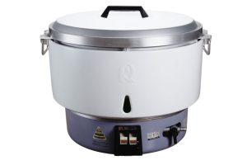                       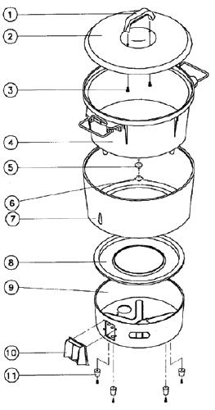

**FIGURE 1: RICE COOKER                        FIGURE 2: COMPONENT OF**

**RICE ROOKER**

Basically, our company rice cooker is made of two parts which is upper and bottom part. As in figure 2, there are many components in a rice cooker, the upper part consists of knob, inner pot, lid and outer jacket while the bottom part is heating plate.

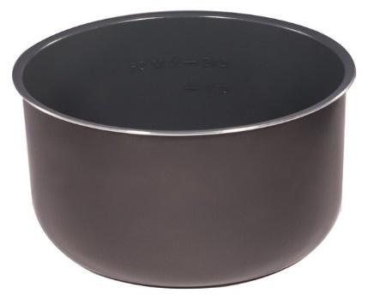

**FIGURE 3: INNER POT**

Inner pot is made of aluminium and ceramic. This inner pot is ceramic-coated, so the rice does not stick to the inner pot as it has non-stick properties. Besides, the burnt rice layered does not stick to the bottom. Since it has non-stick properties, it is easy to clean up. Apart from that, the inner pot also a scratch-resistant.

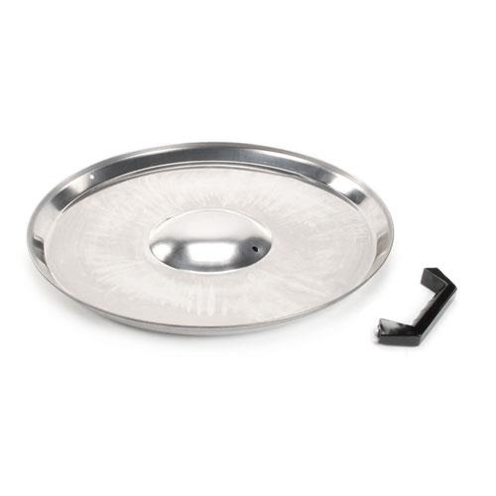

**FIGURE 4: KNOB AND LID**

The knob is made of plastic while lid is made of aluminium. The knob is used to handle the lid while the rice cooker is in hot condition. The lid itself is hot due to the material is aluminium, thus plastic material is suitable for knob because it is non-heat conductor.

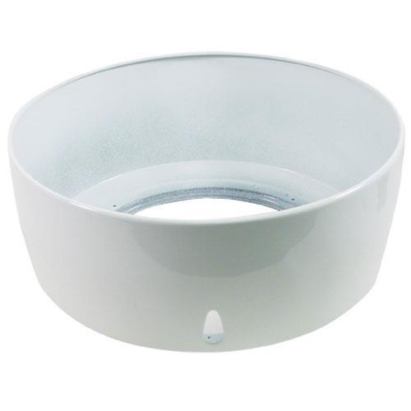

**FIGURE 5: OUTER JACKET**

The outer jacket is used as the container to retain heat. For this component, material that used are plastic as it has good insulation and this kind of plastic did not melt easily when high temperature.

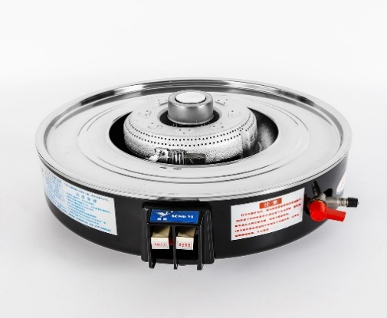

**FIGURE 6: HEATING PLATE**

Heating plate is made out of metal, to be specific it is aluminium, so it is ideal for manufacturing rice cooker as the material can transmit heat to the food rapidly and effectively. This heating plate has several buttons, one of which is the start button.

## 2.3 DIMENSIONAL, SURFACE ETC SPECIFICATION

Our rice cooker is round in shape with heating plate bottom of the pot. This rice cooker is quite different with other normal or smart rice cooker. In the term of shape, our rice cooker is bigger and heavier than normal rice cooker. 15L of the capacity, 2.8Kpa of the gas pressure, 10kW heat power, 10KG rice capacity and estimated 80 people capacity. It is typically 515mm in diameter, 440mm the length of the round heating plate and 520mm for the height. The height is including the handles to grip the pot for cleaning purposes.

The entire surface is round and smooth for the purpose of safety when cooking and good appearance. Our product are resistant to scratches, have high quality of aluminium body, have consistent and excellent heat distribution, smooth and easy for cooking rice. Specially, it can cook for large capacity at one time.

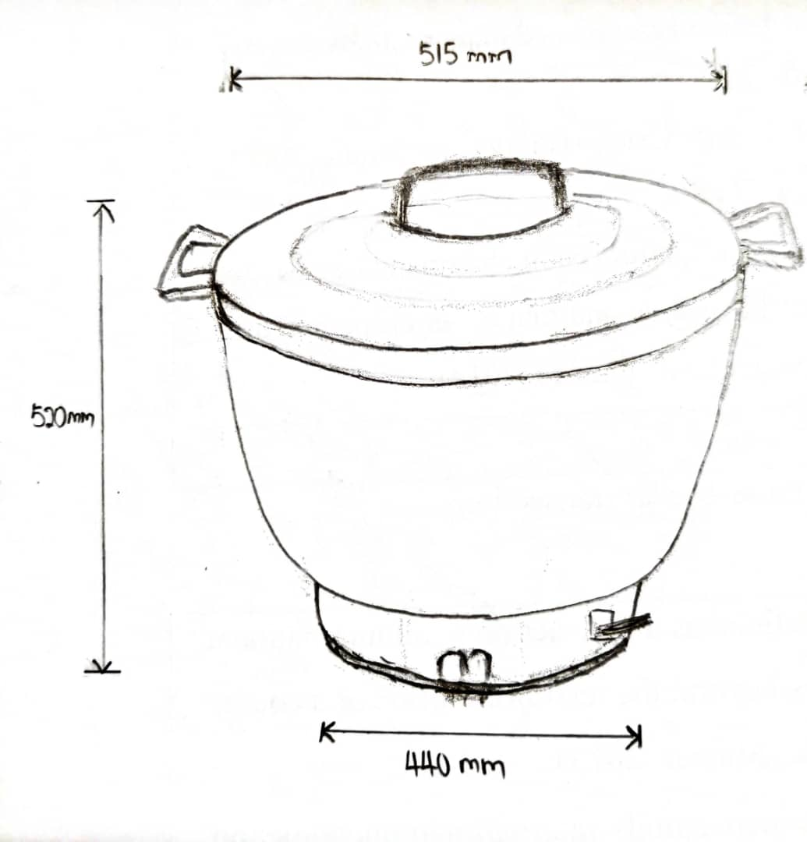

**Figure 7: Dimension of the rice cooker**

## 2.4 TECHNICAL DRAWING

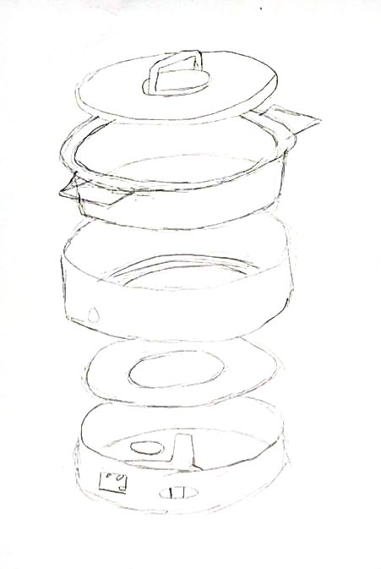

**Figure 8: Technical drawing for rice cooker**

# 3.0 STAGES OF THE PROCESSES

## 3.1 ALTERNATIVE PROCESSES

There are three main processes that involved in producing a rice cooker which are casting process, polymer process and joining process.

### 3.1.1 CASTING PROCESS

Casting process is a manufacturing process used to produce a product of a specific desired shape. Casting is a simple and cost effective solution used by most of the manufacturing industries. This casting process was used to produce the cast of the lid, heating plate (outside component) and inner pot of the rice cooker.

In this casting process, cold-chamber die casting was being used. Cold-chamber is ideal for metals such as aluminium because it has a high melting point. There are several advantages of the die casting, for example, it can produce large quantities of the product economically. Besides that, it has a good dimensional accuracy and surface finish and the rapid cooling can provides small grain size and it can provides good strength to casting. Although more pressure of force is needed in the cold-chamber die casting process, but it has the advantage such as intricate detail, thin walls and superior mechanical properties.

### 3.1.2 POLYMER PROCESS

Polymer processing may defined as the manufacturing activity of converting raw polymeric materials into finished products of the desired shape, microstructure and properties (Marino, 2000). Polymer process was used to produce the outer pot and the knob of the rice cooker.

In this polymer process, injection molding process is used. This process can allow producing large quantities of the product and it can produce a wide range of part sizes with different shapes and designs. Moreover, this injection molding process can help to save resources for plastic molding because the unused molding plastic or scrap can be melted down and reused it (Ryan, 2015).

### 3.1.3 JOINING PROCESS

Joining process is a process that used to assemble two or more parts together to create more complex component or assembly. A joint can be either permanent or temporary. In this joining process, riveting process was being used to join the knob to the lid and the outer pot of the rice cooker.

Riveting process that defines as mechanical assembly may be used to join part together by a rivet. Rivet is a metal part to join the part through adjacent surfaces. The advantage of riveting process is that it can use to join the dissimilar material. For example, we can join the aluminium pot with the plastic knob. Moreover, the production is environmentally as no gases produced in riveting process.

## 3.2 PRODUCTION PROCESSES

### 3.2.1 CASTING PROCESS

**DIE CASTING**

Casting process is a process in which molten metal flows by gravity or other force into a mold where it solidifies in the shape of the mold cavity. For this casting process, it involves pouring molten aluminium into hardened steel dies, where the metal solidifies to the desired casting shape which is an inner pot of rice cooker. The die casting process that the company use is high pressure die casting cold chamber, which is this casting suitable for aluminium.

In this process, the aluminium is melted into liquid state at around 660°C before it can be poured into the unheated mould cavity. After the mould is closed, the melted aluminium must be ladled into the chamber directly, either manually or through a ladle system. Next, it will be injected by a piston into the die through a high-pressure hydraulic plunger and the mould will be left closed for several minutes. Cold chamber takes as short as second to solidify the die. After the molten aluminium solidified, the mould is opened and the casting is removed.

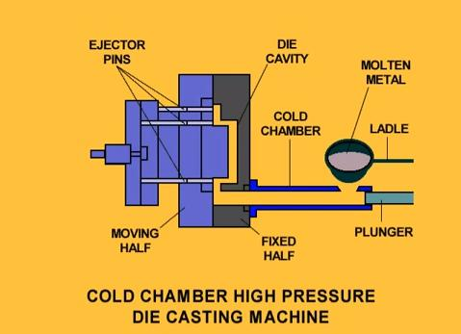

**FIGURE 9: COLD CHAMBER MACHINE**

### 3.2.2 POLYMER PROCESS

**INJECTION MOLDING**

Polymer process is a manufacturing activity of changing raw polymeric material into finished product of desired shape. For this process, injection molding is used. Injection molding is accomplished by forcing molten plastic under pressure into a cavity formed between two matched metal mold halves. Once the plastic cools, the molds are opened and the part is removed**.**

In this process, the mold is heated before pouring the polymer. After that, the mold is closed, and then the cool polymer is injected inside the hopper. Next, when the valves are opened, the screw forced the melt polymer through a nozzle into the mold. The reciprocation starts when the valve is closed. Finally, the last step in this process is when the polymer mold cooled, the press is opened and the molding removed.

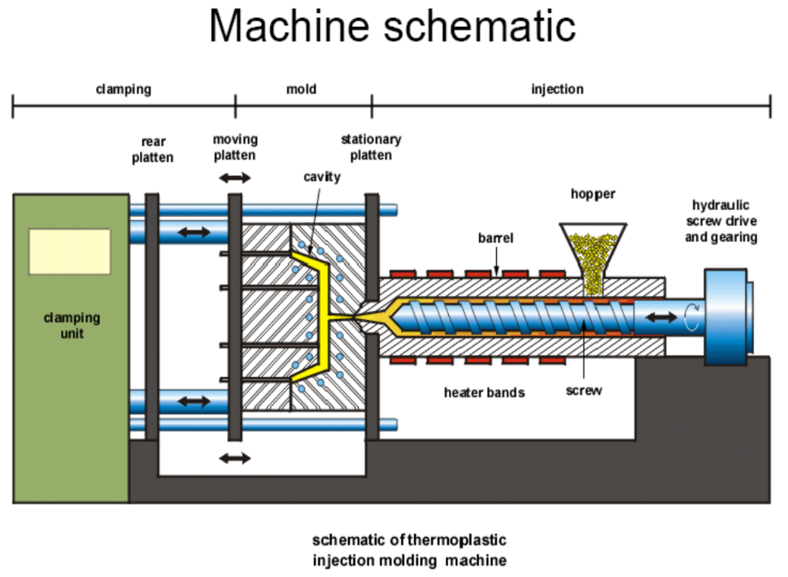

**FIGURE 10: INJECTION MOLDING MACHINE**

### 3.2.3 JOINING PROCESS

**RIVETING**

Joining process is a manufacturing process in which two or more parts are coalesced at their contracting surfaces by application of heat or by pressure. In this joining process, riveting process was being used. Riveting is a mechanical fastener composed of a head on one end and a cylindrical stem on another (called the tail) which has the appearance of a metal pin.

In riveting process, the machine that are being used arehydrauclic radial riveting machine. Hydrauclic radial riveting machine is a bind fastener which can be inserted and set from one side of the work piece. It is a technique to join thin pieces of metal and plastic. The rivet has two parts which are the pin and the rivet. In this process, the lid and the knob are drilled to a size slightly larger than the rivet. After drilled both parts, the pop rivet is inserted into a pre-drilled hole and gripped the mandrel. After that, the pop rivet passed through both holes and the rivet plier is pushed to the pin of the rivet and the handles are pulled together. As this happens, the rivet is sets.

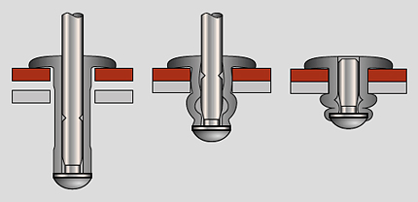

**FIGURE 11: THE PROCESS OF RIVETING**

## 3.3 PROCESS STAGE OR STEPS FLOW CHART

A flow chart showing steps involve in manufacturing rice cooker

Inner pot:

**Figure 12: A flow chart showing steps involve in manufacturing rice cooker**

Outer jacket of the pot and the heating plate:

**Figure 13: Outer jacket of the pot and the heating plate**

The knob and lid:

**Figure 14: A flow chart of the knob and lid of the rice cooker:**

# 4.0 TYPE OF MACHINES / EQUIPMENT FOR EACH PROCESS

## 4.1 COLD CHAMBER DIE CASTING MACHINE

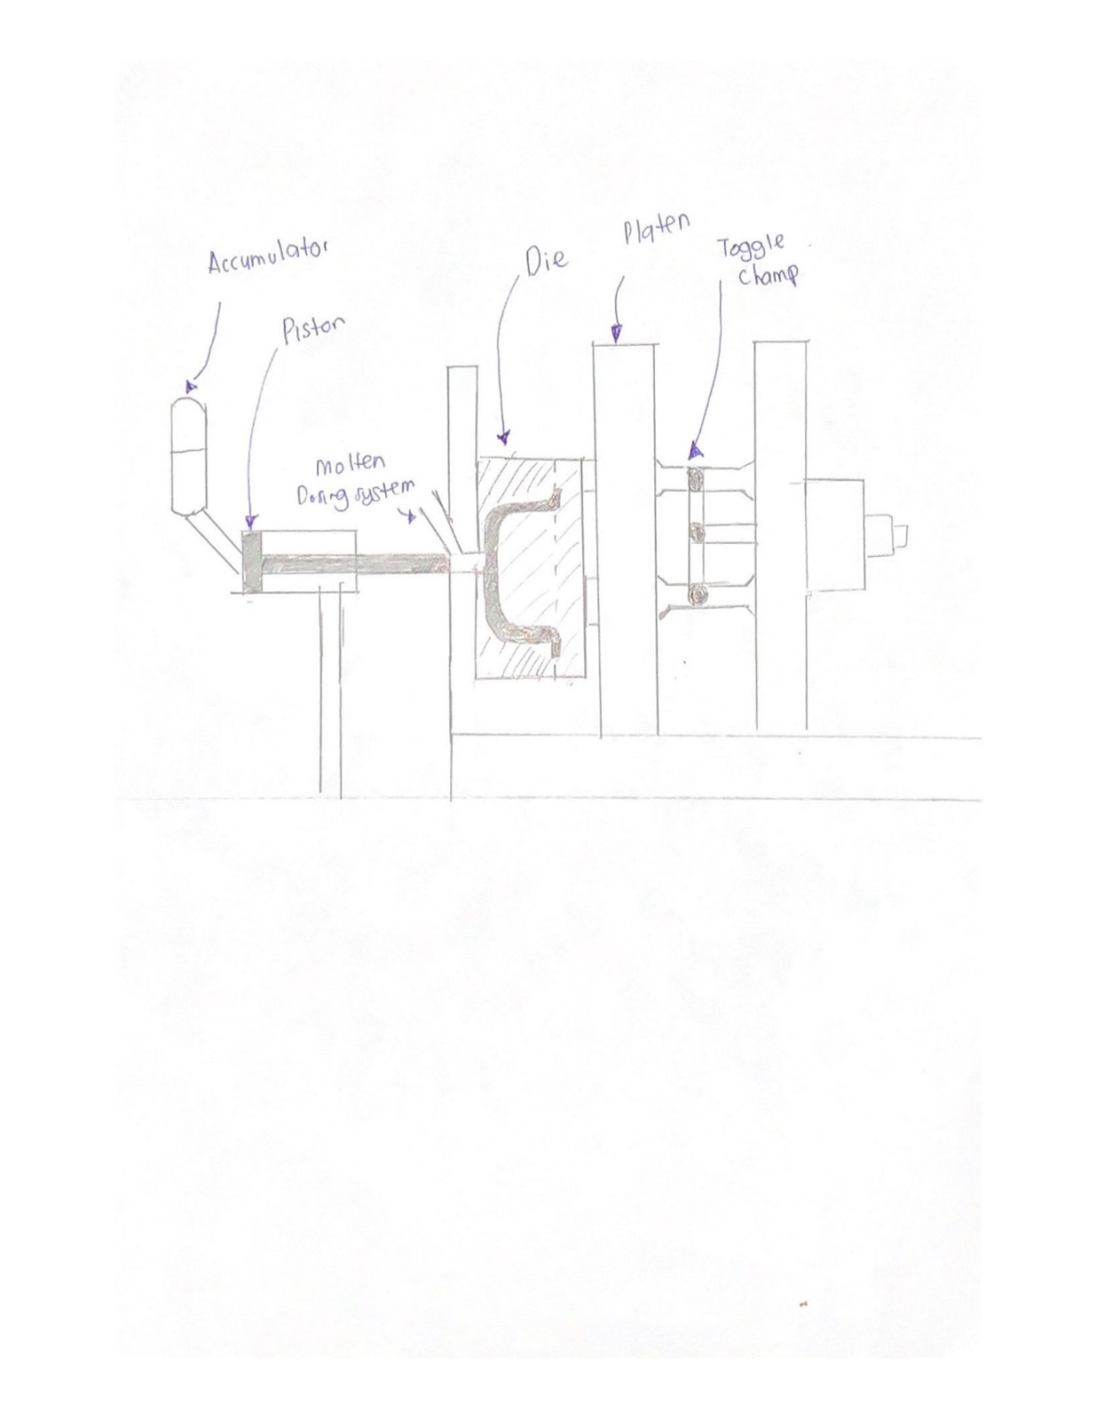

**FIGURE 15: COLD CHAMBER DIE CASTING MACHINE**

The function of this machine is to make a pot of the rice cooker. Molten metal is pouring into the die and then let it cool and solidify.

## 4.2 HYDRAULIC INJECTION MOLDING MACHINE C:\Users\Admin\AppData\Local\Temp\7zOC355514F\0002.jpg

**FIGURE 16: HYDRAULIC INJECTION MOLDING MACHINE**

The outer jacket for rice cooker is making by using this machine. The first step is to fill the feed hopper with polymer resin and the heater will meld the resin and then inject through to the mold.

## 4.3 AUTOMATED MULTI SPINDLE DRILLING MACHINE

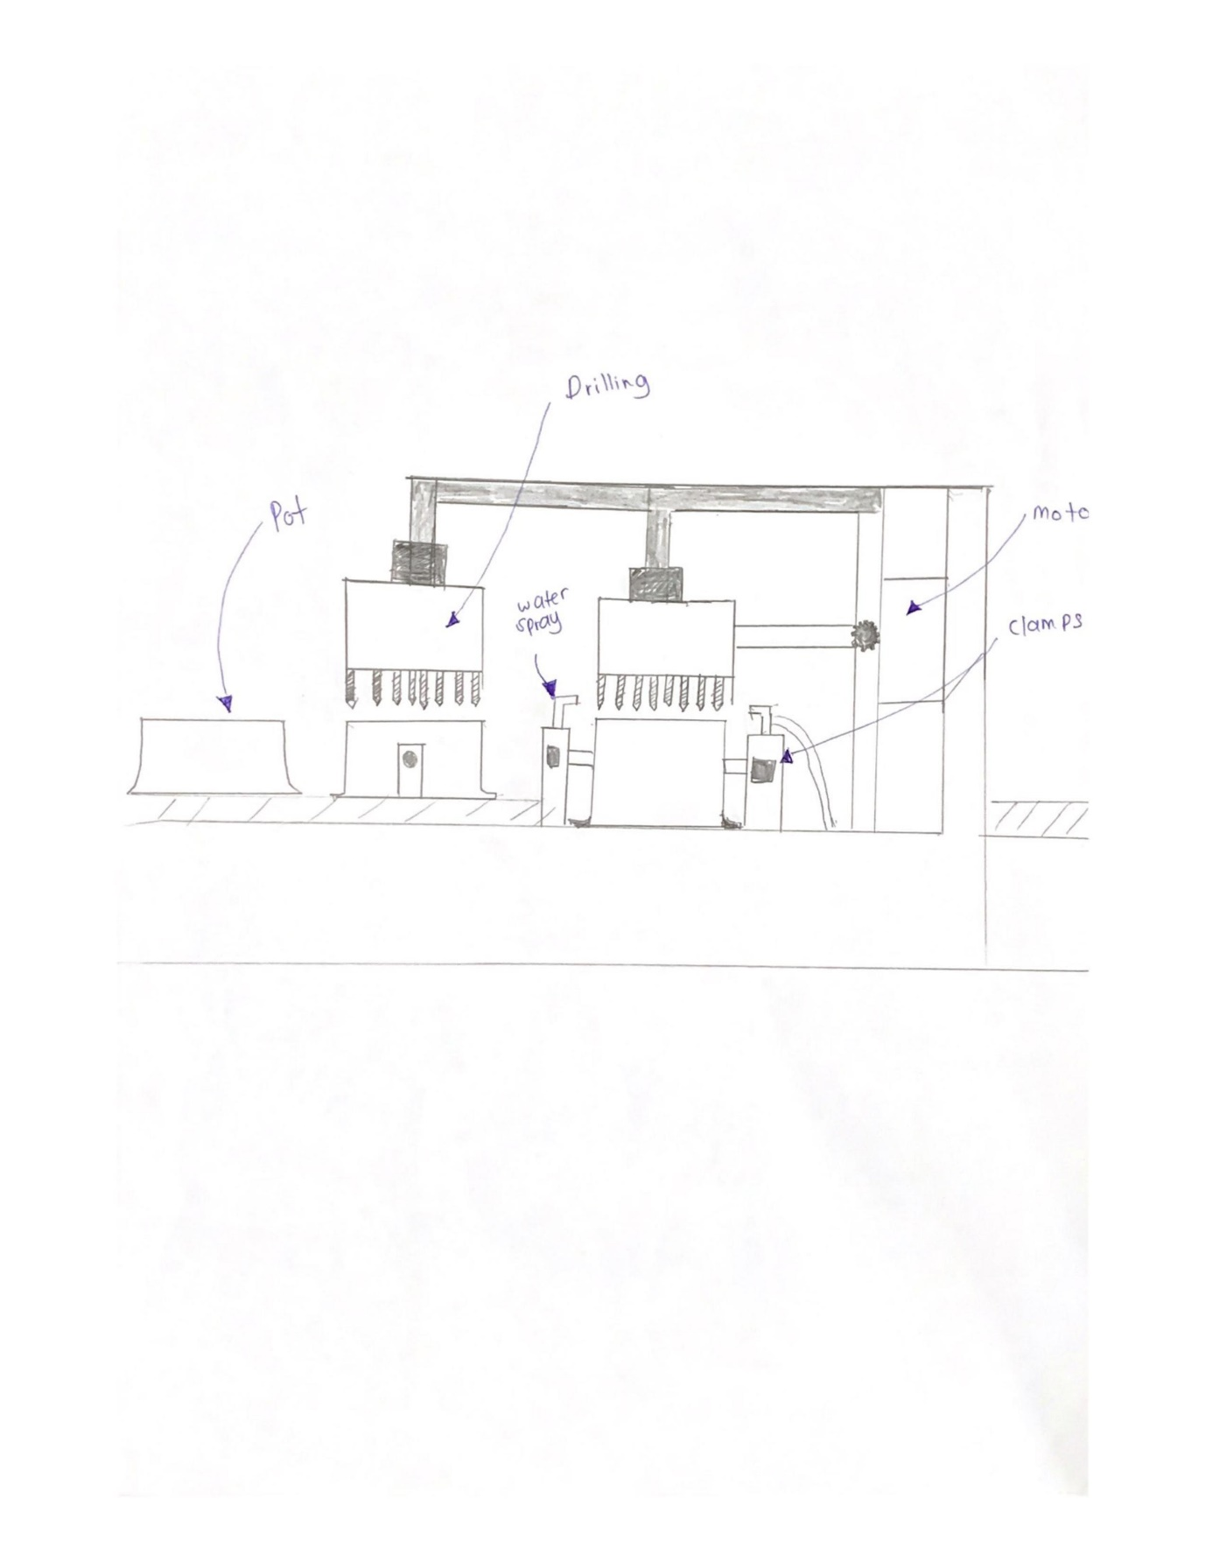

**FIGURE 17: AUTOMATED MULTI SPINDLE DRILLING MACHINE**

The pot is loaded into an automated drilling machine and puncture 18 holes through the bottom for rice cooker heating component.

## 4.4 HYDRAUCLIC RADIAL RIVETING MACHINE

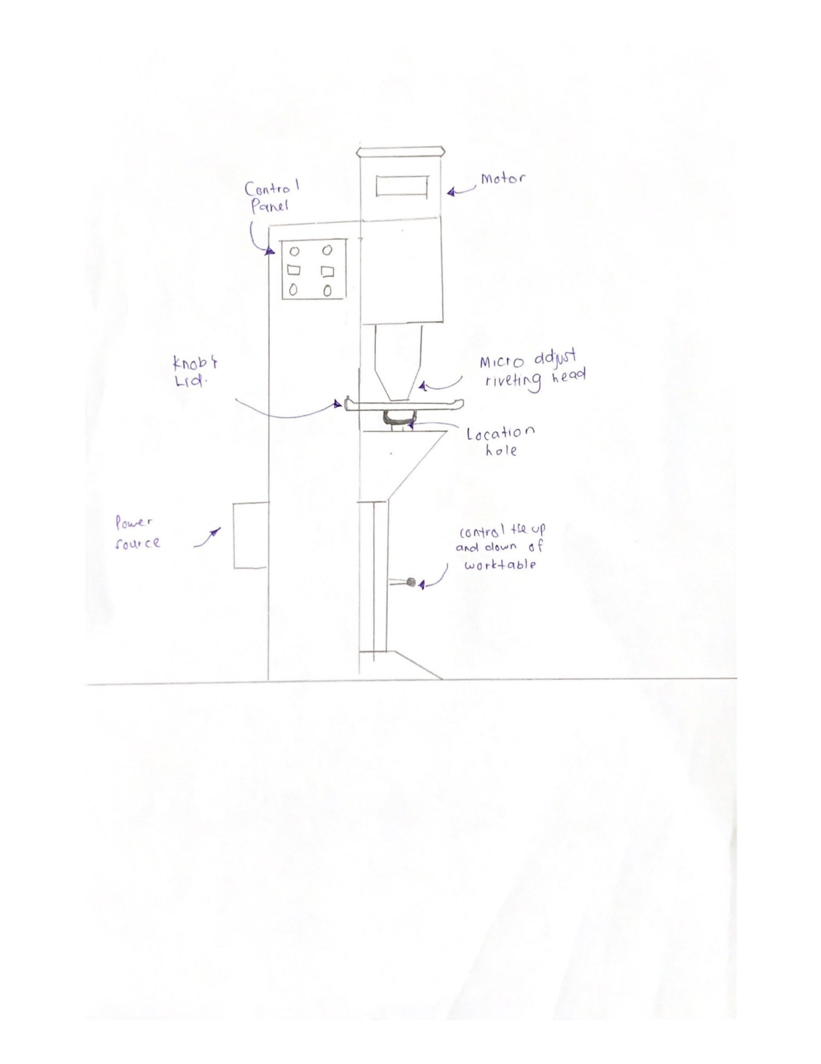

**FIGURE 18: HYDRAUCLIC RADIAL RIVETING MACHINE**

This machine is use to connect between knob and lid by using Hydraulic Radial Riveting Machine

# 5.0 CONCLUSION

In conclusion, the 3 main processes chosen to produce a rice cooker are casting process, polymer process and also the joining process. In casting process, cold chamber die casting was used to produce the cast of the lid, heating plate (outside component) and inner pot of the rice cooker. In polymer process, injection molding is used to produce the outer pot and the knob while in joining process, riveting is used to join the knob to the lid and the outer pot of the rice cooker.

The materials that are needed to produce rice cooker are aluminium, plastics, ceramics, rivet and wire. Aluminium is used to produce the lid and also the inner pot of the rice cooker while plastics are used to produce outer pot of the rice cooker, the knob and also the heating plate (outside component). Moreover, ceramics is used to coat the inner pot as ceramics is an efficient heat transfer and it is also known of its main properties which is non-stick component. Wire is use to install in the heating plate of the rice cooker to conduct electricity when cooking process and rivet is function to join the knob of the rice cooker to the lid and the outer pot of the rice cooker therefore it can be hold easily.

Batch production is chosen to produce our produce, rice cooker. The assumption of the batch quantity of the rice cooker is 500 units. The assumption cost of raw material of one unit of rice cooker is RM 45.48, while the total costs of the rice cooker which are 500 units are

RM 22,865.90.

# 6.0 REFERENCE

Batch Production and It’s Key Characteristics (2019). Retrieved from

[https://www.mbaknol.com/operations-management/batch-production-and-its-key-](https://www.mbaknol.com/operations-management/batch-production-and-its-key-characteristics/)

characteristics/

Chris K. (2014). What is casting? Retrieved from

[https://www.plasticsintl.com/blog/what-is- casting/](https://www.plasticsintl.com/blog/what-is-casting/)

Dominique C.D. (2019). Philips Electronics NV. Retrieved from

<https://www.britannica.com/topic/Philips-Electronics-NV>

EngineeringClicka (2018). Die Casting – design guide, materials, advantages and

disadvantages.Retrieved from <https://www.engineeringclicks.com/die-casting/>

Hallam (2019). Adantages and disadvantages of batch production. Retrieved from <https://www.lacconveyors.co.uk/advantages-and-disadvantages-of-batch-production/>

Hot chamber vs Cold Chamber (2016). Retrieved from

<https://diecasting.com/blog/2016/03/23/hot-chamber-vs-cold-chamber-die-casting/>

Marino, X. (2000). Polymer Processing. Science Direct. Retrieved from

https://www.sciencedirect.com/topics/materials-science/polymer-processing

Panasonic (2019). Retrieved from <https://en.wikipedia.org/wiki/Panasonic>

Richard, B. (2017). Appliance Science: How rice cookers cook rice without burning.

Retrieved from [https://www.cnet.com/news/appliance-science-how-rice-cookers-cook-](https://www.cnet.com/news/appliance-science-how-rice-cookers-cook-rice-without-burning/)

rice-without-burning/ .

Ryan (2003). Pop Riveting. Retrieved from

<http://www.technologystudent.com/joints/popriv1.htm>

Ryan (2015). Advantages and disadvantages of Injection Molding. Retrieved from

<https://designtekplastics.com/tips/disadvantages-and-advantages-of-injection-molding/>

Science Channel (2019). How Rice Are Made. Retrieved from

<https://www.youtube.com/watch?v=Vu4mfza1mz8>

Tefal (2019). Retrieved from <https://www.tefal.co.uk/about-tefal/our-history>

The history of rice cooker.(2019) Retrieved from [http://cookeradviser.com/the-history-of-](http://cookeradviser.com/the-history-of-rice-cooker/)

rice-cooker/.

What is a rice cooker? (2005). Retrieved from <https://www.nisbets.com.au/ricecookers>.

What is riveting and how does it work? (2019). Retrieved from

[https://www.twi- global.com/technical-knowledge/faqs/what-is-riveting](https://www.twi-global.com/technical-knowledge/faqs/what-is-riveting)

Why cooking on ceramic coated pans is good for wellness and wallets. (2019). Retrieved

from https://www.yuppiechef.com/spatula/why-cooking-on-ceramic-coated-pans-is-good-

for-wellness-and-wallets/

Zainal A.A. (2008). Manufacturing Process. Retrieved from

<http://www.fkm.utm.my/~zulkepli/?C-o-u-r-s-e-s/Manufacturing-Processes/Notes%2FSlides>

# 7.0 APPENDIX

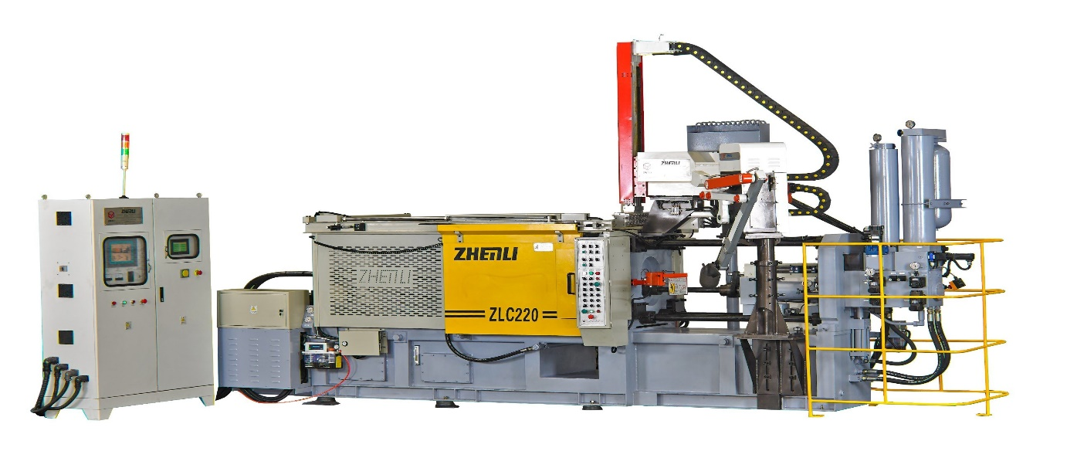

**FIGURE 19:COLD CHAMBER DIE CASTING MACHINE**

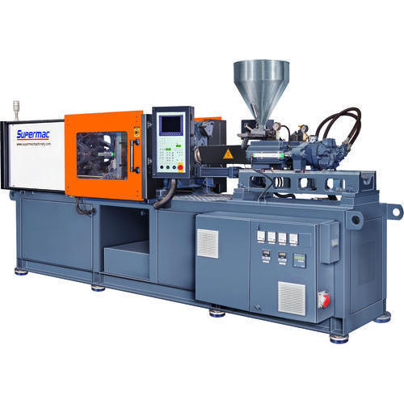

**FIGURE 20 : HYDRAULIC INJECTION MOLDING MACHINE**

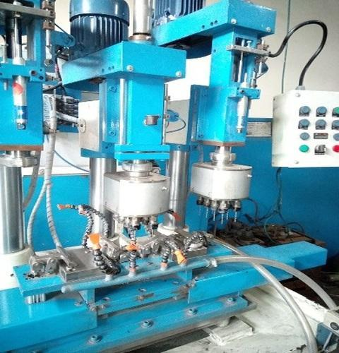

**FIGURE 21: AUTOMATED MULTI SPINDLE DRILLING MACHINE**

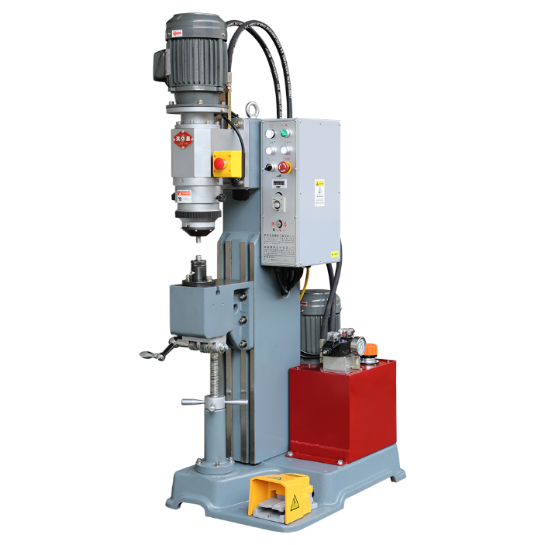

**FIGURE 22: HYDRAUCLIC RADIAL RIVETING MACHINE**

**PROTOTYPE**

Material needed in prototypes

1. Box
2. Manila Card
3. Glue
4. Scissor
5. Tape
6. Spray

How make a prototype

1. Making the rice cooker body frame by using a recycle box.
2. Cover the frame using manila card and attach by using a glue. The reason to cover it with manila card because to make it more beautiful.
3. After that, it is time to make the lid of the rice cooker. We use a box to make the lid and cut it based on the size of the rice cooker body and make sure it fits well.
4. We use the box to make a knob.
5. Last part is heating plate. We use the same concept to make the heating plate frame but it is smaller than rice cooker body.
6. We attach all the parts together using a glue and our prototype is done.

Estimation Cost for Prototype

|  |  |
| --- | --- |
| Material | RM |
| Manila Card | 6 |
| Spray | 7 |

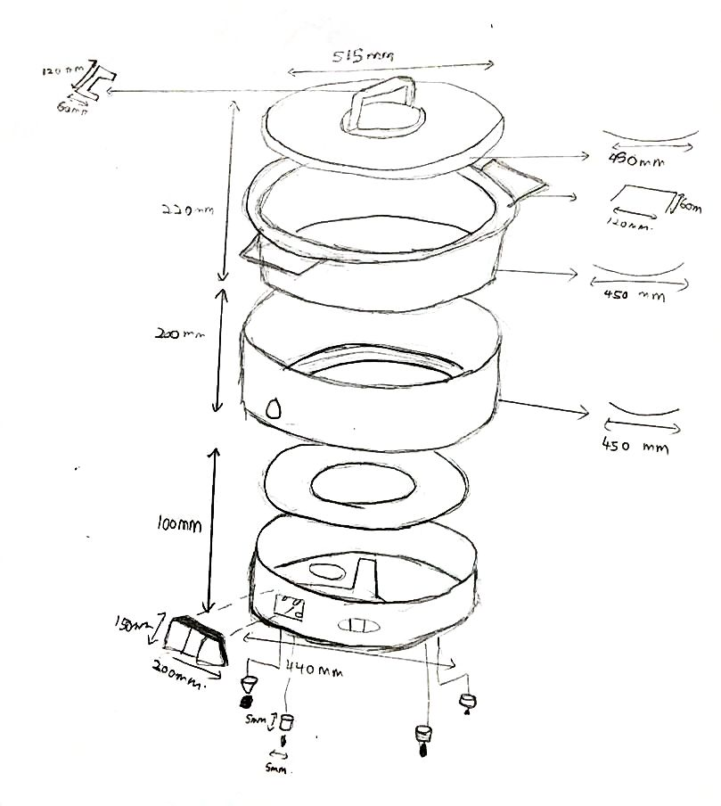

**FIGURE 23: DIMENSION OF THE PROTOTYPE**

**REFLECTION**

**LIM HUI YING (A17HA0076)**

Through this cornerstone project, I have learnt how to interact with these three subject which included Manfacturing Process, Supply Chain Management and Commercial Law together to operate a business. This integration can give me think about the “real world” to operate a business. In this cornerstone project, my group members and I are assist to produce a rice cooker. We are using 3 major processes to produce the rice cooker which includes casting process, polymer process and joining process. After that, we need to buy the raw material that we needed from the supplier. Raw material that we needed to produce rice cooker are plastics, ceramics, aluminium, wires and rivet. After finding and buying the raw material from the selected suppliers, we need to sign contract with the selected suppliers. With that, I not only can learn the concept of the subject on the syllabus but I can see my eyes how the real process of the business flow in simulation. Therefore I think that this cornerstone project is the best method to let students experience themselves in the flow of the business and I suggest that this program must be continued pass on to the students next year.