Report on GLOW(Global Online Workforce)

During the 24th of September 2018 on a Monday, almost all of the students from the School of Computing participated in an industrial talk about eRezeki and Global Online Workforce (GLOW). The talk about eRezeki and GLOW was organised by Malaysian Digital Economy Corporation (MDEC). The venue of the talk was held at N28a, School of Computing seminar hall. The talk lasted for about an hour and it started at 4:00pm sharp. The goal of this engaging talk was to inform students about how to generate income from online working platforms such as Freelancer. This because not many students are familiar with online working platforms and how they work. With this talk, students should have more awareness about these kinds of platforms and know how they can use them effectively in the future.

The industrial talk was handle by Nor Ashikin Binti Halil, who is one of the active members of GLOW. A little bit of information about her background, she has been a freelancer for years now. A freelancer is a person who pursue a profession without a long-term commitment to any one employer. As a freelancer , Nor Ashikin actively does jobs online such as being a translator, writer, virtual assistant, social media manager, voice over, graphic design and many more. Her hourly income is US35/hour, that is equivalent to RM145.00 an hour. Her total income for one year is approximately RM177,980.00 and she has been doing this for 3 years. She was able to achieve massive amounts of income in less than a decade with the help of online social platforms such as Freelancer.com. The speaker, Nor Ashikin was born in Skudai, Johor but she then moved to Kangkar Pulai which is also located in Johor, in the later years. She acquired her diploma certificate from Universiti Teknologi Mara (UITM) which is in Melaka. After awhile, she works as a freelancer and works online in various jobs.

Let’ talk about what is eRezeki. Based on the definitions given by the speaker and MDEC, eRezeki is an entrepreneurship program that enables, especially low-income groups such as students to generate income by doing digital assignments via online crowdsourcing platforms. The definition of crowdsourcing based on Google, the practice of obtaining needed service, ideas, or content by soliciting contributions from large group of people and especially from the online community rather than traditional employees or suppliers. Examples of online crowdsourcing platforms are Facebook, Airbnb, Freelancer, Amazon, Uber and etc. GLOW which is a another company that is under MDEC, also has the same goal. The main purpose of GLOW is to coach, mentor and nurture full time crowd workers that are able to consistently earn a stable digital income of at least RM2,000 a month. The program aims to generate fixed and stable digital income for Malaysians via crowdsourcing.  Crowdsourcing is the future as it enables digital works to be offered and delivered online. Currently, MDEC collaborates with some of the largest global crowdsourcing platforms such as Freelancer and Upwork. Through this program, MDEC aspires to train and nurture qualified apprentices to become successful and capable online freelancers in global platforms. The benefits of online jobs or GLOW overpowers the drawbacks as they are a lot of advantages that you can obtain. Most individuals joined GLOW or work as a freelancer is because of its flexible time and working environment. Furthermore, the advantages of enrolling yourself in this program is that you can generate side incomes without having the inconvenience of leaving your home as all the work can be done from the comforts of your desk. Speaking of working environments, you can choose where you want to work as long as you have a laptop and an internet connection. For students, they may want to do their work in public place such as the library, cafes and etc. If you are a type of person that shy with other people and can’t work in a team, you can just do your work in non-public places.

For over the years, MDEC has made a lot of initiative to attract people to join eRezeki and GLOW programs. The seminar and talk about Freelancer and GLOW were organised at various location all around Malaysia. Other than that, MDEC also collaborated with well-known international companies such as Freelancer and Upwork. MDEC also collaborated with local companies like Kerja Digital, 123RF, Dotcom Sdn Berhad, Supahands and Ezyspark to attract people to join this program. GLOW is open to anyone who wants to join but preferably people who are specialized in IT such as programming, website development, mobile apps development and etc. People who does not have these kinds of skill can also join as long as they are very committed and aspire to be a crowd worker with qualifications and skills in various disciplines. Unemployed graduates are advised to join these kinds of programs.

We are ever so close to approaching the Vision 2020 and although it is still so far away, we have already achieved many great things. We live in a world where we can find everything on the Internet. So I think that, online working platforms such as Freelancer will be the next best thing and will definitely bring a massive impact towards Malaysia. One of the impacts of this program towards our country is that it can reduce unemployment rates among postgraduates and will produce a group of high quality digital workers which will benefit the country. Other than that, this can provide alternative income Malaysia via multiple online platforms. Moreover, this support program can help Malaysian freelancers to remain motivated, driven and committed in earning enormous income via crowdsourcing platforms. In the near future, Malaysia might be recognize as the country with the most IT specialist in the world. Based on my observation on the industrial talk, my thoughts about it are, that it was an informative talk about GLOW and how it can help students especially undergraduates to gain income through online crowdsourcing platforms. Freelancer is the easiest online crowdsourcing platforms that students can use as told by the speaker, Nor Ashikin. Many of the students use Freelancer website to generate income by online means. Since I have been to the seminar on how to use Freelancer website which was conducted by Nor Ashikin herself, I had a bit more of understanding of the platform. Not only will freelancing help students get clean income but, it can also help hone their soft skills as well as help to become discipline and independent workers by having to complete the digital work within the given time and requirements by the employers. In my opinion, every students including computer science students should enter this program as it is very easy to follow and the program provides guidance and mentoring sessions. I’m also hoping that the program will evolve actively and successfully to attain all of their achievements until it can compete with other global programs.

Pictures taken from the talk

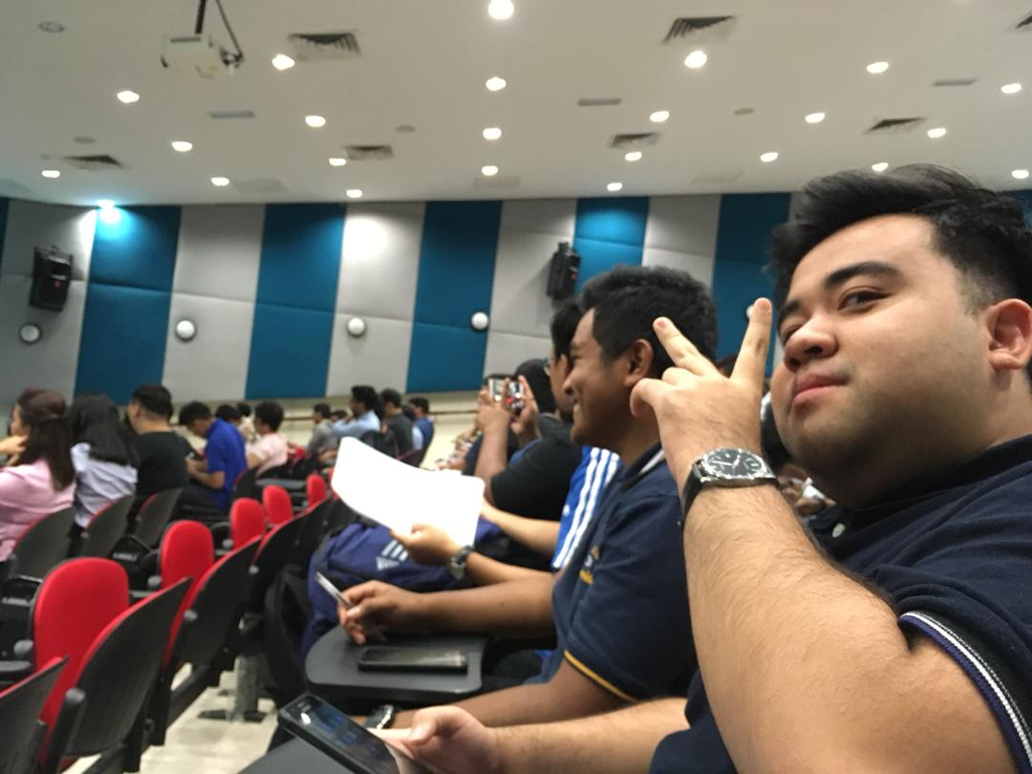

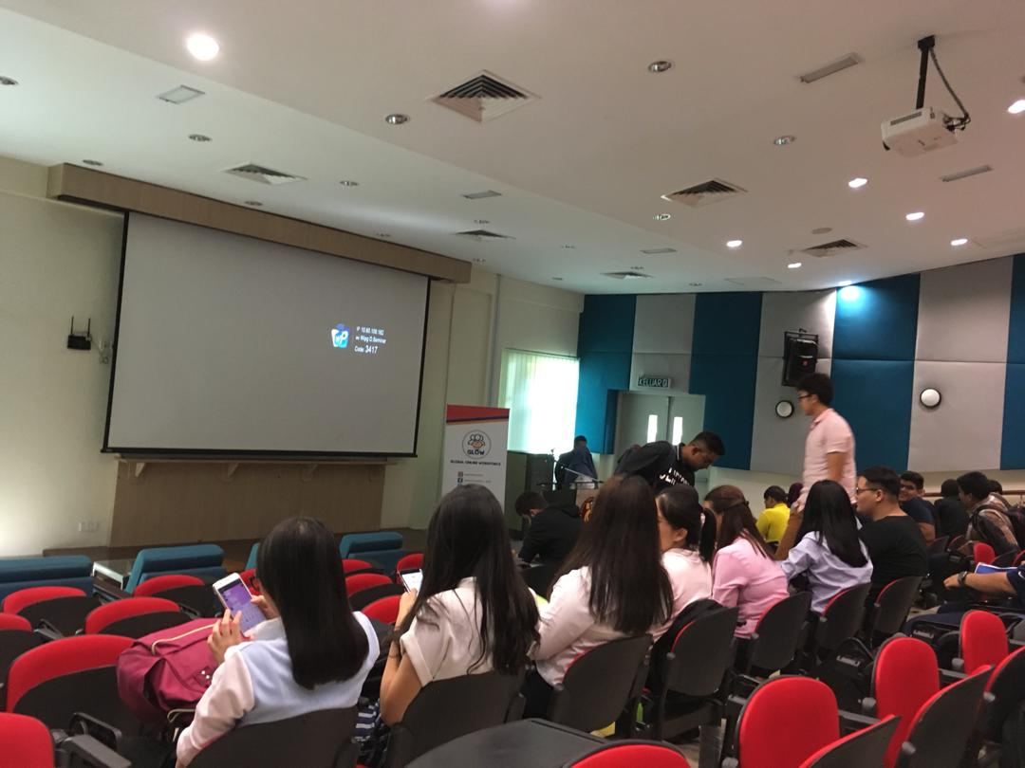

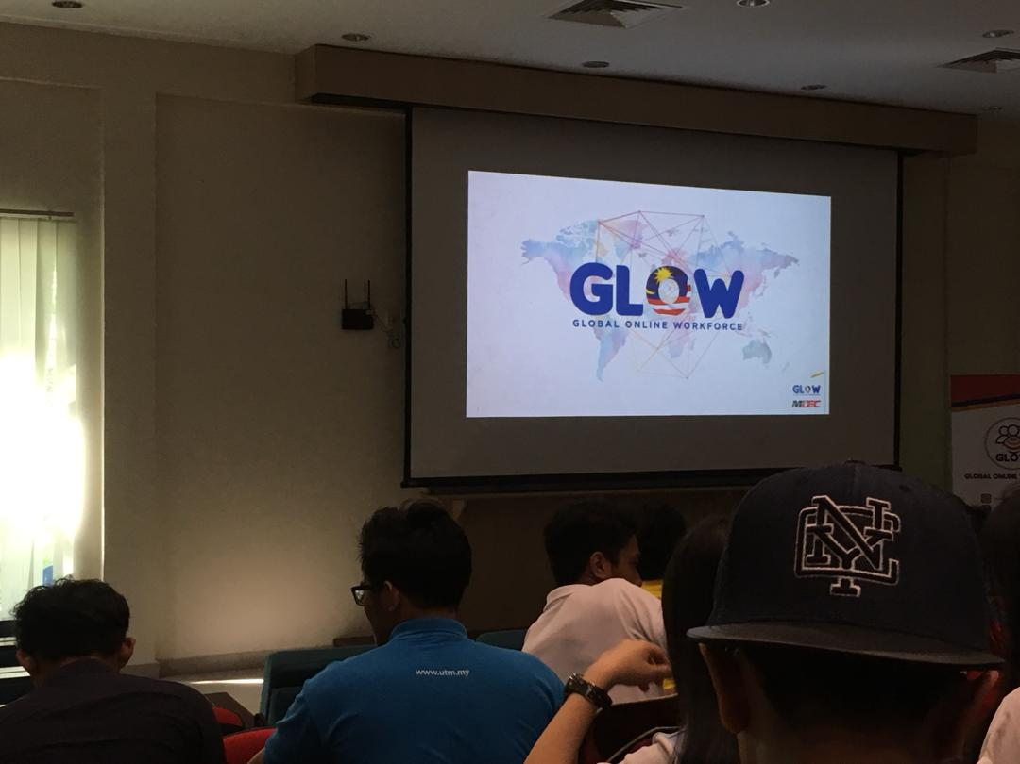 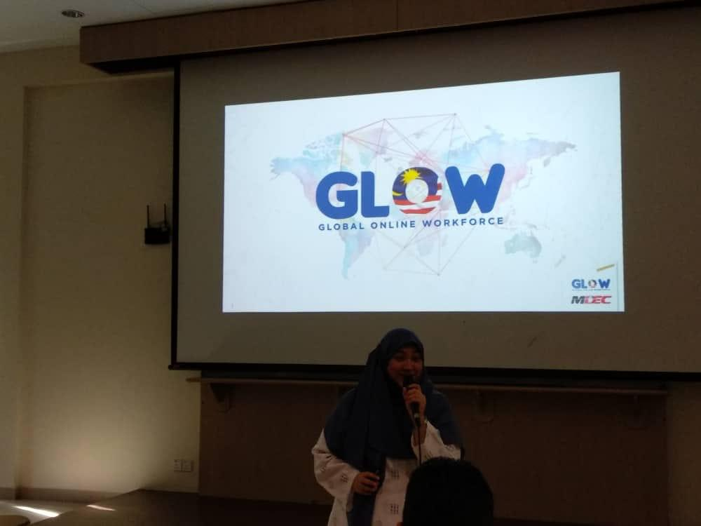

Pictures from the GLOW seminar

