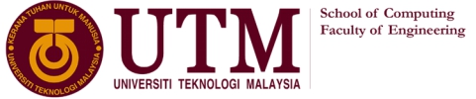

TECHNOLOGY AND INFORMATION SYSTEM  
SECP1513 – SECTION 7

INDUSTRIAL VISIT  
PERPUSTAKAAN SULTANAH ZANARIAH

(CICT / PSZ) UTM

LECTURER: DR. SARINA BINTI SULAIMAN

|  |  |  |
| --- | --- | --- |
| NO | NAME | MATRIC NUMBER |
| 1 | PG. KHAIRIL QAYYIZ BIN PG PUTRA | A19EC0147 |
| 2 | ELMIRA AKMA BINTI RAMAN | A19EC0042 |
| 3 | LIM CHIN QING | A19EC0071 |
| 4 | ILIMBEK ISMANOV | A19EC4029 |

**Introduction**

On 20th of October 2019, our section had a visit to Sultanah Zanariah University Technology Malaysia library for the Center for Information and Communication Technology since the CICT was been transferred to PSZ UTM. CICT is one of the central unit that store the data of all students and all staff in UTM, without CICT, the program, the UTM server as well as the facilities in UTM will not be able to function. Basically, the data will be stored in mainframe which it is secured by the CICT staff so that there will be no hacker hack all the data store by CICT. As a student of Graphic and Multimedia Software, we should be aware of this since we are learning the programming so literally student of computing is the person should know all this stuff. We have been exposed to the introduction of CICT how they work with all data for every student and staff in UTM. Furthermore, the representative of CICT also show us how the technology changed from time to time due to our economics financial, such as from a thick PC it change only to a small and thin PC same goes to a communication which is from a public phone, then to a home one after that become a cellphone and nowadays use a smartphone. Therefore, the representative told us to be grateful for what we have nowadays because during his era they are very difficult to communicate and uses of technology so as a student we should know how difficult the CICT to store all data in the CICT.

**History of camera process**

The camera process was manufactured by Hunter Penrose Ltd.,a company which based in the United Kingdom where thousand of these devices were sold worldwide in 1890 until 1962.The camera in CICT was a gift from the Department of Survey and Mapping Malaysia (JUPEM) was used since the British colonial. The initial model is fully mechanical and it has been used to facilitate students in understanding the principles and procedures of photograpghy production.It is KLIMCH ‘horizontal process camera’ and was used in the Cartography Department, Faculty of Surveying during early 1980s.The students who undertook land surveying course drew map sketches on papers or tracing papers using technical pens to produce maps and graphics in a conventional method.

**History of mainframes**

Mainframe computers, also known as mainframes are computers used primarily by large organisations for critical applications, specifically in data processing. It is generally known by its huge size, amount of storage, processing power and high level of reliability. Most of the mainframes are able to run multiple operating systems. It has the ability to add or hot swap system capacity without disruption. Moreover, mainframes are designed to handle very high volume input and output (I/O) and emphasize throughput computing. A single mainframe can replace dozens or even hundreds of smaller servers.

Mainframe computers were created in the early 1940s. Initially, mainframe computers were bulky machines that required cooling-sensitive rooms. IBM was one of the first manufacturers of mainframes. Later, it continues to design and develop complex systems used in many businesses and organizations. Even though personal computers are more commonly used by the masses, mainframes are still an important behind-the-scenes aspect of major businesses.

During the visit to Center for Information and Communication Technology (CICT) UTM, we found out that the usage of Mainframe System at UTM began in the 1970s at Computer Centre, UTM campus, Kuala Lumpur. It served as a data control of students and staff information. Besides that, it has been used for almost 20 years for various components and functions such as processing, storing, securing and printing the University’s information data.

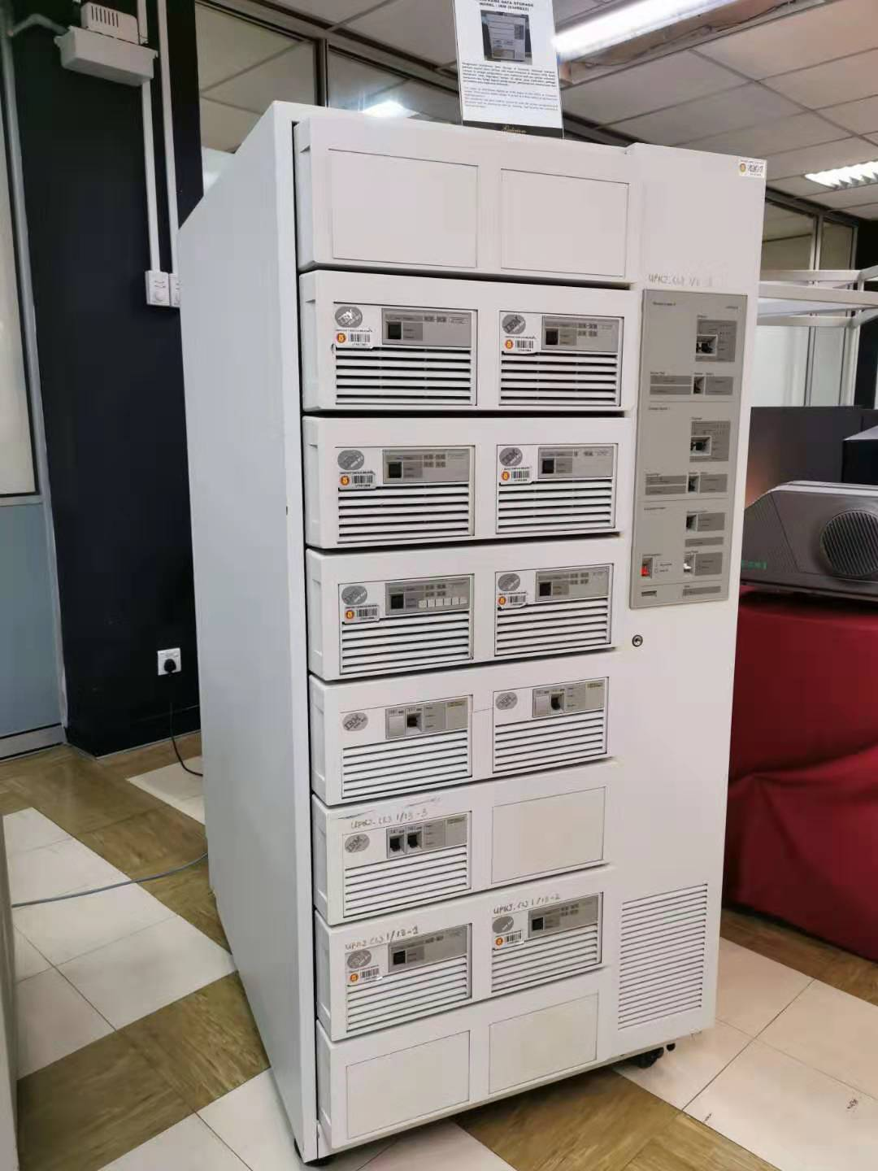

▲ Mainframe Data Storage

Model : IBM (9345B22)

Apart from that, there is also Mainframe Tape Subsystem which was used as a ‘back up’ for mainframe system and information database of staff and students as well as other University’s information system during the year 1987 until 1995. This model used a square shape tape after the round shape tape was no longer in use.

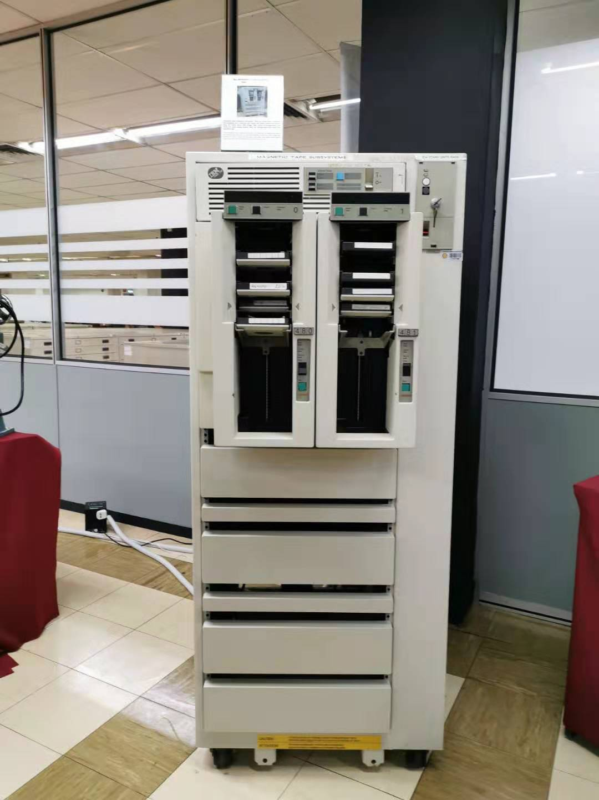

▲ Mainframe Tape Subsystem

Model : IBM 9309

**History of Supercomputer**

The history of supercomputing goes back to the early 1920s in the United States with the IBM tabulators at Columbia University and series of computers at Control Data Corporation (CDC),designed by Seymour Cray to use innovative designs and parallelism to achieve superior computional peak performance.

**History of Memory Disk**

We have a lot of type of memory disk,so for example The first hard disk drive was the IBM Model 350 Disk File that came with the IBM 305 RAMAC computer in 1956. It had 50 24-inch discs with a total storage capacity of 5 million characters (just under 5 MB).Next is floppy disk, The diskette, or floppy disk (named so because they were flexible), was invented by IBM and in common use from the mid-1970s to the late 1990s. The first floppy disks were 8 inches, and later in came 5.25 and 3.5-inch formats. The first floppy disk, introduced in 1971, had a capacity of 79.7 kB, and was read-only. A read-write version came a year later. So basically these two disk is the memory disk that usually use in computer or PC.

**Camera process**

So for camera process is use as one of the technology, so in CICT they provide a camera process to show us how it works based on a QR code that they provide but only in Malaysia, this camera was distributed around the world in 1890 so UTM get this camera from Faculty of Geoinformation and Property in 2009. This camera had to stop distributed around the world in 2004 due to more advance technology around the world. So this camera became popular during the first era when UTM was opened, it become a gimmick when the opening of ‘Galeria of UTM’. So when the CICT receive this camera that had to conserve it so that this camera will be prolong to show to other students in UTM. It took 6 month for them to conserve this camera so that it will not be broken for a long time and still can be used. Nowadays we used other technology to snap a picture and this camera process no longer use but we still need to appreciate people who invented it.

**Reflection**

Basically technology and communication must come along together and both of it are very useful for our daily life without technology there’s no way a communication among us to contact if something happen. As we can see technology and communication become more advance from year to year, from without internet until we can access internet, some of us use the technology given wisely some maybe not that’s why from the CICT visit we learn that how difficult our old generation to communicate and use the technology for daily life compare to nowadays, they need to use a very small storage memory disk to store an information compare to us a z-generation. They need to have a lot of expertise in computer to repair of something happen to their computer, but the challenge is they need to think about the cost to learn differ from us a young child also can fix the problem happen only watch a video on youtube.so in conclusion we should be grateful for what we have, how easy we communicate and use it wisely

**References**

<http://library.utm.my/utmgallerium/galerium-utm/>

<https://royal.pingdom.com/the-history-of-computer-data-storage-in-pictures/>

<https://en.wikipedia.org/wiki/Supercomputer>

**GROUP PHOTO**

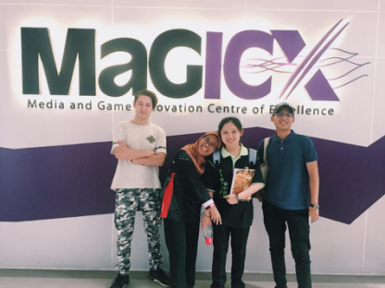

From left : Ilimbek Ismanov(Greg), Elmira Akma, Lim Chin Qhing, PG. Khairil Qayyiz

**GROUP MEMBERS**

|  |  |
| --- | --- |
| C:\Users\user\AppData\Local\Temp\ksohtml\wpsFD7D.tmp.jpg | PG. KHAIRIL QAYYIZ BIN PG PUTRA  MEMORY DISK  REFLECTION |
| C:\Users\user\AppData\Local\Temp\ksohtml\wpsFD8D.tmp.jpg | ELMIRA AKMA BINTI RAMAN  INTRODUCTION  CAMERA |
| C:\Users\user\AppData\Local\Temp\ksohtml\wpsFD8E.tmp.jpg | LIM CHIN QING  MAINFRAME COMPUTERS |
| **C:\Users\user\AppData\Local\Temp\ksohtml\wpsFD8F.tmp.png** | ILIMBEK ISMANOV  SUPERCOMPUTER |