ROBOTS AND DRONES

- Latest trend in research or in the market

IrDeena

There have been many types of robots created since a long time ago. Nowadays, the newest trend in robots interface is that there already exist household or domestic robots. In line with the name, this kind of robot has a main purpose which is to help humans, especially the old people, handicapped or people with limited strength do daily house chores. For instance, sweeping the floor, gardening, doing the dishes and even preparing their meals. It is undeniable that robots have somehow become humans’ friends or peers as most of the time robots have helped humans carry out their daily tasks more than a human has helped other humans.

Yuan

One of the latest trends in research of robots is humans trying to create robots that imitate the physical structure of animals. This is because animals always have capabilities or abilities that are very helpful to human’s life , especially in hazardous settings. And all these abilities of animals come from their physical structure. Let's take an example, snake. Snake has a slim, thin and long body shape. Its body shape allows it to go through small and narrow spaces. So if we build a robot that imitates the physical structure of a snake. It will be useful in rescuing victims of disasters like earthquakes. Through the media, we know that in disaster like earthquakes, many victims will be trapped inside the fallen concrete. The fallen concrete makes the rescue team very difficult in searching for and rescuing survivors. So, if we have snake-shaped robots. The robots can enter the area of falen concrete and help the rescue team to search for survivors. It also helps the rescue team observe the environment first before deciding how to rescue the survivors. So, a robot in the form of animals is very helpful and it is a trend in robotic research now. There are robots that imitate fish, insects, birds etc. All these animal robots are designed to help humans in hazardous settings.

Shasither
It is very clear that drone technology development will reach its next phase and will play a major role in technology development in the coming years. The usability of drones is being expanded to various major fields as part of the utilization of unmanned aircraft to carry out many dangerous and hard tasks. Focussing on the latest trends of drone technology development in the market, one of the hot topics will be the urban traffic management. NASA is currently leading the research in integrating drones efficiently into air traffic. The drone traffic management system coordinates the drone flight permissions and drone flight conflicts. This will help to maintain a safer airspace for other airborne transportations by exchanging data and airspace status such as weather and traffic congestion which will allow the drone operators to properly plan their flight. This development will surely improve air traffic management and solves most of the problems which acts as barriers for drone technology development in the past.
Apart from that, drones are also being utilised in the medical services and disaster relief operations. Unmanned aerial vehicles can access remote areas where the rescuers do not have enough access to. This will greatly help the rescue team to initiate rescue operations once the area has been confirmed to have survivors. In the case of emergency, drones act as the telecommunications and surveillance hub for the authorities to monitor and make decisions on rescue operations. This is because, drones can be used to monitor the effected areas to understand the severity of the disaster, number of effected people and how to effectively operate the rescue mission as well as to coordinate the delivery of emergency services. Take for example the current COVID-19 pandemic situation, drones are used to spray disinfectants in highly contagious areas without the presence of medical personnel which greatly reduces the possibility of the virus spread.
The next big thing about drones are their contribution towards conservation. Apart from monitoring wildfires in forests and remote areas, drones are currently being deployed for wildlife population monitoring. The growing issue of wildlife extinction is being countered with drone technology in wildlife count. The purpose is to identify the severity of the extinction of a specific species and take necessary initiatives for its conservation. With this, we could also better understand the wildlife ecosystem and able to protect it. The further development in drones sees its ability to survey the animals that are hidden within their complex habitats without much of the human effort. On the other hand, drones are also being deployed for surveillance to protect endangered species from poachers and potential threats. This is a timely innovation that will be further developed to be utilised for wildlife protection and conservation.
Hazeeq
- Robot team-up with human in companies
This generation, we expect to see partnerships and ‘the next phase’ as end customers take their automation projects to new levels. The robot revolution in manufacturing and this means things like mobile robot companies teaming up with piece-picking systems, or gripper companies teaming up to create new robot applications in manufacturing. For example, once a robot is able to successfully retrieve and move an item from the warehouse to a packing station, another robot then takes over and grabs the item to pack it or assist workers with the next step. Success will be found by robot companies teaming up with each other on this, rather than trying to build it themselves. These manufacturing robots have many different types from handling pesky tape dispensers to the robot that do dangerous things like welding car parts. The advantage that humans get from this innovation in the manufacturing industry is robots can finish their tasks faster than human workers and save more money from giving salary to human workers as robots don't need salary. Logically, robots don’t need health benefits, vacation or even sleep for that matter.
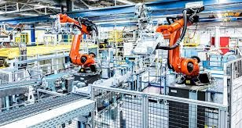
- Self-driving machine that controlled desired locations
Nowadays many companies are trying to bring self-driving cars or machines to the masses. Self-driving vehicles will be seen in last-mile delivery scenarios such as NURO the most self-driving cars are designed to carry people also known as diminutive bot. It can deliver groceries or pizza to people’s homes rather than any personal vehicle for purchase or even a ride-sharing system that gets a large-scale deployment. It’s electric-powered with a battery system designed to last all day without a recharge. The vehicle has two main compartments which can hold six groceries bags. How does this NURO do their job? A person in the delivery area will have to order grocery that they want via NURO app then after staff stock a NURO vehicle with the goods, the car will set off for the customer’s house. The best feature is when the bot arrives at the destination NURO only opens the cargo door that accesses only their own groceries. Delays in regulations, expensive components, and weather situations will all likely continue to prevent the tipping point for this industry in 2020.
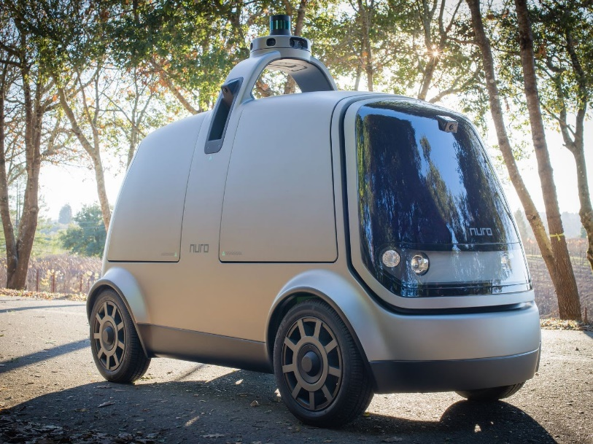

- Drone for Agricultural
This trend was recently used for research carried out by University of Nairobi, University of Missouri. Researchers claimed that those drones can identify 14 different varieties of potatoes in the field through drone-based remote sensors. This innovation has been hailed as ground-breaking by agricultural researchers because it is cheaper and allows scientists to analyse large scale projects without the use of satellites. Drones can point out the crops on scarce areas which can help in mapping out irrigation schemes instead of analysing one crop at a time in a large area. Drones allow farmers to constantly monitor the crop and livestock conditions by air to quickly find problems rather than in ground-level spot checks manually. For example, a farmer would be able to find through time-lapse drone images that part of his crop is not being properly irrigated. There is a feature in brand new drones called mapping. Many newer agricultural drone models come equipped with flight planning software.Its allows the user to draw around the area he or she needs to cover. Then, the software makes an automated flight path that even prepares the camera shots. So that people can do multiple tasks at one time to be more productive with their job. Next, some of these drones also can be able to spray crops with fertilizer and pesticides which is far more precision and economic than a traditional tractor as it is super-intelligent and reduces the release of carbon dioxide in the air.
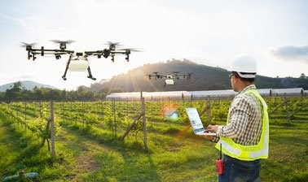

Jing Yi
Drones are flying cameras or they can be flying weapons. According to Global “Drones Market” research report 2020, the unmanned aerial vehicle (UAV) market focuses on the growth opportunities, which will help the Drones market to expand operations in the existing markets.
Trend in drones market 2020-2022
Drone technology will be used in aerospace manufacturing because the Drone Aerial Vehicle (UAV) permitted DJI (technology company in China) to garner $ 1 billion in revenue in 2015. The worldwide market for drones is $6.8 billion anticipated to reach $36.9 billion by 2022.

Main design of drones is based on
· Portability
· Simplicity
· Modularity
· Customizability

Cleo drone is the doughnut-shaped portable drone that can directly slip inside our pocket. It uses LIDAR technology and UAV design. We can control it using apps on smartphone.

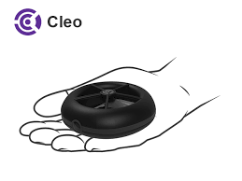

Plexidrone is a based robotic start-up and it can be fit into a backpack when disassembled. Of course, we can fix a Go-Pro onto it to make it a flying camera.
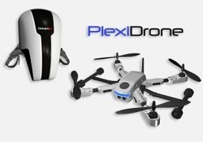

In terms of simplicity, Lily is a simple throw-and-shoot camera. Lily does not have a controller, we just throw Lily in the air to start a new video and it will follow you based on a GPS signalling device on the user’s waist.
Speaking of customizability, FLYBi combines the latest VR technology and features and it is the first drone with virtual reality goggles. Moreover, we can share live footage from the drone via FLYBi VR app.

- Main design and research issues

Idreena

One of the main issues regarding robots and drones is that they are said to be morally unethical if the design of robots enable them to manifest human-like or animal-like manners and etiquette. For instance, the ability of them to communicate like a human-being or the ability to walk on toes, just like some kind of animals. Not only that, robots that are built will usually have the exact representation of every humans’ or animals’ parts of the body. For example, they have a pair of legs, hands, eyes and a mouth, just like us humans and sometimes they also have a tail which is the same as animals’. This issue makes the design of robots controversial as it is debatable as to whether or not such interfaces should be encouraged. It is also arguable as to whether the robots should really be constructed likely to be living things; humans or animals, or should they be created to look like robots, as what they are supposed to be originally. The doubt also applies to the design of their interaction as it is uncertain as to whether the interactions should be designed so that it can communicate as if it were a human-being just like us which includes the ability to talk and express emotions, for example smiling and laughing when they are happy, or should they only be limited to execute tasks when humans give them instructions by implementing human-computer interaction, for example pressing buttons on the robots.

Yuan

In my opinion, one of the main issues of robots and drones also includes the material it made from. Try to imagine if we build a robot that is the same size as a human, but full of high density material like steel. Although The robot has a very strong structure, it is very heavy at the same time. Let's say a normal human adult has 60 to 70 kg, then a robot adult that is made from steel is going to weigh like 130kg. What is going to happen if it falls down accidentally some day. First, no one is able to lift him up without the help of tools. Second, its fall is destructive.Third, what if it falls down on a human and maybe a kid, this is going to be a tragedy. Besides, such a heavy robot is very energy-efficient in many ways (the amount of power to drive it, when we are transporting it, etc) too. So, this issue is very important as it may affect the living of humans, it might even endanger the safety of humans. So, we should try to think about this and try to build a robot from light and soft materials. So, this light and soft robot is very safe. We can easily lift it up if it falls down and it won't hurt humans accidentally. Besides, it is very energy-efficient due to its light weight.
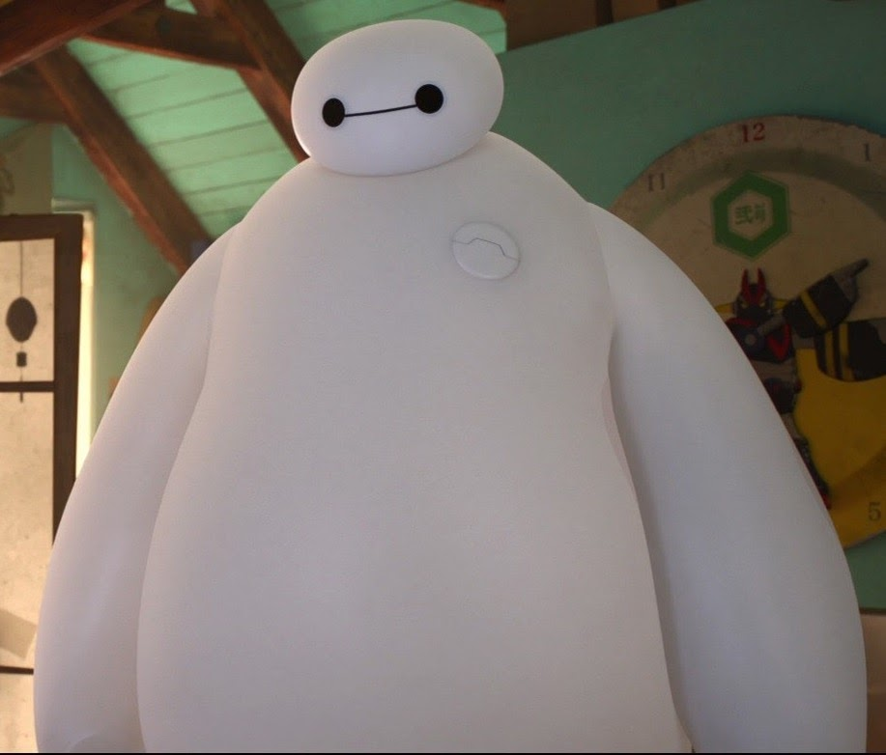

Shasither
The major threat with drone technology is that is can deployed as weaponized drones invoking drone terrorism as part of the global weapon war. Drone attacks will soon be a possibility according to defence authorities. Drones could potentially be used for impermissible surveillance by the terrorist groups without the knowledge of others to plan and execute their terrorist attacks. The use of unmanned aerial vehicles for attack can be vulnerable since the effect will solely be on the target group without any damage to the executant. It is vital to begin planning counterterrorism on how to respond to the potential threat. This includes detection of potential threats and counter-measures through defence training against the attack by weaponized drones. Besides, government regulations should be further improved with the implementation of comprehensive laws and policies for the drone operations to combat the threat of drone terrorism
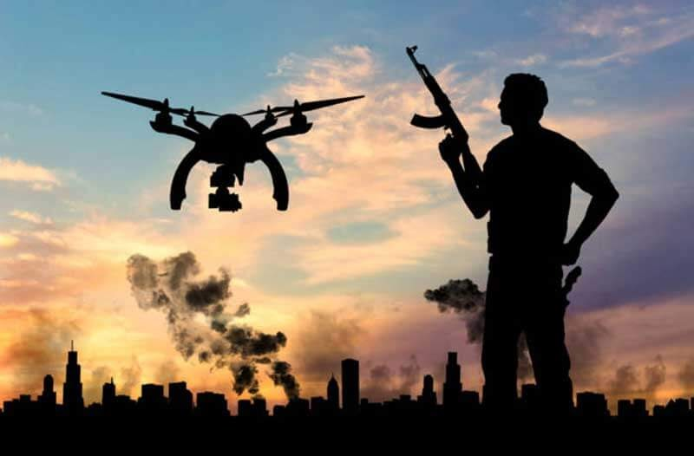

Hazeeq
The main issue of replacing human workers with robots will make more people lose their jobs. There is no denying that robots and automation are increasingly part of our daily lives. The rise of robots has led to some scary warnings about the future of work as robots are able to do everything better than humans. Some people argue that automation will ultimately create new jobs as someone has to program the robots. Besides, it is hard to imagine that robots could replicate human characteristics, like empathy or compassion that are required in many jobs. Would you feel comfortable if the robot is as a doctor, babysitter or teacher? Robots don’t take our jobs entirely, research shows that they will significantly change day-to-day tasks in the workplace. After all, this might be particularly a problem for lower-skilled workers who are not able to retrain for a new job.
The main issue of self-driving robots or machines such as NURO, it has its own risk as some strangers can try to steal the groceries, food or all other stuff in the compartment. But be careful, if some people try to steal the things inside a self-driving vehicle, they should think that they will get more attention when they act like that in public this will make more safety as NURO vehicles were programmed to choose maps using “big road” or highway and literally the public areas. Although it is very well-protected plus the built-in security camera, it still has a small chance for people who don’t even care if they are acting to damage or smash hardly to the robot in public. At the end there would be another issue if NURO customers didn’t receive or delay what they ordered before.
Drone can still be a threat to public safety, nowadays researchers are aiming to set up open drone database to help design radar systems or any detection system technique to prevent violence and crime in society

VR + Robots & Drones
In our opinion, we believe that VR will be very useful in Robots and Drones. And based on what Fansuri’s group discussed, we feel even more that VR can be integrated with Robots & Drones

Hazeeq
Using Virtual Reality (VR) to control Drones or Robots is a very amazing feature, when you are triggered to explore new things, go to an extreme location but you also want to stay safe and so this VR is the best solution as it can enhance your exploring activity. Basically, when we have the drones in the air, we can have an option to toggle the Virtual Reality. Immersive and vertical view is controlled by our movement of head and the way we look.
Robots with VR features can be used in extreme jobs. Military or policies can use this innovation to help their task to stop crime, fighting or even war. These robots that control VR can reduce the number of deaths of the world frontliner team such as policies, soldiers, and doctors. They can replace those frontliner teams if they are in unsafe condition to protect their lives that are in danger.
This is because robots and drones don’t have souls and expressions so if they crash or break, humans can fix them up or make new one to replace them but humans cannot be replaced as they also have family, friends and their own lives.
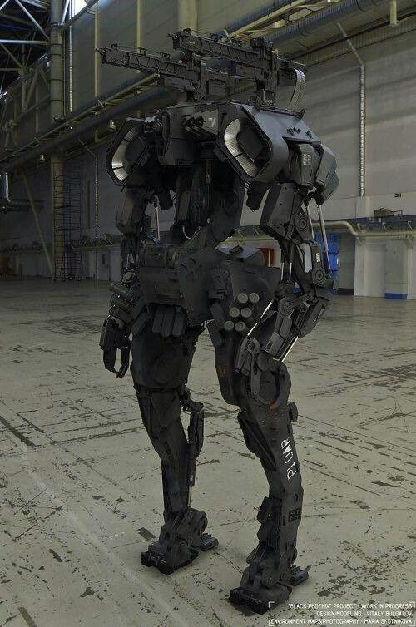

Jing Yi
Drones can be combined with virtual reality (VR) headsets to form a drone VR system that is a powerful combination nowadays. This combination will enhance user experiences in a modern way compared to the traditional way. There is a flight controller, VR goggle, a drone with camera and wireless communication devices in this system. Users can add more 2D and 3D features on the timely-received images from the real scenes to provide a real and challenging scene. The camera of the drone will synchronize with the movement of the user’s head and it can be rotated 360 degrees. For example, the user will feel like they are in a real flight by using the drone VR system as the user can see the real sky when the video captured by the drone is sent back to the VR goggle. During a flight training, the pilot will experience the real view when 3D features are adding to the drone VR system. In order to train the pilots, more challenges could be added like adding some obstacles. It is like physically flying in the sky and going through the clouds. By using this system, a safe virtual environment is created and the training pilots could be secured else at the same time, they will gain new experiences.
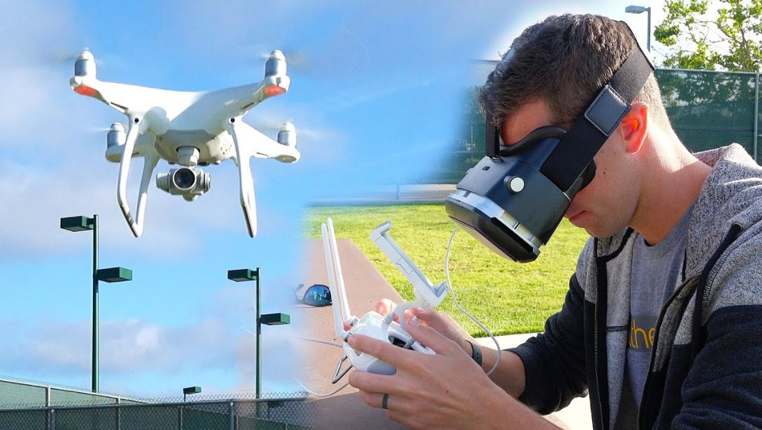

Yuan

Control Robots & Drones with VR
Like what Hazeeq mentioned, using VR to control robots is a very brilliant idea. We, humankind, have developed many ways to explore space or extreme environments like volcanoes and the deep sea. One of the ways is Robots and Drones. Then, why use VR in controlling robots & drones. This is because VR has highly stimulated the real-world environment, it displayed all the things and events that happen at where the robots are. So, we humans can know the real-time situation and can decide the next action of the robots accurately.
If we use Motion and Gesture in controlling robots, then VR will help a lot in the controlling of robots too. Because VR has stimulated the real world condition, we can directly give feedback or response in VR by using motion and gesture
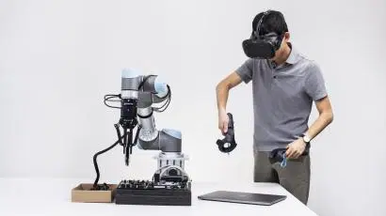

VR can be helpful in Robotic Training (Machine Learning)
Before we can have an AI robot, we need to let the robots undergo lots of training. For example, we need to let them go through object detection training, human activity detection training, motion detection training etc. If we use the real world object and human to train the robot, the process is going to cost a lot and time-consuming at the same time. So, it is better for us to create a Virtual Reality Environment that highly imitates how the real world looks like, the result of training robots in VR will be the same as we train it in Reality. For example, we can trai the robot picking up and putting down objects in a VR first. This is not just an idea, many companies and research teams have practiced this method in training their AI Robots. For example, that is how Tesla and Elon Musks train their self-driving car AI. They train the AI and let it drive a car model in VR before letting it drive a real car in the city. In this way, the company can save a lot of cost and effect in collecting data and real-world objects.
Besides, this is not the only way to train robots by using AI. I have read an interesting article before, a group of researchers, they aim to train a robot to shake hands with humans and hold objects with a precise and correct strength (so the robot won't hurt humans or break the objects accidentally). So what they did is, they let humans control the robot in VR, then synchronised the human's action with the robot's actions. When the human shakes hands or holds objects, the robot will record the strength used by the human controller to shake hands and hold objects. Next time, the robot can refer to the data it collected and shake hands or hold objects with the right strength.
I believe training robots with VR is a good method. This method can save cost, reduce the effort required and maintain safety at the same time. This is because some tasks of the robot are too dangerous to conduct if it is not probably trained before. For example, like Tesla’ self-driving car. If the AI of the self-driving car is not probably trained in VR before and the training process in the real world has gone out of control, it might hurt people or cause destruction accidentally. Another example is military or rescue robots that are used in hazardous settings, if we train it probably in VR first, they have more chance and time for training. So it can conduct its tasks efficiently in hazardous settings.

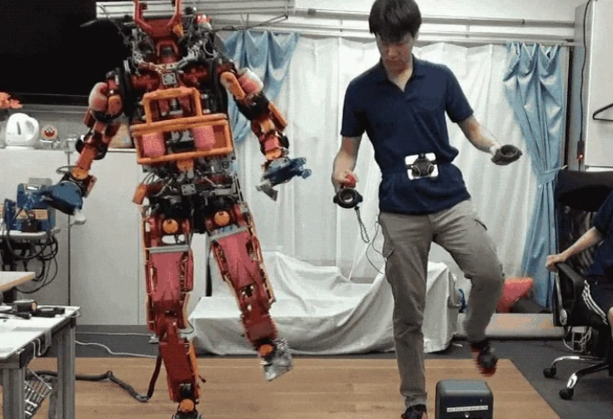

Irdeena

Virtual Reality is an interface that is able to provide an illusory environment where people will feel as if they are inside it or part of it. This makes Virtual Reality have the ability to work together with robots as people can make use of robots by utilising the instinctual Virtual Reality, remotely. By combining both Virtual Reality and robots, various sectors of industries will receive the benefits of it.
One of the sectors is healthcare. It is undeniable that some healthcare facilities around the world have already started to use robots to help them complete daily tasks, most importantly surgeries. As mentioned before, with a Virtual Reality headset, the user who wears it can feel like they are inside a robot's head. The user can also control the robot by matching their movements to the robot's using only gestures. This system can eventually enable the user to control the robot even though they are far away in distance. This means that it would be no problem if doctors and surgeons have to work from home as they can still perform their daily surgeries as usual. The only difference is that they will be using robots and control them with Virtual Reality from home. Other than that, combining robots with Virtual Reality will be useful for training medical students. This is because they can experience performing real surgeries for various diseases or medical complications on virtual patients. This will help them to easily understand about the surgery process and assist them to memorise it faster.
.

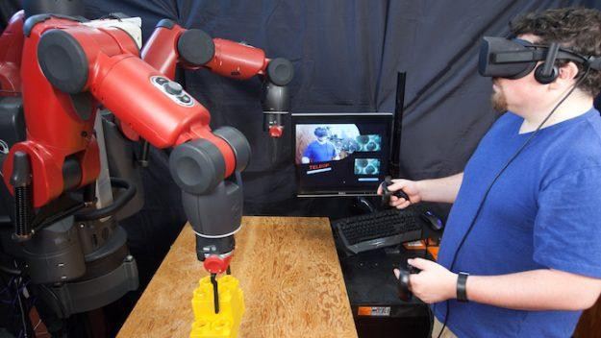
Shasither
The integration of VR with drones will lead to endless possibilities in technological development as it could provide vision in various dimensions that is impossible with humans’ physical abilities. Getting a bird’s eye view from high up in the air through VR goggles and controlling the movement of the drone camera by just turning your head while simultaneously seeing whatever the drone camera sees could be utilized to the advantage in many different fields. For instance, this combination will greatly enhance the inspection industry whereby one just has to put on a VR set and use a drone to inspect the region. With this, the need to manually travel all over the site can be completely eliminated while saving the time and energy. Besides, the incorporation of VR and drone technology in broadcasting live sporting events will provide the next level of viewing experience for the viewers.
Integrating VR with robots, especially the bomb disposal robots are also a major uplift in the technological revolution. Although bomb disposal robots are already around for quite some time, integrating Virtual Reality (VR) technology in this kind of robots could be a great help in the highly dangerous work task. The growing concerns of a highly complex bomb setup has increased the difficulty to dispose of it. Adding to it, the inefficiency in detecting explosives in a limited time period is also a great challenge. These problems could be solved with the presence of VR technology in robots deployed for bomb disposals. VR is the key to bring the bomb disposal expert into the action without putting themselves in any harmful scenarios. The integration will greatly benefit to improve the efficiency in disposing highly complex threats. On the other hand, this technology can also be seen as a way to train the professionals for the hazardous scenarios in the most effective way which is by indulging them in the virtual environment.

