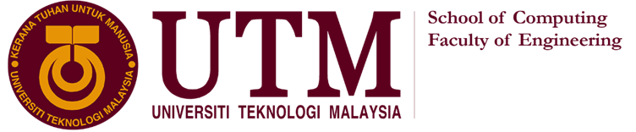

TECHNOLOGY AND INFORMATION SYSTEM  
SECP1513 – SECTION 7

INDUSTRIAL VISIT  
CICT GALLERIUM   
PERPUSTAKAAN SULTANAH ZANARIAH (PSZ) UTM

LECTURER: DR. SARINA BINTI SULAIMAN

|  |  |  |
| --- | --- | --- |
| **NO.** | **GROUP MEMBERS** | **MATRIC NO.** |
| 1. | ROSHANDEV DANIEL A/L | A19EC0156 |
| 2. | NUR LYNNDA BINTI ROSLIZAN | A19EC0134 |
| 3. | KOH XIN YI | A19EC0064 |
| 4. | NG JING ER | A19EC0115 |

CENTRE FOR INFORMATION AND COMMUNICATION TECHNOLOGY (CICT)

CICT is a support unit that offers and delivers ICT services for the university (staffs and students) especially in ICT infrastructure, system development and academic / administrative activities. CICT was known as Computer Centre in 1975, which further developed into Institute of Computer Science in 1984. In 1991, it has changed the name to Computer Centre UTM (PKUTM). The name of CICT is used in 2004 until now.

CICT provides a lot of services that benefit not only the staff but also the students in UTM. Some of the services provided including infrastructure and security, software, application development and facilities such as CICT Gallerium. CICT not only offer hosting services such as web hosting, server hosting and colocation server hosting to UTM community but also the external customer for club activities, special events and so on with affordable price. CICT provides a dedicated server to enable customer to make maximum customization and configuration of servers and applications.

**DETAILS OF THE VISIT**

On 20th October 2019, students from SECP1513- Section 07 visited the CICT Gallerium located in Sultanah Zanariah Library (PSZ), UTM. At 3:15p.m. all students were gathered to enter the gallerium. About 3:30p.m, we are all invited to get into the gallerium. Firstly, Encik Zahari made a briefing about the history of CICT. Then we were first guided to the Information Technology Gallery. Throughout the visit, Encik Zahari was patiently explaining about the trends of technology including the functions of mainframe, development of computer and other components related to computing.

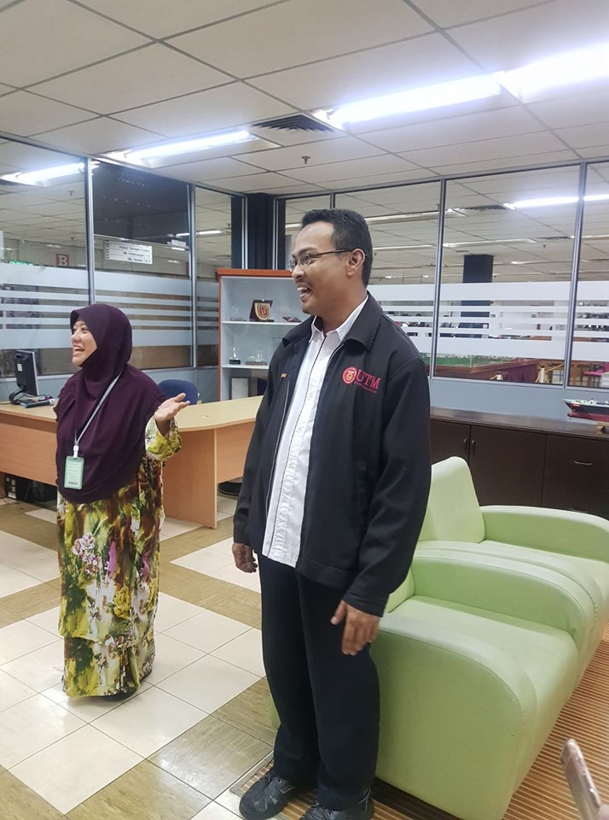

Picture 1: A short brief by Encik Zahari

COMPUTER

A computer is an electronic device that manipulate the information or data. Modern computers have the ability to follow generalized sets of operations, called programs. These programs enable computers to perform an extremely wide range of tasks. There are different types of computers such as mainframe computer, supercomputer and so on. From the visit, we had the chances to see a lot of “old-fashioned” computer models. The computers that on display was used in UTM in early 80s to 90s. And these computers also have different characteristics to carry out some specific functions. For example, the IBM Personal System/2 Model 70 386 featured a high-density memory technology. The computer with its system supported the Library in performances improvement for desktop operation.

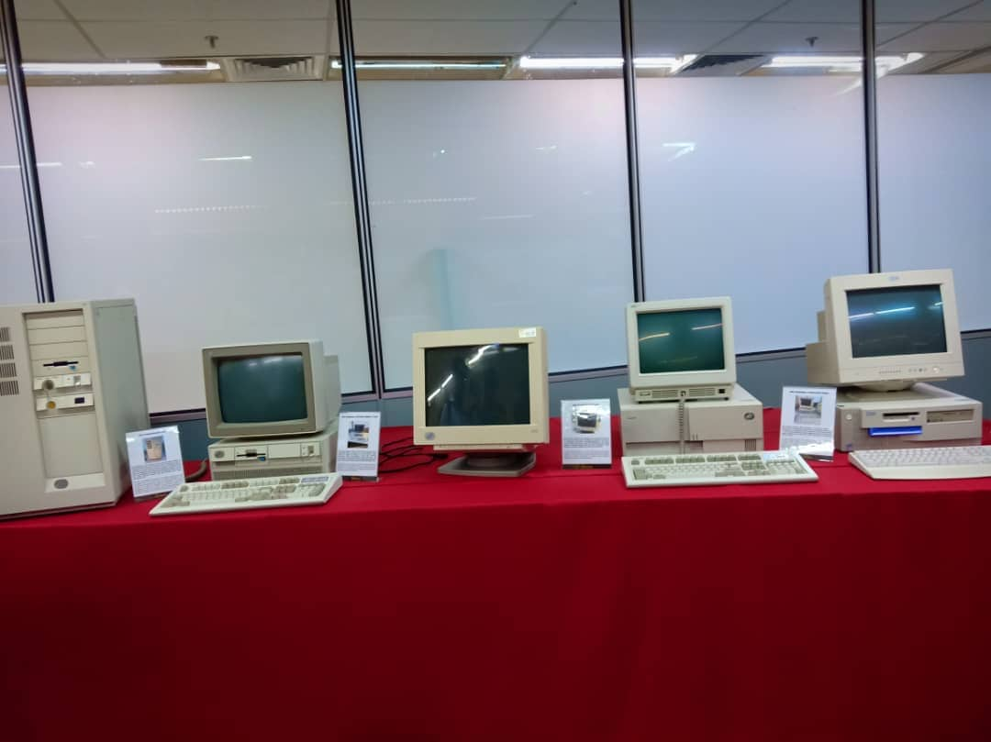

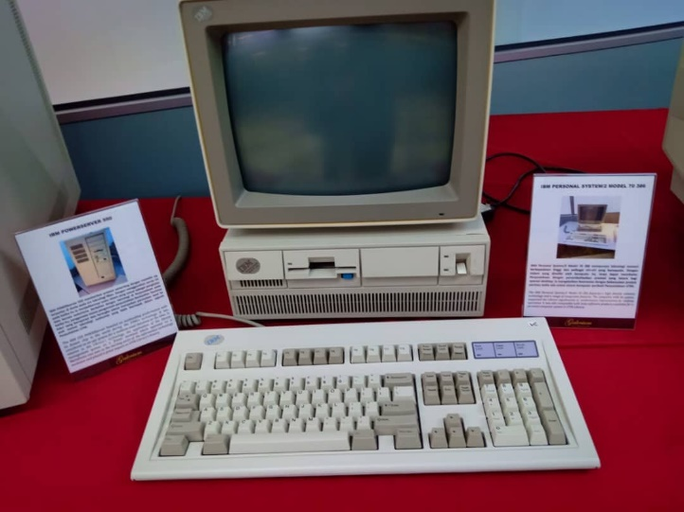

Picture 2: IBM Personal System/2 Model 70 386

Picture 2: models of computer

**MAINFRAME**

Mainframes first appeared in the early 1940s. The most popular vendors included IBM, Hitachi and Amdahl. Some recently considered mainframes as an obsolete technology with no real remaining use. Yet today, as in every decade since its inception, mainframe computers and the mainframe style of computing dominate the landscape of large-scale business computing. Mainframe computers now play a central role in the daily operations of many of the world’s largest Fortune 1000 companies. Though other forms of computing are used extensively in various business capacities, the mainframe occupies a coveted place in today’s e-business environment. In banking, finance, health care, insurance, public utilities, government, and a host of other public and private enterprises, the mainframe computer continues to form the foundation of modern business.

The main difference between mainframes and supercomputers is their typical application domain – mainframes excel in reliable volume computing in domains requiring integer operations (e.g, financial, indexing, comparisons, etc). Supercomputers are design to excel in their ability to perform floating point operations – addition, subtraction, and multiplication with enough digits of precision to model continuous phenomena such as weather. Despite the continual change in IT, mainframe computers considered by many to be the most stable, secure, and compatible of all computing platforms. The latest models can handle the most advanced and demanding customer workloads, yet continue to run applications that were written in earlier decades. For those who think there is no use for the ‘big iron’ now, they would really be surprised. The truth is that we are all mainframe users in one way or another.

**CPU**

CPU (pronounced as separate letters) is the abbreviation for central processing unit. Sometimes referred to simply as the central processor, but more commonly called a processor, the CPU is the brains of the computer where most calculations take place. In terms of computing power, the CPU is the most important element of a computer system. On large machines, the CPU requires one or more printed circuit boards. On personal computers and small workstations, it is housed in a single chip called a microprocessor. Since the 1970's the microprocessor class of CPUs has almost completely overtaken all other CPU implementations.The CPU itself is an internal component of the computer. Modern CPUs are small and square and contain multiple metallic connectors or pins on the underside. The CPU is inserted directly into a CPU socket, pin side down, on the motherboard.Each motherboard will support only a specific type (or range) of CPU, so you must check the motherboard manufacturer's specifications before attempting to replace or upgrade a CPU in your computer.

HARD DISK

A hard disk is an electromechanical data storage device that keep and retrieve digital information. Encik Zahari briefs an old-style hard disk named mainframe data storage to us. Mainframe data storage has 512 MB of data storage. It is as large as a cabinet and hard to carry. The Model 9345-B22 available from 11th February 1992 and had marketing withdrawn on 31st December 1996. It's service discontinued start on 31st December 2008. The IBM 9345-B22 has dual cluster controller models for improved availability and concurrent maintenance. It has an ability for media maintenance with continuous data access. The IBM 9345-B22 subsystem has a wide range of processor attachment capabilities including ESCON. It has the ECKD channel command architecture to enable it to operate in a non-synchronous mode. All software using the 9345-B22 must stick to the ECKD channel command architecture for the best performance.

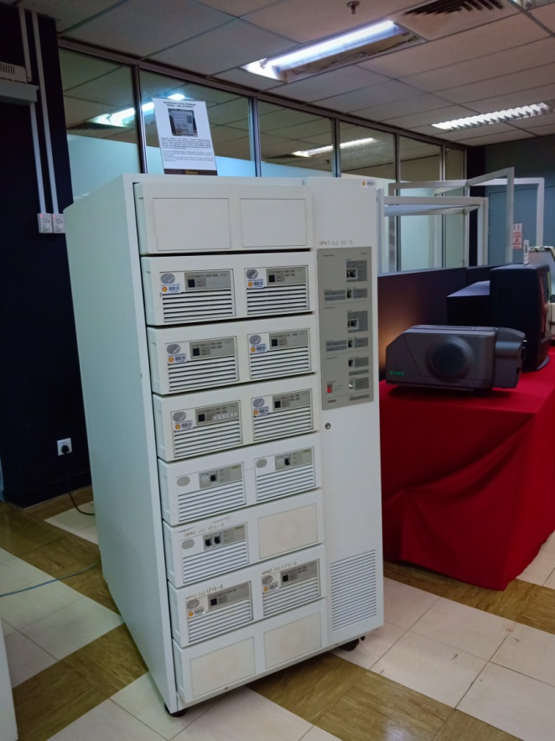

Picture 1: Mainframe Data Storage

Model : IBM (9345B22)

DISKETTE

A diskette, also known as floppy disk is a random access, removable data storage medium that can be used with personal computers. A diskette has a 3.5 inches square shape with a thickness of 2 mm. The storage of one diskette is 1.44MB data. The disk of the magnetic storage medium is sealed in a plastic enclosure lined with fabric to prevent dust particles. The prevalence of floppy diskette is in the late 20th century. There are many electronic and software programs use diskette as save icon during that time. However, the diskette still faces some limitation, especially with legacy industrial computer equipment. As a result, the diskette is replaced by other data storage methods with much greater capacity and faster transfer speed.

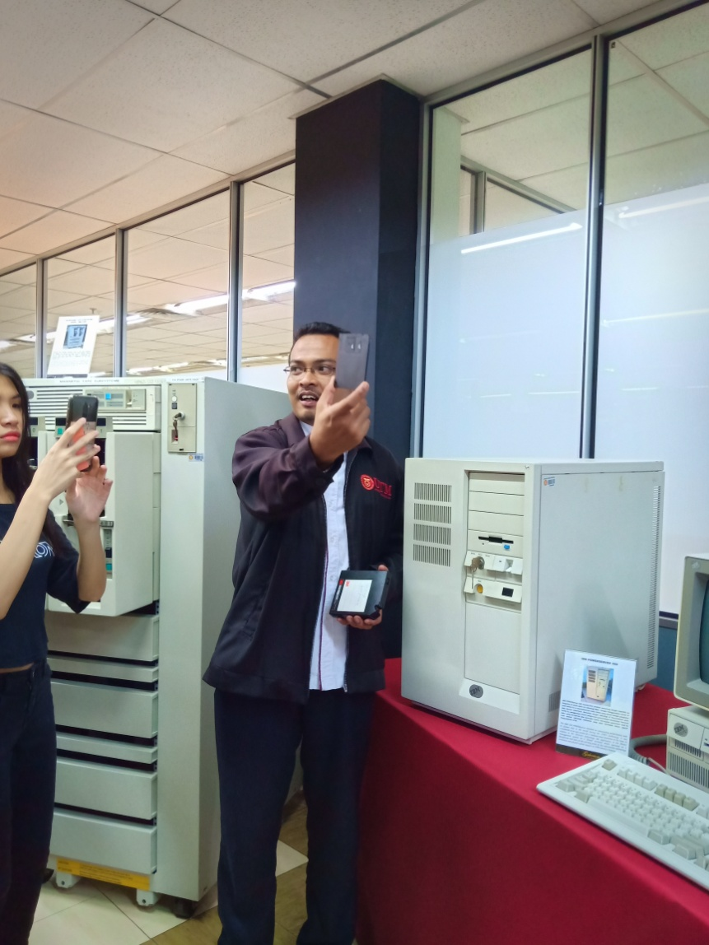

Picture 2 : Encik Zahari shows the diskette to students.

REFLECTION

Based on our visit to the CICT gallerium which was located and held in the Sultan Zanariah Library (PSZ) we were able to realise and sharpen our focus on our goals and dreams after being able to experience and hear about the advancement technology has made in the last couple of decades. This was particularly eye opening for us as we able to realise in depth as well as receiving an opportunity to take a look at some of the technology used in the past decade or so as well as hear about the advancement of it. Encik Zahari was kind enough to brief us on the usage as well as how it varies from the modern version of the technology today in place of it. This gave us all a image of how an idea that started out small was able to be developed and modified till today into something that has made our lives a whole lot easier and smoother. This was a wake up call for us to realise that nothing is impossible as long as we put our heart and soul into it. This made us realize how important it is for us to not give up on our hopes and dreams. So as group and individually we all have realised our goal and purpose is to be able to generate ideas and new ways to overcome everyday issues by technology and making life a much more simple and easy place. It may not happen in a blink of an eye but everything starts from somewhere and so do ideas.

This visit impacted us in more than one way. It showed us the importance of technology and its development and it made us realise that without the advancement of it we would all still be using typewriters or pen and paper to convey a message or pass on information. We would also be using books and having to go through it one by one to receive or find out information as google would have not been developed or compatible to any device. This shows us how important it actually is to strive for success and not settle for less instead continue to push the boundaries of this technological era and platform to its very maximum and make good use of it. With that said we have come to a realization that technology is an ever evolving process and we as students have to take up the responsibility of carrying it further into the future for the generations to come and to continue to understand it so that we are able to advance it further and further to its absolute state.

Throughout this whole process of understanding the importance of focusing and realising our goals we were also able to dig deep and process ways to better ourselves as well an action plan. This goal of ours both as a group and individually requires dedication and whole heartedness. It also demands the very best of our time, energy, and ideas so we must be able to give our very best at every moment and be able to overcome situations to improve ourselves. We must also be absorbent to the things we learn and are able to apply it as well.

**TASK FOR EACH MEMBER**

|  |  |  |
| --- | --- | --- |
| **No.** | **Members** | **Task** |
| 1. | NG JING ER | Introduction, explanation on computer |
| 2. | KOH XIN YI | Explanation on hard disk, diskette |
| 3. | NUR LYNNDA BINTI ROSLAN | Explanation on mainframe, CPU |
| 4. | ROSHANDEV DANIEL | Reflection, compile |

References:

1. Centre for Information & Communication Technology Web. Retrieved from <https://cict.utm.my/>
2. Definition of Computer. Retrieved from <https://en.wikipedia.org/wiki/Computer>
3. Hard disk drive - Wikipedia.(24 Oktober 2019) Retrieved from <https://en.wikipedia.org/wiki/Hard_disk_drive>
4. US - IBM DASD Model B22. Retrieved from <https://www-01.ibm.com/common/ssi/cgi-bin/ssialias?infotype=DD&subtype=SM&htmlfid=897/ENUS9345-B22>
5. Margaret Rouse. (September 2005) What is diskette (floppy disk)? Retrieved from <https://searchstorage.techtarget.com/definition/diskette>
6. Floppy disk - Wikipedia. (23 Oktober 2019) Retrieved from <https://en.wikipedia.org/wiki/Floppy_disk>