**Tan Kuan Wern A11SC0191 Computer Literacy R-Assignment section 1**

> library(stats)

> library (MASS)

1a)

> y=function(x)

+ {

+ z=(4-x^2)^(1/2)

+ z

+ }

> integrate(y,-2,2)

6.283185 with absolute error < 4e-09

1b)

> h=function(x)

+ {

+ w=(3+5*sin(x))^(-1)

+ w

+ }

> integrate(h,0,pi/2)

0.2746531 with absolute error < 6.5e-13

2a)

> deriv(~x^2,"x")

expression({

.value <- x^2

.grad <- array(0, c(length(.value), 1L), list(NULL, c("x")))

.grad[, "x"] <- 2 * x

attr(.value, "gradient") <- .grad

.value

})

2b)

> deriv(~(exp(-x))/sinh(2*x),"x")

expression({

.expr2 <- exp(-x)

.expr3 <- 2 * x

.expr4 <- sinh(.expr3)

.expr5 <- .expr2/.expr4

.value <- .expr5

.grad <- array(0, c(length(.value), 1L), list(NULL, c("x")))

.grad[, "x"] <- -(.expr5 + .expr2 * (cosh(.expr3) * 2)/.expr4^2)

attr(.value, "gradient") <- .grad

.value

})

3)

> babies.q3. = read.table("babies 111.dat", header=T, as.is=T)

> babies.q3

Error: object 'babies.q3' not found

> babies.q3.

> babies.q3.[c(1:5),]

id pluralty outcome date gestation sex wt parity race age ed ht wt1 drace

1 15 5 1 1411 284 1 120 1 8 27 5 62 100 8

2 20 5 1 1499 282 1 113 2 0 33 5 64 135 0

3 58 5 1 1576 279 1 128 1 0 28 2 64 115 5

4 61 5 1 1504 999 1 123 2 0 36 5 69 190 3

5 72 5 1 1425 282 1 108 1 0 23 5 67 125 0

dage ded dht dwt marital inc smoke time number

1 31 5 65 110 1 1 0 0 0

2 38 5 70 148 1 4 0 0 0

3 32 1 99 999 1 2 1 1 1

4 43 4 68 197 1 8 3 5 5

5 24 5 99 999 1 1 1 1 5

4)

> Y=rnorm(100)

> Y

[1] 0.258797096 0.005143267 0.340753021 0.061719289 -0.093699743

[6] -1.387771621 1.878768784 -1.036434943 2.061050293 1.314983416

[11] 0.304466275 -0.563613460 -0.809735084 0.061259052 -0.229790323

[16] 0.745455495 0.146466219 -2.175865297 0.220539039 0.197722809

[21] 0.809771037 0.630354600 -0.502009460 -0.968577239 -1.336500943

[26] 0.267027321 0.759783620 0.051502445 0.714153126 -1.315244739

[31] 1.222144648 -1.469358252 -0.269220400 2.283044327 -0.329256602

[36] 2.191817797 -2.678341481 0.634752799 -0.013764385 -1.814074651

[41] 0.414210371 0.451283099 -1.577976843 0.075391072 -0.492821800

[46] 1.573764578 0.124706577 1.252323318 0.004230893 -0.208637171

[51] -0.290749678 -0.370859284 0.809929405 0.210129523 1.004511812

[56] -1.045497082 -0.346049251 0.105409409 -1.648445150 -0.323934754

[61] -0.394127200 0.115785660 -0.165473542 0.892125987 0.141431611

[66] 0.607530912 0.598248505 -0.196958692 1.109855619 0.849192655

[71] -0.608910151 0.329170587 -0.834028167 0.469134843 -2.849136740

[76] 0.251080252 0.487115483 -0.464923261 -0.539488492 -0.663480397

[81] -0.138275069 -1.407055600 0.892083810 -0.346786444 -1.309743759

[86] -1.067693736 0.471033761 -0.902764937 -1.016333871 0.589468446

[91] -0.799688681 -1.255103858 -1.570271035 -0.045538801 -1.732182880

[96] 1.389244098 -1.540199668 0.237768267 0.391994059 1.417644551

> mean(Y)

[1] -0.0871912

> sd(Y)

[1] 1.005949

> Y[Y>1.96]

[1] 2.061050 2.283044 2.191818

> signif.100.=c(Y[Y>1.96])

> signif.100.

[1] 2.061050 2.283044 2.191818

5)

> X=rgamma(1:100,shape=1,scale=0.5)

> X

[1] 0.218370395 0.444686424 1.369863064 0.345367867 0.032292634 1.507848339

[7] 1.032771523 0.004110783 0.104320790 0.029559011 0.389847572 0.520377796

[13] 0.212262985 0.526345330 0.177531132 0.643377518 1.194858433 0.482670795

[19] 0.026210413 0.606748994 0.149737522 0.384616864 0.716543908 0.006267996

[25] 0.070173748 0.014839263 0.424576417 0.171257468 0.399740143 0.032853694

[31] 0.961666997 0.111324372 0.240793791 1.361562466 0.469522475 0.835912563

[37] 0.207703202 0.375816636 0.980931718 0.560956905 0.060437192 0.223024356

[43] 0.034195362 0.463741379 0.283277661 0.174542393 1.249413905 0.368707061

[49] 0.017538406 0.116981743 0.104017640 0.715741865 0.226504748 0.313602696

[55] 0.484576421 0.059733595 0.361228999 0.737845910 0.351746832 0.183682173

[61] 0.370605594 0.150705570 0.209360567 0.513592933 0.678340723 0.357599923

[67] 1.181153767 0.615540660 0.085907898 0.297222826 0.932242192 0.275782663

[73] 0.490291415 0.270974536 0.017867845 1.333524005 0.042613165 0.011405255

[79] 0.185688655 0.413401940 0.411695618 0.391367995 0.164857992 0.632304222

[85] 0.716004965 2.103717743 0.241809417 0.586540190 0.132511276 1.527410215

[91] 0.217454542 0.450452421 0.123252780 1.633392642 1.389539561 0.391567705

[97] 0.634449879 0.604034071 0.030891805 0.335522537

> hist(X)

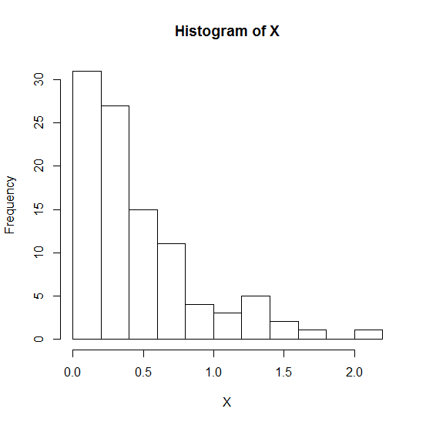

6a)

> A=matrix(c(3,1,-4,2),ncol=2)

> A

[,1] [,2]

[1,] 3 -4

[2,] 1 2

6b)

> t(A)

[,1] [,2]

[1,] 3 1

[2,] -4 2

6c)

> solve(A)

[,1] [,2]

[1,] 0.2 0.4

[2,] -0.1 0.3

6)

> b=matrix(c(6,-3),ncol=1)

> b

[,1]

[1,] 6

[2,] -3

> Ai=solve(A) #Ai is the inverse of A

> Ai

[,1] [,2]

[1,] 0.2 0.4

[2,] -0.1 0.3

> x=Ai%*%b

> x

[,1]

[1,] -2.220446e-16

[2,] -1.500000e+00