

**Semester I 2020/2021**

Subject : Technology and Information Systems (SECP1513) Section : 06

Assignment : Step by step PC Assembly

**GROUP NAME / NUMBER: Creative Thinkers**

|  |  |  |
| --- | --- | --- |
| 1 |  | Name: Muhammad Naim bin Abdul Jalil  Matric Number: A20EC0096  Phone Number: 011-1274 3977  E-mail: muhammad.naim@graduate.utm.my |
| 2 |  | Name: Muhammad Yusri bin Yusoff  Matric Number: A20EC0102  Phone Number: 011-23238869  E-mail: muhammad.yusri@graduate.utm.my |
| 3 |  | Name: Ebrahim Abdullah Ahmed Alnuzaili  Matric Number: A20EC9103  Phone Number: 016-3131298  E-mail: aaebrahim@graduate.utm.my |
| 4 |  | Name: Nafis Ahmed  Matric Number: A20EC4044  Phone Number: +60 16-389 5032  E-mail: n.ahmed@graduate.utm.my |
| 5 |  | Name: Nurul Huda binti Nor Din  Matric Number: A20EC0126  Phone Number: 017-7753837  E-mail: nurulhuda.nd@graduate.utm.my |

**PART A – Tools needed to assemble a PC.**

1.0 Screwdrivers

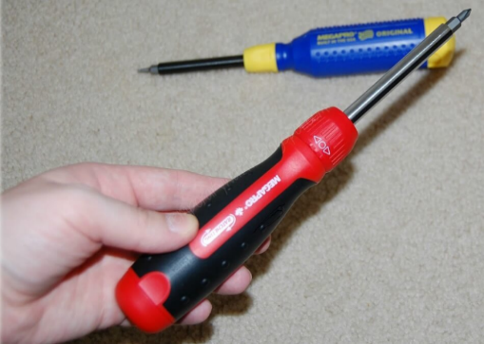

One of the most important and essential tools for the PC assembly. Computers are held together with screws and, luckily, nearly all types of screws used in computers are Phillips-head. The number-one most important tool for PC building is a Phillips-head screwdriver with a big bit, helpful to avoid stripping the head; a long shaft also aids in keeping the handle out of the way when working in tight spaces—it’s a good idea to keep a short screwdriver around as well, for the same reason.

2.0 Anti-Static [ESD] Safe Discharge Wristband Wrist Strap Band Grounding Cord Tool

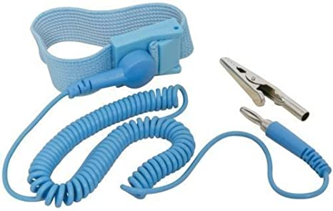

An anti-static wrist strap is a significant aspect of safety equipment that helps prevent the build-up of static electricity in the area of sensitive electronics or other projects where static charge may damage electronics or trigger safety problems. With an anti-static mat or other kind of workspace covering, the wrist brace is also used. In order to discharge static electricity safely, highly conductive threads on the wrist strap lead to a ground conductor. So, an anti-static wrist brace is used to ensure that the voltage difference between our body and the electronic part is balanced. By grounding our body with an antistatic wrist strap, any remaining static charge in our body will dissipate instantly.

3.0 Thermal Paste

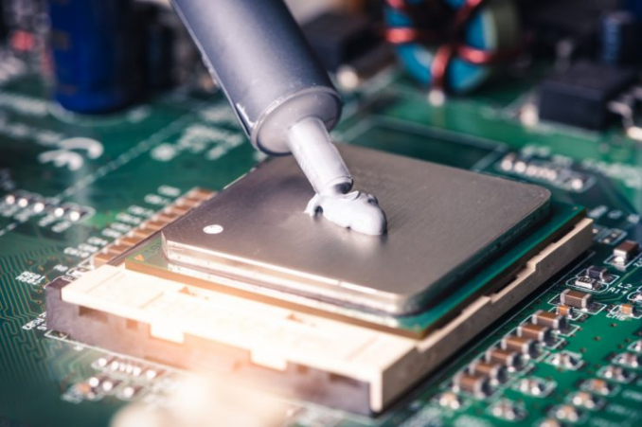

Thermal paste is a silvery-gray substance that you apply to a processor before installing a cooling solution. It allows for an efficient transfer of heat from the IHS of the processor to the base plate or water block of the CPU cooler that is designed to dissipate that heat.

4.0 Cable ties

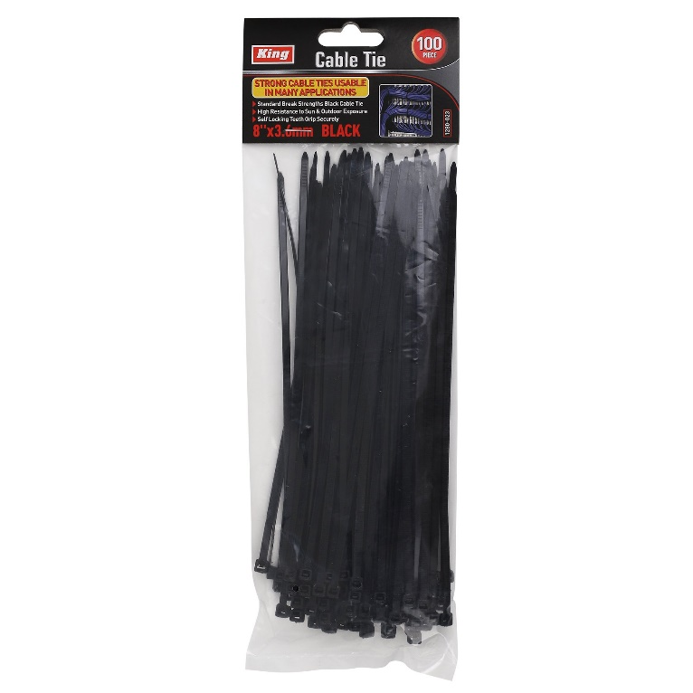

They are fasteners that bundle your cables and wires together to keep them organized and prevent damage. They come in different sizes, lengths, materials and even colors. The most common cable tie consists of a flexible nylon tape with an integrated gear rack, and on one end a ratchet within a small open case. Once the pointed tip of the cable tie has been pulled through the case and past the ratchet, it is prevented from being pulled back; the resulting loop may only be pulled tighter.

5.0 Canless Air Duster

Canless air duster air is used to blast dust out of our computer's nooks and crannies. Never blow with lips into a computer to remove dust because there is so much moisture in our breath. Also, we cannot use a home vacuum cleaner nozzle to clean the inside of a computer. They're producing too much static.

**PART B – Sketch of a mother board layout**

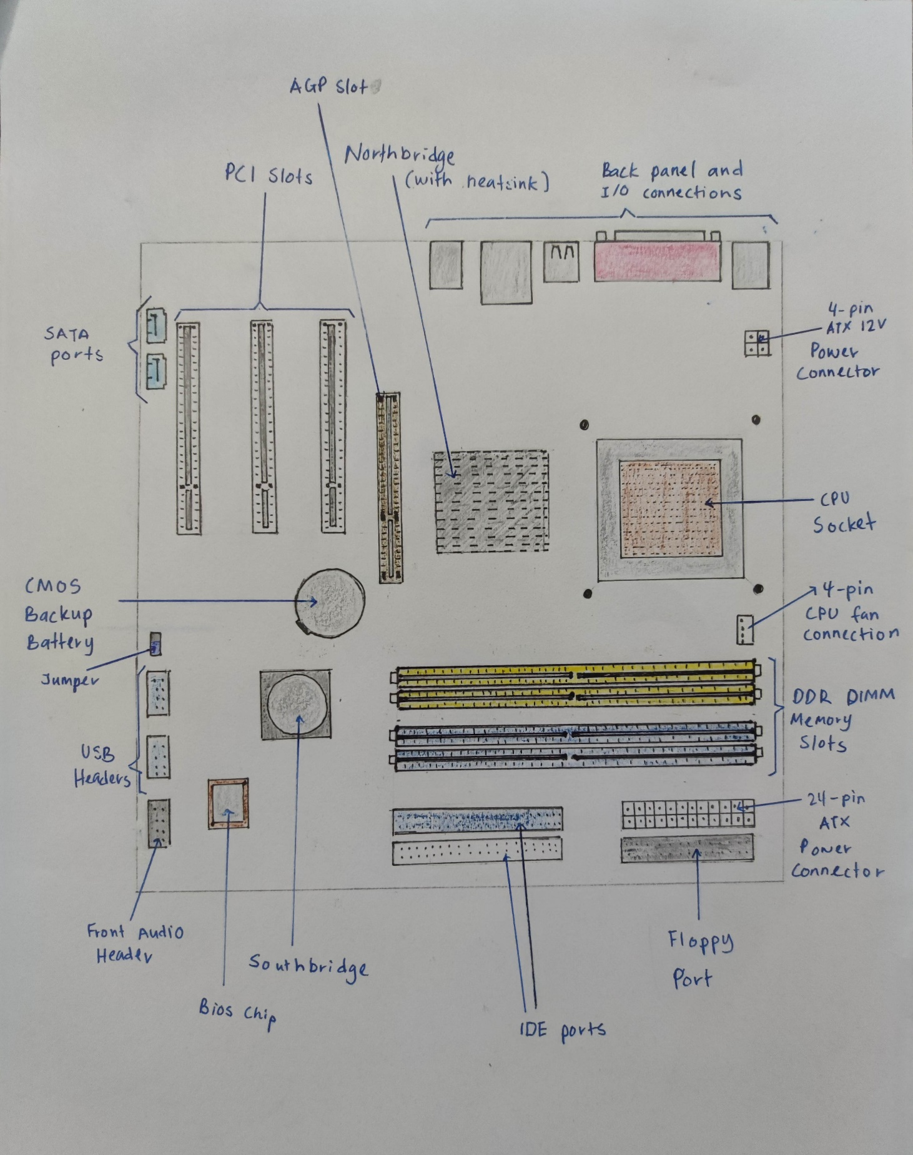

**PART C - Step by Step PC Assembly**

**STEP 1 (mount processor)**

|  |  |
| --- | --- |
|  | Locate the socket holder for the CPU on the motherboard |
|  | Lift the latch lever to unlock and hinge the CPU socket cover open. |
|  | 1) Holding the CPU by its side  2) To ensure the right orientation, line up any alignment notches or the triangle at the CPU corner to the triangle indicated on the motherboard.  3)Place it gently straight into the motherboard socket to seat the CPU  **Precaution:**  - Do not apply force to the CPU to seat  - As any residue from your hands will destroy the heat transfer surface, avoid touching the back of the CPU. |
|  | 1)Lower the cover of the Processor socket over the CPU  2) Lower the latch lever to lock the closed CPU socket holder |

**STEP 2 (Install CPU cooler)**

|  |  |
| --- | --- |
|  | Apply thermal paste if available,  on the surface of CPU |
|  | Sit the heatsink/cooler of the CPU and fixed in position |
|  | Plug the power cable that attached to the heatsink into the motherboard connector |

**STEP 3 (Install RAM)**

|  |  |
| --- | --- |
|  | Press to open the clips on both ends of the RAM mounting slot. |
|  | 1) Seat the RAM into the slots  2) Line up the notch of the RAM stick with the mounting slot  **Precaution:**  Never touch the golden electrical component on the stick because it might damage the RAM |
|  | Press it firmly to the slots |
|  | Closed the clips at both ends of the RAM mounting slot and ensuring that it is correctly aligned |

**STEP 4 (Install power supply)**

|  |  |
| --- | --- |
|  | Mount the power supply at the  top corner on the PC part |
|  | Screw it to the case mounting parts |

**STEP 5 (Install motherboard)**

|  |  |
| --- | --- |
|  | Mount the motherboard into the pc case |
|  | Screw the motherboard into the case |
|  | Connect the largest- cabling connector from power supply cabling to the motherboard power connector |
|  | Connect a 4 pin-cabling connector from power supply cabling into the CPU power connector beside the heatsink |

**STEP 6 (Install graphic card)**

|  |  |
| --- | --- |
|  | 1) Connect the graphics card slot to the AGP slot on the bottom half of the motherboard.  2)Line it up and press down strongly to seat the card |
|  | Screw the graphic card to the side of pc case to keep it in place |

**STEP 7 (Install hard disk)**

|  |  |
| --- | --- |
|  | Mount storage drives in the case drive bays |
|  | Screw through the case frame in the case of the mounting holes on the storage drives. |
|  | Connect the IDE cable into the connection port on hard disk |
|  | Connect the drives to the motherboard by using IDE cable |
|  | Plug in power cabling from power supply to the hard disk |

**STEP 8 (Install CD-ROM/Optical drive)**

|  |  |
| --- | --- |
|  | Remove the front panel from the computer case |
|  | Place the optical drive into the case and close the front panel |
|  | Screw through the case frame in the case of the mounting holes on the optical drives. |
|  | Plug in power cabling from power supply to the optical drives |
|  | Connect the IDE cable into the connection port on optical drives |
|  | Connect the optical drives to the motherboard by using IDE cable |

**STEP 9 (Connect USB cable)**

|  |  |
| --- | --- |
|  | Connect the front panel connectors (HDD LED, POWER LED, RESET SW, POWER SW) to the motherboard front panel I/O headers |
|  | Connect front panel audio connectors to the motherboard front audio header |
|  | Connect front panel USB connectors to the motherboard USB headers.  *need to be done to ensure the button input/output(I/O) on front panel to work |

**STEP 10 (Closing the case and connecting the peripherals)**

|  |  |
| --- | --- |
|  | Attach the monitor cable to the video port.  Secure the cable by tightening the screws on the connector. |
| Keyboard Ethernet    Printer Mouse | Plug the keyboard cable into the PS/2 keyboard port.  Plug the mouse cable into the PS/2 mouse port. |
|  | Plug the network cable into the network port. |
| Monitor Power | Plug the power cable into the power supply. |