

**TECHNOLOGY AND INFORMATION SYSTEM**

**REPORT OF VISIT TO MULTIMEDIA AND GAME INNOVATION CENTRE OF EXCELLENCE (MAGICX) UTM**

**GROUP MEMBERS:**

1. **ABDUL AZIM BIN ABDUL MALIK (A19EC0002)**
2. **IZZATUN NADIAH BINTI ABDUL RAHMAN (A19EC0056)**
3. **ONG YIN REN (A19EC0204)**
4. **LEE HUI ZHONG (A19EC0067)**

**LECTURER:**

**DR. SARINA BINTI SULAIMAN**

**INTRODUCTION**

On Sunday, 6th October 2019, our section SECP1513-07 had visited the Multimedia and Game Innovation Centre of Excellence (MAGICX), UTM. The purpose of this visit is to expose the students towards the requirements and job specification in the field of IT. It also opens up the chances for the student to develop an improvement during the tour. The visits included many components as the agenda. There are five main station shown during the visits. It is the exhibition on 3D printer, driving car simulator, explanation on Kinect Interactive Wall, demonstration on virtual reality of Oculus Quest and the augmented reality program. All this are the main component in IT that is the most desired by most companies nowadays. MAGICX consists of certified researchers, partners and clients. The clients and partners are from reputable organization such as MDEC, Petronas, University of Canterbury and Kementerian Pendidikan Malaysia (KPM) itself. While for the researchers and team, it consisted from member of UTM itself. The ecosystem of MAGICX branches out into four components that are, the MAGICXcel, MAGICXpose, MAGICXplore, MAGICXpert. These four components have their own roles and importance in making MAGICX a unit that it is right now. These four components are the one that will take of things such as research, seminar and workshop, productization, intellectual property protection and much more.

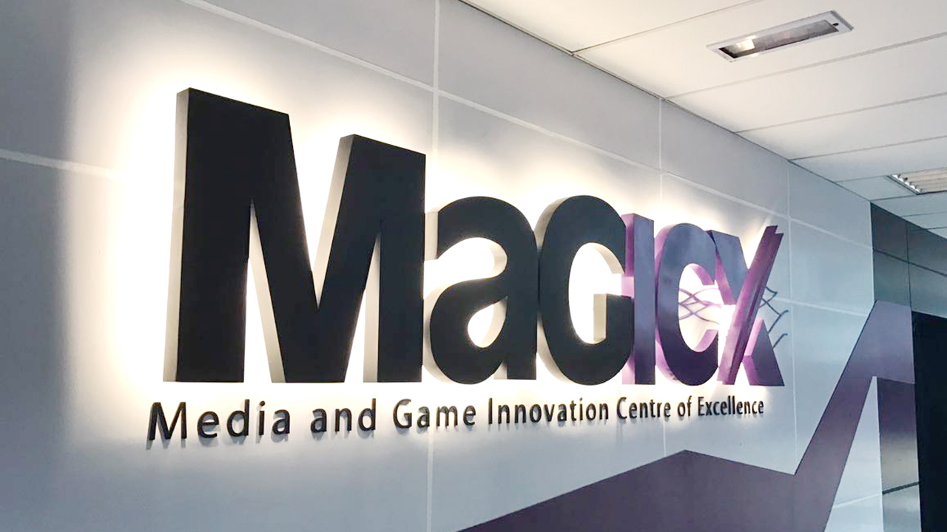

**MAGICX BACKGROUND**

MAGICX was founded in 2013 and it is still relatively new since it has existed only for 6 years. They are still new but the achievements, programs and products that have been made is capable enough to attract most clients to invest. They are cooperating with Iskandar Regional Development Authority (IRDA) to promote the development and ecosystem of creative industry that focuses on gamification and enrichment of digital content. This means they are inventing and providing a platform for the new graduates to acquire a job in this field that focuses creativeness as their main components. Not only that, they also aspire to create an environment that contributes toward talent development, industry promotion, knowledge-sharing and international collaboration.

MAGICX is empowered by a team full of experts from UTM itself. The team members are Associate Professor Dr. Mohd Yazid Idris, Professor Dr. Mohd Shahrizal Sunar, Professor Dr. Ali Selamat, Professor Dr. Mohd Shafry bin Mohd Rahim, Associate Professor Dr. Shukor Abd Razak, Dr. Farhan Mohamed, Azizul Azman and Dr. Kamarulafizam Ismail. This team is assisted by another team of researchers. And from this combination of team and researchers, MAGICX have achieved many achievements. For example, MAGICX Inventors was recognised at the World Inventor Award Festival 2015, Intellectual Property Workshop, GameFounders Big Asia Tour, Mobile-Based Augmented Reality Course with Professor Billinghurst and the IJN-UTM cooperation in cutting the cost of surgery of the heart disease patients.

MAGICX provides many services. Mainly are, augmented reality (AR), mobile and web development focusing on the safety system, training course by unity and android development and VR future custom project (360 degree projection based on environment). For example augmented reality is the personification of reality in augmented computer program, which means it projects the environment of reality into a computer generated reality that is shown in a screen, exactly the same as what is seen in reality. Mobile and web development course mainly trains on innovating a new system that enhances the safety. Training course by Unity will be the program where they develop a game by using the popular platform that is Unity.

As mentioned in the introduction, the ecosystem of MAGICX provides many supports. During the visits, we were told that MAGICX ecosystem consisted of PhD, Master and Undergraduate students that are talented and creative in this field. Next, MAGICX also provides the journal done by most of the researchers in MAGICX as a reference and allow the implementation from the journal for any new development. Furthermore, MAGICX will help the members to product things (productization) and will help them to break through the market with the product created. Lastly, they will also help in terms of packaging the products and will help by deciding how to earn money, make a very successful marketing scheme and ways to acquire customers to be invested in the products created. Basically, MAGICX will give all the help needed when pitching a new idea that seems possible to go through into the market.

**MAGICX Team**

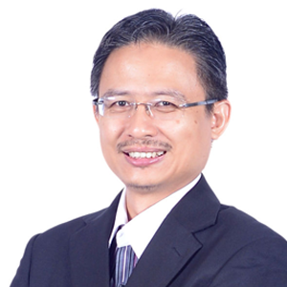

**Assoc. Prof. Dr. Mohd Yazid Idris**

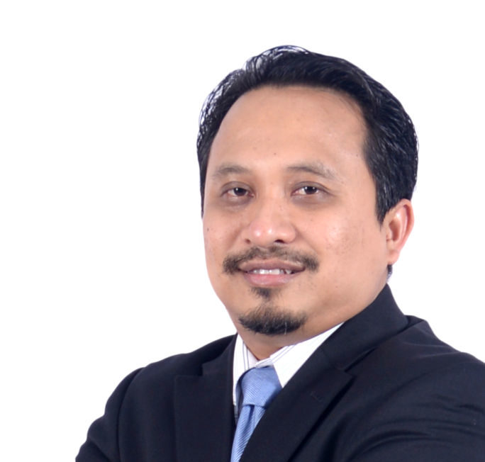

**Prof. Dr. Mohd Shahrizal Sunar**



**Prof. Dr. Ali Selamat**

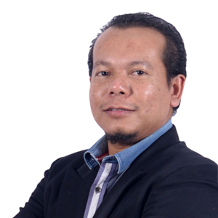

**Prof. Dr. Mohd. Shafry bin Mohd Rahim**

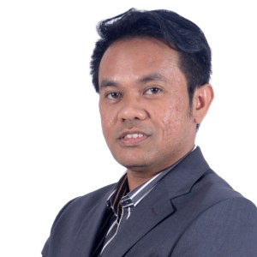

**Assoc. Prof. Dr. Shukor Abd Rzak**



**Dr. Farhan Mohamed**



**Azizul Azman**

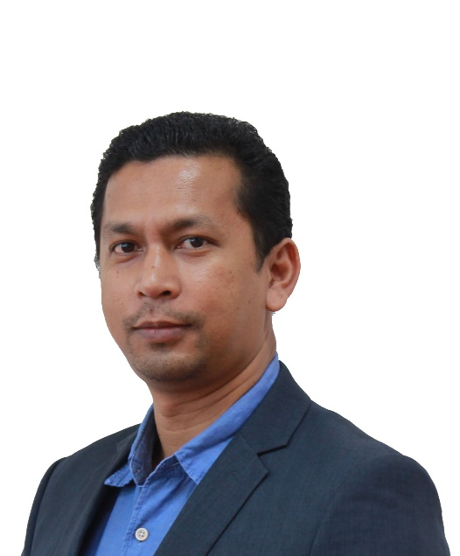

**Dr. Kamarulafizam Ismail**

Pictures are from the official websites of MAGICX: <https://ihumen.utm.my/magicx/research-fellows/>

Achivements and some development from the News section at MAGICX official website, https://ihumen.utm.my/magicx/news/

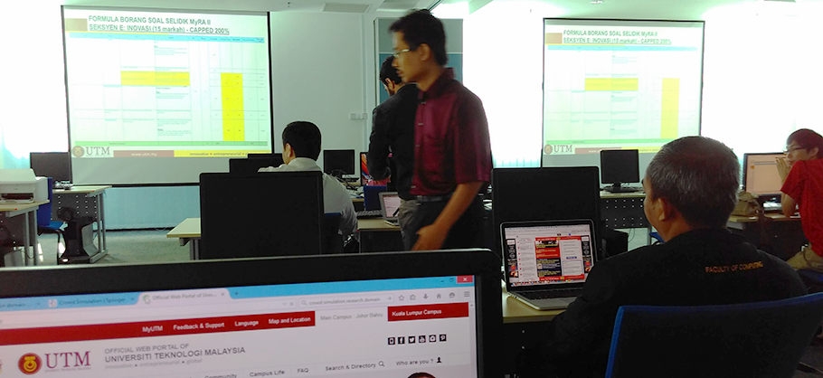

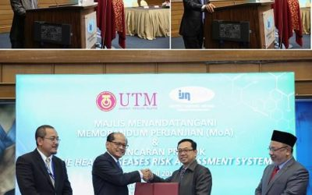



**EXHIBITION ON 3D PRINTER**

One of the projects being carried on in the MAGICX is the 3D printing. Based on the talk, we can more understand about how a 3D printer works. 3D printing process builds a three-dimensional object from a computer-aided design (CAD) model by adding the material layer by layer such as liquid molecules being fused together. 3D printing was considered only suitable for the production of functional prototypes in the 1990s but in nowadays 3D printing is widely used in manufacturing industries. One of the advantages of 3D printing is the ability to produce very complex shapes or geometries. The 3D printable models are created with a CAD package via 3D scanner or digital camera and photogrammetry software. 3D scanning is a process of collecting digital data on the shape and appearance of a real object then to create a digital model based on it. CAD models can be saved in the Stereolithography file format (STL) or Additive Manufacturing File format (AMF). We can correct the errors before printing and we can also enlarge or diminish the size of the models before we print.

In this exhibition, the presenters use a website called ‘Thingiverse’ to customize the object they wanted to print it out. This website provides lessons to teach us in using 3D printer and also create a platform for educators to exchange knowledges on 3D printing. After they finished customized the design, they saved as the STL format and saved it into SD card. The 3D printer is connected to the SD card in order to print the object out. The models are usually printed by using Acrylonitrile Butadiene Styrene (ABS) filament and Poly Lactic Acid (PLA) filament. ABS filament is more commonly used in 3D printing because it is strong, durable, good resistance to heat, pressure and stress.

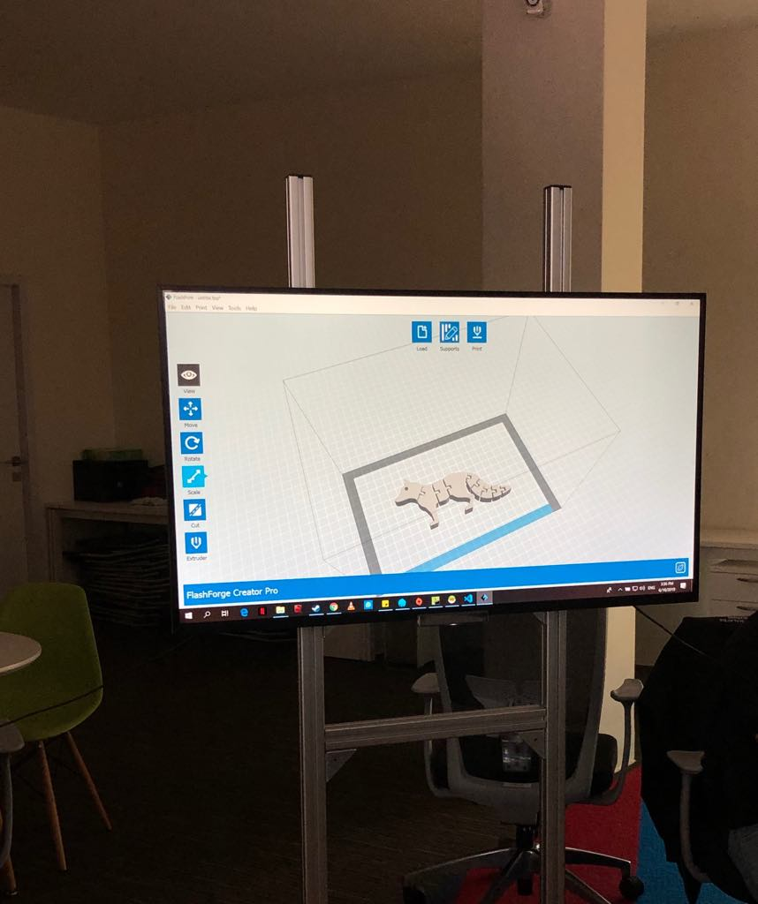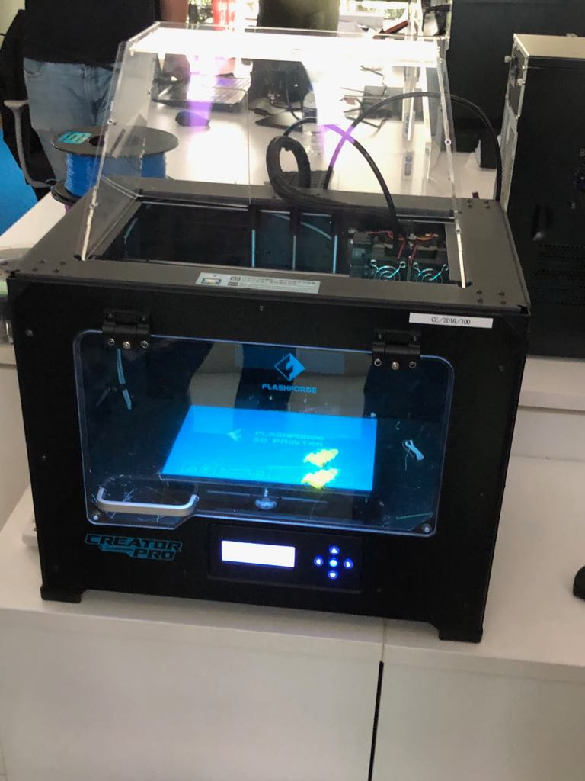*3D Printer: Flashforge Creator Pro Customizing design using Thingiverse*

*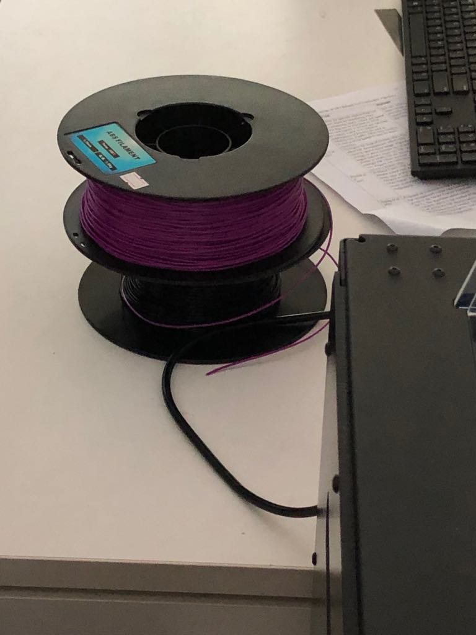ABS Filament*

**DRIVING CAR SIMULATION**

Another project introduced by MAGICX is the driving car simulation. It is just like a video game which provide the player with a realistic experience in driving a car. Driving simulator is used for entertainment and for training in the driver’s education courses. The driving simulator is also used for research purposes in the aspect of human factors and medical research. For examples monitoring driver’s behaviour, performance and attention. It is also used for training in critical driving conditions. The car industry uses the simulators to design and evaluate new vehicles or assistance systems in the vehicles.

Through this introduction, we are able to experience the car driving simulator and we can notice the speed of the car, the surface of the road as well as the conditions of the car. When we hit something on the road, the simulator will show the parts of the car that damage. This is to warn the driver about the conditions of the car so that the driver can be more alert when driving. This is very helpful for us to practice more before we drive on real road. Other than that, the simulator helps us to understand more about structure of the car because the important parts of the car are shown on the screen. However, according to the person in charge of this project, he said that this project still got some aspects that are weak and need some improvement to be done. One of the examples is the user unable to control the direction of the car properly using the steering wheel of the simulator while this causes the car easily loss control and hit to the buildings or other objects along the journey in the car simulator game. We have learnt much lesson throughout this presentation such as determination and teamwork are very important in doing any project in order to reach the result that is satisfied.

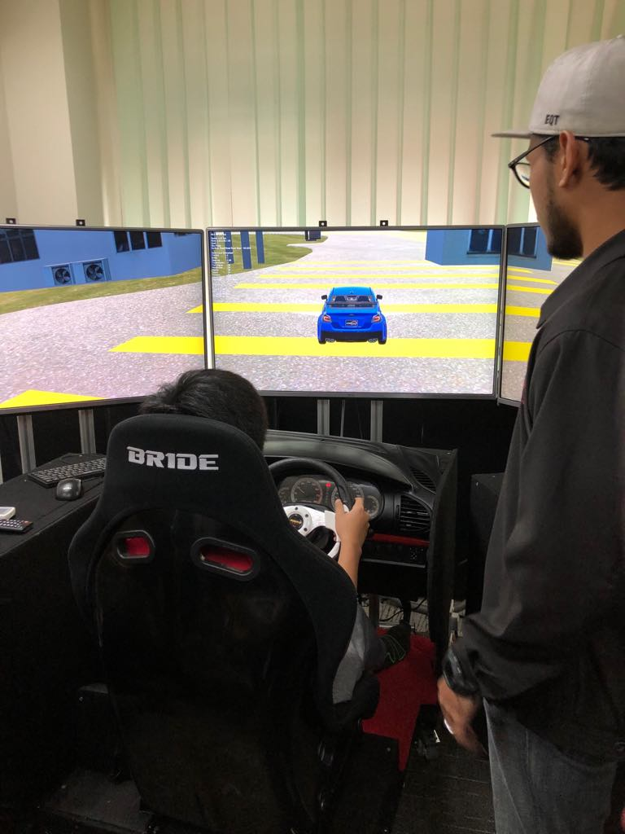

**KINECT INTERACTIVE WALL**

Kinect interactive wall is a touch motion control. It is connected with Microsoft Kinect program that has been customed program. We can stand in front the screen and immediately the camera scanner will identify our body movement. It will be captured into the screen of the monitor. Any movement will be detected by the camera and if the right motion was done it will done the task such as clicking on a program and so on. It is because kinect interactive wall are virtual reality interaction system. Inside the screen, we use the motion of our hand to get into the interactive wall components such as the settings, info of the Kinect and much more. This happens because Kinect uses high resolution 3D scan and display to capture the motion as the input for the system.

The kinetic interactive wall can be used as a projector. By implementing this method, every information regarding MAGICX can be displayed easily without help of the laser pointer, or second person to control the main display. According to the speaker, this interactive wall may be used in the education system which can increase the way of teaching and learning for teachers and also provides much wider understandability for students. Since now is the 21st century, using a much more advanced method is much more welcomed than the usual conventional teaching method of using textbooks and homework.

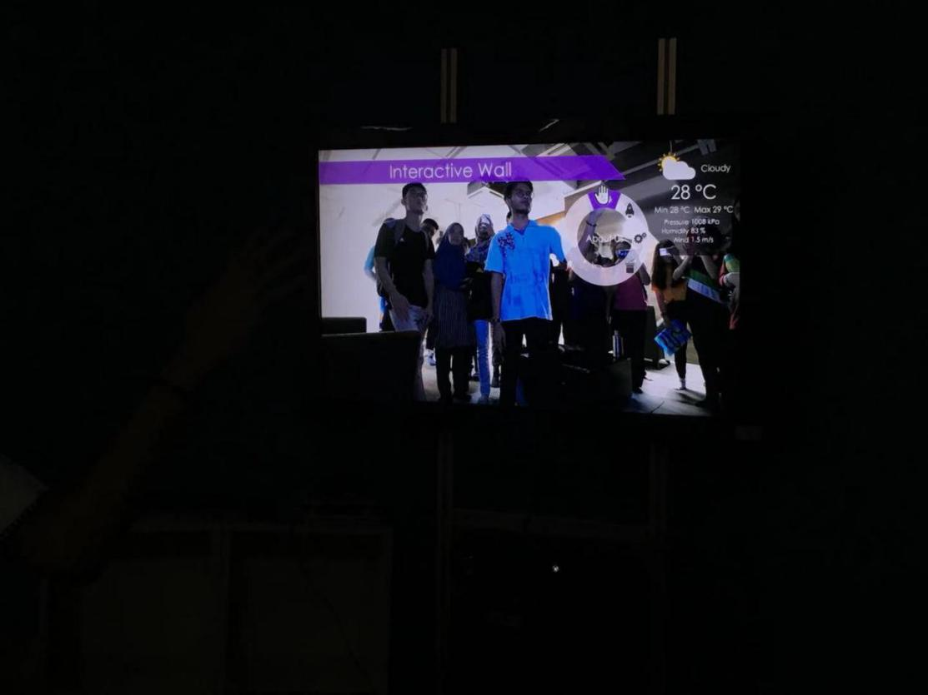

**DEMONSTRATION ON VIRTUAL REALITY OF OCULUS QUEST**

Virtual Reality is a computer-generated simulation of 3D-dimension image environment that can be interacted with in a seemingly real way by a person using the VR helmet (Oculus Quest). Oculus Quest is used because it is much more refined than the Oculus Rift. The main problem that cause the Oculus Rift to not be chosen is because it requires the use of a computer to provide any interaction towards VR while the Oculus Quest do not need any kind of outside connection since it already have its own operating system built in with it. The needs of using VR is to provide more interactivity between the system and the person using it. Since VR allows us, technically to diverge into the reality created, it makes the feeling of using it much more enjoyable. It can easily make you like going into the virtual world. Besides, since the operating system is also like Android, they have the Playstore which enable us to install any application that can implement the use of the VR headset thus making the usage of said app much more immersive. The competition of this product is mainly augmented reality since the application of AR is almost identical with VR.

In this exhibition, we are very honored to have a try of the Oculus Quest. While we are experiencing the VR generated by Oculus Quest, we can use the controller provided as the control method to go into what application we want. It is just like using a mobile phone to go into any applications. It seems like we and the application installed are in zero-distance.

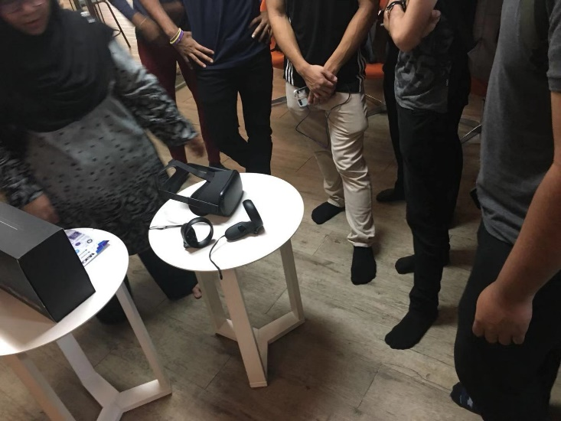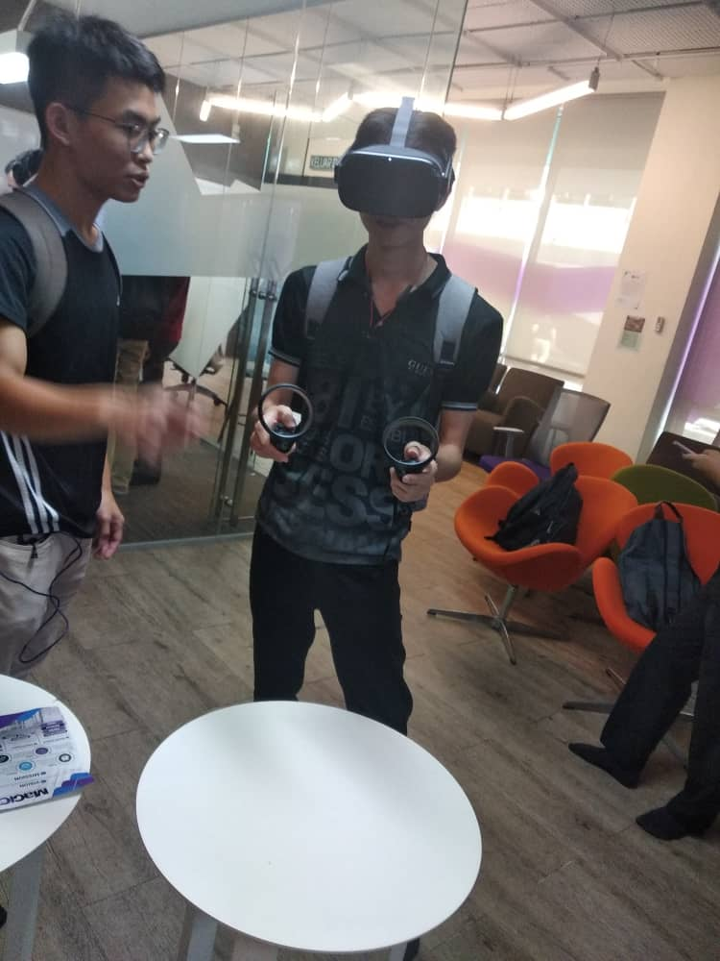

**AUGMENTED REALITY**

Augmented Reality (AR) is also one of the projects that had been introduced by MAGICX. It is an interactive experience of a real-world environment where the objects that reside in the real world are enhanced by computer-generated. AR can be defined as a system that fulfills three basic features which are a combination of real and virtual worlds, real-time interaction, and accurate 3D registration of virtual and real objects. Commercial augmented reality experiences were first introduced in entertainment and gaming businesses. Subsequently, augmented reality applications have spanned commercial industries such as education, communications, medicine, and entertainment. In education, content may be accessed by scanning or viewing an image with a mobile device or by using markerless AR techniques. Augmented reality is used to enhance natural environments or situations and offer perceptually enriched experiences. With the help of advanced AR technologies the information about the surrounding real world of the user becomes interactive and digitally manipulated. Information about the environment and its objects is overlaid on the real world.

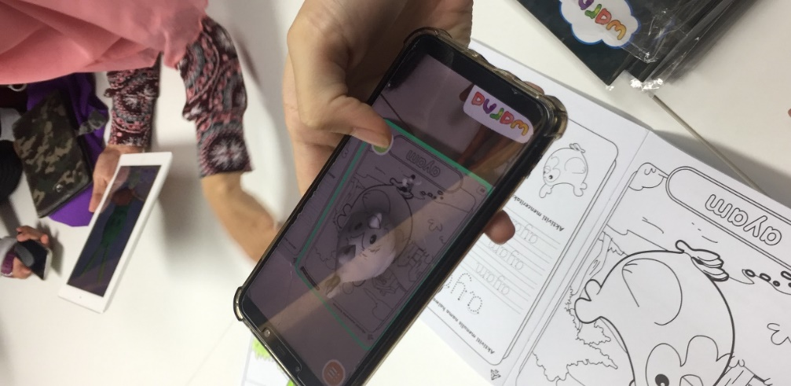So, MAGICX has developed a lot of application and one of them is WARNA. This application can be installed from play store and it is free. We just need to buy the book named WARNA and then the image will be access by scanning the image using the application. After that, the image will be view in 3D at screen of mobile device. It becomes an effective visualization tool because of that 3D display appears like floating on the air. Hence, that display perceived as something magical by children. Besides, it also allows viewers to view that subject learned from different angles due to the 3D image that display on the screen. Hence, the display will lead children to predict and interpret from various perspective. Finally, this process will improve their cognitive development and indirectly will increase the children’s understanding and achievement.

**REFLECTION.**

As we know, we are using technology in order to make our life become more easier and make it more fun. In 21st century learning, the students are not interested in reading anymore because they are exposed with a lot of gadget around them. So in order to take their attention we can make them interact with their work and let them have a better understanding on how it works and looks. It makes it more interesting for the student which in turn makes them pay more attention and hopefully understand the concept of what is being taught to them better. We can learn and apply the project that we had been shown by the MAGICX in our work for a better future. We must think creative in order to create something that can give benefits to our country. For example, the car simulator can be used to prepare trainees to handle unpredictable or safety-critical tasks that may be inappropriate to practice on the road. It also can give the young drivers with driving experience without significantly increasing their crash risk. We hope that MAGICX can improve their innovations towards education because mostly they produced their product only for kindergarten. Maybe they can develop something for the secondary student or university. If you want to follow the speed track you need to follow the speed of the technology.

