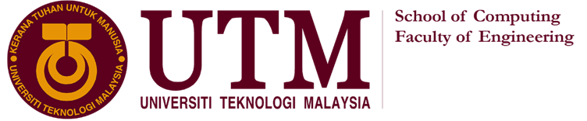

TECHNOLOGY AND INFORMATION SYSTEM  
SECP1513 – SECTION 7

INDUSTRIAL VISIT  
MEDIA AND GAME INNOVATION CENTRE EXCELLENCE

(MAGICX) UTM



LECTURER: DR. SARINA BINTI SULAIMAN

|  |  |  |
| --- | --- | --- |
| **NO.** | **GROUP MEMBERS** | **MATRIC NO.** |
| 1. | ROSHANDEV DANIEL A/L | A19EC0156 |
| 2. | NUR LYNNDA BINTI ROSLIZAN | A19EC0134 |
| 3. | KOH XIN YI | A19EC0064 |
| 4. | NG JING ER | A19EC0115 |

**MEDIA AND GAME INNOVATION CENTRE OF EXCELLENCE**

Established in 2013, Media and Game Innovation Centre of Excellence (MaGICX) is a strategic cooperation between Universiti Teknologi Malaysia (UTM) and Iskandar Regional Development Authority (IRDA) to support and promote the development and ecosystem of the creative industry that focuses on gamification and enrichment of digital content. MaGICX plays an integral role as the anchor for the Iskandar Malaysia Innovation Valley which is envisioned to offer industry players/SMEs/clients technical expertise/consultation, research/product development, business development, publishing, marketing and/or training in producing commercially.

MaGICX aspires to create an environment that contributes towards talent development, industry promotion, knowledge-sharing, and international collaboration, MaGICX’s credits include projects related to augmented reality, mixed and virtual environment, image processing, computer vision, multimedia software engineering, medical computing, computer interaction, human interface, usability, animation and technology, speech and signal processing, visualization, multimedia and software innovation, and emerging technology.

**DETAILS OF THE VISIT**

Before 2:00p.m. students were all gathered up at University Industry Research Laboratory. The students take the bus ride to reach there. About 2:30p.m. we are all invited to get into the building and get a short briefing by Mr. Wong Lih Fong about MAGICX. We are breaking into 5 groups which has about 15-17 people in a group to make sure the journey to try and demonstrate the innovations from MAGICX is going smoothly.

**MAGICX ORGANIZATION**

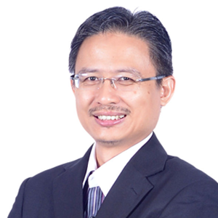 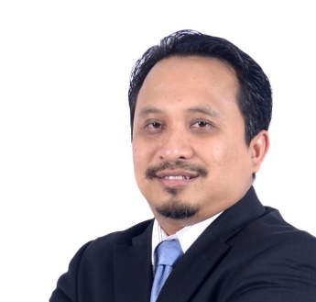 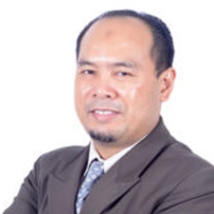

**Assoc. Prof. Dr. Mohd Yazid Idris Prof. Dr. Mohd Shahrizal Sunar Prof. Dr. Ali Selamat**

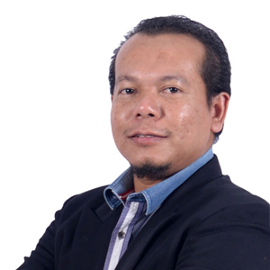 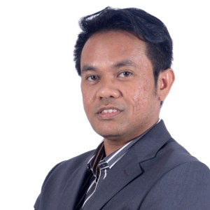

**Prof. Dr. Mohd. Shafry bin Mohd Rahim Assoc. Prof. Dr. Shukor Abd Rzak**

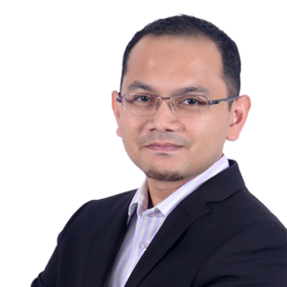 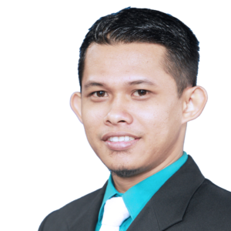 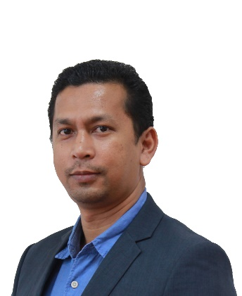

**Dr. Farhan Mohamed** **Azizul Azman Dr. Kamarulafizam Ismail**

**Exhibition on 3D printer**

The 3D printer is named Flashforge Creator Pro. It uses Polylactic Acid (PLA) filaments or Acrylonitrile Butadiene Styrene (ABS) filaments to print the model. PLA is bio-degradable plastic and it will not produce detrimental fumes during the printing process. ABS is an oil-based material and it is more lasting compared to PLA. People have various options to choose the model as Flashforge Creator Pro support printing from SD card. Flashforge Creator Pro outfitted with a pair of aligned print heads. This saves the travelling time of the printer heads compare to IDEX based systems. Besides that, the enclosed printing chamber enhances the temperature-stable printing conditions. It is essential when using ABS filaments. The chamber aids to keep away all dust and foreign particles and avoid the hot plastic fumes flow out from the chamber when using ABS filaments as material. Furthermore, this chamber muffle some of the printing sound. It has a removable cover and an adjustable door to make sure the chamber is perfectly aerated. The PLA filaments tend to be better in this condition.

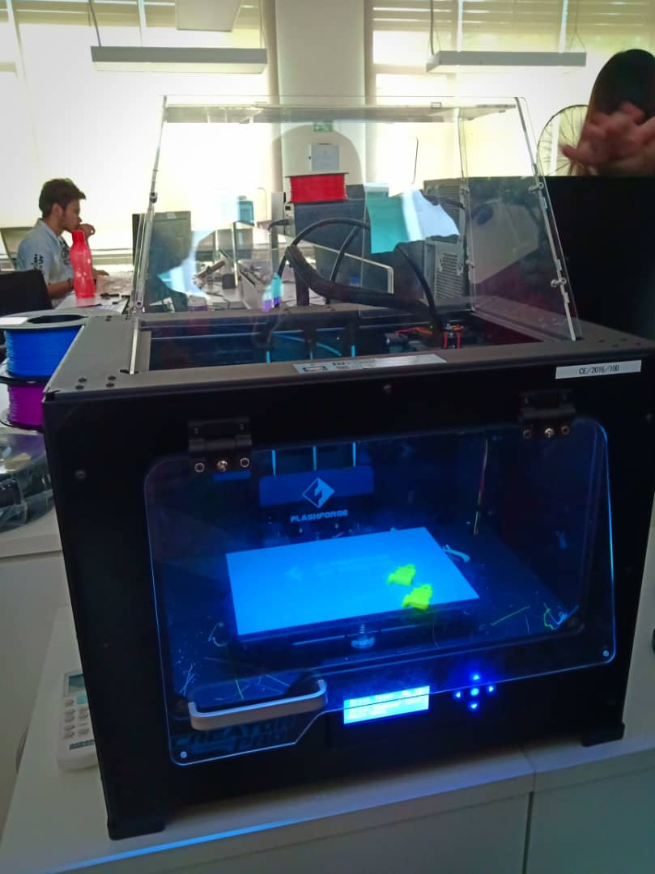

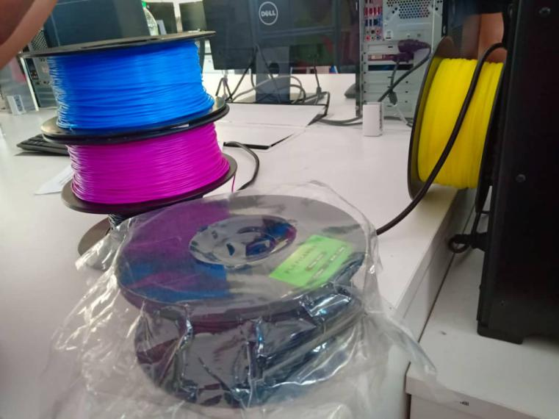

Picture 1: Flashforge Creator Pro Picture 2: Materials for Flashforge Creator Pro

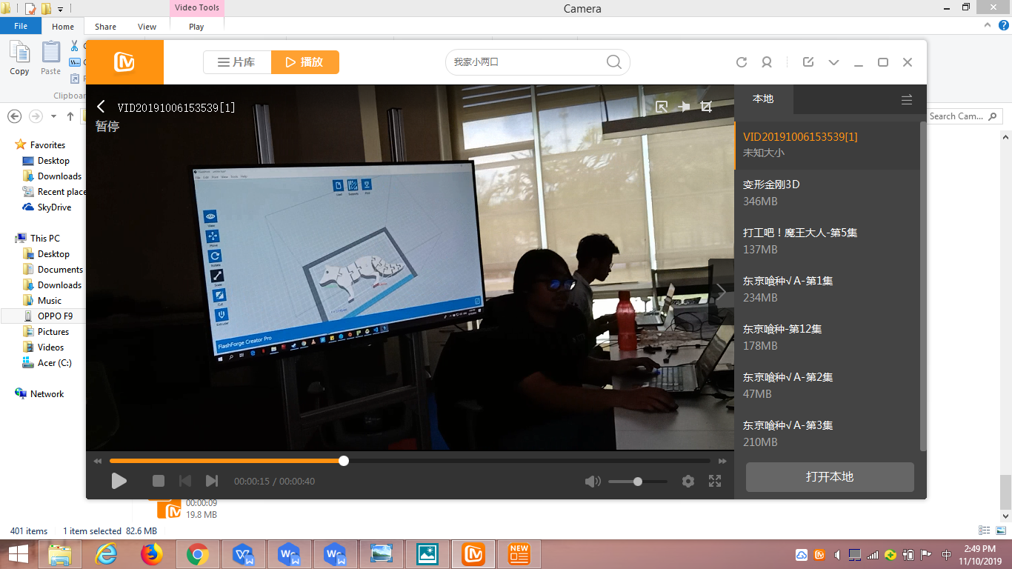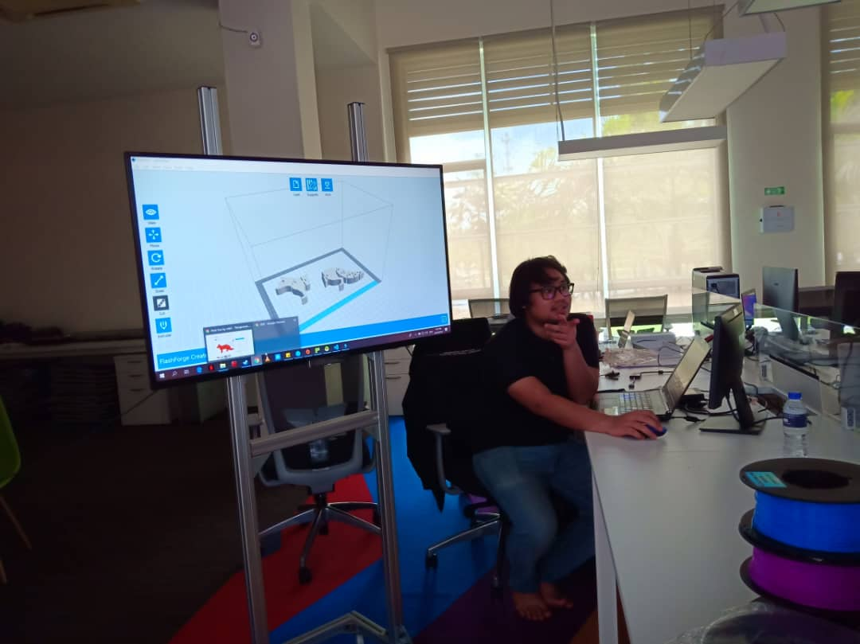

Picture 3: Explanation of 3D Printing Picture 4: 3D Modeling Software

**DRIVING CAR SIMULATOR**

MaGICX has been able to develop a new and interective driving simulator which is known as light vehicle driver simulator which is tool that users can use to practice, learn and carry out indoor driving classes. This simulator uses actual driving equipment such as a steering wheel, brakes and accelerator and a gear shift. The programme is also built around the premise of UTM SKUDAI JOHOR MALAYSIA, and has a realistic feel to it while driving. This is an interactive way to learn driving and also a safer, cheaper and cleaner way as no emissions are released. It is also capable of informing the person of the condition of the car if an accident were to occur. This makes it safer to use as it does not harm you physically. This programme is also so easy to use and operate. This ground breaking programme has the potential of saving energy and time as well as cars in teaching one to drive.

During my visit there, the simulator had certain issues that needs to be attended to urgently. One of the issues faced was that the steering wheel of the simulator was not aligned properly and was loose causing the users to lose control of their cars and crash it. This affects the users as they are not able to experience the full usage of the simulator and are not able to use it to its full capacity.

All in all, it was a great experience being able to learn more about the development of this simulator and test it out first hand.

PICTURE 5 & 6: DEMOSTRATION OF THE PROGRAMME.

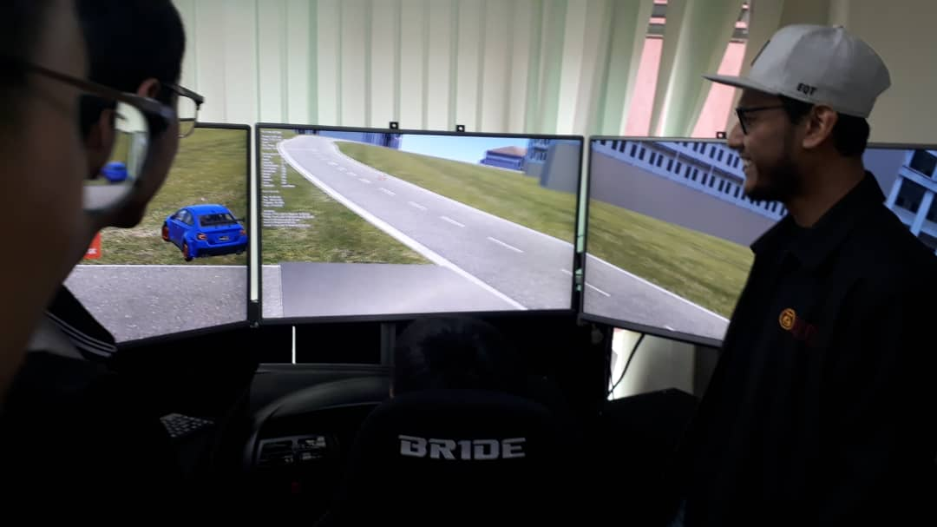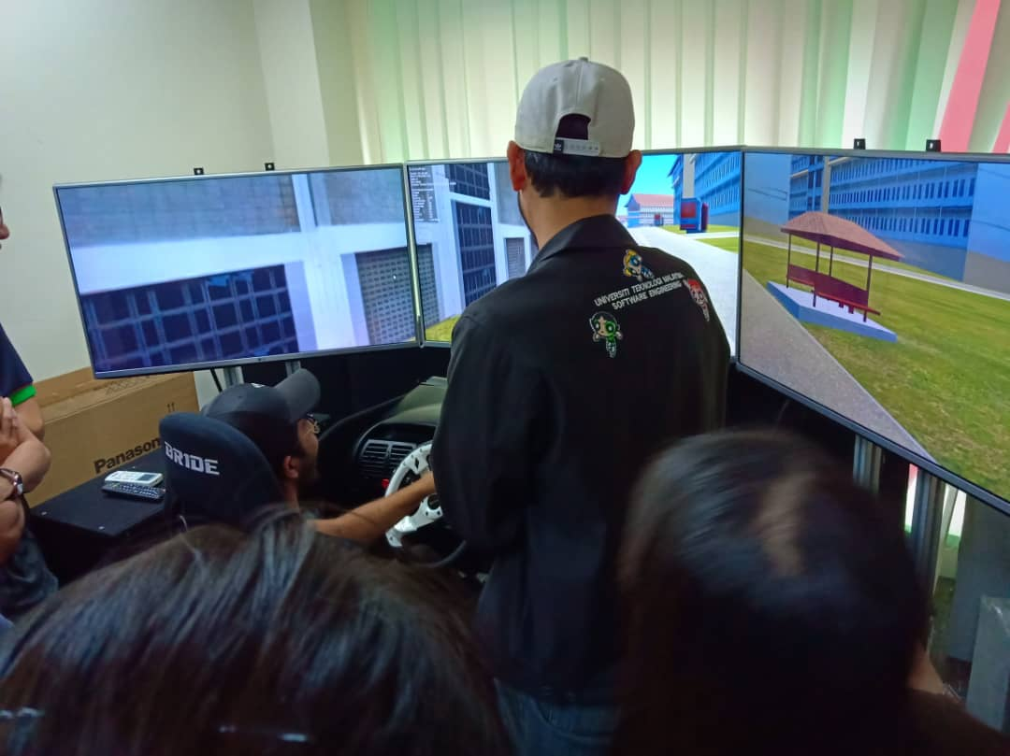

**Explanation on Kinetic Interactive Wall**

MAGICX develop new and interactive customer information centre by harness the capabilities of the Microsoft kinetic. Kinetic Interactive Wall is the next generation tracking platform with endless possibilities. The kinetic interactive wall can detect the hand gesture from a person by just standing in front of the camera. When a person that has been detected make a fist of their hand, it gives order to the software as click. This software is a revolutionary not only because of the technology inside but also because it is the most practical, robust and fun gesture while still being easy to install and operate. This interactive wall is made exclusively by MAGICX for Ministry of Science, Technology and Innovation (MOSTI) Malaysia.

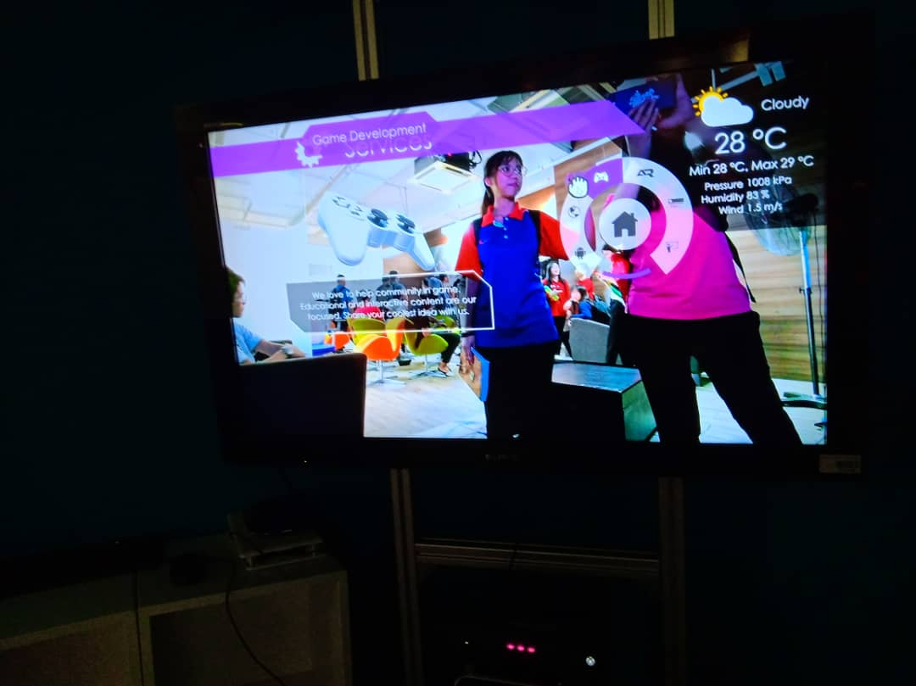

Picture 7: Demo on Kinetic Interactive Wall

**Demo on Virtual Reality of Oculus Quest**

For the session of demo on VR Oculus Quest, we had further understanding about the system of Oculus Quest. And luckily, we are given the chance to experience the VR using Oculus Quest. Oculus Quest is a virtual reality headset created by [Oculus VR](https://en.wikipedia.org/wiki/Oculus_VR), a division of [Facebook Inc](https://en.wikipedia.org/wiki/Facebook_Inc). Through Oculus Quest, users are able to enjoy the interactive three-dimensional environment generated by computers. The Oculus Quest is a wireless gaming system come with the VR headset and 2 Oculus Touch Controllers. [Oculus VR](https://en.wikipedia.org/wiki/Oculus_VR) mostly used for the entertainment function. Oculus VR also used by the kids for educational function. It provides an interesting and engaging experience for the kids while learning.

**Augmented Reality**

Augmented Reality creates a new and innovative way to integrate technology into the real world to build exciting interactive experiences. UTM MAGICX had developed over 100 mobile applications which usually focus on the applications about kids learning, education of students and even as learning materials for the education of higher institutes. The mobile apps that created by UTM which uses Augmented Reality technology enable the users can easily scan any UTM logo through the apps on their mobile devices. This apps also enable the UTM students to get the latest information about UTM easily. Most of the applications can be downloaded from the Google Play Store and the App store for free.

**Achievements of Magicx (VR and AR)**

There are a lot of applications created by MAGICX. These applications including the mobile apps for kids learning such as wARna, Alif Ba Ta Explorer, Jawi Explorer, Learning Jawi, Congkak Master, Eraser Wrestle, Ceper, Shoot Spell, Paper Soccer. And most of the apps containing the educational elements which may help the kids can learn something while having fun. According to Dr Wong Lih Fong, they will make effects to the system or application making it more interesting and enhance the visual enjoyment of users. The achievements of MAGICX not only benefits the UTM students, these developments also hit the goal of UTM to be a university that moving towards a digital and innovative learning revolutions.

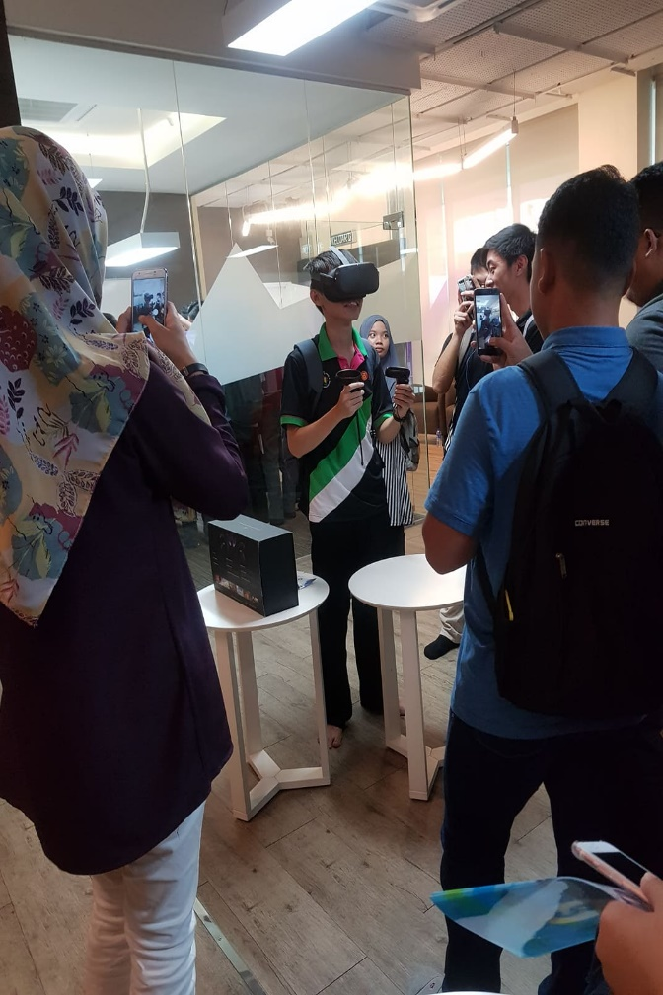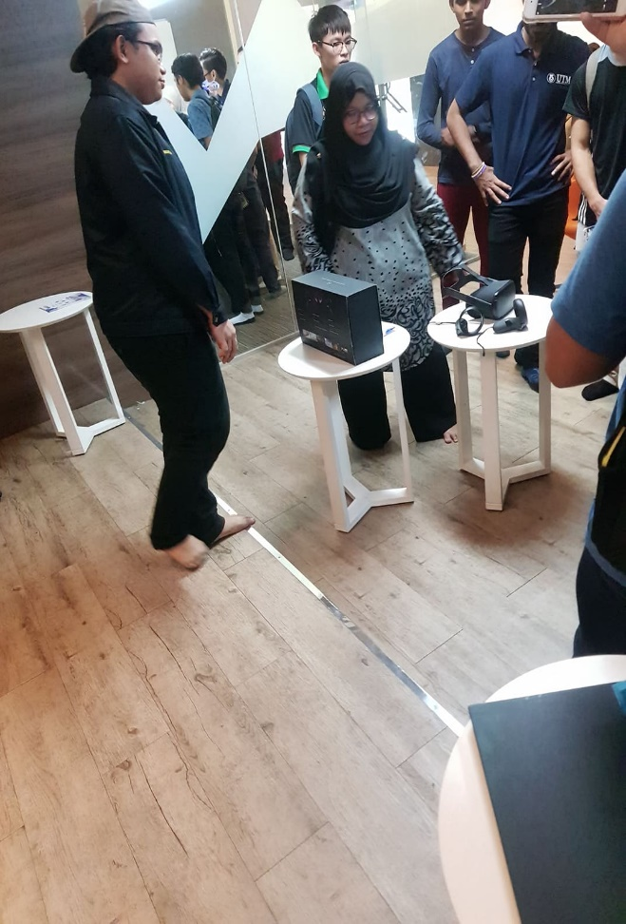

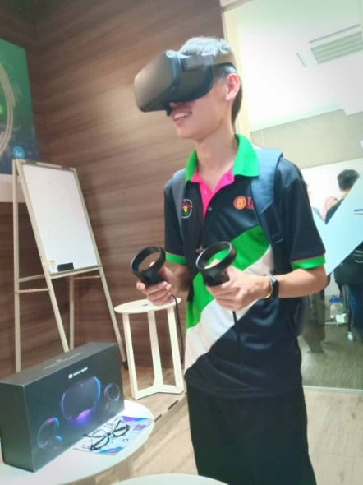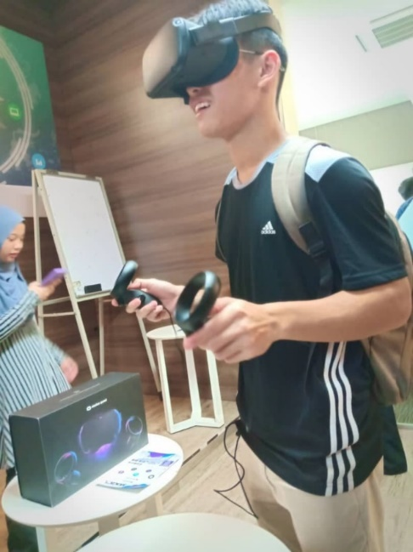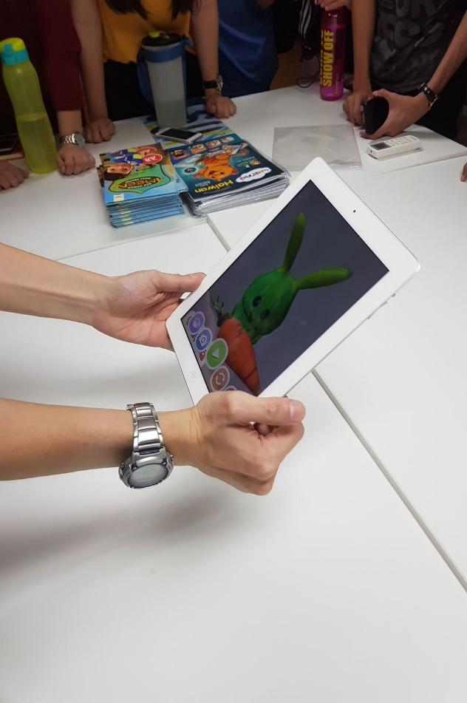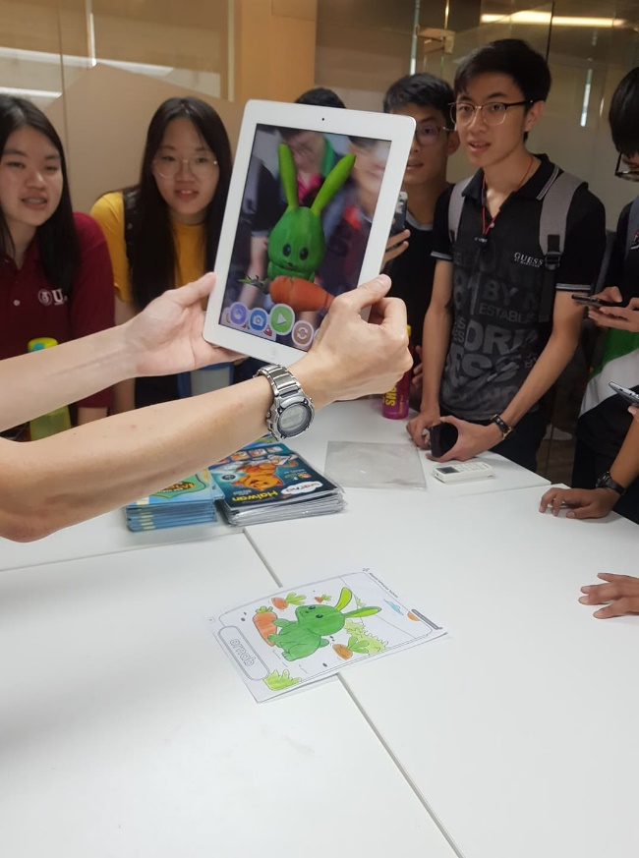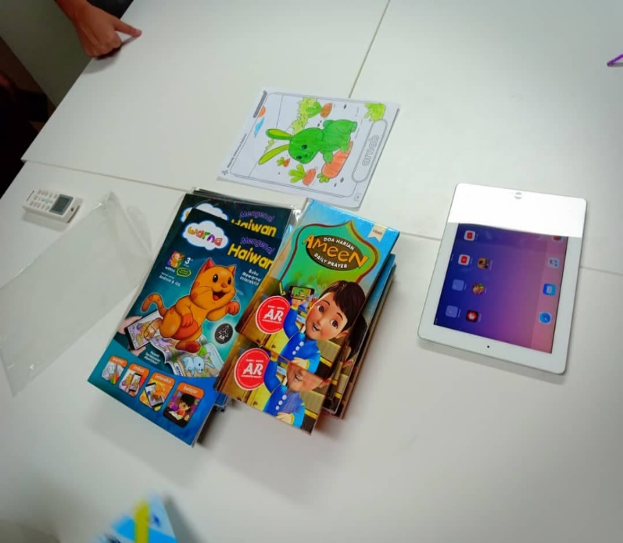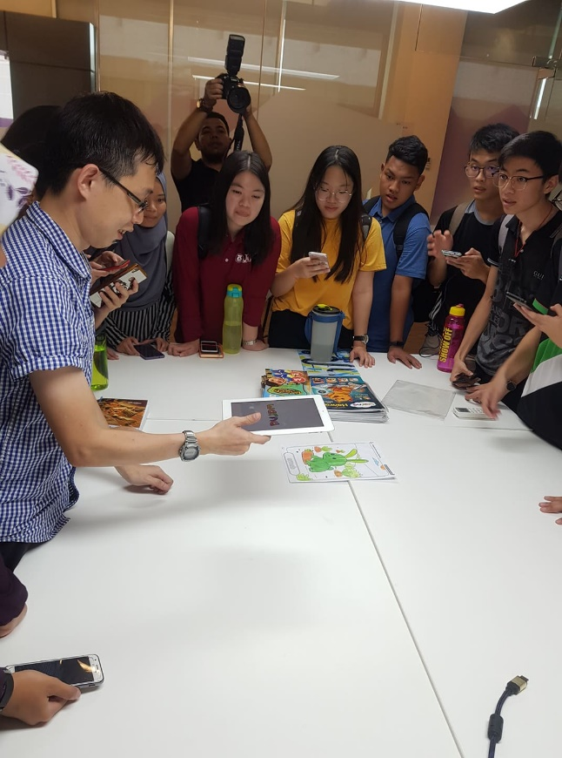

Picture 9: Demo on Oculus Quest

Picture 8: Explanation about Oculus Quest

Picture 11: Demo on Oculus Quest

Picture 10: Demo on Oculus Quest

Picture 15: Demo on wARna

Picture 14: Demo on wARna

Picture 13: Explanation about wARna

Picture 12: Materials for kids learning

**Reflections (Roshan)**

After my visit to MaGICX I realised how important it is to focus on my goal which is to develop an app that would help disabled people at shopping malls and other places to find handicap parkings, toilets and help if it is needed. I realised how important the development of technology and programming is and how it holds the key to better future for our country and the generation to come and it is so amazing to see how our technology has developed to such a stage that it is able to save time, money and even resources.

The visit has opened my eyes to so many possibilities for the future and what can be improved and done in the years to come. An idea that is generated into an invention that years ago people thought was barely possible and how it has helped the industry and the world. There are definitely lots of room for improvement. For examples the funding and handling of equipment has to be better. There is also need for more manpower and resources to continue to carry out the research and development of these programs and inventions.

**Reflections (KOH XIN YI):**

The 3D printing reduces the cost of labour and machine. Manpower is replaced with the 3D printer. The costs of 3D printing are significantly cheaper compared to other manufacturing methods. Other than that, the 3D printing saves the source of the world as it only spends the fixed amount of material to produce a product.

After this visit, I felt impressed with the achievement of my senior in UTM. They complete the project successfully during their studies. The projects can tell tough and need to spend a lot of time and sweat to complete it. Although it still has some defect on the project, their contribution should not be neglected. This motivated me to study harder and try to devote my energy to achieve some accomplishment in my study in UTM.

**Reflections (LYNNDA)**

It was a great experience for me to visit the MAGICX I had a chance to try on some on the invention they made. It makes me realize how many things my course I entered can invent to contribute to everyone.

Before I came to the MAGICX, I thought my course was just only going to learn on develop a mobile or PC games such as PUBG, MOBA, or Need For Speed. But then, it is more than that. The project handled by MAGICX is quite thought because everything is in 3D and very interesting. I hope one fine day I could join the MAGICX and make a new project and focus more on education not only just for kids but also for secondary students and help them to study with a new interesting way. But before that, I have to need to study hard and pass my degree.

**Reflections (NG JING ER):**

Creating my own games and applications that follow the trend of innovations always a dream or goal for me to achieve. I use to imagine that one day, perhaps if I could create inventions that will benefit the people. And these inventions not only enhancing the quality of our life, but also help to reduce the problems faced by humankind.

Through the visit to MAGICX, I think the part that impressing me the most is the stunning working environment. As a good work environment may affect our moods, behaviors, and even our working performances. MAGICX provides a comfortable and flexible working environment which deeply inspire me. Especially there’s a group of members that keen to learn and doing research on innovative technologies.

It’s clearly that those goals need a lot of professional skills. As I haven’t reached the state of “professional”, I have to put more effort and gain more knowledges about these aspects. Only higher education and critical skills enable me to achieve my goals.

**TASK FOR EACH MEMBER**

|  |  |  |
| --- | --- | --- |
| **No.** | **Members** | **Task** |
| 1. | NG JING ER | Explanation on AR and VR |
| 2. | KOH XIN YI | Explanation on exhibition 3D printing |
| 3. | NUR LYNNDA BINTI ROSLAN | Explanation on Kinetic Interactive Wall, Compile |
| 4. | ROSHANDEV DANIEL | Explanation on Driving Simulator, Introduction |

**References:**

1. <https://ihumen.utm.my/magicx/project/mosti-interactive-wall/>
2. Design Studio. (2019). Retrieved from <http://engineering.utm.my/mechanical/laboratory/facilities/design-studio>
3. 2. Florian Gehrke. (2019, Aug 20) 2019 FlashForge Creator Pro – Review the Specs. Retrieved from https://all3dp.com/1/2019-flashforge-creator-pro-review-the-specs/