**An Evaluation of Cloud Computing Service Providers**

Amirul Shafiq Bin Amirrullah1, Natasya Nadhira Binti Ahmad Nazrain1,

Hafiz Surya Nugraha1,

1 School of Computing, Faculty of Engineering,  
Universiti Teknologi Malaysia, Johor, Malaysia

[amirulshafiq@graduate.utm.my](mailto:amirulsyafiq@graduate.utm.my), [natasyanadhira@graduate.utm.my](mailto:natasyanadhira@graduate.utm.my),

[hafiznugraha@graduate.utm.my](mailto:hafiznugraha@graduate.utm.my)

**1 Introduction**

In this era of Industrial Revolution 4.0, Cloud computing is one of the trends that has rapid growth in users and demands. Cloud computing is a service provided by the other company as a place to store data online that can be accessed over the Internet. This rise of technology came by its ease of use to the clients as the cloud service is managed by someone else. It is also available on-demand by subscription basis and it can come in two types of cloud; private and public. Currently, cloud computing is more attractive for collaboration, development and testing, and backup storage. There are a lot of different kinds of cloud computing that are tailored through our needs, thus choosing the right one can make our life more effortless. The main objective of this paper is to analyze the three main cloud service providers and evaluate which is the best for us, young developers.

This paper is organized into 7 sections. The first section outlines the overview and introduction of this paper. Section 2.0 describes the background of Cloud Computing. In section 3.0, reviewing 3 types of cloud models. Section 4.0 is reviewing the differences of cloud services. Section 5.0 is discussing the comparison of the three leading cloud service providers. For the evaluation of the best cloud service provider to be chosen, it will be discussed on Section 6.0. The last section is presenting the conclusion of this paper.

# 2 Background of Cloud Computing (definition, evolution of cc, importance)

This paper is organized into 7 sections. The first section outlines the overview and introduction of this paper. Section 2.0 describes the background of Cloud Computing. In section 3.0, reviewing 3 types of cloud models. Section 4.0 is reviewing the differences of cloud services. Section 5.0 is discussing the comparison of the three leading cloud service providers. For the evaluation of the best cloud service provider to be chosen, it will be discussed on Section 6.0. The last section is presenting the conclusion of this paper.

# 3 Cloud Models (public,private, hybrid, community)

This paper is organized into 7 sections. The first section outlines the overview and introduction of this paper. Section 2.0 describes the background of Cloud Computing. In section 3.0, reviewing 3 types of cloud models. Section 4.0 is reviewing the differences of cloud services. Section 5.0 is discussing the comparison of the three leading cloud service providers. For the evaluation of the best cloud service provider to be chosen, it will be discussed on Section 6.0. The last section is presenting the conclusion of this paper.

# 4 Cloud Services

Cloud computing is offered through three levels of services, which are Software as a Service (SaaS), Platform as a Service (PaaS) and Infrastructure as a Service (IaaS) [2]. A provided program running at a data center in a SaaS cloud is delivered to many end-users or organisations on demand as service instances in real time. Communication, teamwork, corporate processes, customer relationship management (CRM), enterprise resource planning, and human resources can be supported by SaaS applications. Example of a SaaS paradigm is Google Apps.

Usually, PaaS is a low-level applications suite, offering a framework for development and implementation at the application level. It is provided to developers as a service to promote the entire life cycle of applications without the requirement to buy traditional business management equipment and infrastructures, such as a platform for virtualization. Middleware, databases, and programming tools can be used in the low level software, via an API and specific programming languages (Java, C#, or Python). As part of virtualization over the Cloud, the API allows users the opportunity to harness unique platform functionality. Microsoft Azure, Google AppEngine and Amazon Web Services are examples of PaaS infrastructure models.

IaaS offers a suite of virtual hardware and related applications to end-users and organisations as resources over the IaaS cloud. Servers, file networks, routers, and switches are part of traditional virtual hardware. The related functionality provides tools for displaying the features of the virtual OS world and file system over the Cloud. Examples of IaaS offerings are Amazon EC2, Google Cloud Platform and Microsoft Azure.

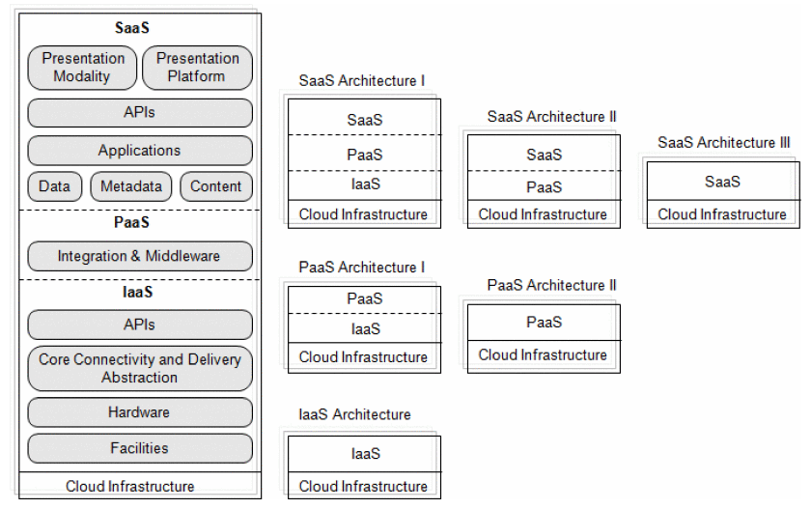

**Figure 1**. The overview of Cloud Computing service model architecture

# 5 Cloud Computing Service Providers

Big technology companies, such as Google, Microsoft and Amazon have their own ecosystem of networks for cloud computing. They are known to be cloud computing service providers, such as Google Cloud Platform (GCP), Microsoft Azure and Amazon Elastic Compute Cloud (Amazon EC2). Each of these services has their own unique purposes and offers to the end user, developers, system administrator and companies.

**Table 1**. Comparative evaluation of Google Cloud Platform, Microsoft Azure and Amazon EC2

|  |  |  |  |
| --- | --- | --- | --- |
|  | **Google Cloud Platform [3][4]** | **Microsoft Azure [3][8]** | **Amazon EC2 [3][9]** |
| Service model | SaaS (Google Apps), PaaS (Google AppEngine) and IaaS (Google Compute Engine) | PaaS and IaaS | IaaS |
| Virtual Machine instance types. | micro, small and medium | micro, small and medium | nano, micro, small, medium and large (general purpose VM) |
| Storage | 4 different storage options available (up to 5 TiB) | Azure File Storage | Amazon Elastic File System |
| OS environments offered | Linux Distributions, Windows Server, Supported operating systems (google.com[)](https://cloud.google.com/migrate/compute-engine/docs/4.8/reference/supported-os-versions) | Linux Distributions,  Windows Server,  Guest operating systems supported | Microsoft Docs | macOS Mojave, macOS Catalina, Mac mini, Linux Fedora and Windows Server. |
| Security | Granular IAM permission | Azure Security Centre | Shared responsibility model |
| Performance and Scalability | Can handle peaks and dips in traffic with excellent performances. | Auto scale according to the demands of the application usage. | great performance and scalability in auto-scaling as its main feature. |
| Pricing model | Free tier, “pay-as-you-go”. | Free tier, Azure Hybrid Benefit, “pay-as-you-go” | On-demand, spot reserved, or per-second instances |
| Auto-scaling / Elasticity | flexibility of auto-scaling at adjusting capacity to meet demand. | built in auto-scaling that can automatically increase or decrease the instances running on the VM. | computing capacity automatically adapts to the site traffic. Mechanism is scheduled based and rule-based |
| Monitoring tools / service provided | Compute, Networking, Storage Databases Big Data, Machine Learning, Identity and Security, Management and Development Tools | Virtual Machines, Azure SQL, Azure Cosmos DB, Azure Kubernetes Service (AKS), Azure Quantum and Azure Cognitive Services | Monitoring tools are Dynatrace and Amazon CloudWatch |

# 6 Cloud Service Provider for Software Development

**Selected Cloud Service Provider for Software Development**

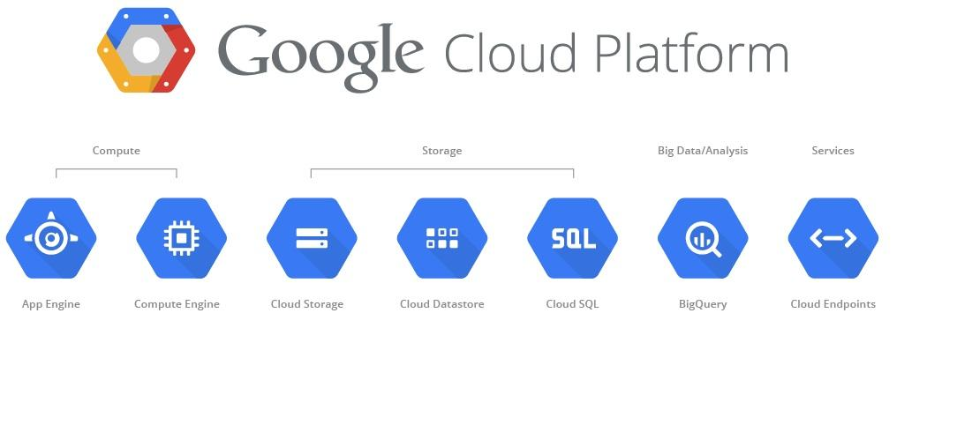

**Figure 9**. Google Cloud Platform Overview

Google Cloud Platform is a Cloud Computing service product from Google consisting of 4 types of services, all of which aim to create a project based on Cloud Computing / Cloud Based Computing in order to be utilized on a global scale. The 4 types of services are Google AppEngine, Google BigQuery, Google Compute Engine and Google Cloud Storage.

* Advantage of Software as a Service(Google Cloud Platform)

It is using Google cloud Platform services that allows us to have highly guaranteed data security. Flexible,Wherever we are we can access the data we store in Google Cloud easily and all we need to provide is internet access. Have an excellent centralized storage. Google Cloud services can reduce the cost of procurement of system infrastructure needed to build an application for our business in long-term.

* Disadvantage of Software as a Service (Google Cloud Platform)

Expensive price, comparable to the quality and performance of the server. Does not support sending Email, especially Port 25, so must increase the budget for smtp relay service rental.

Discussions

By creating this task, we gained complete and comprehensive basic knowledge about cloud service. Starting from the definition of cloud computing to examples of its application in this day and age. We now fully understand its advantages and the disadvantages of every type of cloud services and would be able to discuss more detail about the best type of cloud service providers that we have learned of.

Opinions

There are other unobtrusive arrangements that a cloud supplier can choose to put resources into however the vast majority of them are normally shrouded in the three fundamental branches momentarily presented previously. We will be seeing more insights concerning distributed computing in this arrangement and we trust it will be a brilliant encounter.

# 7 Conclusion

In conclusion, cloud computing is recently as of late new mechanical advancement that can possibly greatly affect the world. Cloud computing is a combination of several computer technologies in a network with internet-based development that has the function to run programs or applications through it.

Computers are connected at the same time. Information stored on the Internet, which is enabled as a server, is permanent. While the data or information stored on the computer of the users is temporary. The benefit of cloud computing is that all data is stored on servers that allow user data to store data centrally and does not need to provide infrastructure. The problems include management in education using cloud computing-based e-learning in terms of learning content management, performance management checks, student management, instructor workload management. The difference between campus and distance education is due to the limitations on e-learning for lab-based education due to computing power. Cloud computing systems deploy modern education systems, therefore for schools, and colleges must take into account a variety of items such as the cost and delivery of fast services useful for learning services, and privacy concerns. The world of education faces challenges in providing the necessary support for educational activities, research and environmental development.

**References**

1. Challita, S., et al. A Precise Model for Google Cloud Platform. in 2018 IEEE International Conference on Cloud Engineering (IC2E). (2018)

2. Bojanova, I. and A. Samba. Analysis of Cloud Computing Delivery Architecture Models. in 2011 IEEE Workshops of International Conference on Advanced Information Networking and Applications. (2011)

3. Aljamal, R., A. El-Mousa, and F. Jubair. A comparative review of high-performance computing major cloud service providers. in 2018 9th International Conference on Information and Communication Systems (ICICS). (2018)

4. Google Cloud Platform. Google Cloud Computing Hosting Services & APIs | Google Cloud Platform, [online] Available: https://cloud.google.com (2017)

5. Kelsey Taylor. Advantages and Disadvantages of IaaS. HiTechNectar, [online] Available:https://www.hitechnectar.com/blogs/advantages-disadvantages-of-iaas-explained/#:~:text=Infrastructure%20as%20a%20service%20(Iaas,on%20maintenance%20and%20software%20upgrades.

6. Jason Hoffman. Advantages and Disadvantages of PaaS You Need To Know. WisdomPlexus. [online]. Available: https://wisdomplexus.com/blogs/advantages-disadvantages-paas/

7. NIBusinessInfo.co.uk. Advantages and disadvantages of Software as a Service (SaaS). NIBusinessInfo.co.uk.[online].Available: https://www.nibusinessinfo.co.uk/content/advantages-and-disadvantages-software-service-saas

8. Microsoft Azure. Cloud Computing Services | Microsoft Azure, [online] Available: https://azure.microsoft.com/

9. Amazon EC2, [online] Available: https://aws.amazon.com/ec2/