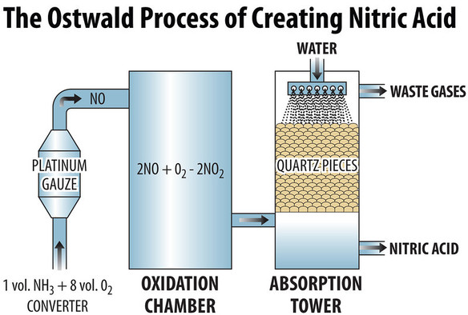

The **Ostwald process** is a [chemical process](https://en.wikipedia.org/wiki/Chemical_process) for making [nitric acid](https://en.wikipedia.org/wiki/Nitric_acid) (HNO3).

Ammonia is converted to nitric acid in 2 stages. It is [oxidized](https://en.wikipedia.org/wiki/Redox) by heating with [oxygen](https://en.wikipedia.org/wiki/Oxygen) in the presence of a [catalyst](https://en.wikipedia.org/wiki/Catalysis) such as [platinum](https://en.wikipedia.org/wiki/Platinum) with 10% [rhodium](https://en.wikipedia.org/wiki/Rhodium), to form [nitric oxide /nitrogen(ii)oxide](https://en.wikipedia.org/wiki/Nitric_oxide) and [water/steam](https://en.wikipedia.org/wiki/Water). This reaction is strongly [exothermic](https://en.wikipedia.org/wiki/Exothermic_reaction), making it a useful heat source once initiated:[[3]](https://en.wikipedia.org/wiki/Ostwald_process#cite_note-jones1-3)

4 NH3 (g) + 5 O2 (g) → 4 NO (g) + 6 H2O (g) (ΔH = −905.2 kJ/mol)

Stage two encompasses two reactions and is carried out in an absorption apparatus containing water. Initially nitric oxide is oxidized again to yield nitrogen dioxide/nitrogen(iv)oxide.[3] This gas is then readily absorbed by the water, yielding the desired product (nitric acid, albeit in a dilute form), while reducing a portion of it back to nitric oxide:

2NO (g) + O2 (g) → 2 NO2 (g) (ΔH = −114 kJ/mol)

3NO2 (g) + H2O (l) → 2 HNO3 (aq) + NO (g) (ΔH = −117 kJ/mol)

The NO is recycled, and the acid is concentrated to the required strength by distillation.

4NO2 (g) + O2 (g) + 2 H2O (l) → 4 HNO3 (aq)

Typical conditions for the first stage, which contribute to an overall yield of about 98%, are:

* [pressure](https://en.wikipedia.org/wiki/Pressure) is between 4–10 standard atmospheres (410–1,000 kPa; 59–150 psi) and
* [temperature](https://en.wikipedia.org/wiki/Temperature) is about 870–1,073 K (600–800 °C; 1,100–1,500 °F).

A complication that needs to be taken into consideration involves a side-reaction in the first step that reverts the nitric oxide back to N2:

4NH3 + 6NO → 5 N2 + 6 H2O

This is a secondary reaction that is minimised by reducing the time the gas mixtures are in contact with the catalyst.