

# (UHLM 1012)

**TAJUK**

**REFLECTION LOCAL FRUIT**

**AHLI KUMPULAN NO. KAD PENGENALAN**

1. MUHAMAD RAFLY A19CS5073
2. IQBAL MUZAKKI A19CS5049
3. SYAFA ILYAS AL MUZANI A19EC0288
4. MUHAMMAD IRFAN HILMI A19EC0263

LOCAL FRUIT

Pisang

 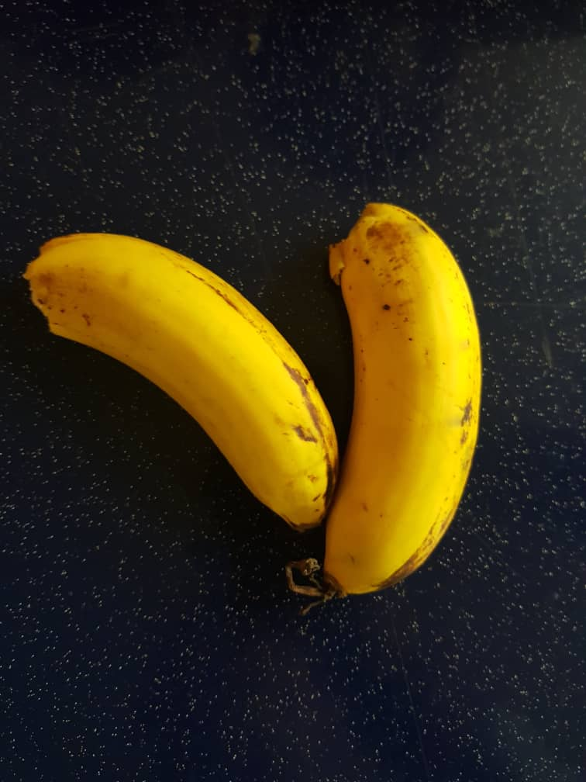

Pisang is a local fruit from malaysia my group found this fruit in Pejabat kolej KTR in K01 they are sold this fruit amount 50 sen per 1 Pisang and this fruit taste so good and this fruit as same like fruit in Indonesia they are called Pisang as same like called from Malaysia and the taste are same like in Indonesia too soo i think Indonesia have a similar local fruit from Indonesia and Malaysia, because we are a neighbor.

In malaysia they have a lot of kind of banana like Pisang Lemak Manis, Pisang Awak, Pisang Tanduk, Pisang Abu, Pisang Helang and so on the best Pisang in Malaysia they people said is Pisang Lemak Manis is the Best pisang they said bcause about the taste so good and delicious and the example banana in the top is a Pisang Emas the taste is good we are like this Pisang after try this fruit I think thats all from group reflection

Thank you.....