

SECP 1013-09

Technology and Information System

New Report:

Inspiring Work Experience & Covid19 Pandemic Challenge

Lecturer : Dr. Sarina Sulaiman

Leader : Lee Qing Ren

Members : Arvind

Heedayah

Raghid

------------------------------------------------------------------------------------------------------------------------------------------------------------------------------------------------------------------------------------------------

------------------------------------------------------------------------------------------------------------------------------------------------------------------------------------------------------------------------------------------------

Inspiring Work Experience & Covid19 Pandemic Challenge

------------------------------------------------------------------------------------------------------------------------------------------------------------------------------------------------------------------------------------------------

------------------------------------------------------------------------------------------------------------------------------------------------------------------------------------------------------------------------------------------------

Lee Qing Ren, Arvind, Heedayah, Raghid, UTM Johor Bahru — Tuesday, Jan 5, 2021 — 2 pages

________________________________________________________________________________________

**Introduction**

Lee Qing Ren

On 29th December, the school of computing alumni sharing session, which was entitled ‘Inspiring Work Experience and Covid-19 Pandemic Challenge’, was held online via webex. It was hosted by Dr. Johanna Ahmad, who is a senior lecturer of school of computing UTM and 4 fresh graduates, Tan Yong Kong, Teo Wen Long, Mohammad Zamarul Akmal Bin Mohd Hussin and Batrisyia Binti Azman Shah had been invited in the sharing session.

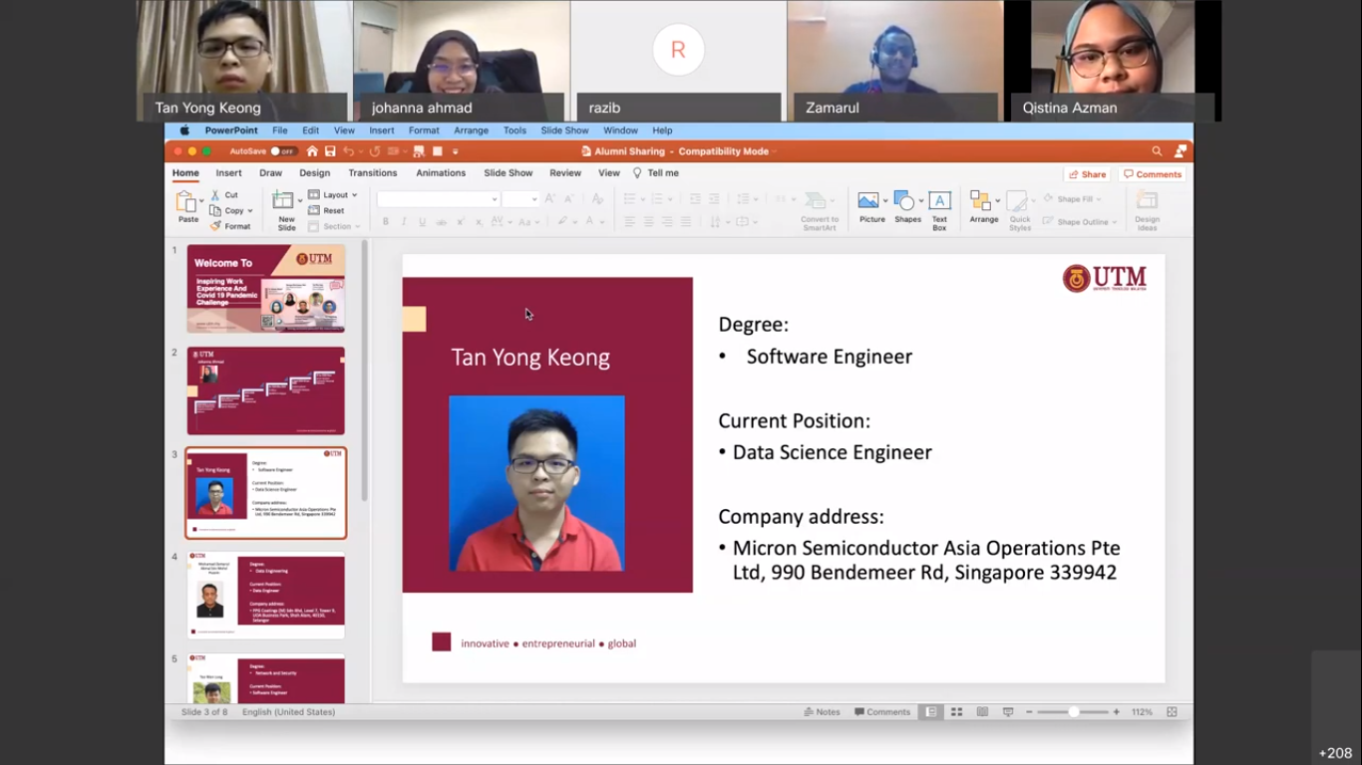

**Inspiring Work Experience**

Lee Qing Ren & Arvind

Tan Yong Kong shared about his experience for getting his current job, a data science engineer in Singapore. In his university life, he was passionate about participating in many competitions and acquired a large amount of achievements naturally. He applied plenty of jobs on the web site, and prepared his upcoming interviews sufficiently. For most fresh graduates, he said, the interviews will mostly ask about the projects and the courseworks they had done during their university life due to the lack of experience. Most importantly, he encouraged us to have a nicely-tailored resume with all the accomplishments and achievements written to get a higher chance to be employed. Besides, he emphasized on the importance of communication skills in the workplace to boost the efficiency of teamwork among colleagues and the importance of participation in events and competitions held in universities.

Mohammad Zamarul got to be hired as a permanent employee during his internship in the company because of his proactiveness in giving ideas. He proposed to create a support dashboard, which is a system to monitor all tasks at once, for the big data environment in the company. Before his proposal, the company used manual monitoring via a big data tool, which is called Talon, to handle all tasks. Therefore, his supervisor began to give more attention to him and tried to absorb him as a permanent staff after his internship. Thus , he did not have to worry about his job after graduating because he had contributed his amazing idea which helped to improve the company’s burden, and it helped him to remain as an employee in the company. He also said that it all depends on the cooperation and collaboration we provide.

Batrisyia is quite similar to Zamarul’s case. She managed to get in the position as social media data analyst in TM One during her internship. She showed her proactive attitude in taking part in the real life project of the company. Her supervisor, who had noticed her eagerness, asked her to join the team after the internship ended to further the project. After joining the team , she had still given her full capability and enthusiasm to the company. This made her want to remain in the job she had been doing during her internship. At last , she did not have to worry about getting a job after graduating because during her internship she had shown and given her full potential towards her career .

**Covid-19 Pandemic Challenge**

Lee Qing Ren

During the pandemic, many encountered challenges to get hired. The host, Dr. Johanna Ahmad, asked about the tips of getting employed during the pandemic. Batrisyia suggested that one has to be proactive in carrying out the task given. For example, proactive in finding solutions without any ado and learning new knowledge from your colleagues. She also advised us to mingle well among our colleagues to get enlightened with new knowledge and get a helping hand from them whenever we ask.

Mohammad Zamarul suggested two tips. The first tip is learning more technical skills, not just the fundamental skills one has learned in the university. During the pandemic, we could take online courses or training programs, such as codecamp, edX and datastar, to learn new technical skills and new programming languages. The second tip is polishing up soft skills. This is because communication skills are important in briefing a project and expressing your ideas into words, otherwise, people would not understand thoroughly and misunderstanding might occur. Meanwhile, soft skills contribute a lot in a team, providing a teamwork environment.

**Tips To Improve Programming Skills**

Arvind

According to the school of computing alumni sharing session, which was entitled ‘Inspiring Work Experience and Covid-19 Pandemic Challenge’, was held online via webex. The alumni speakers which were Tan Yong kong, Mohammad Zamarul and Batrisyia had taught us many information , details and tips to improve programming skills.

Based on Tan Yong Kong’s experience , he was given a tip to improve our programming skills by participating in competitions held in and out of the university. Besides, he had also added that this participation has given him many experiences and ideas to be innovative. By that, he said that he gained enough experience to get ready for his internship. This made him a good programmer before entering the internship.

Well , according to Mohammad Zamarul , he has emphasized that we have to have passion and enthusiasm towards what we are going to do. He said that he was struggling at his first time after starting to program. Because of his passion and enthusiasm , he had the eagerness to learn and thrive in programming . As he said , everybody has their own life problems but it all depends on how we overcome and find a solution for the problems.

Last but not least, Batrisyia who is also a graduate of UTM , has explained how she went through programming all these years in her degree life. Her main point says that we have to learn it by our mind and heart, we must not be waiting for someone else to spoon feed us. We have to go and find the stuff we want, we must not depend on other individuals to do it for us. She had also given a tip to ask the lecturers for guidance if we are not sure what we are heading for. The lecturers will be a great guide for us to improve ourselves. Henceforth , Batrisyia emphasized that we must learn and improve programming skills from the experienced to learn it easily.

**Reflection**

Heedayah & Raghid

From the talk session, there are a lot of new things to learn. Even though the talk is conducted online, alumni shared their experiences and information with students well. To get a stable job in the future, we need to have a strong fundamental knowledge about the field that we are going to work in. It is not only technical skill needed but soft skill is also needed because when we are working we work in a team. We need to meet a lot of people and learn from them. Despite our excellent education, skill is the key to working. As a student, we can participate in a lot of activities so we can train ourselves to work in a team and learn a new skill that gives advantages to us. Besides, gaining confidence by a volunteer to expose ourselves to others. Use time well to prepare ourselves before entering the working field. As long as we can do the job and have a positive attitude there is an opportunity for us to get the job. We need to keep improving and not limiting ourselves. By doing that, we can break the wall and get the job that we want.

The talk session seems very important for us because there are so many new things to learn and reflect. The alumni did a great job sharing the information and explaining the material presented to us. We need to learn and have a strong fundamental knowledge in order to survive and face the real world and have a good enough probability to have a good job in the future. Not only that, but also the importance of teamwork is crucial, because everything we do in the future will involve a team. I am really happy that I can learn a lot from this Industrial Talk, it makes me more motivated to be more confident and to be more active. And because those who spoke were UTM alumni, they mentioned a lot about their former campus life, this made me very excited.