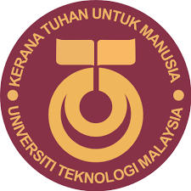

UNIVERSITI TEKNOLOGI MALAYSIA
SCHOOL OF COMPUTING
FACULTY OF ENGINEERING

Group Members | MUHAMMAD ARIFF FANSURI ABDUL RAZAK BIN ROHAIZAD | A19EC0194
 | NOR ARMIRANI BINTI MOHD MAZLAN | A19EC0122
 | LOH YEW CHONG | A19EC0076
Topic | VISIT TO PETRONAS
Date of visit | 11 SEPTEMBER 2019
Place of visit | PETRONAS TWIN TOWERS
Name of Lecturer | Dr ARYATI BINTI BAKRI
Subject | Technology and Information Systems (SCSP1513)
Section | 02
Semester | 1 2019/2020

Table of Contents
Introduction 3
Brief Journey Plan 4
The Journey 5
Graphs and Statistics 7
REFLECTIONS 8
References 9

Introduction

The SECP Data Engineering Class, comprised of 36 students conducted a field trip to the Petronas HQ in the Petronas Twin Towers, located at the heart of Kuala Lumpur on the 11th September 2019. We were accompanied by our lecturers, Dr. Aryati Binti Bakri and Dr. Muhammad Iqbal Tariq bin Idris. All in all, a total of 38 people visited KLCC on that day.
The main purpose of this visit is to study current trends and implementations of Artificial Intelligence and Big Data in businesses today with Petronas providing an inside look of how those technologies are used to augment their operations both in the field and in the office. Providing those insights are the 10 seniors of the SCSP course, who are currently working as interns in Petronas. The information gained from the visit soon proved to be invaluable in our journey to become data engineers.

Brief Journey Plan

Date | Time | Activities
10/09/2019 | 10.00pm | Gathered at Dataran Dewan Sri Resak
 | 10.30pm | Leaving UTM
11/09/2019 | 3.00am | Arrived at UTM in Kuala Lumpur
 | 6.00am | Performed Subuh prayers together
 | 7.15am | Breakfast
 | 8.00am | Arrival at Petronas Twin Towers
 | 8.15am | Visit Petronas
 | 8.45am | Listen to the talk by Petronas’s Group Technical Data (GTD)
 | 10.15am | Meet 10 seniors and visiting the office
 | 11.30am | End of the trip to Petronas

The Journey

At 10th September 2019, we prepared before the trip by assembling ourselves at the parking lot at Dataran Sri Resak, KTDI around 10.00 pm. We were then briefed about the itinerary and stops on our visit to Petronas. At 10.30pm, we began our journey to UTM Kuala Lumpur by bus.
The next day, we arrived safely at UTM Kuala Lumpur. We rested for a moment and prepared ourselves before visiting the Petronas. We then had a breakfast at a cafe in UTM, Kuala Lumpur. After that, all of us began to head out to the Petronas Twin Towers around 7.15 am.
We arrived at the Petronas Twin Towers at 8.00 am. Entering the lobby, we were greeted by the sight of the expansive main lobby of the Petronas head office. However, to enter the offices themselves were nigh-impossible without a visitor card, which we obtained from the receptionist that registered out details to their database.
At 8.15 am, we started our visit. We entered the lift and make to 22nd floor. There, we had some refreshments that was prepared, courtesy of Petronas. There were cookies and a beverage machine that dispensed hot chocolate and coffee.
After that, the Group Technical Data (GTD) leader then proceeded to give us a talk about Petronas and the GTD at the Petronas Digital Collaboration Centre. But first, the Petronas safety personnel played us a safety brief video on evacuation routes, emergency assembly zones, Automatic Emergency Defibrillator (AED) usage methods and other related information on what to do in a crisis. This clearly indicates that Petronas takes health and safety issues seriously.
Following the safety briefing, Syafiq and Atiqa from the Data Operations Team gave a brief overview of the Group Technical Data (GTD). The GTD is under the purview of Petronas Project Delivery and Technology (PD&T).

The GTD was first established in 1974, back then they were known as data management. In 1984, the data management unit was merged with Petronas Carigali. In 2016, they were finally centralized as the GTD.
The Group Technical Data is primarily the custodian of the entire Petronas technological data, conducting both data analytics and related services for the company. From those data, they can learn lessons from previous operations, come up with insights with experts to form solutions and apply it to their business. This is the main part of the continued success of Petronas.
After the GTD briefing, we were greeted by Akmal from Data Operations. He is a data engineer, primarily tasked to support Surface side operations, that is the on-site oil extraction efforts. Data engineers like him perform data capture, data inventory checking for quality control purposes, and prepare the data for delivery for technology forecasting in Production Operations. He noted the qualities that every data engineer needs, chiefly SQL skills for all their database needs, as they deal in sensitive data that is in-house and stored in secure, air-gapped storage to prevent theft of valuable company information. He also described the job as 70% data preparation, 30% data analytics, so he urged new graduates to develop more problem-solving skills to develop new solutions and utilize automation, pattern-based analysis to aid in handling the large amount of data stored.
Next up, the achievements of the GTD in Petronas were proudly displayed, with the efforts of the GTD resulting in around 70PB of data stored in their databases worth RM80 billion. They also have contributed to around RM5.3 billion in savings just by the insights produced by data analytics, RM 3.4 billion gain in Production and Distribution by optimizing their delivery methods.
We then met our seniors in the Petronas offices. There currently 10 seniors that interning at there. The SCSP interns shared their experience working in Petronas for a week. They shared their feelings and what they faced during their internship there for one week. According to them, we as a data engineers, we will frequently explore to new thing so don’t give up easily. We had a Question and Answer section with them. Afterwards, we were given a tour of their working spaces.

Graphs and Statistics
Petronas Corporate Structure
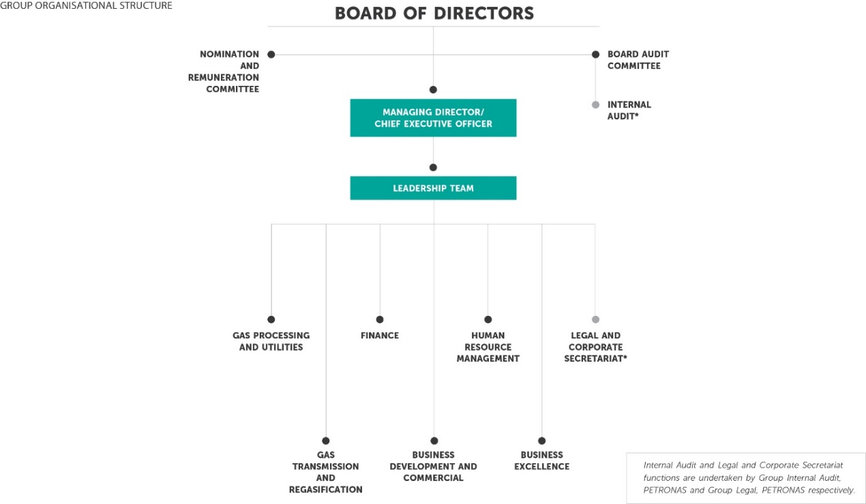 (Petronas, 2017)

GTD Achievement
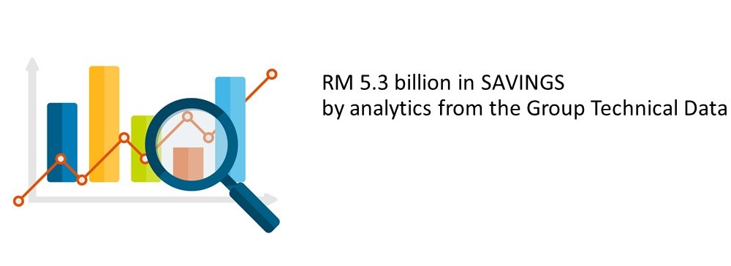

REFLECTIONS

This visit to Petronas opened my eyes to what data engineering is, what it does and what it will be. Firstly, data engineering is a part of computer science where the engineers handle a massive amount of data and find a pattern to deliver accurate predictions in business. For them to do that, they must be capable of using a lot of tools and industry specific skills such as data sifting, data analysis, and information presentation. Additionally, the visit has allowed me to meet with the seniors currently working under internship at Petronas.
Other than that, this visit has opened my eyes and enabled me to see the bigger picture on what I will work on when under an internship or after I graduate. After the visit, I decided to be a data scientist because being one lets me answer the government’s call to have more data engineers and practically, it has a higher average income. The talks during the visit did tell me a lot about data and I realized that maybe I am ready to be a data engineer because data engineers will be dealing more in the business side. As I know, I can continue my master’s in data science, so I intend to apply for the master when it is right for me. I believe I am in the right track although I take a Bachelor of Computer Science (Data Engineering) for now because I can learn more about programming and the skill that a data scientist may have.
To improve my employability in the industry, I will need to learn and master programming languages such as Python, R, JAVA etc. After the visit, I am very interested to do my internship at Petronas, so I will brush up my Python skills because according to interning seniors there, Python is widely used at Petronas. Besides that, I will try to master other languages such as C++, JAVA, RUBY. I plan to master those languages that I will learn in my course first, and then I will master Python. Besides those languages, I will also need to master some useful industry standard tools like Apache Hadoop, Apache Spark, SQL etc. Other than these technical skills, I will also need to improve my soft skills that include communication skills, stress management, time management, decision making, conflict management, leadership, interpersonal skills and public speaking.
For me, this industrial visit gave us a chance for to explore more about our future career as data engineers as it was very informative. I admit that I initially thought it was not a well-known nor popular course, but during this visit I realized that data engineers are indeed in high demand now in Malaysia. However, there’s a lot of other graduates with similar degrees in Malaysia so in order to achieve my dream as a data engineer, I need to compete with them. This visit to Petronas enabled me to know what I need to learn and improve from the companies themselves in order to be a better data engineer. By collecting the information that we get, we can know what we can do or learn to be a better person so that we can achieve what we want. So, this kind of industrial visit gives many advantages to us, as it gives us valuable goals to achieve.

References
Petronas. (2017, October 4). Petronas. Retrieved from Petronas website: https://www.petronasgas.com/aboutus/Pages/cs.aspx

