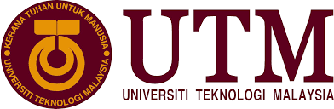

**SECP1513-06**

**Technology and Information System**

**Industrial Visit 1 – CICT UTM REPORT**

**Lecturer: Dr. Aryati binti Bakri**

**Group members:**

1. **Nursyahidatul Asyiqin binti Yusof**
2. **Qudri Ameer bin Mohd Safiee**
3. **Sharmarke Hussien Ibrahim**
4. **Nurul Aqilah binti Ahmad**

Contents

**INTRODUCTION 3**

**DETAILS OF THE VISITS 4**

**THE ANCIENT COMPONENTS 5**

**REFLECTIONS 11**

**TASK FOR EACH MEMBERS 13**

# **INTRODUCTION**

To begin with, this report is about our observation and understanding regarding the revolution of technology devices. It is also about the details of the functions of the ancient components.

The point of making this report is to display and lay out the outcome of our monitoring and what we understand about the changes that were made to the technology devices.

The main purpose of the visits is to expose us with how well the technology have advanced since technology undergoes changes from time to time and becoming better in aspect of features, size, shape and usage. It is important to upgrade the devices so that it will ease the user.

# **DETAILS OF THE VISITS**

The first industrial visit was carried out on Sunday, 20th October 2019. It was held at Galleria, located in Sultanah Zanariah Library (Perpustakaan Sultanah Zanariah) / (PSZ) as a replacement for Industrial visit at Information and Communication Technology (CICT). The visit started from 3.15 p.m. until 4.00 p.m. at level 2 of the PSZ and section that were involved were Section 5 and Section 6.

Inside the library, there is Galerium UTM, where our actual place visit was held and all the collection of old components technology are being kept such as the evolution of computers. Encik Zahari bin Zainal Abidin, who conducted the visits, he showed to us the details of evolution of components computers and explain it well in the easy language so that everyone can have better understanding. At the same time, he made a simple comparison about latest technology and the old one so that we as students, could see the changes happening in our technology era from the time being. Besides, we were also given a simple information on how some of the devices works during that period of time.

# **THE ANCIENT COMPONENTS**

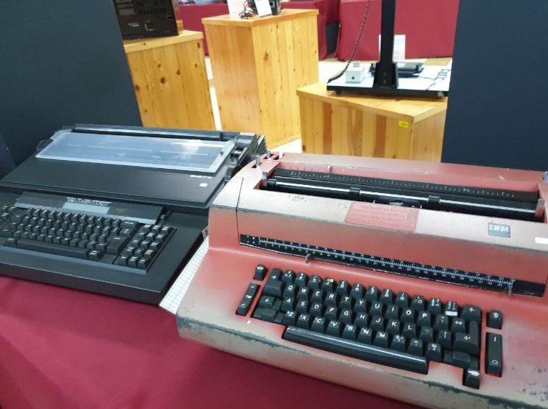

Figure

Figure 1 shows a typewriter. Before the idea of inventing the computers in 1985, these typewriters were used during 1970s until early 1980s to do management or organizational tasks such as typing official letters and memos.

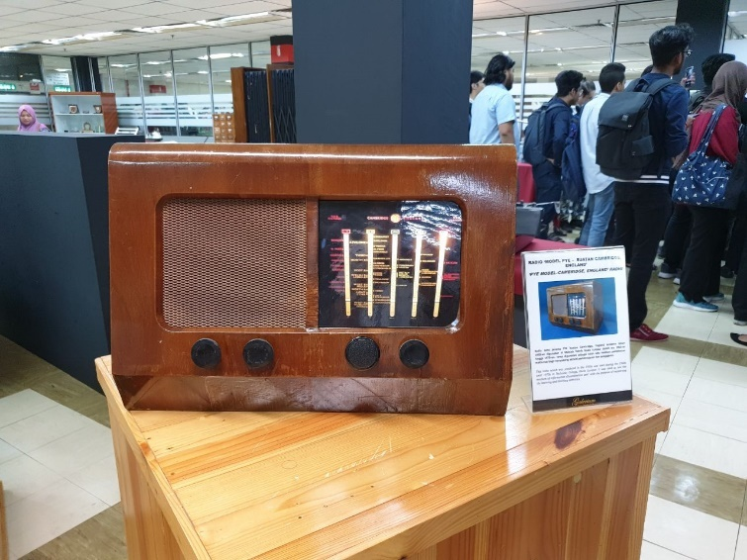

Figure

Figure 2 shows ‘PYE model-Cambridge, England’ Radio. This radio was invented in 1950s but was used from 1960s to 1970s in Technical College that was located in Kuala Lumpur. It was used as one of the methods to spread information. Other than that, it was also used in learning and teaching activities.

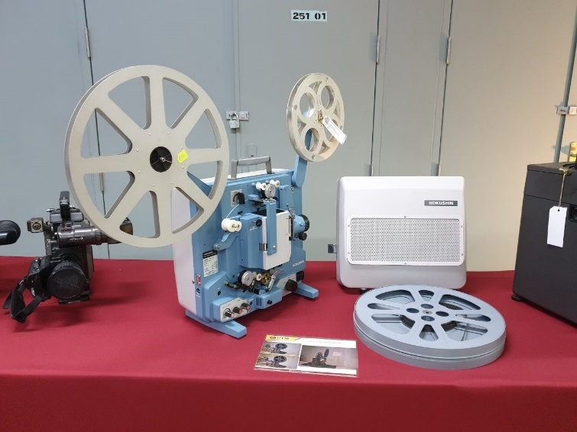

Figure

Figure 3 shows a film projector 16MM Hokushin. This device was used during 1980s until 1990s as one of the mediums used in learning and teaching activities.

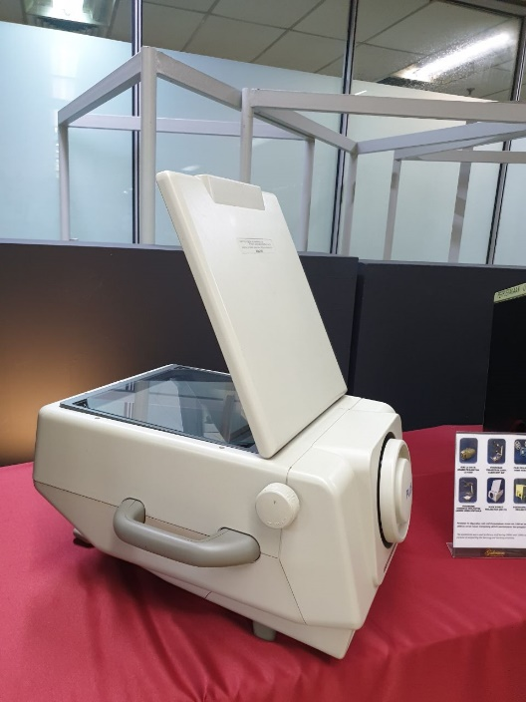

Figure

Figure 4 shows Plus Director Projector – DP-10. Projector is an optical equipment that projects images onto a flat surface to display the images. This tool was used from 1980s until 1990s as one of the mediums used in learning and teaching programmes.

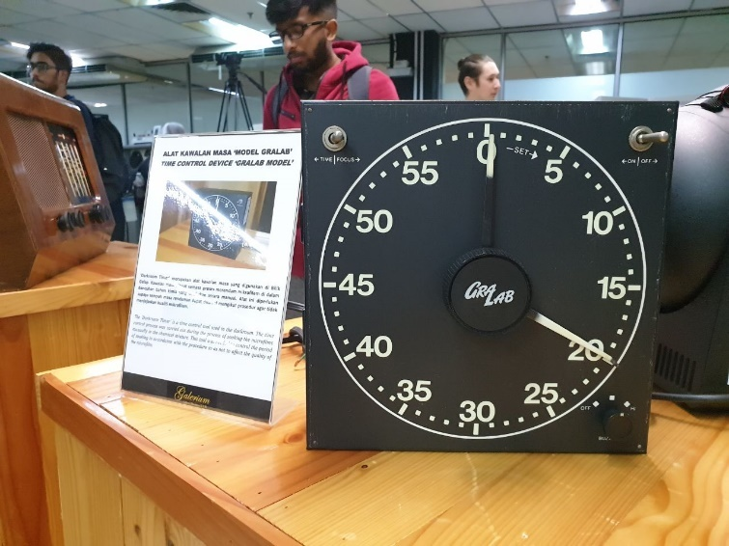

Figure

Figure 5 shows Time Control Device – ‘Gralab Model’. Also known as The ‘Darkroom Timer’, it is a time control equipment used in the dark room. The time control process was carried out during the process of soaking the microfilms manually in chemical composition. This equipment was needed to control the time of soaking the microfilms but still not affecting the quality of the microfilm.

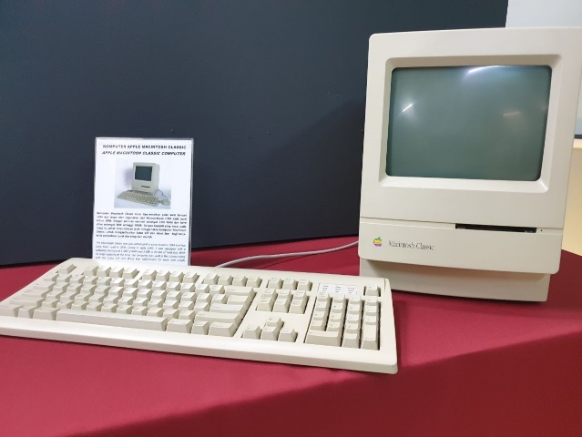 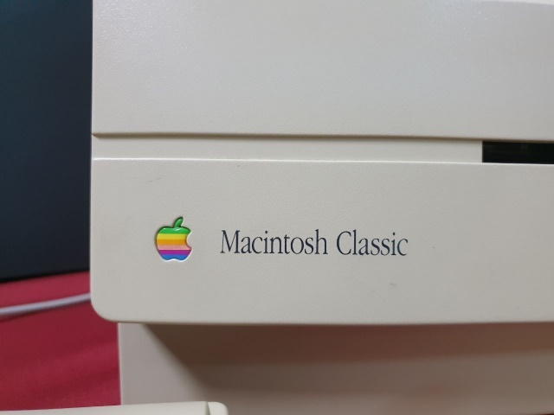

Figure Figure

Figure 6 and 7 shows Apple Macintosh Classic Computer. This computer was first introduced in early of January 1984. It was supplied with a software memory of 1MB of RAM and 2MB to 40MB of hard disk which was considered as large capacity at that time.

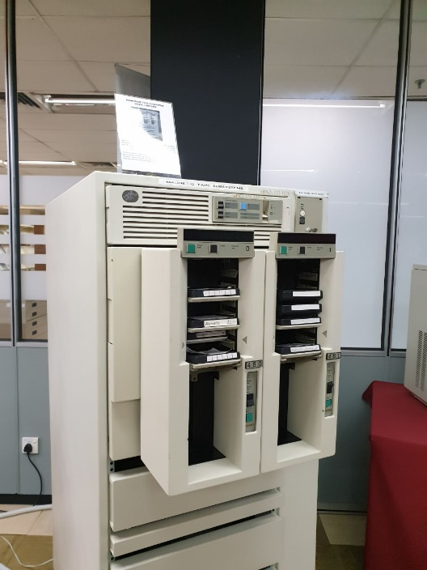 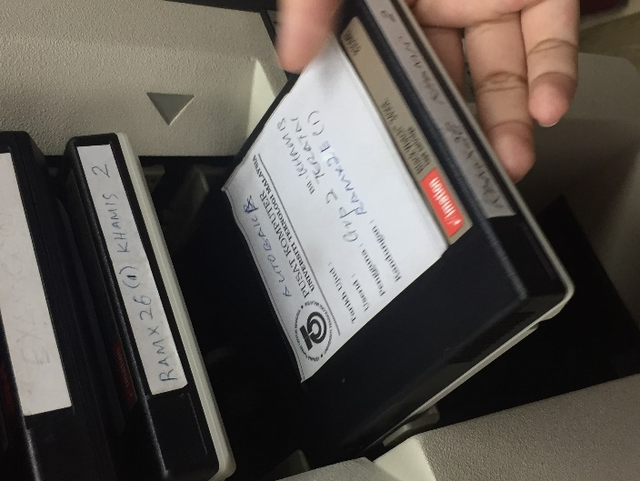

Figure Figure

Figure 8 and 9 shows Mainframe Tape Subsystem Model IBM 9309. The Mainframe Tape Subsystem was used for mainframe system and information database during the year of 1987 until 1995 before the new technology which was the server was being used. This model used a square-shaped tape. The round-shaped tape was no longer in use. As mentioned by Encik Zahari, the name of IBM is used for commercial purposes.

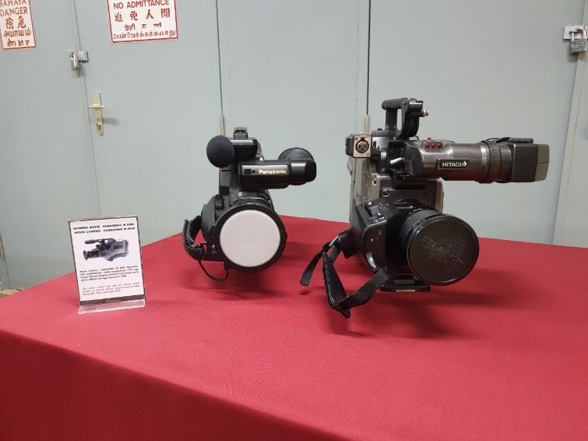

Figure

Figure 10 shows a movie camera – Panasonic M 9000. This camera was used during the 1990s until early of 2000s for Library media service in purpose to record library programmes or activities.

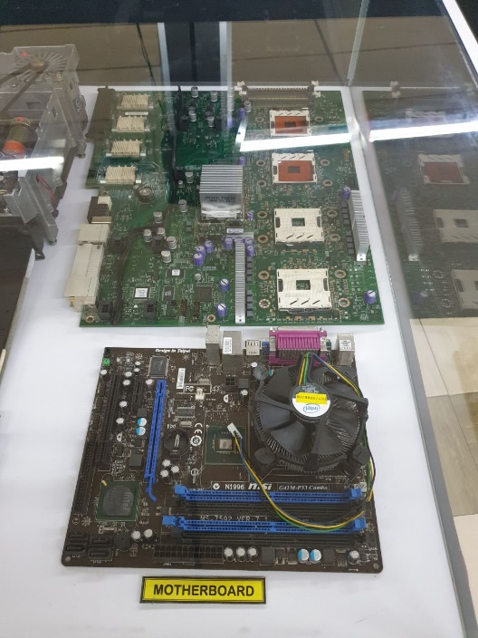

Figure

Figure 11 shows a motherboard. Motherboard is the printed circuit board and is the basis of a computer. The upper motherboard is the first motherboard for the server. It has four CPU so that is why it has four sockets. The smaller motherboard is the current motherboard and has only one CPU.

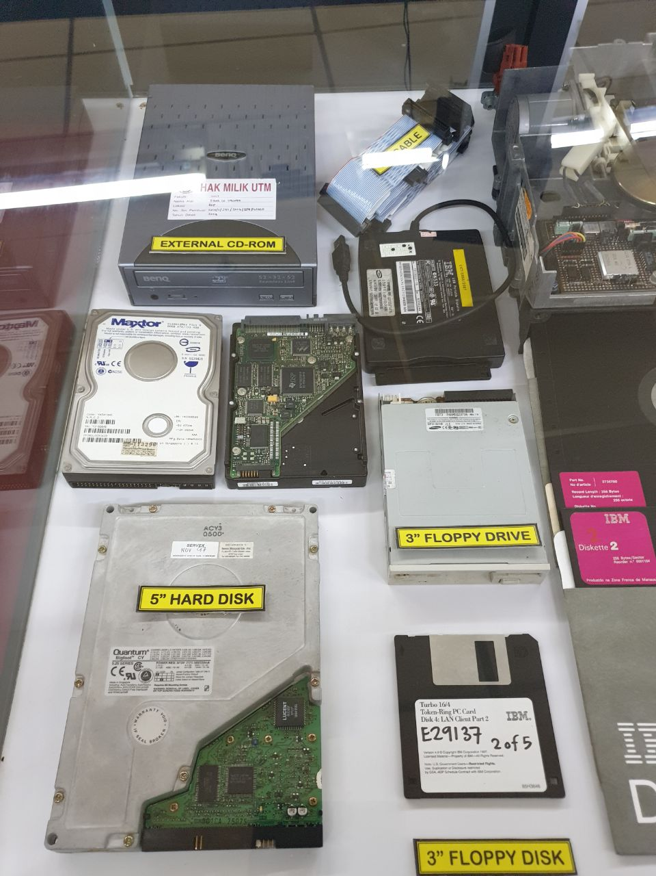

Figure

Figure 12 shows a hard disk. This hard disk is called ‘big foot’ because of its powerful function. Even if this hard disk is cracked, the data will be remained in there.

# **REFLECTIONS**

*Nursyahidatul Asyiqin binti Mohd Yusof:*

With regard to ‘Technology and Information System’ subject, my goal is to improve the computer science industry by making modern and advanced technology such as a new software. Since I had seen all the old components, I understand more detailed about the components of computer history and have a broad exposure to computer system. To work in this Computer Science industry, knowledge of computer system is very important. From time to time, technology becoming more advanced across the science thus, human must think in line with technology development. In conclusion, I must be an up to date person and always think harder to find the problems, solve it and make it better.

*Nurul Aqilah binti Ahmad:*

Regarding to ‘Technology and Information System’ subject, my goal is to do enhancement to the quality of computer science industry by upgrading the existing invention in purpose to ease and smoothen the users’ activities. After the visit, I realized that it is important for me to catch up with the modernization that are happening in this world. It is because I believe it can help others to do difficult and complex job as the world is keep on becoming more challenging. To improve my potential, I will focus more on my weaknesses and find a way to make myself better by upgrading my mindset and create creative idea for better future.

*Qudri Ameer bin Mohd Safiee:*

Regarding the subject of ‘Technology and Information System’ my dream is to help out the world with new technology and machine by improving myself in my education. This industrial visit was exposing some industrial places and unique and stunning technology from ancient times until nowadays which was a great chance for me to gain a lot of knowledge. To be a better version of myself, it is a must for me to appreciate those ancient technology by acknowledging their functions and history.

*Sharmarke Hussien Ibrahim:*

New technology help people a lot in life. It is like all the things that difficult to do become better, faster and convenient than before. Therefore, my goal is to make sure new technology can bring new qualities to the life of human beings. In this visit, I learnt how the technologies had changed our life. In order to build up the quality life of user, we need to see how past technologies and improve the usage of it. So, in purpose to innovate something new and upgraded, I need to think creatively and consider others’ requirements.

# **TASK FOR EACH MEMBERS**

|  |  |
| --- | --- |
| 1.Nurul Aqilah binti Ahmad | -Introduction  -Content  -Reflection |
| 2.Nursyahidatul Asyiqin binti Yusof | -Introduction  -Details of the visit  -Reflection |
| 3.Qudri Ameer bin Mohd Safiee | -Idea for content  -Taking picture and video for report  -Reflection |
| 4.Sharmarke Hussien Ibrahim | -Taking picture and video for report  -Reflection |