SEMESTER 1
SESSION 2019/2020
SECP1513

DESIGN THINKING:
INPUT AND OUTPUT

PREPARED BY:

- NUR ALEEYA SYAKILA BINTI MUHAMAD SUBIAN (A19EC0127)
- IMRAN HAKIM BIN NORASMADI (A19EC0189)
- INTAN MARINA BINTI SULAIMAN (A19EC0053)
- HERTHIK PRATHABAN (A19EC0049)

LECTURER'S NAME: DR. ARYATI BINTI BAKRI
SUBMITTED ON: 7/10/2019

TABLE OF CONTENTS

INTRODUCTION 2
EMPATHISE 3
DEFINE 4
IDEATE 5
PROTOTYPE 7
REFLECTION………………………………………………………………………………………………………………………………………9
TASK OF EACH MEMBER…………………………………………………………………………………………………………………10
REFERENCES……………………………………………………………………………………………………………………………………11

INTRODUCTION

Design thinking is a process where we analysis problems that had been encountered by people and we create a creative prototype models to help them. (3)
Did you know that almost every day we have been dealing with input and output devices? We are practically dependant on them. So that begs the question, what are these input and output devices? Input is any data or instruction given by the user (us) which will be used by the computer.
So, input devices are devices that translate data into a form that the system unit can process. Some examples are, keyboards, mice, image capturing devices, etc. On the other hand, output is defined in computer science as any information that is processed by and sent out from a computer or other electronic device (Computer Hope).
Therefore, output devices are devices used to send data from a computer to another device or user. There are three types of output which are text, graphics/photos and audio & video. Such as monitors, printers and audio-output devices. It is clear that these devices are present everywhere, play prominent roles in our daily lives and makes daily tasks extremely easier and more efficient to do.

EMPATHISE

Design thinking process starts with Empathise step. Empathise means understanding others. In other words, empathise step means understanding the people we’re going to design for, gain info about what they need and what they want. (3) In our project, we are required to meet and interview an experienced person who had witnessed the changes in Input and Output Technologies. During this step, we interviewed an experienced person, Dr. Ahmad Fadhil Bin Yusof. He is 32 years old and he is a lecturer from School of Computing, Universiti Teknologi Malaysia.
At first, we just went to his cubicle on 25th September 2019 at 4.00 pm. But it turns out that he has a guest at the moment. We didn’t want to interrupt him with his guest so we just left without meeting him. So, we decided to meet him the next day. We learnt a lesson that if we want to meet a lecturer or even anyone formally, we should arrange an appointment beforehand. So, we made an appointment to meet him through an email.
We made an appointment on 26th September 2019 at 11.00 am. During the interview, we asked him about his experience in using any input and output devices during his study time. He shared everything with us. We enjoyed interviewing Dr. Fadhil since he is a very friendly person who had witnessed the changes in technologies. As an example, he said that during his childhood era, he used trackball mouse. But today, as we can see trackball mouse is still exist but mostly, people would use optical mouse.

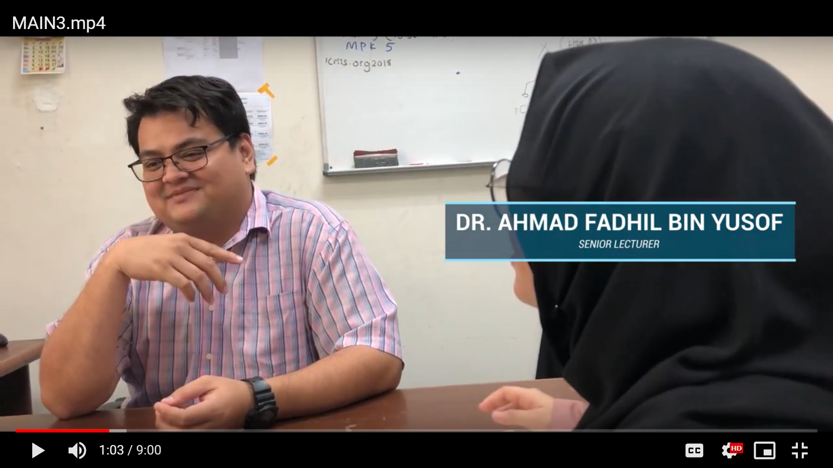
Figure 1: Interviewing Dr. Ahmad Fadhil
DEFINE

The next step in design thinking is Define step. Define in design thinking means we gather all of the problems that we had collected during the empathise step. Define step may become the most challenging part in Design Thinking process, as the definition of a problem (also called a design challenge) that need you to synthesise your observations about the users from empathise step. (1)
During our interview with Dr. Fadhil, he told that in his experience using input and output devices, there were few problems that occured. As examples, when he was still studying, he said that he used cathode ray tubes (CRT) monitor. CRT monitor sizes was big and he stated that it is very inconvenient to use and move it since it heavy also the screen is not so clear. Sir Fadhil then said that he once used an optical mouse, which is not ergonomic and high input latency. Optical mouse also hard to clean and not comfortable to use it.
All problems stated in the interview, we listed it and discuss about the problems together in our meeting, as shown in the figure below;

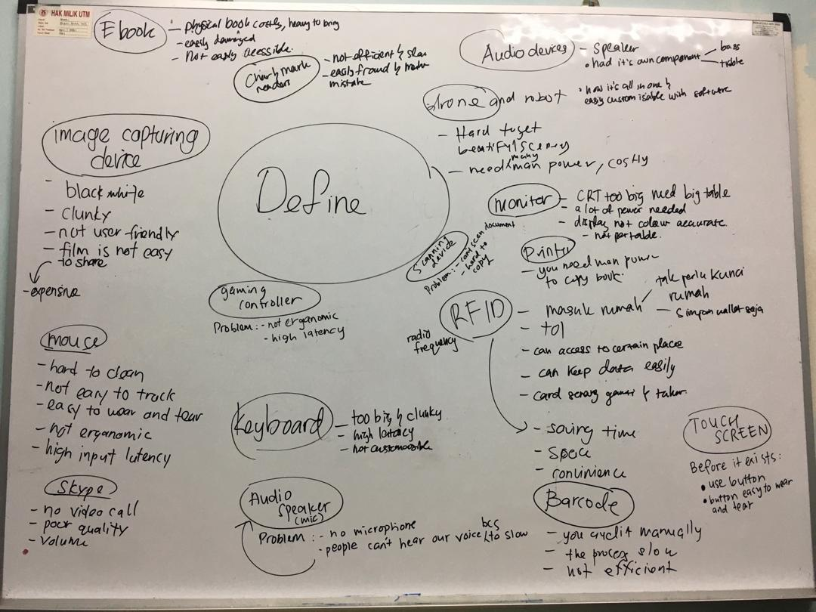
Figure 2: the list of problems that we had collected
IDEATE

Ideate is a step where we form an idea for the solution. After we had gathered all of the problems in the Define step, we brainstorm our mind to create ideas that could possibly be the solution to all of the problems. In this step, each member should come out with a good idea to solve the problems. Our first meeting for Ideate process was on 28th September 2019 at 9.30 pm. We met at ‘Kelab Komputer’ which is located near our college at Kolej Tun Dr. Ismail. We exchanged our ideas but still couldn’t manage to find the best one.
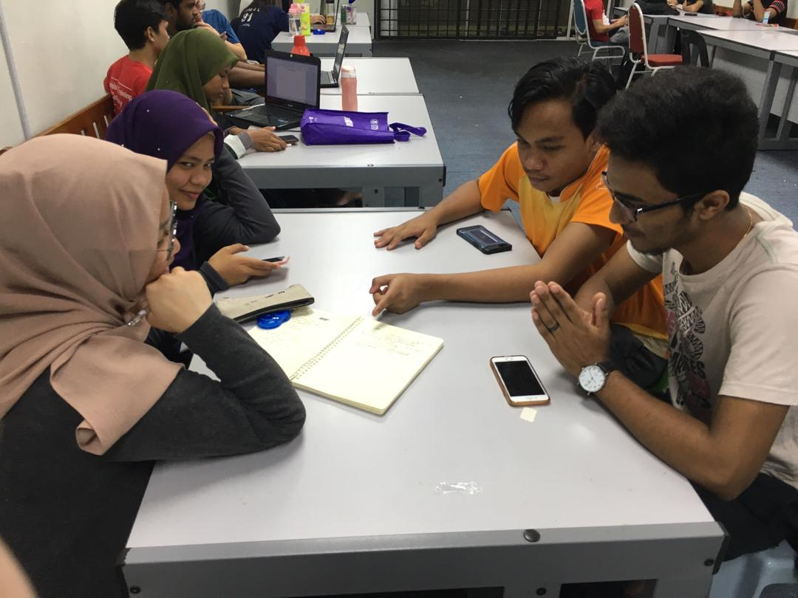
Figure 3: Our first day of brainstorming
Then, we met again on 29th September 2019 at 4.00 pm. We went to one of the Student Activity Rooms at School of Computing, N28. This time we presented a better idea. We came out with solutions after having a hard time to decide which was the best one for each problem.
Figure 4: Our second brainstorming session

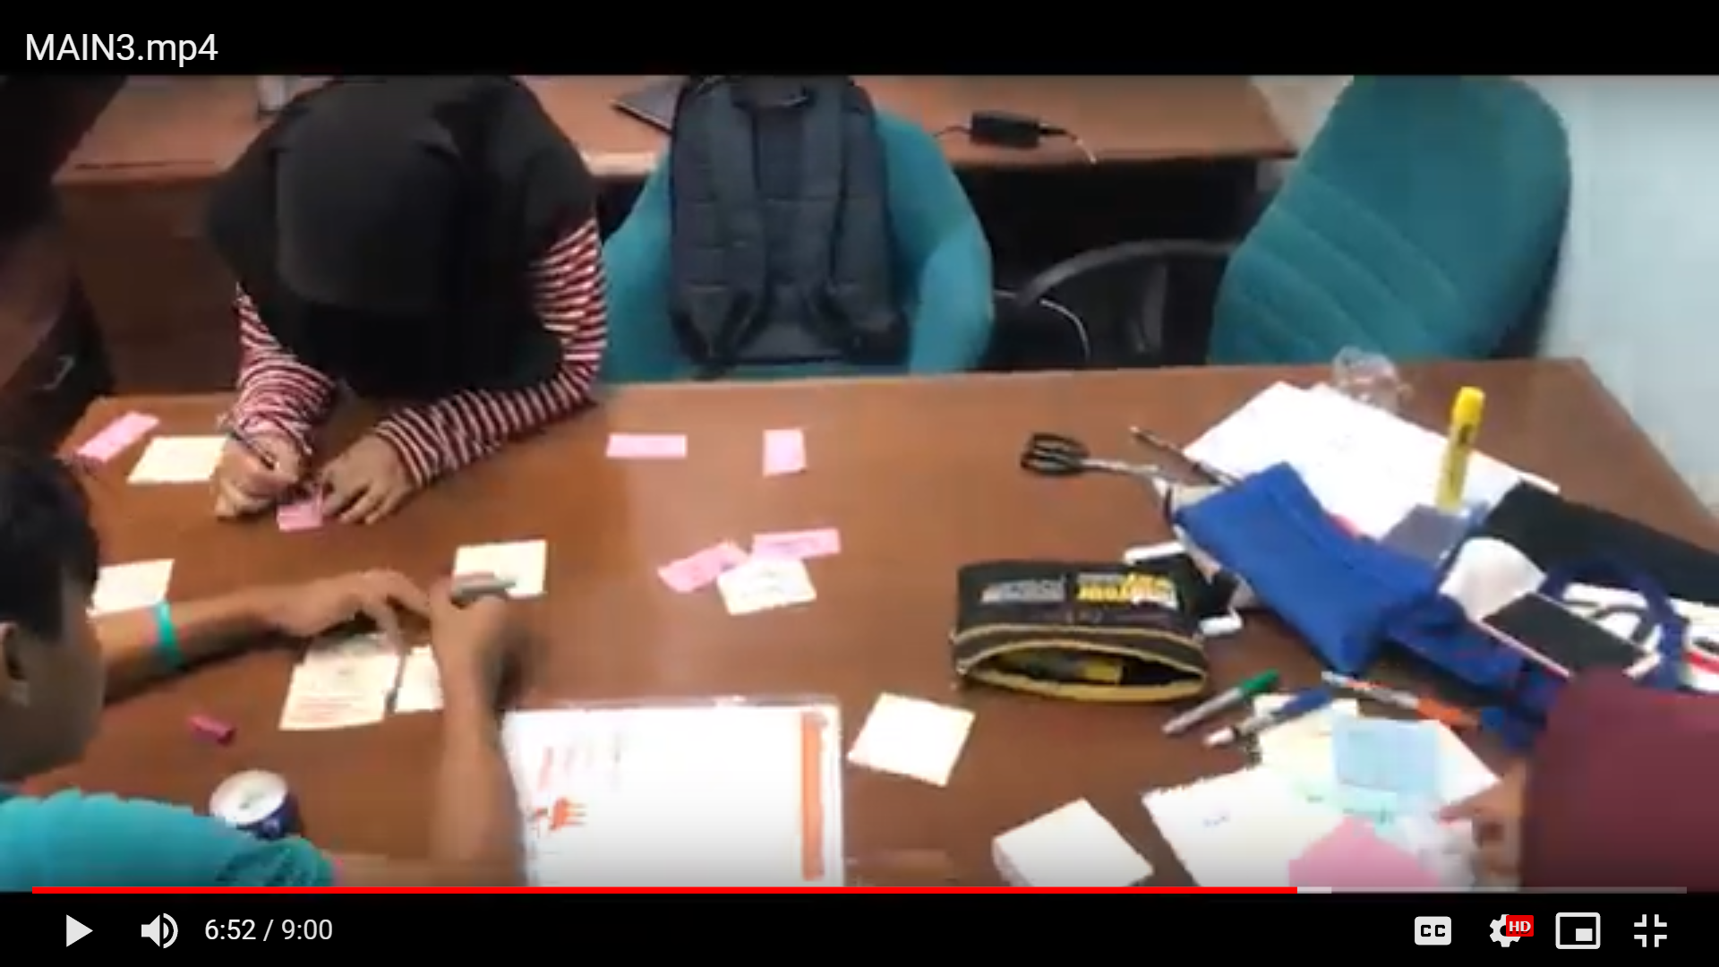
Figure 5
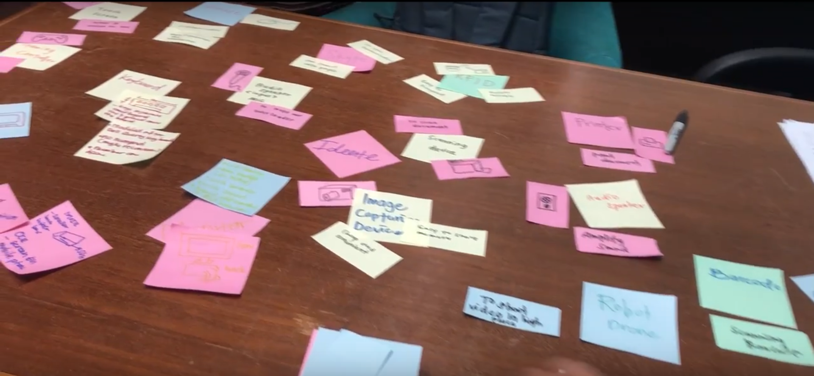
Figure 6
Figure 5 and figure 6 show our second time brainstorming process. We used sticky notes to evaluate more about our problems with the solutions. We realised, by using sticky notes, we could actually visualise the idea even better.

PROTOTYPE
Prototype is the fourth step in design thinking. Prototype can be the faster and effective way to show your idea. Prototyping is an activity which can bring our idea to live also test the viability of the current design and investigate the user’s opinion about the product. (2)
We used material like paper, box and marker to invent our prototype. There were 16 prototypes that we had invented based on input and output devices. We make all the prototype together by assigning tasks that each of our group members make 4 prototypes. We start building those prototypes on 2 October 2019 at night. We use some box that we get from the mart and we build a printer’s prototype together.
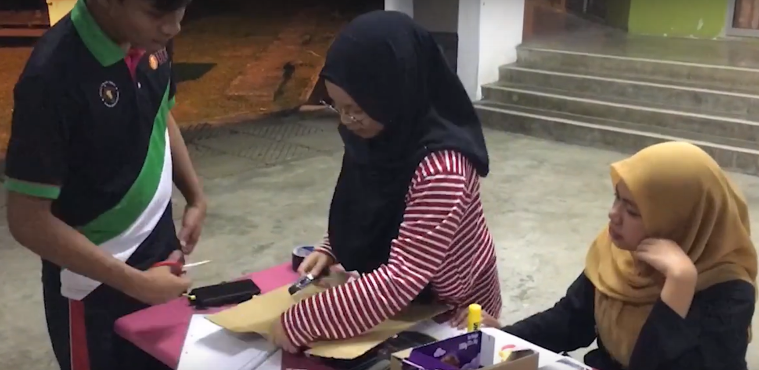
Figure 7
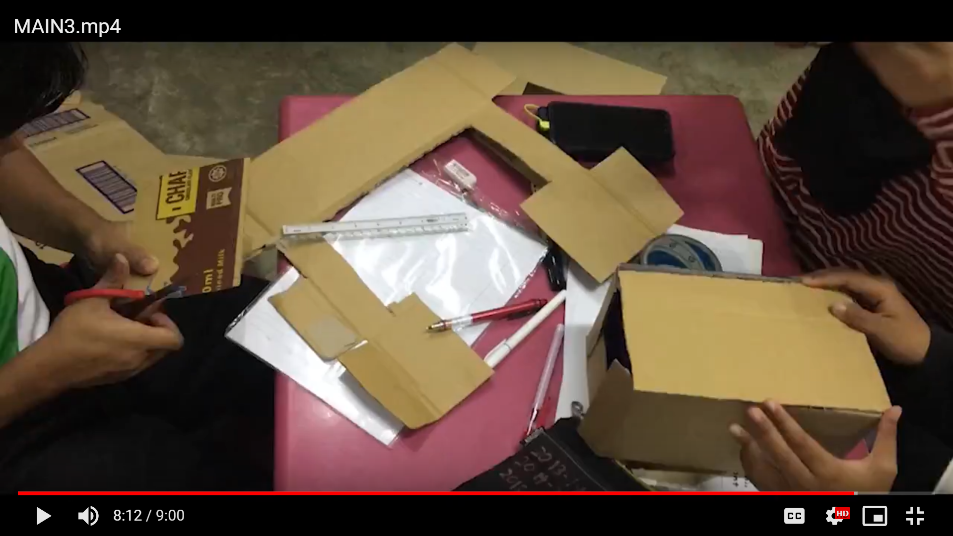
Figure 8
Figure 7 and 8 show the process of building the prototype. On this day, we worked together to build the prototype. Then, we decided to distribute the task of building another 15 prototypes to each member so that we could save our time.

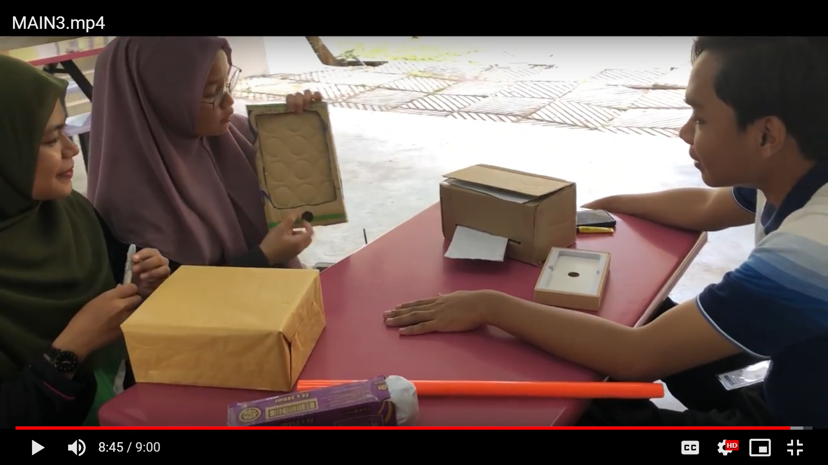
Figure 9
Figure 9 shows our last meeting on 3rd October 2019. We brought our prototypes and explained the functions of each prototype to the group members so that everyone knows.

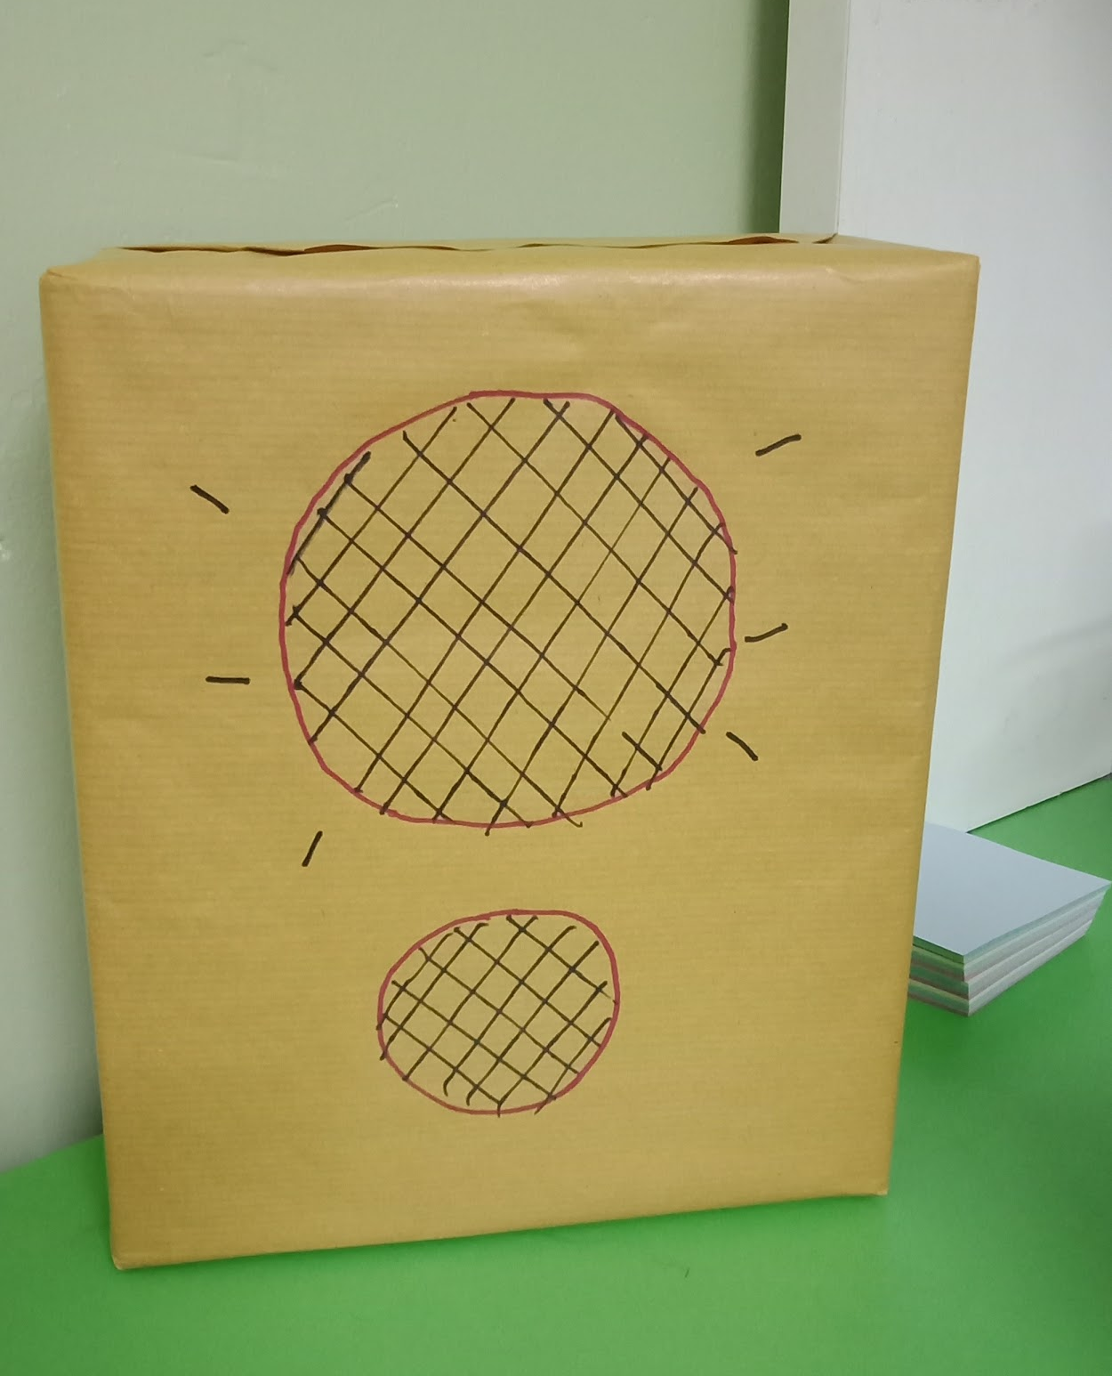
Figure 10: Speaker, an example of output device
Figure 11: Microphone, an example of input device

REFLECTION
Design thinking has significantly affected the way how we approach product designing. It has taught us a schematic flow in designing a product through its four phases; starting from the empathise until the prototype phase. Synonymous, with our goal with regards to the course Technology and Information Systems; which is to be able to become capable and competent graduates that are able to surpass the requirements set by employers; being able to be a part of the workforce. This dream can be achieved through the experience gained through the multiple assignments and group work that were assigned to us. Hopefully, the experience gained will be more than sufficient for us to be ready for going into the workplace and most importantly be acknowledged by the employers.
As employers today are looking for graduates who are not only book smart but are capable of creative problem-solving and critical thinking. Not only that, they are looking for graduates that are able to apply the knowledge and concepts that were gained in an effective manner. In particular, design thinking will be a prominent stepping stone in preparing for the numerous projects where teamwork and problem solving are compulsory in making a project succeed. Design Thinking has taught us the necessary steps involved the creation of any product, also sharpening the skills already possessed by the team. Such as, communication, teamwork, critical thinking and problem solving.
Despite that, there is much to improve and work upon before eventually entering the workforce. The next logical step to take that has been identified is to voluntarily take part in any projects that are available, especially competitions where design thinking will be implemented. This will further enhance the skills that are necessary in the workplace, such as problem solving, analytical thinking and most importantly soft skills. Not only that, participating in numerous projects will prepare us to face and solve any situations that will be encountered in the workplace.

TASK OF EACH MEMBER

NO. | NAME OF MEMBER | TASK
1 | NUR ALEEYA SYAKILA | - writes report  - interview Dr. Fadhil  - build prototype  - touch screen  - scanner  - microphone  - game controller
2 | IMRAN HAKIM | - writes report  - build prototype  - Keyboard  - Ebook  - Monitor  - Mark and
3 | INTAN MARINA | - writes report  - build prototype  - Printer  - Drone/Robot  - Barcode Scanner  - Speaker
4 | HERTHIK PRATHABAN | - videographer  - compile & edit video  - build prototype  - Mouse  - RFID  - Image Capturing Device  - Skype

REFERENCES

- Rikke Dam, T. S. (2019, September). Stage 2 in the Design Thinking Process: Define the Problem and Interpret the Results. Retrieved from Interaction Design Foundation: https://www.interaction-design.org/literature/article/stage-2-in-the-design-thinking-process-define-the-problem-and-interpret-the-results

- Rikke Dam, T. S. (2019, January). Stage 4 in the Design Thinking Process: Prototype. Retrieved from Interaction Design Foundation: https://www.interaction-design.org/literature/article/stage-4-in-the-design-thinking-process-prototype

- Rim Razzouk, V. S. (2012, September 1). What Is Design Thinking and Why Is It Important? Retrieved from SAGE Journals: https://journals.sagepub.com/doi/full/10.3102/0034654312457429

LINK TO OUR VIDEO
https://youtu.be/Q7RuoqLkBlM

