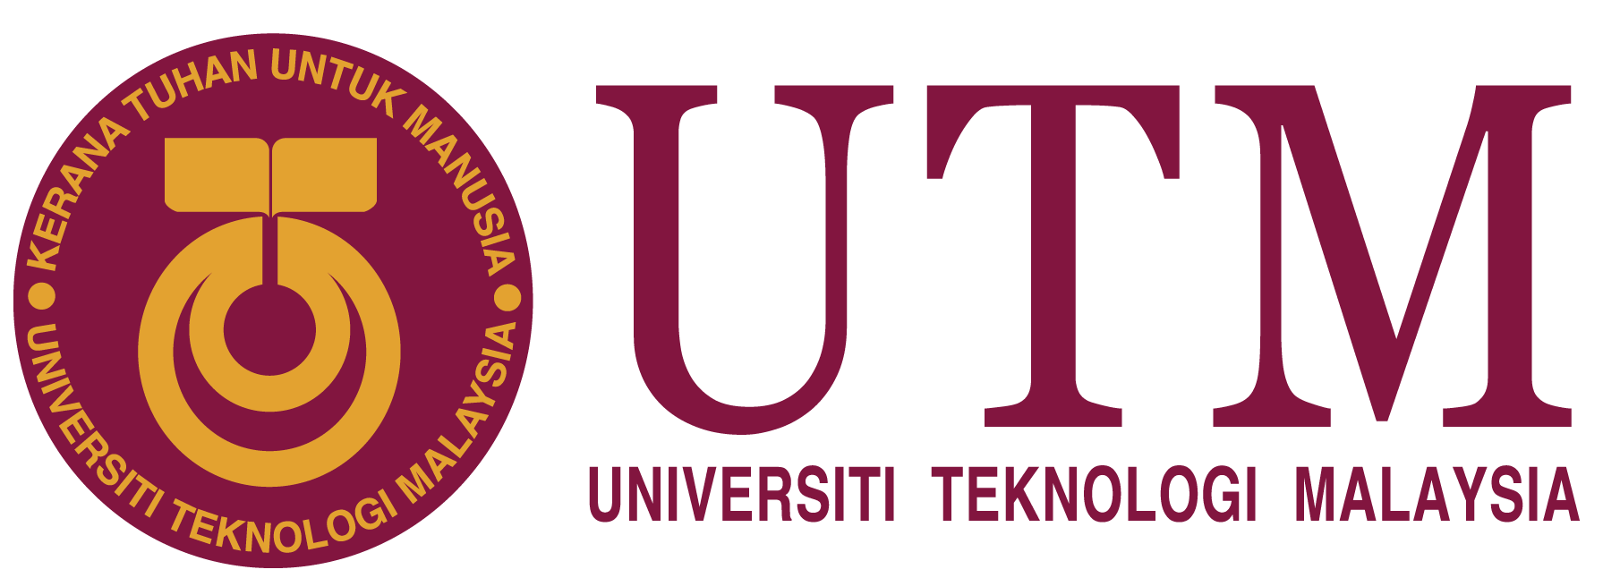

INDUSTRIAL TALK (IOT) REPORT

|  |  |
| --- | --- |
| NAME | LEONG WAI YUI |
| GROUP MEMBER | MOHAMMAD DANIAL BIN DAHLAN, MAZLINA BINTI JUMAT |
| MATRIC NUMBER | A18CS00097 |
| COURSE | TECHNOLOGY AND INFORMATION SYSTEM |
| LECTURER’S NAME | DR. ARYATI BINTI BAKRI |

TABLE OF CONTENT

[1 Introduction 3](#_Toc531085480)

[1.1 Iot-Predictive Maintenance Gets an Extreme Makeover 3](#_Toc531085481)

[1.2 Internet 2.0: Transaction based networking 4](#_Toc531085482)

[2 Content 4](#_Toc531085483)

[2.1 Predictive Maintenance 4](#_Toc531085484)

[2.2 Internet 2.0 6](#_Toc531085485)

[3 Executive Summary 7](#_Toc531085486)

[3.1 Predictive maintenance 7](#_Toc531085487)

[3.2 Internet 2.0 7](#_Toc531085488)

[Figure 1 4](#_Toc531082792)

[Figure 2 4](#_Toc531082793)

[Figure 3 7](#_Toc531082794)

# Introduction

The internet of things, IoT, is a system of interrelated computing devices, digital machines, objects or organisms that provides with a unique identifiers (UIDs). Besides, it means that the ability to transfer to data over a network without requiring human-to-computer interaction. In line with this, Advanced Telecommunication Technology Research Group (ATT RG) that collaborate with ICONIX Consulting Sdn Bhd, JURUTEK, Kolej Tuanku Canselor (KTC), UTM, on behalf of the School of Electrical Engineering (SKE), Faculty of Engineering had organized the IoT Open Day 2018 for the second time, which hold on 18th November 2018. Activities during IoT Carnival includes hands-on traning, hackathon, open booths and industrial talks. There will be participation from 30 secondary students in JB area as part of our Corporate Social Responsibility (CSR) program to encourage exposure and awareness towards Science, technology and so forth that in line with the government’s National STEM Action Plan 2017 initiatives. The main objectives of this carnival is to expose the IoT technology to their guests, UTM staffs and students. Next, is to encourage UTM students to further their studies in IoT-related fields at SKE UTM. Besides, to promote IoT-based products, including research findings, final year projects and related capstone labs project. Last but not least, is to promote the opportunities of research collaboration between industries and researchers with ATT and COMM division,as well as SKE. Their sponsors and collaborators includes Intel, Hewlett Packard Enterprise, favoriot, Tenaga Nasional Berhad (TNB), MIMOS and so forth.

## Iot-Predictive Maintenance Gets an Extreme Makeover

On 18th November 2018, I attended an industrial talk at P03-220, School of Electrical Engineering, UTM. This industrial talk held on 11.00a.m.to 12.00 p.m. The speaker of this talk was Mr. Syahrul Hafidz Suid. He is currently the enterprise consultant of Hewlett Packard Enterprise Malaysia. He holds degree in Technology Multimedia for Universiti Malaysia Sabah (UMS) and master from UTM in information security. Figure 1 is the speaker of this talk.

## Internet 2.0: Transaction based networking

The industrial talk that we attend was held at P03-211, School of Electrical Engineering, Universiti Technology Malaysia which starts at 12 pm until 1 pm. The industrial speaker was Mr. M Nazrul Hazeri Nazirmuddin which is the solution design architect, Maxis Berhad Cisco Service Provider Distinguished Innovation Award 2014 (Team). Figure 2 shows the image of the speaker for Internet 2.0.

|  |  |
| --- | --- |
| Figure 1 | Figure 2 |

Source: <https://iotcarnival.fke.utm.my/open-day/industrial-talk>

# Content

## Predictive Maintenance

The IoT is one of the major factors in new communicative and interactive developments. With the concept of Industry 4.0 spreading across the world, it is worth examining the extent to which Industry 4.0 and the Internet of Things are connected.Industry 4.0 is a name given to the current trend of [automation](https://en.m.wikipedia.org/wiki/Automation) and data exchange in [manufacturing](https://en.m.wikipedia.org/wiki/Manufacturing) [technologies](https://en.m.wikipedia.org/wiki/Technologie). It includes [cyber-physical systems](https://en.m.wikipedia.org/wiki/Cyber-physical_system), the [Internet of things](https://en.m.wikipedia.org/wiki/Internet_of_things), [cloud computing](https://en.m.wikipedia.org/wiki/Cloud_computing) and [cognitive computing](https://en.m.wikipedia.org/wiki/Cognitive_computing). Industry 4.0 is commonly referred to as the [fourth industrial revolution](https://en.m.wikipedia.org/wiki/Fourth_Industrial_Revolution).

The Internet of things (IoT) is the network of physical devices, vehicles, home appliances and other items embedded with electronics, software, sensors, actuators, and connectivity which enables these objects to connect and exchange data. An IoT ecosystem consists of web-enabled smart devices that use embedded processors, sensors and communication hardware to collect, send and act on data they acquire from their environments.

[IoT devices](https://internetofthingsagenda.techtarget.com/definition/IoT-device) share the sensor data they collect by connecting to an IoT gateway or other edge device where data is either sent to the cloud to be analysed or analysed locally. Sometimes, these devices communicate with other related devices and act on the information they get from one another. The devices do most of the work without human intervention, although people can interact with the devices. The internet of things offers a number of benefits to organizations, enabling them to monitor their overall business processes, improve the customer experience, save time and money, enhance employee productivity, integrate and adapt business models, make better business decisions, and generate more revenue.

Security is one the biggest issues with the IoT. These sensors are collecting in many cases extremely sensitive data. Keeping that secure is vital to consumer trust, but so far the IoT's security track record has been extremely poor. Too many IoT devices give little thought to basics of security, like encrypting data in transit and at rest.

Predictive maintenance focuses on predicting when device failure will occur and preventing that occurrence of failure with the help of maintenance monitoring so that maintenance can be planned before an issue manifests.

The concept of predictive maintenance is probably as old as the first machines that humans invented. In the recent past, predictive maintenance solutions were focused on complex machines for which failure would be catastrophic. Often, those systems involved the compilation of large amounts of historical data, the application of machine learning, and the creation of a digital “twin,” a digital rendition of the physical machine that would perform virtually like its physical counterpart. Now, with the present of the Internet of Things (IoT), the lowering of connectivity and storage costs, and the creation of vast amounts of data, predictive maintenance is transforming industries and machines that were previously out of reach.

## Internet 2.0

Internet 2.0 briefly explain about transaction-based networking. Transactions-based networking is Man-Computer Symbiosis. Man-Computer symbiosis defined as an expected development in cooperative interaction between men and electronic computers. It will involve very close coupling between the human and the electronic members of the partnership. Furthermore, Internet 2.0 also explained about the internet problem, which are surveillance and censorship also hack user data. Two of these problems comes from internet history where all the users stuck between these problems, so that Internet 2.0 try to find the solution for it. Next explanation about internet 2.0 is Blockchain strengths. Blockchain is actually a concept of thinking to find a very good solution on a problem. The advantages of blockchain strengths are we can be a hardworking and open-minded person. But there are also disadvantages about this concept of thinking which we can be a very busy and impatient person. By using this method, most probably we will have threats while solving our problem, we might lose our enthusiasm and our project can’t be done properly. So, this skill has its own pros and cons. Internet also has its own trend, Internet 2.0 is one of the way to catch up with the trend.

|  |
| --- |
| 1_9u19q_2M6x4SM-GV-etzkQ  Figure 3 |

Source: <https://medium.com/@rilcoin/new-blockchain-internet-2-0-684fe3a671b3>

# Executive Summary

## Predictive maintenance

This talks has 3 main topics that includes Worldwide CIO Agenda 2019 Predictions by IDC, Industry 4.0 and Predictive Maintenance. For Worldwide CIO Agenda, it has 9 different predictions made. These predictions provide a strategic context that will enable CIOs to lead their organizations through a period of multiplied innovation and disruption over the next five years. IDC FutureScapes present information about technologies, markets, and ecosystems that help CIOs better understand future trends and their impacts on the enterprise.  In this talk, the speaker had mentioned much on predictive maintenance. I had understand that predictive maintenance solutions were focused on some complex machines, such as jet engines. From this talk, I learned that a system involved the compilation of large amount of historical data and also the application machine learning. Next, I realized that industry 4.0 has a very high potential since it offers an opportunities for the manufacturers to optimize their operations quickly and efficiently. The potential for industry 4.0 should not be underestimated. For example, artificial intelligence such as robot and drone. By using this smart machine, it will be beneficial to all the users and industries. In conclusion, industry 4.0 should be emphasized either by industry or manufacturer since it might be very useful in the future especially to those younger generation nowadays. In a nutshell, I hope that this artificial intelligence will not overpower than humans and eventually take over human’s job opportunities.

## Internet 2.0

To sum it up, the invention that brought by Internet of Things (IoT) improved the development of IT. It made internet more rapid and more reliable to use. Just like the internet 2.0, the goal for internet 2.0 are to solve all the internet problem and created a system where we don’t need man-to-man interaction anymore. For example, most of us used TM Streamyx for internet connection but now almost everyone upgraded to use Unifi or Times. Its internet connection is faster and it can reaches up to 100 Mbps (Megabyte per second).All these things are created to ease our daily usage of internet. However, to make this program work more rapidly, all communities have to support the development for this program. We have to work together to get a better and brighter future.