**Lab Exercise 1**

**Name:** BRENDAN DYLAN GAMPA ANAK JOSEPH DUSIT@DUSIT

**Matric No:** A20EC0021

**Section:** 08

Please answer the questions. Any picture format answer is not accepted

1.

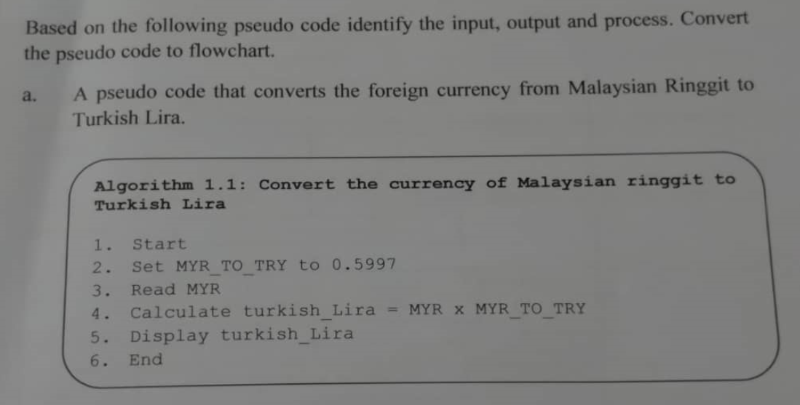

Input: MYR

Output: turkish_Lira

Process: Turkish_Lira = MYR x MYR_TO_TRY, Set MYR_TO_TRY = 0.5997

**FLOWCHART**

b. 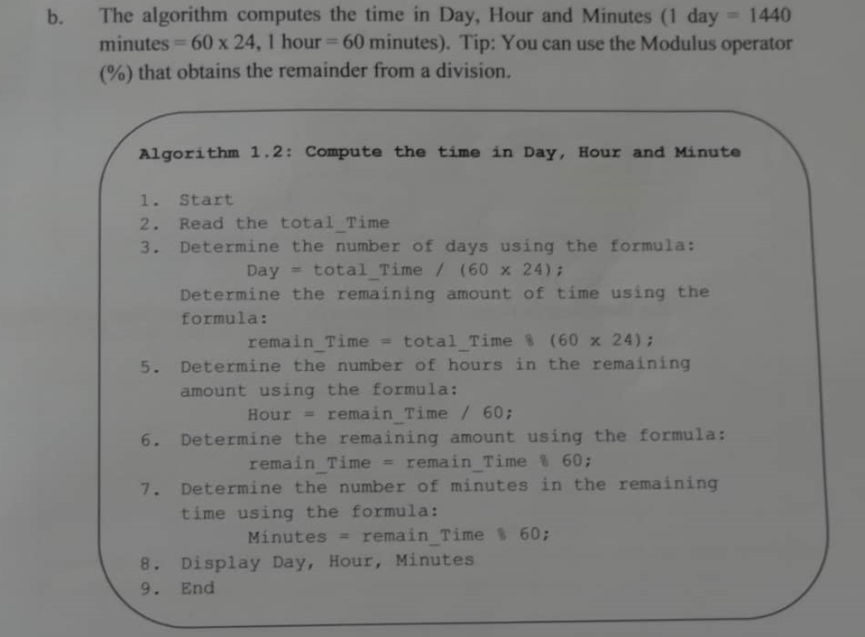

Input: total_Time

Output: Day, Hour, Minutes

Process: Day = total_Time, remain_Time = total_Time % (60 x 24), Hour = remain_Time /

60, remain_Time = remain_Time % 60, Minutes = remain_Time % 60

**FLOWCHART**

2.

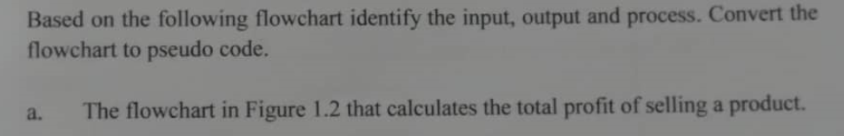

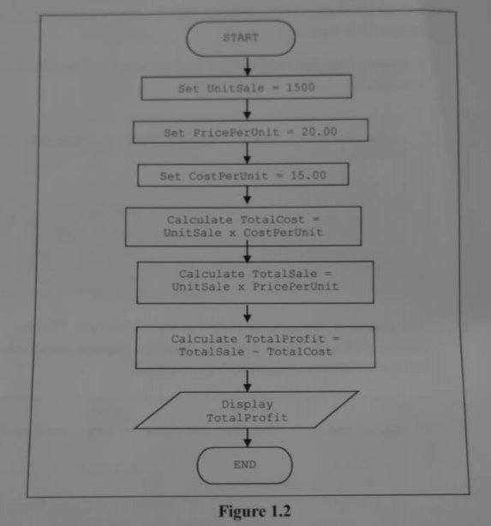

Input: no input

Output: TotalProfit

Process: TotalCost = UnitSale x CostPerUnit, TotalSale = UnitSale x PricePerUnit,

TotalProfit = TotalSale – TotalCost, Set UnitSale = 1500, Set PricePerUnit = 20.00,

Set CostPerUnit = 15.00

**PSEUDOCODE**

1. Start

2. Set UnitSale = 1500

3. Set PricePerUnit = 20.00

4. Set CostPerUnit = 15.00

5. Calculate TotalCost = UnitSale x CostPerUnit

6. Calculate TotalSale = UnitSale x PricePerUNit

7. Calculate TotalProfit = TotalSale – TotalCost

8. Display TotalProfit

9. End

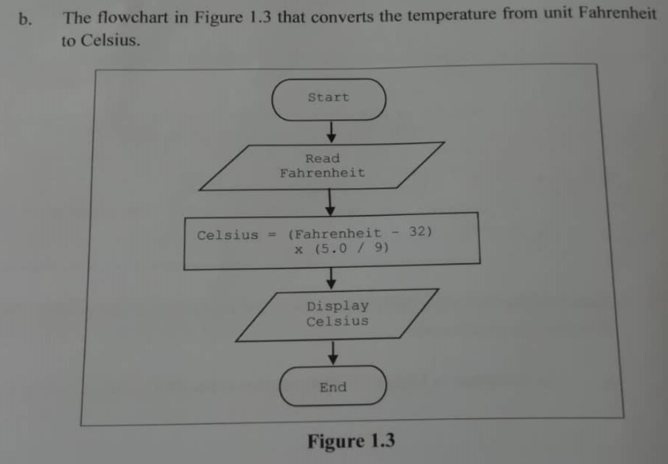

Input : Fahrenheit

Output: Celsisus

Process = Celsius = (Fahrenheit – 32) x (5.0 / 9)

**PSEUDOCODE**

1. Start

2. Read Fahrenheit

3. Calculate Celsius = (Fahrenheit – 32) x (5.0 / 9)

4. Display Celsius

5. End

3.

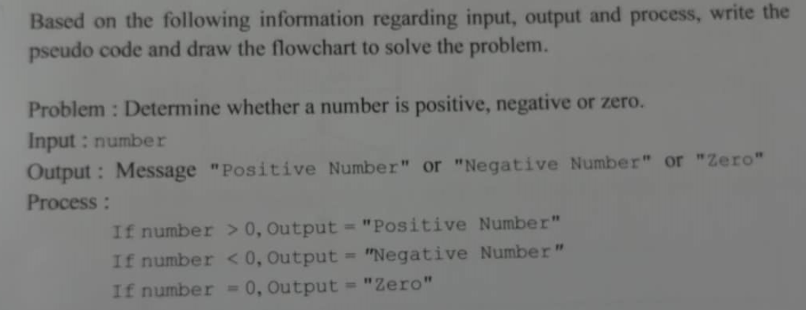

**Pseudocode**

1. Start

2. Read number

3. If number > 0

3.1 Print “Positive Number”

4. Else If number < 0

4.1 Print “Negative Number”

5. Else If number = 0

5.1 Print “Zero”

6. End if-else

7. End

**Flowchart**

4.

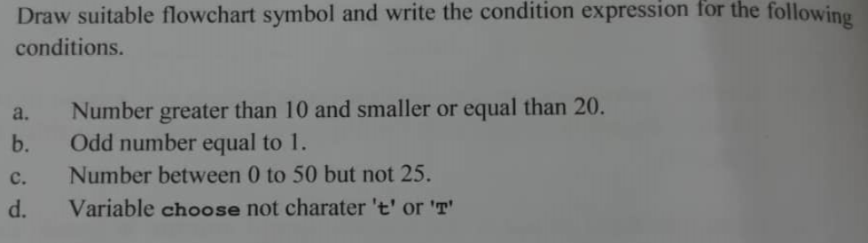

a.

b.

Set

Odd_number = 1

c.

d.

!(choose ( t, T))

5.





|  |  |  |  |  |  |  |
| --- | --- | --- | --- | --- | --- | --- |
| UnitSale | PricePerUnit | CostPerUnit | TotalCost | TotalSale | TotalProfit | Output  Statement |
|  |  |  |  |  |  | 7500 |

6.



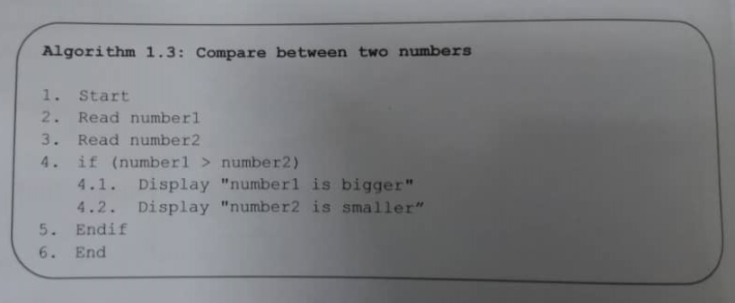

|  |  |  |
| --- | --- | --- |
| **number1** | **number2** | **Output Statement** |
| 103 | 25 | “number1 is bigger”  “number2 is smaller” |
| 90 | 120 | No output |
| 15 | 15 | No output |

a. no output on both second and third data.

b. another relevant pair of inputs:

1. Start

2. Read number1

3. Read number2

4. if (number1 > number2)

4.1 Display “number1 is bigger”

4.2 Display “number2 is smaller”

5. else if (number1 < number2)

5.1 Display “number1 is smaller”

5.2 Display “number2 is bigger”

6. else if (number 1 == number 2)

6.1 Display “number1 and number2 are equal”

7. End if-else

8. End