Semester I 2019/2020

GROUP MEMBERS : HAM JING YI A19EC0048
INTAN MARINA BINTI SULAIMAN A19EC0053
JOSIAH JEEVANRAJ JOSEPH A19EC0060

SUBJECT : TECHNOLOGY AND INFORMATION SYSTEM
SUBJECT CODE : SECP
SECTION : 02
TASK : INDUSTRIAL VISIT – CICT UTM
TOPICS : VISIT GALLERIA
NAME OF LECTURER: DR. ARYATI BINTI BAKRI

Table of Contents
DETAILED DESCRIPTIONS 4
History Component in the Gallerium, PSZ 4
REFLECTIONS 13
CONCLUSION……………………………………………………………………………………………………………………………………15
TASK FOR EACH MEMBER 16
REFERENCES 17

INTRODUCTION AND DETAILS OF VISIT

On the 21st of October 2019, the first year data engineering students had a visit to CICT. The visit was part of their many industrial visits. Previously, the students had visited the Petronas Twin Towers as well as Big Data Week. The visit was participated by all the data engineering students which in total was 42 students. The visit was at the Galerium at the Sultan Zanariah Library on campus located at the heart of UTM. The students was accompanied by their lecturer, Dr.Aryati throughout the visit. She guided the students throughout the visit, ensuring the students were well behaved and safe. The whole visit lasted about 1 hour.

The main purpose of the visit was to expose the students to how technology has evolved through the passage of time, namely technology that was used by UTM throughout the many decades of it’s time standing. From mainframes to typewriters, the pieces of technology that UTM has used in the past was well preserved and now the students had the chance to learn about them and how they have changed and evolved through the years. This will in turn give students an idea of how the people of the past used to think and solve problems.

DETAILS OF VISIT

TIME | DESCRIPTION
3.00 p.m. | Students gather at the library foyer
3.15 p.m. | Students enter the galerium and explore the exhibition
4.00 p.m | Photo session and visit ends.

DETAILED DESCRIPTIONS

History Component in the Gallerium, PSZ
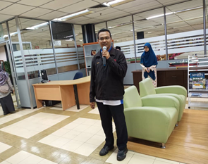
Encik Mohd Zahari bin Zainal Abidin (Figure 1) and Encik Khalid Bin Jaafar(Figure 4)really gave us a new impression about the history component. We receive a lot of useful information through this visit. The improvements and evolution of technologies brings a lot of convenience to humans and change the world nowadays. He explained a lot about the slide projectors, the ‘Model Searly’, old computers, floppy drive, hard disk, the storage, the big motherboard and more.
Figure 1 shows Encik Mohd Zahari are briefing the students about the history components.

He gave away a detailed explanation about the slide projector. The first projector used in UTM is the Kodak CAROUSEL S-AV 2050 projector(Figure 2) which its publication date is on 1985. This slide projector was used in the library to display slide shows until early 1990s. There is only one copy in UTM. The slides inserted is rotated by a round rotary tray. One example to use this projector is in the field of architecture to watch the buildings. It is used to project the slides photography in order to create the slideshows. The first slide projector was invented by David E. Hansen of Fairport , NY on May 11, 1965. (Wikipedia, 2019)

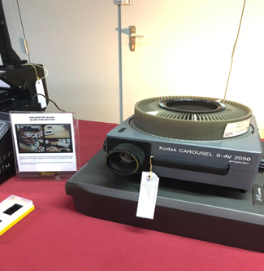
Figure 2 shows Kodak CAROUSEL S-AV 2050 projector.
In year 1985, UTM bought Bell and Howell Model Ringmaster RM850 auto focus 35mm slide projector (Figure 3). The projector has a lot of advantages compared to the CAROUSEL S-AV 2050 projector. It comes along with a handbook, Kodak carousels, remote control, 2 spare projector bulbs, power cable and a travel cover. This projector accepts 80 or 140 capacity Kodak slide trays. The projector can read the slide photography individually which is slides can be projected either onto the built in screen, which makes it ideal for local viewing without the necessity of an external screen and darkening a room, or to an external screen as required. Besides, the sound track also comes along with the projector too ,which means there is sounds on when the slides are running. This is quite fun and I believe this really brings a new experiences to the UTM staffs and students in that year.
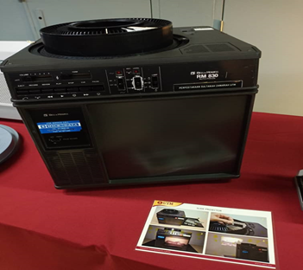
Figure 3 shows Bell and Howell Model Ringmaster RM850 auto focus 35mm slide projector.

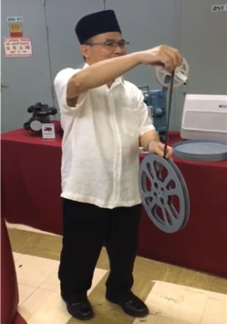
Figure 4 shows Encik Khalid talked about the film.
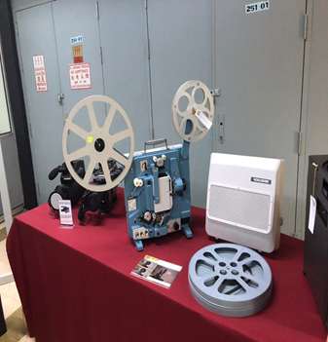
Figure5 shows HOKUSHIN SC-10M

The visually blue projector is a film projector (HOKUSHIN SC-10M)(Figure 5). It uses a 16mm film which is made in Japan by Hokushin Electric Works. There are also many types of history computers like Apple Macintosh Classic Computer, IBM personal computer 300GL, IBM P70 model 6554-673 and IBM personal system/2 model 70 386.
The Macintosh Classic (Figure 6) was first introduced in 1984 and used in UTM library in 1990.They used the computer to do some simple calculation and works along with the Lotus 123 and Word Star applications. The computer that time has a memory of RAM (1MB) and hard disk (2 to 40 MB). At the time, this type of capacity is already considered as a very big capacity.
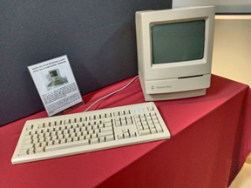
Figure 6 shows Macintosh Classic that used in UTM Library in year 1990.

Next is the turn of IBM PERSONAL SYSTEM /2 MODEL 70 386(Figure 7). Its origin is in USA and year1989 is the year of introduction. Although it was quite expensive, it was a big improvement for CAD and computational applications. This computer is a high-end PC (sometimes it was called "Power platform", before IBM's POWER Series computers) of early 1990s. (MC bx Old Computer Collection). The computer system support the performances improvements for desktop operations. It can also work with many software products in UTM Library. However, there are some disadvantages like if there is more than 6 MB of RAM, the computer cannot see it and will not give a result.
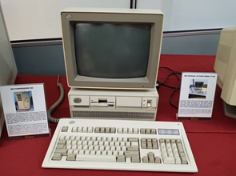
Figure 7 shows IBM PERSONAL SYSTEM /2 MODEL 70 386.

Lastly we talk about the IBM personal computer 300GL(Figure 8) and IBM P70 model 6554-673. PC 300GL increased the productivity by decreasing the cost of ownership of UTM library. It has a parallel port, 2 serial ports, 2 RAM slots and 2 USB slots. We can also think that it is a home or office computer with Windows 98 with only 512MB RAM. In 1985, the typewriters used the computer efficiently in order to store or collect the library activities. In year of 1998, UTM Library bought a IBM P70 model 6554-673. It is used often in that year as it has the ability to support up to 16 MB on the disk storage and can make a better performances on the desktop functioning.
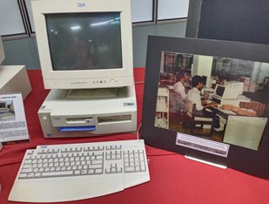
Figure 8 shows IBM personal computer 300GL.

Furthermore, the Mainframe Data Storage plays an important on the data control and storage of information of all the UTM staffs and students. The size of the mainframe is huge, just like a human height and the width is like 3 humans stand together. It is a part of the server. The mainframe is a set of computer that have several equipment. The model of the Mainframe Data Storage is IBM (9345B22) already functioning for almost 20 years to work on big data such as processing, analysing, storing, securing, and printing. All information about UTM can be found here and it is a safe place in which the data can be stored. However, data stored maybe lost due to the machine functioning problem or the problem of technicians. So, there is a back-up system called mainframe tape subsystem (IBM 9309) which is a magnetic tape subsystem. During the year 1987 till 1995, this system is used as back-up to store all the information of UTM, staffs and students. At first, this system used a round shape tape(Figure 9) but after it had an improvement on the tape. So, the model used a square tape(Figure 10) after the round tape are not longer used. This magnetic square tape system is the third generation for the back-up unit system whereas the magnetic round tape system is the first generation for back-up system. What Encik Zahari said was all the staffs in that old time have to back-up the information in the break of dawn as the internet was too slow.
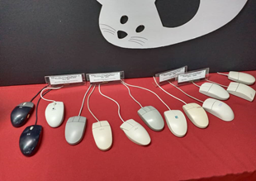
Moreover, he also showed us a lot of computer mouse(Figure 9) they used during the old time.

Figure 9 shows the mouses
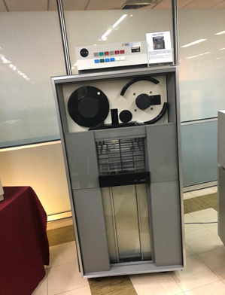
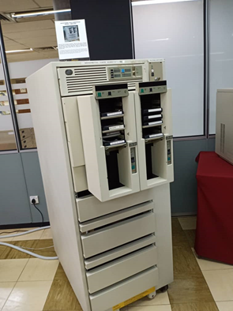

Figure 10 Figure 11
Figure 10 shows round shaped mainframe tape subsystem while Figure 11 shows square shaped mainframe tape subsystem. There is an evolution of shape of mainframe tape subsystem from round to square.
Then, we move on to the part of IBM POWERserver 550(Figure 12). As we know in the year of 1990, it contained the fastest and most effective chip in the world, it worked a lot in boasting the performances. It was known as an apt system for a medium-size database in that time. Just like Encik Zahari said, the powerserver 550 is a ‘freeze’ terminal which can assist and work along with the mainframe in order to start the technology revolution in UTM and ended up with great impact on UTM Library. For further explanation, I would say that to connet the IBM PowerServer 550 to a laptop, all we need is a serial cable and PuTTY. After do some setting in the laptop, all is done. The powerserver 550 was first announced in 12 November 1990 and will be available in January 1991. The model cranked up the power to 54.3 specmarks and came along with the 64 MB of RAM in the basic system. (Marshall, 1990, p. 46)
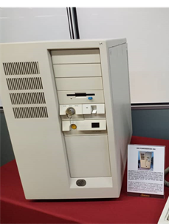
Figure 12 shows IBM POWERserver 550 used in UTM Library
There are various type of electronic component inside a computer. They are motherboard, floppy drive, IDE cable, RAM, hard disk, CPU slot cards, network card, processor and more. (Figure 13 and 14)

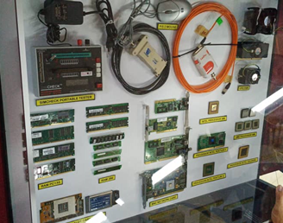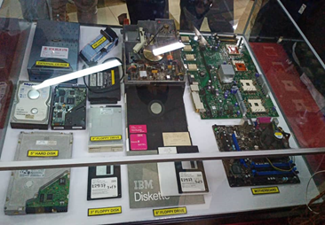
Figure 13 and 14 show various type of electronic components inside a computer.

The motherboard is a printed circuit board. It has a lot of bus lines to provide the connectivity with the RAM, ROM, CPU, hard drive and various types of cards. It is a piece of circuit that can hold everything together. The sizes and types of motherboard are not always the same. The size always changes to fit to different types of computer. There are a lot of slots, circuits, connections and ports on the motherboard. In 1981, we called it ‘planar’ instead of motherboard.
During the explanation, RAM that showed at the galleria is RAM 286 type and RAM PC133. RAM PC133 is computer memory standard that functions on frequency of 133MHz, 64-bit-wide bus, at voltage 3.3V. This RAM known as the fastest that can delivers a bandwidth of 1066 MB per second. There is 4 RAM PC133 that showed at the galleria. While RAM 286 is a RAM that implemented in PC 286 CPU board. It was a rare type of RAM. The old server motherboard in UTM had 4 processors, it provided high performances in data representation, data analysis and so on. CPU that displayed in the galleria is INTEL Processor 386, Processor INTEL Pentium II and III, AMD Processor 486 and Processor INTEL Celeron. This is the task of the server but not the computer and pc. Our personal computer had only 1 socket for CPU but the server had 4 processors. Besides, there are 5” hard disk, 3” floppy disk, 8” floppy drive, 3” floppy drive displayed in the gallerium.
Floppy disk is a diskette. It used to store information in a flexible magnetic storage. The appearance of the floppy disk is a thin rectangular plastic carrier. If we want to read the information stored in the floppy disk, we need a floppy drive. For example, we need to insert a 3”floppy disk in a 3” floppy drive to read the information. At the previous time, hard disk are needed for data storage. When we run some programs or data and we have to save or install the programs, they will save inside the magnetic hard disk. The information will still remain if the computer is power off. Nowadays, people prefers the solid-state drive (SSD). Although the price of the SSD are more expensive, the operating time and power consumption of SSD are much lower than the hard disk. After that he gave many explanation on the simcheck portable tester. The simcheck portable tester in UTM Library is the second generation of memory tester. It is used to test different types of memory devices except Synchronous DRAM devices.

REFLECTIONS
We are thankful to have a chance to visit to the CICT as we can gain a lot of experiences to have a close distance to have a look at the history hardware that supported our software which we used every day. The opportunity is golden, I think a wise man will never let it go by him. I have a chances to look how the evolution of technology happens in the case of hardware in the early 80’s till today. It is amazing to see how a big and bulky thing turns into a small and capable thing in the progress of time.
The world nowadays change a lot compared to the old time. World today full with technologies, massive and complex big data. Although the world now is full of high-technology, we as a data engineer after 4 years is to keep the world goes better and better but not remain there. We have to try hard to create new things that can really bring a lot of benefits else with reasonable price so that everyone can own it. Besides, we can also modify the new technology to deal with those big data. My goal is to use the data, process it, analyse it and make use of it to create something new. My dream is to become an authority in the field of computer science and technology. So, I have to make a lot of improvements to get my goal.
First, I have to improve my professional skill. If people do not believe us in the first impression, it is quite difficult for me to get my goal. What we learn in the university is not enough, it is just a preparation or some basics for us to solve simple stuff in the field of computer science. What if we face a huge problem regarding to the history components? So, I wish I can take part in more visits like visit to CICT to know the how the thing looks like in the primeval stage. Secondly, I have to improve my creativity and innovative skill. This skill is crucial in modifying the old thing to a better one not only from its appearance, but also the inner, the functions, size and the capability to store information. Creativity thinking will activate our mind and helps to create a alternative solution to solve big problem. We have to solve problem one-off with a best solution. This will help to save time and increase a company’s productivity.
By HAM JING YI
As we all know, hardware which is components of computers is a basic knowledge that all science computer students need to master it. This visit about history component related to computing, it was an excellent chance to know about hardware that we used almost every day as a data engineering students and it was really help us to know deeper about all the components of the computers. It was a wonderful opportunity for us to increase our knowledge in this field as well as a real pro. As a data engineering students, my goals is to become an expert in programming and building data pipelines and my dreams is to become a professional data engineer. In order to achieve the goal and dream I need many improvements from myself.
In the first place, for the purpose of increase my potential in this field, I need to know about a lot of technologies. As a basic knowledge, I need to be familiar with all the hardware that I need to use in becoming a data engineer. I also have to study and be more focus on learning my programming skills because programming is a base in data engineering. Other than that, I need to find more experience in this field. From my opinion, experience can beat education, because gaining experience is one of effective ways in learning. So, as example method for me to gain my own experience in becoming data engineering, is by visiting to site that can give us undergo the feeling in becoming a data engineer. Last but not least, I need to improve my social and communication skills and some soft skills, so that we can work easily with our customers.
By INTAN MARINA
Visiting CICT has helped me understand a little bit the way people used to think. This is most apparent when they are given a problem. As we all know, with everything in life, including inventions and technologies, there is always room for improvement. It is how we approach this and make the improvement that separates the good from the best. It is the reason some products and technologies have become obsolete and it is the reason why some become revolutionary pieces of technology. Every problem requires a different method of approaching it and these technology is a testament to it. This knowledge is important to us data engineers as we have to know how to approach and solve problems. Knowing how to think is better than knowing what to think.
Besides that this visit has made me realize that knowing about the past is equally as important as knowing about what to expect. By getting to know how they used to think, it opened up a new perspective on approaching a situation. Similarly, if I do more studies on the past and how they think, I will be able to learn a lot about them and in turn be able to think better. This will benefit me greatly especially when I graduate and start working.
By JOSIAH

CONCLUSION
We gain a lot of knowledge through the visit to Centre of Information and Technology (CICT). The evolution of technology is very important in technological progressing. By visiting the Gallerium CICT, we know more about the history components related to computing since the early 80’s until now. We can see how the changes of the hardware when the time flies. The improving of capacity and reducing the size of devices manage to save the space and time. For example, from the hard disk to SSD, from the mainframe to laptops, tablets, smartphone and smart watch today. We understand that the improvement of the devices need a lot of tests and effort. So, we hope that we can receive something new via the main subjects we are studying to provide a better technology environment. We as a data engineering college student, we can say that we must work hard, improve our creativity to bring new things to the world. We believe that if there is hardworking, there comes good works.

TASK FOR EACH MEMBER
For this report, every group has 3 members. So, each of the members has their own task and work together to make an excellent report. In our group there is Josiah Jeevanraj Joseph (Jo), Ham Jing Yi (Jing Yi) and Intan Marina binti Sulaiman (Intan). At the galleria hall, Jo act as leader in our group and his task is to lead our group to greet the person in charge. Jing Yi and Intan ask questions and take note the answer or advice from the person in charge at the galleria also take some picture around the galleria. We also collect information by asking question and take some knowledge from the staff there.
However, we divided our job fairly when it comes to the report making. Each of us have our own job and we also had some meetings to discuss among us about this report.

REFERENCES

Marshall, M. (1990). Announcements of IBM. Info World Media Group.
https://books.google.com.my/books?id=tDwEAAAAMBAJ&pg=PA46&lpg=PA46&dq=IBM+POWERserver+550&source=bl&ots=PmbR_zBo1e&sig=ACfU3U3Y8ciNaK9e9k15alJBxwZ7oXuFbA&hl=en&sa=X&ved=2ahUKEwiAu9b5hL7lAhVMsI8KHbxJBhMQ6AEwC3oECAgQAQ#v=onepage&q=IBM%20POWERserver%20550&f=false
(n.d.). MC bx Old Computer Collection.
http://oldcomputer.info/pc/ps2_70/index.htm#menu2
(2019). Wikipedia. Gah4.
https://en.wikipedia.org/wiki/Carousel_slide_projector

