SUBJECT: SECR1013 DIGITAL LOGIC
LAB 4: MINI PROJECT - PHOTOCOPYING (XEROX) MACHINE

SECTION : SECR1013-01
COURSE NAME : BACHELOR OF COMPUTER SCIENCE – DATA ENGINEERING

NO. | NAME | STUDENT ID
1 | LEE TONG MING | A19EC0069
2 | MOHAMED AZIM BIN MOHAMED NAZLEN | A19EC0089

LECTURER’S NAME : DR ZURIAHATI
DATE OF SUBMISSION : 1 JAN 2020

DEDICATION AND ACKNOWLEDGEMENT

First and foremost, we would like to extend our gratitude to our Digital Logic teacher, Dr Zuriahati binti Mohd Yunos, for teaching us Digital Logic and supporting us by equipping us with the knowledge we needed to complete this project completely.
We would also like to thank madam for giving us advice and guidance, so that we were able to complete this mini-project completely. We also would like to take this opportunity to thank all our friends for helping us and giving us wonderful insights by lending a hand, or giving us new ideas, which made the project successful.
We also would like to show our appreciation to the staffs that helped and guided us throughout the project. For any mistakes or shortcomings, we would like to express our apologize and ask for your kind forgiveness. We also would like to say thank you all for guiding us in this project.
To end this, I hope that this project can benefit others. We also hope that lecturers are able to identify our potentials and guide us for betterment.
Thank you very much.

Table of Contents
Background 4
Problem 4
Objective 4
Flowchart 4
Components and Requirements 5
Materials and Software Used 5
Circuit Implementation 5
- Figure 1 : 2 Bit Circuit Implementation 5
- Figure 2: 3 Bit Circuit Implementation 6
Physical System Implementation 7
- Figure 3: Circuit Setup 7
Discussion 7
Conclusion 8
References 8
Appendix A (2-bit XEROX System) 8
Appendix B (3-bit XEROX System) 10

Background
This mini project implemented 3 different components on a single GAL device, those components are 3-bit Count Up Counter, 3-bit Comparator and Clock Disabler.

Problem
User will initially enter amount of copies to use, the counter will count the number of copies that has been photocopied. The machine will stop once the required number of copies produced.

Objective
The objective of this laboratory is to introduce the students to the development of PLD device and a simple hardware description language.

Flowchart
Start
Design Logic Circuit
Program code for IC
Compile
Syntax or logic error?
Infuse the code into IC
Test the circuit
End
Yes
No

Components and Requirements
- Switches is used to set the required number of copies.
- Counter is used to count the number of copies that has been made.
- Comparator is used to compare the number of copies required with the number of copies produced.

Materials and Software Used
The Integrated Chip (IC) that we used to make photocopying machine is a PLD ATMEL GAL22V10. The reason why PLD ATMEL GAL22V10 was used is because it can be reprogrammed many times. Before the PLD can be used in a circuit it must be programmed. The software that we used is WinCUPL 5.0 which allows us to write the logic equations, and then it gets compiled to a JEDEC file, which has the information regarding which internal fuses should be burn. Then the JEDEC file will be programmed into the PLD by using Wellon Universal Programmer.

Circuit Implementation
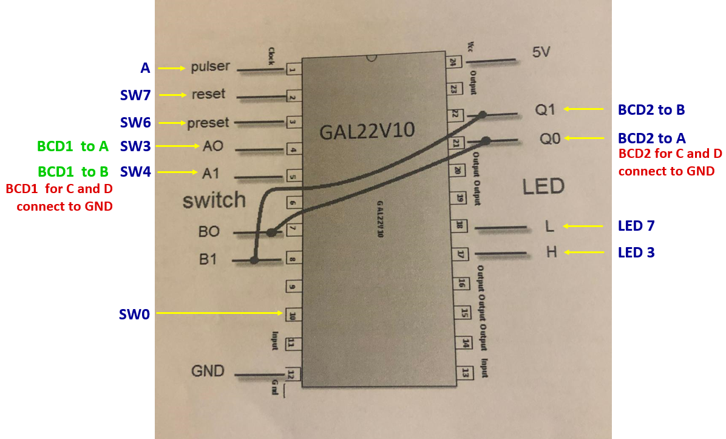
Figure 1 : 2 Bit Circuit Implementation
For the input pins, pin 1 is connected to the Pulser A which is the clock. Pin 2 is connected to switch 7 which is for reset. Pin 3 is connected to switch 6 which is for preset. Pin 4 is connected to switch 3, then to BCD1 A which is for the comparator A. Pin 5 is connected to switch 4, then to BCD1 B, BCD1 for C and D connected to GND. Pin 7 is connected is connected to pin 21 which is for the comparator B. Pin 8 is connected to pin 22. Pin 10 is connected to switch 0 which is for the start printing machine.
For the output pins, pin 17 is connected to LED 3 which is for the XOR (A B not equal HIGH). Pin 18 is connected to LED 7 which is for XNOR (A B equal HIGH). Pin 21 is connected to BCD2 A which is the output counter. Pin 22 is connected to BCD2 B which is the output counter, then C and D is connected to GND.

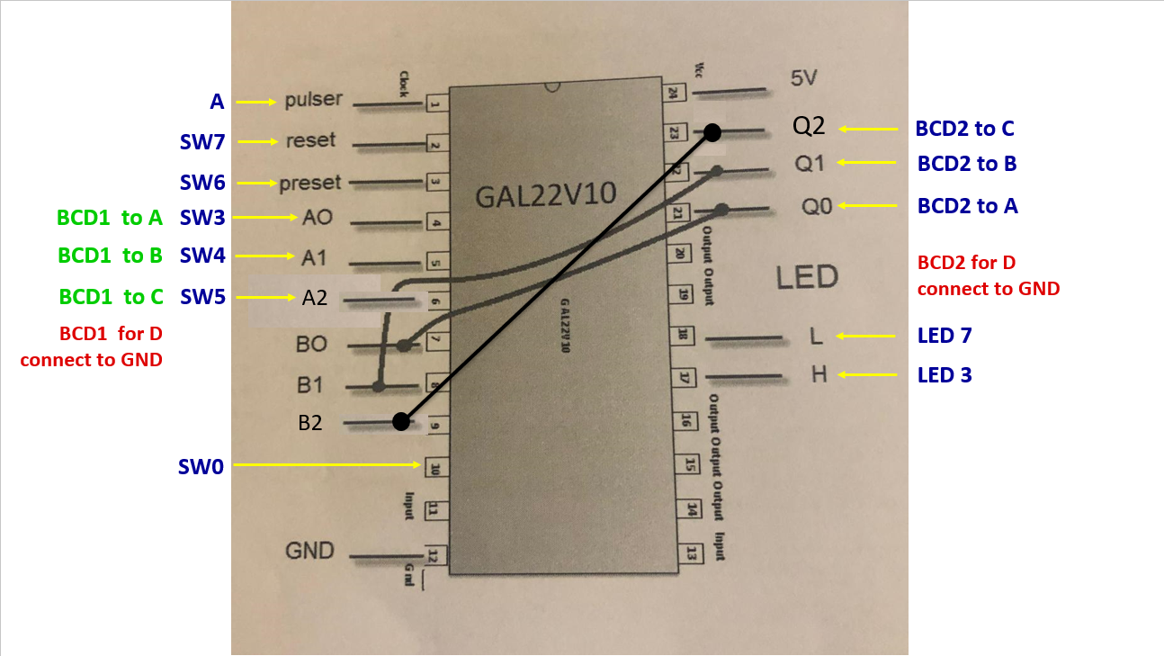
Figure 2: 3 Bit Circuit Implementation
For the 3-bit circuit implementation, we add another input for BCD1 to make it become 3 bit which is A2 (MSB) at Pin 6 that is connected to switch 5, then the BCD1 C is change from GND to A2. Pin 9 is used for BCD2 as B2 (MSB), then it is connected to Pin 23 for the output as Q2. Lastly, BCD2 C is change from GND to Pin 9.

Physical System Implementation
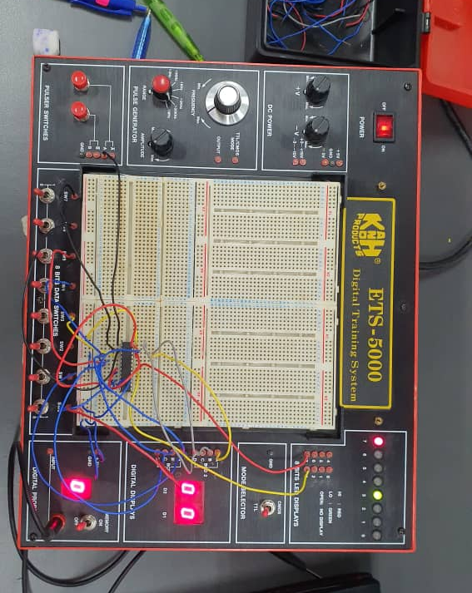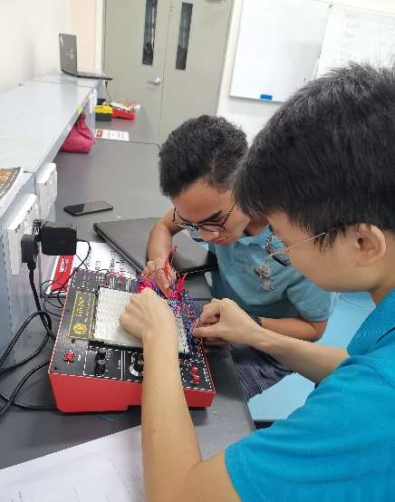
Figure 3: Circuit Setup
Figure above shows the circuit setup based on the circuit implementation theory and steps stated before. Digital Training System ETS-5000 is used as the platform for all the component to assemble and connect with each other. The jumper wire is used to connect all the components.

Discussion
The summary of the whole project is to expose the use of WinCUPL software and Wellon Universal Programmer to develop a PLD device. In this project, we are instructed to produce a photocopy machine system by using the PLD IC. Through this project we can easily assimilate with the software environment which is WinCUPL and Wellon. So, it helps us to master the program efficiently. Besides, our skills to assemble and connect all the components also contribute a lot to this project. We can produce the circuit in a short time and there are no mistakes when connecting the components. This saves our time.
Some of the problems we faced while executing the project is that the Wellon Universal Programmer take a long time to execute the program. Other than that, the Wellon hardware used is also limited as we need to wait for our turn to use it. Lastly, malfunction connecting wires also interfere our project as there will be a short circuit and we will need to detect which wire is malfunctioning which takes time since many connecting wires are used.
As for future improvement, we could try to simplify the wiring and make it more systematic for people to easily and clearly understand the circuit setup before doing the wiring.

Conclusion
From this mini project, we learnt that the importance of understanding the topic before starting the project because at first, we were struggling a little bit especially the positioning of the wiring. Secondly, we learnt that teamwork is very important especially in making a project because it helps us to complete the project faster and easier.
As a computer science student, Digital logic subject is a fundamental as it teaches the basic knowledge that is compulsory in learning future subject as Computer Organization and Architecture. It trains us to understand more about the logic of computer especially binary numbers because computers only understand in binary which are 0 and 1.

References
- Abd. Bahrim Yusoff, Mazleena Salleh, Mohd Fo’ad Rohani, Ismail Fauzi Isnin, (2018). Digital Logic Fifth Edition. School of Computing, Faculty of Engineering, Universiti Teknologi Malaysia

Appendix A (2-bit XEROX System)
Name XeroxMachine2BIT ;
PartNo 00 ;
Date 07/12/2017 ;
Revision 01 ;
Designer Engineer ;
Company UTM ;
Assembly None ;
Location ;
Device G22V10 ;
/* *************** INPUT PINS *********************/
PIN 1 = clk ; /* clock */
PIN 2 = reset ; /* reset */
PIN 3 = preset ; /* preset */
PIN 4 = a0 ; /* Comparator A */
PIN 5 = a1 ;
PIN 7 = b0 ; /* Comparator B */
PIN 8 = b1 ;
PIN 10 = startPrt ; /* Start Printing */
/* *************** OUTPUT PINS *********************/
PIN 17 = diffCmp ; /* XOR (A B not equal HIGH) */
PIN 18 = sameCmp ; /* XNOR (A B equal HIGH) */
PIN 21 = q0 ; /* output counter */
PIN 22 = q1 ;
/***** Function Comparator************************/
sameCmp = !(a0$b0)&!(a1$b1);
diffCmp = !sameCmp ;
/**** Function Clock Enabler *********************/
clkEn=startPrt & diffCmp;
/*** Function Counter 3 Bit UP *******************/
field count =[q1..0];
$define s0 'b' 00
$define s1 'b' 01
$define s2 'b' 10
$define s3 'b' 11
count.ar=reset; /* connect reg AR to reset (Asyn Mode) */
count.sp=preset; /* connect reg AR to preset (Syn Mode) */
sequence count{
present s0 if clkEn next s1;
default next s0;
present s1 if clkEn next s2;
default next s1;
present s2 if clkEn next s3;
default next s2;
present s3 if clkEn next s3;
default next s3;
}

Appendix B (3-bit XEROX System)
Name XeroxMachine3BIT ;
PartNo 00 ;
Date 07/12/2017 ;
Revision 01 ;
Designer Engineer ;
Company UTM ;
Assembly None ;
Location ;
Device G22V10 ;
/* *************** INPUT PINS *********************/
PIN 1 = clk ; /* clock */
PIN 2 = reset ; /* reset */
PIN 3 = preset ; /* preset */
PIN 4 = a0 ; /* Comparator A */
PIN 5 = a1 ;
PIN 6 = a2 ; /* */
PIN 7 = b0 ; /* Comparator B */
PIN 8 = b1 ;
PIN 9 = b2 ; /* */
PIN 10 = startPrt ; /* Start Printing */
/* *************** OUTPUT PINS *********************/
PIN 17 = diffCmp ; /* XOR (A B not equal HIGH) */
PIN 18 = sameCmp ; /* XNOR (A B equal HIGH) */
PIN 21 = q0 ; /* output counter */
PIN 22 = q1 ;
PIN 23 = q2 ; /* output counter */

/***** Function Comparator************************/
sameCmp = !(a0$b0)&!(a1$b1)&!(a2$b2);
diffCmp = !sameCmp ;
/**** Function Clock Enabler *********************/
clkEn=startPrt & diffCmp;
/*** Function Counter 3 Bit UP *******************/
field count =[q1..0];
$define s0 'b' 000
$define s1 'b' 001
$define s2 'b' 010
$define s3 'b' 011
$define s4 'b' 100
$define s5 'b' 101
$define s6 'b' 110
$define s7 'b' 111
count.ar=reset; /* connect reg AR to reset (Asyn Mode) */
count.sp=preset; /* connect reg AR to preset (Syn Mode) */
sequence count{
present s0 if clkEn next s1;
default next s0;
present s1 if clkEn next s2;
default next s1;
present s2 if clkEn next s3;
default next s2;
present s3 if clkEn next s3;
default next s3;
present s4 if clkEn next s4;
default next s0;
present s5 if clkEn next s5;
default next s1;
present s6 if clkEn next s6;
default next s2;
present s7 if clkEn next s7;
default next s3;
}

