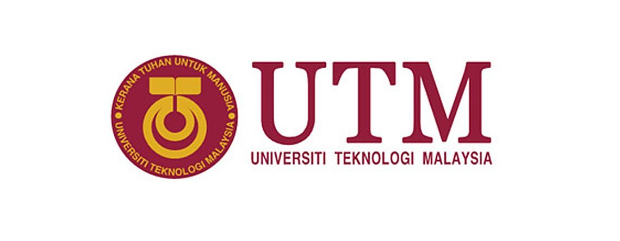

**SBSD 2083 - 01**

**INDUSTRIAL VISIT TO PORT OF TANJUNG PELEPAS**

**TITLE : REPORT AND REFLECTION**

NAME : WAN MAISARAH BINTI WAN MUHAMMAD FAISAL

I/C NUMBER : 980519-10-6714

MATRIC NUMBER : B19BS0017

LECTURER’S NAME : DR [MOHAMAD SHAH BIN KASSIM](http://aimsweb.utm.my/eppp/borang_BI.asp?sesisem=201920201&nokp=%A8%A0%91%97%93%9A%A5{%97%A9%96%9B&kodmp=SBSD2083&seksyen=01&tempoh=11&nokerja=9344)

REPORT AND REFLECTION OF INDUSTRIAL VISIT TO PORT OF TANJUNG PELEPAS

The Port of Tanjung Pelepas is the fastest growing container port in Malaysia. The facility is located on Malay Peninsula’s most southern tip, on the eastern mouth of the Pulai River, in the State of Johor. Port of Tanjung Pelepas (PTP) is a port operated by MMC and APM which both of them a major corporations in the port industries of Malaysia. They offers o Shipping Lines minimal deviation time of 45 minutes and is situated in a sheltered bay and also has no tide restrictions.

Local cargo movement to to all the major industrial estates are accessible through the second Malaysia-Singapore expressway and the north to south highway. In addition to intermodal connections between road, sea and air, PTP is also related to the national rail system which operates from Singapore to Southern Thailand via Peninsular Malaysia.

The Port of Tanjung Pelepas (PTP) also has 14 linear berths totalling 5.04km. The terminal is equipped with 58 Super Post Panamax cranes, 16 of which have a 24-box outreach catering for the next generation of Triple E size vessels. These cranes also have twin-lift capability to further enhance productivity. PTP’s current average over 32 moves per hour/crane, and berth productivity stands at 100 moves per hour minimum.

PTP has developed five core values which are focus on customers where they always strive to exceed customer’s expectations. They also deliver results through innovation and continuous improvements. Besides that, they value people as a team, respect and care for each other. Then, they uphold integrity like demonstrate integrity in words and actions. Lastly, they promote sustainable development which they care about heath, safety and environment.

**REFLECTION ON THE INDUSTRIAL VISIT**

By visiting the industrial of The Port of Tanjung Pelepas (PTP), I have discovered and exposed to the real operation of businesses in PTP. PTP is the the most suitable industry for a visit since they are most advance container terminal and one of the major ports in Malaysia. PTP is also using advance technology to manage containers from all around the world.

The Port of Tanjung Pelepas (PTP) has given me a better understanding on how their services relate to international trade activity. I was given the opportunity to experience visiting their port terminal where I saw the containers were moved from ships to their terminal by using automated cranes system. As far as I know, they have 58 units of super-post panamax cranes (16 EEE cranes), 163 units of Rubber Tyred Gantry cranes, 430 units of Prime Movers, 460 units of trailers, 22 Empty Handlers and 3 units of Reach Stackers. Besides that, they also use modern IT systems like Integrated IT Systems - Navis N4, FZIPs and ORACLE.

Furthermore, PTP also regulated Free Trade Zone.The Free Zone in PTP promulgates the local container trade volumes of the port and forms part of the hinterland cargo catchment area. The Free Zone area is suitable for the development like warehousing and logistics and export driven light to medium scaled manufacturing industries.

This free trade area makes PTP as one of the logistic’s attraction as it reduces cost of taxes, custom duties and directly help them to boost global market. Any businesses deals with PTP are using Malaysia Ringgit so anything that PTP charges will cost less than the port in Singapore since our currency is much more lower than Singapore Dollar.

In conclusion, this industrial visit has given me so much knowledge upon logistics and international trade. I have also gained knowledge about the real logistic businesses operation especially that is involving port and shipments. Overall, this visit has exposed me to the real business operations that connects country from all over the world.