SQ3R (SURVEY- QUESTION-READ- RECITE- REVIEW) Paste your ARTICLE on the next page
5. REVIEW
Answer each question you generated before reading the text:
Q1: Consumers cannot recognizes a significant difference between the desired and the actual state of affairs.
Q2: Social networking sites, social news website, media sharing sites and blogs.
Q3: Consumers begin the process of searching, obtaining information and evaluating other options for future buying decision.

3. READ
Look for the answers to your three questions as you actively read the text. It is important to take the time to re-read any sections or portions of the text that are unclear.
4. RECITE
Write a short summary of the text in your own words.
Summary:
When we want to purchase a product, we first need to know what is the problem that we face to buy this product. Upon that, we need to search for more info about that product so as to search other alternatives ways to replace the product via social media before purchasing this product as we want to have the best choice among the selection. After we had made a purchase, we need to give our satisfaction to the product. That’s all when we need to buy something via social media.

1. SURVEY
Answer the following questions before reading the text:
What is the topic of the text?
Answer: The Impact of Social Media on Businesses and Consumer Habit

What is the title of the text?
Answer: Social Media, Consumer Behavior, and Service Marketing

Are there subtitles, headings or chapter. How is the text organized?
Answer: Have heading and chapter.

Describe the picture/ graphic included in the text.
Answer: It shows 5 stages of Consumer Decision process.

2. QUESTION
Before you start reading, write these questions you have about the text:
Q1: What are the problems faced by the consumers?
Q2: What are the types of social media?
Q3: What will the consumers does if they’re not satisfied?

PASTE YOUR ARTICLE HERE:
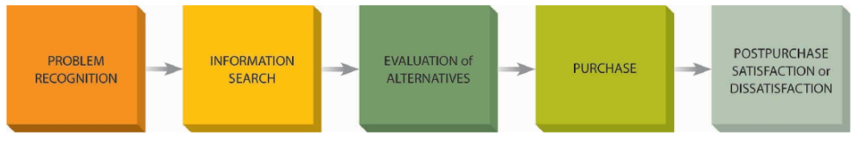
- Problem recognition
Problem recognition takes place whenever a consumer recognizes a significant difference between the desired and the actual state of affairs, which is insufficient magnitude to arouse and activate the decision process (Solomon, Bamossy and Askegaard 2002). At the point when an individual is activated remotely, for example, an individual may see a TV notice for a get-away, the upgrades triggers musings or thoughts regarding the chance of making. Once consumers recognize a want, they need to gather information to understand how they can fulfil that want, which leads to step 2.

- Search of Information
The last buy choice won't be made without a moment's delay, in any event, when people recognize, perceive their issues, and focus on the accessible items; similarly, when possibilities have a certain enthusiasm for an item or administration, they will in general experience the accompanying strides before completing any activity – recognizing accessible choices, considering data of chose alternatives, and in the end judging which of these choices can no doubt convey the best result. While inquiring about their choices, purchasers again depend on inside and outside elements, just as past associations with an item or brand, both positive and negative. In the search of information, they may peruse through alternatives at a physical area or counsel online assets, for example, Google or client audits.

- Evaluation of alternatives
When data has been gathered, the customer utilizes it to assess and survey the elective item decisions to show up at a buy choice. The elective assessment and data search stages, however, introduced independently, are unpredictably interlaced during dynamic, and shoppers frequently move to and fro between the two. Elective assessment includes the determination of decision options and evaluative measures. When decided, the exhibition of the considered decisions is thought about along the notable rules, lastly, choice standards are applied to limit the choices to make the last determination. This stage prompts the arrangement of convictions, perspectives, and goals, prompting the resulting phase of the procurement. The alternative that is simpler to use or arrange, or what is preference of the majority or various other reviews and experiences matters in the evaluation.

- Final decision
Purchase choice alludes to the last decision or choice made with respect to which item to purchase.. The act of purchase is the last major stage, with the consumer deciding on what to buy, where to buy, and how to pay. Purchase is a function of intentions, environmental influences and individual situations. Some of the influences that can affect the purchase action include the time available for decision making, information availability, and the retail environment. The attitude of family and friends, and unanticipated circumstances such as product availability (size, colour) and stock-outs may also force a re-evaluation (Kotler and Armstrong, 2014).

- Post-purchase decisions
After consumption, the consumer then experiences certain levels of satisfaction or dissatisfaction and evaluates the wisdom of the choice made in selecting the alternative. Two potential outcomes are derived from this phase – satisfaction or dissonance. When consumer experiences dissonance towards the purchase, the choice is ‘devaluated’ and the consumer begins the process of searching, obtaining information and evaluating other options for future buying decision, in which triggers new behaviour. (Sternthal and Craig 1982). In this part the process involves initiative from both buyer and seller where the expectations of the buyer had to be met perfectly by the product and seller has to ensure future engagement and repurchase by the buyer.

