

SECI1013-06 STRUKTUR DISKRIT

TUTORIAL 5

Lecturer: Assoc. Prof. Dr. Roselina Sallehuudin

|  |  |  |
| --- | --- | --- |
| No. | Name of Students | Student ID |
| 1 | Muhammad Aniq Aqil bin Azrai Fahmi | A20EC0083 |
| 2 | Muhammad Kasyfi bin Kamarul Hamidi | A20EC0093 |
| 3 | Muhammad Naim bin Abdul Jalil | A20EC0096 |
| 4 | Muhammad Azzam Hamiludin | A20EC5003 |

|  |  |
| --- | --- |
|  | **SECI1013: DISCRETE STRUCTURE**  **2020/2021 – Sem. 1**  ASSIGNMENT 5 |

# QUESTION 1

Let M = {S, I, q0, fs, F) be the DFA such that S={q0, q1, q2, q3}, I={a,b}, F={q1}, q0=initial state and fs is given by:

fs (q0, a) = q1, fs (q0, b) = q2

fs (q1, a) = q3, fs (q1, b) = q2

fs (q2, a) = q1, fs (q2, b) = q2

fs (q3, a) = q3, fs (q3, b) = q2

1. Construct a state transition diagram of the DFA given the state transition function, fs.

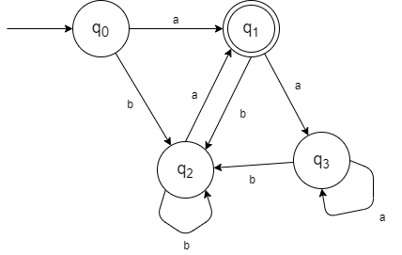

1. DFA can be applied for verification of email password. Justify why DFA is suitable for verification?

Because DFA input will only reach the final state if the string of password is correct.

# QUESTION 2

Given a deterministic finite automaton (DFA) as in Figure 1.

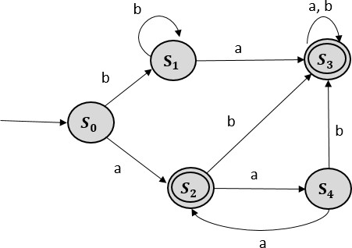

# Figure 1

* 1. Construct a state transition table for state transition diagram.

|  |  |
| --- | --- |
|  | Next State |
| Current State | Current Input  a b |
|  |  |
|  |  |
|  |  |
|  |  |
|  |  |

* 1. Identify whether the following input can be accepted by the DFA.
     1. w = **aaaaaa**
     2. w = **ababab**

Show the configuration of the state transition in each question.

1. w = **aaaaaa**

**a a a a a a**

**   **  ** ,** Input unaccepted.

1. w = **ababab**

**a b a b a b**

**     ,** Input accepted.

# QUESTION 3

1. Given a deterministic finite automaton (DFA) as in Figure 2.

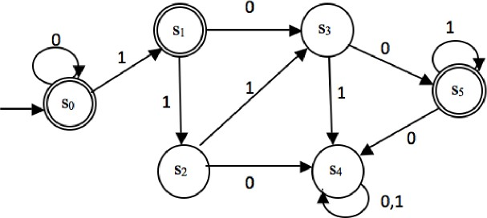

* 1. List all the components of *S*, *I*, *qo*, *F*.
  2. Find the sequence of configurations and state if the string **0011101100** is accepted by the DFA.

0

0

1

1

1

0

1

1

0

0

not accepted.

1. Construct a DFA that accepts the set of all bit strings that contain three consecutive 1s.

State Transition Table

|  |  |  |
| --- | --- | --- |
|  | 0 | 1 |
|  |  |  |
|  |  |  |
|  |  |  |
|  |  |  |

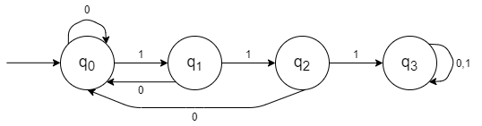

# QUESTION 4

You are going to develop a simple shooting game. There is one hero in a battle field with few enemies and other characters. There are three states in the game which are *WANDER*, *EVADE* and *ATTACK*. When the hero is wandering the field and suddenly encounters enemies while he is not in vulnerable situation, he will go into *ATTACK* stage by shooting the enemies. However, if while wandering the field and the hero suddenly encounters enemies and he is in vulnerable situation, he will shoot the enemies and goes into *EVADE* stage. While in *ATTACK* stage, if the hero encounters enemies and he is not vulnerable, he will remain in that stage and continues shooting. But if he encounters enemies and he is vulnerable, he will shoot and goes into *EVADE* stage. While in *EVADE* stage, if the hero encounters enemies and he is not vulnerable, he will go into *ATTACK* stage and shoots. But if he encounters enemies and he is vulnerable, he will remain in that stage and continues shooting. When the hero encounters characters that are not his enemies, he will not shoot. If he is in the *WANDER* stage at that time, he will continue wandering the field. If he is in *ATTACK* or *EVADE* stages, he will switch into *WANDER* stage. The inputs and outputs are given in the Table 1 below. **Construct a finite state diagram to model the game**.

|  |  |
| --- | --- |
| Input | Output |
| not enemies | shoot |
| enemies & not vulnerable | not shoot |
| enemies & vulnerable |  |

# Table 1

States: WANDER, EVADE, ATTACK

Inputs: not enemies, enemies & not vulnerable, enemies & vulnerable

Outputs: shoot, not shoot

Define: WANDER =W, ATTACK = A, EVADE = E, not enemies = F, enemies & not vulnerable = ENV, enemies & vulnerable = EV , shoot =1, not shoot = 0.

Table Transition table

|  |  |  |  |  |  |  |
| --- | --- | --- | --- | --- | --- | --- |
|  | fs | | | fo | | |
| F | ENV | EV | F | ENV | EV |
| W | W | A | E | 0 | 1 | 1 |
| A | W | A | E | 0 | 1 | 1 |
| E | W | A | E | 0 | 1 | 1 |

**QUESTION 5**

ATM is a computerized machine that provides bank customers to gain access to their accounts using magnetic encoded plastic card and code number. It enables the customer to perform online transactions without involving cashier, clerk and bank teller. The customer makes cash withdrawal, check account balances, transfer money as well as purchase prepaid mobile phone credit by using ATM card. Typical PIN based ATM has following processes:

* Insert ATM card to establish interface. The card will be validated to ensure the correct ATM card is inserted. If the card is unsuccessfully validated, the card is ejected and ATM session is terminated.
* For valid ATM card, user is asked to enter the PIN and press the execution key for the system to match the PIN, if PIN does not match, then user access is denied to the next stage and he or she is requested to repeat the operation with the correct PIN for a fixed two retries.
* If after the third time the PIN is unmatched, the card will be locked and ATM session is terminated.
* If the PIN matches then the transaction interface is displayed and user has to select the transaction that they wish to perform.
* After the machine performs the chosen transaction, it will prompt user if a new transaction is to be performed. If the response is ‘Yes’, the transaction interface is again displayed and if ‘No’ the transaction is terminated and card ejected and ATM session is terminated.

Based on the above description, the states, inputs and outputs are as follow:

# States:

|  |  |
| --- | --- |
| S1: Welcome screen | S6: Choosing transaction screen |
| S2: Validating card | S7: Performing transaction |
| S3: 1st PIN entering screen | S8: Asking for other transaction screen |
| S4: 2nd PIN entering screen | S9: Terminate ATM session |
| S5: 3rd PIN entering screen |  |

**Inputs:**

|  |  |
| --- | --- |
| A: Insert ATM card | F: Transaction is selected |
| B: Valid ATM card | G: Complete transaction |
| C: Invalid ATM card | H: Yes for other transaction |
| D: Correct PIN | I: No for other transaction screen |
| E: Incorrect PIN |  |

**Outputs:**

|  |
| --- |
| 0: Nothing happened |
| 1: Eject ATM card |
| 2: Lock ATM card |

**Draw the transition diagram for the above system.**

