Semester I 2020/2021

Subject : Technology and Information Systems (SECP1513)
Section : 4
Assignment : Step by step PC Assembly

GROUP NAME / NUMBER : 1

1 |  | Name: Abdulaziz Tawfik Othman  Matric Number: A20EC4004  Phone Number: +601163687227  Email: tawfikothman@graduate.utm.my
2 |  | Name: Abdullah Faisal N Alhujaili  Matric Number: A20EC4010  Phone Number: +966050810536  E-mail: abdullah.hujaili@gmail.com
3 |  | Name : Muhammad Syahir Bin Sulaiman  Matric Number : A20EC0101  Phone Number: 012-7021454  E-mail : syahir01@graduate.utm.my
4 |  | Name : Nur Syakirah binti Mohd Shukri  Matric Number : A19EM0384  Phone Number: 017-9871644  E-mail : shashashukri@gmail.com
PART A – List at least FOUR tools needed to assemble a PC. For each tool, Provide picture(s), explanations of its functions and its importance.
- Screwdriver
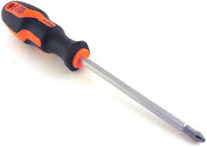

Function: Tighten & loosen the screws
Importance:
- Screwdriver is used to firmly lock the components in its respective place in the pc case.
- It is also used to remove or loosen the screws which holds the components in order to change to a new one.

- Thermal Paste

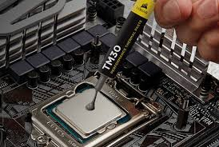

Function: Enable the effective transfer of heat from the processor's integrated hear spread to the CPU cooler's base plate or water block built to dissipate the heat
Importance:
- It fills the small imperfections here between CPU and the heatsink that otherwise trap air particles, prohibiting the CPU from sufficiently cooling.
- Cable / twist ties
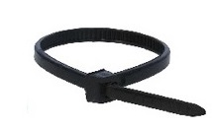
Function: In the case, tie up some loose cables left around
Importance:
- Promote better airflow
- Makes the end product(the built) neat.

- Light Source
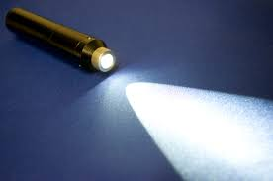

Function: To illuminate darkness
Importance:
- To be able to see the tiny screws which stays in the dark spots/corners of the pc case

- Anti-static wrist strap
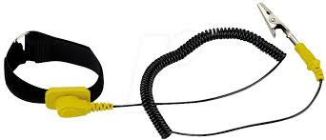

Function: To discharge any electrical build up
Importance:
- It helps to avoid electrical risks when touching the metal objects in the pc case.

PART B – Sketch of a mother board layout

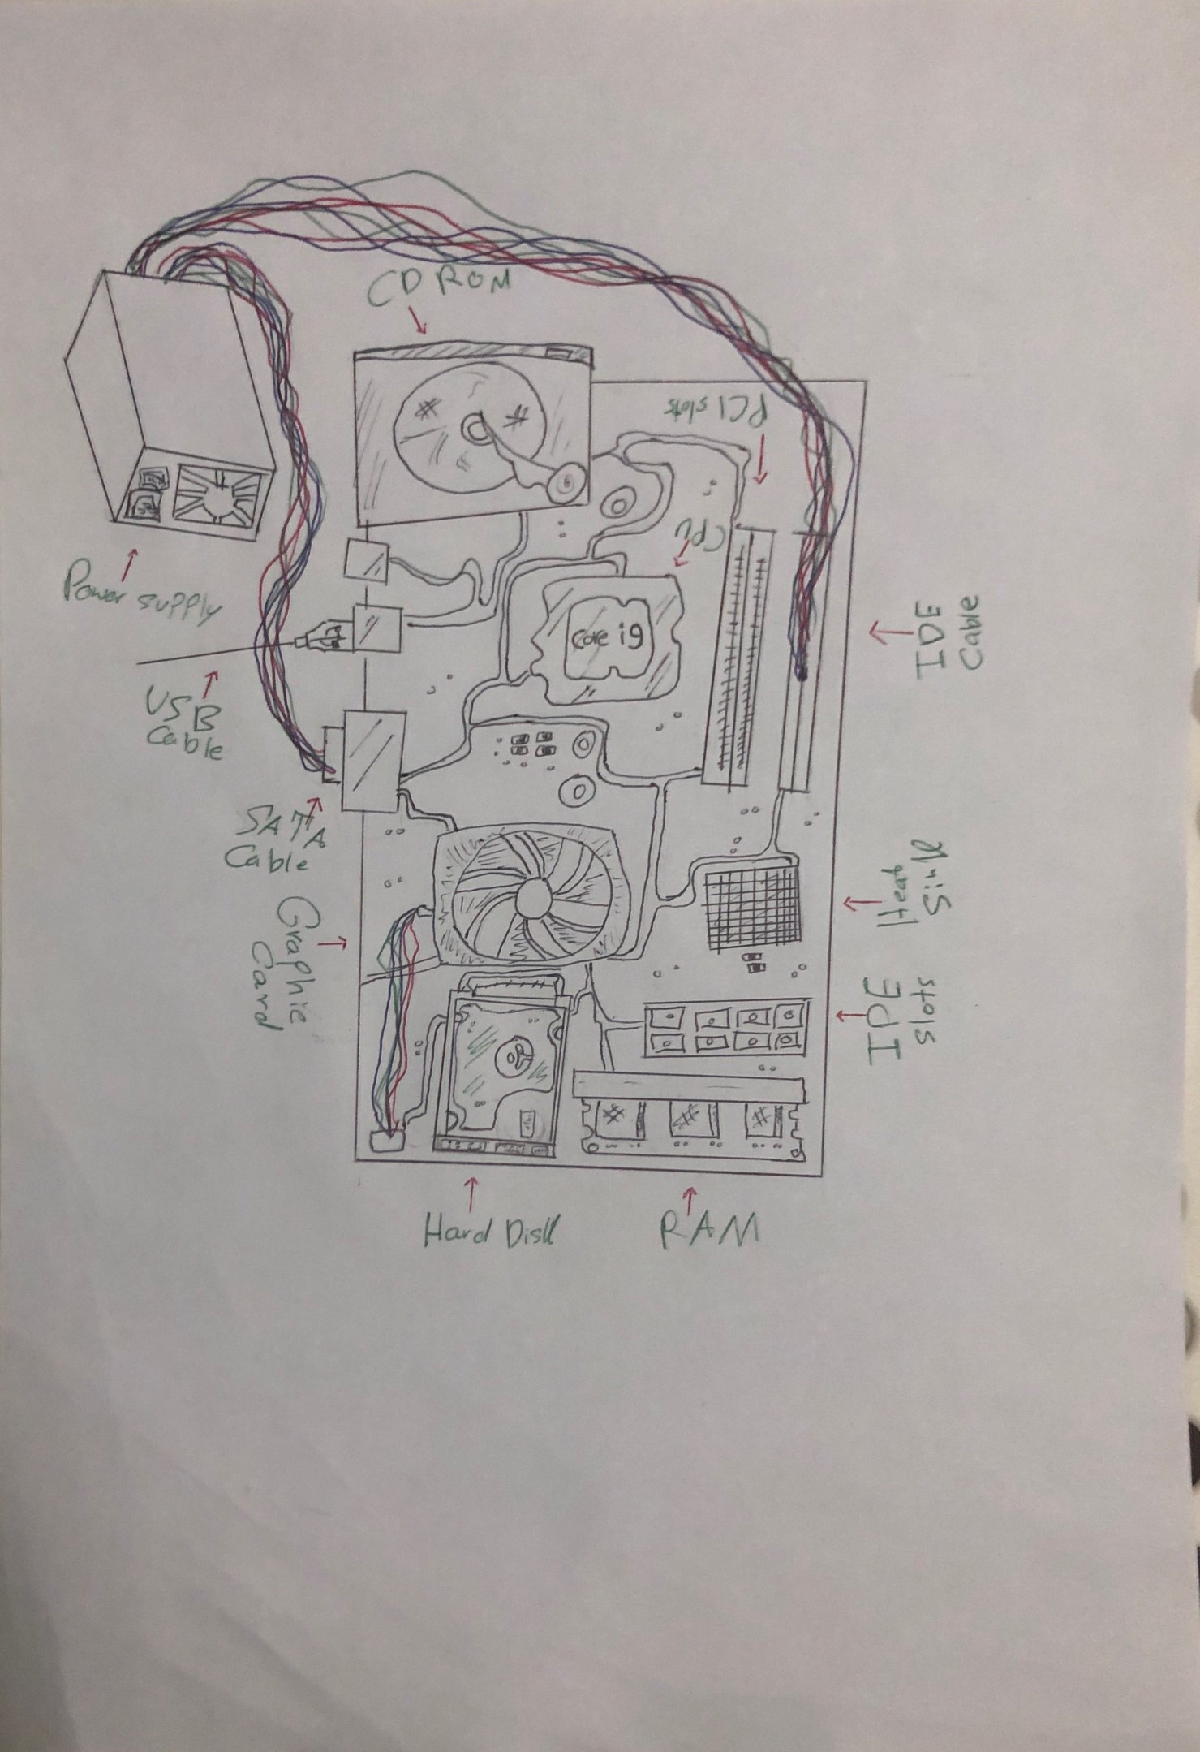

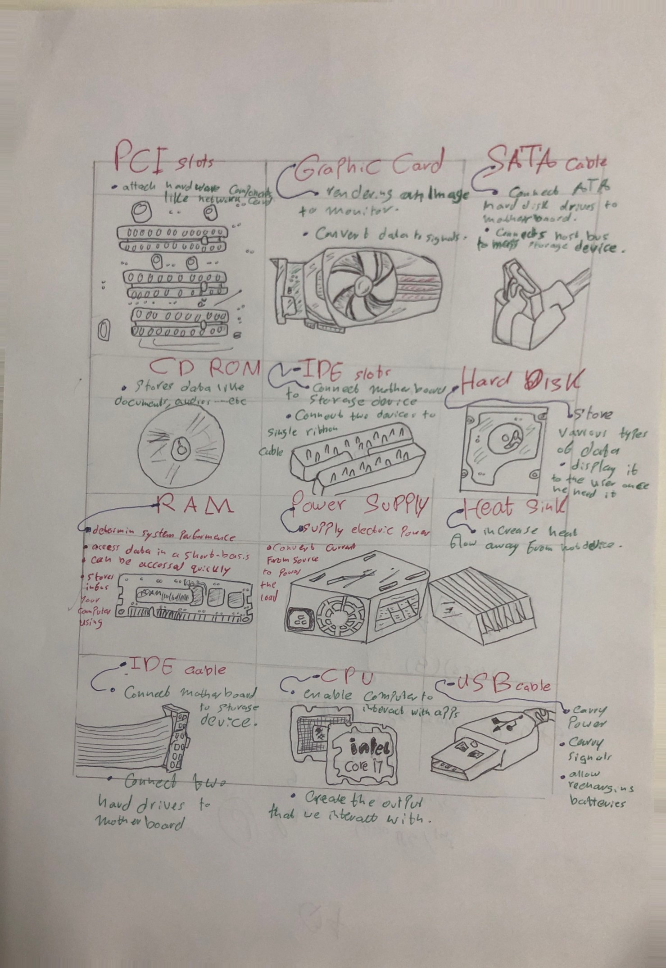
Part C – Step by Step PC assembly

Step 1: Install the CPU
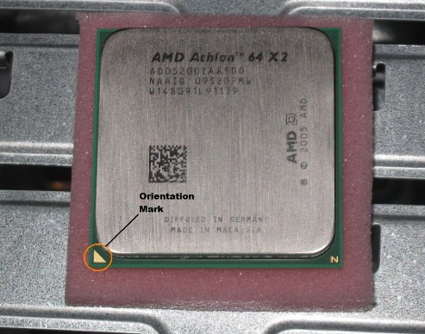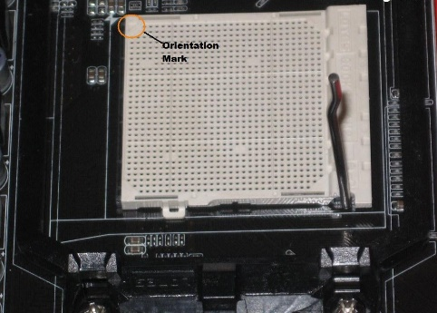
Figure 1 Figure 2
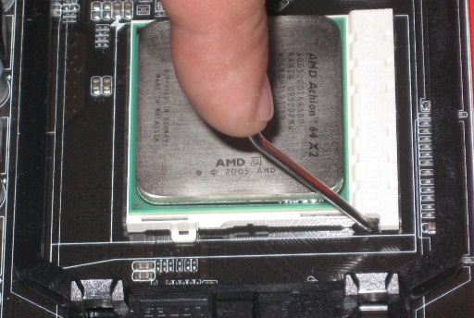
Figure 3
- Find the corner marked on the CPU as shown in figure 1. For this assemble, we use AMD brand processor, the corner is marked with an arrow.
- Lift the rod up next to the socket as shown in figure 2.
- On the CPU socket, locate the correcponding marking and mount the CPU so that the marks are lined up.
- Lock the processor with push the small rod down as shown in figure 3.

Step 2: Install the CPU fan
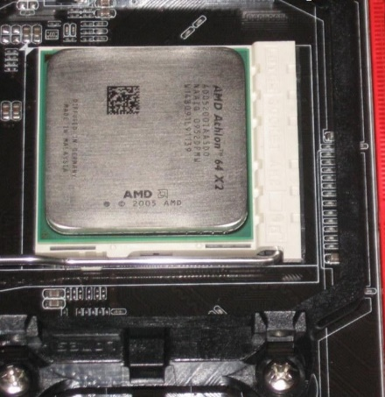
Figure 4
- Apply the right amount of thermal paste to the CPU as shown in figure 4.
- Set the fan assembly on the CPU with tabs aligned.
- Pull the locking rod down to lock into position on the fan assembly.
- Connect the fan asssembly’s connecter to the motherboard.
Step 3: Install Power Supply and Motherboard
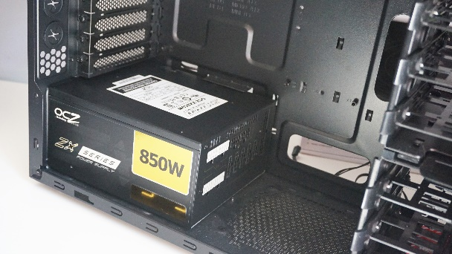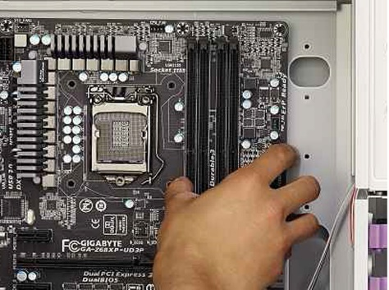
Figure 5 Figure 6
- Attach the Power Supply on the mounting holes in the case as shown in figure 5.
- Attach the IO shield and mount the motherboard in the case like in figure 6.
- Insert screws and tighten to hold power supply and motherboard in the case.

Step 4: Install Hard Drive
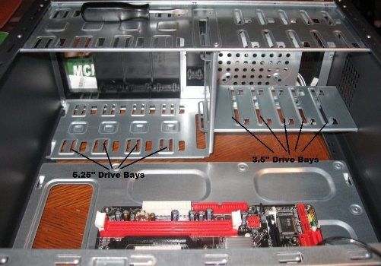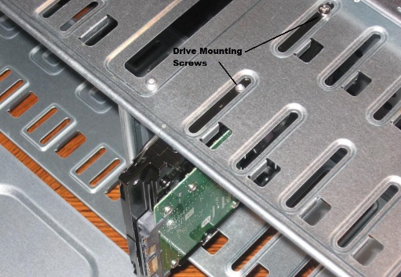
Figure 7
The hard drive is the device that stored all of our data. It is 3.5” wide as shown in figure 7.
- Find a 3.5” drive bay in the case to install hard drive. Slide the drive into place until the screw holes on the slides are lined with the holes in the case.
- Install the screws and tighten.

Step 5: Install RAM
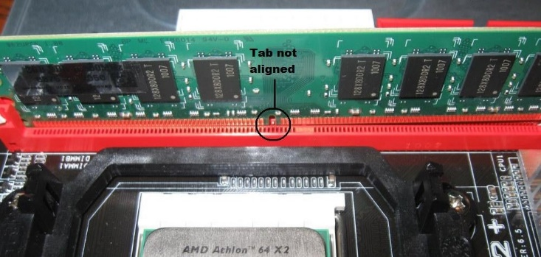
Figure 8
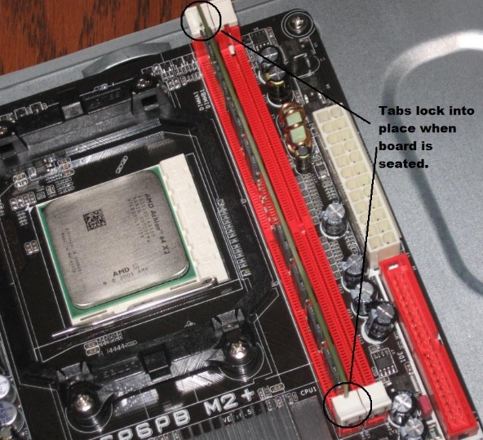
Figure 9
- As shown in figure 8, set the RAM board in the socket. Test to see if the notch is in the right position on the board. Turn it around 180 degree if it is not.
- Press firmly on both ends of the board to set it into the socket. Make sure the tabs lock into place as shown in figure 9.

Step 6: Install Optical Drive
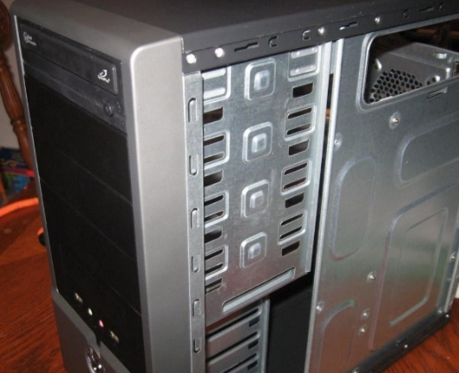
Figure 10
- Find a 5.25” drive bay to install optical hard drive in the case.
- Slide the drive into the drive bay until the the screw holes are lined up and the front of the drive is flush with the front of the case as shown in figure 10.
- Instal the screws and tighten.
Step 7: Connect Cable
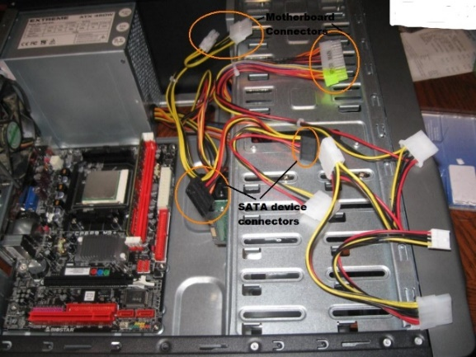
Figure 11
- Connect the power switch to the motherboard. Usually power switch wire marked PWR SW. The power switch wires need to connect to the power jumpers on the motherboard.
- Connect the Reset Switch Wires to the jumper on the motherboard and usually it marked RESET SW.
- Connect USB wires on the motherboard.
- Installing FireWire connection to motherboard. The plastic connecter on the wires may be marked as 1394.
- Connect Audio Wires on the motherboard.
- Connect CPU Fan wires on the motherboard, often labelled as CPU FAN.
Step 8: Closing the case and connecting the peripherals.
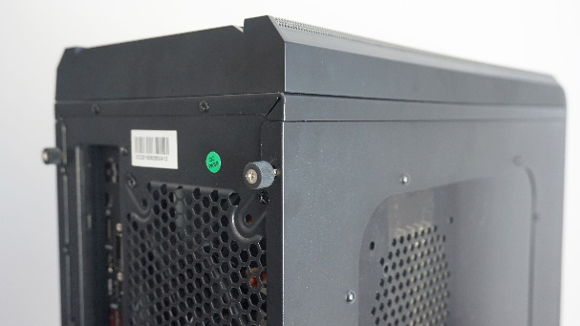
Figure 12
- Place the side cover back on and secure the side panels with case screws.
- Connect peripheral devices which include mouse, printer, keyboard, webcams and wireless network dongle with the CPU by plugging into USB port.
- Connect speakers and microphone into 2.5 mm sockets.
- Finally connect the CPU with monitor by plugging into display ports.

