THE WOLRD IN THE VIEW OF ISLAM

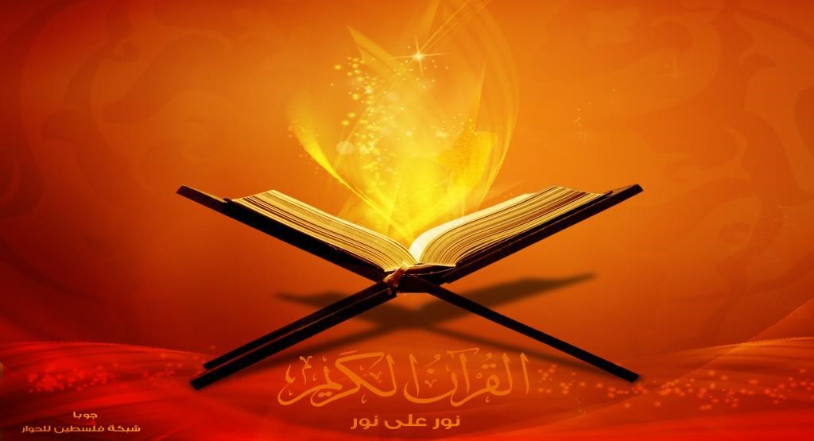

* Allah is the God of this universe and we have to practice Islam, in order to become a true muslin and gain success in life and after death. Islam means

Introduction

to achieve

peace.



Islam and the world.

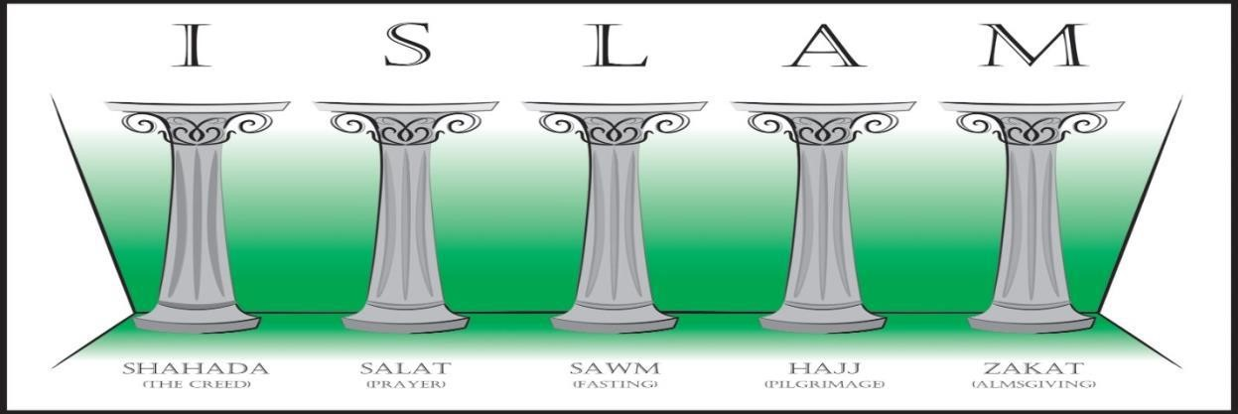

* Every single thing for this world, for a human lifetime is written in the Quran.

It’s the book of Allah where everything is written very clearly with logic.

# Islamic Philosophy

* The philosophy which is produced in Islamic society is called islamic philosophy. Islamic Philosophy is generally a discipline which concerned with the general problems of being, knowledge, soul, God, and religion.
* There are two main sources of Islamic philosophy . They are “The Quran” and “Hadith”.
* The Al-Quran The Hadith.

# Logic of Islam

 Early Islamic political philosophy emphasized a unique connection between science and religion and the process of ijtihad for the search for truth. Ibn al-Haytham argued that in order to discover the truth about nature, it is necessary to remove human opinions and errors and allow the universe to for itself.

Different logic

Aristotelian logic:

Avicennian logic:

## Metaphysics

* What is metaphysics.

Metaphysics is a branch of philosophy that examines the essence of reality, including the relationship between the mind and matter, between matter and properties, and between possibility and realit

* Some metaphor of Islam.

The search for an entity on the fundamental basis of Islam is known as the Muslim metaphor



PROBLEMS

WORLD IN THE VIEW OF

ISLAM





I)PROBLEMS ARE SO HARD TO FIND IN ISLAM

BECAUSE ISLAM IS THE BEST RELIGION IN THE

WORLD AND IT IS TOTALLY FULFILLED WITH

EVERYTHING . THERE IS NO WRONG EVEN IN THE

HOLY QURAN . SO MANY YEARS PASSED BUT THE

QURAN IS ALL THE SAME ,NO ONE CAN FIND ANY

MISTAKE ON IT.





THE BIG PROBLEM IS WE HAVE TO MAKE CHANGE

ABOUT WHAT OTHER RELIGIOUS PEOPLE THINK

ABOUT US . WE HAVE TO CHANGE THE VIEW OF

ISLAM .FOR THIS WE HAVE TO DO A LOT OF HARD

WORK.AS ISLAM SAID ALL THE BAD WORKS IN

TOTALLY BARRED IN ISLAM ,WE SHOULD ALWAYS

TRY TO MAKE OUR FAMILY MEMBERS CARE ABOUT

ISLAM AND ITS RULE .NOT ONLY FAMILY MEMBERS

WE HAVE TO CARE ABOUT OUR FRIENDS ALSO .





NOT PROTESTING ABOUT CRIME IS ALSO ANOTHER

TYPE OF CRIME ,WE SOMETIMES THINK THAT IF WE

ARE WELL ,EVERYTHING IS OK BUT IT IS NOT

BECAUSE WE CANT SUPPORT CRIME WE HAVE TO

PROTEST IT AT ANY COST TO REMOVE IT FROM THE

SOCIETY . IF WE DO NOT DO SO , ONE DAY THE

SOCIETY WILL SUFFER BECAUSE OF THEIR OWN

SECURITY . THE PEOPLE ARE BAD INFLUENCERS , WE

CAN SUGGEST THEM TO COME IN THE PATH OF

ISLAM AND OBEY AS IT IS SAID IN THE HOLY QURAN

.





TO LIVE HAPPILY WE CANT FORCE ANYBODY TO

COME IN THE PATH OF ISLAM , THIS IS THEIR

CHOICE TO OBEY ISLAM OR NOT RATHER WE CAN

DO SEMINARS(MAYBE ONLINE BECAUSE OF

COVID 19) ON ISLAM AND ITS SAYING . WE CAN

SUGGEST THEM TO FOLLOW OUR PROPHET

ACCORDING TO THE HOLY QURAN’S RULE AND

REGULATIONS .

* RAPE IS A BIG PROBLEM . IN ISLAM , IT IS WRITTEN THAT WE HAVE TO SEE

EVERY GIRL AS OUR SISTER (WITHOUT FAMILY RELATIONS LIKE WIFE ,MOTHER

,MOTHER IN LAW ETC ) WE HAVE TO SHOW RESPECT TO EVERY KIND OF

WOMAN IN THE SOCEITY BUT SOMETIMES SOME BAD PEOPLE TAKE ATTEMT TO

RAPE AND EVE-TEASING WHICH IS TOTALLY FORBIDDEN IN ISLAM

.RESPECTING OUR MOTHERS OR ANY KIND OF WOMAN IS OUR DUTY

BECAUSE ISLAM ISLAM IS A RELIGION OF PEACE

# Issues

* Islam in the eye of other religion.

THERE ARE SO MANY ISSUES TO DISCUSS IN ISLAM .SOME PEOPLE THINK THAT WE ARE AGAINST OF OTHER RELIGIONS WHICH IS TOTALLY WRONG

* Tragedies happened recently

a tragedy in NEW ZEALAND where it is shown that a guy is killing muslim people in the mosque ,that guy is not muslim ,then why people blame muslim about terrorism?

## Goal of Islam

* Every conscious and awake mind questions the purpose of life. The purpose of life for us is related to the purpose of creation of this world. The Holy Qur'an often emphasizes the purpose of the creation of this universe.

Muslims have six main beliefs.

* Belief in Allah as the one and only God.
* Belief in angels.
* Belief in the holy books.
* Belief in the Prophets
* Belief in the Day of Judgement.
* Belief in Predestination.