UNIVERSITI TEKNOLOGI MALAYSIA
SCHOOL OF COMPUTING
SESSION 2019/2020 SEMESTER 2

COURSE CODE
SCSV 2113 – Human Computer Interaction

LECTURE’S NAME
Dr Aida Ali

T1-INDIVIDUAL ASSIGNMENT

TITLE
Good and Bad User Interface Design

STUDENT’S NAME
HAM JING YI
MATRIC NO
A19EC0048
SECTION
01

Contents
PURPOSE OF THE OVERALL DESIGN 3
A) BMW Car Dashboard and Security System 3
B) Scientific Calculator 4
Appropriate Pictures of The Design 5
Particular Aspects Of Good And Bad 8
A) BMW Car Dashboard and Security System 8
B) Scientific Calculator 9
Explanation of Good and Bad Aspects Based On Usability Goal and Design Principles 11
A) BMW Car Dashboard and Security System 11
B) Scientific Calculator 12

PURPOSE OF THE OVERALL DESIGN

A) BMW Car Dashboard and Security System

One of the examples of Human Interaction Design Interfaces that I choose are Bayerische Motoren Werke (BMW) car dashboard (Figure 1) and security system. Second example is the calculator. Firstly, the BMW car dashboard is a control panel usually located directly ahead of a vehicle's driver, that is always in front of the car steering. The car dashboard consists of several signals of the car. All of these signals are to display the instrumentation and controls for the vehicle's operation. The car dashboards are able to show all the warning lights. Purpose of the overall design / interface of the Bayerische Motoren Werke (BMW) car dashboard is to show specific warning light when one of the machine is malfunctioning else the user can understand what is the condition of the car. Car dashboard allow the car to communicate with the user when there are problems existing. Nowadays, every employees usually own a car. As a BMW car user, we know that the car dashboard consists of many rooms with different gauge kits that provide a variety of functions. BMW car dashboard gauges include the speedometer, tachometer, fuel gauge, odometer and temperature gauge. The most important part is the warning lights on the dashboard, We must always aware the warning lights. When one of the unfamiliar warning lights is on for a large problem, we must quickly send it to the Lee Motor to have a check. That is how communication occurs between the car and the user.
The purpose of the overall design / interface of the Bayerische Motoren Werke (BMW) car security system (Figure 2) is to secure the car and tracking the car from any stealing and breaking. As we know that the BMW cars apply the smart key system (Figure 3 and 4). The smart key plays a crucial role in protecting the car from stealing. This is because the codes in the key will change every time once the car is started. This will prevent some car thieves steal the car easily. If luck is not on our side, the BMW car has been stolen by someone, the GPS system in our BMW car can assist the police to help finding our car by providing GPS tracking data.

B) Scientific Calculator

Calculator helps students to get an accurate quick answer. In the other hand, calculator can help to save time as it allows students to come up with the best answer without struggling with the long workings and calculations. I also can say that with a graphing calculator(Figure 6), students can directly get an accurate graph pattern with some button pressing when they are solving some graphical mathematics. Students are allowed to use the calculator when they are already good in basic skill and just want to save time by pressing calculator to get accurate answer. Where students once spent most of their time copying down long charts of questions and answers, they could now focus on the concepts that these formulae demonstrated. Besides, scientific calculator like fx-570ES PLUS (Figure 5) has a lot of functions that can be used till the end of the tertiary education. The OCT, BIN, HEX and DEC button are very useful during the digital logic class as students can direct get the answer by pressing two buttons. Another example is, during the class of mathematics, we can check the accurate answer using the scientific calculator during differentiation and integration so that we can know that our workings and the concepts is true or false. The purpose of scientific calculator is also to allow a communication between the computer and the user. A scientific calculator is a scientific medium so that it can be used to solve the mathematics problems. When people try to communicate with it by pressing some numbers and arithmetic buttons, the calculator will respond by returning an accurate answer related to the question. This will save a lot of time of the user as user does not need to do a long workings, the user can uses the time to learn other mathematics concepts and techniques.

Appropriate Pictures of The Design
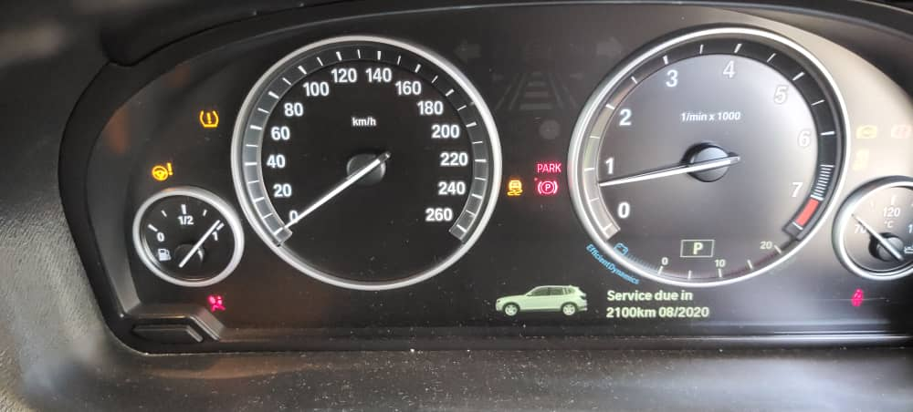
Figure 1
Figure 1 shows the BMW car dashboard. The gauges include the speedometer, tachometer, fuel gauge, odometer and temperature gauge. The time of car service is also mentioned at the bottom of the dashboard. We can see that there are red and yellow colour of the warning light. We know that the fuel of car are almost full after referring to the fuel gauge. The car in stationary position after referring to the speedometer.

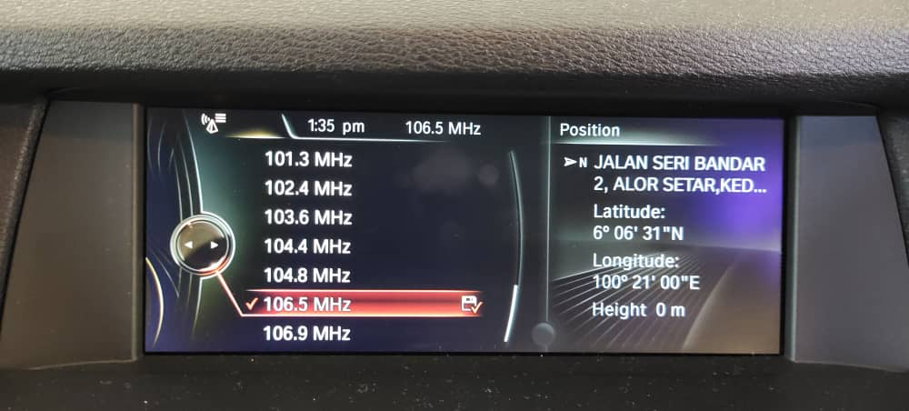
Figure 2
Figure 2 shows the BMW car GPS system that shows the current position of the car. What
shows on the screen can be known by user by downloading a BMW ConnectedDrive apps.
There are two sides on the screen. Left side is about the radio stuff and the right side shows the current position, the longitude, latitude of the car.
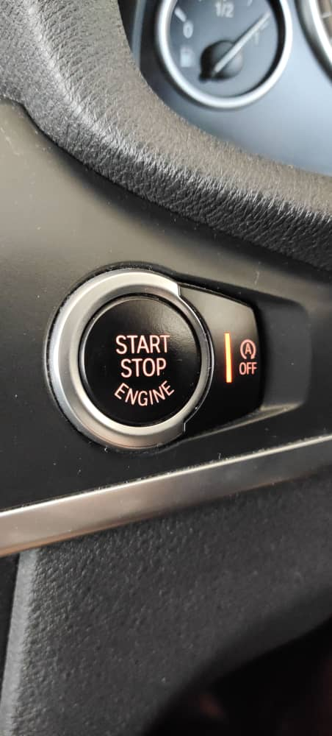
Figure 3 and 4 show the smart key system. The car users do not need a physical key. The users can just put the smart key at somewhere else, then press the START STOP ENGINE until engine starting sound is heard.
Figure 4
Figure 3

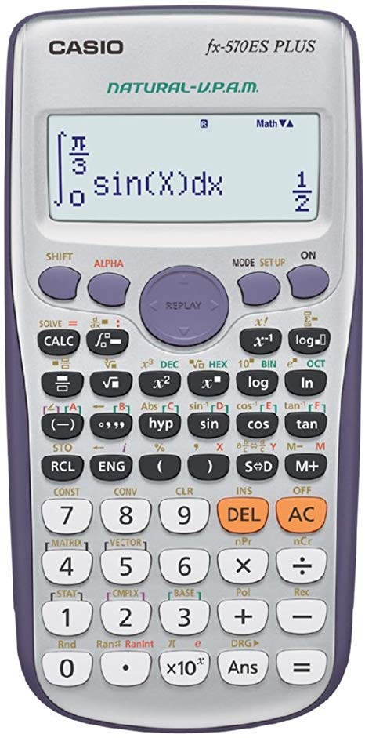
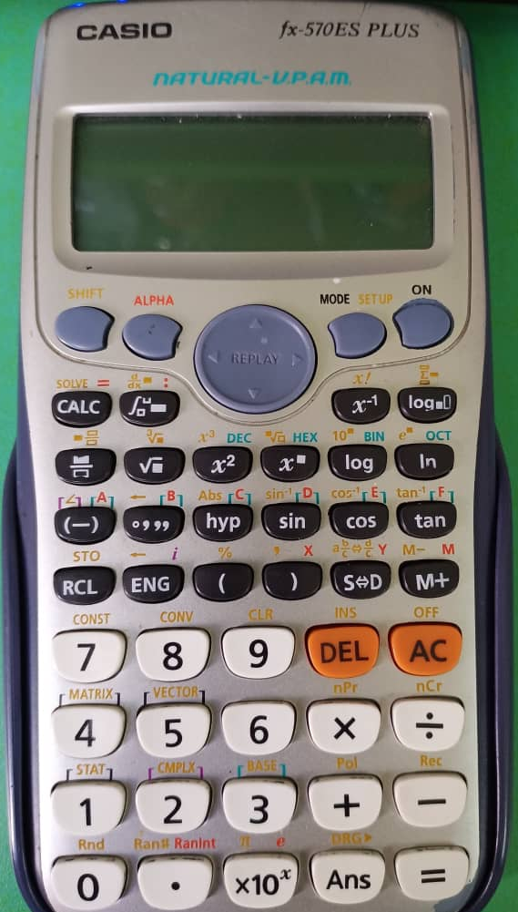
Figure 5 Figure 7
Figure 5 shows a scientific calculator (fx-570ES PLUS) that are working on integration.
Figure 7 shows the white colour on some of the function keys are ran off on the scientific calculator. So, the number keys are in black colour with white background is to make the number clearer because the chances for user to use the number keys is higher than the function keys.

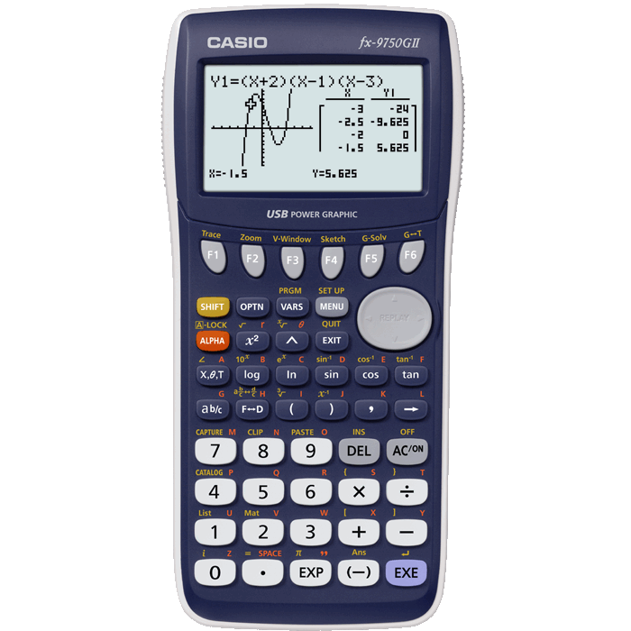

Figure 6
Figure 6 shows a graphing calculator (fx-9750GH) that are showing a graph when enter an equation. The screen of the graphing calculator is make larger than other simple scientific calculator because the graph displayed have to be clear enough for the user to see. It has more functions than the simple scientific calculator so that it is more expensive.

Particular Aspects Of Good And Bad

A) BMW Car Dashboard and Security System
First and foremost, the particular aspect of the car dashboard that I find good is the colour of warning signals on the dashboard play an important role in alerting the car user where the problem is. When something goes wrong and the user becomes anxious, he or she can just look at the dashboard and the user will know where the problem is. For example, when the parking brake indicator are on in red, that means that you are pulling the hand break and the car is parked successfully. They set the colour red is to aware the user as the red colour. Red is the emotionally intense colour that associated with danger, energy and more. On the other hand, when the unfamiliar indicator is on and the car is fixed on the ground no matter how you try many times, we better give a call to a car service centre. As a user, we must understand how the car dashboard functioning by referring to the owner’s manual for further descriptions. After reading the manual, we know that the BMW uses colours on the warning indicators to assess how serious the car problem is. For example, if there is red indicator light come across the car dashboard, meaning that the problem occurred is more severe and we need to have the vehicle checked immediately without any hesitation. On the other hand, if the indicator light comes on in yellow it means caution and that we should have the vehicle checked too. It is safer for us to stop by the roadside, solve the problem before continuing the journey.
The second good aspect of security that surprising me is the BMW smart key can just keep in our pocket and the door can be opened. The smart key is used to lock, unlock the door and start the car engine without a physical key. The smart key communicate with its matching car by sending the radio waves (signals). When the smart keys are located 1.5 m from the matching car, the car will automatically unlock with just a full touch on the handle. There is a small computer chip inside the car and the chip will receive the signals that have the same frequency from the smart key and regenerate the frequency once the car is locked. When there is problem with the BMW car, the mechanical will connect the smart key to the computer just to track where the problem is. This is the latest technology of the smart key of BMW car.
The particular aspect of the car security system that I find bad is the lock button on the smart key is not labelled obviously and clearly. As a first time user to drive the BMW car, the user will press the bottom silver button. Actually, the lock button is in the middle, which is the logo of the BMW. Although the shape of the lock button is designed quite good in order for the users to differentiate among all those button, the first time user will confused at their first time. At the same time, the small lock sign beside the round logo lock button are too small to catch the user attention. So, the first time user will surely press the bottom at the bottom or don’t know which button to press when they want to lock their car.
The particular aspect of the car security system that I find bad is the electronic codes car is still can be decoded easily. Since the electronic codes of BMW car keeps on changing once the engine is started, the security system of the car is not good enough to prevent the car stolen by the car theft. The car theft in the U.S nowadays use only a 20 dollar stealing kits to steal the luxury car. The worst thing is the thief stole the car using the wireless technology without breaking in or stealing the key. We can understand that the electronic codes are not that strong to protect the cars from street stealing. With the advances in technology, the car thief can redirect the wireless signal from the key fob, producing the electric signal that is precise to the computer chip inside the car and finally the car cab be stolen as easy as ABC.

B) Scientific Calculator
One of the good aspect of the scientific calculator is all the keys are categoried clearly using different colours. There are 4 colours to differentiate the buttons and the same colour keys are grouped together. This will make things easier for the user. For example, the grey colour is for the SHIFT key, ALPHA key, MODE and Set Up key else the ON key. These 4 buttons are very important so that the calculator can make a lot of complicated and accurate workings when the user press the grey key. The part that catch my eyes is there is no label on the key, the labels are cleared printed on top of their particular key. Moreover, all the function keys are in black colour and the labels on them are set in white so that user can see clearly. Here comes the most important part. The number key, last answer key, equal key and basic operation keys are in white and the labels on them are in black. So, the user can find all the numbers and basic operation keys faster as white is more clearer than other colours. The delete key and off key are in orange. Furthermore, there are 2 colours of labels on top of all the function keys, gold colour labels on top of the number keys and basic operation keys. This colours will have its own functions and this will described later.
Besides, the good aspect of the scientific calculator is the size of all of the keys are user-friendly. The big and round cursor key at the middle is the biggest key that contains the direction key and replay key. The SHIFT key, ALPHA key, MODE and Set Up key else the ON key are designed in notched oval but still can fix to the size of our fingertips. This will save a lot of space. All of the functions keys in a smaller size compared to number keys in order to ensure that there is enough space to store the enough functions that are needed by the users. However, the size of number keys and basic operation keys are designed bigger so that it can more fix to the user fingertips in order to increase comfortability of the user. They purposely make it because the number of times the number keys been used is much more higher than the function keys.
Moreover, the aspects that I find good of the calculator is the size of screen of the calculator is designed good to fix the calculator special functions. The size of the graphing screen is big enough to see graphs comfortably. When the graph is played on the screen, surely a larger screen is needed to display the graph, the ratio of the screen and the graph is display pretty good for the user. At the same time, for non-graphing scientific calculator, the screen is making smaller just to show the equation entered and answer related to the question. This will helps to save a lot of space and the remaining space can be used to insert more function buttons so that the calculator can be upgraded.

Explanation of Good and Bad Aspects Based On Usability Goal and Design Principles

A) BMW Car Dashboard and Security System
The colour of warning signals on the dashboard is good because the colour can protect the users from dangerous condition. When the warning indicator is on in red colour and the red will grab attention of the driver. For example, when there is a P indicator light is on in red, the BMW user will know that the P hand break button is on and he or she has to push the button down to off the red light. Red indicates danger. The BMW car dashboard is safe to use and it has good utility. When there is yellow colour emerge on the dashboard, that means there is a severe problem. Yellow is the colour of sign that alert us to danger or caution but yellow is also colour of optimism. Unfamiliar yellow colour is on when massive problem occurs will not make user too depress. The human eye processes yellow first. All of the colours on the dashboard provide the right kind of functionality. As a user, when there is warning light on, better we have a stop and check the vehicle first as this small step can save a live. In my opinion, the car dashboard system can still be better by letting the warning light flashing in a higher frequency when it is on, follow with a warning sound. This is because the user can notice the flashing sign in a short time and have more time to secure.
BMW smart key can just keep in our pocket and the door can be opened is a good aspect because the smart key is effective and efficient to use. This is because there is a sensor in the car, the car senses that the smart key user is approaching within 1.5m and user can directly pull the handle. It is very useful and effective to use because if the user is a female and she is carrying a lot of things and she even has to put all of the things down and take out the key from her bag. It is such a dangerous situation if there is a robber standby there. However, in the case of the design principles, I would say that the smart key and the car sensor do a good job here to save the time and bring a lot of advantages. However, it can be better if the distance between the smart key and car can be shorten like 10 feets. Besides, it is better if there is a standard hook link with the smart key so that user can hang it inside the pocket or handbag. This will prevent the smart key from missing easily.
The lock button on the smart key is not labelled obviously and clearly is one of the aspect I find bad because this bad aspect will make the smart key not that efficient to use. The first time user will need little time to find the button. This is because the lock sign is too small and its colour is same with its background. This will not attract the sight of the user. In my view, the designer have to make the 3D lock sign larger and apply a attractive colour like red. The do thing is the lock logo must designed to be attractive and round, seems like different from other. However, if the user didn’t notice the lock sign, he or she will only think that it is only a logo but not a button. So, the don’t thing is colour of sign and background is the same, and the sign is too small.
The electronic codes car is still can be decoded easily is a really bad aspect that I have found. When the electronic coded car is decoded and the car thief can steal the car using only the cheap stealing kits, the car is not save to use anymore. In order to prevent the situation to happen, the users have to install an anti-theft system and alarm system. Furthermore, Phantom’s brand-new iTrackOBD tracking and security system provides protection from keyless car theft. Then the car will be safe to use anymore.

B) Scientific Calculator
All the keys in the scientific calculator are categoried clearly using different colours is the good aspect because this will make the scientific calculator more efficient and effective to use. Users know that where are the function keys, numbering keys and basic operation keys. This will make the thing easier as when the users want to do integration and differentiation function, he or she can just looking at the black keys. The same function keys that the grouped together let the users easy to learn and use. I believe that after using for several times, users can remember all the positions of the keys and how to operate the calculator. The design principle is the particular signs must be labelled on each keys and same function keys grouped together. When there is too many keys on the calculator, don’t lets all the keys in the same colour. Maybe we can make a boundary and grouping of the keys.
The size of the keys are suitable is a very good aspect because it is effective to use. The size of the number keys are made bigger compare to the function keys is because the users use the number keys, basic operation keys and off key more often. The number keys is made fix the size of fingertips will bring a lot of comfortabilities to the user. At the same time, the function keys are rare to use. I might say that the ratio of pressing number keys to function keys is 10 to 1. Interaction design must have clear sign of keys and effective to use it. At the same time, the colour of the signs and the background must not be the same to decrease the confusion if the user.
Size of screen of the calculator is designed good to fix the calculator special functions is a aspect I find good because it has a good utility. The screen of the calculator is just look good for only the question and answer but not the graph, for graphing calculator, to make the graph looks more clearer and let the system to be more effective, it is designed to have a larger screen and more keys just for the graphs displayed. Thus the utility and effectiveness is increased. The graphing calculator is just like laptop, the screen of the laptop is designed bigger and fix to the size so that the users have a bigger view when they are browsing, searching, writing and programming.

