

SEMESTER I 2020/2021

REPORT:

DESIGN THINKING

COURSE/COURSE CODE:

TECHNOLOGY AND INFORMATION SYSTEMS (SECP1513)

GROUP/TOPIC:

GROUP 4: PRIVACY AND SECURITY

LECTURER’S NAME:

DR ARYATI BINTI BAKRI

GROUP MEMBERS:

|  |  |  |
| --- | --- | --- |
| NO. | NAME | MATRIC NO. |
| 1 | TAN YONG SHENG | A20EC0157 |
| 2 | TERENCE A/L LOORTHANATHAN | A20EC0165 |
| 3 | NUR IRDINA ALIAH BINTI ABDUL WAHAB | A20EC0115 |
| 4 | NUR IZZAH MARDHIAH BINTI RASHIDI | A20EC0116 |
| 5 | NURARISSA DAYANA BINTI MOHD SUKRI | A20EC0120 |

# 

# TABLE OF CONTENT

TABLE OF CONTENT 1

LIST OF FIGURES 2

1.0 Introduction 3

2.0 Design Thinking Process 4

2.1. Detailed Steps And Description 4

2.1.1. Empathize 4

2.1.2. Define 5

2.1.3. Ideate 5

2.1.4. Prototype 5

2.1.5. Test 6

3.0 Detailed Description 7

3.1. Problems 7

3.1.1. Students Keep Forgetting Their Username And Password 7

3.1.2. Setting Password As Default 7

3.1.3. Students Do Not Install Antivirus Software 7

3.2. Solution 7

3.2.1. Using A Biometric Iris Scanner And IMEI Number To Login 7

3.2.2. Biometric Iris Scanner 7

3.2.3. IMEI Number Can Track Computers Infected With Malware 7

3.3. Team Working 8

4.0 Design Thinking Assessment 9

5.0 Design Thinking Evidence 10

5.1. Work by students working to solve the design challenge 10

5.2. Link to our Design Thinking and Chapter Presentation videos: 14

6.0 Reflections 15

6.1. Tan Yong Sheng 15

6.2. Nur Izzah Mardhiah binti Rashidi 15

6.3. Nurarissa Dayana Binti Mohd Sukri 16

6.4. Nur Irdina Aliah Binti Abdul Wahab 16

6.5. Terence A/L Loorthanathan 17

References 18

Appendix A 19

Ideate phase: Brainstorming process on shortlisted prototype design 19

# LIST OF FIGURES

Figure 1: Zoom Meeting And Discussions 5

Figure 2: Our First Discussion On Google Meet 10

Figure 3: Interview Questionnaire 10

Figure 4: Virtual interview with Mr Zahari 11

Figure 5 and 6: Whatsapp Group Discussions 11

Figure 7: Whatsapp Group Discussion On Prototype 12

Figure 8: Nur Izzah Mardhiah’s prototype 12

Figure 9: Nur Irdina Aliah’s prototype 13

Figure 10: Nurarissa Dayana’s prototype 13

Figure 11: Terence’s prototype 13

Figure 12: Tan Yong Sheng’s prototype 13

Figure 13: Prototype Simulation 14

Figure 14: Yong Sheng’s sketch 19

Figure 15: Izzah’s sketch 19

Figure 16: Irdina’s sketch 20

Figure 17: Terence’s sketch 20

Figure 18: Arissa’s sketch 20

# Introduction

Due to the rapid growth of technology and the Internet of Thing (IoT), privacy and security are very important to our digital world. It becomes a part of our needs just like electricity and tap water, without IoT and technology, human evolution would be affected (Aggarwal, 2017). As the end user, we must take the responsibility to recognize the potentially negative impact as well. Less consideration for privacy and security in the digital world will contribute to the disclosure of information without personal consent and cybercrime. Therefore, users must also be mindful that privacy and security are keys to preventing a third party from getting the ability to use it in a wrong way.

In this design thinking assignment for Technology and Information System (SECP1513) course, our tasks are writing a report and producing two videos on Video Design Thought and Video Chapter Presentation. The objectives are to educate us on how to develop collaboration, communication, analytical, and innovation skills. The interview with one of the CICT staff has inspired us to come up with solutions to the problems they face. Based on the Design Thinking phase, which includes the process of redefining problems and finding potential solutions, it emphasizes on evolution, constructive exchange of ideas and the building of innovation.

There are five phases in Design Thinking processes, which are Empathize, Define, Ideate, Prototype and Testing. It allows us to gain a deeper understanding of the issues that we face in terms of privacy and security, and encourages us to be more creative and innovative in seeking a solution to this problem. The development of our prototype will give a clearer image of its purpose, we used the online platform application called Assemblr to present our prototype.

# 

# Design Thinking Process

## Detailed Steps And Description

### Empathize

|  |  |
| --- | --- |
| Observe | Students at Universiti Teknologi Malaysia (UTM) must be very familiar with the UTM portal, which serves a variety of purposes, such as course registration and e-learning. Since they use this portal on a daily basis, some students could log in using multiple or other student’s devices without logging out. This can lead to the abuse of accounts for cybercrime and personal information theft.  Hence if privacy and security in UTM is not secured, both UTM staff and students will face issues such as valuable information in the UTM database being vulnerable to hackers. For example, bank account number, the details on the identification card and the home addresses of students and staff. We interviewed one of the CICT staff to gain a better understanding of what privacy and security problems UTM is facing. The staff we invited was very experienced in maintaining a solid UTM portal firewall and have been aware of the problems they face with regard to the personal details of students in UTM. |
| Engage | Through our scheduled interview with Mr Mohd Zahari bin Zainal Abidin, who previously worked as an Information Technology Officer at UTM Digital, currently in Customer Relationship Management (CRM) as a technical staff, we are aware that UTM has policies for processing our personal data safely and correctly in accordance with Data Protection Law such as UTM ICT Policies, Email Policies, and Internet Policies, yet Mr. Zahari's main concern was an insider attack.  Mr. Zahari has revealed that insiders, such as students or employees are more dangerous. Issues begin with students giving away or losing their username and password, or the student has negative intentions. |
| Immerse | After having an interview with Mr Mohd Zahari bin Zainal Abidin, we came to know what issues he had encountered through the session, and we also clearly understood the value of security and privacy in our everyday lives. From the interview, we begin to brainstorm our ideas and perspectives regarding security and privacy. |

### Define

After the empathize phase, we arranged a series of meetings through Zoom and together discussed the current issues affecting the UTM cyber security team. We gathered some of the results from the lecturer and the common issues faced by the cyber security team. We are able to recognize and derive the problem from the stage of empathy.

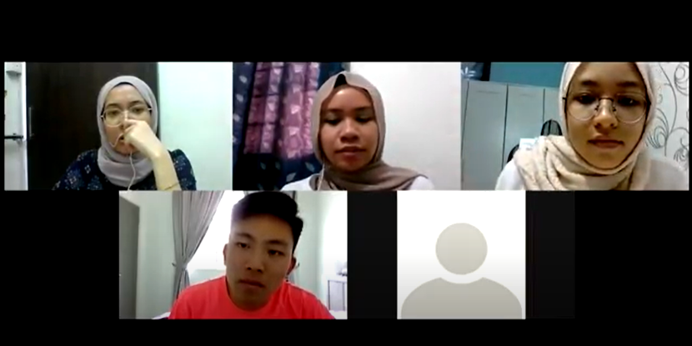

##### Figure 1: Zoom Meeting And Discussions

### Ideate

After contemplating and recognizing the issues of privacy and securities in UTM, our team arranged meetings and discussions to list every possible solution to reduce the chances of students logging in via multiple devices that makes UTM’s system vulnerable.

Upon discovering and developing the feature and how the prototype will function, we sketched a number of prototypes’ design before listing the most ideal version (refer Appendix A). The chosen prototype focuses more on optimizing the use of biometrics, the Media Access Control (MAC) address and the International Mobile Equipment Identity (IMEI) number to allow only one registered device per student to log on to UTM websites and minimize data breach.

### Prototype

At this point, we have built our prototype using the power of augmented reality (AR) via assemblrworld.com. Due to the inconvenience caused by the pandemic, we are restricted to presenting and constructing our prototype via simulation.

To build the prototype effectively, we need to thoroughly understand the features of our invention and discuss every aspect of the device. There are some important concepts that we have highlighted and incorporated in this process in order to achieve a successful outcome.

First, we need to build a prototype that gives the user or client a clear idea of how it would function at the end. Second, to always imagine ourselves in the user’s shoes. Finally, to always remember the purpose of our prototype. We used the service provided by assemblrworld.com for our prototype simulation and fluidui.com to simulate the interface. This process will make it easier for all parties to have the process of building a prototype understandable, controllable, and more comfortable.

### Test

Due to some constraint to physically test our prototype, we are only creating a visual simulation of how it looks and functions. We received feedback and suggestions after the first testing on improving the design of our prototype then we implemented the suggestions from users. Lastly, we finalized the architecture and functions of our prototype.

# Detailed Description

## Problems

### Students Keep Forgetting Their Username And Password

This is the most common problem as students tend to forget their username or password which causes the UTM cybersecurity team to have a hard time dealing with it.

### Setting Password As Default

The second issue is that some students are saving their password as default on some of their computer's websites due to lack of awareness. This allows another person that uses their device to access the UTM e-learning website without notifying the host.

### Students Do Not Install Antivirus Software

Over 70 percent of students use third-party software without installing antivirus software on their computer giving the chance for viruses to spread and infect their computer. Consequently, it will trigger the virus to harm the UTM network and eventually, target the database in order to obtain their personal data.

## Solution

### Using A Biometric Iris Scanner And IMEI Number To Login

As stated, our primary problem was to solve the issue where students frequently forget their assigned username or password. To solve this, we debated on having IMEI number login or a biometric iris scanner login. We decided that this might be a good solution since there is no memorization aspect involved other than the systems’ memory so students' forgetfulness would not be a problem.

### Biometric Iris Scanner

Based on the second stated problem, a biometric iris scanner was implemented into our prototype to solve the issue in which students forget their assigned username and password while also verifying only registered users logging in.

### IMEI Number Can Track Computers Infected With Malware

Finally, if the UTM cybersecurity team detects a malware in the system, they can track down the infected device using the IMEI number used to register and ensure that the malware is quarantined and removed.

## Team Working

Before we start to do our project, research is done by us to ensure we understand about this project and chapter. In our first meeting, we exchange our ideas and share our knowledge with our group members to have a deeper understanding of the project. Afterwards, we fairly divide our group into three parts which is video editing, interviewing and also prototype builder. We divided the task according to the member's strength to further enhance our progress.

During the empathize phase, we sent out our interview invitation and details to the CICT staff and organized an interview with them. Every information and problem given were recorded. After that, we sorted out and arranged our data and information in a systematic order. In the define phase, we list out the issues to make it clearer and easier to brainstorm the solution. During the ideate phase, everyone is involved in brainstorming the ideas by contributing their views and coming out with the best solution. Hence, we finalize our solution which is creating a biometric iris scanner and register of IMEI numbers to overcome the problem. This idea has been approved by our lecturer.

Afterwards, we start to design and create prototypes by using online tools. Once the prototype is done, we start the test phase to ensure the prototype is functional. In a nutshell, teamwork is very important in completing this design thinking assignment and every one of us have done their task by playing a significant role in this project. Therefore, we are able to complete our task on time.

# 

# Design Thinking Assessment

Assessments were done after each step of the design thinking process and after project simulation. For the empathize phase, while trying to understand the user's behaviour towards privacy and security, we realized that we are unable to experience the difficulties faced by UTM CICT staff due to students’ recklessness in handling their private data. Efforts were made to prepare detailed interview questions to have a better comprehension regarding this problem from the staff themselves.

Following the synthesizing of the core problem during the define phase, we faced uncertainty in identifying the main issues of privacy and security in UTM. Nevertheless, discussions and going through our recorded meetings with teammates solved the issues to define our main concern.

During the ideate phase, originally our planned prototype utilized Internet Protocol (IP) address and biometrics for security. However, IP address changes and onlookers can stitch together a lot of details about individuals who have access to the internet by viewing their online behavior associated with a specific IP address (Weissman, 2015). Agreements were made to use MAC addresses and IMEI numbers to ensure only registered devices can log in to the UTM network.

Due to limitations caused by COVID-19, we are unable to build physical prototypes. We overcome this limit by conducting online simulation and prototype using assemblrworld.com and provide a detailed display of our prototype. Then, we tested the prototype through visual simulation and made amendments from users' suggestions.

# 

# Design Thinking Evidence

## Work by students working to solve the design challenge

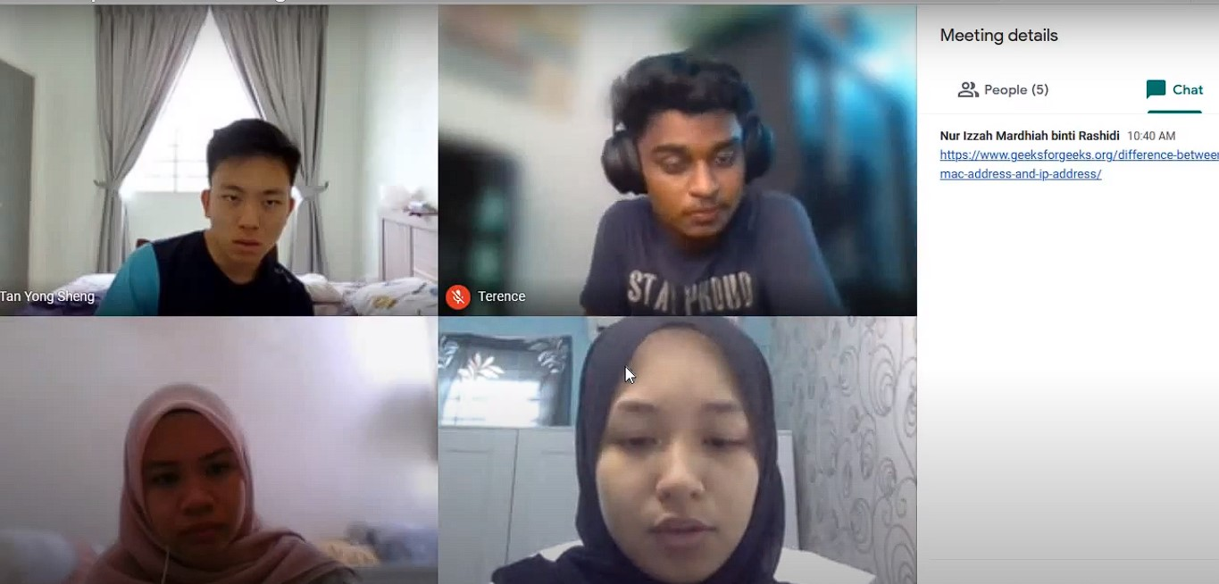

##### Figure 2: Our First Discussion On Google Meet

|  |  |
| --- | --- |
| Phase/Evidence | Remarks |
| **Empathize**   Figure 3: Interview Questionnaire  Figure 4: Virtual interview with Mr Zahari | After observing how most users log in to UTM websites, we prepared detailed and thorough questions for our interviewee and scheduled a virtual interview with him.  As for what we learned, we as students of technology and information system courses did realize it's more efficient during this empathize phase to observe our users' experience in their shoes and engage with them through scheduled and short 'intercept' encounters and immerse in their experience. |
| **Define**     Figure 5 and 6: Whatsapp Group Discussions | We did our brainstorming, analysing and discussions based on information we received and gathered in a messaging platform called Whatsapp.  During the define phase, we as a team unpacked and synthesized our findings from the empathize phase into needs of the users |
| **Ideate**   Figure 7: Whatsapp Group Discussion On Prototype | We debated on the pros and cons of IMEI and biometric security.  During the following ideate phase we focused on idea generation. We explored a wide solution space both a large quantity of ideas and a diversity among those ideas. From the ideas we built our very own prototypes to test with the users. |
| **Prototype**   Figure 8: Nur Izzah Mardhiah’s prototype  Figure 9: Nur Irdina Aliah’s prototype  Figure 10: Nurarissa Dayana’s prototype  Figure 11: Terence’s prototype  Figure 12: Tan Yong Sheng’s prototype | **Figure 8** shows Izzah’s prototype, the features of this design are facial and thumbprint recognition with the benefits of providing extra securities and it is easier to understand, by showing how this system will functioned therefore, we decided to base our prototype on this.  **Figure 9** shows Irdina’s prototype, the features of this design is very simple it includes basic operations of privacy and security like iris scanner. The prototype model is too simple and not appealing. This is the first rough representation of our solution.  **Figure 10** shows Dayana’s prototype, the features of this design are also biometrics verification and the machine are large in size but it did not emphasize on the use of IMEI number that is why we decided not to choose this design.  **Figure 11** shows Terence’s prototype, the features of this design are the multiple cameras for accurate biometric scan and we decided not to choose this design since it lacks in software and IMEI is not integrated into the design.  **Figure 12** shows Tan Yong Sheng’s prototype, the features of this design are the iris scanner which is able to verify the user identities and a touch screen pad to allow IMEI registration and our feedback is positive as it includes our needs. The final look of our prototype is based on this combined with the features from Izzah’s prototype.  During the prototype phase, the team decided to draw out our visions from the ideas we generated from the ideate phase. Since we learned, prototyping is getting ideas and exploring into the physical world. Plus, a prototype can be anything that takes a physical form, so we drew our vision. |
| **Test**   Figure 13: Prototype Simulation | Figure 13 shows the finalized look of our prototype that utilizes biometrics, MAC address, and IMEI number for device registration.  In the test phase, the team tested our final prototype to find out its strengths and weaknesses in serving the users. Because, testing is the chance to refine our solutions and make them better. |

## Link to our Design Thinking and Chapter Presentation videos:

* + 1. Video Design Thinking:

[TIS DESIGN THINKING : PRIVACY AND SECURITY ( GROUP 4 )](https://www.youtube.com/watch?v=y533mKIkOyw&feature=youtu.be)

* + 1. Video Chapter Presentation:

[SECP1513 02 Chapter 9 : Security and Privacy (Presented by Group 4)](https://www.youtube.com/watch?v=BwUd0DJkL2A&feature=youtu.be)

# 

# Reflections

## Tan Yong Sheng

My goal and dream in this course are to become a professional data engineer. I’m passionate about doing data analysis and interpreting data and that is why I choose this course. Besides, I also wish to learn as much knowledge as possible in order to utilize my knowledge in my future career. Apart from this, I enjoy learning and developing computer related skills to shape myself better and improve my employability skills.

After completing this design thinking project, I had learned how to conduct an interview, brainstorming ideas with teammates, edit video and master design thinking skills. It is a very good opportunity in training yourself to think out of the box and develop teamwork within teammates. Throughout the five phases from design thinking, we had done interact and communicate with each of the members in our group. Hence, we are able to determine the problem and search for the solution by working together.

Lastly, the action I will do to improve my potential in industry is make myself more creative in thinking and never stop learning new knowledge. I will utilize my knowledge learnt in this course by helping people deal with big data and analysing data to reduce the burden of their life. I also plan to improve my soft skills by participating activities held in UTM in order to enhance my communication skills and leadership skills. Goal will never be a dream and I will always strive hard to achieve my goal in future.

## Nur Izzah Mardhiah binti Rashidi

My goals regarding this course is to master everything that I learned and will learn through this course, the biggest topics until the smallest ones. Personally, to be a master in something means that I can remember particular lessons not just by my mind, but also by my heart. I believe that in order for myself to reach that point is by practising what I have learned over and over. In terms of this course, I am confident that in order to master, I have to implement my knowledge to my daily life.

I am sure that the course that I am studying requires the students to be able to solve problems by thinking critically and creatively. Thus, making the process become more complex and complicated. Through the learning design thinking process, I get to learn the fundamentals of how to solve problems efficiently. I found that by doing it step-by-step, the flow of the progress became smoother and more efficient. This is the basic that I have to remember and master because I believe that if we master the basics enough, for every challenge that might come later, we can go through them.

Regarding this topic, I think that I need to improve my critical thinking skills. I used to act first and along the way, I will think of the solution. I realized that it is not an ideal way to think as it will cause a waste of time and the final outcomes could not reach the highest quality. I learned that it is okay to take time in planning your project or solve given problems because, in the end, it is worth the time as the outcome produced is the best. For me, it is better that way. I need to practise to solve problems using the design thinking process from now. So that, when the time comes where I have to serve for the industry, it will be easier and faster for me to resolve. In industry, it surely will be more challenging and the issues might be more difficult than what I have to solve now. I need to focus on improving myself from now on.

## Nurarissa Dayana Binti Mohd Sukri

Through this course (SECP1513), I aim to master all the structured modules in order to implement the knowledge, soft and hard skills to achieve my career goals and be an expert in the computer science field.

This assignment allowed me to practice and improve my communication, decision-making and people-managing skills. I faced difficulties in collaborating and networking with others before but I have learned not to limit my views and ideas by being proactive during discussions with my team. Thus, it helps me develop confidence when voicing out my opinion which I personally find important for my character to achieve my goals.

I planned to be committed and ready to accomplish new tasks. Contributing my strength by being resourceful, above all, accepting and overcoming my weaknesses for the purpose of showcasing my potential in the industry and professional world.

## Nur Irdina Aliah Binti Abdul Wahab

My goal for this course is I can explore more about databases and IT structures. I found it is very interesting since I can learn a new thing every day. Furthermore, the IT world is one of the most valuable communities in the world, since the existence of technologies, it gives a big impact to this world.

The most obvious thing I found during the project was the advantage of working as part of a team. While attempting to balance other; ideas so that the group can come out with the best ideas. it Is quite challenging since the pandemic happened, we could not get enough information, so it is very helpful to have a team that can help you up.

Other than that, I revealed my strength when doing my job, which is time management. When making an appointment with our group members, I made some timetables to have an online meeting to discuss our project. I had taken my duty from this project to give momentum within our group so that each work being distributed to members was perfectly completed.

Finally, this design thinking project gave me a good brief about my course. I think that I can improve myself if I want to participate more in group projects since it helps me to implement my soft skill and teach me to be more responsible towards other group members. I hope that I can grab this opportunity in the future to try and do another similar project.

## Terence A/L Loorthanathan

My end goal is to become a machine learning data engineer. After this design thinking project, one of the things I learned is how to conduct an interview, brainstorm ideas, record and mostly the importance of teamwork. It’s true that a complex task can be easy if we have a good communicating team.

After this design thinking project, my goal is to become more efficient and be more responsive. It also taught me to communicate better as a team member.

In order to develop my potential in the industry, I planned to improve my soft skills which include communication skills, stress management, time management, decision making, and conflict solving skills and leadership by participating in activities held in UTM. In a society, we need to have soft skills to communicate with others so that we can solve a problem effectively and fast. Finally, I also plan to learn more programming languages such as Basic, C#, JAVA etc. I will now work hard and try my best to contribute to human society.

# 

# References

Aggarwal, M. (2017). *Technological advances and its effects on human evolution*. Medium. Retrieved 2020, from https://medium.com/@manuj.aggarwal/technological-advances-and-its-effects-on-human-evolution-5329718639e7

Dam, R. F., & Yu Siang, T. (2018). *Stage 4 in the Design Thinking Process: Prototype*. Interaction Design Foundation. Retrieved 2020, from https://www.interaction-design.org/literature/article/stage-4-in-the-design-thinking-process-prototype#:~:text=One%20of%20the%20best%20ways,problems%20with%20the%20current%20design.

Mishra, S. (2019). *The Importance of Prototyping in Designing*. UX Collective. Retrieved 2020, from https://uxdesign.cc/importance-of-prototyping-in-designing-7287c7035a0d

Weissman, C. G. (2015). *What is an IP address and what can it reveal about you?* Business Insider. Retrieved 2020, from https://www.businessinsider.com/ip-address-what-they-can-reveal-about-you-2015-5?utm_source=copy-link&utm_medium=referral&utm_content=topba

# Appendix A

## Ideate phase: Brainstorming process on shortlisted prototype design

|  |  |  |
| --- | --- | --- |
| Sketches | Features | Feedback |
| Figure 14: Yong Sheng’s sketch | Steps to register  -Enter MAC address  -Scan your retina biometric  -Done register | -A very detailed and structured design.  -Small in size which is convenient  -Need more features explanation  -Feedback partially positive |
| Figure 15: Izzah’s sketch | Steps to register:  -Enter UTM ID and password  Register Device:  -Enter type of device  -Enter MAC address  -Enter IMEI address  Register biometrics:  -Scan your retina biometric.  -Scan your fingerprint biometric. | -A very good design structure  -Familiar and user friendly interface  -Provides extra security  -We based our prototype on this  -positive feedback |
| Figure 16: Irdina’s sketch | -Kept files of registered IMEI devices  -Prototype will ask for biometrics and only allow registered devices to log in to UTM websites. | -A very simple design  -Not appealing  -System is restricted to registered IMEI numbers only which means only unique devices can log in  -Negative feedback |
| Figure 17: Terence’s sketch | -Iris scanner to verify user identities  -Touch screen pad for IMEI registration | -Lack in software features  -IMEI is not integrated into the design  -Negative feedback |
| Figure 18: Arissa’s sketch | -Use biometrics verification  -Large size machine  -Emphasize biometric scanner application | -Did not include any IMEI address features    - Negative feedback |