**Lab Exercise 2**

Please answer the questions.

1.

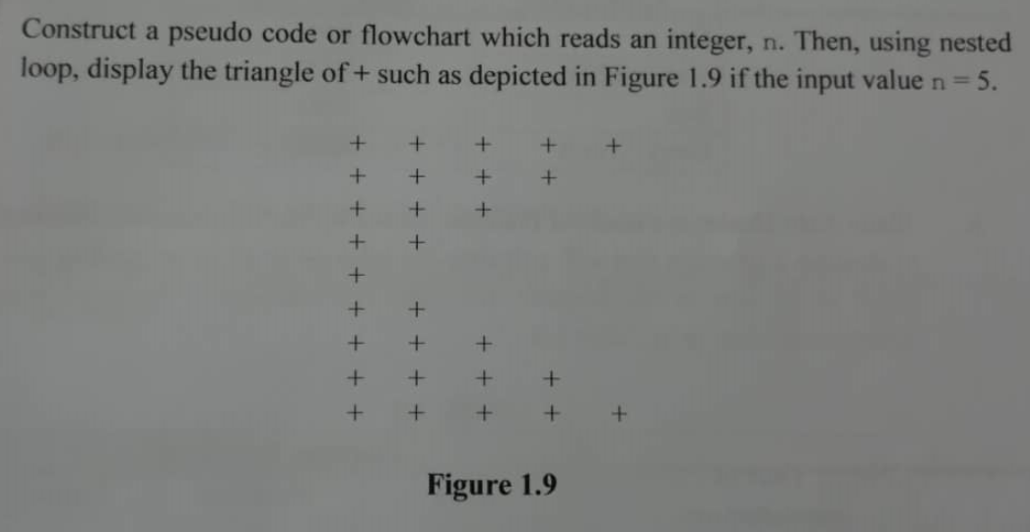

1. Start
2. Read n = 5, a, i
3. For (i = n; i >= 1; i--)
   1. for (a = 0; a >= 1; a++)

3.1.1 Print “+”

4. for (i = n; i <= 1; i++)

4.1 for (a = 0; a <= 1; a++)

4.1.1 Print “+”

5. End_for

6. End

2.

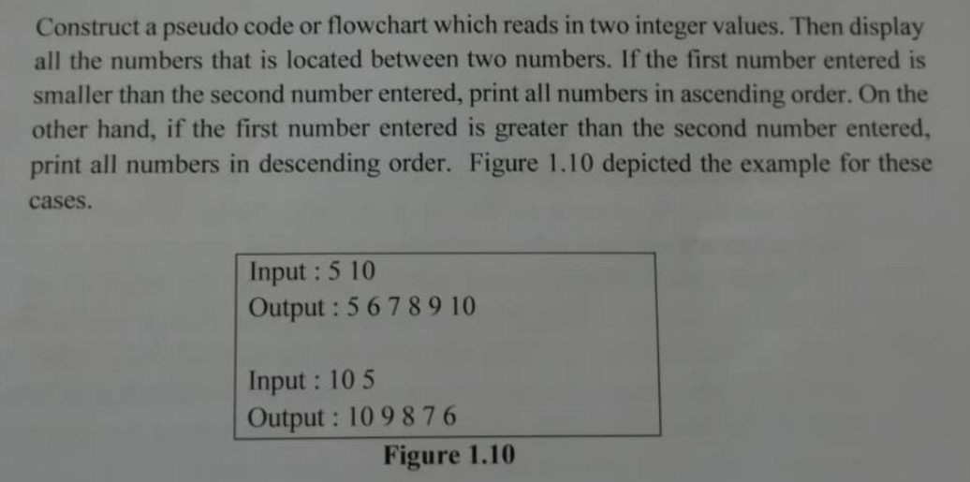

1. Start
2. Set num=0, cnt=0
3. Read num1, num2
4. If (num1 < num2)

4.1 Print num1

4.2 While (cnt < 6)

4.1.1 num = num1 + 1

4.1.2 Print num

4.1.3 cnt = cnt + 1

4.3 End_while

4.4 Go to step 7

5. Else if (num1 > num2)

5.1 Print num2

5.2 While (cnt<6)

5.1.1 num = num2 - 1

5.1.2 Print num

5.1.3 cnt = cnt + 1

5.3 End_while

5.4 Go to step 7

6. End_if-else

7. End