**Lab Exercise 2**

Please answer the questions.

1.

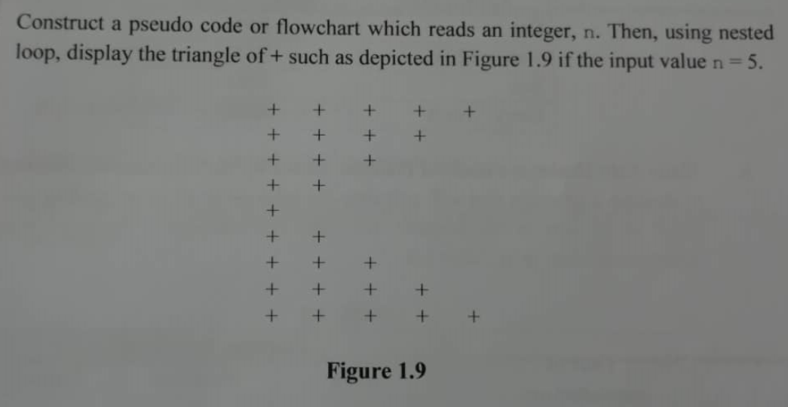

PSEUDOCODE

1. Start

2. Set n=5

3. for ( row = n; row >= 1; --row)

3.1 for ( col = 1; col <= row; col++)

3.1.1 print (“+ \t”)

3.2 print (“\n”)

4. for ( row = 1; row <= n-1; ++row)

4.1 for ( col = 0; col <=row; col++)

4.1.1 print (“ + \t”)

4.2 print (“\n”)

5. End for

6. End

2.

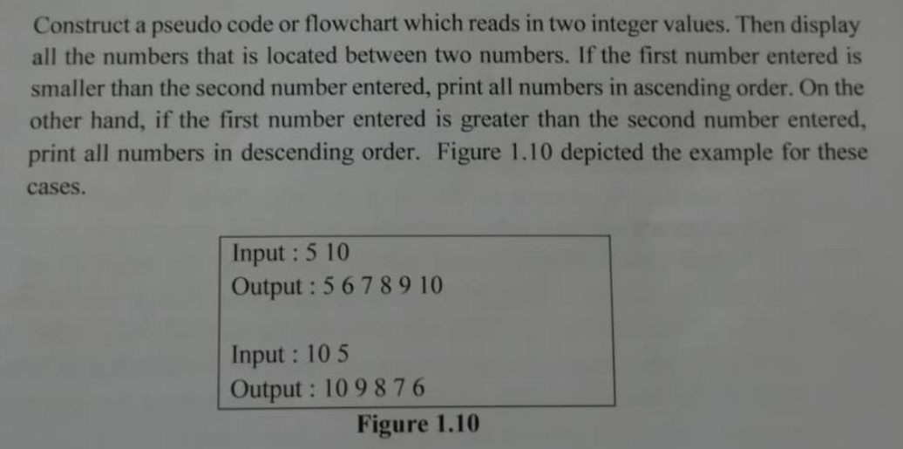

PSEUDOCODE

1. Start

2. Print (“Input: “)

3. Read a,b

4. Print (“Output: “)

5. if ( a < b)

5.1 for ( i = a; i <= b; ++i )

5.1.1 printf i

6. else if ( a > b)

6.1 for ( i = a; i >= b; --i )

6.1.1 printf i

7. else if ( a == b)

7.1 print (“No number in between the inputs”)

8. End if-else

9. End