Name : Muhammad Rafly

Matric No. : A19CS5073

KACANG POOL

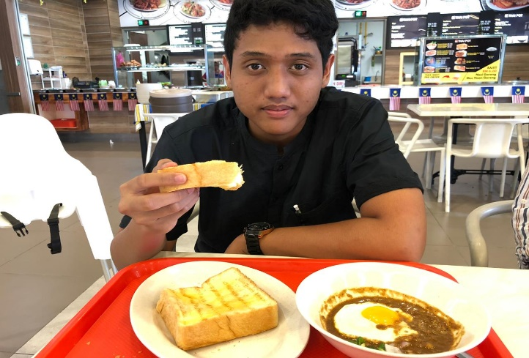 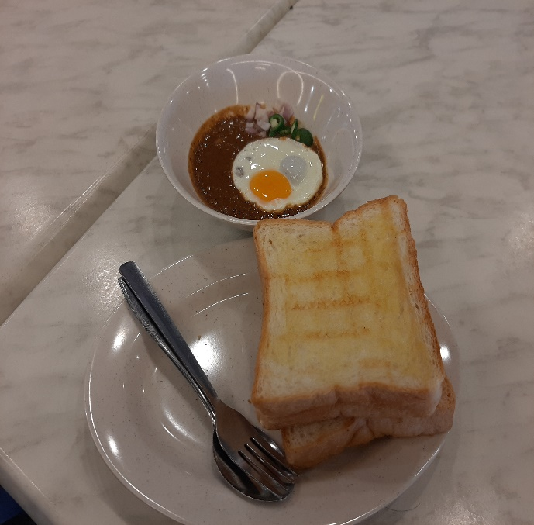

Peanut pool is a typical food in Malaysia, which is in the form of peanut sauce on top of which is placed with a half-cooked egg and 2 breads, the way to eat it is by placing peanut sauce on bread with eggs provided on top of peanut sauce. For myself the taste of the peanut sauce is like rendang and a little curry in it. For me the pool beans are delicious and the bread is tasty.

Compotition:

1.Horse beans

2.Baked beans

3.Machete nuts

4. and mixed with spices like curry