TECHNOLOGY & INFORMATION SYSTEMS
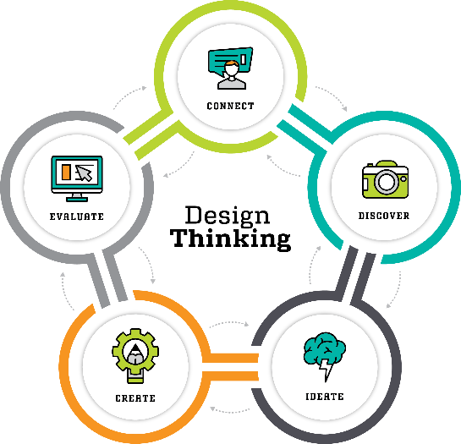

TOPIC: DESIGN THINKING
LECTURER: DR. ARYATI BINTI BAKRI
DATE OF SUBMISSION: 07 OCTOBER 2019
GROUP MEMBER:
NAME | MATRIC NUMBER
RAGU RAJU NAIDU A/L S PALANI RAJU NAIDU | A19EC0152
FATIMA AZ DZIKRUN BINTI SAHROL NIZAM | A19EC0046
HAM JING YI | A19EC0048
CHIA WEI HONG | A19EC0033

Contents
No | Title | Page
1. | Introduction | 3-4
2. | Detailed Step | 5-8
3. | Detailed Description | 8
4. | Design Thinking Assessment Point | 10-11
5. | Design Thinking Evidence | 12-15
6. | Reflections/ Conclusion | 16-18
7. | Reference | 19

INTRODUCTION
In general Design Thinking is an important process to come out with an innovative idea to solve our daily life problems. Design Thinking is very useful because it can be used in any fields no matter Technology, Education or Business. This show that design thinking is not only necessary have to be study by students that major in design related course, but should be study by every courses because design thinking can improve someone creativity and hence giving contribution to the development of country. This is because design thinking focus on the demand of the human in daily life and come out with a solution that is suitable to solve the problem they face in daily life. Furthermore, design thinking is not just use to create a new things but also useful in improve the quality and function of the old products through analyzing and understanding on what is the feeling of the users with the products. There are four steps in design thinking which are Empathize, Define, Ideate, Prototype.
The first step is Empathy which is a starting process in design thinking. It let the designer to know on what the user needs by observing and engaging with people to understand their needs. The second step is Define which is a step to gathering all the needs and problems of the user in Empathy step and start to find out what the main problems and what is the problems they need to solve. The third step is the Ideate which is the step where to improve our creativity. In this step the designer need to explore new solution through brainstorming and mind mapping process. This help the designer to narrow down the idea and come out with a best idea to move to next step. The final step is Prototype, Prototype is a step that bring the first product to test whether the product can really help the user or not and give some improvement in the product.

When we had observed all the technologies that has been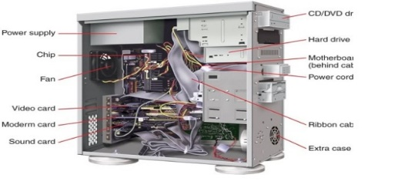
invent along the revolution, human kind did a lot of improvements to suit with the era nowadays.
In most of devices that we use, they contain system unit which an essential part for a device to keep working. Therefore, what is system unit? System Unit is one of the main part of a desktop computer that contain a motherboard, CPU, RAM and etc. The term “system unit” is used to differentiate the peripheral devices (example: monitor, keyboard and mouse) from the computer. For example, when your computer is broken and need to repair the shop owner/technician will ask you to bring your computer to the shop. But it is hard to know that if you want to bring the computer or just the peripheral devices as well. Therefore, if the technician told you to bring only system unit, that mean you just only need to bring the computer itself without the peripheral devices.

Detailed Steps and Descriptions

DATE | ACTIVITIES
23 SEPTEMBER 2019 | - Briefing by Dr. Aryati on the topic.  -Here we learnt about our topic and find out the criteria we needed to achieve in order to complete the tasks given.
24 SEPTEMBER 2019 | - Meet up with group members to draw a plan on the topic.  - Fatima was selected as the group leader, she allocated the tasks to the members according to the preference.  - Wei Hong was chosen as the editor of the video  - Ragu was chosen as the editor of the report while Jing Yi was chosen to monitor the presentation preparation.
25 SEPTEMBER 2019 | - We draw a draft on the questions we should ask to the lecturers and technicians regarding the topic.  - We went to CICT to interview the technicians to clarify our doubts on the topic.  - We recorded the whole interview and took note on the interview.
28 SEPTEMBER 2019 | - We checked our outcomes on the interview with the lecturer.  - We rectify the mistakes.  - We meet up again to discuss on the video and report and we finalised the discussion with the final insights and critics.
1 OCTOBER  2019 | - We identify the problems and found the solutions for those problems.  - We design the prototype.  - We took video on the entire process.
3 OCTOBER 2019 | - We check for the flaws and redesign our prototype.  - We finalise our prototype.  - We started to edit our video.
5 OCTOBER  2019 | - We complete the editing.  - We wrote the reflections on the topic  - We complete the slides for the presentations  - We complete the report.
(Table 1: Detailed Step In Design Thinking)

Detailed Description (Include problems , solutions and team working)
The problems that all of us had discussed about is the components and the characteristic of the system unit for the user. From the investigation and interview we find out that majority of the user say that the system unit is too big and hard to bring form one place to another place. Besides, they also think that the device now has too many ports and sometimes will make them annoyed to differentiate the port and the cable. Moreover, they also think that the memory is too small for the demand as the document they need to store is too large and the device now cannot fulfill their demands. Last but not least, the device also give them bad stimulation as the device need longer time to process some simple tasks.
MONITOR | : It's one of the output devices which shows pictures and the videos .  monitors are usually connected to the computer through Digital Visual interference (DVI), Display port and low voltage differential signalling (LVDS) in the past . Monitor is the main component of the computer to track processing in computer .It creates a better user interference to both programmers and users .  In 1990's the computer monitor used cathode ray tube screen . We found out there are several problems with the computer monitor .  Firstly it too heavy to move the monitor around . Moreover , the monitor is too large and there is a lack of quality in those monitor screens .  We solve this problem by inventing , LED monitors .  Led monitors are lighter. We can move the monitors around easily .The LED screen consume less power than the conventional monitors and it's brighter and with higher pixel density .
CPU | It's the main component of the computer  Usually the CPU is produced with a case that contained with power supply , microprocessor , motherboard , memory , bus , floppy disk drive and cooling panel.  In past , the CPU have a lot of connection port which is used to connect every part of the components inside and outside of the computer .  We see this as a serious problem , cause it reduce the flexibility of the user to use their computer . User often confused with the wires and it's connecting port since there is a lot ports. For example , you need to use 1 wire for pictt and another wire for the audio output , just to watch a video or show a video to a croud .Thus , we came out with our invention that to create wireless connection between the computer components . This eventuy reduced the number ports , since there is no need for many wires .
CABLES | Cables are connecting cords both internally and externally in a computer. Cables ease the transmission of power and data from input source to output and vice versa .There are many types of cables currently in use .But the primary cables are data cable and power cable .The problems with the cables in early days were there are many types of cables and the usage of the cable too specific that you can't use the same kind of cable for multipurpose .For example you need 3-4 different types of cable to project a video .
POWER SUPPLY | Power supply is the heart of a computer .It powers the computer ,control the electrical flow and most importantly change Direct Current (DC) to Alternative Current (AC). Computers usually have the power supply in the desktop CPU while , laptops and mobiles have their supply internally which is able to convert DC to AC by it's own . Wireless charging panels are available nowadays , and the capacity of power supply is increasing nowadays.
PORTS | Ports is a receiver for the connecting cables , and transmit the signals to the system board in a computer .There are two types of port which are standard port and specialized port . One can insert cables , cords and cards in the ports . Without ports , it's hard to create connectivity between 2 different devices.
EXPANSION SLOTS | Next we have expansion slots . Expansion slots basically expand the capabilities of the computer or a device by adding external components into a computer . The few common expansion slots are graphics card , network interference card , wireless card and sd cards . Graphics card improve the graphics of the computer allowing us to watch extraordinary visuals from the computer while SD cards increase the memory capabilities of the computer.

After we defined all the problems, all of the us have a meeting at KTDI and do the brainstorming together to find out what is the suitable ways and solutions to solve the problems that we faced in system unit. Since our main focus is on lecturer or technician so our ideas of solving are based on their situation and using styles. The solution that we prefer is creating a system unit that is more user friendly such as small monitor, lighter and convenience. This is because the lecturer and technician already above 40 years old cannot carry the device easily from one place to other place by making the devices lighter and smaller so they can put and store the device in their beg or pocket.
After we had analyzed all the possibility of problem and solution, we finally came out a final decision which is creating a tablet which is smaller and easily to bring and have function like normal desktops such as messaging and surfing internet. During discussion, although we had some small argument and dispute but at the end all of us are willing to listen and accept other members’ point of view and come out a solution and product which all of us are agree. After all of us achieve the agreement, we distributed all the tasks to every member like someone in charge of video editing and some preparing the written report. For the prototype we have to do together so the product can be completed fast. From this design thinking, we see that the spirit of team working is the key that make this project to be progressed and to be done on time.

Assessment Point
In design thinking, assessment point has plays an important role because it give us a chance to evaluating our own work. Without this step it is hard for us to make any progress as we cannot know if our idea is workable or not. This is because assessment point come out after each step in design thinking that is conducted in the end of the project demonstration. As in our case, assessment point was being conducted in between the phase.
EMPATHIZE | As our topic is system unit which is more focus on the components inside the computer. We decided the interview the technician and lecturer about this topic. This is because technician and lecturer have more experience because they had experience the evolution of system unit and can share the problems they face when the computer is newly invented.
DEFINE | In this phase, we identified the problem that had been faced by the user during empathize phase. This will give us better understanding about what the user need and want to solve their problem in term of system unit.
IDEATE | In this phase, we had a meeting to discuss and give suggestion on what can we do to improve the satisfaction of the user in system unit. We have list down a lot of suggestion to improve the performance in the system unit. At the end we just choose some of the idea that we think it will give the best result and high chance to success.
PROTOTYPE | After numerous discussions, we decided to do our first prototype that is a computer with high performance and storage. To be more specific, we come out with a prototype that has a thin monitor, less port and bigger storage. Throughout this phase we always keep in mind that our mission and vision is to give the user a user friendly device. We also keep evaluate and update our prototype until we satisfied.
(Table 3: The Assessment Points during The Transition of the Phrases)

During the end of the design thinking, we had carry out reflections to know what is the impact of the design thinking give to us and how we use the design thinking to solve our problem in daily life.
In conclusion, assessment point is very important in design thinking because it act as a guideline that help us to determine if our ideas and solutions are on the right track or not.
Design thinking evidence
Empathy
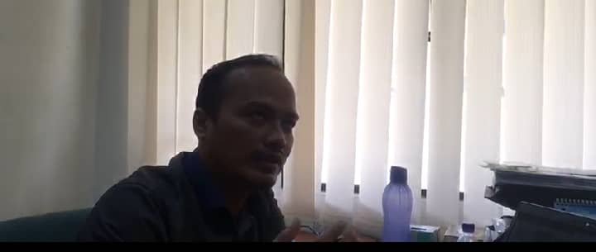
Define the problems
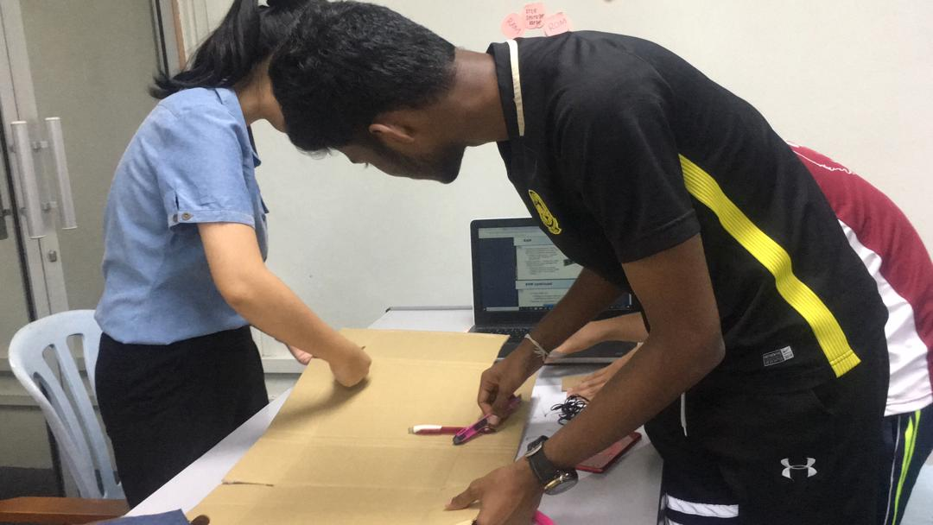

Ideate
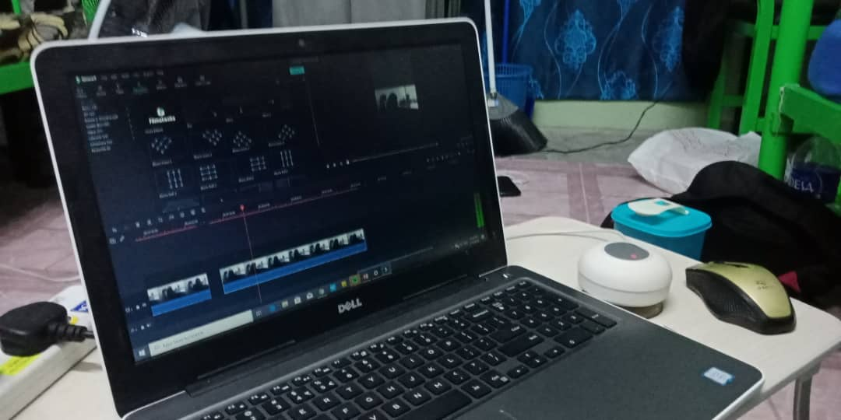
Prototype
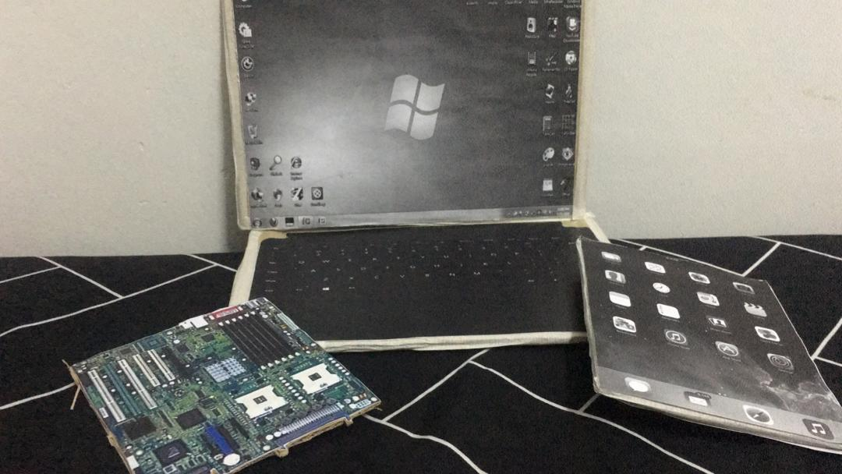

The pictures above are the evidences for the work we have done according to the steps in design thinking . We have recorded a video on the assignment .
The link is as stated below
https://youtu.be/LalNSQwhAns

Steps in design thinking
STEP 1 (EMPATHY]
QUESTION : What is your opinion on the devices last time
ANSWERS: The devices are very heavy , costly , big and hard move around .Thus , it's hard to bring the computer and other devices from one place to another .Morever , it is not economic friendly when it come to repair the devices .
QUESTIONS: What you think on the processing and computer stimulation
ANSWERS : The processing speed of the computer that days wasn't fast enough , thus it makes hard for the user to update the software.Morever , the memory capacity is too low, thus it can't hold much cache.
QUESTIONS: What is the , problem with memory storage ?
ANSWERS: The memory is too small to keep up with the tasks and projects and once we generated one data you can't undo or delete the thing . Thus we need to much of external hard drive to increase the memory capacity .But we need more cables to connect those
QUESTIONS : What is the problem with the cables and ports .
ANSWERS: The problems with the ports are , there too many port which you can only for a single purpose .Fur the more , you can't misconnect a wrong cable to the port , which will block the signal transmission. The cables are too specific and you need many cables just to get a single output

STEP 2 (DEFINE)
Problem derived from Empathy stage
1.Devices are too large and hard to carry around, it give burden the user whenever , they shift from one place to another place . Thus , we know that we shoul make the devices lighter by making modifications , in the system unit . Here , we have few simple ideas like , making smaller and flexible components.
2.Storage is too small and not enough to store many information. Whenever the user run out of storage they needed to buy new external storage which is vey expensive . Moreover, they find it difficult to delete the existing files , because most of the data in the storage stay permanently in the device .
3.Port are too many and very annoying. There are too many ports because all of the ports have specific function and they cannot perform multi tasks .
4. There are too many cables and It is very confusing to create connection . This is because many cables have single usage purpose. Thus we identify the immediate need of new types of cables like HDMI cabels.

STEP 3 (IDEATE)
BRAINSTROMING
LAPTOP |  | TABLET
-THIN MONITOR  -CPU INSERTED IN DEVICE  -GOT KEYBOARD  -GOT MORE THAT TWO PORT  -LARGE BATTERY  -STORAGE UP TO 200GB  -LARGE SIZE  -HEAVIER | VS | -THIN MONITOR  -CPU INSERTED IN DEVICE  -KEYBOARD INSIDE THE SCREEN  -ONLY HAVE TWO PORT  -SMALL BATTERY  -STORAGE ONLY 120GB  -SMALL SIZE  -LIGHTER

Based on the comparison above, we found that both laptop and tablet have thinner monitor and the CPU is inserted inside the device compare to the old desktop. This feature allow the user to bring the device easily from one place to another place. While the difference between two devices is laptop got the manual keyboard and the tablet got the keyboard inside the screen. From this comparison tablet have more advantage because when the keyboard is inserted inside the devices it consume less space compare to the laptop.
But in term of battery lifestyle and storage, laptop has more advantage than tablet because it got more space to store large battery and memory compare to tablet that only can store a small battery and memory. Although laptop have higher performance compare to tablet, but tablet is still our choice because of our mission and vision is to invent a device that is user friendly. Therefore, in term of the user friendly tablet is our final decision because it has small size and lighter that allow the user to carry easily.

STEP 4 (PROTOTYPE)

After we got the solutions, we started to bring out the solutions into prototype. We created prototype by using the cardboard. Basically we design all the ideas we generated into prototype to find which would one suit the user preference of usage . We design the prototype in a way that we can compare and contrast with the old model and then , identify the flaws to rectify the mistakes . Our final prototype is shown in the picture.

Reflection

Ragu Raju Naidu A/L S Palani Raju Naidu
As saying goes, dreams aren't real till you work for it. Thus, I took my first step to materialize my dream to establish my own firm in big data industry by joining Data Engineering course. By joining this course , I could possibly learn the technical knowledge which is necessary for me pursuing my dream in this field .Thus , by doing Design Thinking Program , I can get the chance to apply the knowledge I gained during the program .
By doing Design thinking project , I could possibly make a reality check on how far could my idea work .Thus , I can find out the parts of my idea which won't work out and I could trouble shoot those errors and find a solution for those problems
This project had stimulated my idea generating skills. I found out that brainstorming is an important skill in carrying out a project since, we should have ready made some backup plans to support our project in case of failure of first plan
Thus, I realized that I should visualize the progression in advance so that I could guess the setbacks. Finally, I understood that doing a complete plan is the building blocks of a project which will suppose enhance the valuable insights.

CHIA WEI HONG
My dream is to become a success data engineer in a big company such as Maybank, Top Gloves and etc. This is because data is very important for the development of the country, as we all aware our life cannot move away from data. From this data we can do analysis the habit of the people in the country and make assumption of the people health condition without going to hospital.
Through this design thinking I had learnt a lot of things such as teamwork, video editing, and basic knowledge in system unit. Besides, through the design thinking it let me know that creativity is also one of the important skills we should have besides just coding according to the instruction given. Because with the idea and the creativity we maybe can develop our own software and business to become successful in the future and not just be a worker that work only under the instruction.
To get my dream come true it is important for me to study hard and get a lot of soft skills such as leadership, public speaking and etc. Therefore, to develop more soft skill, it is important to join some competition and society that related to the data to increase my knowledge and experience.

FATIMA AZ DZIKRUN BINTI SAHROL NIZAM
What is my dream with regard to my program?
When I go through all the flow and all the course that I will be learn for 4 years and especially for Technology Information System, my dream is majoring in data analysis and minor in Artificial Intelligence. Why? It is because nowadays lots of data had produced from every company even if that company is a small company and they need data analyst to conduct all of data from leaking out to unauthorized people or company. By that, I’m struggling pursue this course to be that person because not everyone can get the opportunity to learn deeper about handling big data of an organization.
How does this design thinking impact on my dream regard to my program?
Design thinking teach me a lot about in produced an effective and efficient output for users or customer according their needs. It is because design thinking taught me the productive flow to generate and produce solution. As example, the first process of design thinking which is emphatise had taught me to more understanding what users need to solve their problems. By that, it had increases my desire to keep on pursuing my studies in this field so I can explore more problems in technologies that people has faced and discover all the possibilities to solve the solution. It is because to be the data analyst, that person should have the high level of curiosity.
What is the action for me to improve my potential in the industry?
To fit in the industry, I am going to increase my knowledge in information technology and also keep exploring about what is going to happen in future. I also going to prepare myself with high level thinking and more skills such as in programming technique.

Task of each member

Picture 1: Ragu Raju Naidu A/L S Palani Raju Naidu
Picture 2: Jing Yi
Picture 3: Wei Hong
Picture 4: Fatima Az Dzikrun Binti Sahrol Nizam

Conclusion
In a nutshell, design thinking had sharpened our critical thinking in solving problems and help us to be more organize in solve problems .We hope in future , the technology that had been currently invented are beneficial to others .By that, lots of improvement occured to build an efficient system unit to the users nowadays. We hope that the prototype we build is useful as a reference . We hope the future generation would appreciate the development in technology and contribute something to the mankind in near future. We hope by applying the principles of design thinking , we could possibly solve a whole lot of problems in technology nowadays, and increase the pace of the technology development . We hope we could use the knowledge and experience we gained through the development of this assignment in our daily life and once we enter the real world . As the final words from our team members we would like to thank all the individuals involved in the project .

Reference
1.http://computerit4u.weebly.com/system-unit.html
2.https://www.interaction-design.org/literature/article/5-stages-in-the-design-thinking-process
3.https://www.techopedia.com/definition/2308/system-unit

