

**Semester I 2020/2021**

Subject : Technology and Information System (SECP1513)

Section : ____09____

Assignment : Step by step PC Assembly

**GROUP NAME / NUMBER : Group_11**

|  |  |  |
| --- | --- | --- |
| 1 |  | Name : Lee Qing Ren  Matric number : A20EC0065  Phone number : 011-10671640  Email : leeren@graduate.utm.my |
| 2 |  | Full name : Qhairul Heedayh bt Tamsor  Matric no : A20EC0134  Phone number : 01111232906  Email : qhairulheedayah@graduate.utm.my |
| 3 |  | Fullname : Raghid Muhammad Thareq  Matric number : A20EC0328  Phone : +62 081219319681  Email : raghid@graduate.utm.my |
| 4 | C:\Users\HP\Pictures\Camera Roll\ab.jpg | Name : Arvind  Matric Number : A20EC0016  Phone Number : 0103954606  E-mail : arvindarvind@graduate.utm.my |

**Content**

|  |  |  |
| --- | --- | --- |
| **No** | **Topic** | **Page** |
| 1. | Cover Page | 1 |
| 2. | Content | 2 |
| 3. | Part A: Tools Needed to Assemble a PC | 3-4 |
| 4. | Part B: Sketch of a Motherboard Layout | 5-10 |
| 5. | Part C Steps by Steps PC Assembly | 11-19 |
| 6. | Duty Table | 20 |

**PART A – TOOLS NEED TO ASSEMBLE A PC**

1. **SCREWDRIVERS**

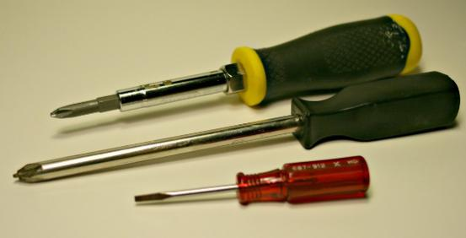

Screwdrivers (Phillips-head and flat-head screwdrivers).

This tool is the most important tool because it is among the basic fixing tools. It is really handy all times because it avoids stripping the head of a screw. Next , it is to seperate the plastic housing. Screwdrivers are important to mount the component inside the case. It also assures the screws are in the best position to tighten the components and avoid PC from breaking after fixing it.

1. **ANTI-STATIC KIT / EQUIPMENT**

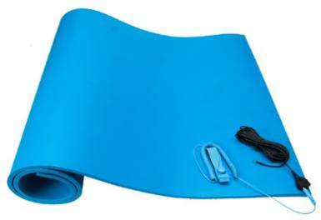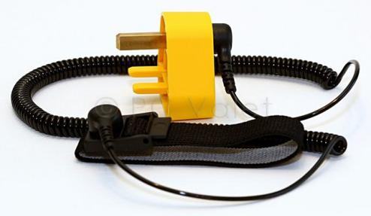

Anti-static equipment (a rubberized mat and a wrist strap that attaches to both the mat and the computer or electronic device).

This kit is to eliminate the risk of electrostatic discharge from the electric and electronic components. Moreover, it protects the equipment from static damage and protects your tabletop from scratches. Also, used to safely discharge static build up. Its importance is for avoiding injuries or damage to our body. Plus, it is to avoid contact with any surface to avoid component damage.

1. **LIGHT SOURCE**

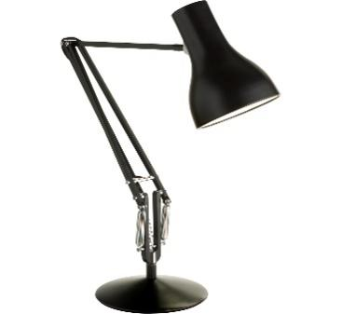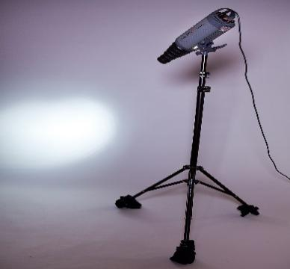

Light source

Because it's difficult to see in small spaces inside the computer case, especially after you begin mounting components. It gives a bright pointing in a specific direction while building PC. When there is a clear image , you get to do the things clearly without confusions in an easier way. Hence , it is to avoid making mistakes while building. It is important to build PC cause it saves much more time to complete building and cut costs from taking too long to build. Lastly , it is important for a better and smooth work flow.

1. **FORCEPS AND TWEEZERS**

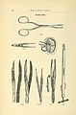

Forceps and tweezers.

Very small needle-nosed pliers, forceps, or tweezers are very handy for removing and inserting jumpers on motherboards and hard drives. It is also to take small stuffs that falls into motherboard easily without affecting build parts. It is important to keep the place clean and tidy while building a PC. Because the small stuffs (screws, cut wire, unwanted components) must be removed to make the work flow smooth. Lastly , to handle small stuffs because finger is too large.

**Part B : Sketch of a Motherboard Layout**

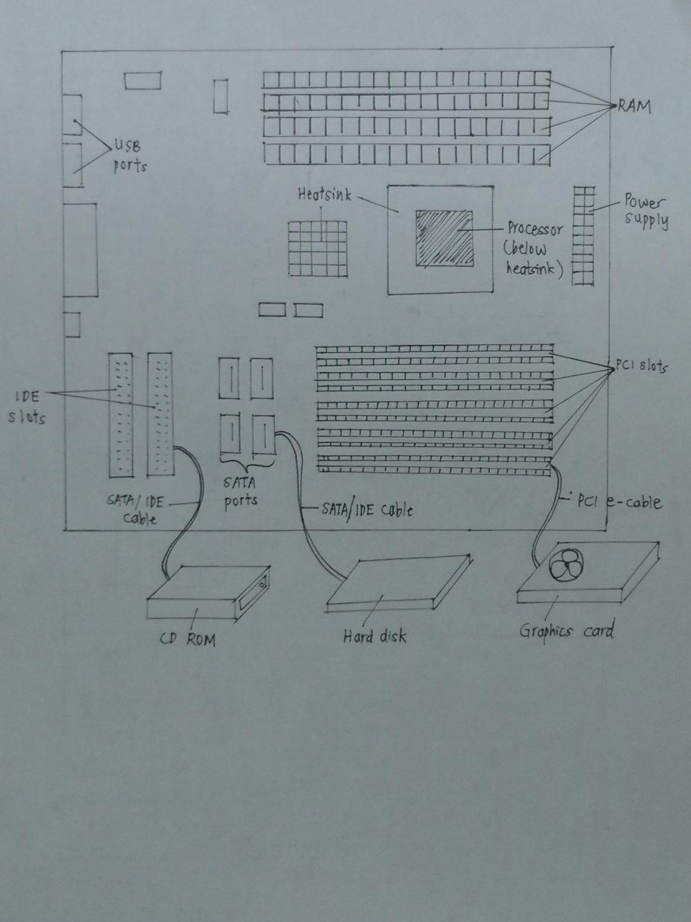

Picture 1 : The simple layout of a motherboard

1. Graphic Card

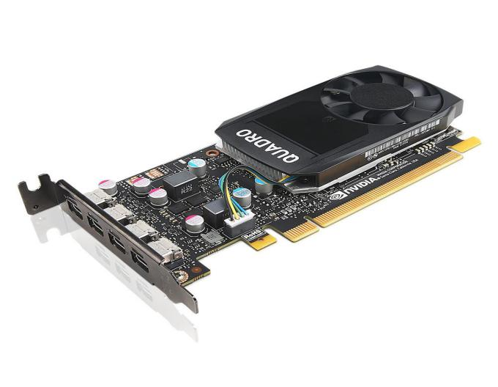

Graphic card is also known as video card. It has graphics processing unit (GPU) as its core. With this core, graphic card is able to help to generate and display images on the monitor. In the process of displaying, graphic card will receive the information about images from CPU first. Then, graphic card will convert the data received from CPU into an image,which will be displayed pixels by pixels on the monitor. The processed information by graphic card will be sent to the monitor through a cable. The examples of models for graphic card are :

* Nvidia GeForce RTX 2080 Super
* AMD Radeon RX 5700
* Intel HD Graphics 630
* Nvidia Quadro RTX 4000
* Intel Iris Plus Graphics 650

1. 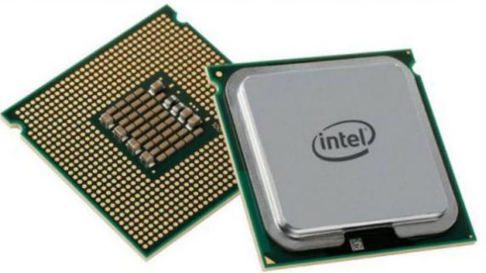CPU (Processor)

The full name of CPU is Computer Processor Unit, which is also called processor in short. It is an integrated circuit (IC) chip. It is the main component and acts as the brain in a computer because all instructions and interpretation of data are processed here by 3 basic operations, which are fetch, decode and execute. In these 3 steps, CPU receives instructions, decodes the instructions and performs the instructions. The quality of a computer performance in completing tasks depends on the power of CPU. The more power of a processor, the more faster for the computer to complete the tasks. There are examples of models of CPU below :

* Intel Core i7-8750H
* Intel Core i5-8300H
* AMD Ryzen 9 5900X
* AMD Ryzen 5 3600X
* [Intel 80486DX2](https://en.wikipedia.org/wiki/Intel_80486DX2" \o "Intel 80486DX2)

1. Heatsink

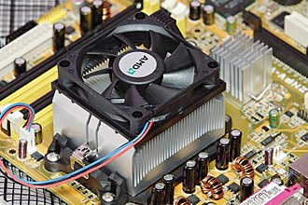

Heatsink is a device made of aluminium or copper. It helps to cool the other devices such as CPU and GPU, which generate a lot of heat and are unable to dissipate the heat by themselves. Normally, heatsink is designed into a fan to to make an exit for the hot air to regulate the temperature of the devices. The examples of heatsink models are [XFP. MSA HEATSINK 10mm](https://www.te.com/global-en/product-1963850-2.html) tall and [HEAT SINK SFP DWDM 10.0mm](https://www.te.com/global-en/product-1963854-2.html) tall.

1. CD ROM Drive

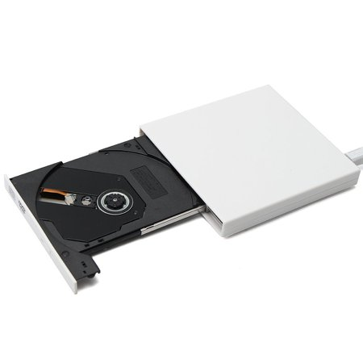

CD ROM is a disk drive that enables a computer to read the data contained in the disc. In order to read the data inside, the reflective surface of the disc is scanned by a laser, converting the information into binary data and sending it to CPU to read. There are examples of CD ROM drive models such as :

* [Intel Black SATA Slim DVD Drive Model AXXSATADVDROM](https://www.newegg.com/intel-model-axxsatadvdrom-slim-dvd-drive/p/N82E16827192003" \o "View Details)
* [Dell Inspiron 17 (3721) (3737) Laptop SATA DVD/RW Optical Disk Drive 9M9FK](https://www.newegg.com/p/1B4-0016-001E7" \o "View Details)
* [Dell Sony DDU1681S-DB 5.25in SATA 18x DVD-Rom J7VMY 18x DVD 48x CD Black Drive](https://www.newegg.com/p/1B4-0016-04101" \o "View Details)
* [ASUS Black SATA DVD-ROM Drive Model DVD-E818AAT (DVD- E818AAT/BLK/B/GE)](https://www.newegg.com/asus-model-dvd-e818aat-dvd-rom-drive/p/N82E16827135304" \o "View Details)

1. 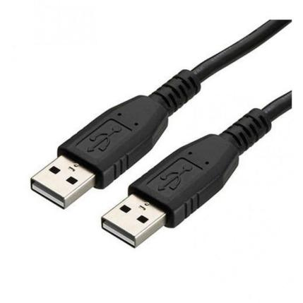USB cable

Universal Serial Bus (USB) cable is used to connect peripheral devices such as keyboard, mouse, smart phone and printer to a computer. It carries signals and power to transfer data at high speed, up to 480Mbps. It can be detached from the computer with the power is on, and this technology is called “hot swapping”. There are many types of USB cable, such as type A, type B and type C.

1. IDE slot

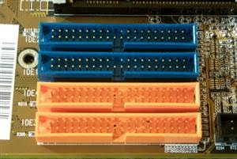

Integrated Drive Electronics, IDE slot is port provided to connect hard drives and optical drives such as hard disk drive, CD ROM drive and floppy disk drive, to the motherboard via IDE cable. Each IDE port is able to connect to two drives.

1. IDE cable

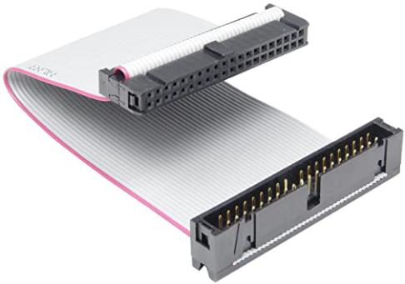

Integrated Drive Electronics (IDE) cable is the media to connect hard drives and disk drives to IDE ports. It have 34-pin IDE cable and 40-pin IDE cable as its examples of models.

1. 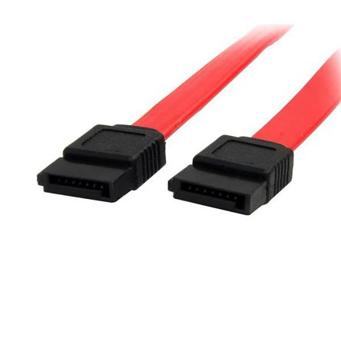SATA cable

SATA stands for Serial Advanced Technology Attachment or Serial ATA in short. SATA cable is used to create a connection between a mass storage device and the motherboard in a computer. It also supports hot swapping technology like USB cable. There are many types of SATA cable such as e-SATA, SATA power, SATA Bridge and Low Profile SATA. Each type of SATA cable possesses different uses and applications.

1. PCI slot

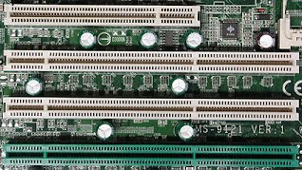

Peripheral Component Interconnect (PCI) slot is a computer expansion bus. It is designed to allow attachment of peripheral like graphics card, sound card and USB to the motherboard, in the form of integrated circuit (IC) or expansion card. The transmission data is carried out synchronously at a fast rate by PCI bus. There are few types of PCI slot, such as CompactPCI, PCI-X and PCI Express.

1. RAM

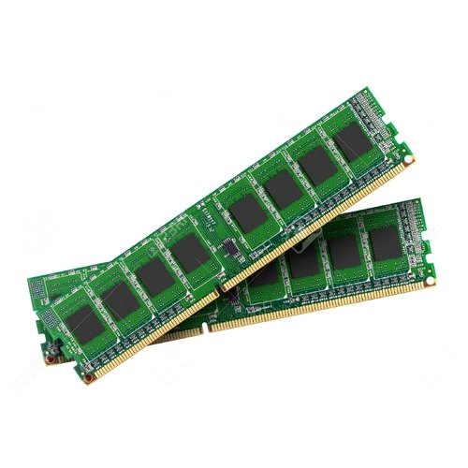

RAM represents Random-access memory. It is a temporary storage for data and allows user to read or write. The performance of a system is affected by RAM, depending the amount of RAM installed. For example, lots of programs are launched at the same time and the time for switching in and out between programs depends on the RAM. In a simple word, RAM allows multitasking to become easier. There are many types of RAM such as DRAM, SDRAM, DIMM, VRAM, DDR2, DDR3 and DDR4.

1. Power Supply

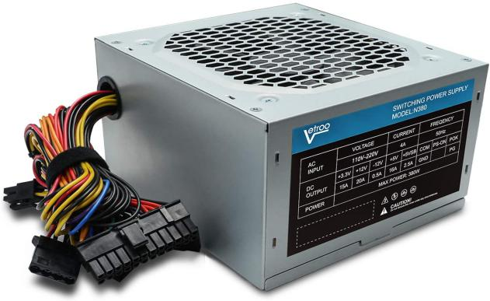

Power supply supplies power to the computer by changing alternating current (AC) into direct current (DC) in low voltage. Several cables are available in the front of the power supply. Power supply is connected to the motherboard and other devices via these cables. There is a fan inside the power supply to regulate its temperature.

1. Hard disk

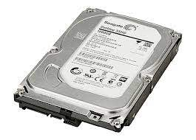

It is a storage device for non-volatile data, which is a long-term data. An internal hard disk is situated in a drive bay in the computer. With the support of SATA or IDE cable, it is connected to the motherboard and the power supply unit in a computer. It can store all types of files, such as operating system, installed software programs and documents. The storage amount varies depending on the type of hard disk. Whenever user wants to read the data in a hard disk, the disk controller will interpret the data from the hard disk. Meanwhile, there are jumpers at the back of hard drive. User is able to modify device resources by alternating the location of the jumper shunt. In this case, we can differentiate the setting of a hard drive between master setting and slave setting. Examples of hard disk are Hard Disk Drive (HDD) and Solid-State Drive (SSD).

**PART C – STEPS BY STEP PC ASSEMBLY**

STEP 1 – INSTALLATION OF CENTRAL PROCESSING UNIT (CPU) ON THE MOTHERBOARD

* Find the CPU socket on the motherboard
* Open the CPU socket on the motherboard by lifting the retention arm ( the small metal lever on the side of the socket) and unlock the retention arm by pulling it away from the socket.
* Lift the arm all the way and open up the socket cover.
* Look for a small mark in the bottom left corner of the CPU socket and arrow on the CPU.
* The small mark is to secure which way to install the CPU.
* Make sure not to touch the bottom and top of the CPU to keep the top of the CPU is clean before putting the thermal paste.
* Place CPU so that the arrow on the CPU matches the mark on the bottom left of the socket.
* Make sure aware of the arrow and which way to install the CPU to avoid damaging pins.
* Make sure not to drop the CPU and slowly and carefully lower it into the socket.
* Confirm that CPU is fully installed
* Lock the socket by lower the socket cover and then retention arm and clip it back to the hook.

|  |  |
| --- | --- |
| https://www.build-gaming-computers.com/images/how-to-open-intel-cpu-socket.jpg |  |
|  |  |

STEP 2 – USE THERMAL PASTE

* Make sure the surface of the CPU is clean.
* Squeeze a small amount of thermal paste onto the centre of the CPU.
* Make sure to use the correct amount of thermal paste, which is the size of a grain of rice.
* The thin layer of a thermal paste is for a gap between the CPU and the bottom of the CPU

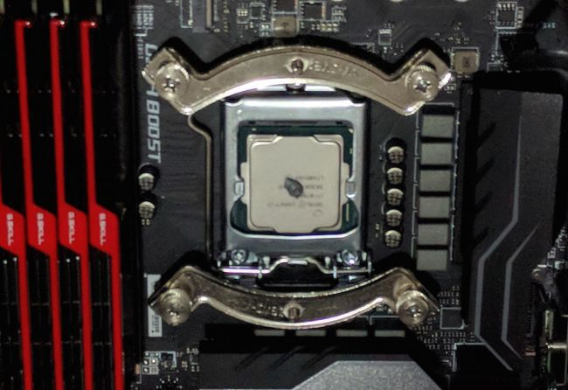

STEP 3 – INSTALLATION OF HEATSINK ON THE MOTHERBOARD

* Make sure the bottom of the heatsink is clean.
* Align the heatsink above the CPU so that the clamps are in line with the mounting points around the CPU.
* Clamp the heatsink in place by screwing the heatsink.
* Be careful while screwing, a slip of a screwdriver can cause a lot of damage to the motherboard.
* Locate the power lead for the heatsink on the motherboard.
* Connect the heatsink power cable to the header on the motherboard.
* Make sure it is secure and keyed.

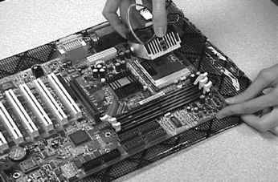

STEP 4 – INSTALLATION OF RANDOM ACCESS MEMORY (RAM) ON THE MOTHERBOARD

* Locate RAM sockets.
* Take RAM by gripping it from the sides.
* Avoid touching the contacts on the bottom of the circuitry on the board.
* Insert the RAM into the RAM slot by the line up the notch in the stick of RAM to the notch on the slot.
* Set the stick into.
* By applying equal pressure onto the stick, push down on both ends of the stick until it clicks into place.
* Confirm
* RAM is locked.
* Repeat the process for each stick of RAM.
* Make sure not to force while push down the RAM stick it to avoid damage.

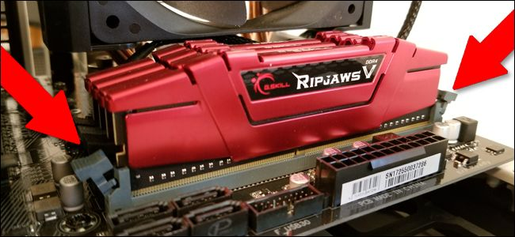

STEP 5 – INSTALLATION OF POWER SUPPLY

* Open the computer case and lay it on its side with the exposed side facing up.
* Find the power supply location in the PC and insert the power supply.
* The back of the power supply with plugs and a fan should face the back of the case.
* Screw all parts so that the power supply is in its place.
* Make sure and confirm all screw is tightened.

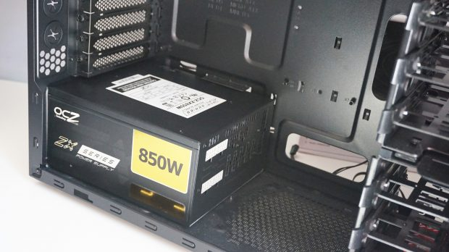

STEP 6 – INSTALLATION OF MOTHERBOARD

* Find and install standoffs to keep the motherboard above the case.
* By comparing the actual layout of the connectors on the motherboard, install the I/O panel shield by applying pressure to four corners of the panel and lock it into place.
* Make sure to install the panel in the correct direction.
* Place the motherboard on the standoffs.
* Screw the motherboard into its place.
* Make sure not to overtighten the screw and motherboard is safe.

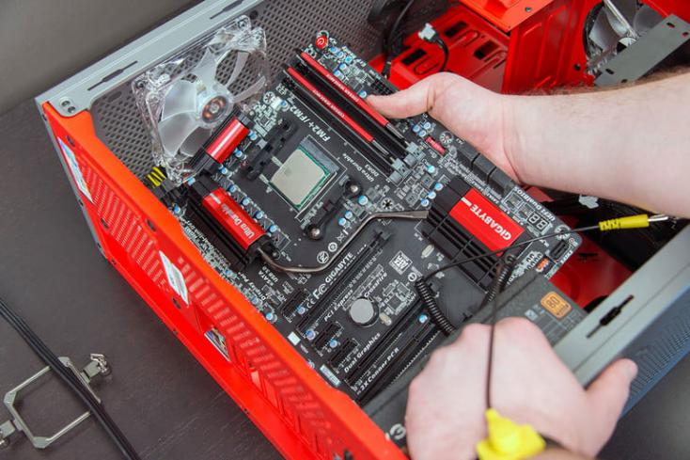

STEP 7 – INSTALLATION OF GRAPHIC CARD

* Locate PCI- E slot on the motherboard.
* Take the card and insert it into the PCI- E slot.
* Make sure to avoid touching any of the circuitry.
* Apply pressure on the top of the card until it is fully seated.
* Screw the holder of the card.
* Make sure the screw is tightened and neat.

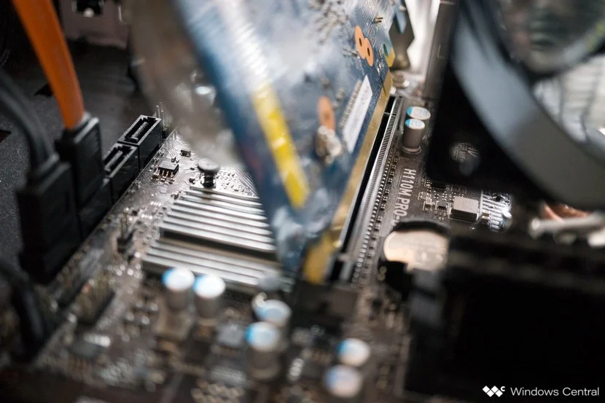

STEP 8 – INSTALLATION OF CD- ROM DRIVE

* Locate the place to put the CD-ROM drive, typically it is in front of the PC.
* Insert the CD-ROM drive inside the drive bay.
* Make sure to do it gently and slowly to avoid the drive get stuck.
* Tighten the screws.

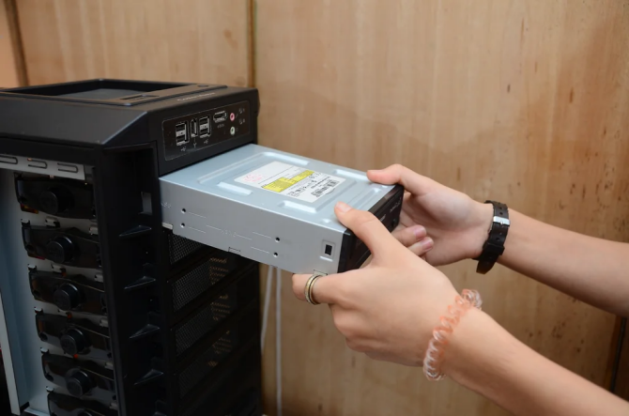

STEP 9 – INSTALLATION OF HARD DISK DRIVE

* Locate the hard disk drive slot.
* Insert the drive into its slot.
* Secure the hard disk drive by screwing it.
* Make sure the screws are tightened and the hard disk drive not loose to avoid damage.

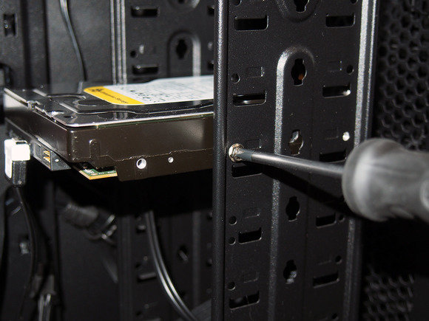

STEP 10 – INSTALLATION OF IDE, SATA, AND POWER SUPPLY CABLES

* Locate the SATA slot at the motherboard, CD-ROM, and power supply.
* Connect the SATA cable to the CD-ROM drive.
* Connect the other end of the SATA cable to the motherboard.
* Connect another SATA cable to the CD-ROM drive.
* Connect the other end SATA cable to the power supply.
* Locate the IDE slot before connecting the cable.
* Connect the IDE cable to the hard drive.
* Connect the other end of IDE to the motherboard.
* Take power supply cable and connect to its place.
* Connect all the cables neatly to saving space and reduce heat in the PC.
* Make sure to do it carefully to avoid damage to the cable.
* Make sure all connection is fully connected at the right place and not loose.

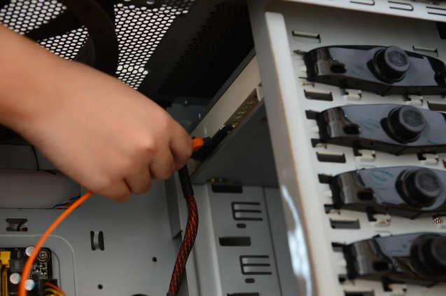 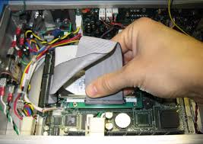

STEP 11 – INSTALLATION OF SWITCH CABLES AND USB CABLES.

* Find switch cables and USB cables at the PC
* Connect front panel USB and audio to motherboard.
* Connect switch cable to the motherboard.
* Make sure all the connection is correct and tightened.

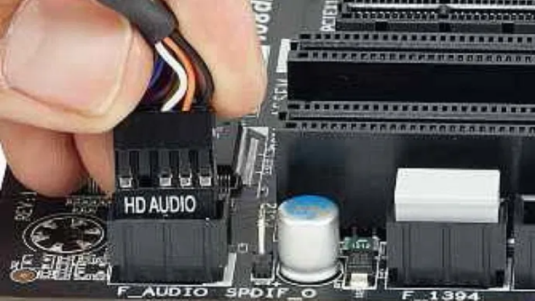 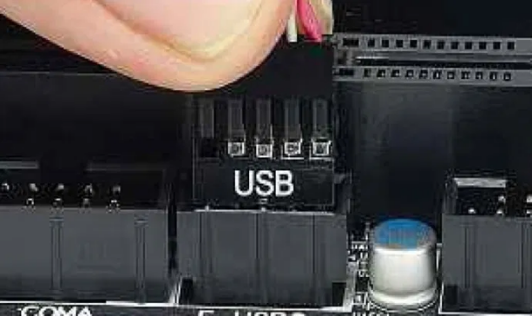

LAST STEP - CLOSING THE CASE AND CONNECTING THE PERIPHERALS

|  |  |
| --- | --- |
|  | Place the side cover back on and secure the side panels with case screws. |
|  | Connect peripheral devices which include keyboard, mouse, wireless network dongle, printer and webcams with your CPU by plugging into USB port. |
|  | Then, connect speakers and microphone into 2.5 mm sockets. |
|  | Finally connect the CPU with monitor by plugging into display ports |

**PC Assembling Stimulation Video URL :**

<https://youtu.be/Haqi0LoggE8>

**Duty Table**

|  |  |  |
| --- | --- | --- |
| 1. | Lee Qing Ren | * Writing Report in Part B * Compiling report |
| 2. | Qhairul Heedayh bt Tamsor | * Writing Report in Part C |
| 3. | Raghid Muhammad Thareq | * Assembling PC * Preparing Video on Assembling PC |
| 4. | Arvind | * Writing Report in Part A |