**EXECUTIVE SUMMARY**

Global Online Workforce (GLOW) is one of the programme that is organised by Malaysia Digital Economy Corporation (MDEC). MDEC is a government-owned agency which belongs to the Ministry of Communication and Multimedia (KKMM). It brings up a few beneficial programmes such as e-Rezeki, e-Usahawan, You Can Duit and others GLOW is one of the programme under MDEC. MDEC pursues a digital future in Malaysia. Thus, it rolls out initiatives that revolve around four key pillars including attracting investors, globalising local tech champions, catalysing industry-driven digital ecosystem, driving inclusive adoption of technology and building critical enablers of digital economy



Picture 1

Picture 1 shows the logo of the programme e-Usahawan.



Picture 2

Picture 2 shows the logo of the programme You Can Duit.

**1.0 INTRODUCTION**

On 24.9.2018 (Monday), the department from the School of Computing organised an industrial talk for the students. The topic of the industrial talk was about GLOW. The speaker who gave the industrial talk was Mr. Mohd Ihsanuddin Jamhari. He is now a master trainer under the GLOW programme. Previously, he finished his degree course which was electrical engineering in Universiti Teknikal Malaysia Melaka (UTem) but he finished his master programme in Universiti Teknologi Malaysia (UTM). He was graduated as a Master of Education in UTM. Apart from being a master trainer under the programme GLOW, he also works as a full time freelancer which is proficient in photography, Information and Communication Technology (ICT) service and consult, project manager, education and also graphic design.



Picture 3

Picture 3 shows the photo of Mr. Mohd Ihsanuddin Jamhari

According to Mr. Mohd Ihsanuddin Jamhari, he said GLOW is a programme that assist Malaysians to earn digital income consistently and on a full time basis through the way of “crowdsourcing”. He explained that “ crowdsourcing” is a way that people can generate digital revenue through global online platforms as various types of works, jobs and projects can be taken up through those online platforms.

**2.0 DISCUSSION**

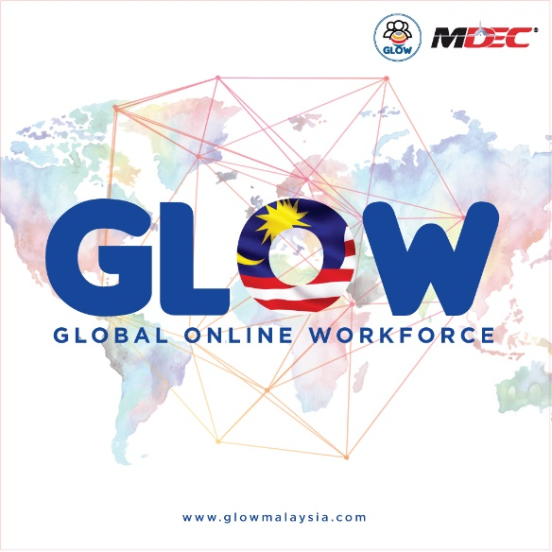

Picture 4

Picture 4 shows the logo of the programme GLOW.

The programme of GLOW is being implemented because the government wants to create a community of full time high qualities workers among Malaysians The government also wants to create a sustainable model on the GLOW programme through the cooperation with the strategic partners. Currently, MDEC cooperates with some of the largest online platforms such as Upwork.com and also Freelancer.com Besides, the purpose to carry out the programme of GLOW is to provide an alternative sources of income for the people in Malaysia through various types of crowdsourcing platforms. The GLOW programme can also acts as a support programme for the Malaysians’ freelancers to be motivated in generate digital income through online platforms.

Malaysians actually can gain lots of benefits through the GLOW programme. This is because the programme can increase the chances for them to gain monthly paid digital income as they can find their interested job through the online platform. Besides, Malaysians can also do their jobs wherever and whenever they want because the GLOW programme creates the flexibility for them. They also can earn digital income according to their own abilities and needs. Lastly, when they get in touch to the GLOW programme, they will have the chances to open their markets and develop a digital agency.

|  |  |
| --- | --- |
| **INTERNATIONAL PLATFORM** | **LOCAL PLATFORM** |
|  |  |
|  |  |

Table 1

Table 1 shows the examples of international platform and local platform.

Normally, MDEC will attract people to join the programme of GLOW through the method of outreach programme. MDEC will send a group of trainers to go to certain places to give some information talk for the public. This will make the public to understand the concept of GLOW programme. To attract more people to take part in GLOW programme, MDEC will also put their efforts in educating the universities’ students. The trainers will give the talk to the students and make them more familiar to the concept of GLOW. After graduate, these students have higher chances to be take part in the programme of GLOW as they can find the jobs that they are interested through the global online platform. MDEC also get people to join GLOW programme through social media. For example, GLOW has its own page in Facebook. The administrators of GLOW will update the latest news in Facebook. This is one of the most effective way to get people to join the GLOW programme because most of the people will use social media to communicate with others.

According to the official webpage of GLOW, it is noticed that every Malaysian can join the programme if they have skills in the field of ICT, graphic design and also proficient in linguistic. Experienced freelancers are welcomed to join this programme. Committed individuals who have the qualifications in various fields such as ICT, languages, creative and design and others can also join the programme to earn digital income. Besides, experienced offline and face-to-face freelancers are also invited to be join in the programme. Even students and housewives who have the capabilities in the required fields are also welcomed to join this programme for the purpose earning extra income for themselves. Retrenched workers and unemployed graduates that full with commitment to become the crowd workers can also become the members of the GLOW programme. Those who are qualified to join the GLOW programme must also committed to take part in full time three months intensive training at the e-Rezeki Apprentice Centres and also committed active digital workers who are able to generate a minimum digital income of USD 500 monthly

Actually, the GLOW programme brings a lot of great impacts to Malaysia. For example, the GLOW programme helps people to generate extra income instead of just doing their full time job in the real world. Nowadays, most of the fresh graduates cannot get their jobs immediately. During that moment, they can make full use of their time to earn digital income through the online platforms. This proves that the GLOW programme can help unemployed people to generate income effectively. The GLOW programme can give a path for the unemployed people to have their own job as a freelancer. When most of the Malaysians have their own job and able to generate income, Malaysia’s economy will become better. More foreign countries are willing to invest in Malaysia when our country’s economy become better. When our country has enough money, the government can make use of the money to increase the quality of our infrastructure which is more beneficial to Malaysians. Besides, through this GLOW programme, the users can make new friends from all around the world as most of the clients are from foreign countries. The GLOW programme cooperates with a few global online platforms such as Freelancer.com which is founded by Matt Barrie in Australia and also Upwork Global Inc. which its headquarter located in California. Indirectly, this will make the relationship between Malaysia and foreign countries become closer.

**3.0 REFLECTION**

Through this industrial talk, I noticed that the speaker who give the talk, Mr. Mohd Ihsanuddin Jamhari is a very well-spoken person as he can attract the attention of the students during his talk. He also can give some relevant information for the students to learn new knowledge. I believed that most of the students can learn new things from him.

From this industrial talk, I think that MDEC really plays an important role in transformation of Malaysia’s digital economy. This is because it brings up the GLOW programme which can actually help the unemployed people to gain digital income. They can just surf the Internet and look for the jobs that they are interested instead of wasting their own time to wait for a proper job in the real life. In my opinion, the GLOW programme brings a lot of advantages for Malaysians because not only can earn extra income, but also can improve their skills that they had learnt as they will face different situations when they are completing their jobs.

Apart from the GLOW programme, MDEC also brings up the e-Rezeki programme. E-Rezeki is a programme under MDEC which is more focus on the Malaysian citizens with household income of below RM4000 per month, including students, housewives, retirees and also the senior citizens. Those Malaysian citizens with household income less than RM4000 per month can join e-Rezeki and find the jobs through the platform and earn extra income

Lastly, in my opinion, I proposed that MDEC should always encourage people to use their mobile devices to earn extra income. According to the survey done by Malaysian Communications And Multimedia Commission(MCMC), it is noticed that in the year 2017, still have about 31% of Malaysian using the feature phones instead of using the smartphonesIf MDEC is successfully persuade the feature phones’ user to change into smartphones’ user, our country’s economy will become better as all of them can become an online worker to earn digital income.

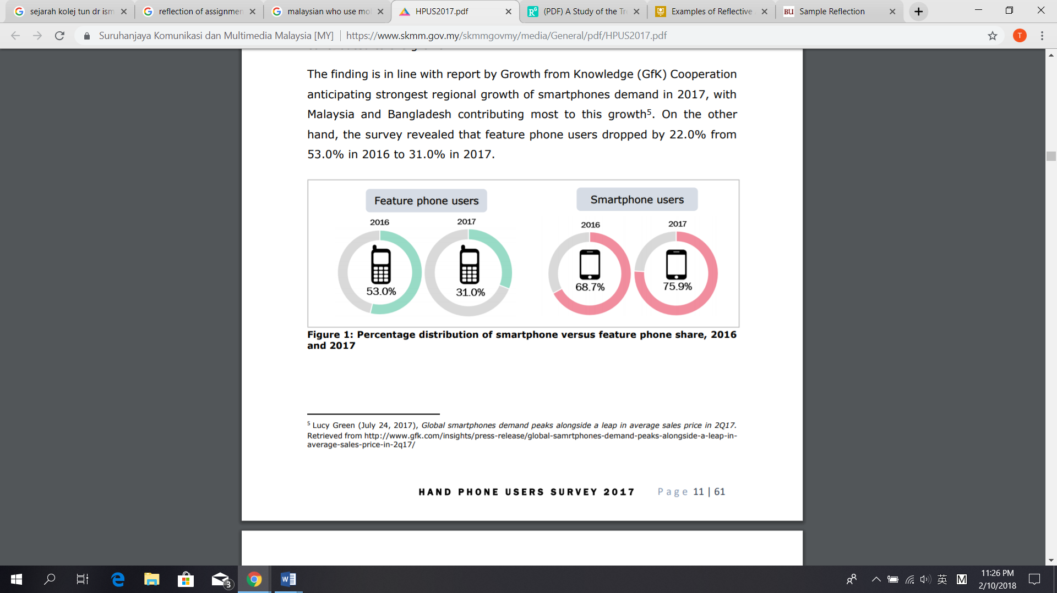

Figure 1

Figure 1 shows the percentage distribution of smartphone versus feature phone share,2016 and 2017.

**4.0 CONCLUSION**

In conclusion, GLOW programme is a very good programme for Malaysians as it brings lots of benefits for us. Thus, I hope that more people will involve themselves to join this programme and become a qualified freelancer. I also hope that MDEC can proposed more beneficial programme that can encourage people to be active in the world of digital as now everything is related to technologies. When our Malaysian citizens are professional in digital world, we will not being eliminated from this world of technologies in 21st century easily.

**REFERENCES**

Balqis Lim. MDEC's eRezeki and eUshawan initiatives are revolutionising the local cottage industry. *New Straits Time.* [online]. March 26,2018. Available from: <https://www.nst.com.my/lifestyle/bots/2018/03/349416/mdecs-erezeki-and-eushawan-initiatives-are-revolutionising-local> . [Accessed on 25th September 2018]

E-Rezeki. *Now everyone can benefit from the digital economy.*[online].Available from: <https://erezeki.my/about> .[Accessed on September 2018]

*EUSAHAWAN*. (n.d.). [image] Available at: https://web.facebook.com/eUsahawanMY/?_rdc=1&_rdr [Accessed 27 Sep. 2018].

Global Online Workforce. *Partners*. [online]. Available from: <https://glowmalaysia.com/partners/?lang=en> .[Accessed on 26th September 2018]

Global Online Workforce. *Why is the Global Online Workforce Program being Implemented?*. [online].Available from: <https://glowmalaysia.com/what-is-global-online-workforce-freelancer/?lang=en> .[Accessed on 26th September 2018]

MCMC. *Hand Phone Users Survey 2017.*[online]. Available from <https://www.skmm.gov.my/skmmgovmy/media/General/pdf/HPUS2017.pdf> [Accessed on September 2018]

MDEC. *Building Malaysia’s Digital Future.* [online]. Available from: <https://www.mdec.my/about-mdec> .[Accessed on September 2018]

*Mohd Ihsanuddin Jamhari on Behance*. (2016). [image] Available at: https://www.google.com/search?q=mohd+ihsanuddin+jamhari&tbm=isch&source=iu&ictx=1&fir=85ZJruw0CNFf3M%253A%252CVTYDJ92D2ZdTBM%252C_&usg=AI4_-kS6ilPKDDWJsZXJnNJo5N_LkpWEdA&sa=X&sqi=2&ved=2ahUKEwiXkrS5je_dAhXp34MKHcPnBeAQ9QEwA3oECAYQCg#imgrc=85ZJruw0CNFf3M: [Accessed 26 Sep. 2018].

You Can Duit. (n.d.). [image] Available at: https://youcanduit.mdec.my/bm [Accessed 27 Sep. 2018].