

**UKQE 3001 EXTRA-CURRICULAR EXPERIENTIAL LEARNING**

*Reflection 2*

*Kembara Ukhuwah Bersama Lambaian*

*(Community Service)*

*Lecturer: Dr. Aiza*

Izzat bin Idris

A18KE0075

3SKEL

Reporting

At 23rd of November 2018, I was a part of a community service, a non-profit program called ***Kembara Ukhuwah Bersama Lambaian***. It is a collaboration between 2 clubs in **Kolej Tuanku Canselor** (KTC) of **Universiti Teknologi Malaysia** (UTM) which were **Kelab Lambaian Masyarakat** and **Kelab Remaja Ukhuwah**. It is a program to show support to the people who have fallen through the safety net in terms of their welfare and care needs in Johor Bahru. The program lasts from 8:00 in the morning until 8:00 at night.

Since I was the executive community of social media, I was responsible of handling postings for the program and activity recording through pictures and videos. Prior to the event, lots of meetings had been conducted in order the program to be executed smoothly. Due to tight schedules, the ideas and suggestions that I wanted to convey for the improvement of the program were not written effectively or comprehensibly and weren’t delivered properly. I did not reach an agreement with the organising team a lot of times. Most of the time, I left the meeting having some aspects of the program that I wanted to resolve or understand better went unclarified and unnoticed.

During the program, we first gathered the participants and the organising team in front of KTC’s S01 in the morning. After everyone is gathered, we went to a social intervention centre, *Anjung Singgah*, located in *Johor Bahru* by bus. *Anjung Singgah* is a place where the people who are less fortunate generally homeless people are given a space and chance to start an independent life. The facility includes a dining room and accommodation.

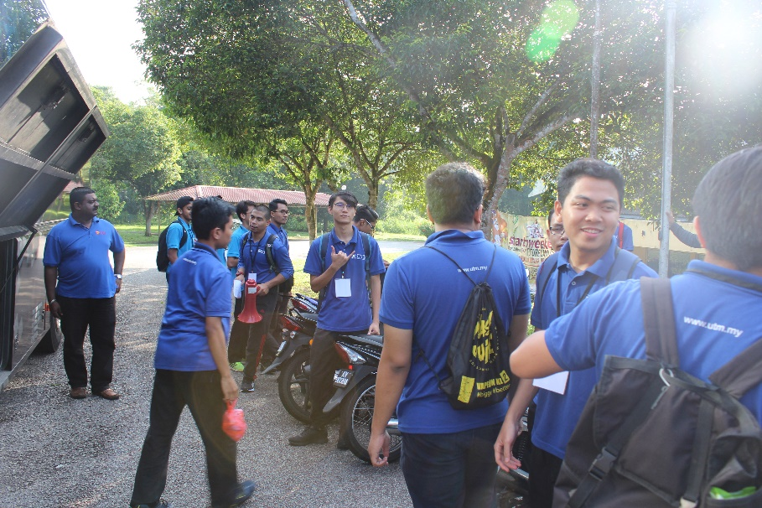

**Gathering of participants.**

Upon arrival, we got down from the bus, carrying all the stuffs that we will be using during the program. Once we reached our destination, we were greeted warmly by the residents in *Anjung Singgah*. We, the participants and the organising team, dispatched into teams to continue the program with *gotong-royong* immediately. With the help of the residents there, we were able to clean up the building, help fold donated clothes and generally making the place tidy and neat relatively quick.

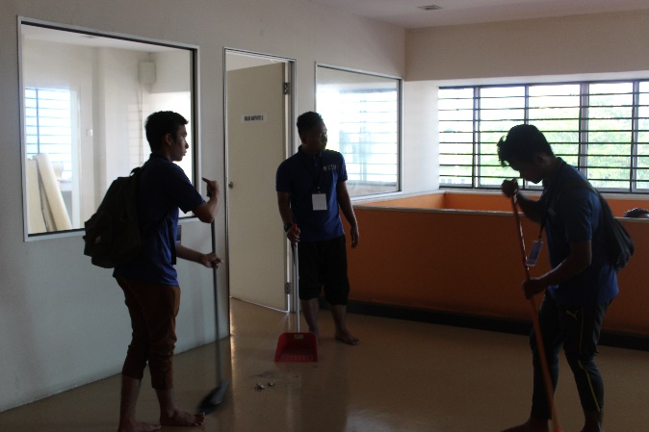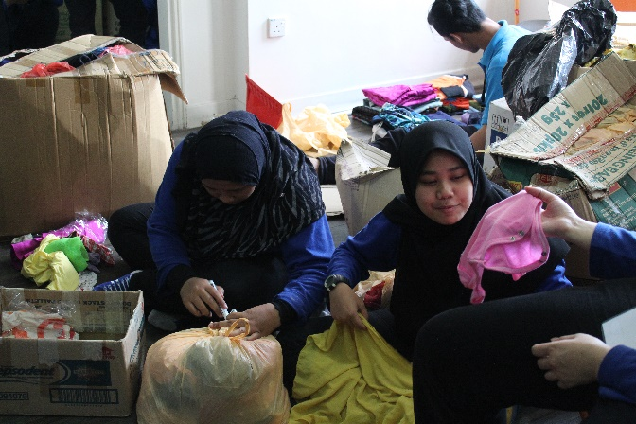

**The participants cleaning and folding donated clothes.**

After that we had a breakout session with everyone there. We played several games here and there. I was not as proactive as the other members but I still enjoyed and follow through the activities we had during the session. The residents there also follow along the activities open-hearted.

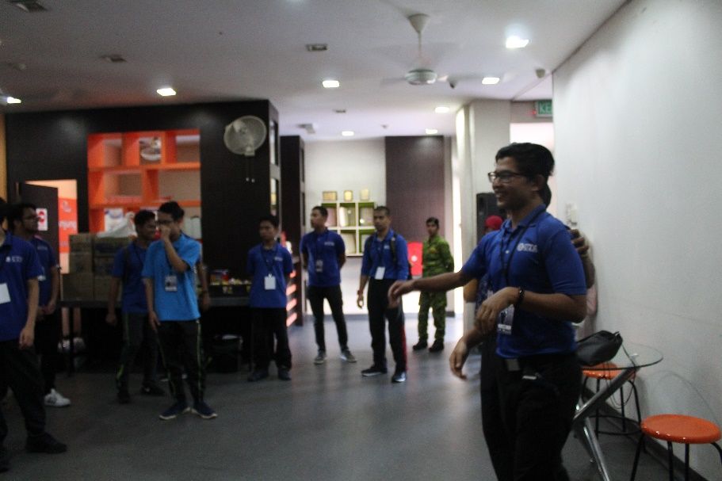

**The host initiating the ambience for the breakout session.**

After the breakout session, we began distributing foods and beverages to the people who were in need of nourishments. At first, we had trouble delivering the foods from UTM to *Anjung Singgah* since the transportation was limited to carry it all but we successfully finished distributing all of it.

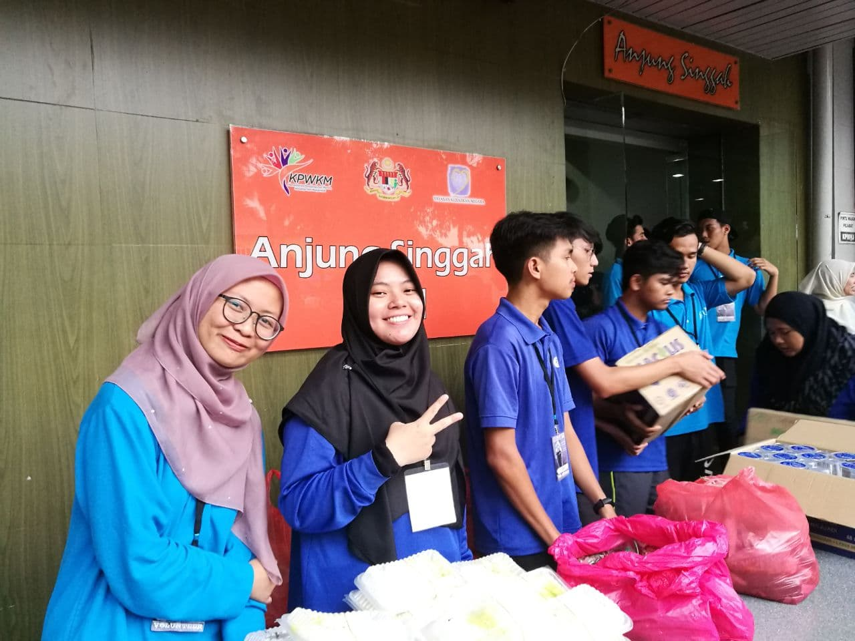

**Participants distributing foods and beverages.**

We had a group photo session at the end with everyone. The director of the program gave his speech of honour and was grateful that we were able to conduct such a meaningful event and able to provide helps and hope to the people that requires our attention the most.

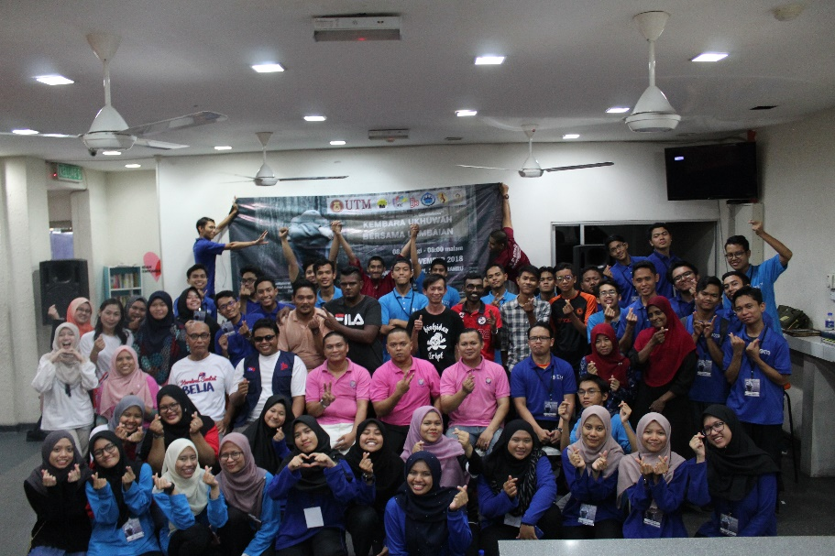

**Group photo of KUBL.**

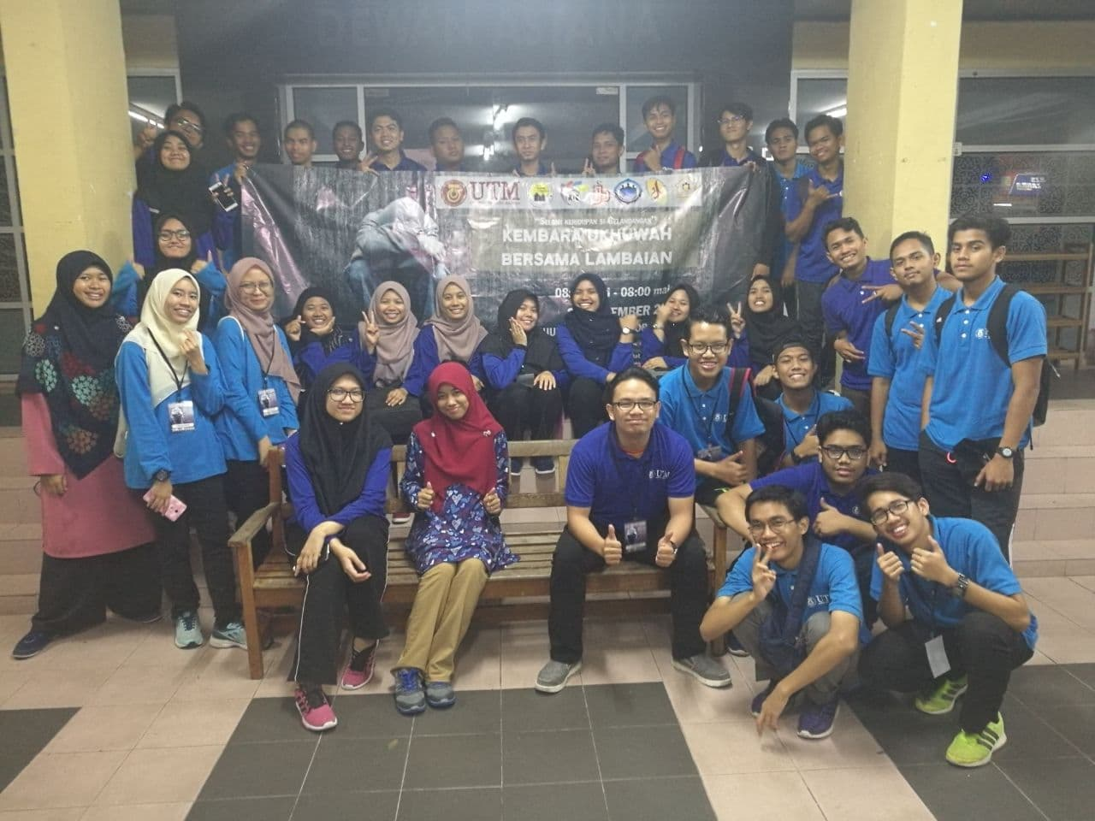

**Another group photo after we reached back UTM.**

Responding

As for having meetings before the program, because that I did not prepare the agenda that I wanted to present due to time constrictions, I also stuttered when I presented and it led to my ideas being not able to be delivered orally in a clear manner. Regarding to reaching agreements between the organising members, I had a fear and an illusion of thought that their expectations of me must be high due to the fact that most of them are older and much more experienced than me in conducting programs. I was able to listen attentively but was not responding actively due to me being hesitant. Furthermore, I feel much more comfortable communicating using English rather than Malay which probably had contributed to my awkwardness during the meeting.

Since meeting is the actual backbone of the program, it is not surprising that most of the problems I encountered are from there. I realized that I was heavily dependent on the organising team on aiding on my progress of work. I also felt uncertain to seek and take opportunity of additional relevant information that I could be searching from other sources. It made me feel sluggish doing my work as I was feeling unsure and insecure.

In contrast, during the day of the program I felt joy in running my responsibility as an executive committee of social media for the program professionally. I was able to interact with the team and participants well enough and surely enough it boosted our relationships. As a result, we finished our respective tasks efficiently and with bliss. We never had conflicts whatsoever.

Since the program involved interactions with the more unfortunate community, I tried to be more courteous and act more ethically in my decision makings and interacting with them. I was able to adapt to new cultures, communities and environment with ease. The program lasted almost half a day and the feel of fatigue was undeniable but the feeling of joy overcame it.

Relating

Focusing on the problems, I realise that the issues I encountered during the program is a recurring issue that I have had for every meeting regardless of the agenda. I had a concern in delivering my ideas or contribute suggestions but never got around to it. The main contributing factor was the fact that I feel everyone is much better and experienced, able to make better decisions than I do. I also thought that the illusion of everyone having higher expectations from me is deterring me from being proactive at all as I tend to overthink a lot.

Furthermore, I mutually depend on others when I have tasks unfinished. This might be due to the fact that I am not utilising and improving my thinking skills. I always have trouble analysing and make well-supported judgment to works that I am not used to. I am not able to think critically to handle the recurring issues that I face nor think holistically and systematically so that the issue that can be tackled with a working and efficient work frame even though being inquisitive is one of my personality.

Diverged from the difficulty I have from communication skill; I have no troubles doing my works under pressure if properly structured and guided. Moreover, I feel happy having to have work done since it adds up to my experience cumulatively. To give an instance, volunteering work is the easiest work that I could do and it gives me great pleasure doing it. It never fails to give me more work experiences since we always are involved in different communities during community services. It keeps me updated with current world issues and also develops my own character needed for myself to prepare for the real world. It teaches me to decide and interact ethically with different communities while being profession and responsible in carrying out duties.

Reasoning

The root behind the whole meeting situation is what happens when I come in unprepared with vague plan and blanked mind, without knowing my main goal. I have this idiosyncrasy that I tend to keep everything in my mind, that I will remember everything that I want to voice out or the points and ideas everyone is contributing. This proves to be a major issue especially when I am trying to gain experience through learning with people that are more knowledgeable in the field.

I also treat everyone far more superior than I should, triggering the inferiority complexity inside of me. I think that the main idea for the stated issue is due to the fact that I am afraid to learn via mistakes and I would be ashamed to publicly admit to my mistakes. I also was not willing to take risks. Now that I took it from other perspective, I can see that I could actually save more time and contribute more if I was to just treat everyone as work peers and only want to finish unfinished businesses.

Second of all, addressing the issue of me depending on the others to aid on my tasks. Surely enough, a team should support each other’s responsibilities. But knowing that everyone has their own schedule and time is constricted, it is not helping me finishing my overdue tasks. The problem with me is that I heavily depend on others and was not looking for alternative sources to solve my own issues. I should have been more receptive towards new or different ideas for independent, self-directed autonomous learning experiences.

Reconstructing

Based on the self-thought constructive criticism, I have learned that I beforehand need to prepare mentally and physically of what to be expected and what issues that I need to address during a meeting through a planned structure. By merely taking about 10 or 20minutes to prepare the agenda before a meeting, I could save time for both myself and the person I am meeting with. With the agenda, I could clear the ambience and share the objectives that I expect and receive suggestions from my peers. Alternatively, I could also message my peers so that they can prepare prior to the meeting. Using this method will definitely shorten the meeting time while having it being fruitful.

I should also be confident and courageous in delivering ideas and suggestions, not disinclined and afraid in making mistakes because mistakes are our best teacher. I should also start to utilise my overthinking habit to something more useful rather than making it as an obstacle of me reaching my goals. Relationship development is also important for me to improve on so that I would feel more comfortable around my peers and it would also contribute to my proactive learning.

In addition, I should terminate my life-long developed mindset that every solution to a problem would be provided without asking. I should be more independent currently and in the future in looking solutions to the issues that I work with. Developing an inquisitive mind and adapting to the use of systematic research methodology will prove to be beneficial for me in doing my tasks. I should also not be fearful to initiate and implement changes to my daily life from what I am used to so that I would be able to recognize more potential for self-improvement and discover new solutions and experiences and apply it to future new situations.