Amazon Forest Fire

The fires raging in the Amazon have drawn attention to the alarming speed of deforestation in one of the most biodiverse places on Earth, along with urgent warnings from scientists that a “tipping point” could be near, putting the rainforest at risk of gradually turning into dry savanna.

The main cause of the forest fire is due to the agriculture field of the country. Slash-and-burn agriculture, also called fire-fallow cultivation, is a farming method that involves the cutting and burning of plants in a forest or woodland to create a field called a ‘**swidden**’. The method begins by cutting down the trees and woody plants in an area. The downed vegetation, or ‘**slash**’, is then left to dry, usually right before the rainiest part of the year. Then, the biomass is burned, resulting in a nutrient-rich layer of ash which makes the soil fertile, which also temporarily helps by eliminating weed and pest species.

The other cause of the forest fire is due to Brazil's recently-elected President Jair Bolsonaro, also nicknamed Captain Chainsaw. Jair Bolsonaro’s government blocked 30% of the Brazilian environment agency’s budget for preventing fires, according to an internal document seen by Unearthed. The document shows that R$13.5m (Brazilian reals) or £2.7m was frozen from Ibama’s fund for fire prevention earlier this year. He has also opened called for the stripping of Amazon protection and opening it up to public mining and agribusiness interests.

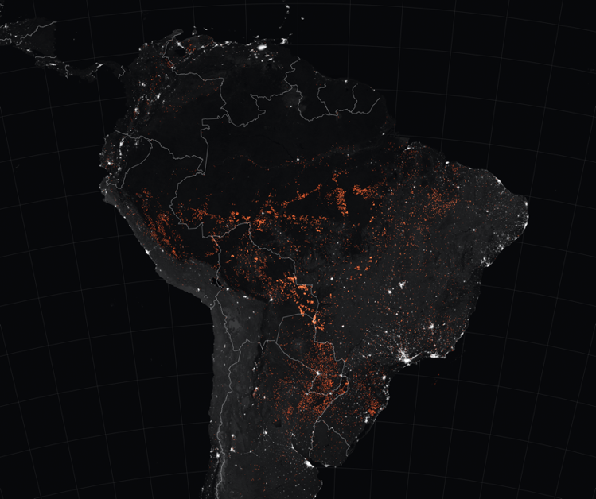

The spots marked in orange, are the locations of the forest fires, from 15th August to 22nd August 2019.

I have some suggestions that may help prevent forest fires from starting.

1. Be a Responsible Smoker: If you're moving through a wooded area, don't smoke while you're walking. Ashes that you leave behind you can actually create a trail of heat sources that can ignite nearby vegetation. When you do smoke outside, be sure to fully extinguish your cigarette butt and take it with you. Do not let it sit on the forest floor.
2. Never leave any fire unattended. If you went for camping or outdoor activity and started a campfire, bonfire or burn-pile, make sure someone is always monitoring the fire. As we already know, fire is very powerful and can be extremely unpredictable. Some sparks can unknowingly hop to some nearby dried leaves and start a fire.
3. The next one is fireworks. Make sure when playing with fireworks, do it in an open area with more soil/ dirt instead of choosing places with dried leaves or grass. Always make sure to keep a bucket of water, a hose, or even a fire extinguisher nearby in case of some unforeseen events. Also make sure to douse the fireworks and fully extinguish them before leaving.

To actually solve and put a stop to this problem, everyone has to play their own part at saving nature. They can't be selfish and always think that someone else is going to do the work for them. NGO’s should also start being more active in gathering people and organizing large-scale campaigns to help spread the awareness to more citizens. And most importantly, the United Nations definitely play the biggest role in this prevention. As I have mentioned earlier about getting together and playing our roles in preventing this situation, it can't be possible without leaders who actually have a clear vision on what needs to be done. Then only can the people of the world have someone to look up to and follow their footsteps. And last but not least, always remember that, ‘Every effort counts.’

References

1. J.S. Holmes. (1911). Forest fires and their prevention. Retrieved from <http://richardstreeservice.com/about/resources/prevent-forest-fires.php>
2. Rachael D’Amore. (2019, August 24). Amazon rainforest fires: What caused them and why activists are blaming Brazil’s president. Retrieved from <https://globalnews.ca/news/5794191/amazon-rainforest-fire-explained/>
3. Ryan Zinke. (2018, August 8). Wildfires seem unstoppable, but they can be prevented. Here's how. Retrieved from

<https://www.usatoday.com/story/opinion/2018/08/08/active-forest-management-prevent-wildfires-column/913801002/>

1. Kate Evans. (2019, September 5). Ancient farmers burned the Amazon, but today's fires are very different. Retrieved from <https://www.nationalgeographic.com/environment/2019/09/ancient-humans-burned-amazon-fires-today-entirely-different/>