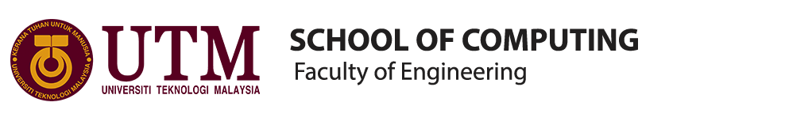
INDUSTRIAL VISIT REPORT
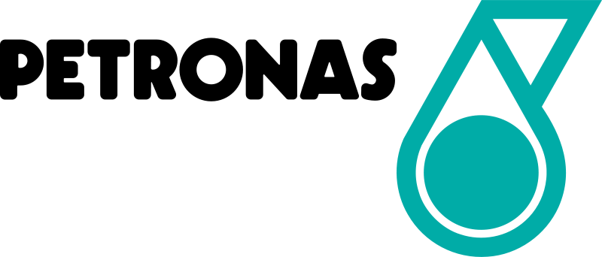

TITLE : INDUSTRIAL VISIT TO PETRONAS
COURSE/SECTION : SECP
LECTURER : DR. ARYATI BT. BAKRI
GROUP MEMBERS : 1) AZRIANA BT. ZAINAL ABIDIN (A19EC0027)
2) MIRZA SABRINA MOHD SALMI (A19EC0086)
3) CHIA WEI HONG (A19EC0033)

TABLE OF CONTENTS

EXECUTIVE SUMMARY 3
INTRODUCTION 3
DETAILS OF JOURNEY 4
DESCRIPTION ABOUT PETRONAS 7
GROUP TECHNICAL DATA 9
REFLECTION 9
CONCLUSION 11
REFERENCE 11

EXECUTIVE SUMMARY
Petronas is a custodian of oil and gas in Malaysia. Petronas had established Group Technical Data (GTD) to collect and analysis data in order to improve their management thus increase value to the company. This make us realize that data analytics play a big role in a company. We had become more confident in pursuing in our course which is Data Engineering. It is a great experience for us because we can know more about our job opportunities in future after we graduated as data engineer.

INTRODUCTION
On 11th September 2019, we went to the Petronas Twins Tower for our first industry visit. This trip was organised by Dr. Aryati Bt. Bakri for data engineering students from school of computing. There were 37 data engineering students and escorted by 2 lecturers during the whole trip. The purpose of this trip is to give the exposure about data engineering job scope and the demand for data engineering in the future.
Petronas stands for Petroliam Nasional Berhad which is a Malaysian oil and gas company that was founded on 17 August 1974. This company is owned by the Government of Malaysia and was given a responsibility to develop oil and gas resources in Malaysia. As we had heard from the talk, Petronas had to collaborate with an international company to ensure their hydrocarbon from extinct. Otherwise, the hydrocarbon may no longer exist in another 20 years because they did not have an advanced machine to maintain the hydrocarbon.

DETAILS OF JOURNEY
Table 1: Tentative Program of the Visit to Petronas
TIME | EVENT
08.00 A.M | Arrived at the Petronas Twins Tower
08.30 A.M | Having some simple refreshment
09.00 A.M | Welcome & Talk Sessions with Madam Niza Adila Binti Hamzah
10.00 A.M | Q&A Sessions and Closing
10.30 A.M | Meeting with our senior
11.00 A.M | Tour around Level 44, Tower 3

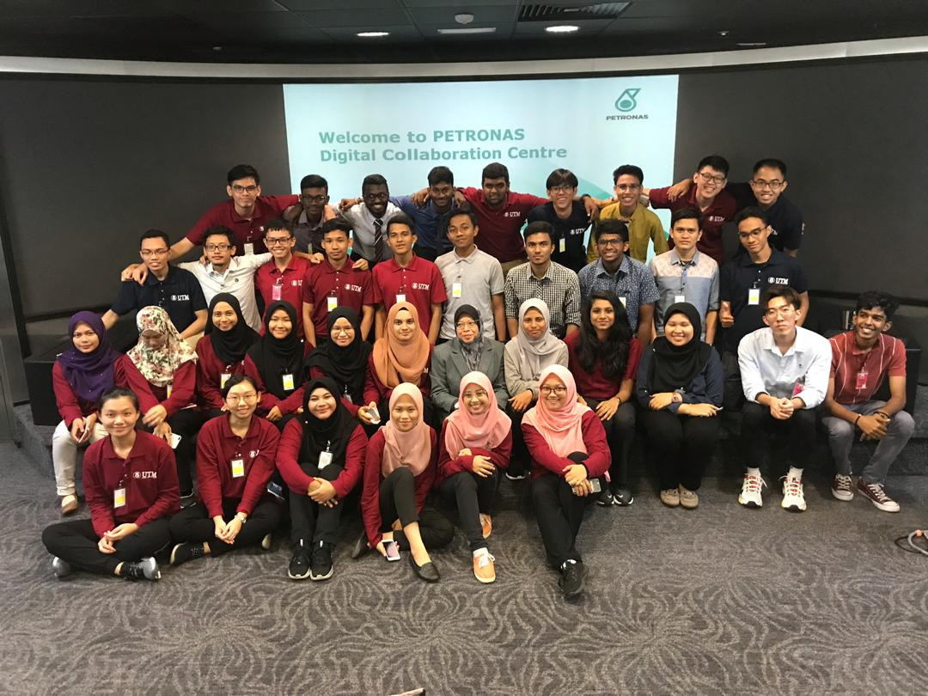
Figure 1: Our Trip Team with Dr Aryati
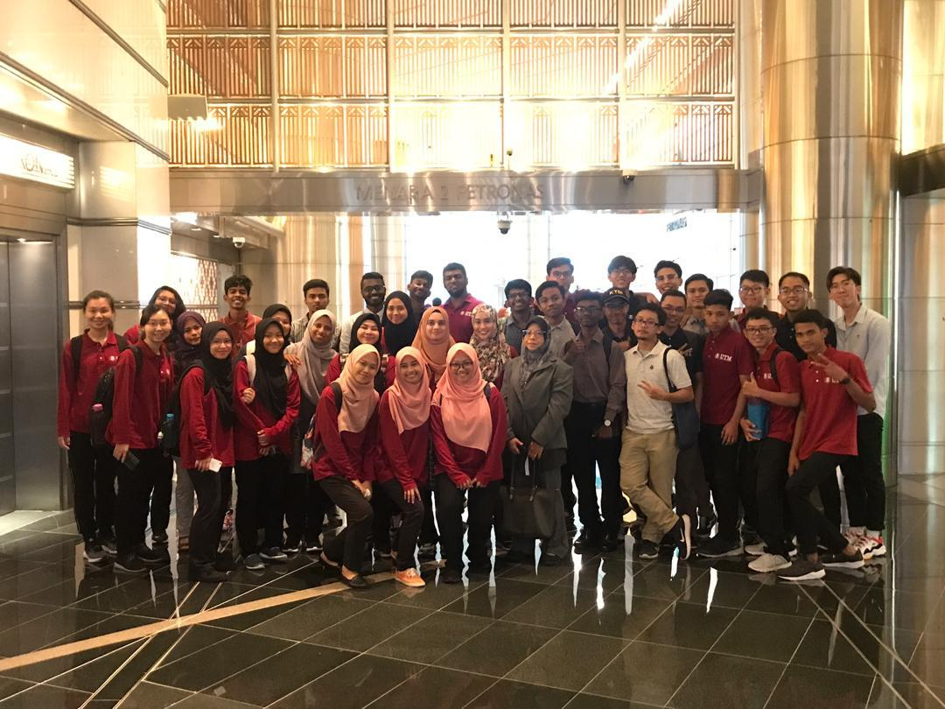
Figure 2: Arrived at Petronas
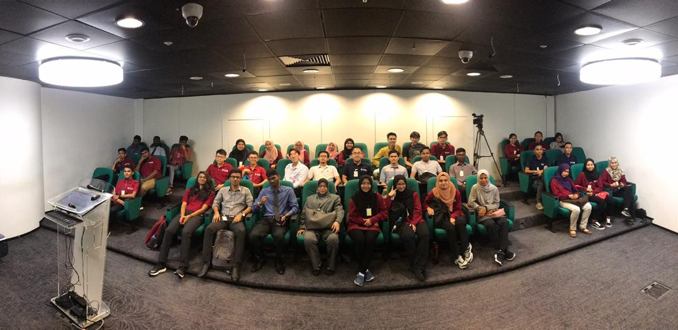
Figure 3: Welcome and Talk Session

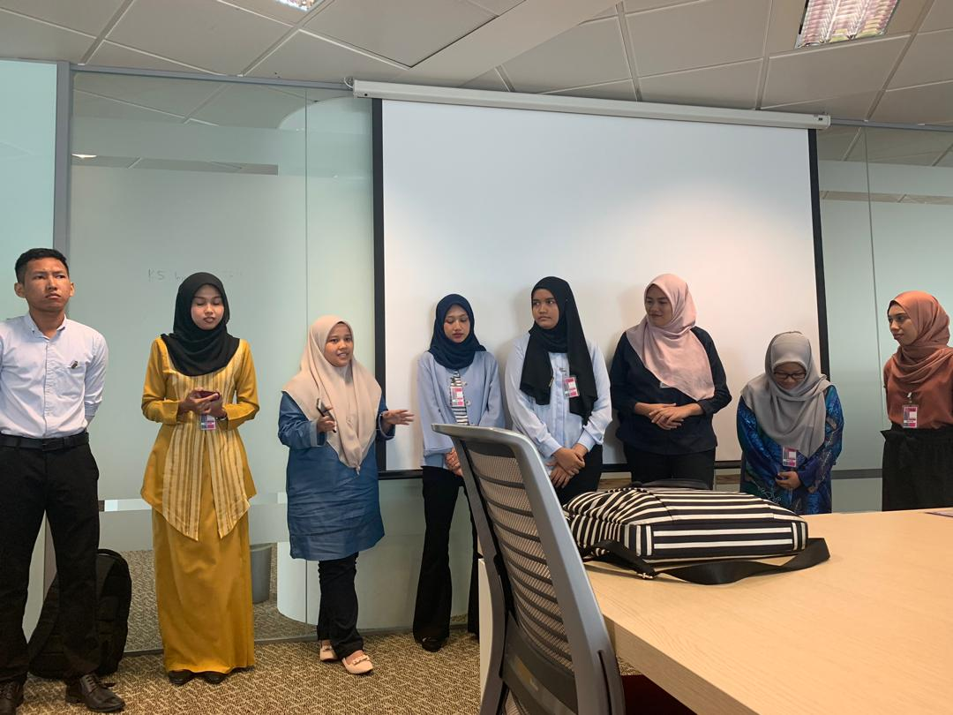
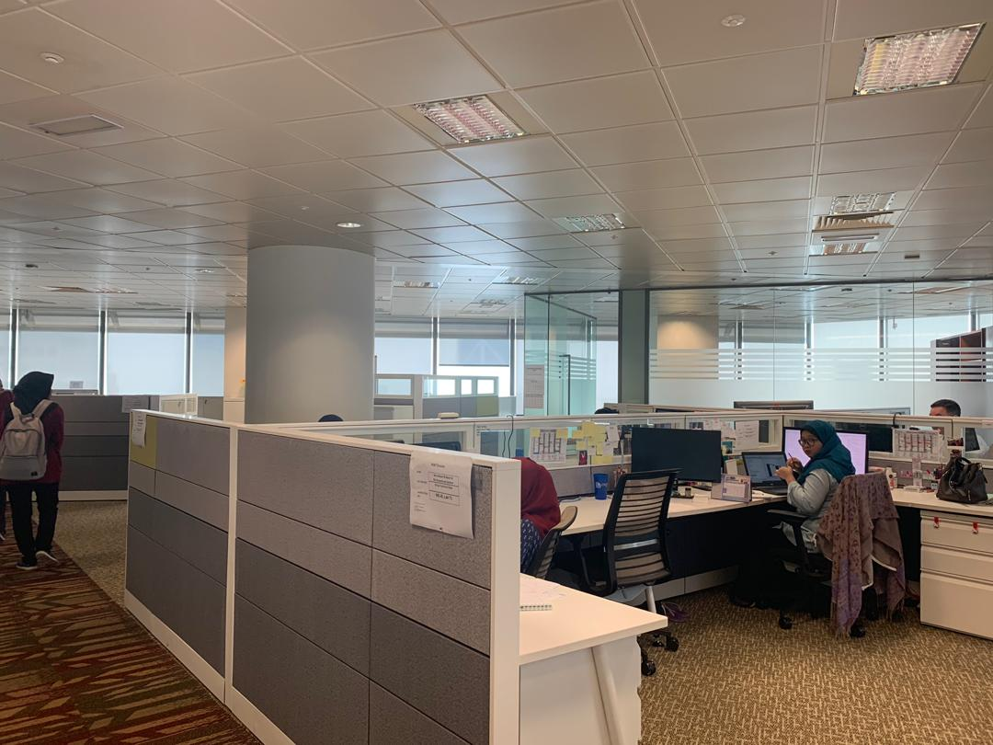
Figure 4: Senior giving talk and advise
Figure 5: Tour around level 4 where the stuff is working

DESCRIPTION ABOUT PETRONAS
Petroliam Nasional Berhad as known as Petronas is a Malaysian oil and gas company that was founded on 17 August 1974. Carigali has been established in 1981 to manage data for Carigali and it has been involved up to 2016 where it is been centralized as a group. Subsurface is the most longest data created in Petronas since 1970. Challenge that they face is they do not have much analytic application in house. Subsurface is different from the surface. Surface develop a lot of analytic because their data are processed by daily production while subsurface data only recall within a few months and it is in big sizes.

ORGANIZATION STRUCTURE

ACHIEVEMENTS

VISION
- A LEADING GAS INFRASTRUCTURE AND UTILITIES COMPANY

MISSION
- WE ARE A BUSINESS ENTITY
- GAS INFRASTRUCTURE AND UTILITIES IS OUR CORE BUSINESS
- WE OPERATE SAFELY, RELIABLY AND COMPETITIVELY
- WE OPTIMISE THE GAS VALUE CHAIN TO MAXIMISE RETURNS FOR OUR STAKEHOLDERS

SHARED VALUES

GROUP TECHNICAL DATA

Group Technical Data is also known as GTD. Group Technical Data is a group organized by Petronas to collect and store the data to give a contribution to the Petronas. GTD not only take care of action data but also take care of technical data. From 2016, GTD started to take advantage of what they can with all the data they collected. Initially, they face the first challenge. That is data selection of the data they got or collected from their partner. So they decided to put all the data inside the database and provide it to their customer when customer need it.

To give more value to the Petronas, GTD started looking into data analytic and look into the possibility of creating more value from the data. GTD as the custodian of Petronas technical data besides act on behalf Petronas to finish and eliminate the technical data, they also do some data analytics that come out with the insight by established standard and also solution development. GTD also provide data services for business for the use of Petronas. Besides that, GTD also got a function known as logic management that looks in how they can avoid the serious problem in the future. In a nutshell, they do some analysis to come out with some solution that can apply to the business. But this needs to be proven by the evaluation from the business.

REFLECTION
MIRZA SABRINA
I think that this trip of industrial visit was beneficial to me in my learning of data engineering as my course is attached to the industries. I got a lot of new knowledge in data analysis during this trip and I was so grateful that I was able to be a part of this experience. It was incredible being at Petronas' headquarter as Petronas is one of the big companies in Malaysia. The surrounding of the office in Petronas Twin Towers motivated me to study hard to be their internship thus being absorbed as their permanent worker. I realize that data analytics play a big role in a company. I was able to see how Group Technical Data (GTD) of Petronas bring value to the business. On a personal level, it was great being able to spend time with my classmates. This trip helped me to get to know my peers better and we had become closer even though we just met for a week. This value can promote a great teamwork in working as GTD in the industries to produce a better performance.
AZRIANA
I think this industrial give a lot of benefit to me because I got to learn many new things about managing the data. For example, they give me knowledge about how they handling their company data, what is the advantage and disadvantage of handling those big data. As Petronas produce chemical product, they must have a good security wall to protect their data such as firewall and malware. The environment around the Petronas office motivates me to study hard and get to be a part of them in my future. I hope that I can be like my senior that already went to their internship there in the fourth year. I had understood that Petronas use Phyton as their programming language, thus I must excellent on Phyton. I also need to improve my English and communication skills. This is because fluent in English can increase my chances of getting a great job in an international company. Besides, English is an international language so that I can interact with people easily. Moreover, I must explore more about my course by myself and not just rely on my lecturer. Lastly, I must contribute to all my group assignment because our senior said data engineering students must have great teamwork because work as data engineer is not as easy as studying the course.

AH HONG
Through the industry visit in Petronas, I can see that Petronas also emphasise on the usage of data to increase the profit of the company. This is because the Petronas had employed a lot of the data engineering students from UTM to join their Digital Collaboration Centre. The job scope of Digital Collaboration Centre is to collected and store the data to increase the profit of the company. Besides, the Petronas have the intention to employ more data engineering students. As we all know Petronas is one of the hardest companies to join due to the high competition. But our senior from UTM data engineering manage to get into this big company. Therefore, it gave me a lot of confident to study hard and get a good result so that I can also join the Petronas and give my contribution to the company.

TASK BY EACH MEMBER
Mirza | Photographer  Detailed descriptions of Group of Technical Data  Reflection  Task by each member
Azriana | Recorder  Description of Petronas  Reflection  Introduction
Wei Hong | Interviewer  Conclusion  Reflection  Details of Journey

CONCLUSION
We were so grateful that we were able to be part of this experience because of the new knowledges that we had learnt. As we all know Petronas is one of the hardest companies to join due to high competition, but our seniors manage to do their internship at there. This gave us motivation to improve our academic and soft skills so that we can do our internship at Petronas thus being absorbed as their permanent worker. This trip gave a lot of benefit to us because we got to expose to many new things about industrial. We realize that data scientist is important for a company to improve the management. This can help the company to increase value as GTD had contribute some profit to Petronas. Therefore, we had become more confident to continue pursuing in our course which is Data Engineering due to the job opportunities in future.

REFERENCE
  - Syndicated News. (2015, November 26). Petronas wins two global awards. Retrieved from Mole: http://mole.my/petronas-wins-two-global-awards/
  - Arndt, Stvn. (2016, March 10). How To Write An Industrial Visit Report.
Retrieved from the Pensters: https://www.thepensters.com/blog/industrial-visit-report

