Semester I 2019/2020

Subject : Technology and Information Systems ` (SCSP1513)
Section : 01
Task : Design Thinking

Group Members :

NAME | STUDENT ID
NUR IZZAH IZZATI MOHD YUSOF | A19EC0132
ARINA ZAFIRA BINTI AMRAN | A19EC0024
DIVIYA ARUMUGAM | A19EC0041
HAFIZ RIDWAN | A18CS9011

INTRODUCTION

A system always plays a vital role in education, business and also in politics. Today, our main system uses modern technology which provides a bundle of information. To organize all this information we need to use the information system. The information system is a store which keeps data in order. It works together with its components which will process data organization. There are different types of information system which has different roles based on its main use. For example, in business information system helps to get more accurate business details and efficient resource allocation. It also helps to get better data visualization to predict future events and find patterns in historical data. Other than that, in education-wise, information system is been a backbone for students to gather more data about their studies and important information which are related to their education.

Moreover, there are many types of information system exist. Those are Executive Support Systems(ESS), Management Information Systems (MIS), Decision Support Systems(DSS), Knowledge Management Systems (KMS), Transaction Processing Systems(TPS), and Office Automation Systems (OAS). All these types of information systems are also having their own roles other than the roles that we have mentioned above.

Although the information system owns many benefits it still lacks some features which can organize data in more efficient order with the use of modern technology components

WHAT IS DESIGN THINKING?

Design thinking process is proposed by Hasso-Plattner Institute of Design at Stanford. Design thinking is a method for practical and creative problem solving that involve varied field such as engineering, architecture and business. The core of the design thinking is discovering what people needs and creatively develop an idea to meet the needs. This process consist of five process; empathize, define, ideate, prototype and test.
Empathize is to conduct interviews to give you an idea of what people care about. We need to empathize with the situation. In the interview, maybe they can share some ideas on how to solve the problems. We need to go deeper in the conversation so that we can properly analyse the difficulties that they are facing.
Next is define the problems, looking at the interviews we can understand the actual need that people are trying to fulfilled. We need to highlight the activities when talking about the problems, from these we can analyse the problem. Then we can formulate the problem statement.
Step three is ideate, in this step we will focus on the problem statement can develope ideas to solve the problems. At this stage we have to come out with many ideas and sketch the ideas. Then show the ideas to people and get the feedback on the ideas.
Then develop a prototype. In this stage, we have to think how the ideas fit with the context of people life. The solution can be the combinations of new idea or something that have already exist. Sketch up the final solution and go build the real prototype that just good enough to be tested.
Last stage is test. Test the protoptype with actual users. If people do not like the idea, record the feedback and learn what works and what didn’t. Then upgrade the prototype.

DETAILED STEP AND DESCRIPTIONS

Students are the ones who will feel the lack of some features in the information system as we required to use it in our daily life. Students tend to use many applications for their education or daily use. Thus, this application will take a lot of space on our memory phone. It is inconvenient for the students to manage their memory phones daily. This is one of the causes of problems for students.
After studying this issue, we interviewed several university students to learn more about the problems they encountered.
We find that most students face financial difficulties, miss important information, unorganized schedules, and get lost in the university.

Diagram: Interview process

Our group had gathered and discussed how these problems can be resolved. We need to find solutions to make it easier for students to use all these applications without any worries.
After a long discussion, based on the idea given by the interviewee, we've got a solution in which an application that combines all that is needed by students. We started with a rough draft of the prototype for the application. Then, we make prototypes using cardboard that will function as the phone.

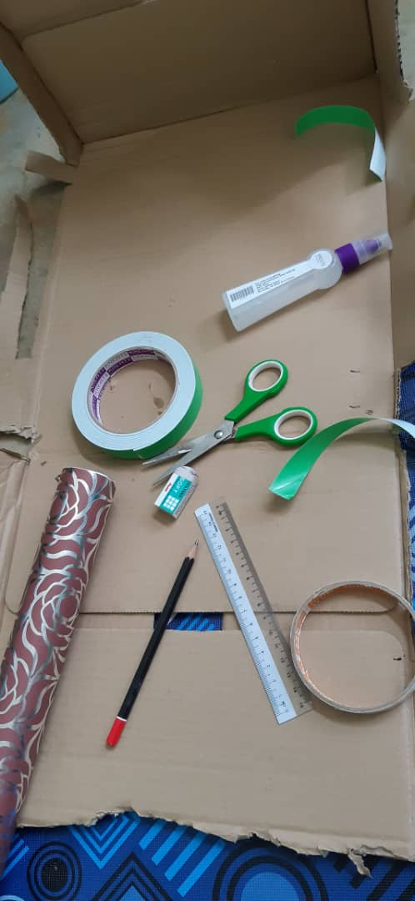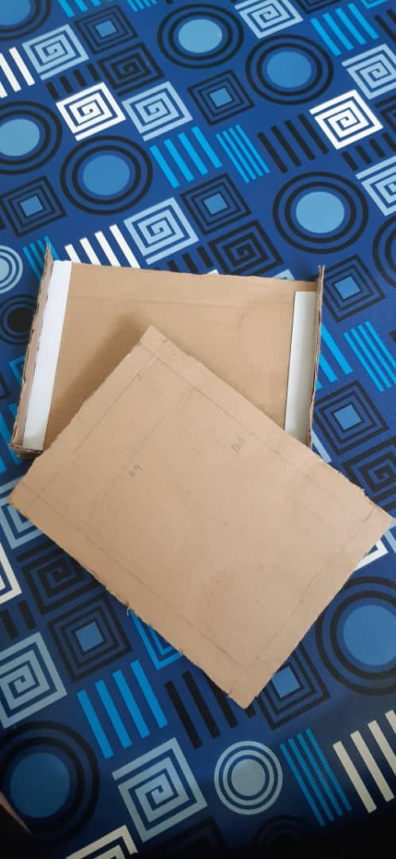
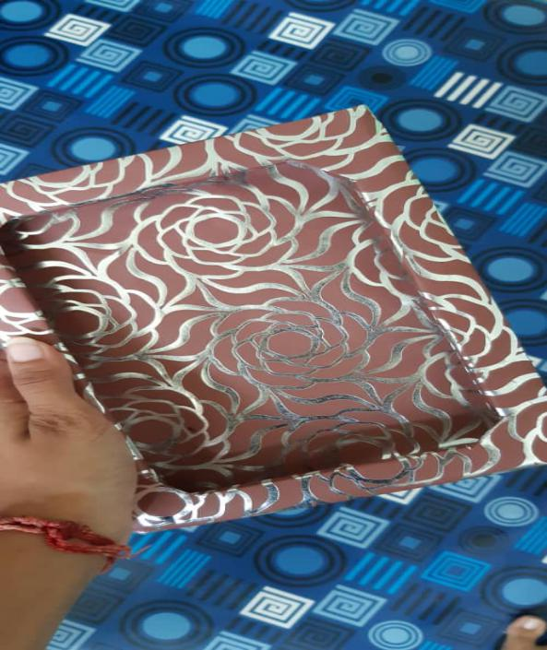
Diagram: The making of the prototype

This application will contain :
- Calendar with daily expences detail
- Maps/GPS
- Parcel tracker
- Prioritize important message
- all the important message will be saved in this application;
- Alarm;

All these features have been combined in one application for the student's use. This makes it convenient and more comfortable for students to use it as it much more easier and save time.
We named it "SMARE" that stands for smart remainder and also means ‘to share with' with the hope that one can share good things with others.

DESIGN THINKING EVIDENCE

a.The sample work by us

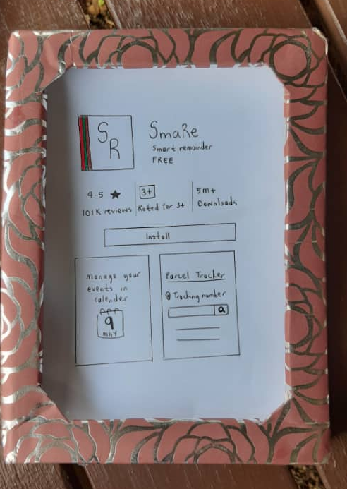

b. Record for each phase
i) Empathy: Questions for users based on empathy
We need to focus on giving the user the ability to use the app based on their decision. An app suggests the user to do something, and it has a lot to gain by making the user comfortable with their choice. We need to remove negative emotions from the experience, the slight feeling of guilt when declining, and the sensation of pressure the next time a suggestion pops up. And, it's also an opportunity to add positive ones. We can't force a user to proceed through an app, making the user comfortable with saying no is just one part of giving suggestions.

Questions for users based on empathy for this application
1) What are the problems they faced as a student?
2) Do they have any problems with parcel tracking?
3) Do they have any problems with compiling the information?
4) How was their experience monitoring the expenses?
5) Do they have any problems with GPS accuracy?
6) Their thoughts about messaging application?

ii) Define:
During the Define stage, we put together the information we have created and gathered during the Empathize stage. This is where we will analyse our observations and synthesize them in order to define the core problems that a team has identified up to this point. We should seek to define the problem as a problem statement in a human-centered manner.

iii) Ideate:
To solve a design problem we need to generate ideas. We brainstorm ideas by collecting information's from the groups by engaging with each other, listening, and build other ideas. To create a stable application we need to think outside of the box meaning expanding our ideas and experience it from a different perspective.

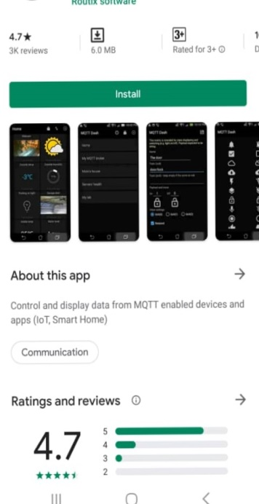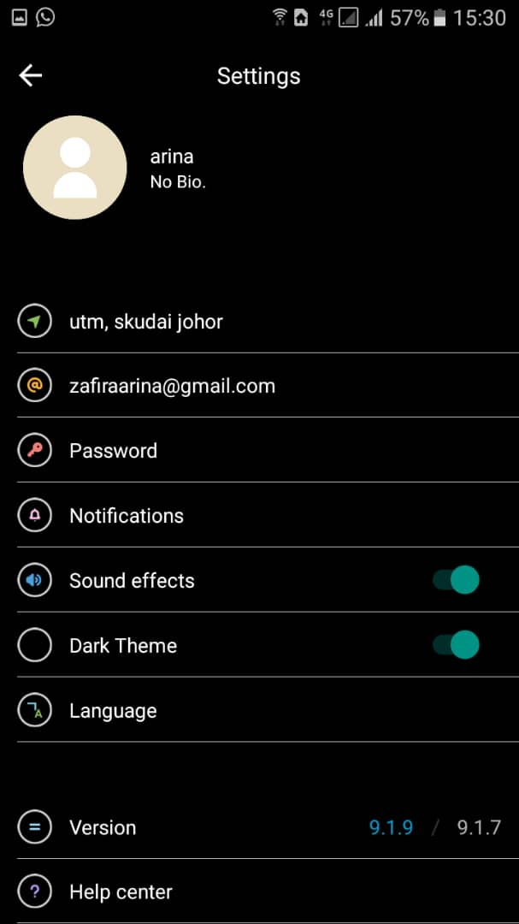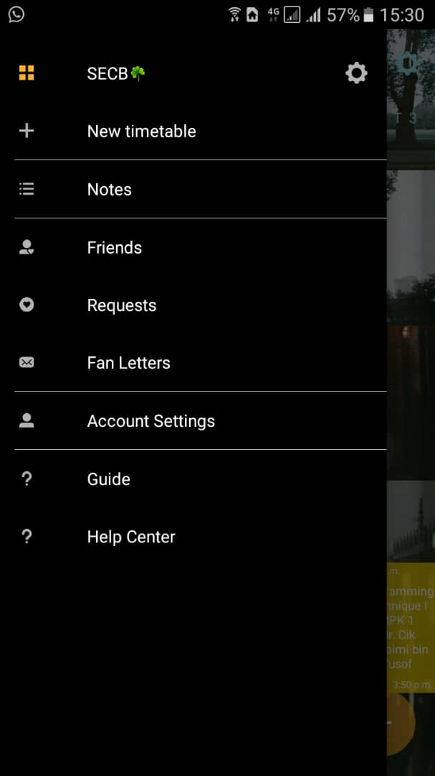

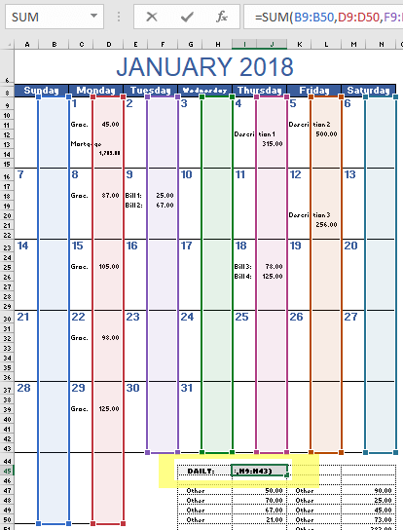
Diagram: ideas for the app
iv) Prototype:
For our Application 'SmaRe' we added a lot of features to the prototype. In play store, we added previews of the application to give users a basic idea of how this app will look and operate.

Install page
This app is available in android and apple product. It is free to download this app. The preview will show users the basic idea of the app.
Log in page  To log in into this app, the user can use their email address, so it is easier for the user to get any information and notification from the apps. For the security issues, the user can create a password. | 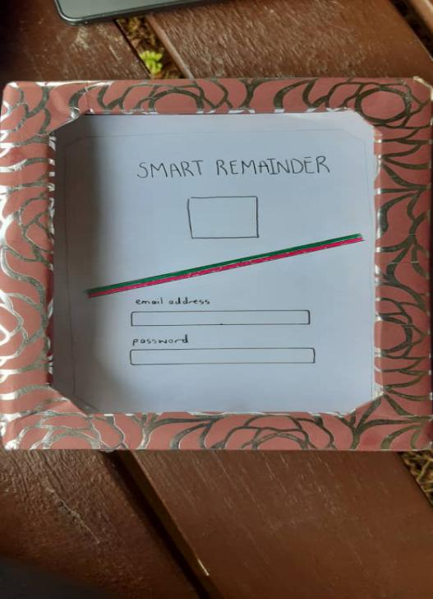
Agenda  In this page, user can compile the important message from any apps such as whatsapp. This page will display the message based on the keywords searched and the detail of the message were shown. | 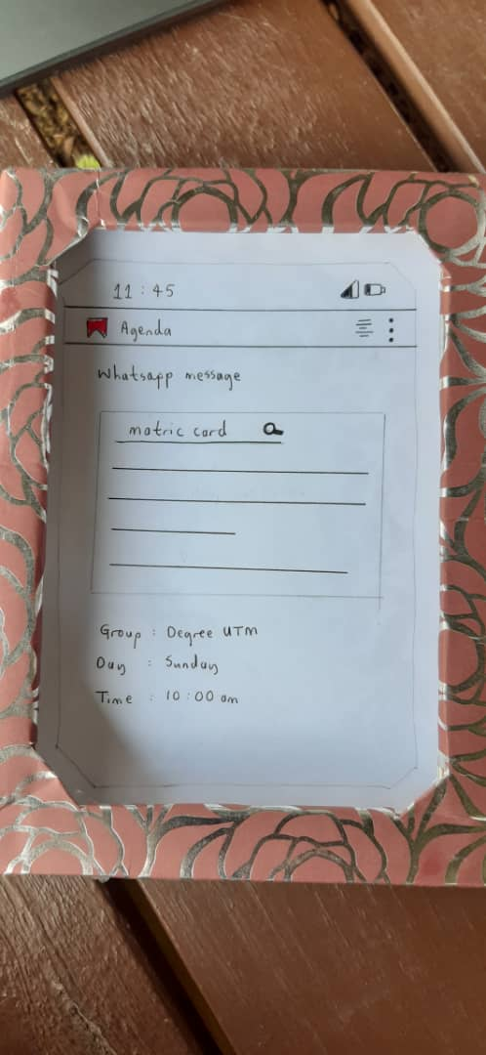
Calendar  User can keep track on their expenses by inserting the amount spent daily and calculate the total expenses each month. In this page also, we can save important events and date as a remainder. For important event, there will be the maps or GPS of the event. | 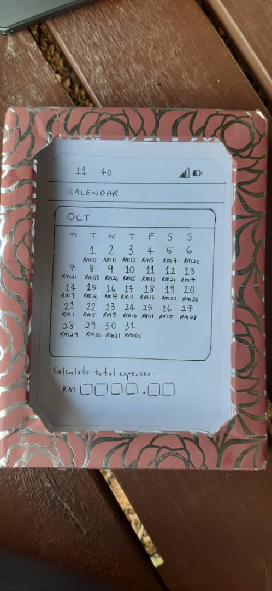  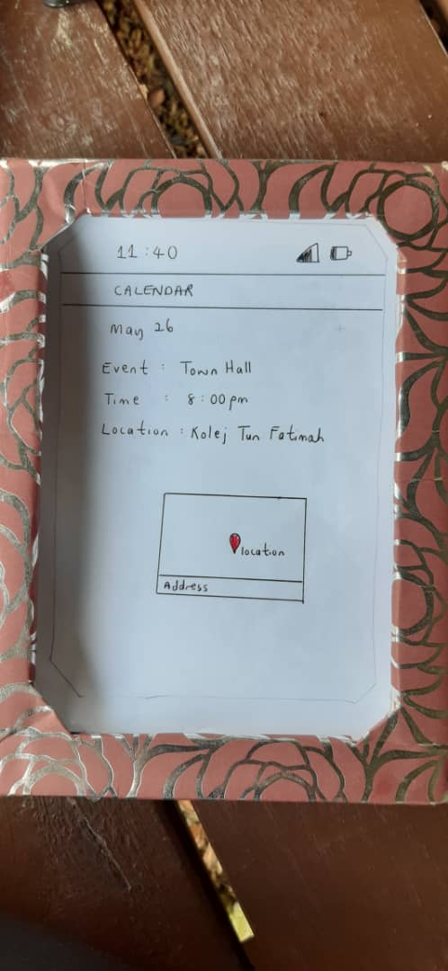
Notifications  User can set the remainder and the notifications will pop-up. For the notification, user can set the ringtone within the option. | 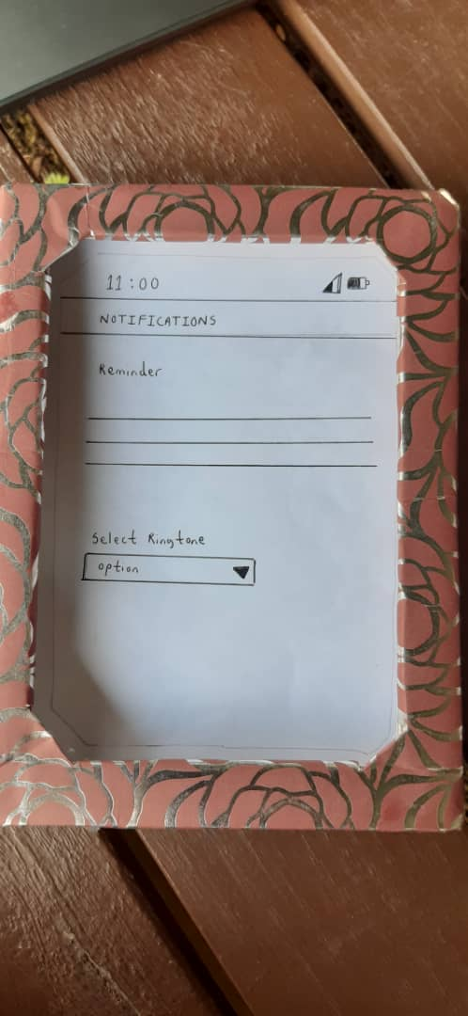
Parcel Tracker  User can keep tracking their parcel of any agencies in this page. The user just need to enter the tracking number and the details will be shown. | 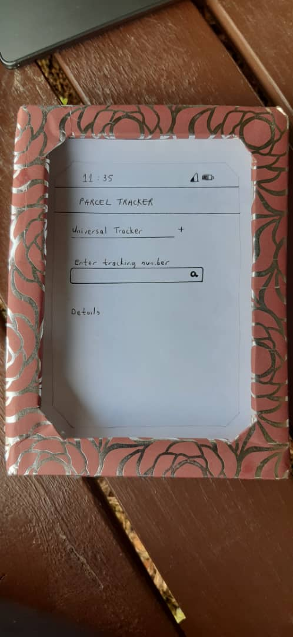

Here users can see their profile and take control of how they want to use this app. In Agenda, they can write notes for planning and document their projects. They can use built in calendar in the app alongside Parcel tracker feature to track their parcel's current location and arrival date. So basically this app feels like a combination of many popular and useful apps which will allow users to handle many tasks in a single app.

v. Test:
The interviewee will test the prototype. After we done with our prototype, we asked the interviewee to test the prototype to see if the application could solve their problems. They will give their opinion and feedback based on the prototype.

Diagram: The interviewee is testing the prototype
REFLECTION
The key aspects of Bioinformatics is the creation of the data algorithms and specialized computer software to specify and evaluate the components of biological structure. Our goal is to develop tools that can aid in the research and to make sure the data was comprehended accurately and meaningfully. In this era, technology was quite avant-garde so this made it possible for us to process and examined the digital data such as the DNA and genes. Design thinking extremely beneficial toward our goal in this course. It assists us to tackle complicated problems with only five-step which are empathised, define, ideate, prototype and test. In empathise phase, comprehend the difficulties that we attempt to solve by conferring with the expert and takes people's opinions. For the define phase, we gather the information we discover from the interview and research to be analysed.
Next, we have to find ideas as many as we can in the brainstorming proses. Then, develop a prototype based on the ideas to solve the problems. Lastly, test and improve the deficiency if the prototype. Design process refers to strategic and empirical processes that enable us to do research in our course. Through this process a lot of traits that we learn such as build our confidence as we have to meet the experts and voice out our opinions. This process also trains us to think critically to develop a decent and promising idea. With these traits, design thinking will give a big impact on our goals regards to our course.
Today, employers are not only interested in our academic achievement. They want a skillful and smart employee to maintain the performances of their company. So we need to improve in all aspects to be employed. Firstly, we need to improve our communication skills. The potential to communicate effectively with superiors and colleagues is essential, no matter what industry you work in. Communication skill is very important as we work in a team, miscommunication will lead to commotion.
Next, analytical and research skill need to be strengthened as this process involve deduction reasoning, drawing hypothesis and applying judgments from the evidence and the output of study to reach a conclusion. Lastly, we need to improve our learning skills. In this industry, we will discover new and foreign stuff so we have to keep learning and don't shy to ask questions. We also have to make reading as our routine to boost our proficiency.

