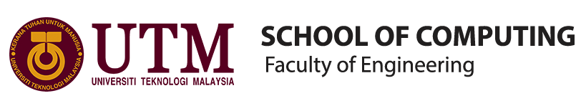
SCSP 1513
SECTION 07

GROUP REPORT: INDUSTRIAL VISIT 3
IOT Open Day FKE

SCHOOL OF COMPUTING

NAME: | MATRIC NUMBER:
MUHAMMAD FIRDAUS BIN NOR AZMAN | A18CS0149
TOON SHU HUI | A18CS0268
CHOY WAN LING | A18CS0049
IDZNI BIN MOHAMED RASHID | A18CS0075

LECTURER:
SIR HAIRUDIN BIN ABDUL MAJID

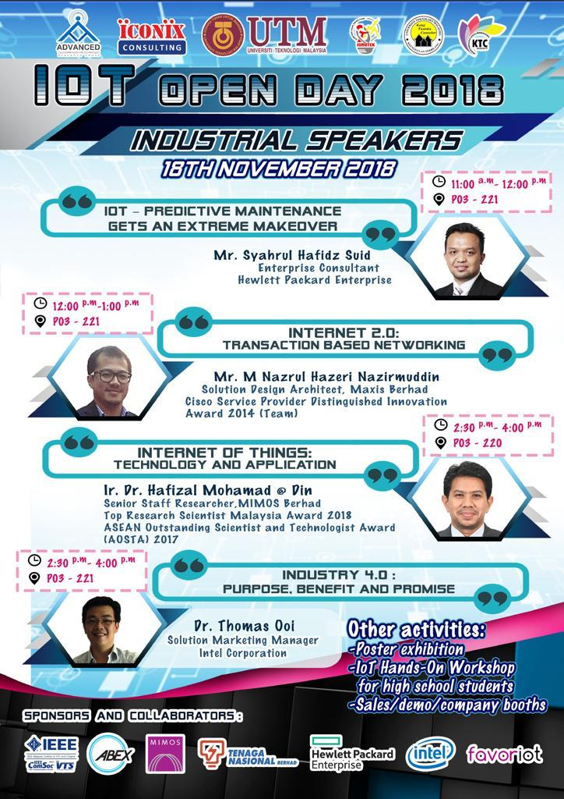

Work Plan
On the 18th of November 2018, an industrial visit has conducted for the first year SCSR student by our subject Technology and Information System lecturer, Dr. Hairuddin. We have our industrial visit to Internet of Things (IoT) Open Day of Faculty of Electrical Engineering (FKE).

There are three slots with three different time and title. Our group are attended the slot at 11AM with title IoT – Predictive Maintenance Gets an Extreme Makeover. We were all given a talk regarding to the title in Room 221, Block P03 (FKE) by the industrial speaker Mr Syahrul Hafidz Suid, an enterprise consultant from Hewlett Packard Enterprise (HPE).
There are some IoT products show to us at the company booths and IoT Hands-On Workshop outside the room 221 so that we can understand more about IoT through these activities. Lastly, we were allowed to visit the poster exhibition at the corridor and listen to the presentation of second year students based on the poster regarding to the technology Internet of Things (IoT) which apply in many areas and fields nowadays especially in computing area and industry field.

Introduction
The Internet of things (IoT) is using software, actuators, sensors, electronics and Internet connectivity to connect the network of physical devices such as vehicles, home appliances and other items in an embedded system to collect and exchange data. These physical devices can communicate and interact each other on the Internet with embedded technology in embedded system. The analog data converted to digital data using IT support technology called IoT. Hence it enables people easily get the software to control and can be remotely monitored the physical devices using IoT and embedded technology system. IoT not just used by the standard devices such as laptops, desktops, tablets and smartphones, it can also extend the Internet connectivity to any range of non-internet-enabled physical devices.

As said by the speaker, predictive maintenance defines as we fix it before it fails. We predict the possible error which may occur first and try to give out a solution to fix it before it really occurs that error and make us troubles. For example, one of the largest suppliers of industrial and environmental machinery called Flowserve corporation which is an American multinational corporation captures the sensor data from heavy machinery. It also performs analytics and uses machine learning by comparing this data with information from other equipment to predict failures before they occur. This step is important in industry field and computing area because it required to avoid the serious problem, extending the life of assets, improving safety and reducing costs.

Hewlett Packard Enterprise (HPE) is a popular and big company which promote technology innovation and technology transformation that fosters business transformation. It has pioneering the future of computing. It gives a lot of IT services and contribution in the field of industry and area of computing such as it has contributed in embedded technology system and a lots of IoT products. Hewlett Packard Enterprise are continually improving their embedding quality and continually introduces new products and services, explores technology and market trends, and provides industry insight and best practices.

Content
In the first talk the speaker Mr Syahrul Hafiz Suid has given a talk about IoT – Predictive Maintenance Gets an Extreme Makeover. Mr Syahrul has talked about the development of industry revolution from first industrial revolution until industrial revolution 4.0. He also talks about the history in the industrial revolution and give a thinking in a new scope of Industrial Revolution 4.0 that have we know that global has dramatically change when Industrial Revolution 4.0 get in into the industry.

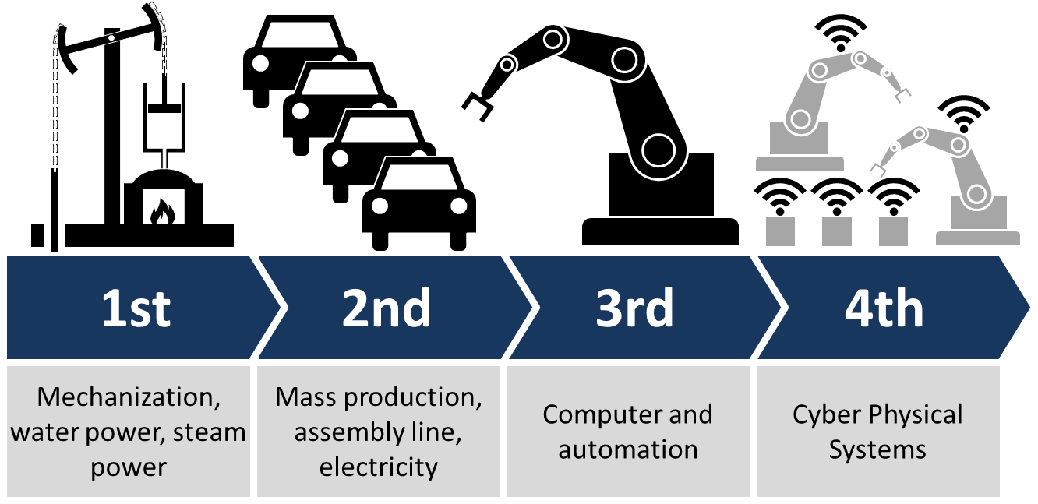

Industrial Revolution 4.0^{[1]}

Industrial Revolution 4.0 is a name given to the current trend of automation and data exchange in manufacturing technologies. It includes cyber-physical systems, the Internet of things, cloud computing and cognitive computing. Industrial Revolution 4.0 is commonly referred to as the fourth industrial revolution.

Industrial Revolution 4.0 fosters what has been called a "smart factory". Within modular structured smart factories, cyber-physical systems monitor physical processes, create a virtual copy of the physical world and make decentralized decisions. Over the Internet of Things, cyber-physical systems communicate and cooperate with each other and with humans in real-time both internally and across organizational services offered and used by participants of the value chain.

Malaysia has been introduced to this revolution in a years ago but even though other country has already introduced to this long ago. More innovative and creative creation have been revealed around the world. For today session, the main focus is about Internet of Thing (IoT) and Artificial Intelligence.

One question has been asked by the Mr Syahrul, he asked “What is Artificial Intelligence (AI)?”. Artificial Intelligence (AI)^{[2]} sometimes called machine intelligence, is intelligence demonstrated by machines, in contrast to the natural intelligence displayed by humans and other animals. In computer science AI research is defined as the study of "intelligent agents": any device that perceives its environment and takes actions that maximize its chance of successfully achieving its goals. Colloquially, the term "artificial intelligence" is applied when a machine mimics "cognitive" functions that humans associate with other human minds, such as "learning" and "problem solving".
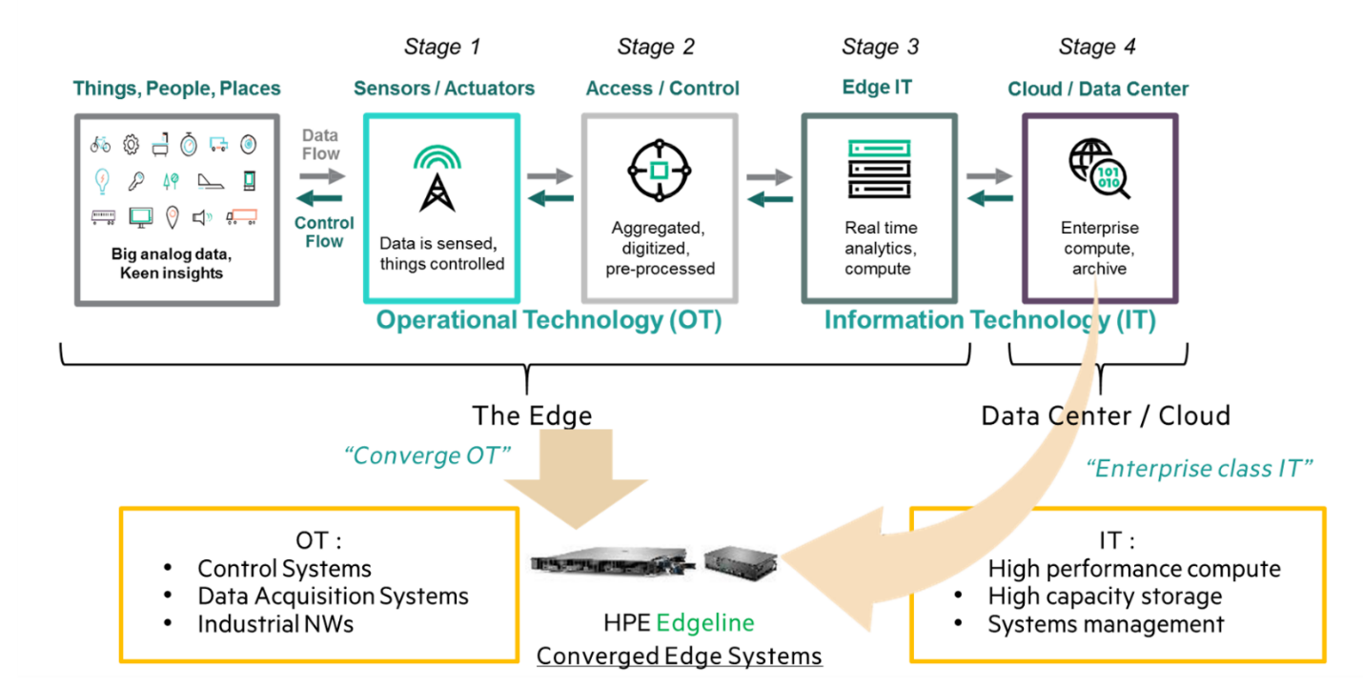

Industrial Revolution 4.0^{[1]}

Mr Syahrul said that AI is how the program or machine can manipulate data that it has to become useful resources for worker or technician use to maintain machine or predict the problem before it happens. Speaker give an example in AI-Manufacturing which use Augmented Reality to check a machine in a real time without a need to test it. It also helps determine any problem and identified error before it happens “We fix it before it Fail”.
Another example of IoT and AI technology that speaker has talk is implemented in Oil and Gas Industry which is national oil company Petronas have collaborated with HPE to integrated the system and increase the production. Process start from Edge which is the oil platform the sensor will analysts what the company needed to increase the production the data sent by using satellite and transfer to the mainland and data is process in the data centre to keep the data and make an improvement about production the useful data was sent back from the data centre to the oil platform for the worker use the data to maintain and identified error before it become major problem the data also is collect from other oil platform also. 3 main part in IoT and AI Technology (Edge, Control, Core)

Mr Syahrul has also shared the IDC Reveals Worldwide CIO Agenda 2019 Predictions that have been revealed from IDC FutureScape. IDC FutureScape reports are used to shape IT strategy and planning for the enterprise by providing a basic framework for evaluating IT initiatives in terms of their value to business strategy now and in the foreseeable future. IDC's FutureScape are comprised of a set of decision imperatives designed to identify a range of pending issues that CIOs and senior technology professionals will confront within a typical five-year business planning cycle.

The prediction that IDC FutureScape revealed is:

- Prediction 1:
By 2021, driven by LOB needs, 70% of CIOs will deliver "agile connectivity" via APIs and architectures that interconnect digital solutions from cloud vendors, system developers, start-ups, and others.

- Prediction 2:
Compelled to curtail IT spending, improve enterprise IT agility, and accelerate innovation, 70% of CIOs will aggressively apply data and AI to IT operations, tools, and processes by 2021.

- Prediction 3:
By 2022, 65% of enterprises will task CIOs to transform and modernize governance policies to seize the opportunities and confront new risks posed by AI, ML, and data privacy and ethics.

- Prediction 4:
Through 2022, 75% of successful digital strategies will be built by a transformed IT organization, with modernized and rationalized infrastructure, applications, and data architectures.

- Prediction 5:
By 2020, 80% of IT executive leadership will be compensated based on business KPIs and metrics that measure IT effectiveness in driving business performance and growth, not IT operational measures.

- Prediction 6:
By 2020, 60% of CIOs will initiate a digital trust framework that goes beyond preventing cyberattacks and enables organizations to resiliently rebound from adverse situations, events, and effects.

- Prediction 7:
By 2022, 75% of CIOs who do not shift their organizations to empowered IT product teams to enable digital innovation, disruption, and scale will fail in their roles.

- Prediction 8:
Through 2022, the talent pool for emerging technologies will be inadequate to fill at least 30% of global demand and effective skills development and retention will become differentiating strategies.

- Prediction 9:
By 2021, 65% of CIOs will expand agile/DevOps practices into the wider business to achieve the velocity necessary for innovation, execution, and change.

- Prediction 10:
By 2023, 70% of CIOs who cannot manage the IT governance, strategy, and operations divides between LOB-dominated edge computing, operational technology, and IT will fail professionally.

Meanwhile, Mr Syahrul has pressed that prediction 2 is especially important because it is a main guideline for the evolution of IoT system.

Job requirements in Information Technology (IT)
Requirement is a quality or qualification that you must have in order to be allowed to do something or to be suitable for something. In short, your requirements are the things that you need. Some says that it was something demanded or imposed as an obligation.
Now working in a company based on the product can really accelerate your career in financially but you would need knowledge regarding to the company
The requirements that must have in every single student are:
- You need to be very good in communicating with others. Communication skills should be enough if you are looking for a customer’s support kind of jobs. If you want to settle in as software developer or consultant then you need to have complete knowledge of various programming language.

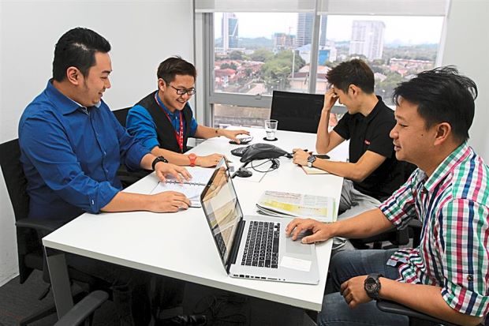

- Some positions will require applicants to have a certain level education. In nowadays, the jobs that employees need to have are diploma, graduate degree or etc. The will list the educational requirements for the job in the job posting. In some cases, related work experience, known as equivalent experience, may be substituted for some or all of the educational requirements. What do you do, though, if you don’t have all the educational requirements for a job? If your educational background is a close match for the job and if you have employment, volunteer, internship, or learning experiences that would support your application, it is worth taking the time to apply. If it’s obviously a stretch – the job requires a Ph.D. Example, and you have an undergraduate degree – don’t waste the employer’s time or your own by applying.

- Technical competency is the most positions require certain skills that are advertised on the job posting. If you are hired to perform certain tasks when you should have the skill. Improving your skills along the way is also expected.
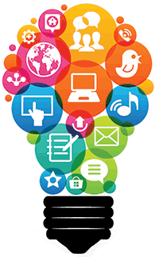

- Ability to work with Co-workers. Employers and managers like to have people working who can get along with their colleagues and who can work with others effectively in different circumstances.
- Skills in problem solving. Companies are looking for people or students who can motivate to take any risks and challenges with minimal direction. Employees should see when something needs to be done and react accordingly.

Job specification in Information Technology (IT)
Job specification is a statement of employee characteristics and qualifications required for satisfactory performance of defined duties and tasks comprising a specific job or function. Job specification is derived from job analysis.
In Information of Technology, there are many kinds of job specification that can be select and choose.
- Webmasters developer. Is the job may include backup of the company website. Updating resources or development a new resource. Webmasters are often involved in the design and the development of website. Some webmasters monitor traffic on the site and take step to encourage the users to visit the site. Webmasters also may work with marketing personnel to increase site traffic and may be involved on development of web promotions.
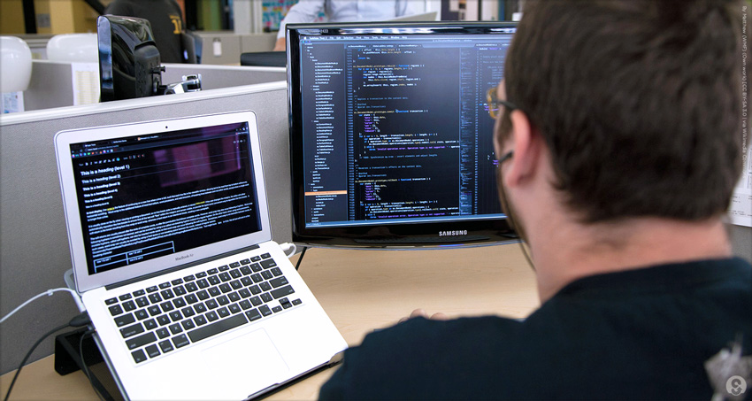
Employers look for information systems with a bachelor’s or associate’s degree in computer science or information systems and knowledge of common programming language such as HTML and CSS.
- Software engineers analyze user’s needs and create application software. Software engineers typically have experience in programming but focus on the design and development of programs using the principles of mathematics and engineers.
A bachelor’s or an advanced specialized in computer science or information systems and extensive knowledge of computer. Internships may provide students with the kinds experience employers for in a software engineer. Usually it is on analytical skills

- Computer scientists conduct research to develop new computer technologies in order to solve problems in a variety of fields. A doctoral degree is usually required for this career although there might be some opportunities with only a bachelor's degree. Computer scientists develop new technologies, systems and computer-based solutions. The most common educational requirement for advanced research positions in the field is a doctorate degree in computer science; however, those working for the federal government may hold only a bachelor's degree in computer science or a similar field. A career as a computer scientist is most suitable for those who have strong math skills and are detail-oriented.
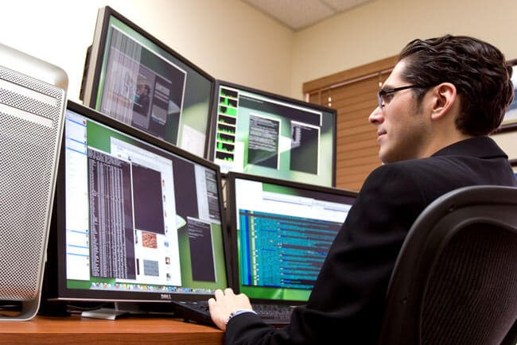
Computer scientists, also called computer and information scientists, can work for government agencies and private software publishers, engineering firms or academic institutions. Businesses and government agencies usually employ these scientists to develop new products or solve computing problems. Computer scientists employed by academic institutions are typically involved in more theoretical explorations of computing issues, often using experimentation and modelling in their research.

Computer scientists often work as part of a research team with computer programmers, information technology professionals, and mechanical or electrical engineers. Their research often is used to design new computer technology. They typically investigate technological topics like artificial intelligence, robotics or virtual reality. The results of their research can lead to the improved performance of existing computer systems and software as well as the development of new hardware or computing techniques and materials.

Career for Information of Technology (IT) in financial field

Technology is changing the way businesses operate and deliver products to consumers in many sectors. We have alarms that detect poisonous substances in our air, medical equipment that can identify life-threatening conditions before they become an issue, or smarter computer software to make controlling vital equipment easier than ever before.

There are various types of IT career in financial field.

- Online banking was traditionally something that was done in the non-virtual world. People would go into town to their bank to withdraw money, transfer funds from one place to another, and sort out their finances. You’d speak to a helpful staff member and interact with people in a brick and mortar building. However, these kinds of premises are rapidly becoming redundant. Online banking is getting more and more sophisticated on a daily basis – we can transfer money or pay for goods with just the push of a button.
There are billions of financial transactions that are happening on a day to day basis, this is why information technology is perfect for the way the financial systems are set up. The software tools and computer systems that are in place for automation create a huge importance for the use of information technology in finance.

- Fraud detection. The investigation and identification of fraud used to be an equal effort from both man and machine. The system would help to track potential fraudulent transactions, but it would be up to the staff who were trained to find fraud to look through all the information and determine if there was fraudulent activity on the account or not.

- Enterprise resource planning. Even very small companies use accounting software packages that generate financial reports such as income statements and cash flow statements. This simple form of IT allows a small business owner to save accounting time and have management reports available on a timelier basis. Mid-size and larger companies use more sophisticated IT systems called enterprise resource planning or ERP, which are groups of software modules that serve the needs of all functional areas of the company. As its name suggests, ERP helps the company plan the use of its resources, a process that the finance department oversees.
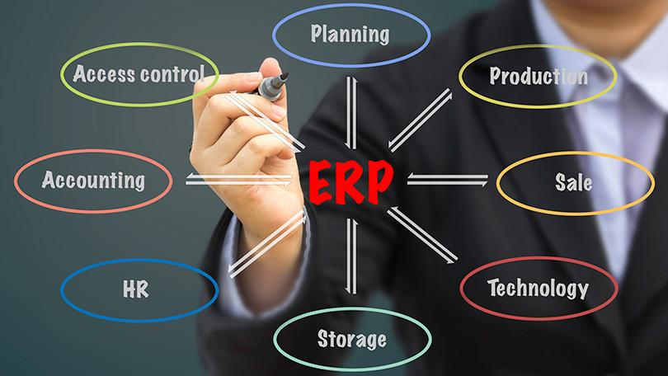

- Faster flow of information. IT systems allow a company to link up every department within the organization. Information generated by the manufacturing, marketing and finance divisions can be shared for example. This information is available real-time, meaning as soon as it is created on the system. Accessing it does not require a great deal of research or manual effort. The time finance staff used to devote to “digging” for the numbers they needed can now be devoted to analysing and interpreting the information -- finance’s primary role in the organization.

Reflection and Conclusion
From time to time, technology has advanced sophisticatedly. The IoT system is introduced to solved many problems and insufficiencies in available technology. For example, smart watch is introduced as smartphones is more expensive as compared to a smart watch which is more affordable. Besides that, smart home is also being introduced as an easy way for human being to control all the electrical appliances using voice control.

After the IoT talk, I get to know that the internet of thinking system will probably be widely used by the world in the future. It has given us as students the opportunity to explore and to innovate more IoT technologies. The talk also gives us initiative as a network student to set our goal in creating IoT system related to cyber security. Beside that, this talk has given us a lot of information regarding the IoT system so that we are clearer and more specific about what we as a future IT technician could do in helping the development of IoT system. This talk also encourages us to learn actively so that we achieved our goal successfully.

Through this talk, we get information that although IoT is developing very fast but many of today’s IoT devices are rushed to market with little consideration for basic security and privacy protections. As a network security student, further study is needed in these IoT products to enhance the security issue od these devices. Beside that, the artificial intelligence technologies had been talked about a lot in these talk. It has given us reflection that as IT students, Artificial Intelligence has to be learned and to be widely used in the future as it will ease the human being work load in the future. The speaker mentioned that although AI has the ability to take over a load of job and reduce man power but jobs are also opened to those to create the AI system or machine at the same time.

The actions that necessary for us to improve our potential in the industry is that first of all we need to develop proper etiquette so that we can communicate with our colleague, give and receive opinion and also respect the opinion given by others. Secondly, always be alert to the growth of technology so that we are always updated and always know the user needs and can develop solvation accordingly.
References
- https://en.wikipedia.org/wiki/Industry_4.0 ; last surveyed on 20th November 2018 ;
- https://en.wikipedia.org/wiki/Artificial_intelligence ; last surveyed on 20th November 2018 ;
- https://en.wikipedia.org/wiki/Internet_of_things ; last surveyed on 20th November 2018 ;
- https://www.hpe.com/us/en/home.html ; last surveyed on 20th November 2018 ;
- https://www.idc.com/getdoc.jsp?containerId=prUS44420918 ; last surveyed on 22th November 2018 ;
- https://www.google.com/amp/s/www.collinsdictionary.com/amp/english/requirement ; last surveyed on 22th November 2018 ;
- http://www.businessdictionary.com/definition/job-specification.html ; last surveyed on 22th November 2018 ;

