Industrial Visit 3 – PSZ UTM Report

Subject: Technology and Information Systems (SECP1513)
Section : 07
Lecturer: Dr. Sarina binti Sulaiman

Group 9
Members:
- Chai Ming Choy (Leader)
- Wan Nur Atiqah binti Junaidi
- Goh Jo Ey
- Zaimi Mohamed

- Introduction

UTM Gallery is the main exhibition or gallery space that forms the original name of UTM Galerium alongside other galleries. It is located on level 2 of Sultanah Zanariah Library Building in UTM Johor Bahru. The galerium has opened since Sept 28, 2017, and its opening ceremony is done by UTM Vice-Chancellor, YBhg. Prof. Datuk Ir. Dr Wahid bin Omar. There are a few small galleries inside the UTM Galerium such as the University Heritage Gallery, Microfilm Gallery, Information Technology Gallery and Audience Gallery. The artefacts on display were equipment used by the university during the 1970s and 1990s. UTM Galerium is an important entity for the university in its goal to collect, preserve and record the university's historical ancestry. The university's diversity of artefacts across technology, science, engineering and cultural arts should be nurtured with the commitment of all parties for the benefit of the next generation. It aims to the development of knowledge and information through exhibition activities, educational programs and callings and establishes a network of cooperation and good relations between UTM Gallery and external bodies and organizations for the benefit of the university.

- Details of Visit

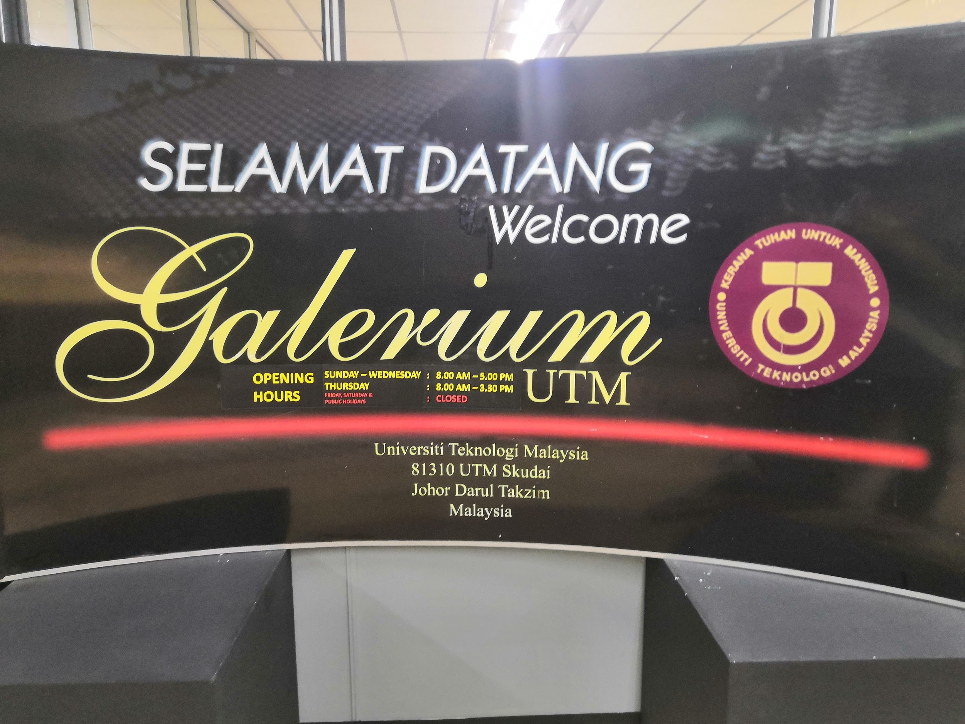

The visit to the Galerium UTM in Sultanah Zanariah Library(PSZ) on the 20th of October (Sunday) begins sharply at 3.30 p.m. All of our coursemates gathered on the second floor of the library where the Galerium UTM belongs at around 3 o'clock before the visit started. Since there are 3 sections of students which will have the visit tour, we are divided into two main groups to smoothen the organization and tour process. Our tour has been guided fully by one of the executive officers of the Centre for Information and Communications Technology(CICT). Mr Zahari gave multiple explanations and briefing on various retro computing devices for almost half an hour, providing us with the knowledge about the history and the method on how the computing component from the past worked for them. He also explained how CICT store and manage the abundance amount of data of students from both UTM KL and UTM Skudai Johor during the past decades using the older technologies and computing compartments. After his explanation tour, we are given the freedom to explore other appliances individually. Some of us has als o asked questions on the networking and data storage and management to Mr Zahari to find out more about these type of information that we as a student rarely knew. The tour ended at 4.15 p.m. for the first group which includes us, giving a chance to the rest to examine and explore the galerium.

- Details Descriptions

Mr Zahari had explained to us regarding the history of the computer and its components. The evolution of ICT began with the mainframe. The International Business Machine(IBM) Dictionary Of Computing defines "mainframe" as a large computer, in particular, one to which other computers can be connected so that they can share facilities that the mainframe provides. (Ibm.com, 2019)There were two types of the mainframe that he had shown to us which were mainframe data storage and mainframe tape subsystem.

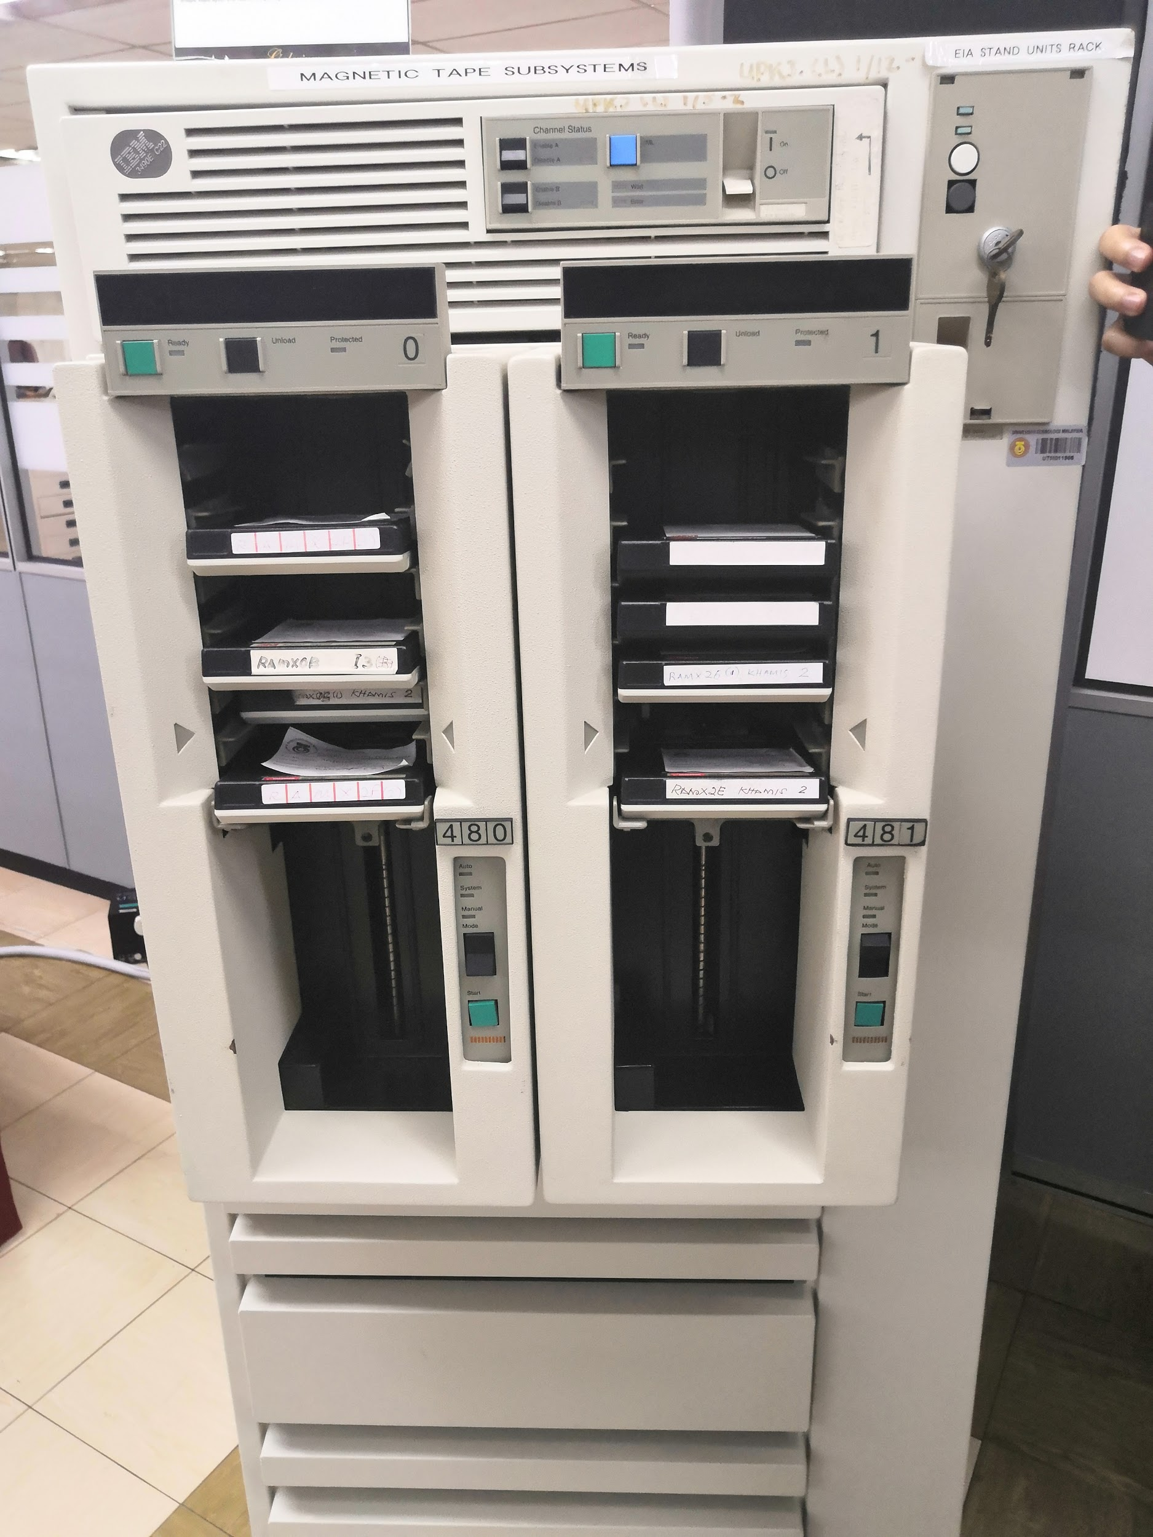
Figure 3.1: Mainframe Tape Subsystem

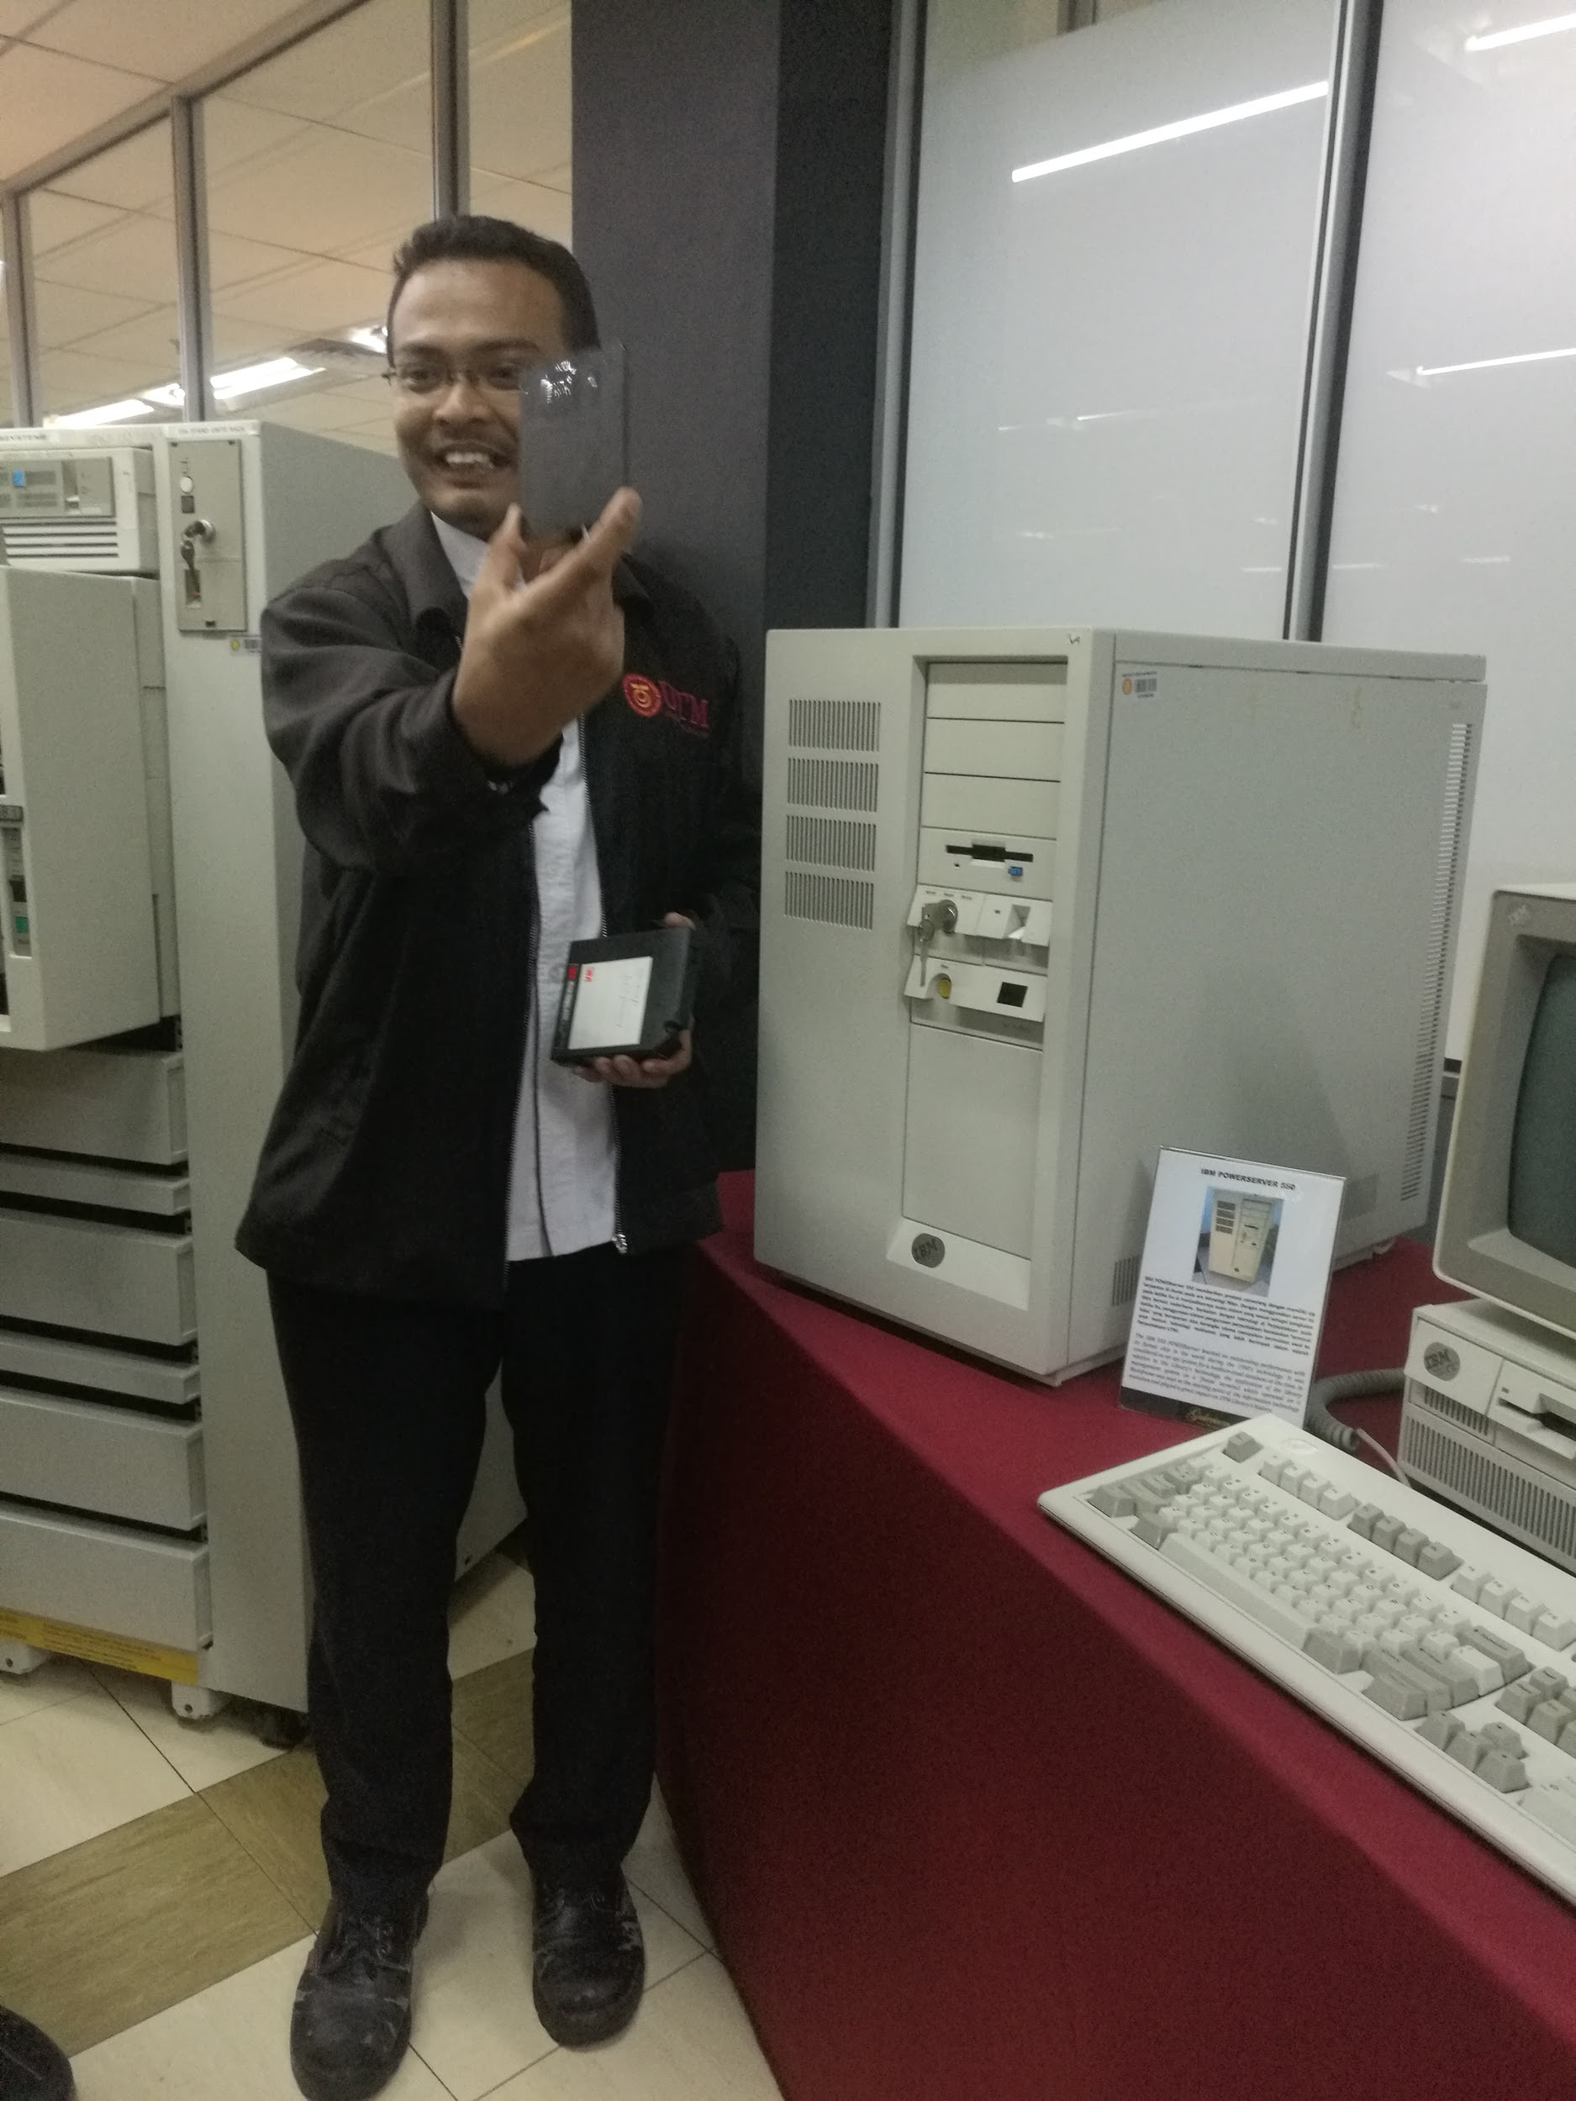
Figure 3.2: Mr Zahari showed the square tape used in that time

The first mainframe that he showed to us was the mainframe tape subsystem: IBM 9309. The mainframe tape subsystem was mainly to backup information systems and database of the staff and students during the year 1987 until 1995. This model used a square shape tape in which we called it as pendrive nowadays. The tape stored data for backup for about the size of 1.44MB. It was more than enough back in the days due to the black and white resolution used in the database. The examples were microfilm and x-ray film. However, for this era, even a 2GB storage is still not sufficient for us to store backup data, as nowadays, we have coloured resolution in which it is in big pixels. Thus, a larger storage memory system is needed.

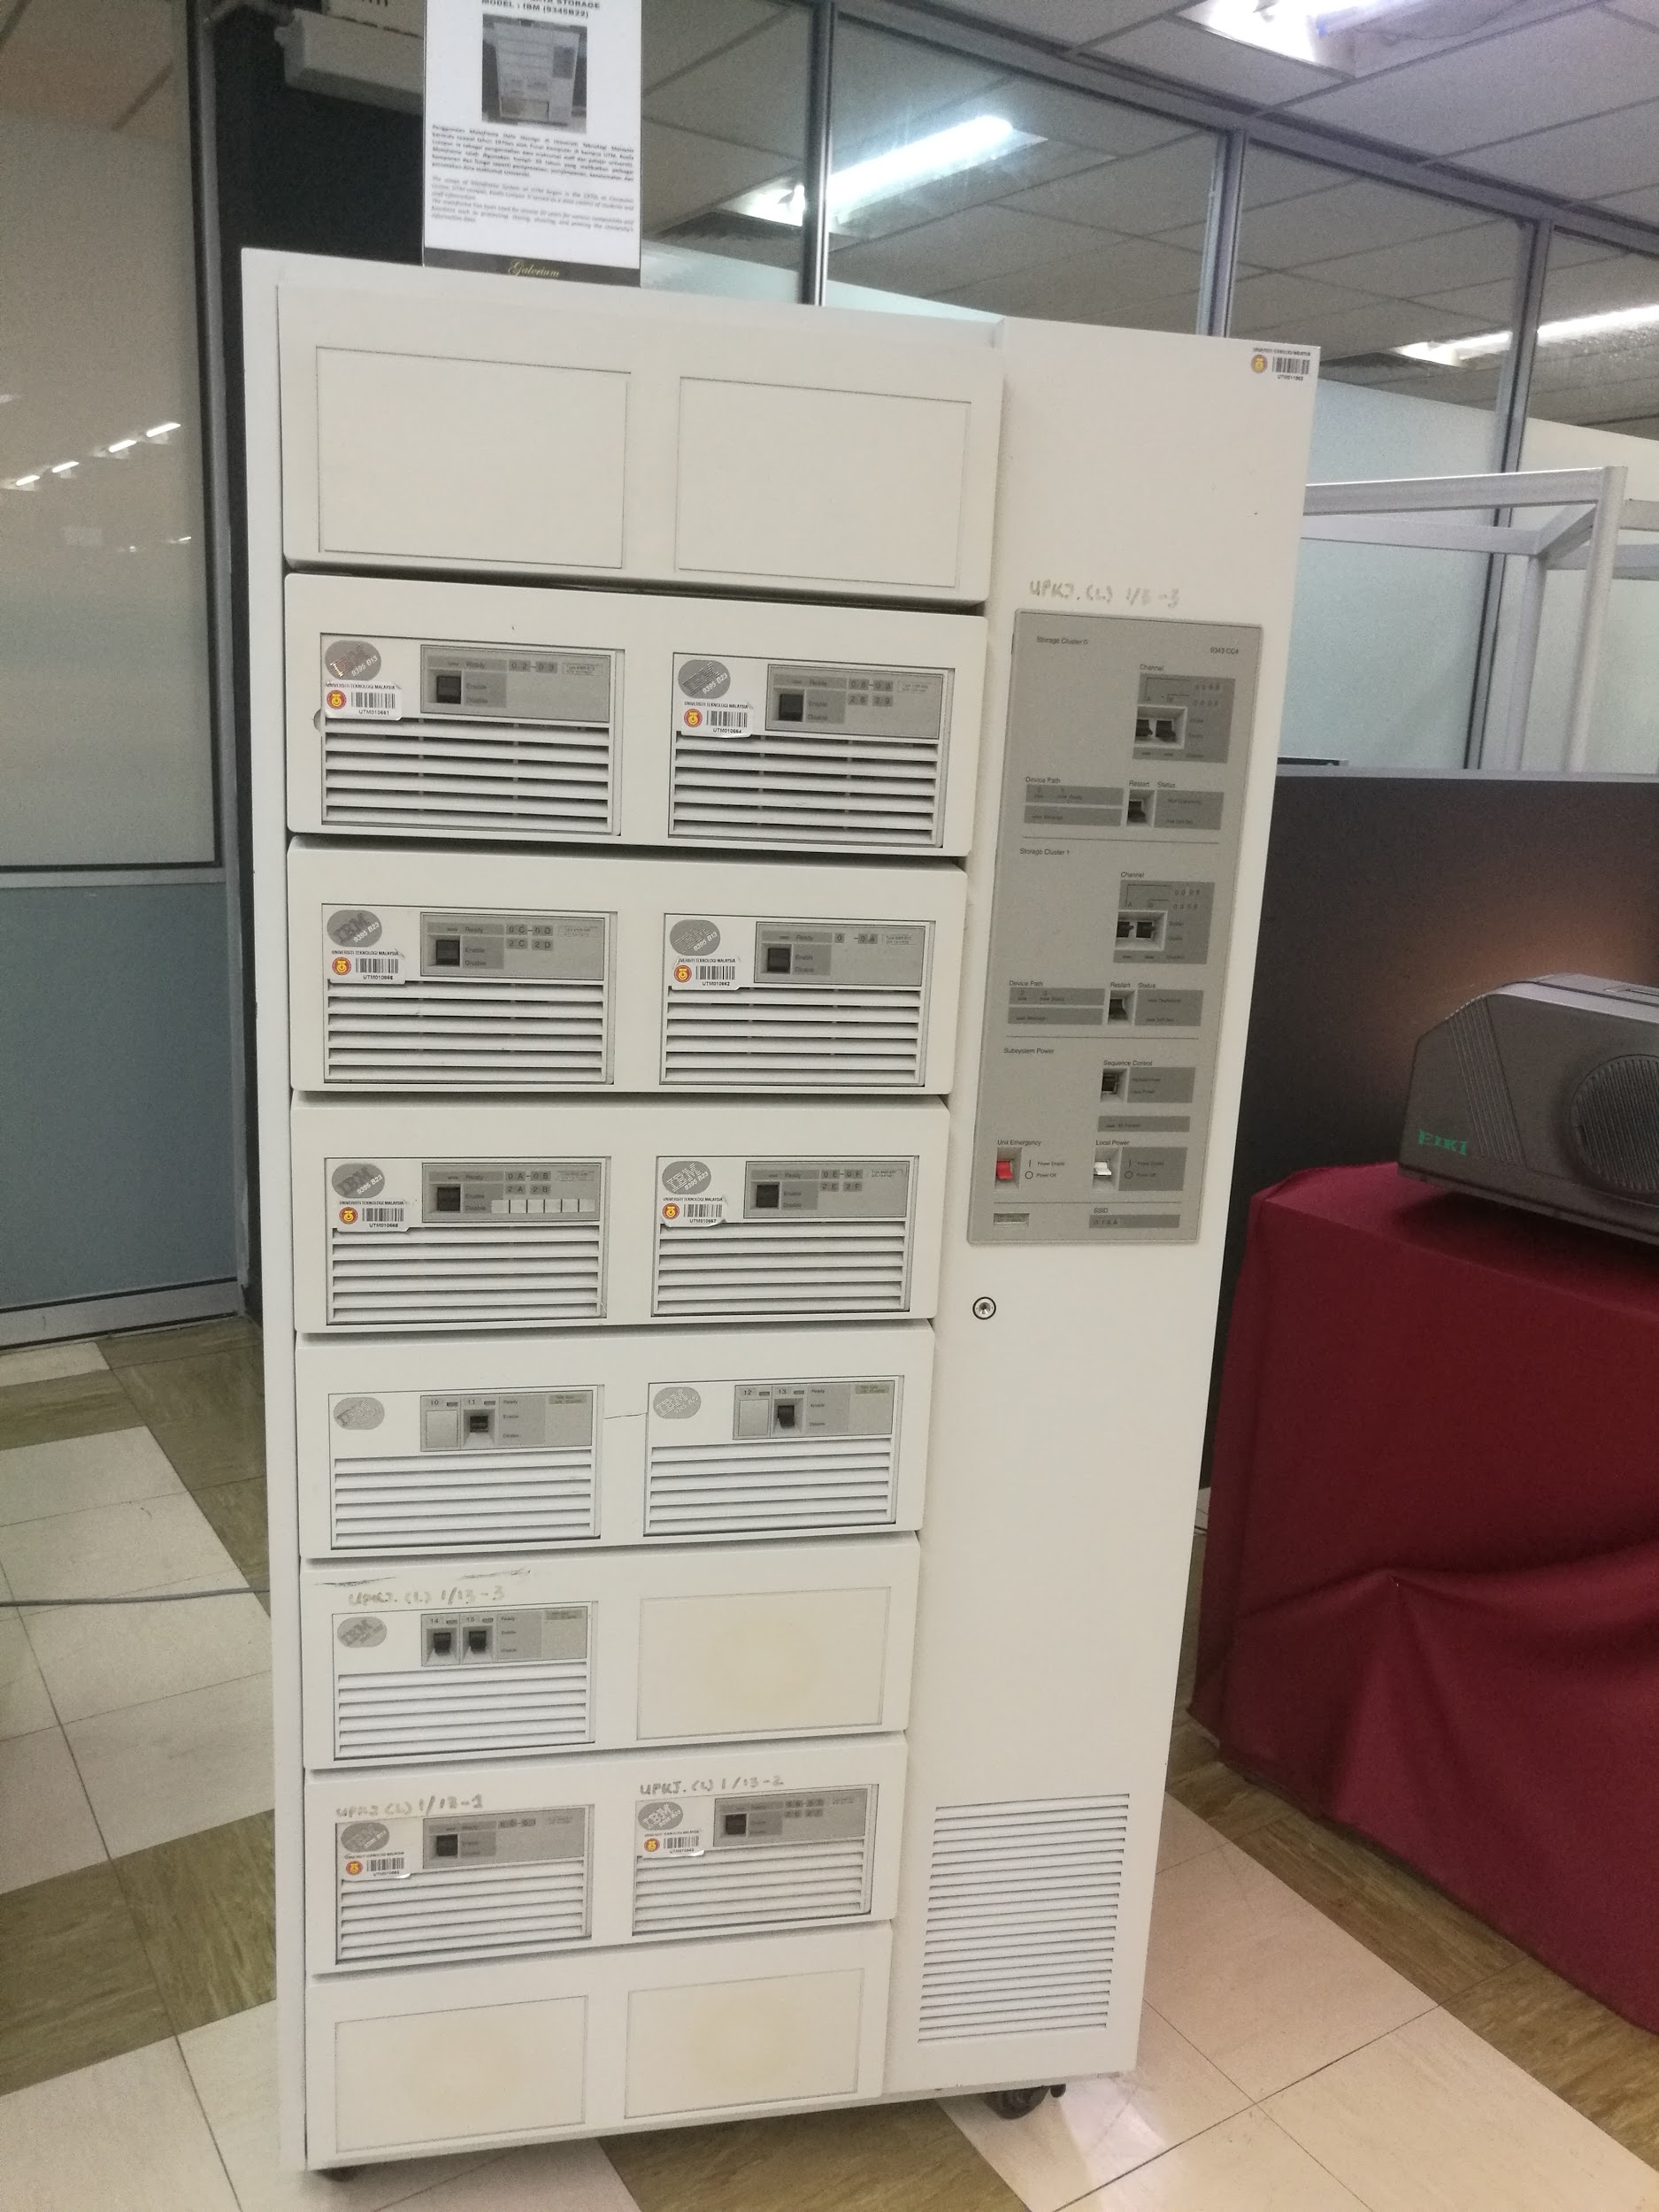
Figure 3.3: Mainframe Data Storage

The second mainframe was the data storage mainframe. The model that Mr Zahari had shown to us was the IBM (9345B22) model which had helped UTM in terms of data control of students and staff information. The usage began in the year of 1970s at UTM Kuala Lumpur Computer Centre. The mainframe has been used for almost 20 years for various components and functions such as processing, storing, securing and printing the university’s data. Starting from the year 2000, the need for data storage has widely spread across the globe hence the capacity of data storage has been increased for us too.

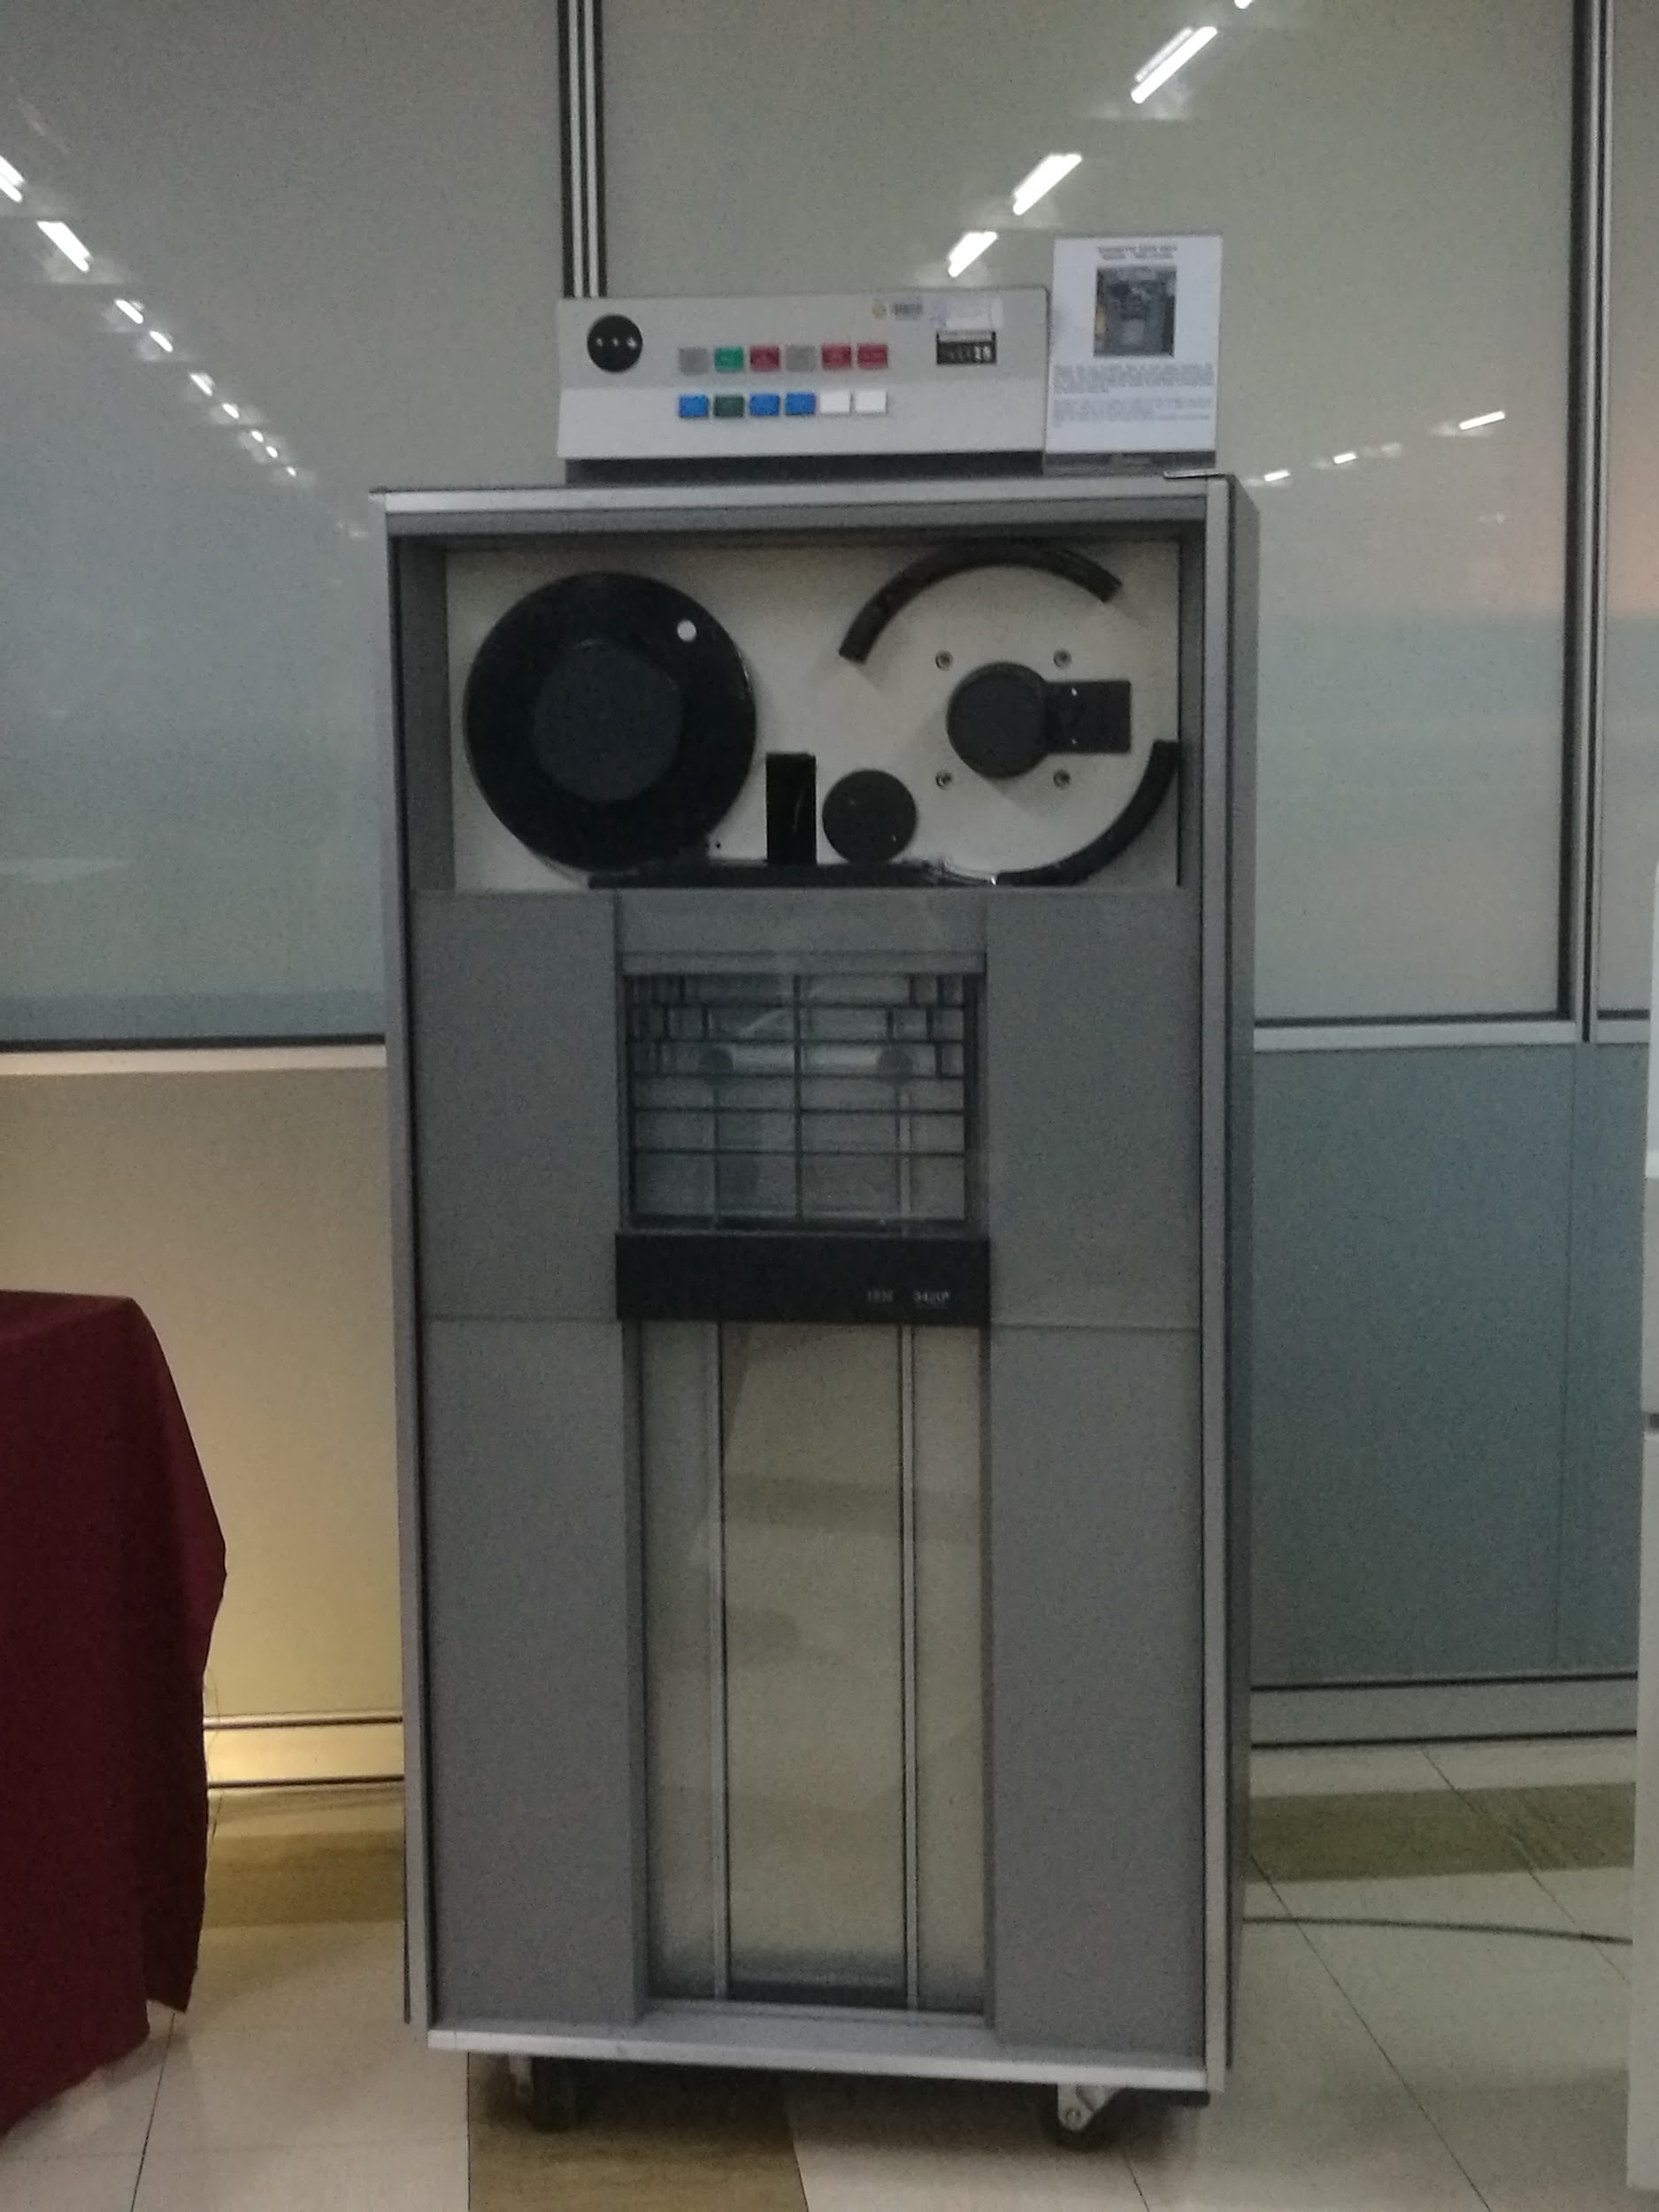
Figure 3.4: Magnetic Tape Unit Model

Before the existence of both of the mainframes, there was the magnetic tape unit model: IBM (3420). It also had the same function as the mainframe tape subsystem which was backing up data but the difference between them was that this model used a round shape tape instead of square tape. Using round shape tape for backing up data involved through a process of digital recording. It was useful for long-term archives.

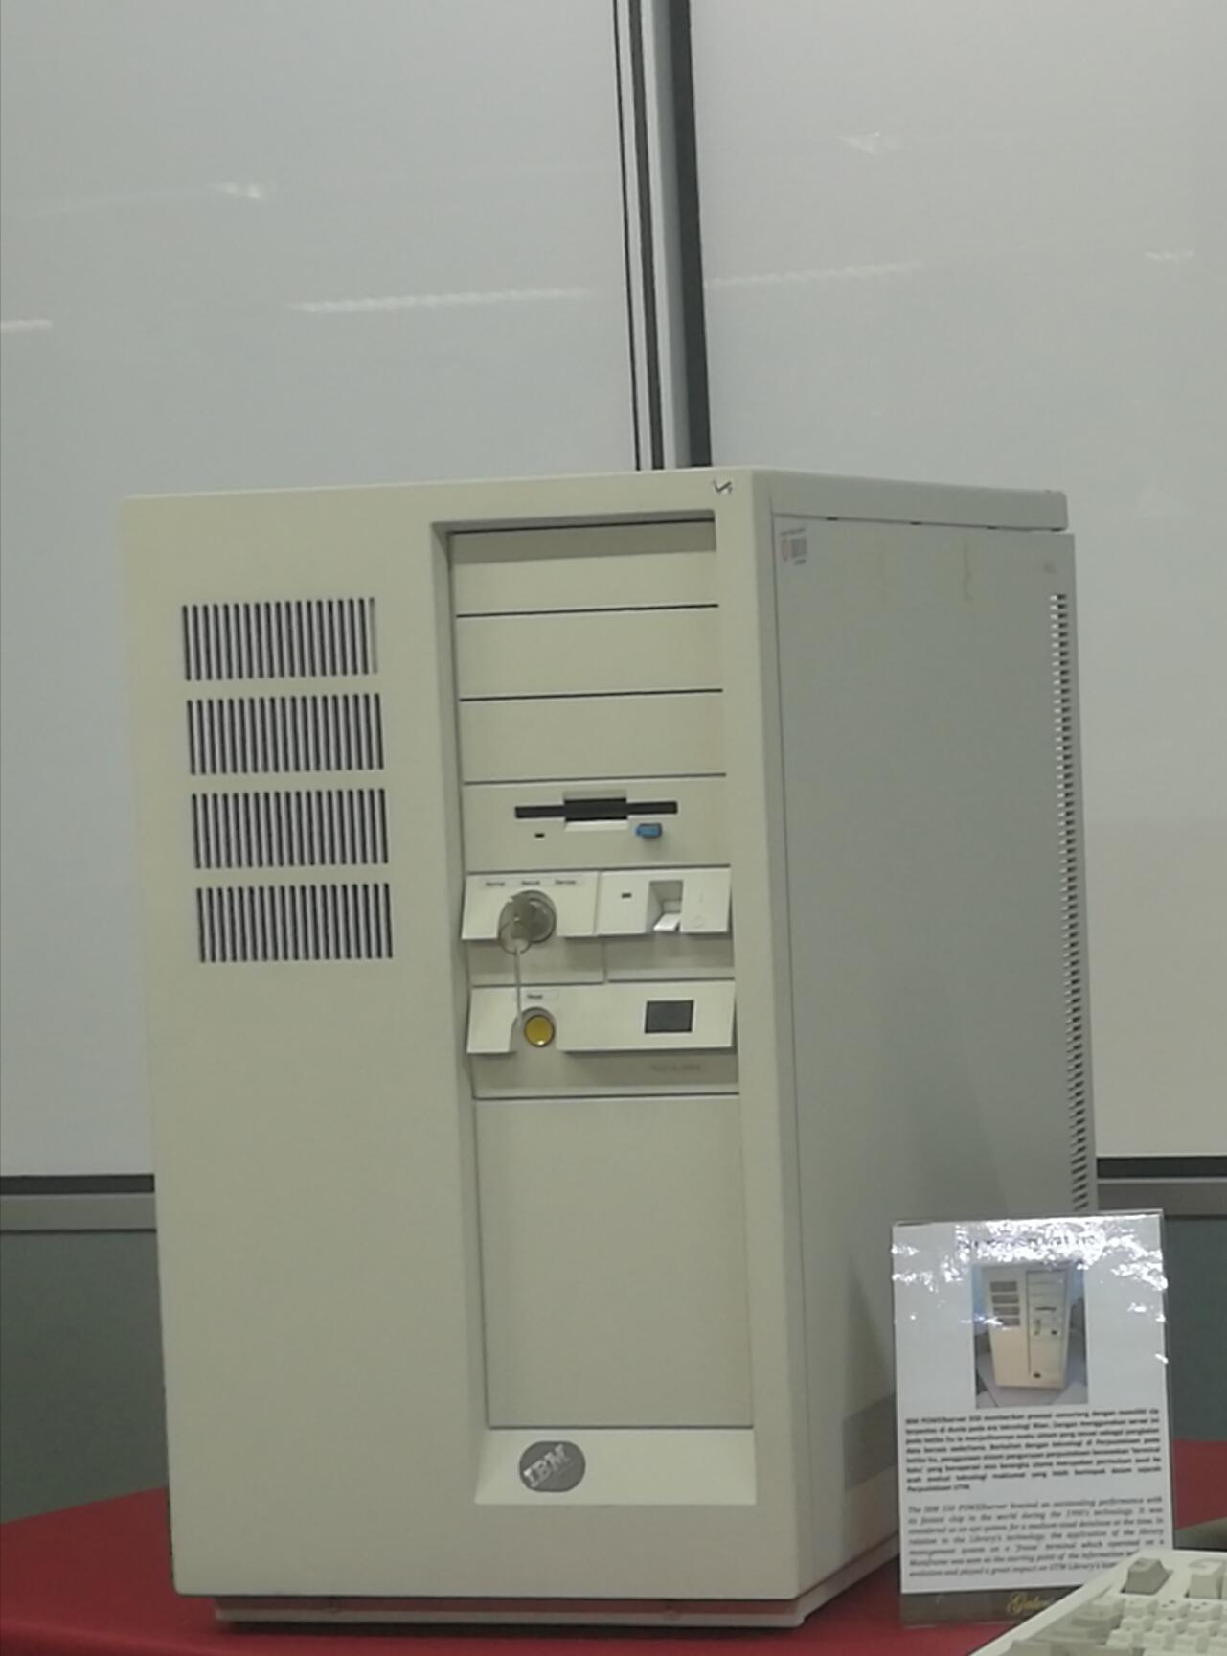
Figure 3.5: IBM Powerserver 550

He has described on the IBM Powerserver 550 as well which related to the mainframes. A server is a computer, a device or a program that is dedicated to managing network resources. (Techopedia.com, 2019)It has given an outstanding performance with its fastest chip in the world during the 1990’s technology. This is because it had been said that it has the ability to update software or hardware without rebooting it, capable for advanced backup of critical data, advanced networking performance, automatic data transfer between devices plus high in resources, data and memory protection. It was considered as an apt system for a medium-sized database at that time. Correlated to the Sultanah Zanariah Library (PSZ), the application of the library management system was on a ‘freeze’ terminal in which it was operated on a mainframe and was seen as the starting point of the Information Technology evolution, showing great impact to the library’s history.

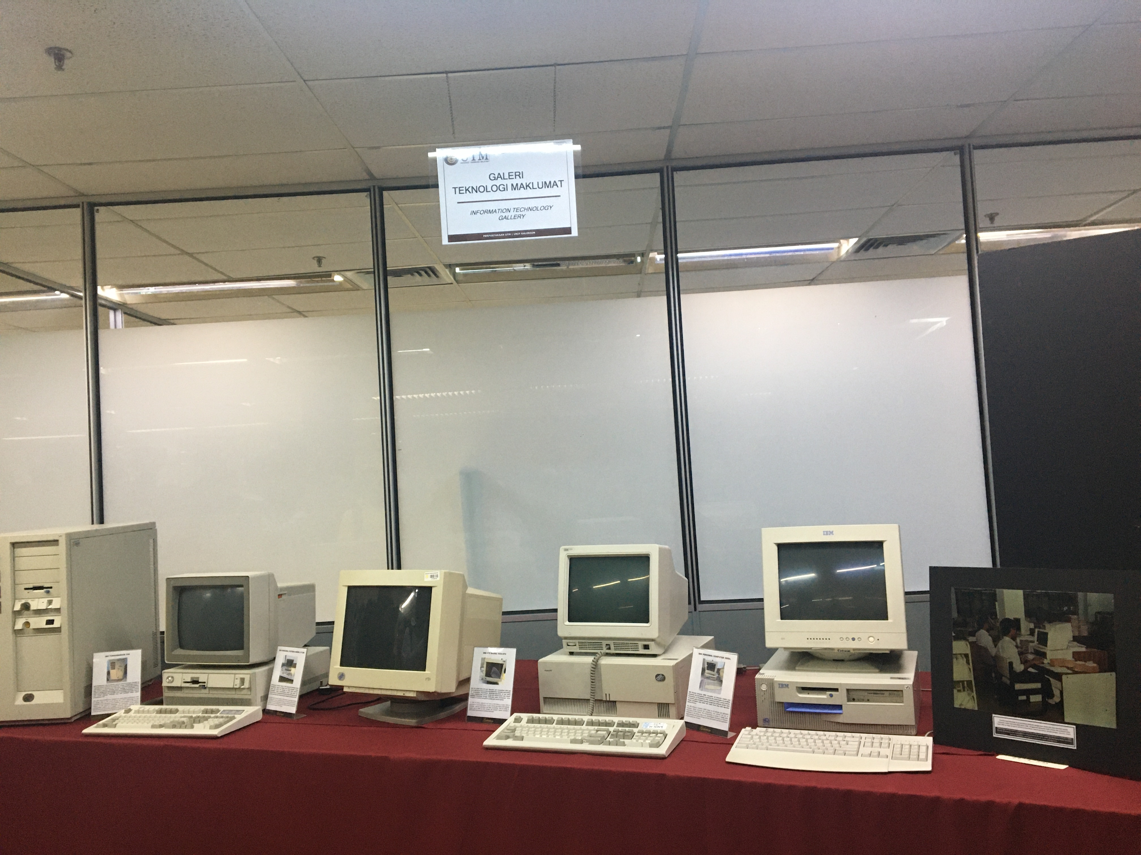
Figure 3.6: Different types of computers
There are a few types of computers displayed in Gallerium. For example, IBM P70 Model 6554-673, IBM Personal Computer 300GL, IBM Personal system/2 model 70 386 and Apple Macintosh Classic Computer.

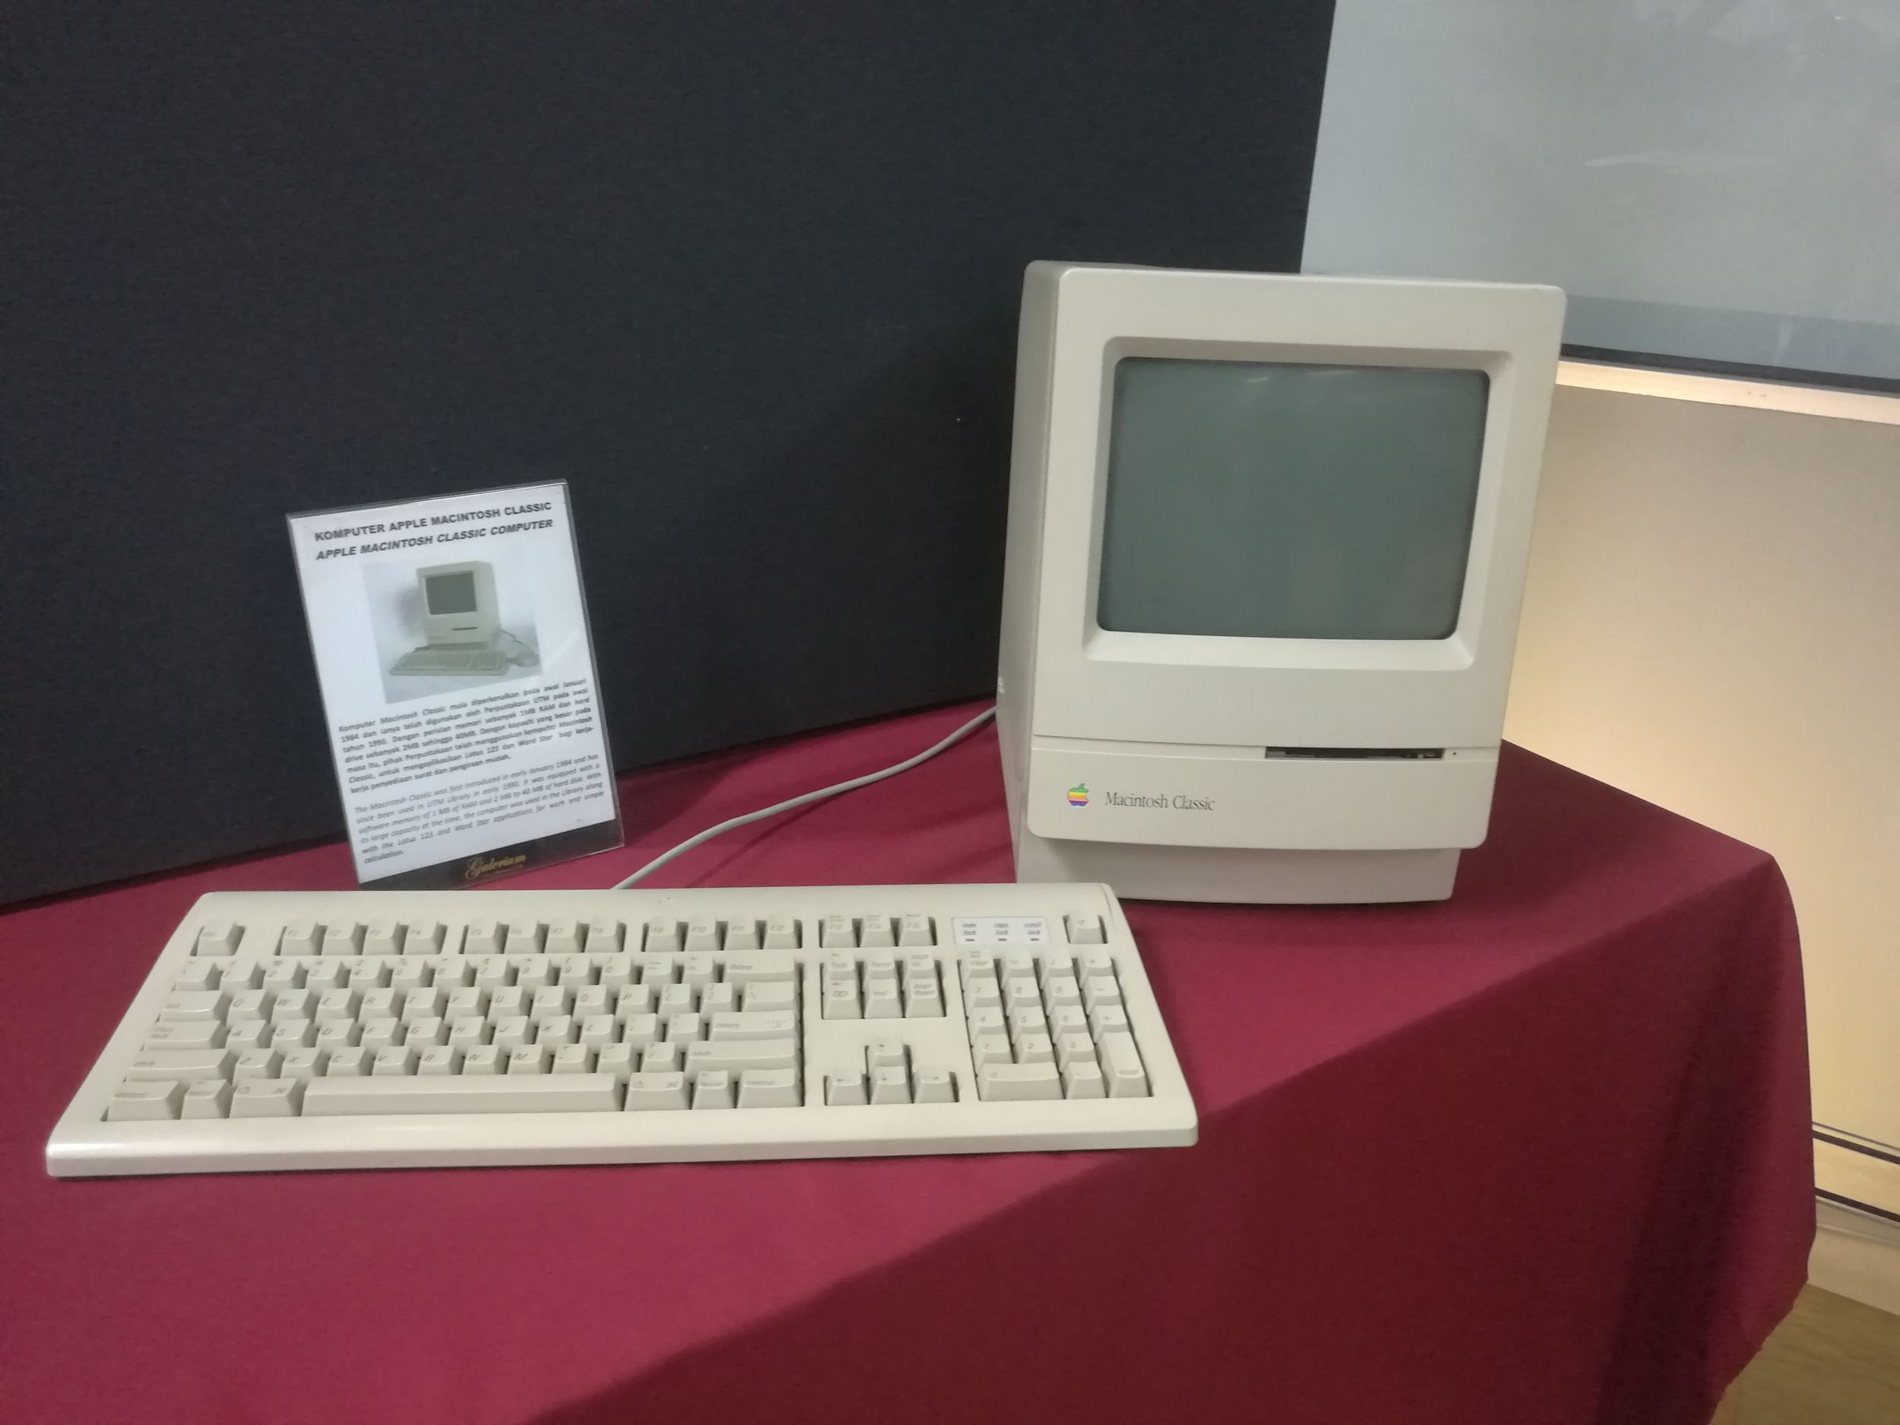
Figure 3.7: Apple Macintosh Classic Computer
Mr Zahari has shown us the Apple Macintosh Classic Computer. In early 1990, this computer was used in UTM and the capacity of this computer is sufficient for usage at that time. The Macintosh Classic was first introduced in early January 19884. It was equipped with a software memory of 1MB of RAM and 2MB to 40MB of the hard disk. The computer was used in the Library along with the Lotus 123 and Word Star application for work and simple calculation.
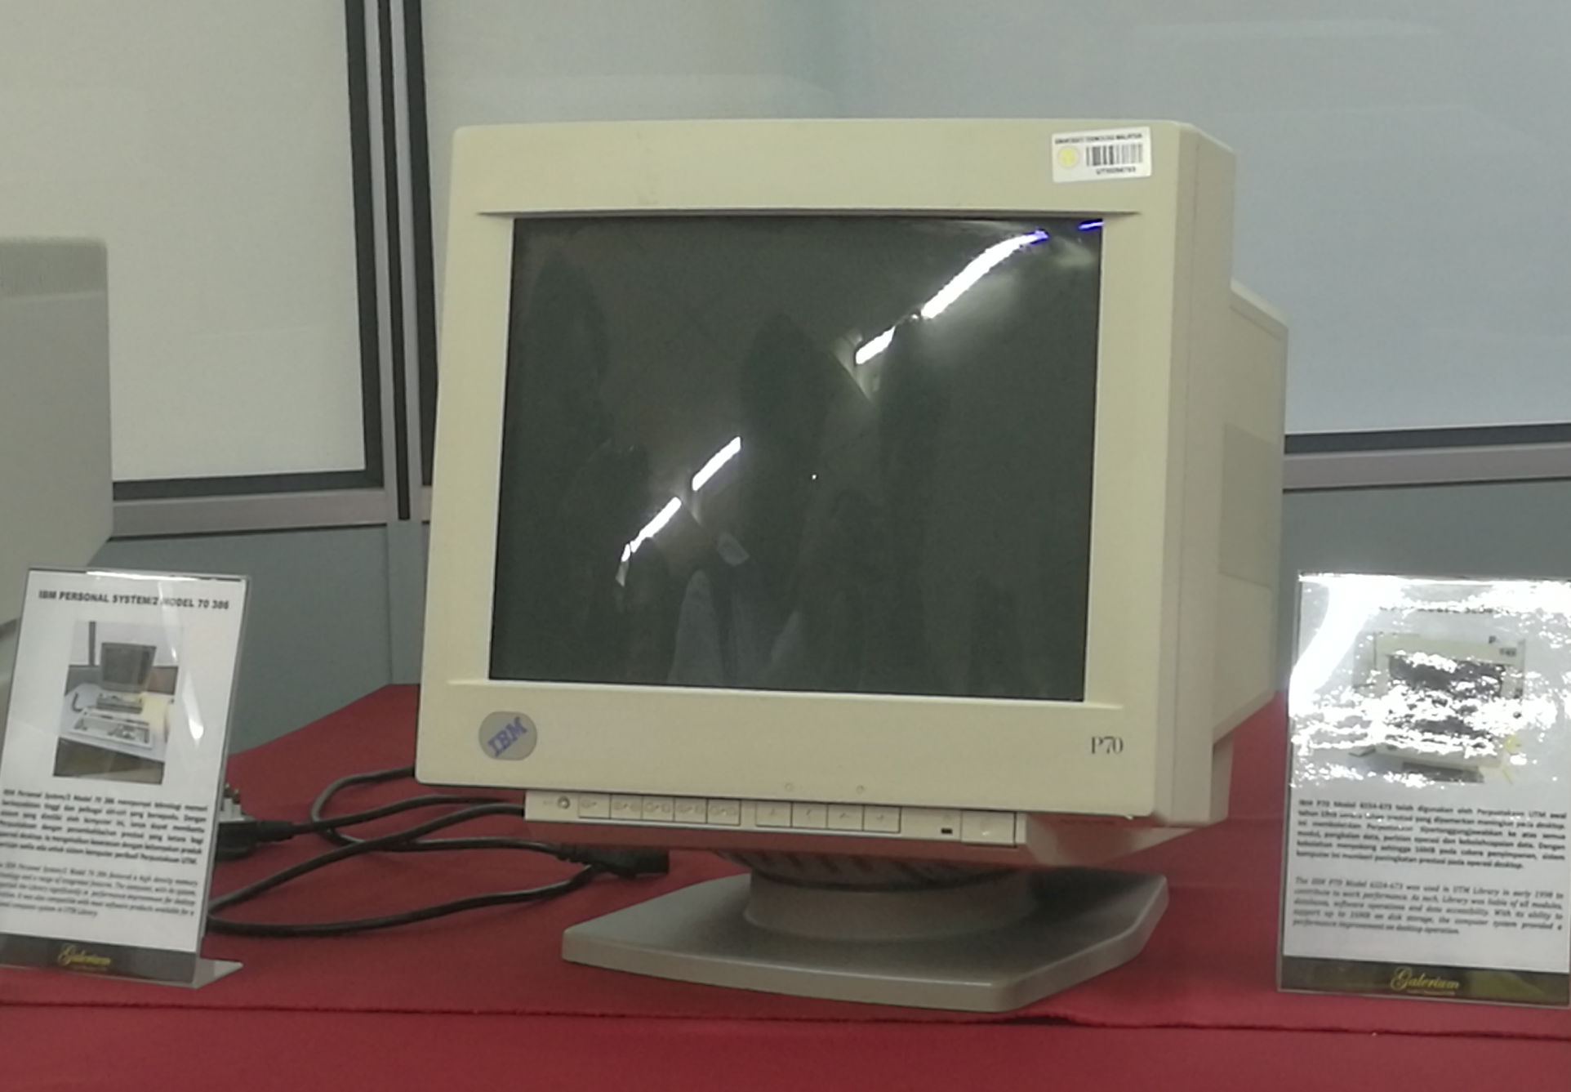
Figure 3.8: IBM P70 Model 6554-673
For the IBM P70 Model 6554-673, this model was used in the library of UTM in early 1998 and contribute to work performance. IBM P70 Model 6554-673 able to support up to 16MB on disk story and the computer system provided a performance improvement on the desktop operation. Library of UTM was liable for all modules, databases, software operation and data accessibility.
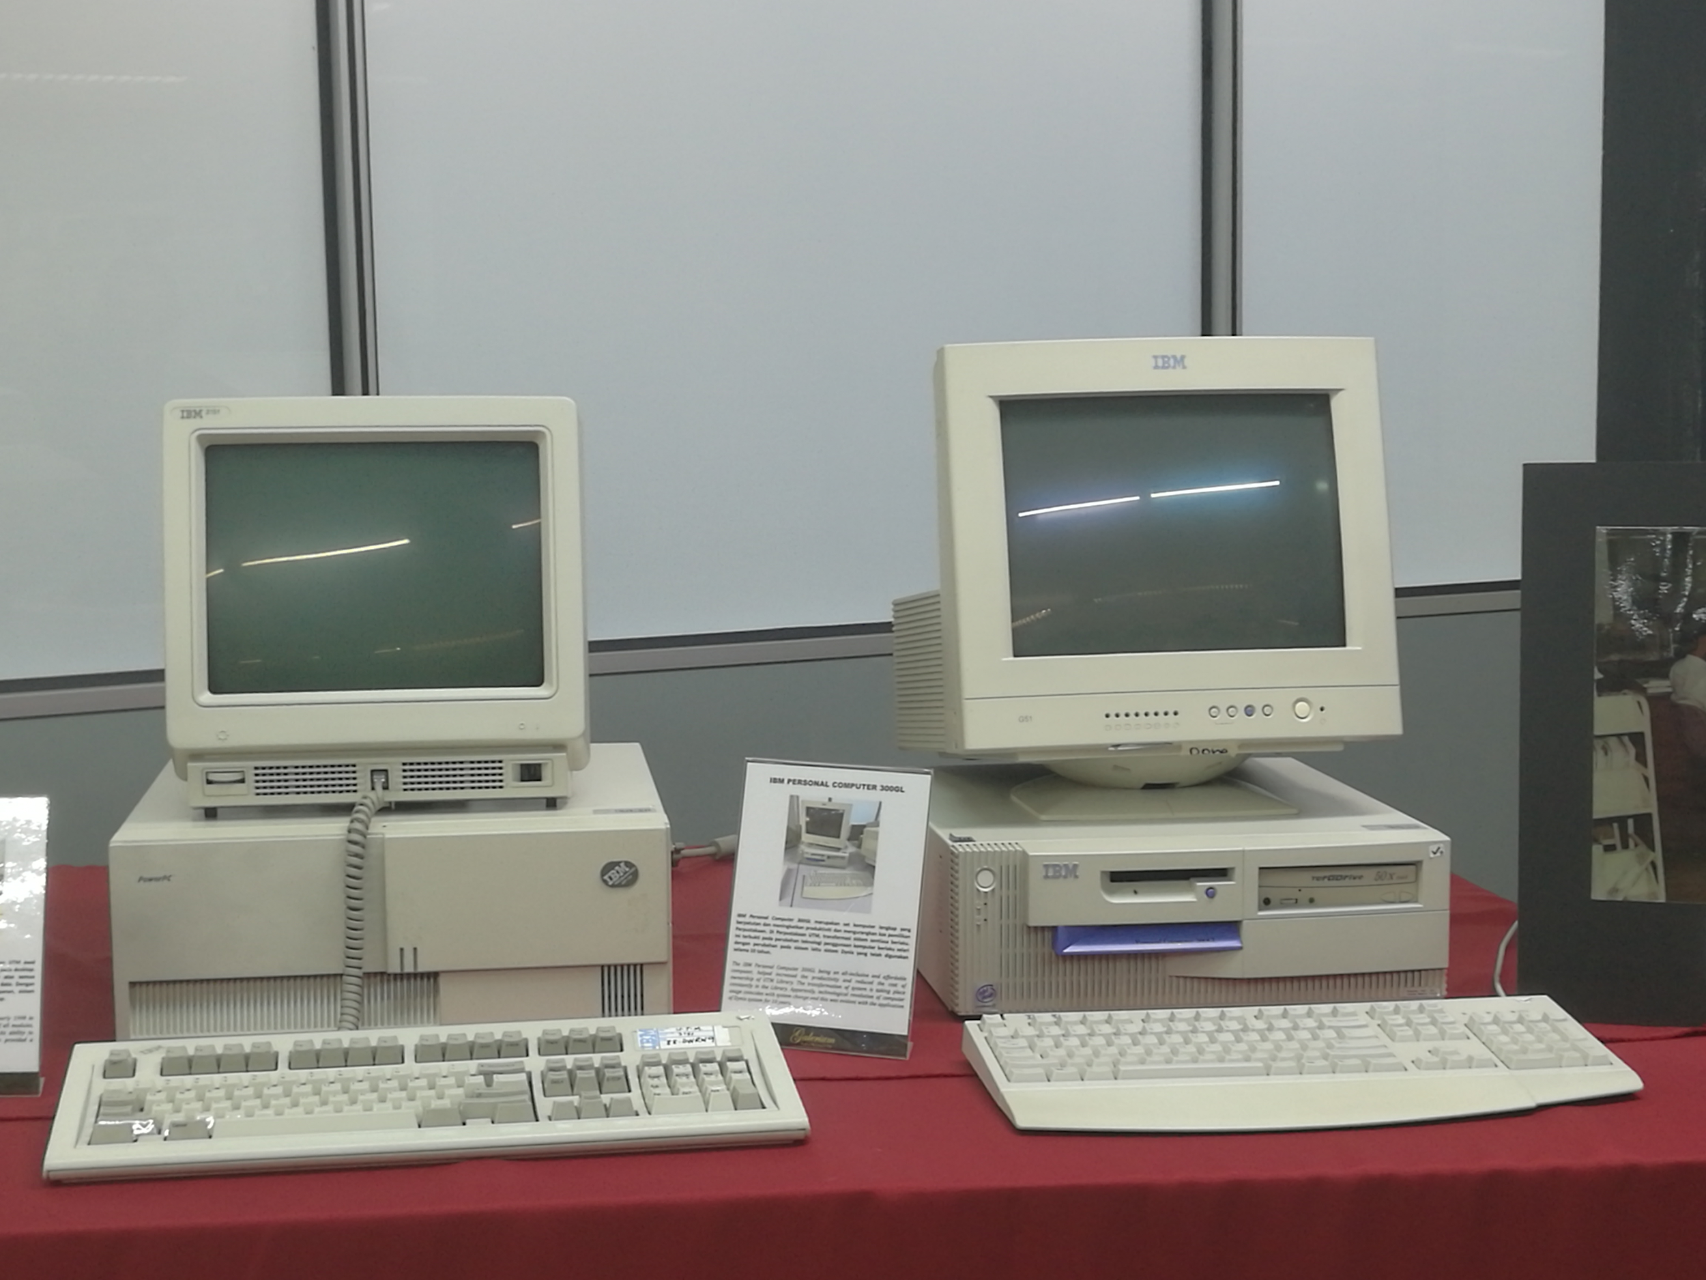
Figure 3.9: IBM Personal Computer 300GL and IBM Personal system/2 model 70 386
IBM Personal Computer 300GL is an all-inclusive and affordable computer. It helped the library to increase productivity and reduced the cost of ownership. IBM Personal system/2 model 70 386 featured a high-density memory technology and a range of integrated features. It helped the library significantly in performance improvement for desktop operation. It was also compatible with most software products available for a personal computer system in UTM Library.
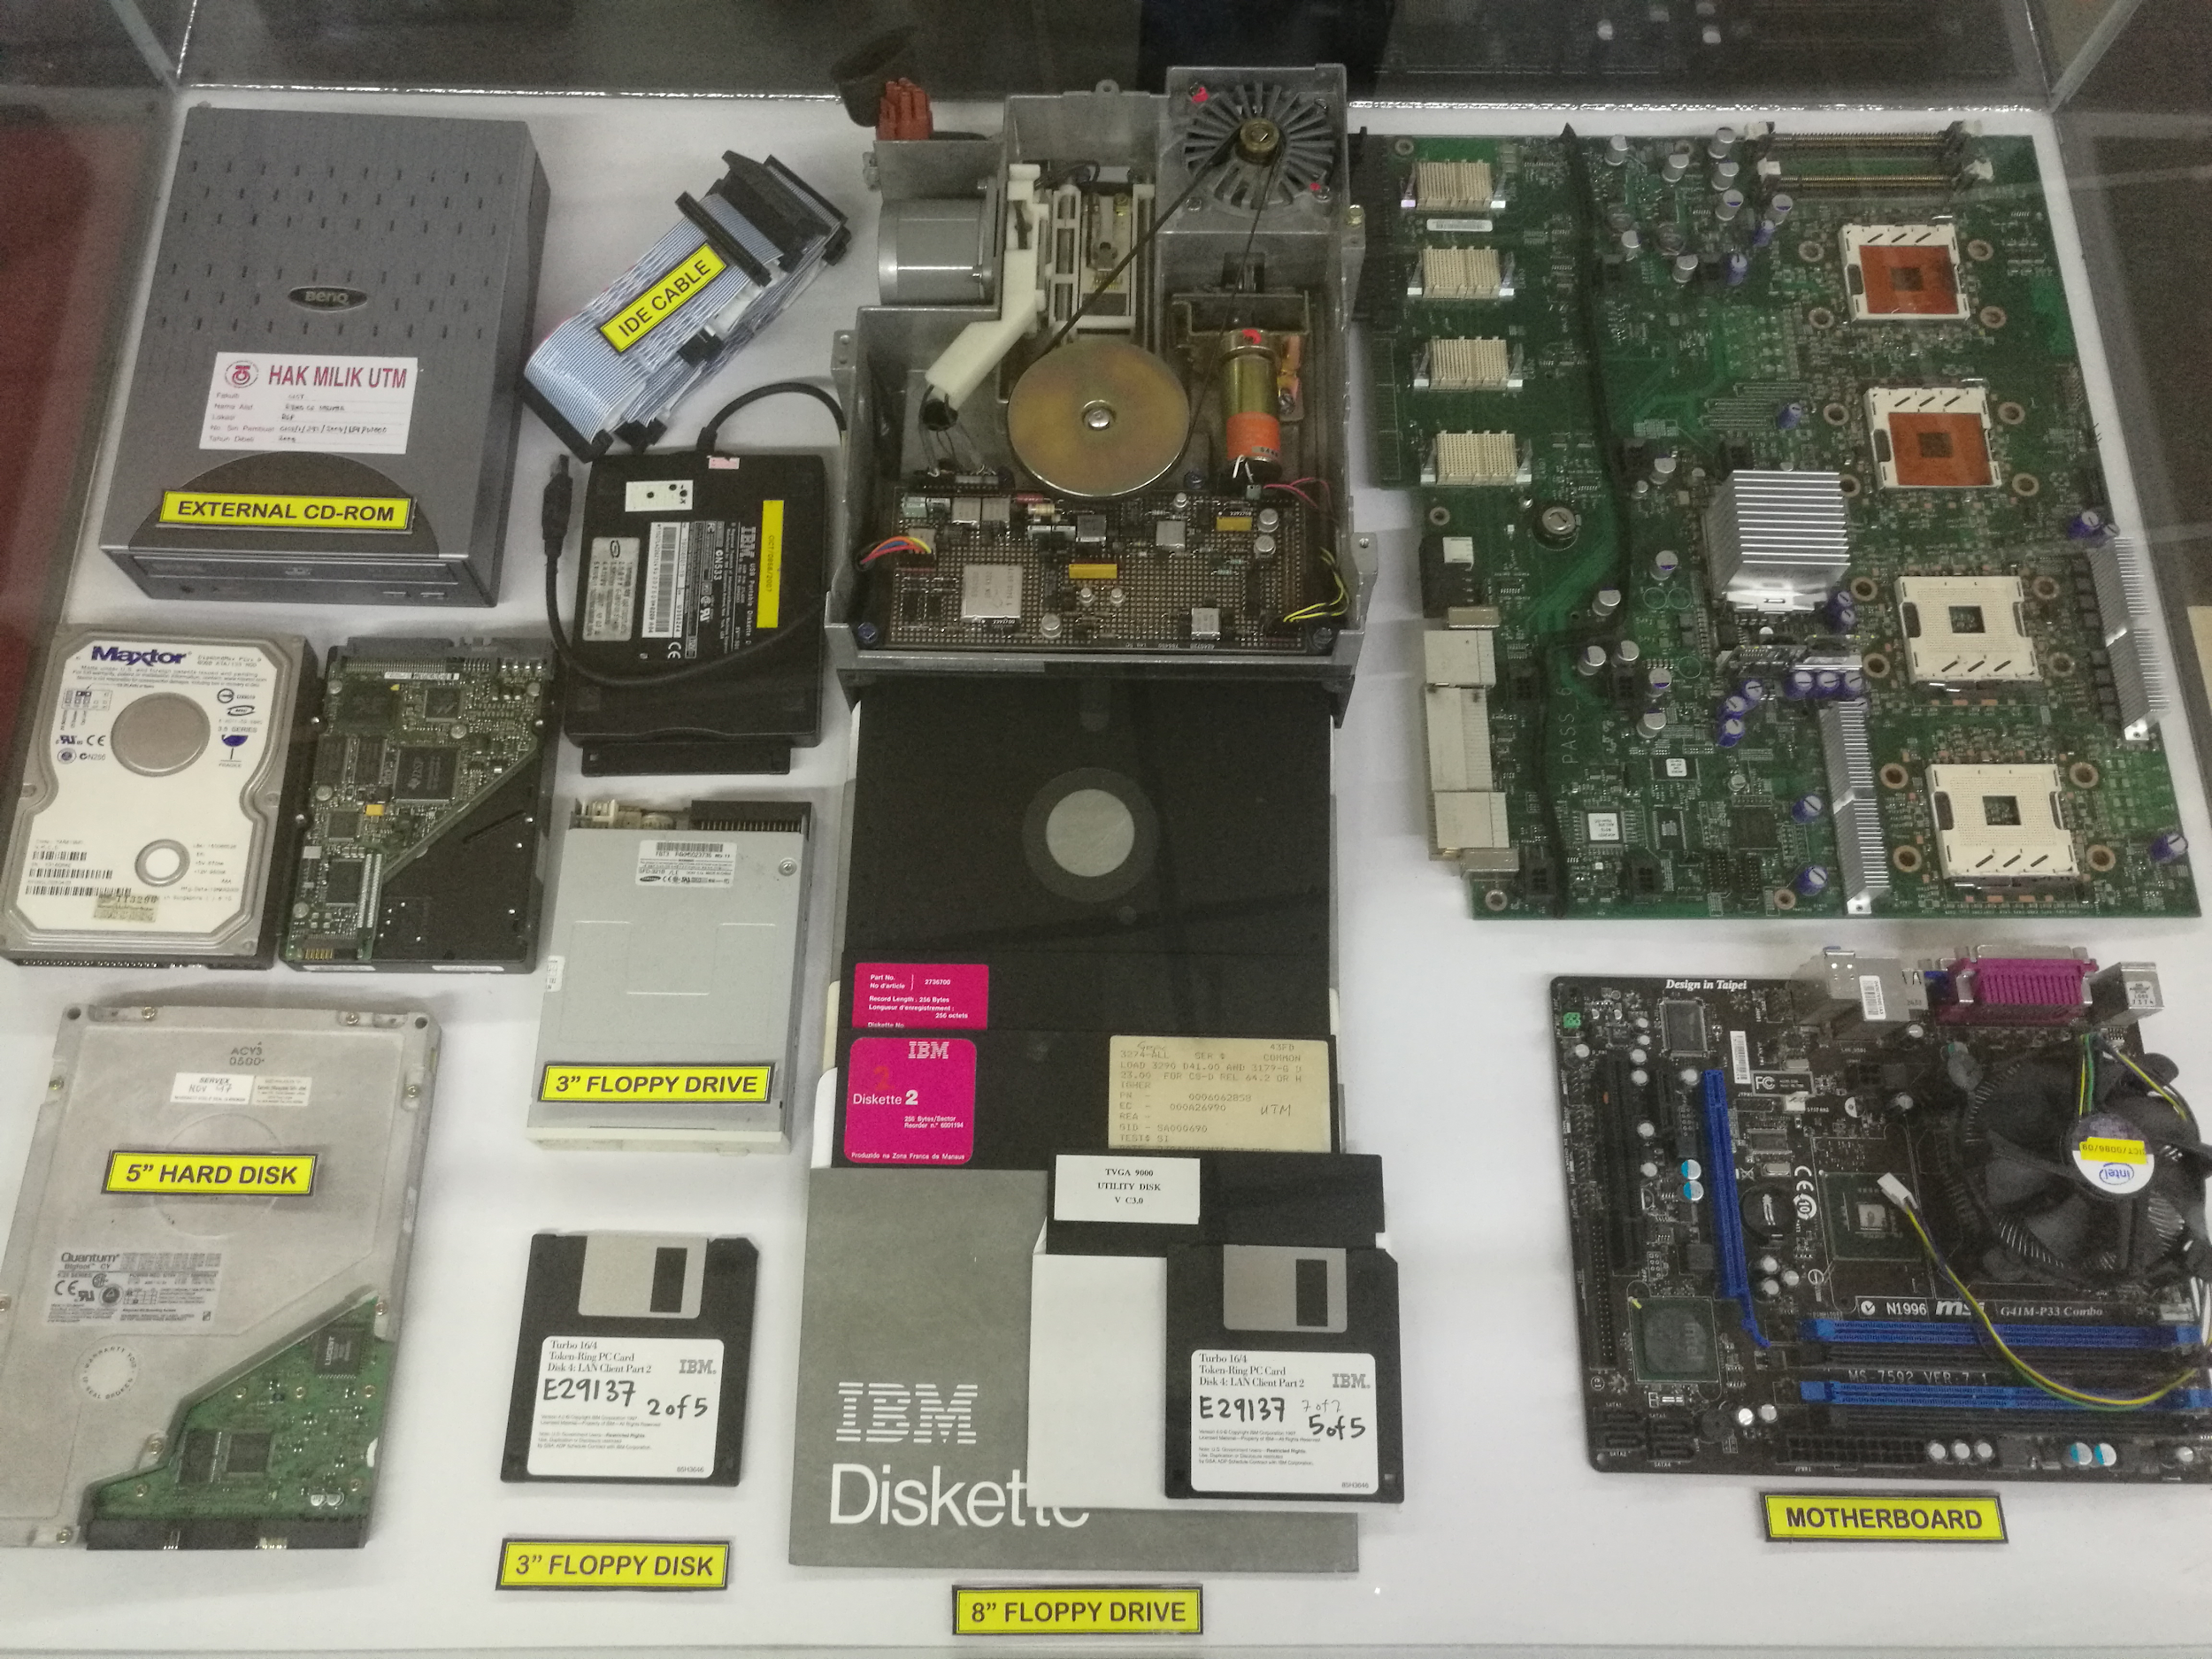
Figure 3.10: Motherboard, Floppy Drive, Floppy Disk, Hard-disk, External CD-ROM Drive, and IDE Cable
Next, Mr Zahari has also introduced to us the motherboard, floppy drive, floppy disk, hard-disk, external CD-ROM drive, and IDE cable. A motherboard is the most important component in a computer. (Computerhope.com, 2019) A motherboard is the main printed circuit board (PCB) found in general-purpose computers and other expandable systems.(Study.com, 2019) The motherboard holds together the Central Processing Unit(CPU), memory, and peripherals. (Study.com, 2019)There are a lot of components in a motherboard such as BIOS, diode, cache memory, fuse, electrolytic, dip switches and so on. All of these components were implanted on a thin film of non-conductive material with a thin layer of aluminium or copper on it. The function of the motherboard is to provide an electrical connection of its components and also the Central Processing Unit(CPU) plus hosts its subsystem. Floppy drive which described as a diskette drive is used to allow the user to read and write on a removable floppy disk. Floppy drive is a type of hardware device used to read the data storage. For the floppy drive, it has a lot of sizes such as 8 inches and 3 inches. Floppy disk is also known as diskette which a square design. There is also a 3-inches floppy disk. The function of a floppy disk is to store, process and transfer data. The floppy disk is read and written by using the floppy drive. The external CD-ROM drive which is known as External Compact Disc Read-Only Memory Drive is used to read the data stored in a CD. IDE cable is an interface that used to connect the Central Processing Unit(CPU) to a storage device.
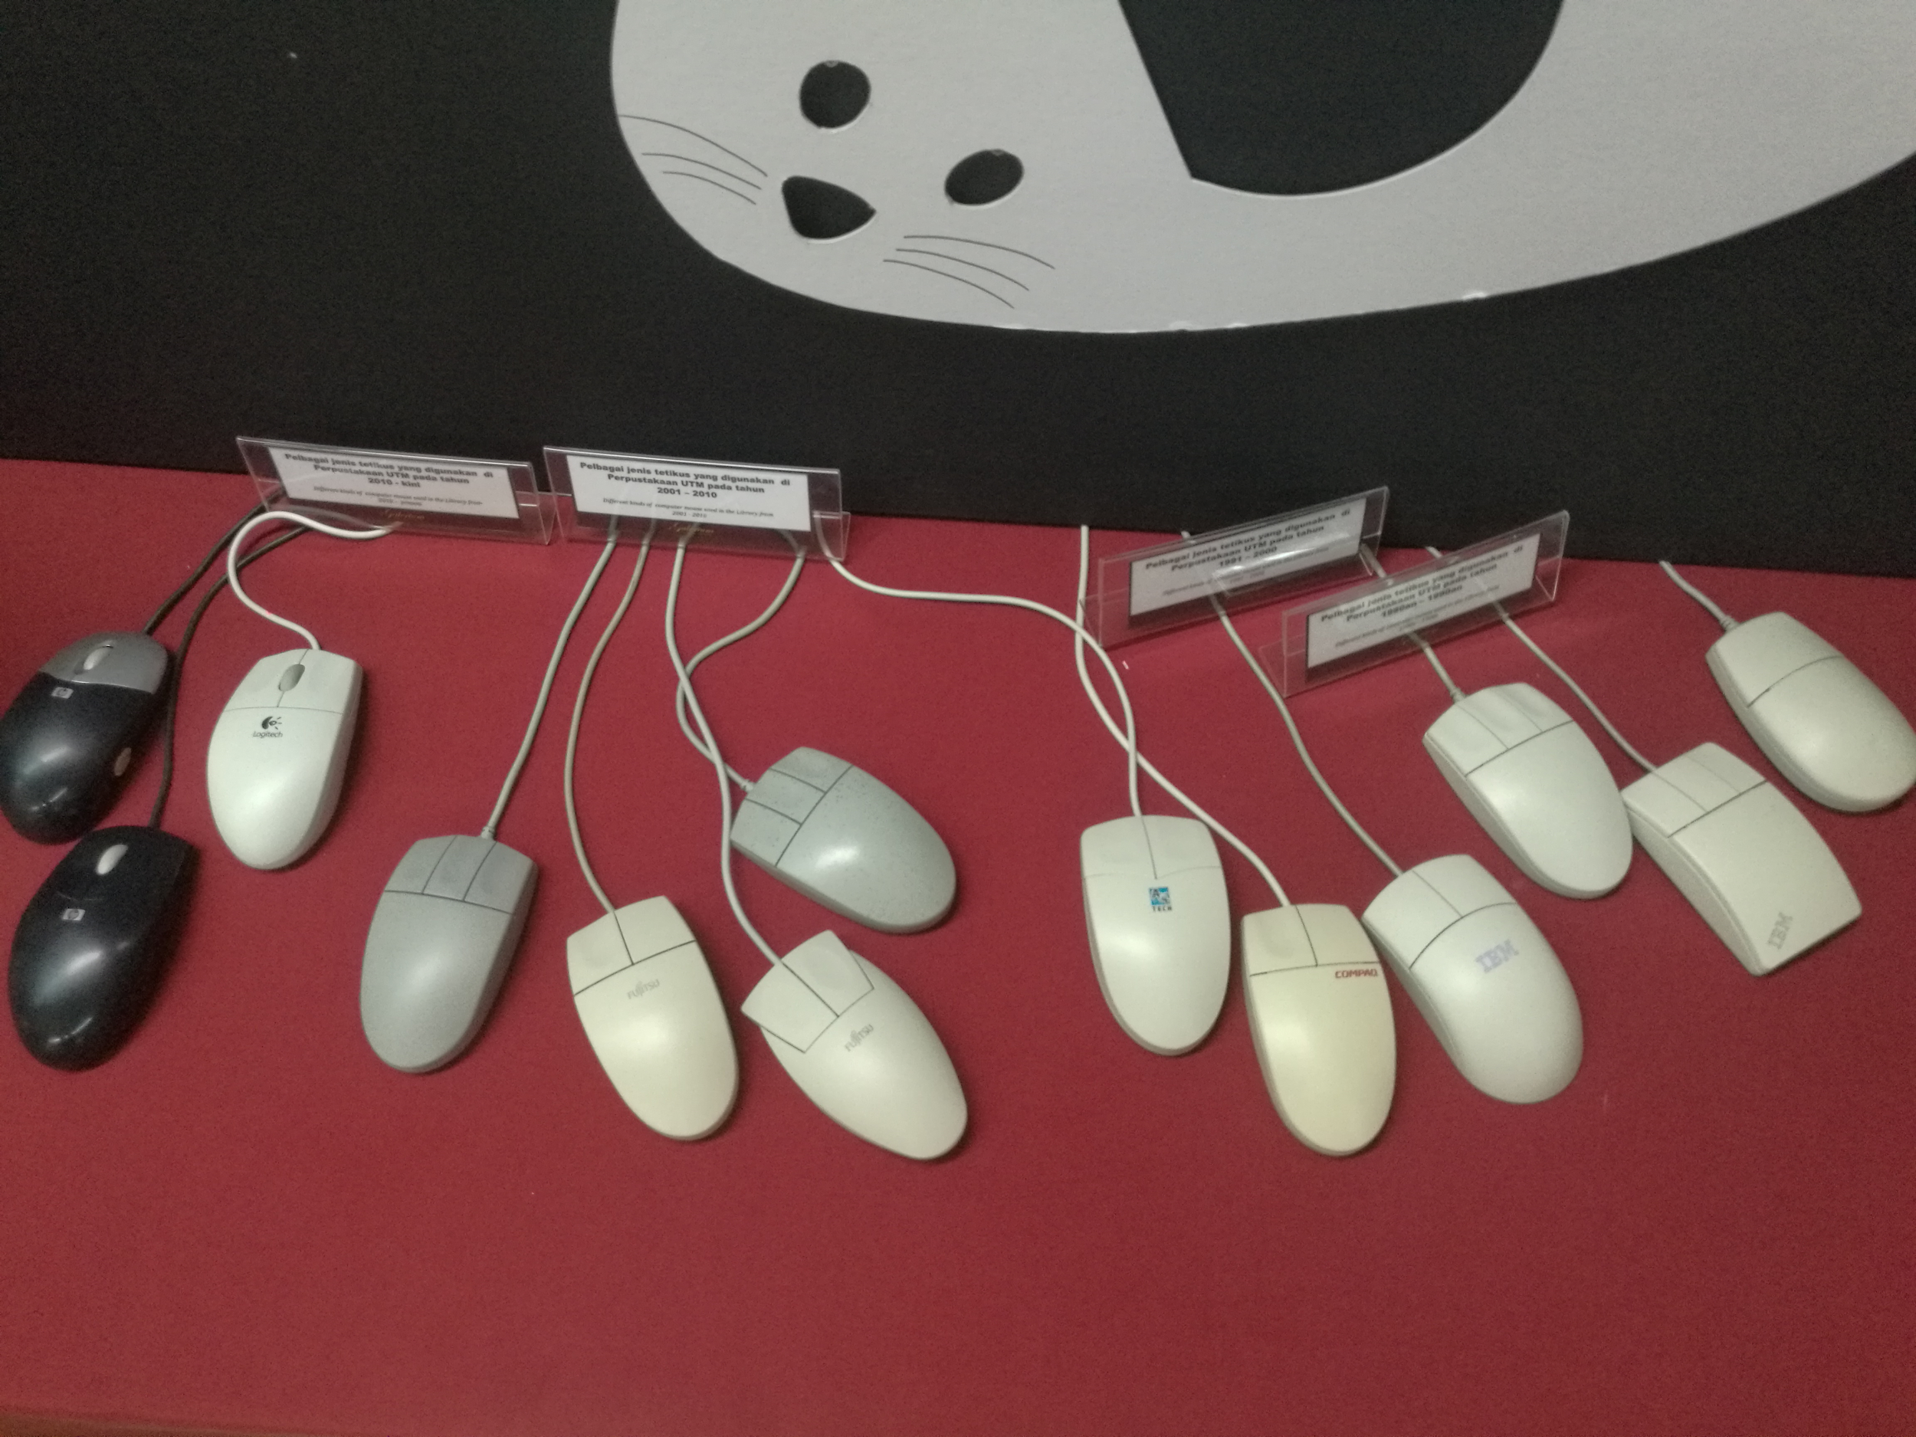
Figure 3.10: Different kinds of computer mouses
In galerium, there are different kinds of computer mouse used from the 1980s-1990s, 1991-2000, 2001-2010 and 2010-present. During the period of the 1980s-1990s, the brand of the computer mouse was IBM while the brand of the computer mouse was COMPAQ from the 1991s-2000s. For the period of 2001-2010, the brands of computer mouse were Fujitsu and A4 Tech. From 2010 until now, the brands of computer mouse used in the UTM Library are Logitech and HP.
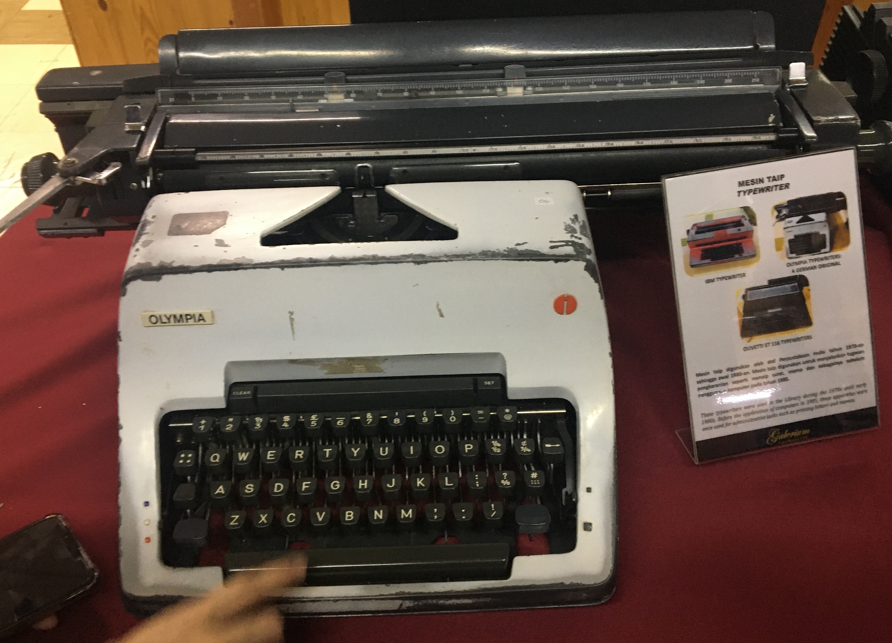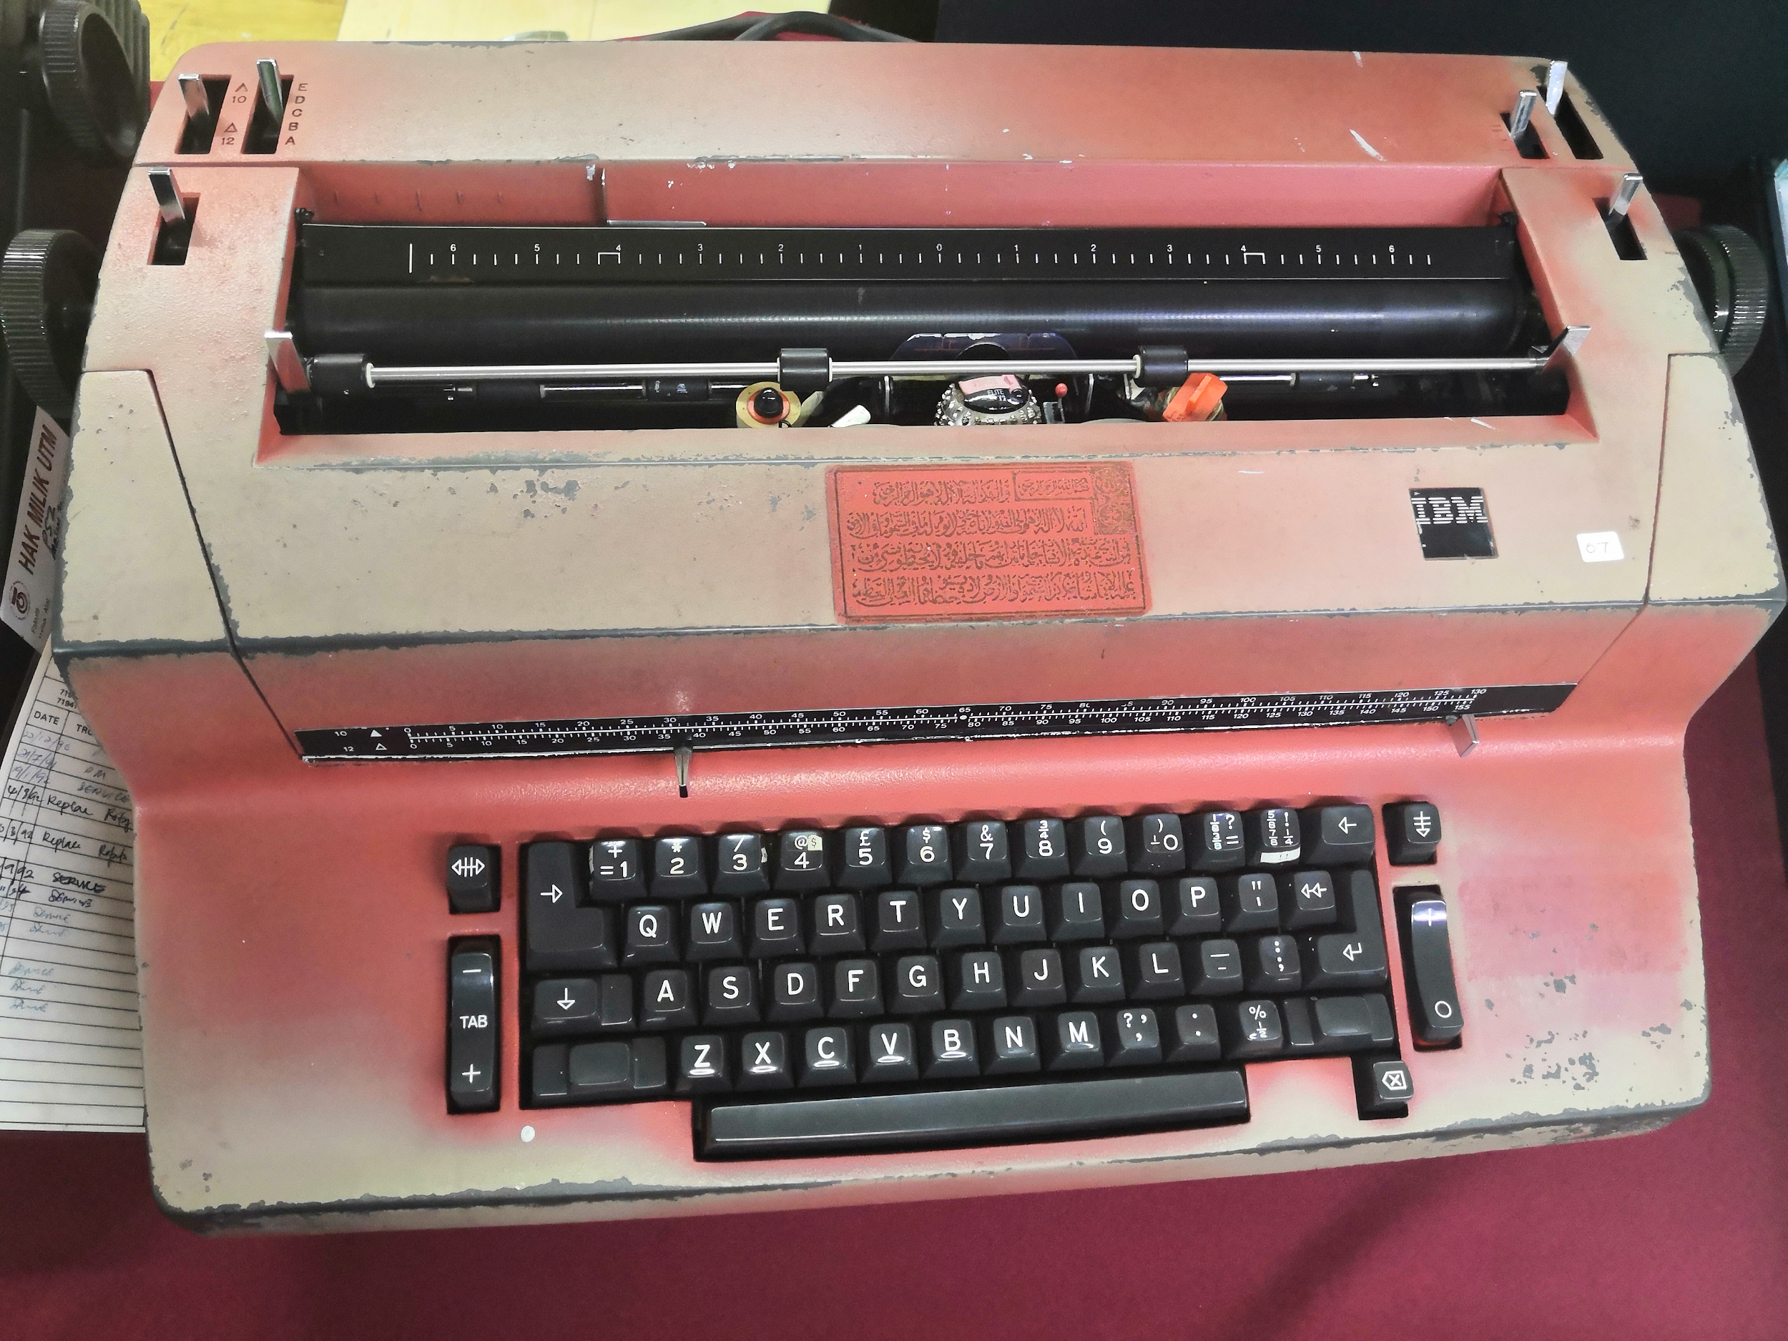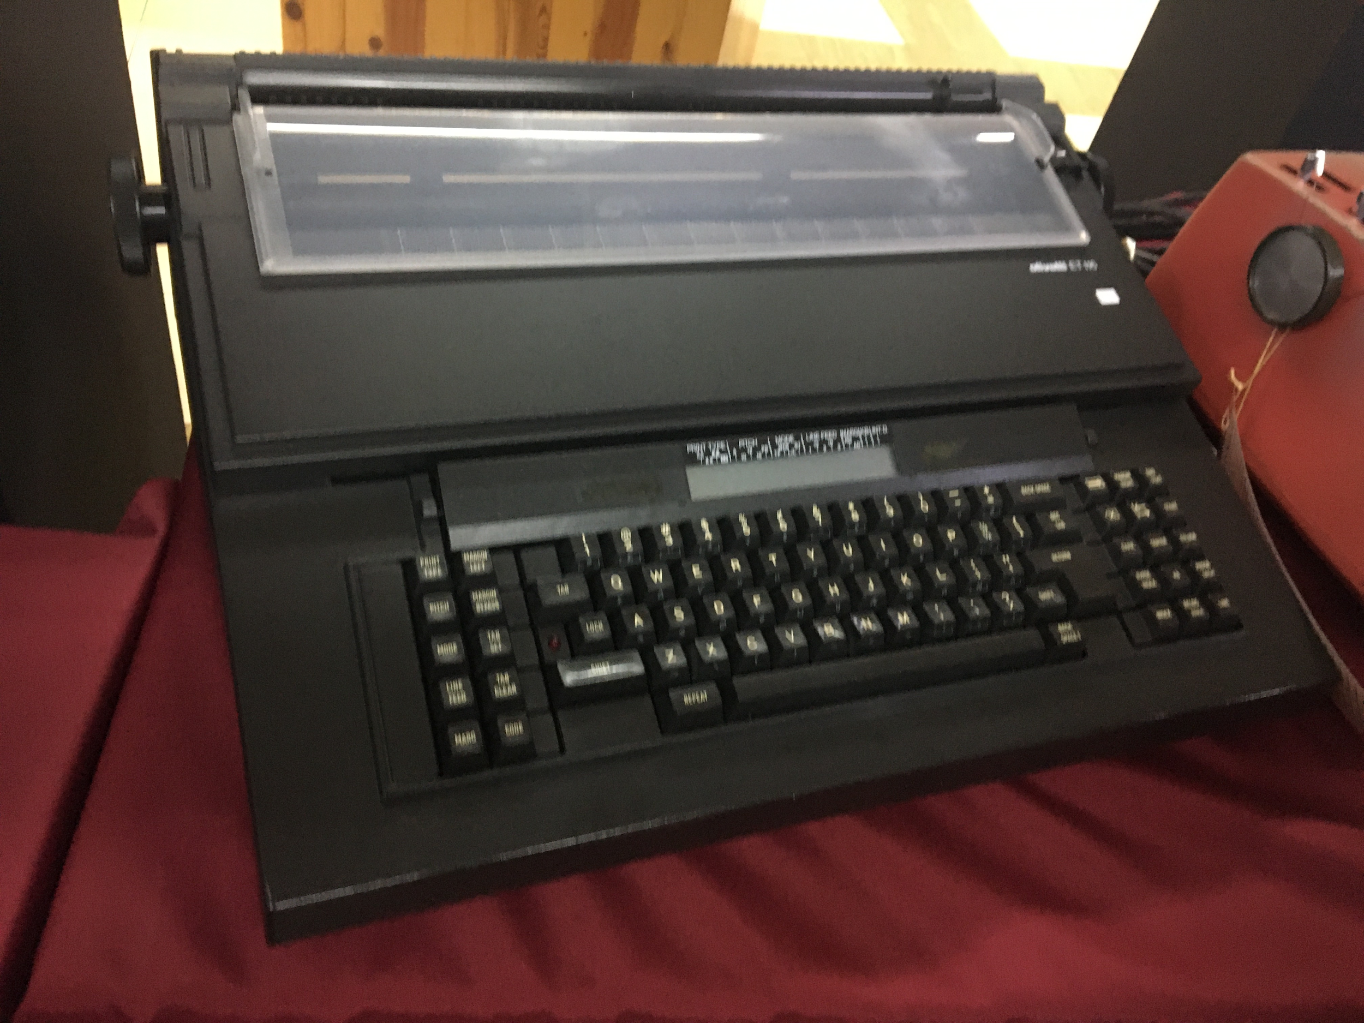
Figure 3.11& Figure 3.12 & Figure 3.13:IBM typewriters, Olympia Typewriters and Olivetti et 116 typewriters
There are 3 types of typewriters which are IBM typewriters, Olympia Typewriters (A German Original) and Olivetti et 116 typewriters show in Galerium UTM. During the timezone in between the 1970s to the early 1980s, these typewriters were used in the library of UTM. These typewriters were used for the purpose of administrative tasks before the application of computers in 1985. For example, printing letters or memos can be done using a typewriter.

- Reflections:
a. What is your goal/dream with regard to your course/program?
All of our group members desired to have a career related to our course such as a computer graphic designer, game developer or a multimedia programmer. Our target towards this type of career selection is the main motivation which drives us to choose this course as our main field of study in order to achieve our dream career for our future so that we can work happily with interest.

b. How does this visit impact on your goal/dream with regard to your program?
This visit provides us with the knowledge of history on how the computing world develop from the era that we have not even born yet, till now. Through this visit, we knew that the computing world is always developing and becoming better day by day. We also have learned about the system or components that have been used in the past. Therefore, we will have more appreciation towards the modern technologies and computing components that we are using now. This also motivates us to not just focus solely on our field of study, but also to think critically and creatively on how to improve and improvise the computing component existing now to something better, which can benefit us to study or work more efficiently in our field of expertise which is computing.

c. What is the action/improvement/plan necessary for you to improve your potential in the industry?
After this visit, we have come to a realization that we need to not just focus solely on improving our programming skills and gaining more knowledge in graphics and multimedia software, but we also need to think and care more about the development of the current technology and if possible, contribute in making the computing components nowadays to become better and more advanced. Having this realization gives us an advantage as we do not just limit ourself and our knowledge to a certain field, but also to know more about the information which can help to improve our experience in working or studying to make our life, study and work become more efficient and effective.
- Task for each member

Members | Task
Chai Ming Choy | - Reflections  - Introduction
Wan Nur Atiqah binti Junaidi | - Detailed descriptions
Goh Jo Ey | - Detailed descriptions
Zaimi Mohamed | - Details of visit  - Introduction
All | - Check overall work  - Add on for any other parts

- References:

- Aspg.com. (2019). What to know about mainframe storage media - Advanced Software Products Group. [online] Available at: http://aspg.com/know-mainframe-storage-media/ [Accessed 25 Oct. 2019].

- Techopedia.com. (2019). What is a Server? - Definition from Techopedia. [online] Available at: https://www.techopedia.com/definition/2282/server [Accessed 25 Oct. 2019].

- Ibm.com. (2019). IBM Archives: IBM Mainframes. [online] Available at: https://www.ibm.com/ibm/history/exhibits/mainframe/mainframe_intro.html [Accessed 25 Oct. 2019].

- Computerhope.com. (2019). What is a Motherboard?. [online] Available at: https://www.computerhope.com/jargon/m/mothboar.htm [Accessed 26 Oct. 2019].

- Study.com. (2019). What is a Motherboard? - Definition, Function & Diagram Video withLessonTranscript|Study.com.[online]Available at: https://study.com/academy/lesson/what-is-a-motherboard-definition-function-diagram.html [Accessed 26 Oct. 2019].

