TECHNOLOGY INFORMATION SYSTEM (TIS)
SESSION 2019/2020 SEMESTER 1
PROJECT REPORT
INDUSTRIAL VISIT PERPUSTAKAAN SULTANAH ZANARIAH (PSZ)

GROUP 6
AARON RYAN SHAMIKA (A19EC0001)
YU KAH WEI (A19EC0178)
CHONG HONG LEI (A19EC0035)
NUR SYAFRINA BINTI AHMAD (A19EC0139)

LECTURER
DR. SARINA BINTI SULAIMAN

DATE OF VISIT
20TH OCTOBER 2019

DATE OF SUBMISSION
27TH OCTOBER 2019
INTRODUCTION
On Sunday, 20th October 2019,an industrial visit to Information Technology Gallery at Gallerium, Perpustakaan Sultanah Zanariah,Universiti Teknologi Malaysia,81310 Johor Bahru. There are two section visited Gallerium with their TIS lecturer. This industrial visited to know history of computer and its component and also transformation of computer in PSZ. For example, Apple Macintosh Classic Computer has been used in UTM in early 1990.There are several collection of computer in Gallerium like Apple Macintosh Classic Computer, Mainframe Data Storage and IBM Personal Computer 300GL and also its components such as hard disk, floppy drive, motherboard and external CD-ROM. Some of services by Centre for Information and Communication Technology(CICT) are ID Account and Access(ACID) that used by students to log in e-learning portal

ORGANIZATION STRUCTURE
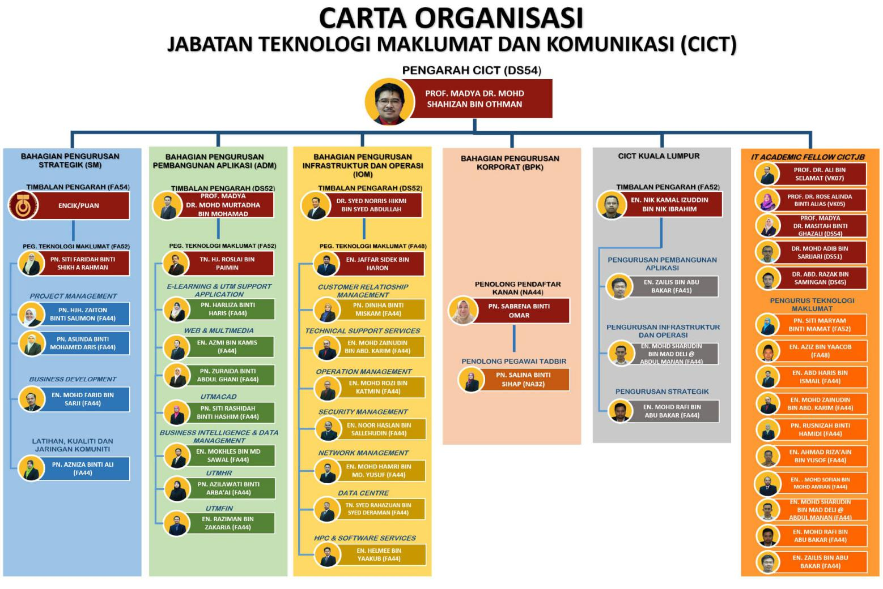

MEMORY DEVICES
A memory is used to store data and instruction just like human brain. Computer memory is one of the storage spaces we used to process data in computer and it required instruction during data processing. Memory are divided into two types: internal memory and external memory.
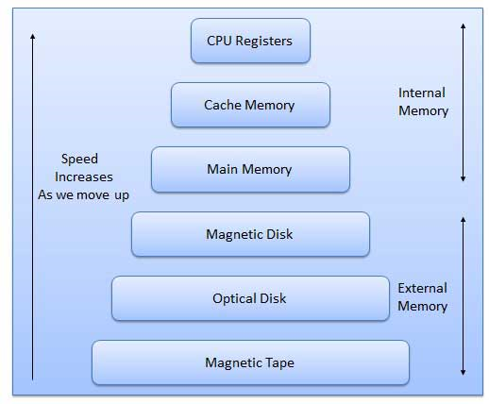
During the industrial visit, we have discovered some history of external memory storage. Memory storage by using Williams-Kilburn tube was found in 1947 at Manchester University. It used a cathode ray tube to store bits as dots on the screen’s surface and the information was read by a metal pickup plate that would detect a change in electrical charge.
In 1950, magnetic drum memory was discovered and over ten years, it became the primary way early computers wrote, read, and stored data. An improvement was done by replacing circular magnet with magnetic wire because it capable for changing polarization. Bubble memory which is weighed less, cheaper to produce, and energy saved was also another short-lived magnetic memory technology in the1980’s.
IBM is primarily responsible for driving the early evolution of magnetic disk storage. They invented both the floppy disk drive and the hard disk drive and their staff are credited with many of the improvements supporting the products. IBM developed and manufactured disk storage devices between 1956 to 2003.
A floppy disk is an easily removed, installed and portable storage device. It is made of magnetic film encased in a flexible plastic, and is inexpensive to manufacture. In 1970’s to mid-1980’s ,8-inch floppy drive was mainly use. It specifically for the System/370 mainframe. On the downside, the floppy disk is very easy to damage.
In 1976, a smaller version of floppy disk was developed. This is because IBM’s 8-inch floppy disk was too big for a standard desktop computer. The new 5.25-inch floppy disk was cheaper to manufacture and could store 110 kilobytes of data. These disks became extremely popular and were used on most personal computers.
The 3.5-inch floppy disk (introduced in 1982) gradually became more popular than the 5.25-inch floppy disk. The 3.5 version came with a significant advantage. It had a rigid cover protecting the magnetic film inside. However, both formats remained quite popular until the mid-1990s.
In 1980, an optical disc(optical recordings) was developed to replacing magnetic disk(magnetic recordings). The idea of using light as a mechanism to record have success leading to the invention of CDs (Compact Discs) and DVDs (Digital Video Recordings) and Blu-Ray.
Flash drives appeared on the market, late in the year 2000. A flash drive plugs into computers with a built-in USB plug, making it a small, easily removable and very portable storage device. Unlike a traditional hard drive, or an optical drive, it has no moving parts, but instead combines chips and transistors for maximum functionality. Generally, a flash drives storage capacity ranges from 8 to 64 GB.
Now, internet have made cloud data storage become more economical for individual and businesses to use. It provides a large capacity of data storage to user for multiple usage such as information backup.

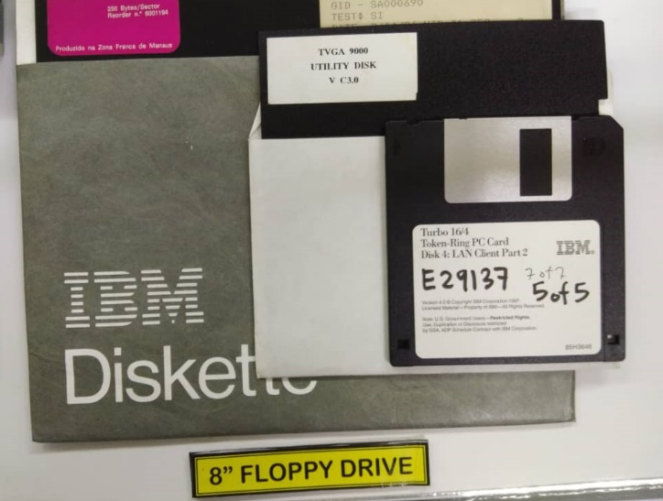

8’’ floppy drive

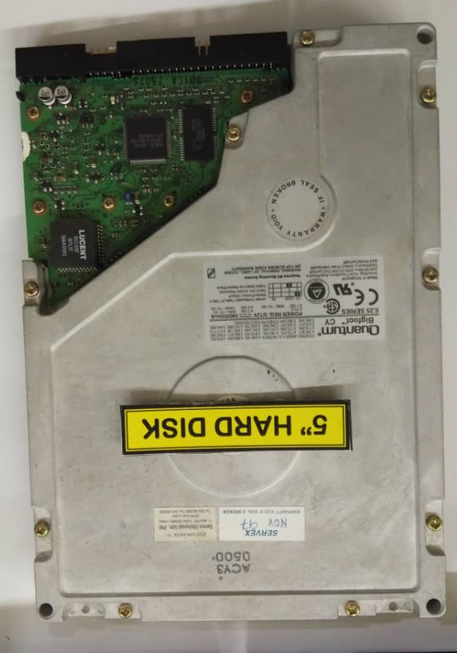

3’’ floppy disk

5’’ hard disk

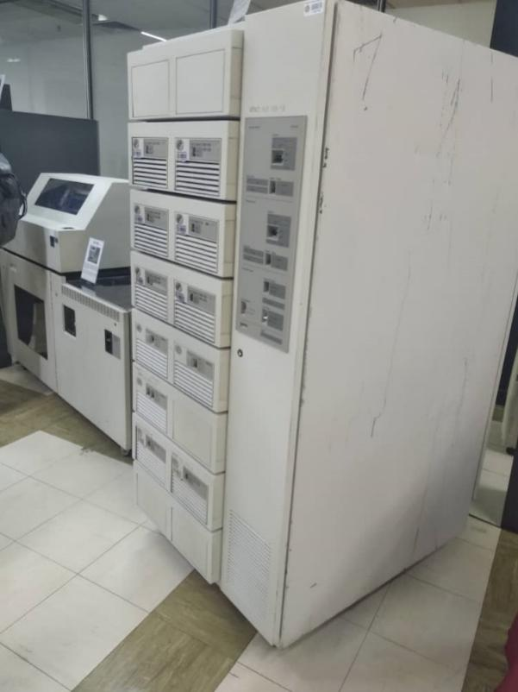
Mainframe data storage
The usage of mainframe in UTM began in year 1970’s at Computer Centre, UTM campus, Kuala Lumpur. It served as a data control of students and staff information.
The mainframe has been used for almost 20 years. It is used for processing, storing, securing and printing the university’s information data.

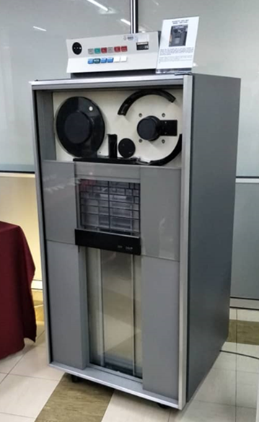
Magnetic tape unit model :IBM 3420
The Magnetic Tape Unit was used as a ‘back up’ for the mainframe system and information dataspace of staff and students as well as other University’s information system during year 1976 until 2010.
Initially, this model used as a round shape tape before it converted into square shape tape.

Mainframe tape subsystem model: IBM 9309
It is used as a “back up” for mainframe system and information database of staff and students as well as other university’s information system during the year 1987 until 1995. This model is used a square shape tape after the round shape tape was no longer in used.

SUPERCOMPUTER
A supercomputer is a computer with a high level of performance compared to a general purpose computer. Traditionally, supercomputers have been used for scientific and engineering applications that must handle very large databases or do a great amount of computation (or both). Although advances like multi-core processors and GPGPUs (general-purpose graphics processing units) have enabled powerful machines for personal use, by definition, a supercomputer is exceptional in terms of performance. The performance of a supercomputer is commonly measured in floating point operations per second (FLOPS) instead of million instructions per second (MIPS).
The early history of supercomputers is closely associated with Seymour Cray, who designed the first officially designated supercomputers for Control Data in the late 1960s. His first design, the CDC 6600, had a pipelined scalar architecture and used the RISC instruction set that his team developed. In this architecture, a single CPU overlaps fetching, decoding and executing instructions to process one instruction each clock cycle.
Cray pushed the number-crunching speed available from the pipelined scalar architecture with the CDC 7600 before developing a four-processor architecture with the CDC 8600. Multiple processors, however, raised operating system and software issues.
When Cray left CDC in 1972 to start his own company, Cray Research he abandoned the multiprocessor architecture in favour of vector processing, a split that divides supercomputing camps to this day.
Cray Research pursued vector processing, in which hardware was designed to unwrap "for" or "do" loops. Using a CDC 6600, the European Centre for Medium-Range Weather Forecasts (ECMWF) produced a 10-day forecast in 12 days. But using one of Cray Research's first products, the Cray 1-A, the ECMWF was able to produce a 10-day forecast in five hours.

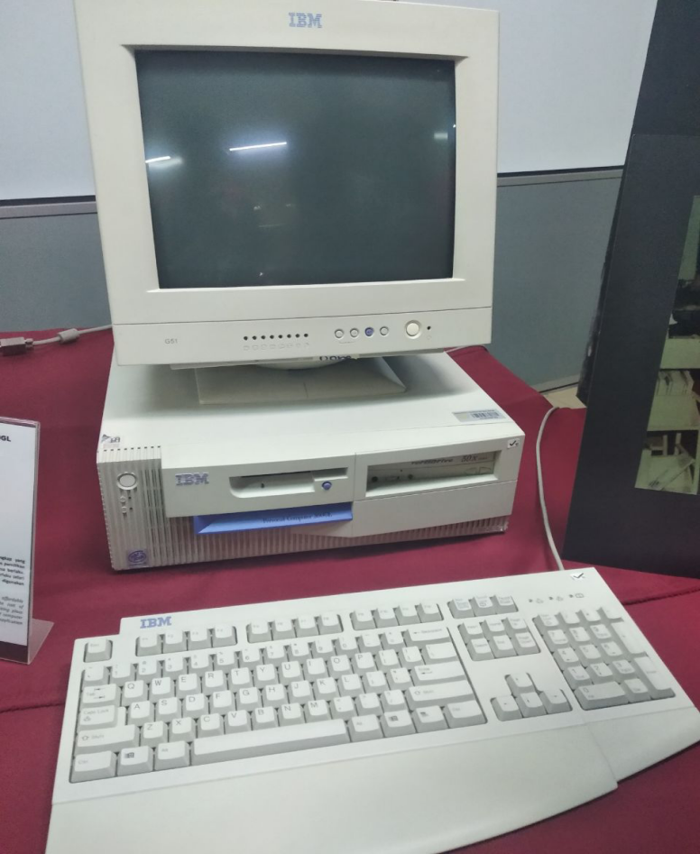
IBM Personal Computer 300GL
The IBM Personal Computer 300GL being an all-inclusive and affordable computer, helped increased the productivity and reduced the cost of ownership of UTM library. The transformation of system is taking place constantly in the Library. Apparently, technological revolution of computer usage coincides with system change and this was evident with the application of Dynix system for 10 years.

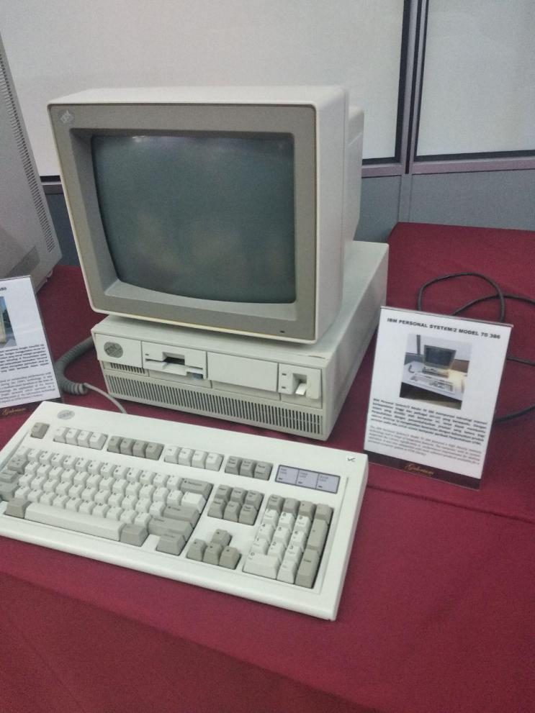
IBM Personal System/2 Model 70 386
The IBM Personal System/2 Model 70 386 featured a high density memory technology and a range of integrated features. The computer, with its system, supported the Library significantly in performance improvement for desktop operation. It was also compatible with most software products available for a personal computer system in UTM library.

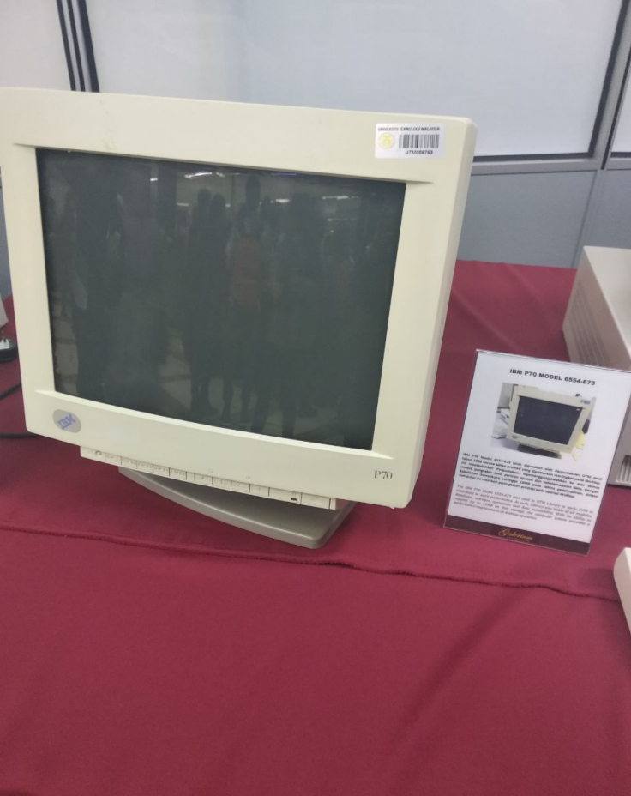
IBM P70 Model 6554-673
The IBM P70 Model 6554-673 was used in UTM library in early 1998 to contribute to work performance. As such, Library was liable of all modules, databases, software operations and data accessibility. With its ability to support up to 16MB on disk storage, the computer system provided a performance improvement on desktop operation.

REFLECTION
After visiting the PSZ, we realized that the technologies we have now are much more advanced than the ones we saw in there. The technologies inside PSZ were old and slow but at their time, it was an innovation, and the pinnacle of technology but if we were to use the old technologies in these generation, we would not be making any progress at all doing our projects due to the fact that the old technologies are much more slower compared to ones we have currently. Therefore, we are grateful to the technologies we have now because we do not have to use those old and slow technologies to do our bidding. If we have a relatively fast technologies compared to the old ones, we can sure make an even faster and better technology in the future by using the ones we have now as a reference and prototype to make some improvements to it.

PG during the PSZ visit
“Full marks will be given” - Dr Sarina

REFERENCE
Jan Matlis. (2005, May 31). A brief history of supercomputers.
Retrieved 15:25, October 25, 2019,
from https://www.computerworld.com.au/article/132504/brief_history_supercomputers/

Keith D. Foote. (2017, November 1). A brief history of Data Storage.
Retrieved from https://www.dataversity.net/brief-history-data-storage/

Wikipedia contributors. (2019, October 5). Supercomputer. In Wikipedia, The Free Encyclopedia. Retrieved 15:18, October 25, 2019, from https://en.wikipedia.org/w/index.php?title=Supercomputer&oldid=919731999

