Semester I 2020/2021

Subject : Technology and Information Systems (SECP1513)
Section : _______________01___________
Assignment : Step by step PC Assembly

GROUP NAME / NUMBER : __08________

1 | Photo | Name : FELICIA CHIN HUI FEN  Matric Number : A20EC0037  Phone Number : 0175459581  E-mail : feliciahui@graduate.utm.my
2 | Photo | Name : ERICA DESIRAE MAURITIUS  Matric Number : A20EC0032  Phone Number : 0128157778  E-mail : erica@graduate.utm.my
3 | Photo | Name : MOHD FIRDAUS BIN ZAMRI  Matric Number : A20EC0080  Phone Number : 01121897707  E-mail : mohd01@graduate.utm.my
4 | Photo | Name : LUE GUO MING  Matric Number : A20EC0073  Phone Number : 01155171681  E-mail : lueming@graduate.utm.my

Part A

1.0 Screwdriver

The screwdrivers are used to tighten or loosen the screw. The importance of screwdrivers is it help screw and connect the component needed in the PC such as motherboard so that these components can connect together and function well.

2.0 Antistatic mat

The antistatic map is used as an antistatic device to eliminate static electricity . The importance of antistatic mat is it gives protection on the computer equipment by preventing the static electricity from accumulating on the hardware or on the technician.

3.0 Headlamp (light source)

A headlamp can provide light source in a PC case that is full of shadows. We can control the direction of light source easily by moving our head. It makes multitask easier because we don’t hold a light source by using hand, our hands are free for task. With a light source, we can easily find any small components such as a screw that lost in the dark corner of a PC case.

4.0 Pliers
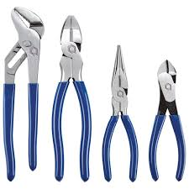

Pliers are needed when a screwdriver cannot fix the screw properly, sometimes it can be used as a cutter, either cut a wire or a cable tie. They are important to improve stability of screws in a PC case so that components will not out of their position. Pliers are used to cut wrong wire or excess wire to ensure a PC can function well.

Part B
1.0 Sketch Diagram of Motherboard

2.0 Component in Table 1.0
2.1 Graphic card

Graphic card is used to provide high-quality 3D graphics and animation for games and simulations. There are two types of graphic card which are dedicated graphic card and integrated graphic card. Dedicated graphics card is not bound to motherboard and it has its own memory and processor for generating its images, and does not slow down the computer. Integrated graphic card is bound to motherboard and share the memory with the CPU thus it will reduce the total amount of memory available. Examples of model for graphic card are ASUS graphics card video, Nvidia Titan X graphics card video and Radeon RX 480 graphics card video.

2.2 CPU/ processor

The main function of CPU is processing data in the PC by performing basic arithmetic, controlling, logic and input or output operation specified by the instruction in the program. There are many types of CPU such as single-core CPU (execute only one command at a time and not efficient in multi-tasking), dual-core CPU(manage the multi-tasking effectively), quad-core CPU(four times faster in execute multi-tasking) and so on. Examples of model for CPU is Intel Core i3 processor, Intel Core i5 processor and AMD Ryzen processor.

2.3 Heat sink

The function of heat sink is it help to cool down the hot device in PC such as CPU. There are many types of heat sink such as passive heat sink, active heat sink, aluminium heat sink, stamped heat sink and so on. However, the major type is active and passive heat sink. Active heat sink is generally fan type and utilize power for cooling purpose. Passive heat sink does not have any mechanical components and is made from aluminium finned radiators and it help dissipate heat by using convection process. Examples of its models are Noctua NH-D15, Cooler Master Hyper 212 and NZXT Kraken Z-3.

2.4 CD ROM

CD ROM is defined as compact disc read only memory. Thus, its function is to read data store in computer such as graphics, audio and text. The data in the disc only can read and cannot be written. Examples of model of CD ROM are Intel CD ROM and Asus CD ROM.
2.5 USB cable

The function of USB cable is used to connect devices to computer in order to transmit data between the device and the computer. There are two types of USB cables which are the cable act as a single type and as one type to another. The examples of model are USB-A (use type-A connector, USB- B(use Type-B connector), USB-C (use Type-C connector) and so on.

2.6 Slots

The function of slots is it act as a place to install card such as sound card, video card and network card to the computer. Examples of models are AGP slot (video card), PCI slots (network card, SCSI, sound card and video card) and PCI-Express (video card, network card, modem, sound card).

2.7 RAM
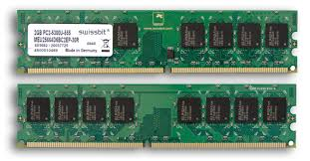
RAM (Random-access memory) is a volatile memory that store current running program. It is used to store working data and machine code. There are two main types of RAM which are Dynamic RAM (DRAM) and Static RAM (SRAM). DRAM (pronounced DEE-RAM), is widely used as a computer’s main memory. Each DRAM memory cell is made up of a transistor and a capacitor within an integrated circuit, and a data bit is stored in the capacitor. Since transistors always leak a small amount, the capacitors will slowly discharge, causing information stored in it to drain; hence, DRAM has to be refreshed (given a new electronic charge) every few milliseconds to retain data. Example of model is MDRAM. SRAM (pronounced ES-RAM) is made up of four to six transistors. It keeps data in the memory as long as power is supplied to the system unlike DRAM, which has to be refreshed periodically. As such, SRAM is faster but also more expensive, making DRAM the more prevalent memory in computer systems. Example of model is DDR3.

2.8 SATA Cable
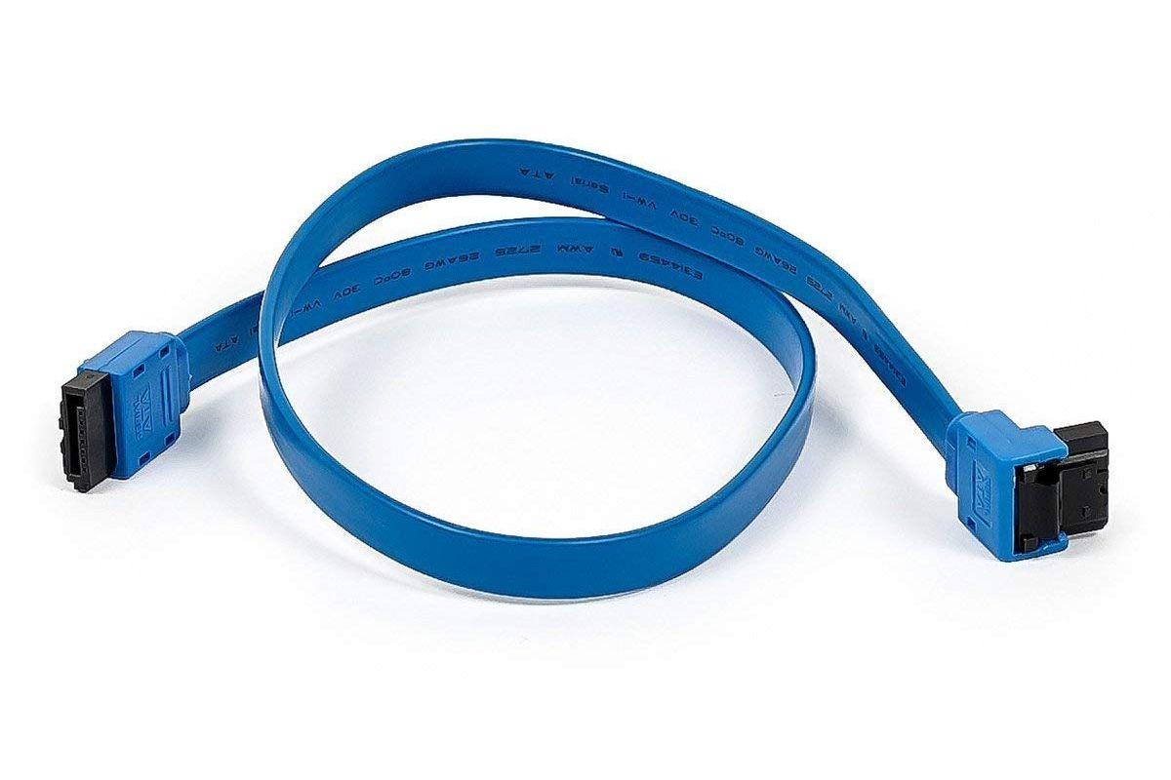
SATA cables are used to connect a mass storage device such as hard disk drives, optical drives, solid-state memory drives to a motherboard in serial connection. There are seven types of SATA cables. The first one is e-SATA cable which available in lengths ranging from 0.5-2m. Second, the Low Profile SATA which consists ultra-thin SATA cables with low profile connectors. Thirdly, the Micro SATA which is a SATA data cable. Fourth, the SATA Bracket which consists of dual-port e-SATA expansion brackets. Fifth, the SATA Bridge where SATA interface acting as a bridge between devices. Next, the SATA Power which help SATA interface power cable. Lastly, the SATA-SATA which is the Standard SATA cables available in a variety of lengths

2.9 IDE Cable
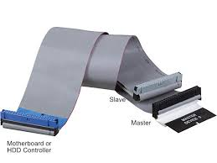
IDE cables are used to connect hard drives and optical drives to each other and to the motherboard in parallel connection. The two most common types of IDE ribbon cables are the 34-pin cable used for floppy drives and the 40-pin cable for hard drives and optical drives.

2.10 Power Supply
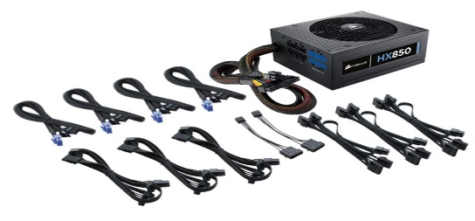
Power supply changes alternating current from a wall socket of mains electricity to low-voltage direct current to operate the processor and peripheral devices. There are three common types of power supply which are AT power supply, ATX power supply and ATX-2 power supply. Examples of models are AT computer power supply, ATX computer power supply and BTX computer power supply.

2.11 Hard Disk
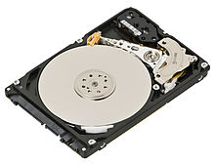
A hard disk is an electro-mechanical data storage device that stores and retrieves digital data using magnetic storage. There are two types of hard disks which are internal hard disk and external hard disk. Example models of hard disk are SATA hard disk and IDE hard disk.

PART C - Step by Step PC Assembly

Step 1 - Installation of CPU on motherboard

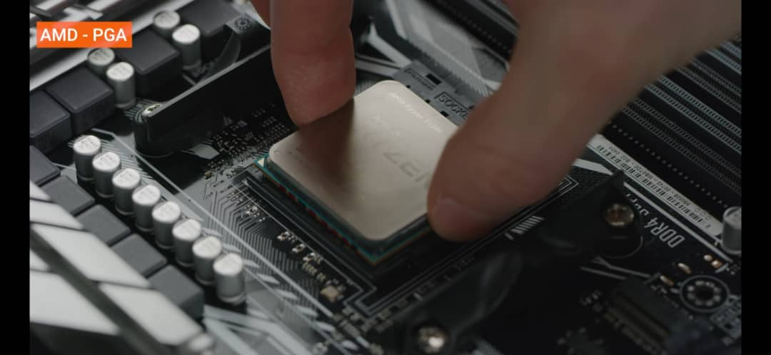

Insert the CPU on the motherboard and apply some thermal paste.
Caution : make sure that the CPU is inserted in the correct socket and tidy before it is tightened with a clip.

Step 2 - Installation of fan processor and heat sink
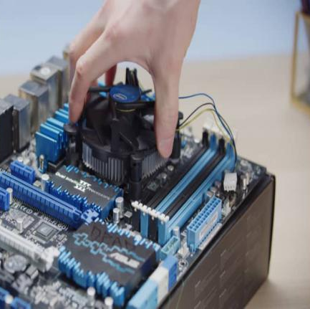

Install the fan processor and heat sink neatly onto the CPU.
Caution : Ensure that fan and heat sink have been tightly clipped.

Step 3 - Installation of RAM

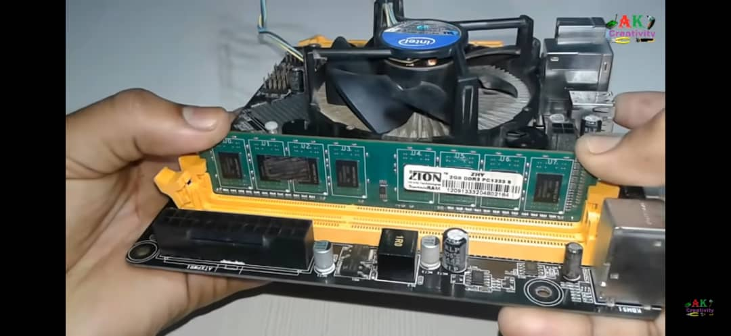
Install the pieces of RAM into the slot of the RAM.
Caution : Make sure the RAM has been installed correctly.

Step 4 - Installation of power supply and motherboard

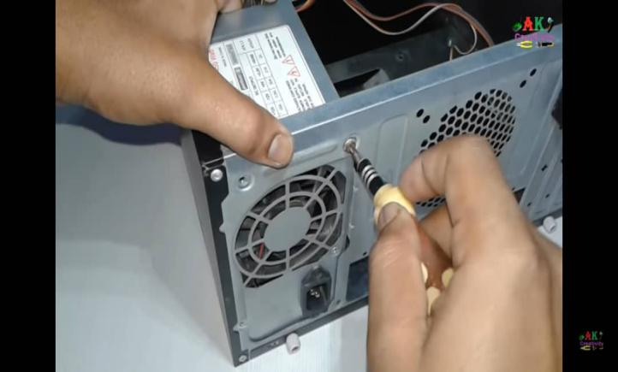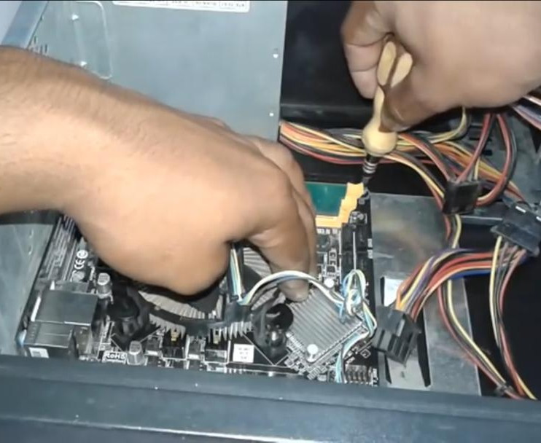
Install the power supply and the motherboard into the chassis plate and tightened the screws at every parts of the computer case respectively.

Step 5 - Installation of graphic card

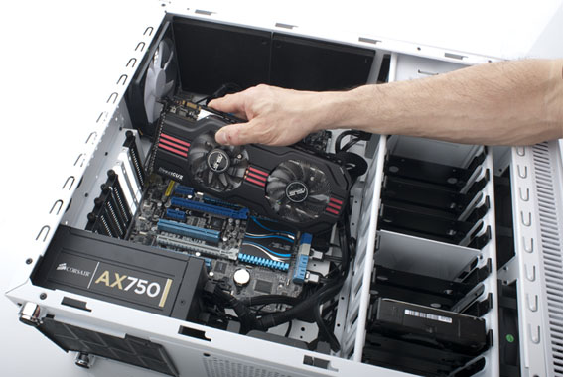

Install graphic card at the slot PCI-E and screw at the graphic card holder so that it is tidy and will not unplug easily.

Step 6 - Installation CD ROM Drive

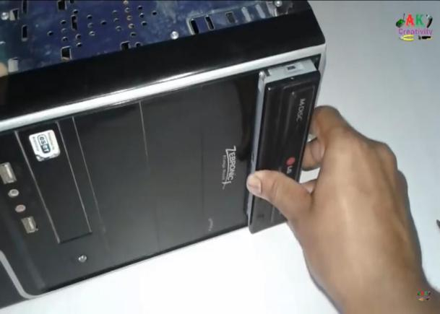

Install the CD ROM Drive into the chassis plate.

Step 7 - Installation of hard disk
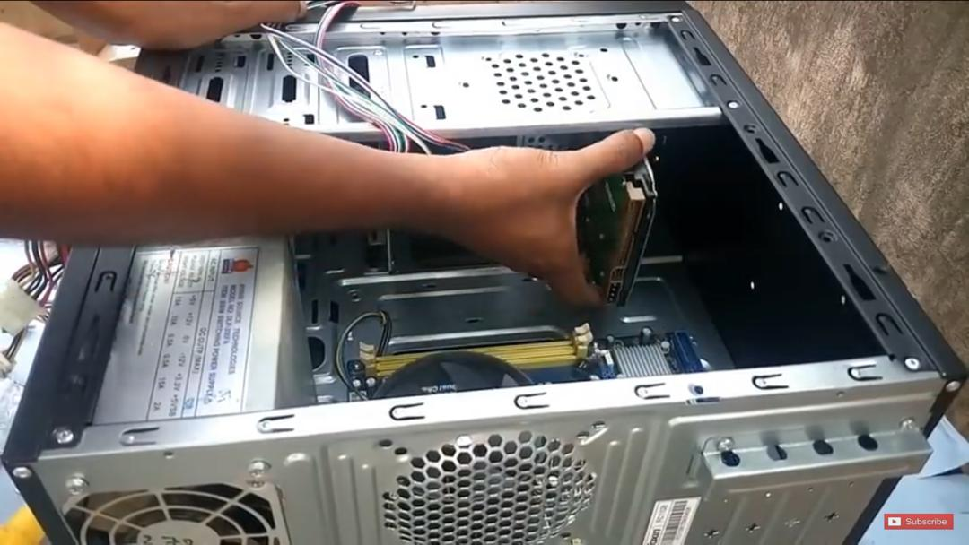

Install the hard disk into the chassis plate. Then, tightened the hard disk with a screw at every part of hard disk holder.
Caution : Make sure that the hard disk and CD ROM is stable and does not shake easily. This is to prevent hard disk and CD ROM from being damaged easily.

Step 8 - Installation of IDE cable, SATA cable and Power Supply

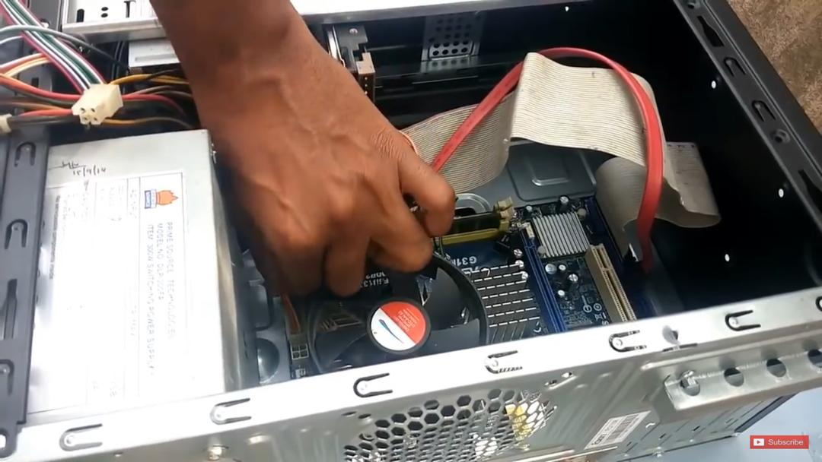

Connect the cable IDE to the CD ROM Drive, the SATA cable to the Hard Disk Drive, the power supply to every drive respectively.
Caution : Make sure the cable IDE and Power Supply is connected neatly to save up spaces and lessen the accumulation of heat in the chassis plate.

Step 9 - Installation of switch wire and USB to the motherboard

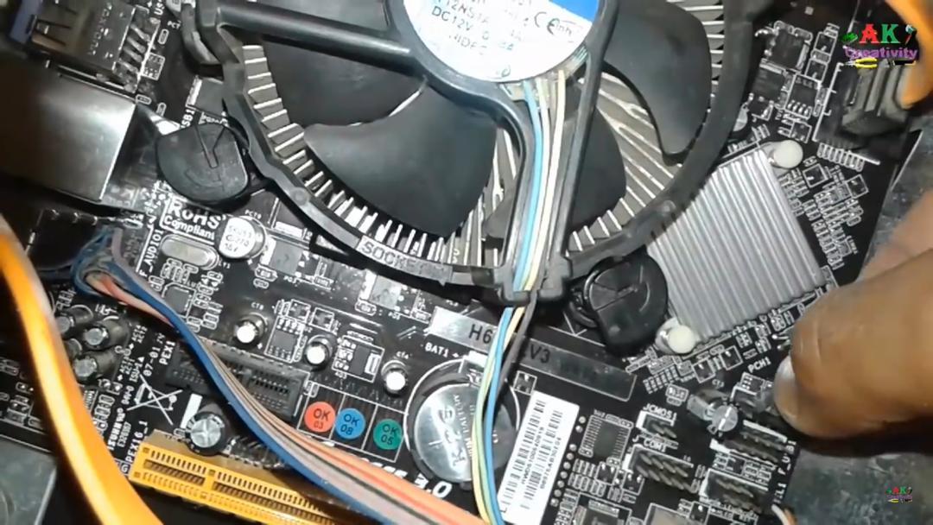
Connect the switch wire and USB of the chassis plate to the motherboard.
Caution : Make sure refers to manual book so that the installation of wire and USB is correct and precise.

Step 10 - Installation of chassis plate
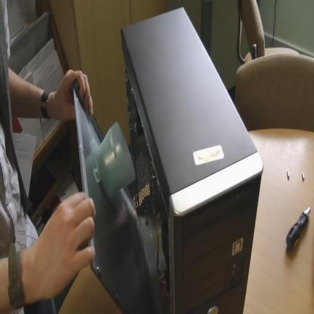

Make sure to close the computer case tightly and neatly. Screwed all the parts that have been provided. This is to prevent the accumulation of dust in the chassis plate.

Step 11 - Testing of the system

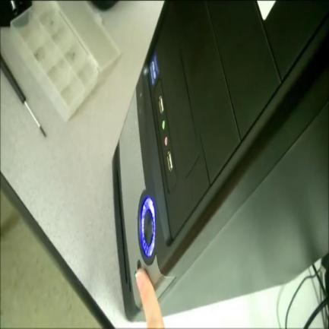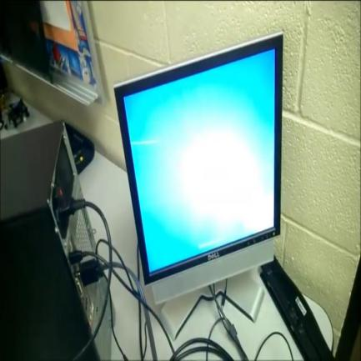
Connect the CPU that is fully installed to the power supply and monitor. Switch on the CPU and once the screen of monitor pop out then the assembling of the CPU is a success.

References

- (Expansion slot, 2020; Hale, 2018; Lathan & GamersNexus, 2016; Types of CPU; Video Card, 2020; What is a Heat Sink and its Importance)
Expansion slot. (2020, 8 February). Retrieved 29 November from https://www.computerhope.com/jargon/e/expaslot.htm

- Hale, B. (2018, 29 September). Dedicated Graphics Card vs. Integrated Graphics: Which is Better for YOU? Retrieved 29 November from https://techguided.com/dedicated-graphics-card-vs-integrated-graphics/#2

- Lathan, P., & GamersNexus. (2016, 23 December). 5 tools you need to build a PC. Retrieved 24 November from https://blog.nzxt.com/tools-need-build-pc/

- Types of CPU. Retrieved 29 November from https://www.educba.com/types-of-cpu/

- Video Card. (2020, 27 November). Wikipedia. Retrieved 29 November from https://en.wikipedia.org/wiki/Video_card#Graphics_Processing_Unit

- What is a Heat Sink and its Importance. Retrieved 29 November from https://www.elprocus.com/different-types-of-heat-sinks-and-their-importance/

- Marsha James. (2017, 10 February). Types of CD ROM Drives. Retrieved 29 November from https://itstillworks.com/types-of-cd-rom-drives-10408.html.

- IDENTIFYING YOUR USB CONNECTOR OR USB CABLE TYPE. Retrieved 29 November from https://www.cmd-ltd.com/advice-centre/usb-chargers-and-power-modules/usb-and-power-module-product-help/identifying-usb-connector/

- CompTIA A+ | Microsoft MTA O/S: PC Expansion Slots. Retrieved 29 November from https://asmed.com/comptia-a-pc-expansion-slots/

- Tim Fisher. (2019, 30 November). What is an IDE Cable? Retrieved 29 November from https://www.lifewire.com/what-is-an-ide-cable-2625908

- Brett Hoven. (2015, 12 August). What is SATA Cable? What are different types of SATA cables and which one do you need? Retrieved 29 November from https://customcablesbrett.wordpress.com/2015/08/12/what-is-sata-cable-types-of-sata-cables-and-input/

- Christine Taylor. (2018, 2 November). SRAM vs. DRAM. Retrieved 29 November from https://www.enterprisestorageforum.com/storage-hardware/sram-vs-dram.html.

- PC Power Supply. (2020, 9 March). Retrieved 29 November from https://powersupplypc.com/choosing-the-right-types-of-computer-power-supply/

- M.Dowler. (2008, 22 January). SATA and IDE Hard Drives. Pg. 2. Retrieved 29 November from https://www.pcstats.com/articles/1778/2.html

- Hard disk drive. (2020, 23 November). Wikipedia. Retrieved 29 November from https://en.wikipedia.org/wiki/Hard_disk_drive#cite_note-erwpnw-154

- Arjuna CelikIT. (2011, 14 October). Asas Pemasangan Sistem Komputer (ESS207). Retrieved 29 November from https://www.youtube.com/watch?v=ctK58A71DTs

- How to Make or Assemble Desktop CPU Step by Step At Home | How to Build a Computer with used Parts. (2017, 28 December). Technology Guide. Retrieved 29 November from https://www.youtube.com/watch?v=m_-G9Cacx2U

