SCSP 1513
SECTION 07

GROUP REPORT: INDUSTRIAL TALK 2
NEW ACADEMIA LEARNING INNOVATION
(NALI) 2018

SCHOOL OF COMPUTING

NAME: | MATRIC NUMBER:
MUHAMMAD FIRDAUS BIN NOR AZMAN | A18CS0149
TOON SHU HUI | A18CS0268
CHOY WAN LING | A18CS0049
IDZNI BIN MOHAMED RASHID | A18CS0075

LECTURER:
SIR HAIRUDIN BIN ABDUL MAJID

Introduction
The development of revolutionary technologies in this era of globalization are incredibly increasing. This era is more ease and relevant for the alpha generations. For example, the computer revolution, where the computer before these are more for environmental studies such as computation of nuclear range, space and field research studies such as sending of information during the war.

The era has grown more because of human ideology that is able to think in a more creative and innovative way in developing the daily lives of mankind. Meanwhile, technology has its pros and cons if studied in detail through the entire aspect. It has become very common that there are many online scams such as spreading fake news online, currency fraud, and etc. The cause of these are because of people who do not know their responsibilities as a consumer.

The younger generation nowadays should be exposed and get the chance to learn about technologies so that they are aware that scamming is illegal and incident like this will not happen again. Besides that, exposing the younger generation to technologies also make sure that they develop innovative thinking and entrepreneurship and their level of life is in line with global thinking.

Dr Maszlee Malik, the Ministry of Education Malaysia once said after being asked about the education in Science, Technology, Engineering and Mathematics (STEM) in Malaysia, he will emphasis in enhancing critical thinking among students, teachers and lecturers in the future. With this kind of statement, we can say that the effort of government evolves learning via technology or “E-Learning” is something very important to instructors and students. This will make them more ease in searching information or finishing an assignment.

Nowadays education relating issues in Malaysia has become a concerned issue because most of the teachers in primary and secondary school are more comfortable with the old ways of teaching which is the one-way communication relations. In this new generation, the students are not the same like before who like to be in their own form. But instead, they need the full attention from their teacher and parents for them to understand something. Students are not all born clever, for those who has difficulty in understanding something might be embarrassed to ask. Therefore, teachers need to take appropriate action to teach them with a system of two-way communication which is in line with the scope of learning.

Therefore, with this report, we hope that parents and teachers together with their children and pupils will step forward on par with developed countries.

In this report we will explain about what are “New Academia Learning Innovation (NALI)” and its functions, what are “Tangible Education Game (TEG)”, “Virtual design and construction (VDC)” and “The Service-Learning Educational Framework: Rumah Ihsan Johor (RIJ) Projects” and their functions to the nation. We’ll also explain more details on their plans and projects to facilitate students to apply what is taught in class in method of online.

New Academia Learning Innovation

NALI 2018 is a is a celebration for innovative teaching and learning practices. It is organized by the Centre for Academic Leadership (UTMLead) in collaborate with the Faculty of Social Science & Humanities, University Technology Malaysia (UTM) and Asia Technological University Network (ATU-NET). It shows cases of innovative, transformative and immersive practice, research and product in learning and teaching amongst academicians and students.

The organising of NALI 2018 is to:
- recognize NALI research and innovation products in teaching and learning through exhibition and competition
- be the platform for sharing of research and innovation products in teaching and learning
- improve educator’s competency in practicing teaching and learning in the 21st Century through NALI talk series and workshops
- To improve STEM awareness among educators in practicing NALI

NALI 2018 was held in Sultan Iskandar Hall, University Technology Malaysia in 25th-26th September 2018. This event is target for teachers, academicians, undergraduates and also postgraduates that could inspire to make an innovation in learning and teaching method for next era generation in the digital and computerize platform and learning environment without any boundary.

Group Planning for Project
This event is held in two days. On the first day of the event our group sent 2 delegates to have a brief looking at the event area as we were a little late to explore the exhibit because of the packed class schedule that day. On the second day of the event we went to the hall in group and we manage to have a full look at the exhibits and made short interviews with several exhibitors whom are from Tangible Educational Game (TEG), Development of Virtual Design and Construction Model for Open Education Resources – M&E Works Measurement and The Service-Learning Educational Framework: Rumah Ihsan Johor (RIJ) Projects.
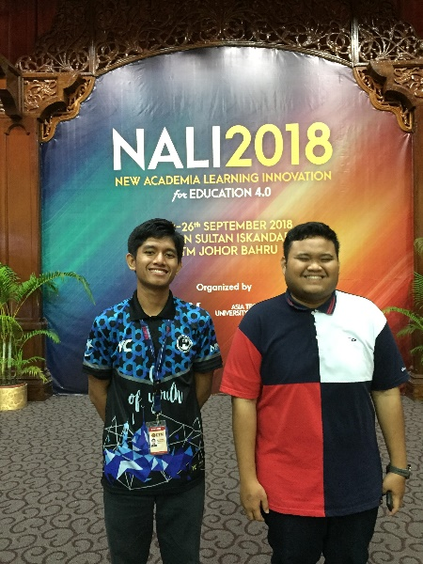

First Day of Exhibit with two of our group mates.
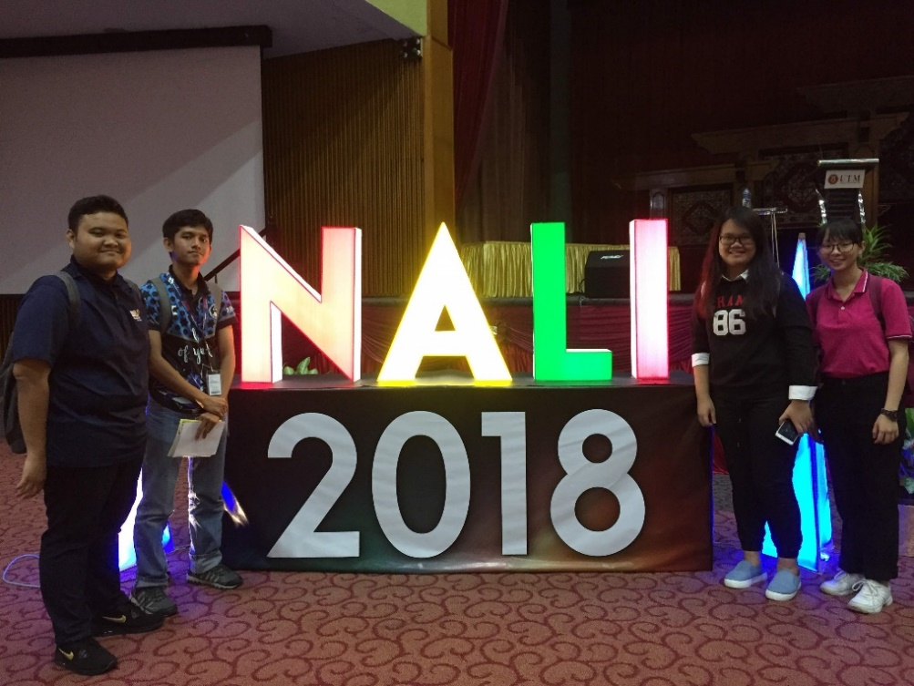

Second Day of Exhibit with all of our group members.
Tangible Educational Game (TEG)
For our first interview, we have visited the Tangible Educational Game (TEG) and we have been introduced to an application and how it is work. TEG is a physical play set that integrates tangible objects with mobile application with a concept that allow kids to play beyond screen. TEG uses Augmented Reality engine as core of the mobile-based games application that combines with mobile devices as display, reflector mirror, stand and set of tangible objects as tracking and interaction technology. TEG sees a vision of the future where technology is greatly used to create boundless interaction, while still embodying the concept “play to learn”. This work can be a platform for the kids to learn by playing collaboratively with more various games designed for education. The teams get the innovation in creating this application is because of kids nowaday are playing with screens more than traditional toys. This causes kids to be less social and more difficult to control. By taking the advantage that kids are more to the “screens”, the team decided to innovate this application so that the kids can learn while using the pads, phones and etc.

How the application works:
- Questions such as mathematics questions, jawi writing and animals name are asked through screens.
- Children are required to find the cards with relate answer and put it under a refletor which is a mirror located near the front camera of any devices.
- Each cards has special patterns designed for the devices to recognised the alphabet or number.
- When the devices recognised the cards, the number or alphabet will be shown on the devices as answer.

As mentioned by the exhibitor, this application is still in a develop state so it can only perform easy qiestions for the moment. But we believe that this application will be the next era of studies style used by children all over the world as the technology has grown as fast as lightning.

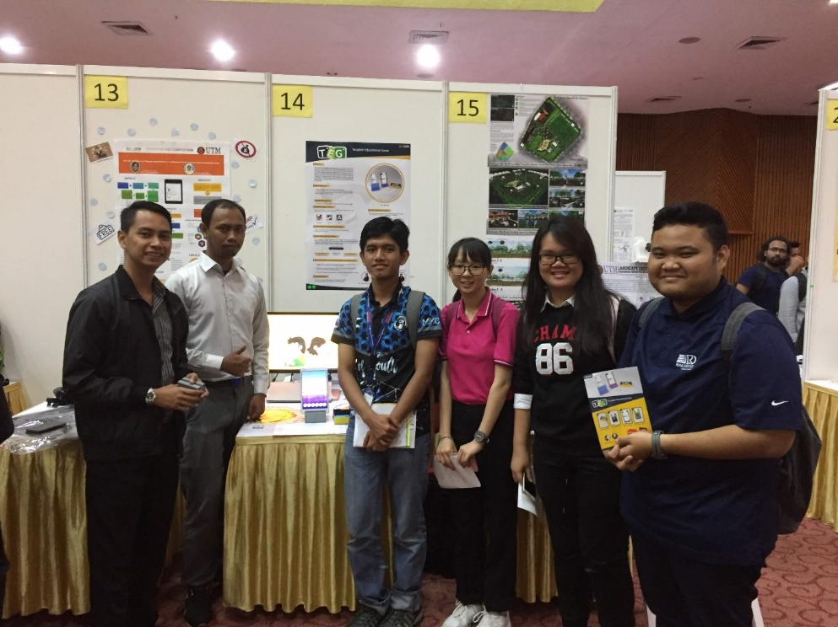

Group photos with exhibitor for TEG

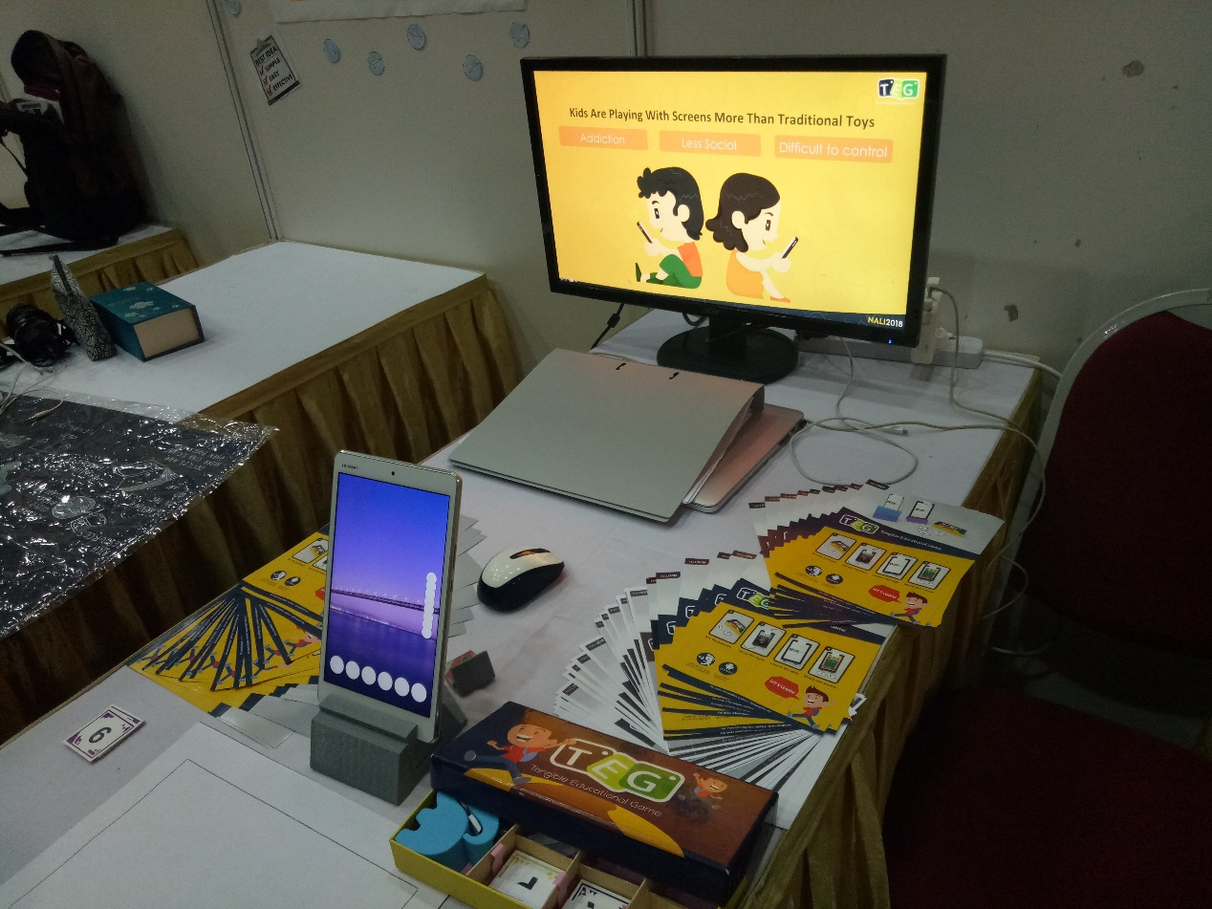
TEG Exhibition

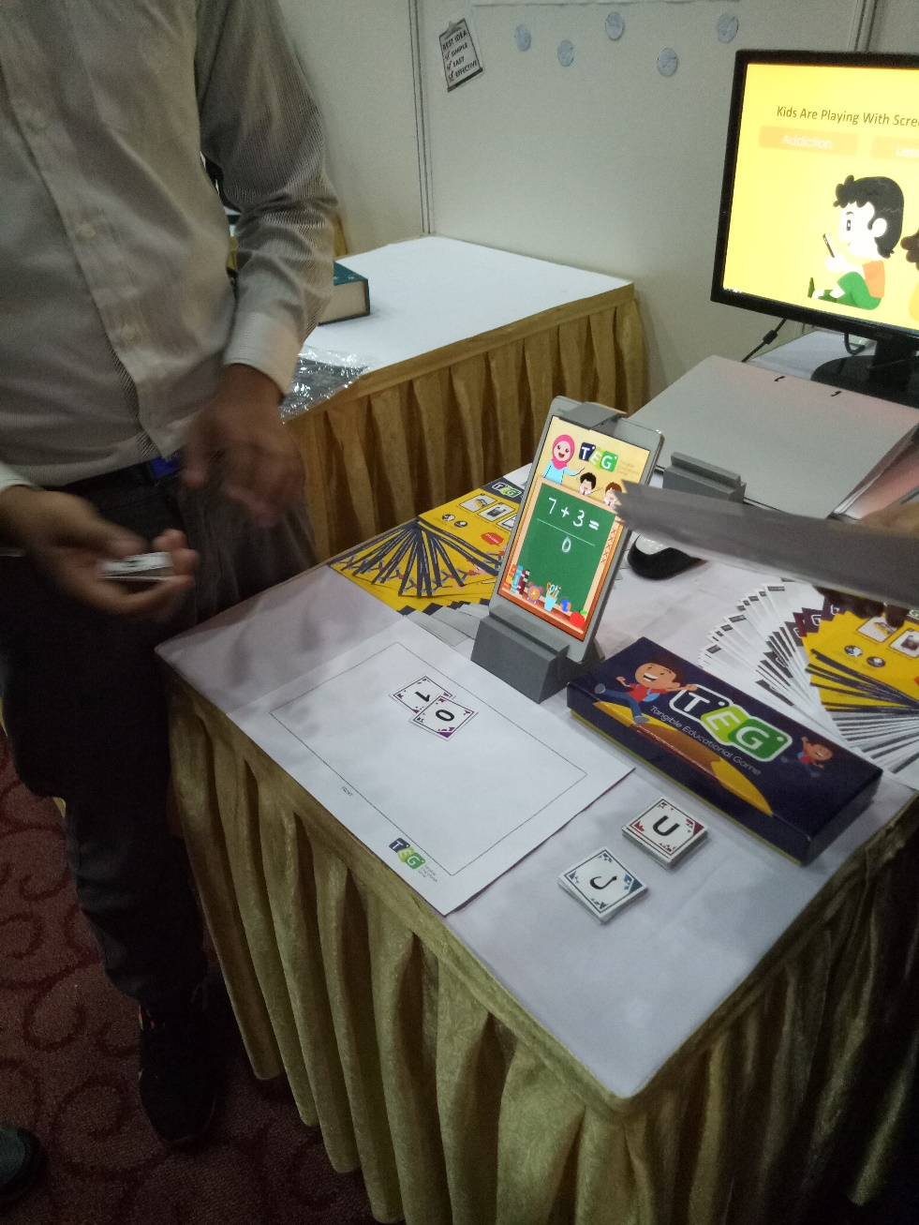
TEG Exhibition

The objective for this project is to design tangible object interaction using AR engine and to design mobile-based games using play beyond the screen concept. From this program, it has given a significant impact for young student in learning such as helping them to use their imaginary and creative thinking to solve a problem. TEG also encourage the children to work as a team where they can play the game in a group instead of playing alone. It also helps the teacher in kindergarten to teach and expose the children in innovative learning. This project has commercialization potential for early education market size more than 800,000 children between 4 to 6 years old that attend kindergarten in Malaysia.

Development of Virtual Design And Construction Model for Open education Resources – M&E Works Measurement (VDC)
The second interview we had it with another project about Augmented Reality which is the virtual design and construction (VDC) for M&E Works Measurement. VDC is becoming the norm for designing and delivering building projects in the U.S, and worldwide including Malaysia. The process of traditional quantity extraction form 2D mechanical and electrical drawings is complex and is prone to human error. Therefore, the team had created an application which could create and coordinate the design of mechanical and electrical in virtual reality to allow design teams to integrate their design electronically in the computer and identify conflicts in all three dimensions.

How the VDC works?
- It is an application that creates a 3D model of M&E design automatically which only required the users to key in related information of their designs.
- The application will first identify the M&E components in locational, installation method and dimensional.
- Then user is required to key in the general information, item classification, supplementary information, M&E bills of quantities and others related information of their design.
- According to all data keyed in by users the application will portrait a 3D model of the design.
- The model included all M&E component required in specific place as well as water pipe system if the design is a building.

Applicability of this project:
- Standard learning tools for part time students in different learning centre in Malaysia and TNE programme.
- Training tools for young engineers to visualize construction drawings and undertake clash analysis.
- Online professional development modules to improve the coordination among design team
Impact of this project towards students and industrial practitioners:
- Open delivery
  - Any place and anytime to content, instruction and developed VDC model

- 3D visualization
  - 2D M&E drawing is complex which detail layout is not included in the drawings

- Learning of mastery
  - Allows students to achieve mastery of concept before moving on to the next knowledge area

This project has won several awards and one of it is that it has won a gold medal in Strategies for Implementing MOOC’s in Build Environment (PBL) Educational Framework, IUCEL 2016.
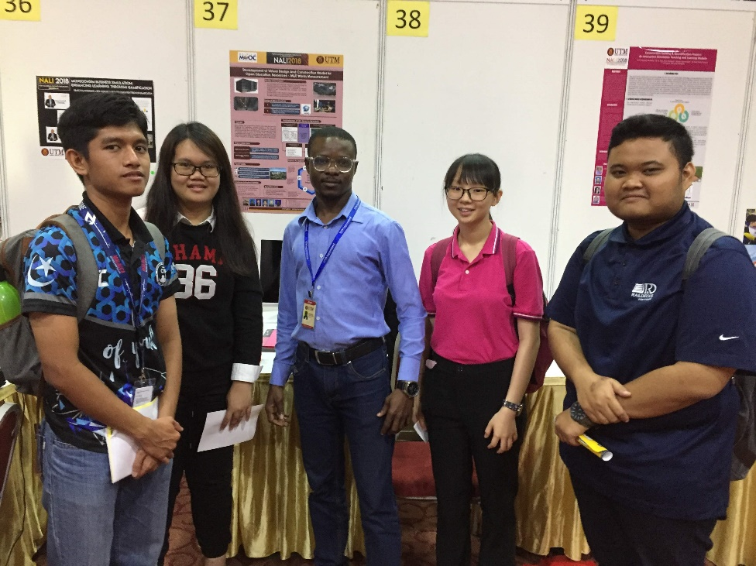

Group photo with exhibitor for VDC
Services-Learning
The last booth we visited is about the project that applied the academic syllabus in practical that we call The Service-Learning Educational Framework: Rumah Ihsan Johor (RIJ) Projects. The project is aimed to meet the challenges of the Industrial Revolution 4.0. One of the programs under this project is involving students in the construction of The Rumah Ihsan Johor. This program is considered one of the learning services as it required students to apply knowledge in the construction technology courses for Construction and Quantity Surveying students at the Faculty of Built Environment and Surveying, University Technology Malaysia. This allow student gain not only theoretical knowledge but also practically. Through this program, students have been involved in the effort to build an aid house for those in need in three days through volunteerism concept. Various new knowledge, practical knowledge and volunteerism element can be tackled by students and become useful learning experiences for students. The framework developed help the academicians in planning and executing such projects in later time.

Objective of this program is to promote the concept of service-learning in higher education which we applied what we study at public in volunteerism concept and to develop the service-learning framework for higher education.

This program is applied with a service-learning cycle in such a good framework to use by higher education with 5 Phases which is:
- Initiation Phase
  - Identify need and service that need to be done. Strength, Weaknesses, Opportunities, Threat (SWOT) analysis occur and make establishment contacts and partnerships
- Project Design Phase
  - make a discussion on objective and aims. Do student log and design of the project and make a logistic analysis.
- Execution Phase
  - make an active collaboration, demonstrate intercultural diversity and also demonstrate the commitment to the project.
- Reflection Phase
  - make a preparation of program report and reflections and also peer review.
- Sustainability Phase
  - make a sustainable plan and future collaboration. Also, research and development.

This project is applicable as a frame work for service-learning subjects in higher education. Become a planning tools for lecturers and tutors conducting service learning subject and become references for community project to the community, NGO’s and government agencies. It also has commercialization potential for ministry of education, construction agencies and much more. It will give an impact to student such as integration between academic knowledge and community service’s needs. Enhanced student’s learning experience. Enhanced generic skills among students. Make a sustained community partnership and improve guided reflection.

Conclusion
In conclusion the role of parents is very important in the developing thinking skills among children and in controlling the use of gadgets and teach the right way of use of digital tools to children as well. As a teenager, we also play an important role as we our self are the one to change and control our habits in handling technologies. By understanding the role of each individual, we can produce a society or family who is able to overcome the new era without boundary a in digital environment.

Graduates must involve themselves in innovation revolutionize education in Malaysia to a much better era. The community must also include themselves in this without considering whether there are from the government or not to prepare the future generation to survive in a harsh and challenging era and step forward.

TEG, VDC and Service-Learning is among the innovation that Malaysian has contributed for our future education and prepared Malaysia for the 4.0 industry revolution which emphasize in applying what we have studied and use of digital platform in education in future. NALI 2018 give such a great impact to Malaysia as Malaysian are lacked of inspiration to develop their innovation and creativity. This event will inspire the community to work together and develop new innovation for the next generation. It also raises awareness to the commercialize industry and government agencies to use the innovation innovated in order to improve our education syllabus and method to develops future generation which is more critical thinking to build a better nation.

This industrial talk has inspired us to make changes in our education system and also to implement innovation education in our education system so that the Malaysia education system will get a big leap forward. We also get to know that there is a lot of innovation has been created but we still need more improvement in order to become an innovative country. Education is the platform where we can produce younger innovator and the first and most important thing for this to happen is to change the education system to a better one which emphasis in technologies. We hope that with this platform it could change the education system to a better way and the community must be aware which there is still a lot a work to do before achieving the title of “Modern and Innovative Country”.
References
- http://ctl.utm.my/nali2018/exhibition/ ; New Academia Learning Innovation (NALI) 2018 ; last surveyed on 7 October 2018

