UNIVERSITI TEKNOLOGI MALAYSIA
SCHOOL OF COMPUTING
SESSION 2019/2020 SEMESTER 2

COURSE CODE
SCSV 2113 – Human Computer Interaction

LECTURE’S NAME
DR AIDA ALI

T1-INDIVIDUAL ASSIGNMENT
TITLE

Good and Bad User Interface Design

STUDENT’S NAME
AZRIANA BINTI ZAINAL ABIDIN

MATRIC NO
A19EC0027

SECTION
SECTION 01

PURPOSE
Microsoft Excel is a software for spreadsheeting. The design objective that has already been selected is a good publishing tool primarily used to build grids of calculation-specificing text, numbers and formulas. For many companies that use it to document expenditure and revenue, prepare expenditures, report details, and quickly present fiscal results, this is extremely valuable. It can be designed to take in data from external sources such as stock market feeds, running the data automatically through formulas such as financial models to update those information in real time. Excel has become a de facto standard in the business world, as has Microsoft Word, with Excel spreadsheets often exchanged and otherwise shared to exchange data and perform various calculations.
IMAGES INTERFACE
These are the sample pictures of previous Microsoft Excel where there is a lot of flaws due to their interface design which make user difficult to use especially to beginners. These shown that the software have bad interface design which is relate to bad user experience (UX).
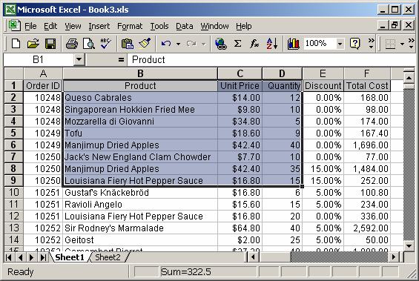
Figure 1 :The colour is dull ,not attractive

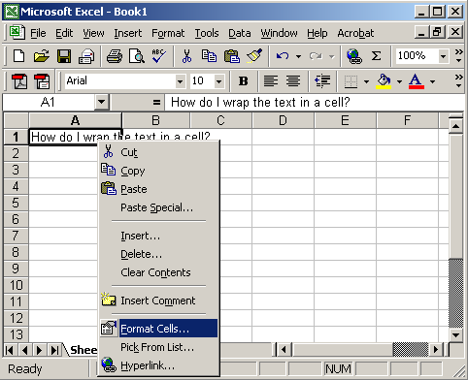
Figure 2 :Unclear button on their tools

ASPECTS YOU FIND GOOD AND BAD.

INTERFACE | EXPLAINATION
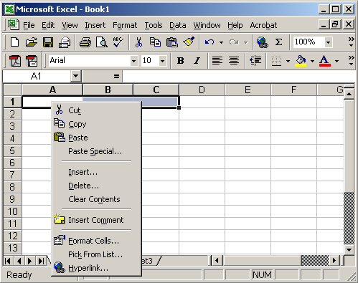 | Tab provided does not have a good directory which will make an emotion to the user such as anger. This is because user might click on the wrong tools. Those icon used is not familiar especially to those beginners.
 | Besides that,those colour that have been choose for those tools is too dull and not attractive. Mostly it used grey colour and its will make the user confuse . This shows that the interface did not provide good features for user to focus on specific things .
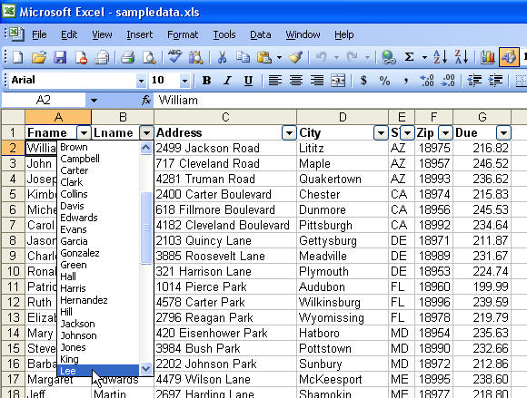 | The figure shows that Microsoft Excel interface look crowded. This caused narrowspace between the document representation and the tools button.
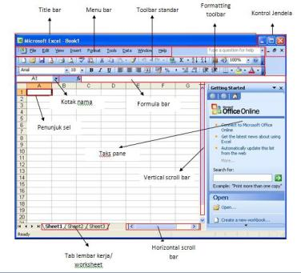 | User of previous versions will find Microsoft Excel easy to use. However, those who are new to Microsoft Excel may find it less user-friendly, requiring more effort to locate common features and formatting options. The user interface in Excel is not as streamlined as other software, and Excel also turns on options by default that users may find annoying, like some auto-formatting settings.

USABILITY GOALS
A good interface required 7 features of usability goals which are efficiency, effectiveness, safety, learnability, utility, and memorability. However, the interface above shown out of the given requirements. So the conclusion that can be made from the features above is it is a bad interface design that needs to be improved for future use.
USABILITY GOALS | EXPLAINATION
Learnability | For learnability, the software is quite hard to learn especially for beginners. Learnability means that interfaces that allow users to quickly become familiar with them and able to make good use of all their features and capabilities. This is because there is a lot of features in excel which are on the tools bar menu. Those tools are designed in the icon which is quite difficult to recognize their function. It's impossible to learn Excel in a day or a week, it takes time to learn Microsoft Excel which now we can see that there are many learning sessions about Excel Workshop.
Memorability | Memorability means that the ability of a user to come back to the website after an extended period and not need to relearn how to use it. As we can see mostly Microsoft Excel use the same colour for their tools bar in the menu. Users will have difficulties in remembering those tools. To overcome this problem they should use different types of colour so that the user can differentiate each icon.
Efficiency | Efficiency means that how fast they can accomplish their goal using the website. There are too many complicated buttons on the menu which is not efficient because it took too many steps to do one task.
Effectiveness | Effectiveness is more related to how after one understands the navigation, organization and functionality; it should be easy for users to carry out their tasks. This can be said because here are some task that user can accomplish completely due to some factor.

PURPOSE
MYUTM portal https://my.utm.my/ was developed to provide an easy access to retrieve various kinds of systems available in UTM, to obtain personal data and information, and to learn about the latest news and events from just one single page. This portal is used by lecturers and students from UNIVERSITI TEKONOLOGI MALAYSIA(UTM). Student’s can access all their profile data information, lecture notes , to submit as assignment and others.
IMAGES INTERFACE
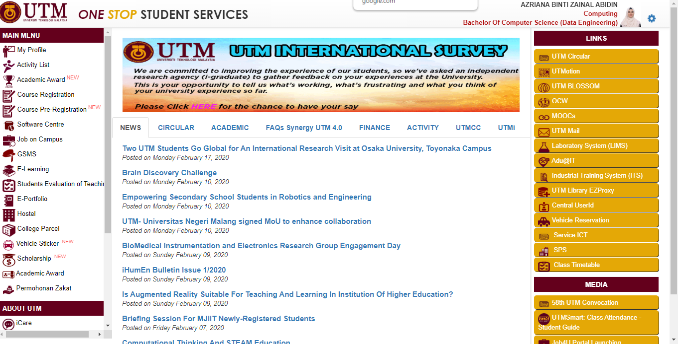
These are the sample pictures of MYUTM portal where there is a lot of good interface due to their design which make user easy to use it especially to beginners.
Figure 3 : MYUTM INTERFACE DESIGN
Figure 1 :The colour is dull ,not attractive

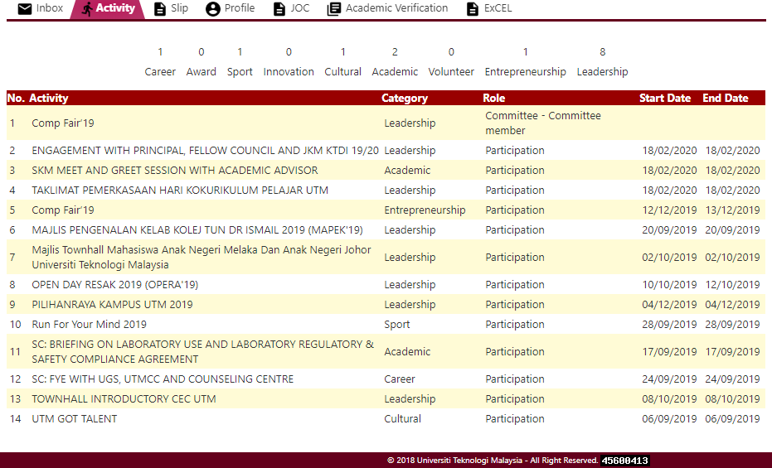
Figure 4: MYUTM activity list

ASPECTS YOU FIND GOOD AND BAD.

INTERFACE | EXPLAINATION
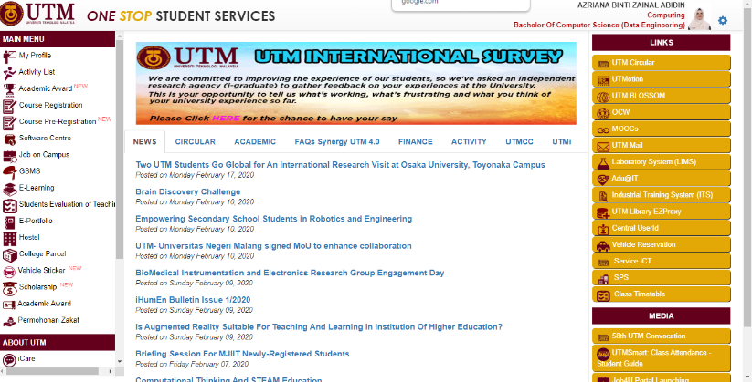 | This figure shows that the interface design of the portal which is quite attractive because it’s not crowded and have a plenty space which make it look organized. The colour used also make the interface look good . We can see that the colour of the header and the background is contrasting.
 | This figure shows that the interface already provided the list of activities provided for the students to join. This will make students always up to date to any new activity in UTM. So then they can easily add their UTM merit .
 | From this figure we can see that the interface using a familiar icon to represent the button. This will avoid user get confused and it is user friendly because user can easily recognize those button based on the icon.
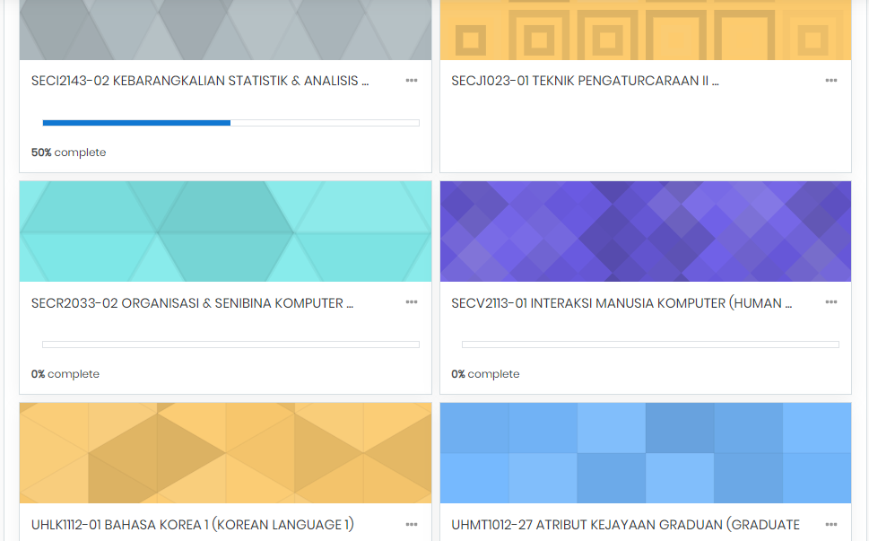 | A user interface is a vehicle that takes you places. A good interface should allow you to perform those functions faster and with less effort. So here the figure shows that a list of a subject taken by students that contain those lecture notes to ease their task.
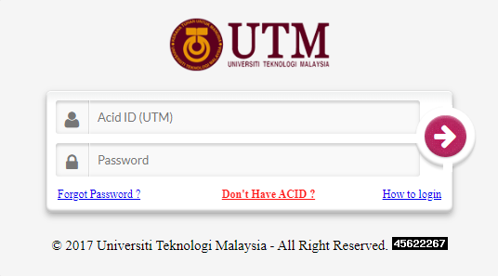 | The figure shows that MYUTM portal required a login system which will make the system more secure and all the user private information will be keep privately.

USABILITY GOALS
A good interface required 7 features of usability goals which are efficiency, effectiveness, safety, learnability, utility, and memorability. However, the interface above shown out of the given requirements. So the conclusion that can be made from the features above is it is a good interface design that can be an example for other application.
USABILITY GOALS | EXPLAINATION
Learnability | For learnability, the portal is quite easy to learn especially for beginners. Learnability means that interfaces that allow users to quickly become familiar with them and able to make good use of all their features and capabilities. This is because instructions provided are clear enough to the user. So it is impossible if there is any problem regarding how to use it.
Memorability | Memorability means that the ability of a user to come back to the website after an extended period and not need to relearn how to use it. It combined white, red and maroon colour. As we can see, the interface used different type of colour which make user more familiar to recognize those button.
Efficiency | Efficiency means that how fast they can accomplish their goal using the website. UTM portal really minimizing numbers of step to do any task because user does not have to explore many buttons. This is because each of the button will directly go to the task that you desire. For example to see lecture note, user have to click “E-Learning” only.
Effectiveness | Effectiveness is more related to how after one understands the navigation, organization and functionality; it is easy for users to carry out their tasks. This prove that MYUTM portal achieved the effectiveness of usability goals.
Safety | Safety means that any errors are recoverable and it will not pose any danger to the user. MYUTM portal prioritizes the safety of the portal which makes the user feel safe to use the portal. This portal protecting the users from dangerous errors, for example losing all the user’s data or protecting the user’s confidential information.

