A Report Regarding a Visit to CICT.
1 October 2018.
Nor Bahiah Binti Hj. Ahmad.

Group 9teen-1 ;
- NURUL HANA BINTI AZAM
- NURUL AIN NADHIRAH BINTI SHAMSUL BAHRIM
- SAFIRA NURUL IZZA
- NUR IZZAHTUL SYAFIQAH BINTI MOHAMAD FADZIL
- MD SAMSUL ALAM RONY

BIL. | Contents | Page
1. | Introduction | 3
2. | Organization structure | 4
3. | CICT services | 5-6
4. | Achievements | 7
5. | Developed Information System | 8-15
6. | Reflection | 16
7. | Conclusion | 17
8. | Appendices | 18-20
9. | Reference | 21
TABLE OF CONTENT.

INTRODUCTION

Centre for Information and Communication Technology (CICT) is a centre that provides everything that related to technology, ICT services and information system for university staffs and students. CICT also means Creative, Innovative, Cohesive, and Technopreneur. Technopreneur is a combination of Technology and Entrepreneur words that brings a meaning of an entrepreneur of high technology.
The objective of CICT are to provide services that related to all development of system or support system either in ICT infrastructure or academic activities. For example, the website of my utm was created by CICT staffs and it is making the process of teaching and learning activities become more efficient and easiest for all lecturers and students especially e-learning. The services that being offer by CICT to students are student lab, UTM ID/ACID, WiFi, and VPN.

ORGANIZATIONS STRUCTURE
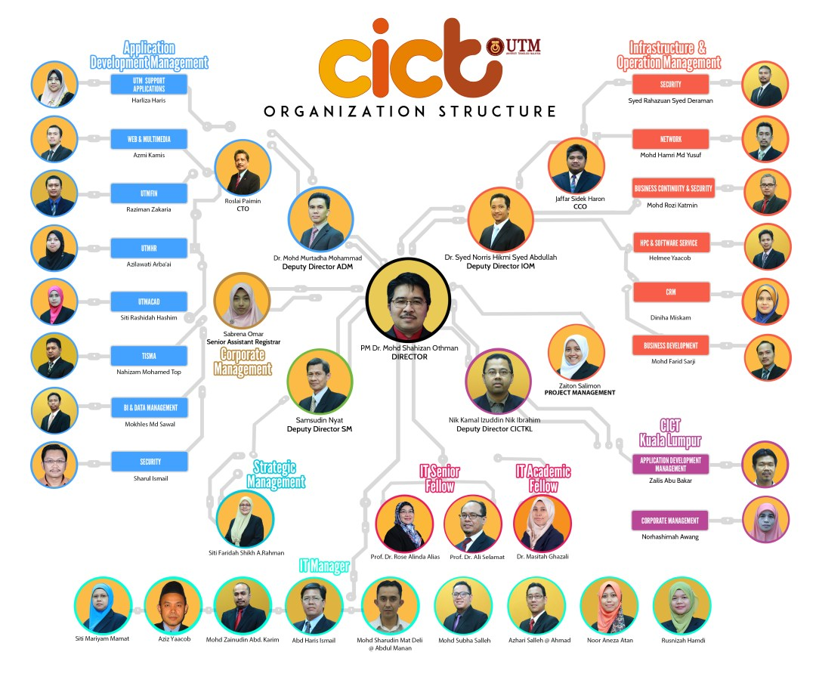

CICT SERVICES
There’s a lot of services provided by CICT including infrastructure and security, application development, and also software. Basics ICT services are PPICTP, Wi-fi UTM, VPN, ID account and access and video conference and streaming. Below are the description of basics CICT services.
ID Account and Access
ACID is a unique ID of user through the authentication server that help the user to log into the university systems. After registering the program, all students have their own user ID according to their respective faculties. Meanwhile, the staff must have a mail account official UTM first before applying ACID account.
Email
Starting from 28th June 2015, UTM is officially migrated from Desknow to Gmail in order to improve email services to all UTM community, especially UTM staff.
UTM move from Desknow to Gmail for several reasons which are :
- Unlimited Mailbox Quota
- Reliable services.
- 99.99% availability.
- Integrated with all Google Cloud Tools (Google Docs, Google Drive, etc)
- Google Calendar including free SMS for sending reminder.
- Link to Google Scholar Citation; to keep track citations of academic articles.
- Powered by Google – energy efficient data center.
- Can be accessed anywhere.
UTM Hosting
CICT offer hosting services like web hosting, server hosting and colocation server hosting to UTM community and external customer for conference, association or club activity, special events with reasonable price.
CICT provides a dedicated server to enable customer to make the best customization and configuration of servers and applications.
UTM Ads
CICT encourage all of UTM staff or interested parties to promote and advertise their product brand to UTM citizens. This advertising platform Is the first of its kind in Malaysia. UTM Ads platform will insert digital advertiser banner direct into a user browsing session via campus Hotspot Wi-Fi network (UTMJB and UTMKL) and endorse the product brands and its contents. The banner impression will continuously be repeated during the browsing session even they change the website page as long as the user is using campus Wi-Fi network.
Virtual Private Network (VPN)
A virtual private network, also known as a VPN is a private network that extends across a public network or internet. Users are free to send and receive data across shared or public networks as if their computing devices were directly connected to the private network.
Wifi
The key features of hotspot in UTM is unified login portal. By using ACID account, student and guest can login to access the internet. While admin or academic networks are mostly wired in faculties and admin offices. Colleges’ network is mostly Wifi and wired in certain buildings.

ACHIEVEMENTS
In 2017, there’s two achievements acquired by CICT. CICT had received an award for Standard Accounting System for Government Agencies 2017 (PENGANUGERAHAN SIJIL PEMATUHAN SAGA) that was presented by Accountant General’s Department on 22th of November 2017. (Refer Appendix 1)
UTM are among 59 out of 416 agencies that have received acknowledgment for their best services besides another public universities USM, UPSI, UMP, UPNM, UNISZA, UTHM and UPM.
On 7th February 2017, CICT had won the most actives PTJ in Senamrobik Perdana for the second series 2/2017 for Acturus Zone at Azman Hashim Stadium, UTM Johor. About 50 out of 123 supporting and high-spirited staff joined and contributes 40.7% to statistics on staff presences for the activites. (Refer Appendix 2)

INFORMATION SYSTEMS THAT HAVE BEEN DEVELOPED OR MAINTAINED BY CICT
To improve university’s service efficiency and quality, CICT build and manage administrative-support, multimedia, teaching, and learning application.
New application which are web base and mobile was develop and the current Utm application base are still maintain used request by PTJ in term of data requirement.
The key feature in CICT developed:
- Administrative Applications Development Tools/Technology
- Teaching and Learning Applications Development
- Support Applications Development
- Web Applications Development
- Montage and Video Production
- User Requirement Specification
- Documentation preparation
- Mobile & Web Programming

Types of computer used by different generation:

- Mainframe Terminal (model IBM 3471 infoWindow)
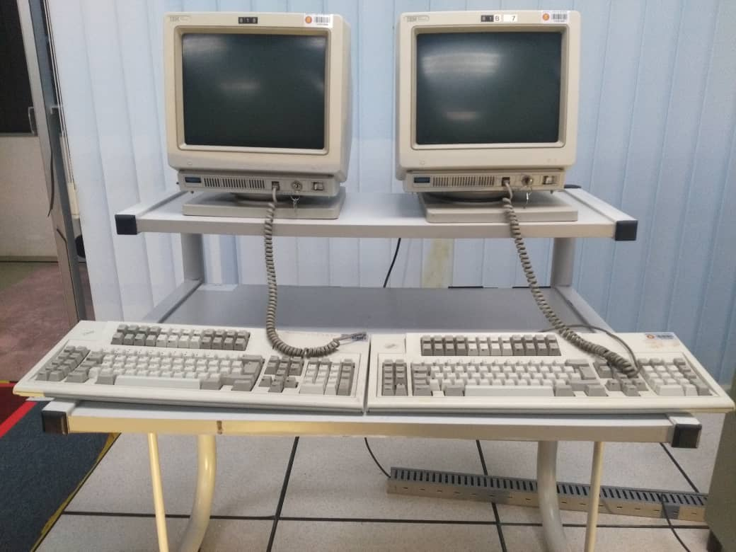

2) Controller (model: 3274 41D)
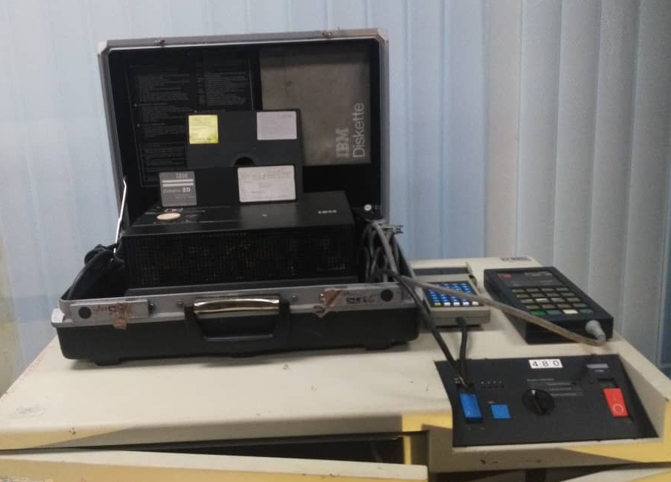

3)IBM Mainframe CPU (model: IBM 9672-R21)
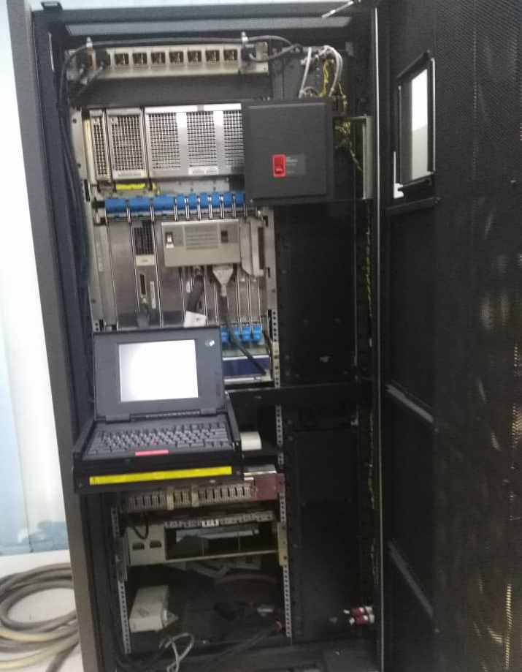

4) Mainframe main system power (model: IBM 9309 2)
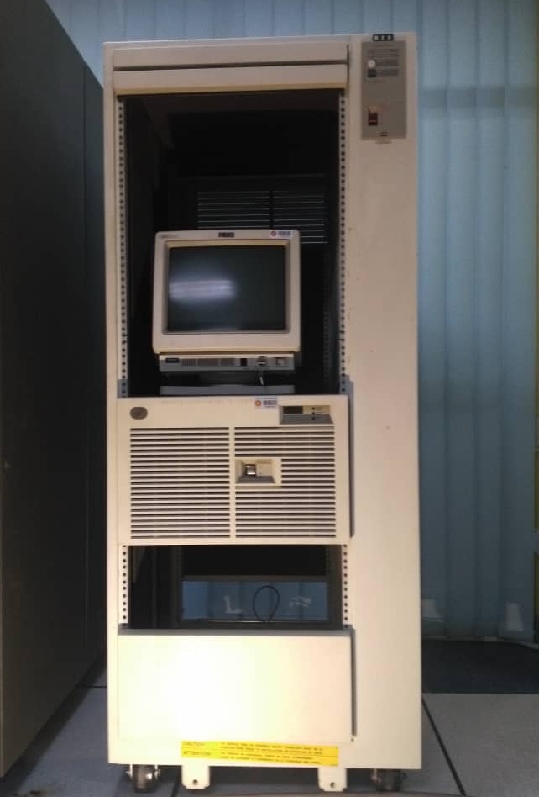

5) IBM tape drive systems (model: IBM 3490E A10)
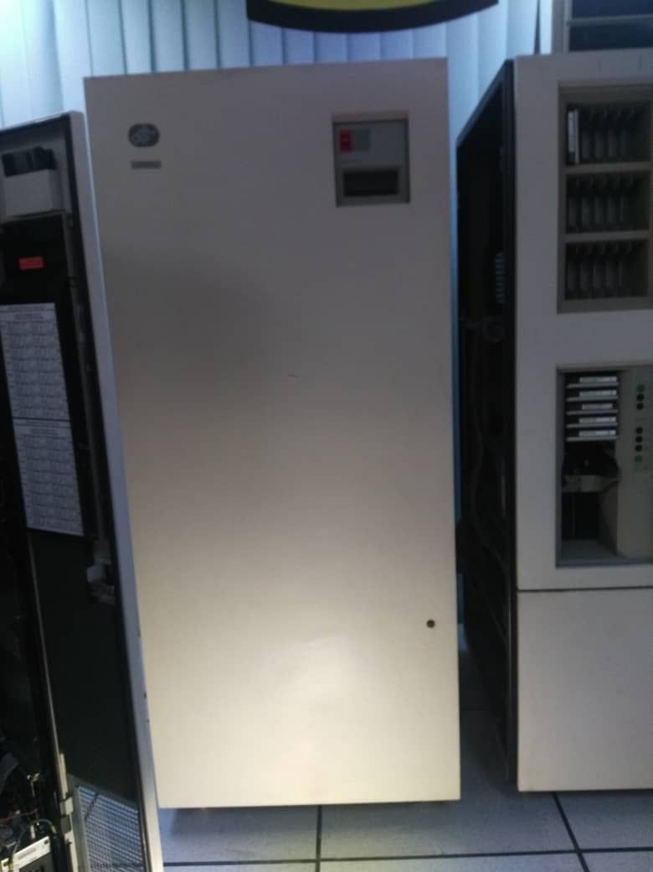

6) Mainframe data storage (IBM 9394 2)
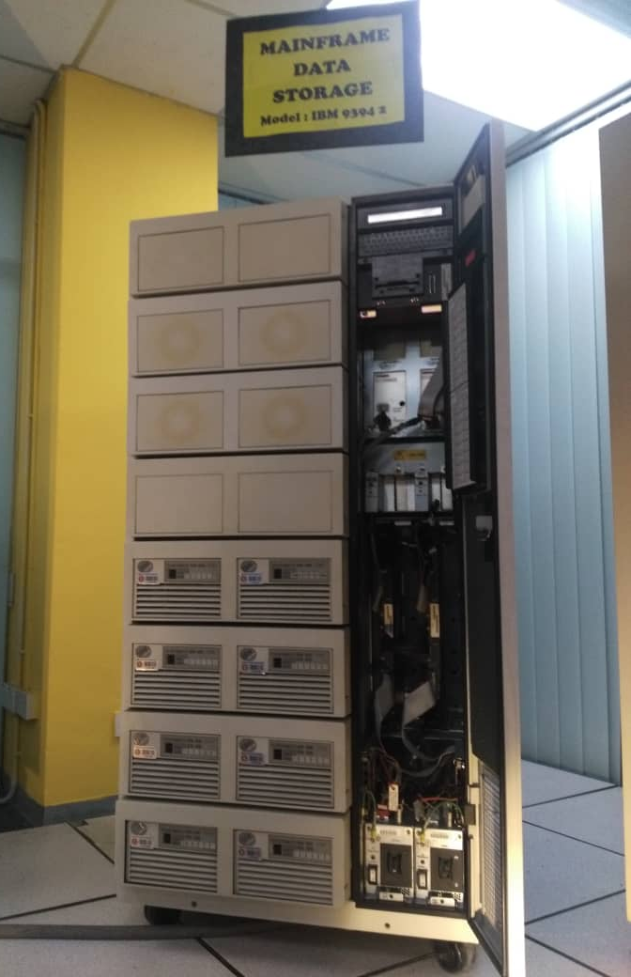

7)Mainframe tape subsystem control drive (model :IBM 3422 A01)
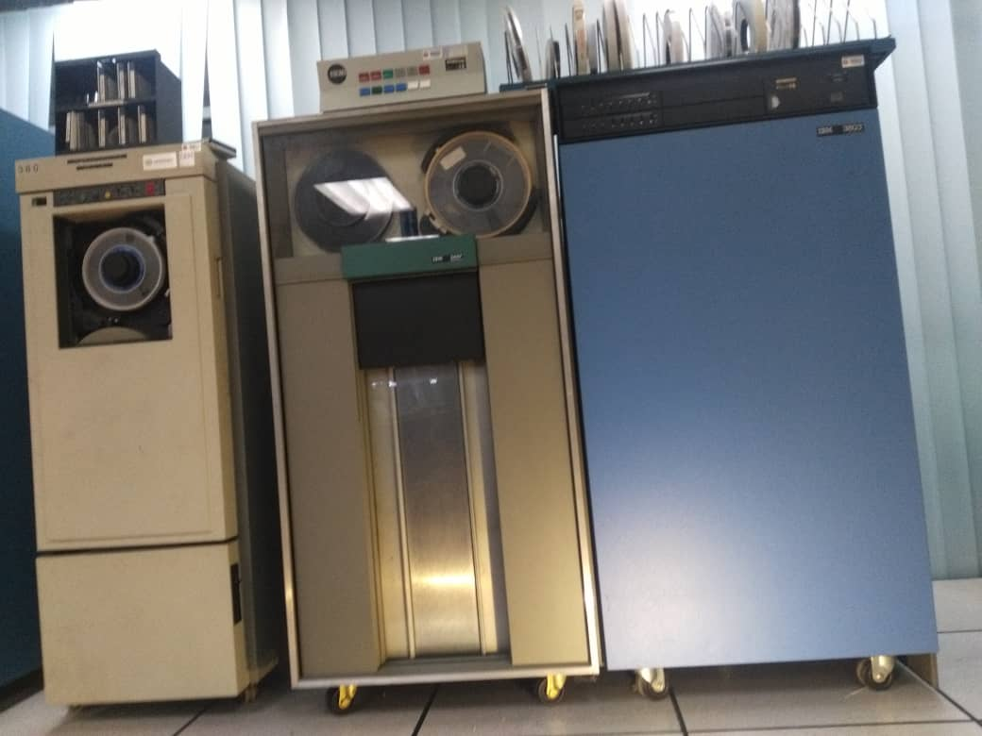

8)IBM Magnetic Tape unit(IBM 3420)
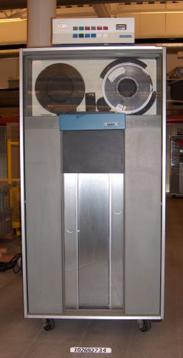

9)Impact printer(model :IBM 4245 12)
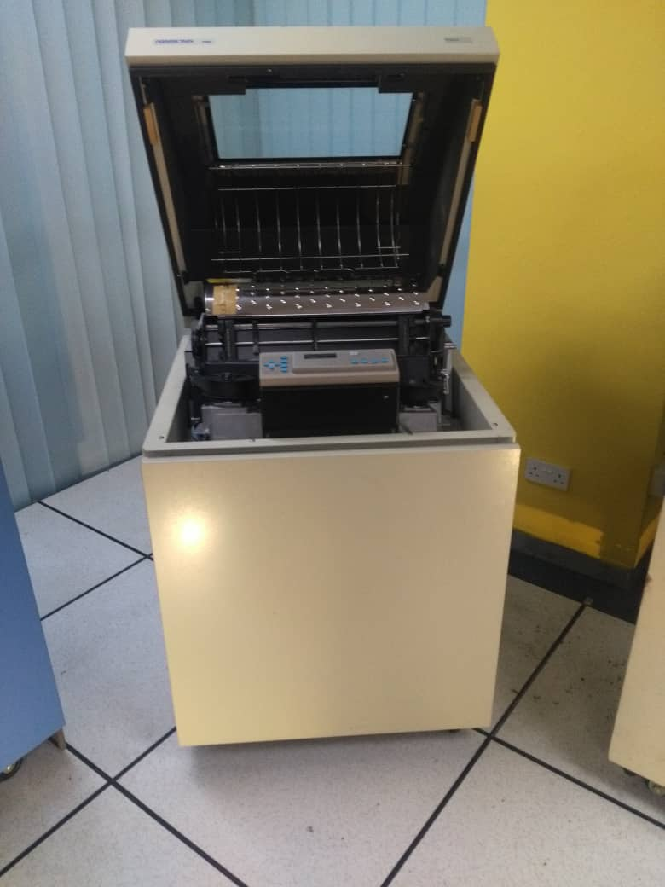

10)Tower server power edge
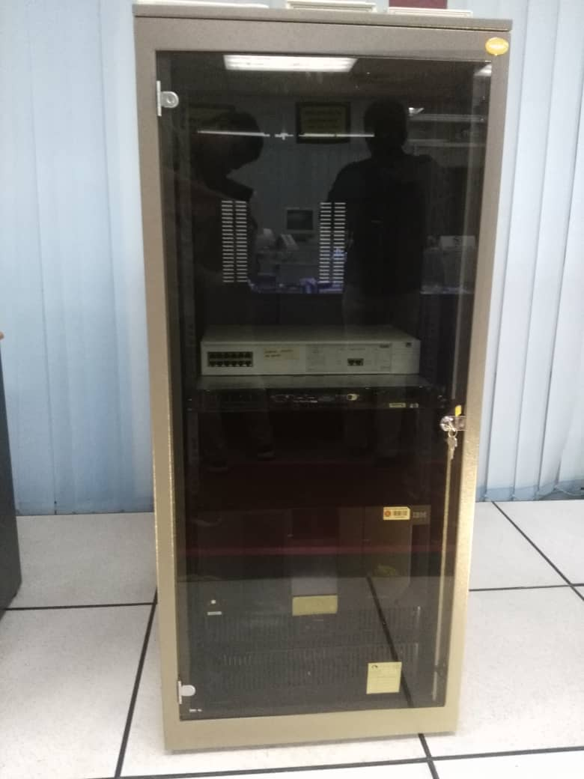

11)Rack mount server (model: com-rack)

Some parts in computer or system used:
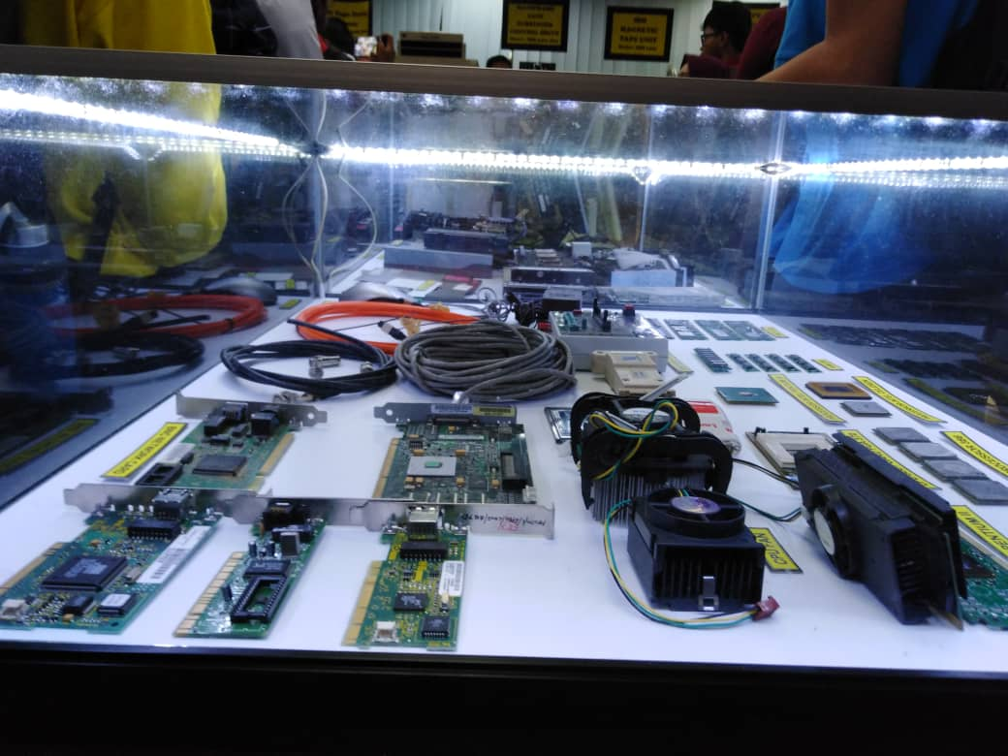
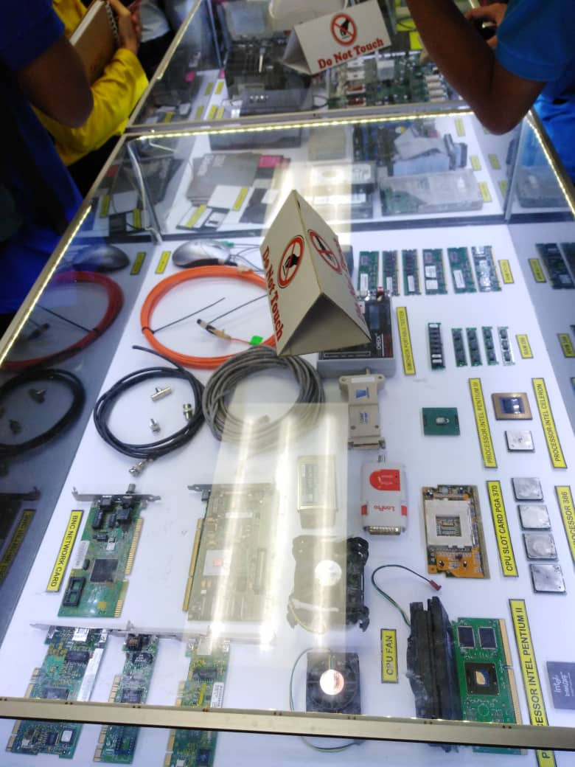
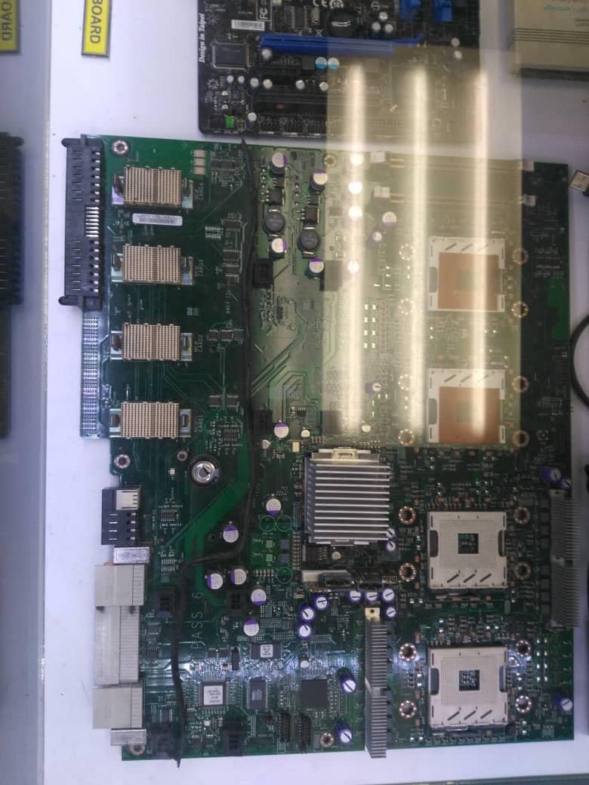
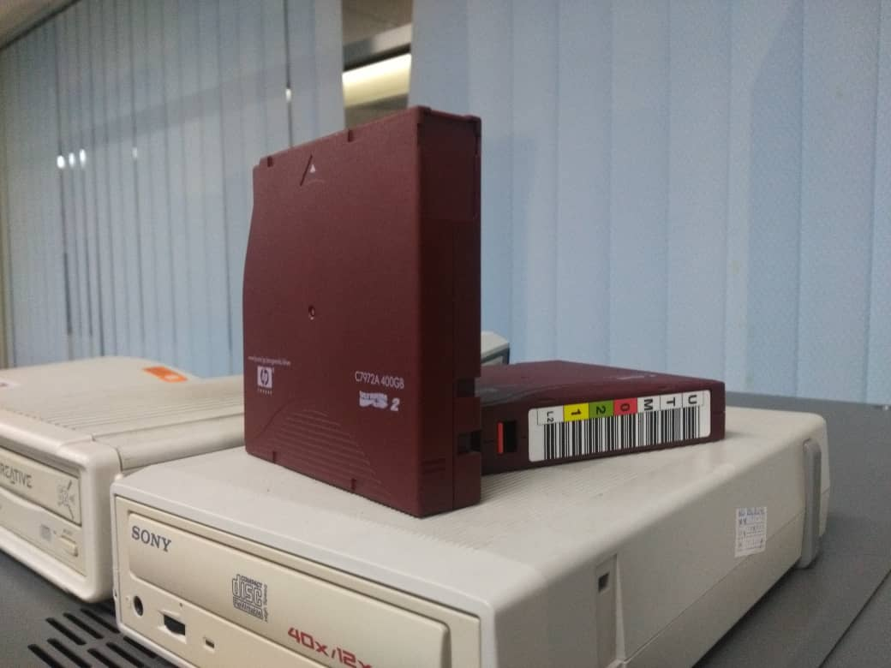
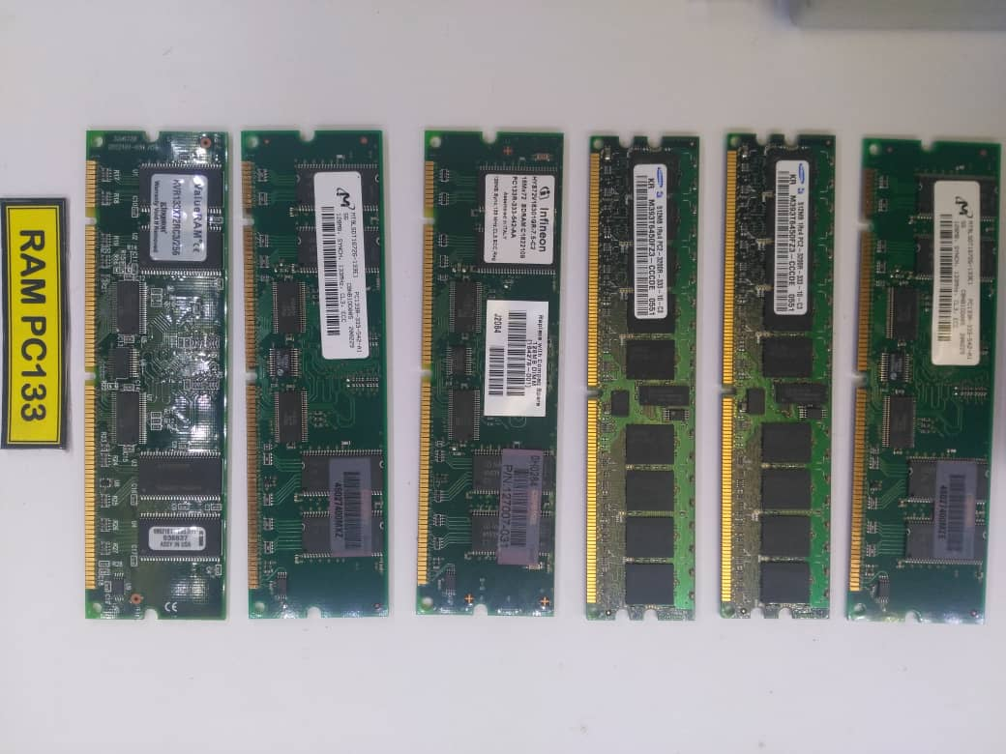
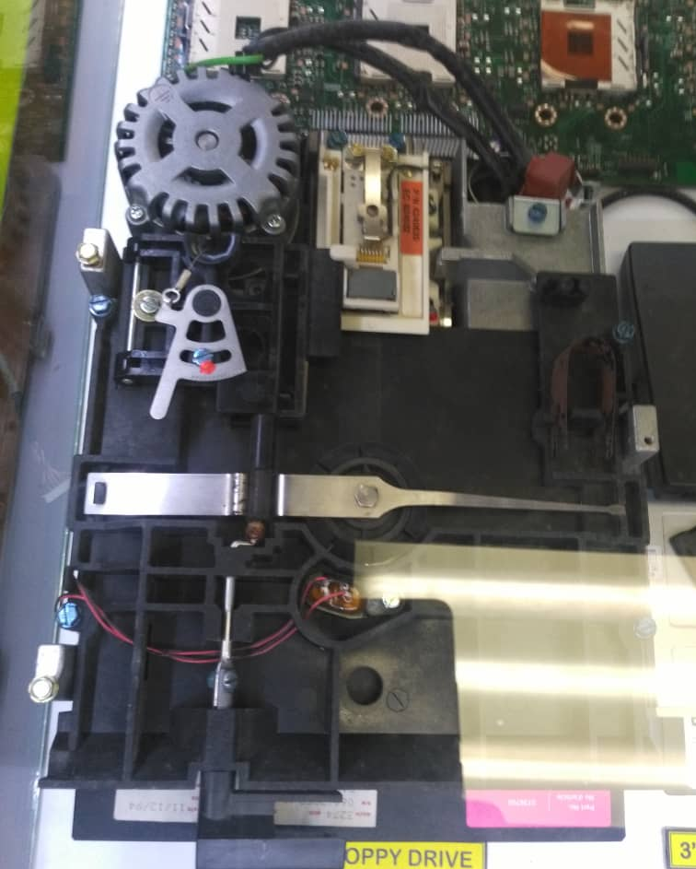

Different type of laptop used in different generations:

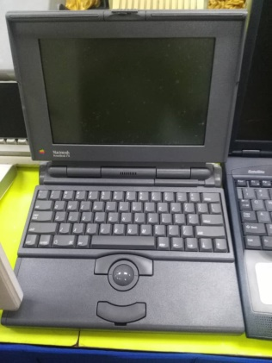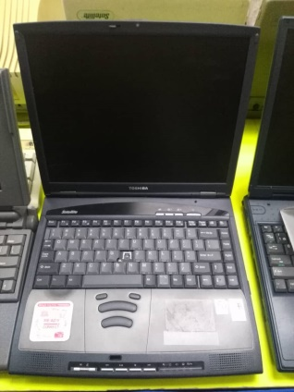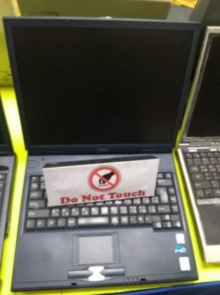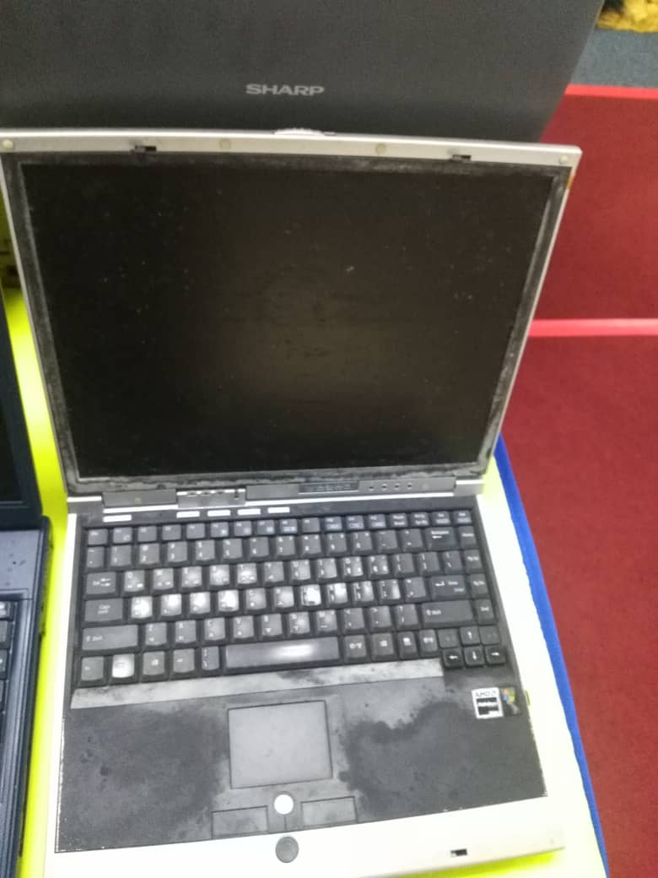

Reflection

The development of computer technology is needed to facilitate the public. The development of hardware technology must also be balance with the development of software technology. Because software technology relates directly to users and is created to make it easier to apply technological developments.
Software engineering is part of computer science, more precisely the development and construction of computer system software and application software. The software system consists of programs that manage computing utilities and operating systems. Software applications include user-focused programs, such as database programs, web browsers, and others. Our goal of studying software engineering is because we want to create and make computer technology easier for all people to use.
After our visit to CICT, we got to know more about technology development from time to time. From the first time the computer was created to become sophisticated as it is now. Technology is very helpful for humans to solve various problems. However, there are a lot of people that cannot operate technology optimally. As in certain city, only a few people can operate technology well, we afraid that my country will be left behind with other big countries. Therefore, our goal is to make technology easy to be use for all people.
Identifying the goal is the first thing to improve our potential in the industry. After visiting CICT we have learnt something very important in our life. And the thing was about our goal. Thanks to you Dr. for giving us the opportunity.
Of course, we want to be a person who is successful in our career. The meaning of career success varies from person to person. We are the student of software engineering. From our point of view, career success means to have a lots of client who wants to develop their software. So we need a very good presentation skill.

Conclusion

Our aim of life changes with the change of time. No one knows what will be the career for us until we meet our destiny. It doesn’t matter how careful or how prepare you are, your career can be anything. So the action/improvement plan can be changed in the future.

Appendices
Appendix 1

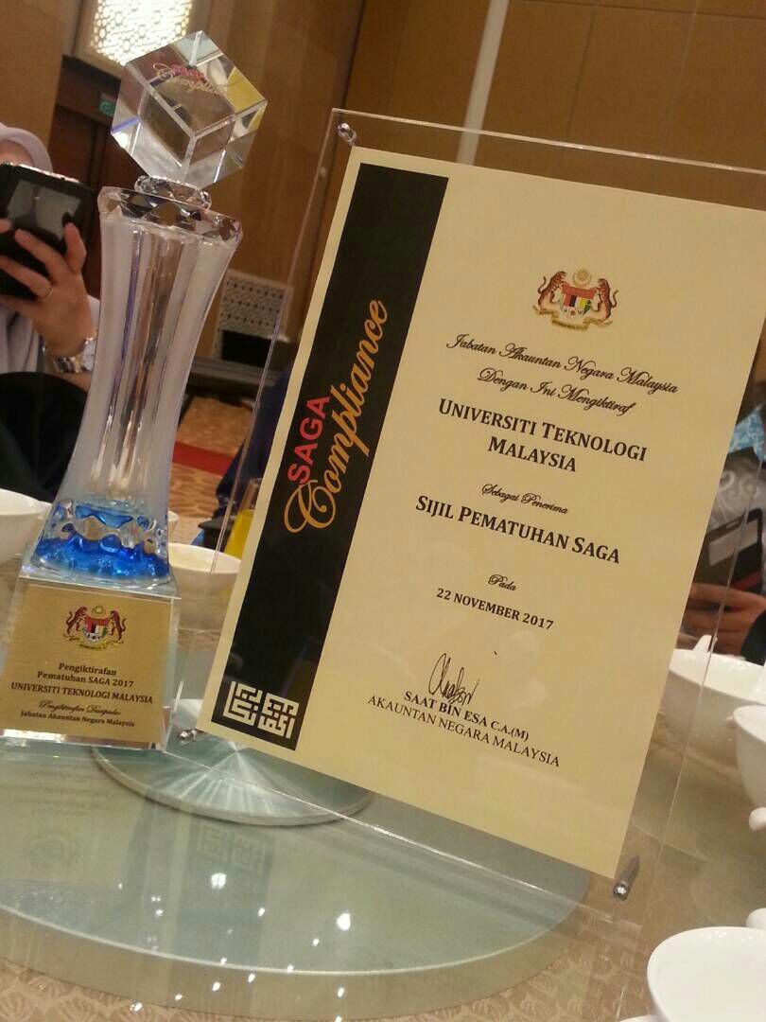

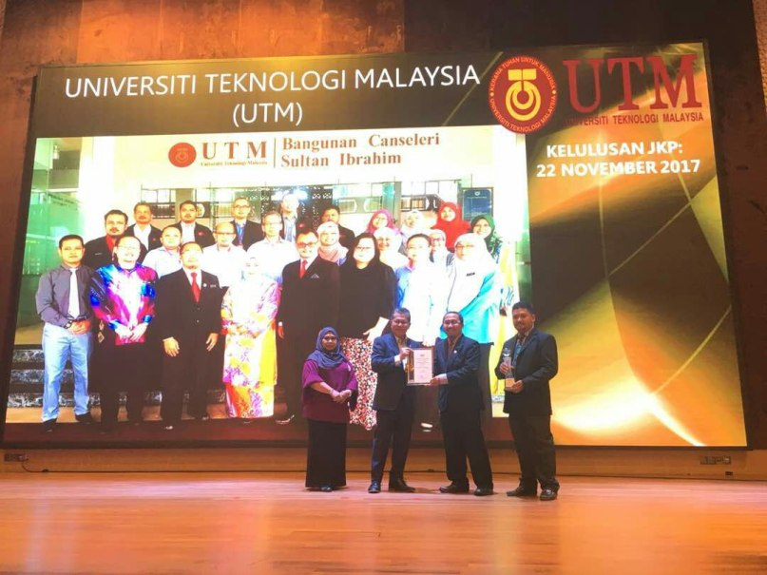

Appendix 2

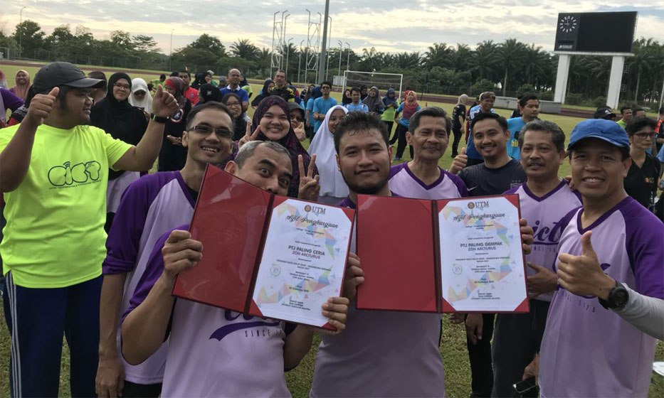

Reference
- http://cict.utm.my/ict-services/system-development/

