Semester I 2020/2021

SUBJECT : Technology and Information Systems (SECP1513)
SECTION : 03
ASSIGNMENT : Step by step PC Assembly

GROUP NAME / NUMBER : 08

1 |  | Name: Jonathan Ting Moi Yao  Matric Number: A20EC0194  Phone Number: 01133837701  Email: ting2001@graduate.utm.my
2 |  | Name: Yu Kok Yong  Matric Number: A20EC0232  Phone Number: 01137338263  Email: boonyangju22837508@gmail.com
3 |  | Name: Cha Zhi Ye  Matric Number: A20EC0022  Phone Number: 01115670422  Email: chazhiye@gmail.com
4 |  | Name: Lee Wan Fu  Matric Number: A20EC0066  Phone Number: 0177356440  Email: leefu@graduate.utm.my

PART A – List at least FOUR tools needed to assemble a PC. For each tool, provide picture(s), explanations of its functions and its importance.

- Screwdriver
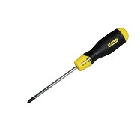
The screwdriver is to tighten the screws that are about the whole casing. Normally all the screws of a casing and the screws that are needed to be screwed on the mother board are the same size, so you only need to have a one size screwdriver only. The most ideal screwdriver is those that is magnetic. That way, you can pick up the screws easily from the container.
Recommended: Phillips Screwdriver QM-STVR 12 Inch Screwdriver (Magnetic Tip, Cross Head Number 2).

- Anti-static wrist strap
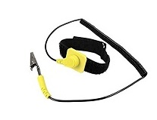
It is a bracelet-like thing that straps on your wrist. Just as the name says, it prevents you from getting static shock. It connects to an electric socket, and if any electrical charge builds up between you and your hardware components, the charge is safety dissipated through to the socket (avoiding a spark and potentially causing damage to your parts).
Recommended: Rosewill RTK-002 Anti-Static Wrist Strap Band

- Thermal Compound/Thermal paste
Example: Arctic Silver 5 High-Density Polysynthetic Silver 3.5 g

Thermal paste (also called thermal compound, thermal grease, thermal interface material (TIM), thermal gel, heat paste, heat sink compound, heat sink paste or CPU grease) is a thermally conductive (but usually electrically insulating) chemical compound, which is commonly used as an interface between heat sinks and heat sources such as high-power semiconductor devices. The main role of thermal paste is to eliminate air gaps or spaces (which act as thermal insulation) from the interface area to maximize heat transfer and dissipation. Thermal paste is an example of a thermal interface material.

- Twist ties or Zips
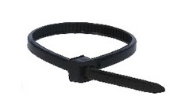
Twist ties are used to tie up any loose cables from the power supply. The result will produce a much neater cable management and it also provides better air flow. We do not fit these too tight around your cables as you could damage them. To cut the ends of your ties once you have fitted one you can simply use sharp scissors

- Flashlight
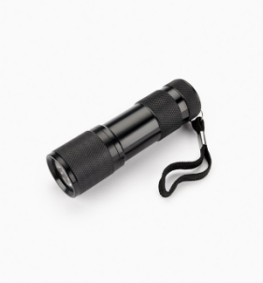
Some corner edges of the casing might be harder to see if there is not enough light source. A better option would be a lamp that has an adjustable neck that you can place beside your build and angle right inside of your case. Even better would be a headlamp, which may feel a little over the top but would be most convenient and frees up both your hands to properly handle your components with care.

- Needle-nose plier
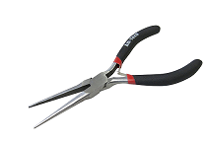
You could use pliers for loosening up screws or bolts that are super-tight, picking up hard to reach screws that you may drop within your case and cutting zip ties. Always remove screws that you dropped inside the casing, as it pose the possibility of causing an electrical shortage.

- Rubbing alcohol
For cleaning off old thermal paste or any other PC components, rubbing alcohol is the easiest solution. Some heat sink will have thermal paste already applied to the metal surface but that would be all dried up. Rubbing alcohol is a strong enough solvent to dissolve grime, but it evaporates quickly and without leaving residue or causing corrosion. This makes it ideal for wiping-down metal contacts inside keyboards or elsewhere. Allow sufficient time to dry before applying any kind of thermal paste. High alcohol content solutions dry in a matter of seconds to a minute.

- Extra screws
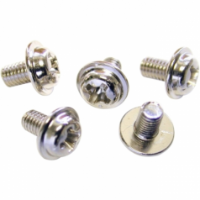
Just in case you lost some screws when you are building your PC, it is a great idea to prepare some extra screws just in case there is not enough of it.

- PSU cables
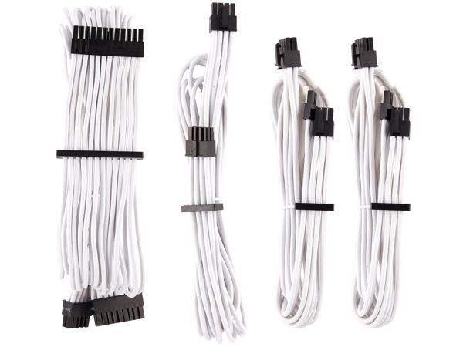
Just in case the power cables that comes with the power supply unit have defects.

Recommended: Corsair CP-8920217 Premium Individually Sleeved PSU Cables Starter Kit Type 4 Gen 4 - White

PART B – Sketch of a mother board layout

- Motherboard layout sketching
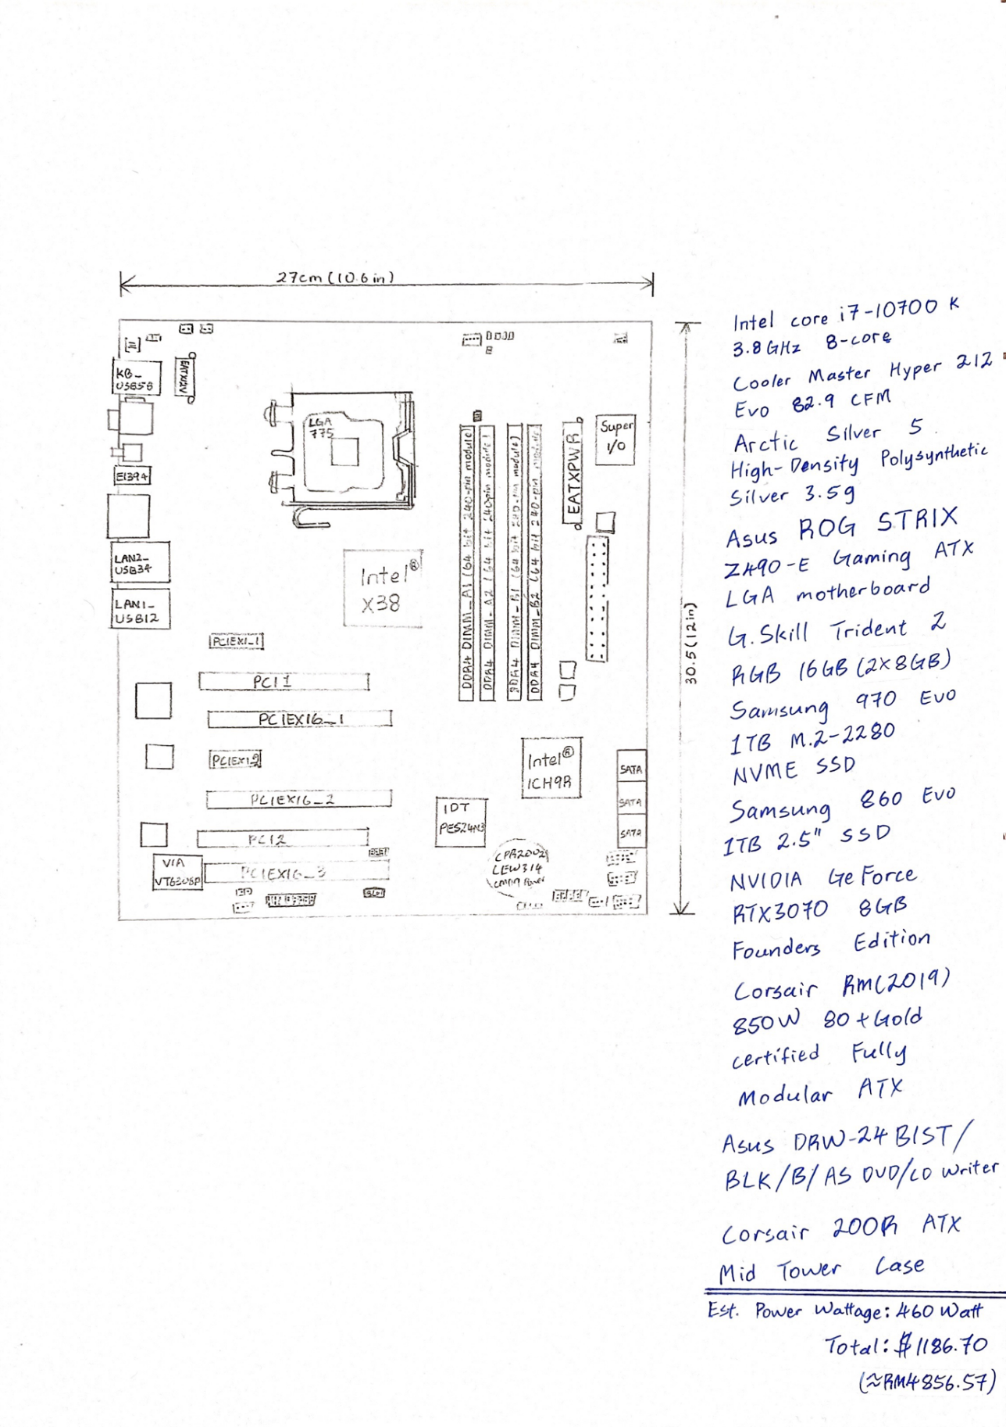

- For each keyword in Table 1.0. Provide picture(s), explanations of its functions and example of models.

- Graphics card
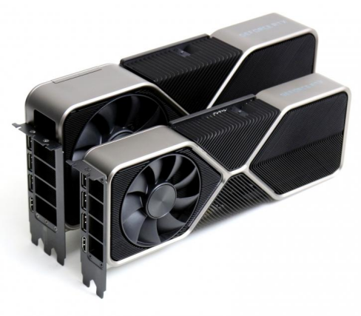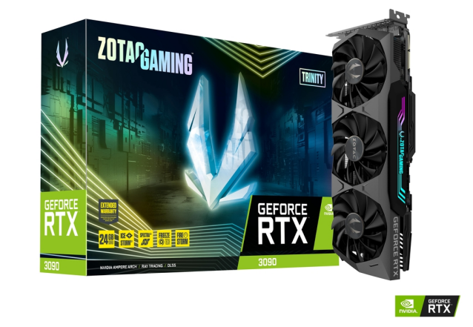

NVIDIA GeForce RTX™ 3090 Founder’s Edition
A video card (also called a graphics card, display card, graphics adapter, or display adapter) is an expansion card which generates a feed of output images to a display device (such as a computer monitor). The better your graphics card the better, and smoother an image can be produced. This is naturally very important for gamers and video editors.

TYPES OF GRAPHICS CARDS
Integrated – Graphics built into the motherboard where no add-in card is used. You’ll find these built into most ‘standard’ laptops and computers; they are a cost-effective model but cannot be easily upgraded.
Dedicated – An add-in graphics card that is installed on to the motherboard as an extra component. Ideal for those wanting to modify their system by upgrading the graphics cards.
Most people using a modern computer for standard tasks like surfing the internet, creating documents, or watching movies will be fine using the integrated graphics. For users branching out into gaming or video editing, a discrete graphics card is usually needed to speed up the image processing time. Without this, the user may find their game lagging or jittering at crucial points.

GPU
GPU stands for Graphics Processing Unit. It is the brain of the graphics card and is what creates the visuals you see on the screen. The GPU works as a translator, it takes data coming from the CPU and transforms it into imagery. More complex visuals, like you find in high-definition games require more complex and quicker GPUs to accommodate the stream of data.

EXPANSION SLOTS
You can expand your PC internally by adding additional cards. Over the years graphics expansion slots have changed significantly from PCI (Peripheral Component Interconnect), AGP (Accelerated Graphics Port) to the latest PCI-E (Gen1/2/3) (PCI-Express) which offer the best bandwidth.

NVIDIA GeForce Generations Timeline
1999 | GeForce 256 | 2010 | GeForce 400 series
2000 | GeForce 2 series |  | GeForce 500 series
2001 | GeForce 3 series | 2011 | -
2002 | GeForce 4 series | 2012 | GeForce 600 series
2003 | GeForce FX series | 2013 | GeForce 700 series
2004 | GeForce 6 series | 2014 | GeForce 800M series
2005 | GeForce 7 series |  | GeForce 900 series
2006 | GeForce 8 series | 2015 | -
2007 | - | 2016 | GeForce 10 series
2008 | GeForce 9 series | 2017 | -
 | GeForce 200 series | 2018 | GeForce 20 series
2009 | GeForce 100 series | 2019 | GeForce 16 series
 | GeForce 300 series | 2020 | GeForce 30 series

- Central processing unit (CPU)

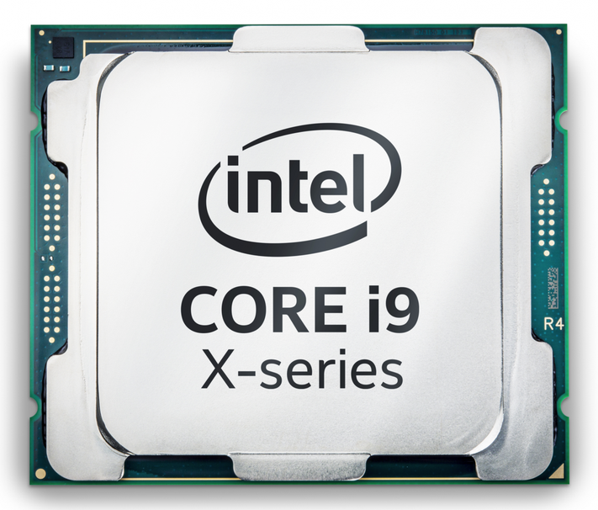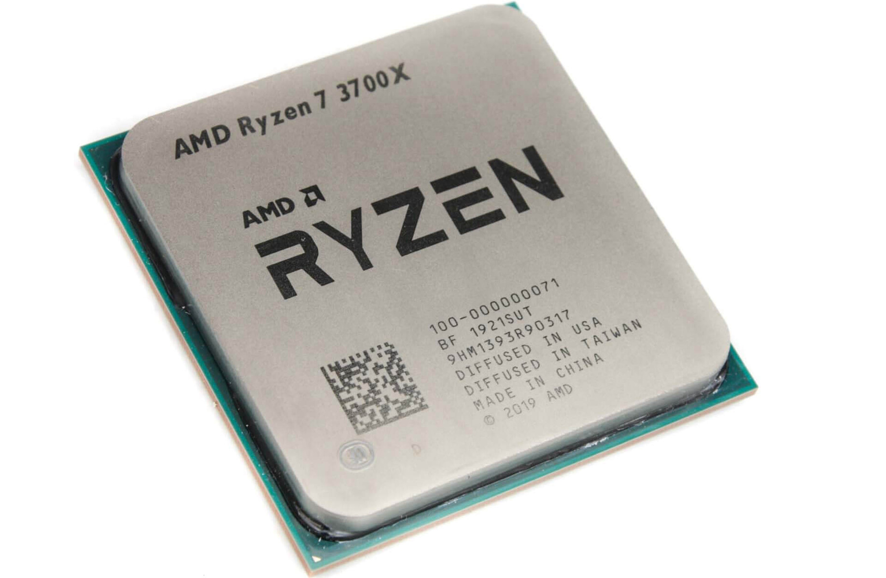

A central processing unit (CPU), also called a central processor, main processor or just processor, is the electronic circuitry within a computer that executes instructions that make up a computer program. The CPU performs basic arithmetic, logic, controlling, and input/output (I/O) operations specified by the instructions in the program. This contrasts with external components such as main memory and I/O circuitry, and specialized processors such as graphics processing units (GPUs).

The computer industry used the term "central processing unit" as early as 1955.

The form, design, and implementation of CPUs have changed over time, but their fundamental operation remains almost unchanged. Principal components of a CPU include the arithmetic logic unit (ALU) that performs arithmetic and logic operations, processor registers that supply operands to the ALU and store the results of ALU operations, and a control unit that orchestrates the fetching (from memory) and execution of instructions by directing the coordinated operations of the ALU, registers and other components.

Most modern CPUs are implemented on integrated circuit (IC) microprocessors, with one or more CPUs on a single metal-oxide-semiconductor (MOS) IC chip. Microprocessors chips with multiple CPUs are multi-core processors. The individual physical CPUs, processor cores, can also be multithreaded to create additional virtual or logical CPUs.

An IC that contains a CPU may also contain memory, peripheral interfaces, and other components of a computer; such integrated devices are variously called microcontrollers or systems on a chip (SoC).

Array processors or vector processors have multiple processors that operate in parallel, with no unit considered central. Virtual CPUs are an abstraction of dynamical aggregated computational resources.

Intel Core
Intel Core are streamlined midrange consumer, workstation and enthusiast computers central processing units (CPU) marketed by Intel Corporation. These processors displaced the existing mid- to high-end Pentium processors at the time of their introduction, moving the Pentium to the entry level, and bumping the Celeron series of processors to the low end. Identical or more capable versions of Core processors are also sold as Xeon processors for the server and workstation markets.
As of June 2017, the lineup of Core processors includes the Intel Core i3, Intel Core i5, Intel Core i7, and Intel Core i9, along with the X-series Intel Core CPUs.

Example: Intel® Core™ i9-10850K (20M Cache, up to 5.20 GHz)

AMD Ryzen
Ryzen is a brand of x86-64 microprocessors designed and marketed by Advanced Micro Devices, Inc. (AMD) for desktop, mobile and embedded platforms based on the Zen microarchitecture. It consists of central processing units marketed for mainstream, enthusiast and workstation segments and accelerated processing units (APUs) marketed for mainstream and entry-level segments and embedded applications. Ryzen is especially significant for AMD since it was a completely new design and marked the corporation's return to the high-end CPU market after many years of near total absence. This is because AMD's primary competitor Intel had largely dominated this section of the market starting from the 2006 release of their groundbreaking Core microarchitecture (derived from their earlier Pentium 3 core, which continues to underpin its CPU designs to this very day) and continuing for the next ten years.
Example: AMD Ryzen™ 9 5950X (64MB Cache, up to 4.90 GHz)
- (a) USB cable

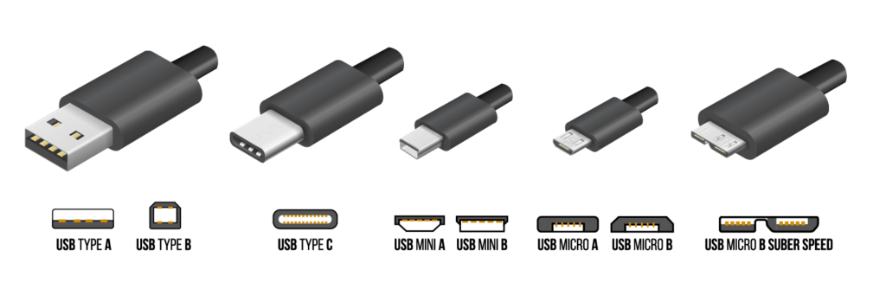

Universal Serial Bus (USB) is an industry standard that establishes specifications for cables and connectors and protocols for connection, communication and power supply (interfacing) between computers, peripherals and other computers. A broad variety of USB hardware exists, including eleven different connectors, of which USB-C is the most recent.

Released in 1996, the USB standard is currently maintained by the USB Implementers Forum (USB-IF). There have been four generations of USB specifications: USB 1.x, USB 2.0, USB 3.x, and USB4.

(b) “On-board USB” (headers)
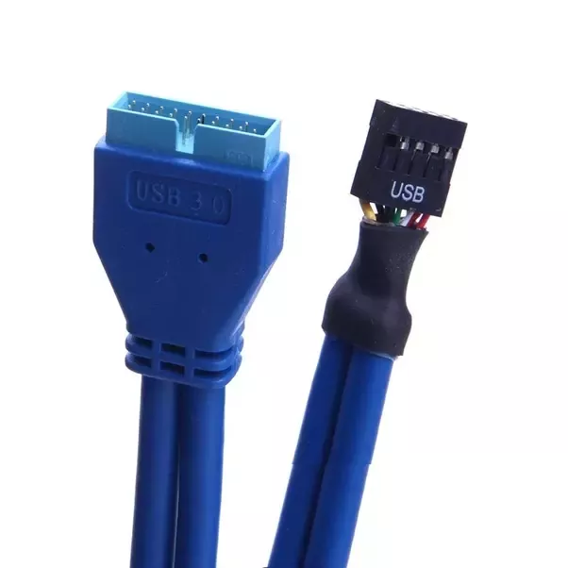 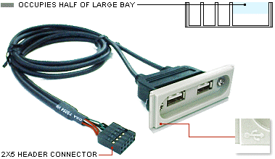 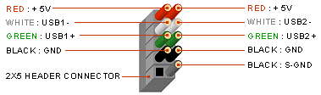 DUAL USB TYPE A INTERNAL
The terminology is a bit confusing, since of course the regular ports are also attached to the board. The “on-board” ports are what others have referred to as “headers”; they are synonymous terms. Headers, however, have a completely different cable interface that is pin based.
- Parallel ATA

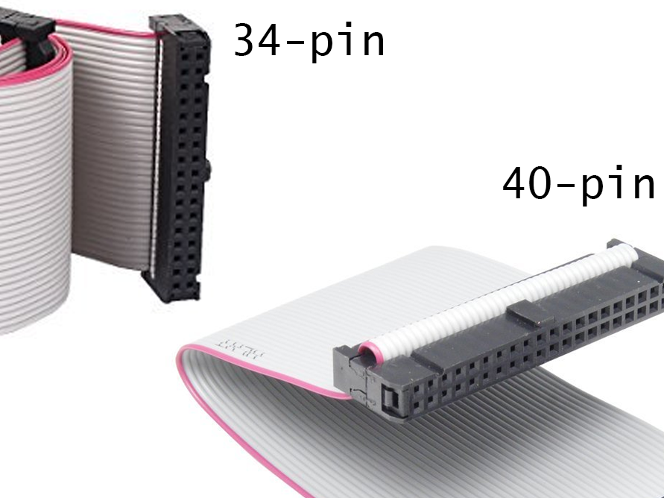

Parallel ATA (PATA), originally AT Attachment, is an interface standard for the connection of storage devices such as hard disk drives, floppy disk drives, and optical disc drives in computers. The standard is maintained by the X3/INCITS committee. It uses the underlying AT Attachment (ATA) and AT Attachment Packet Interface (ATAPI) standards.

The Parallel ATA standard is the result of a long history of incremental technical development, which began with the original AT Attachment interface, developed for use in early PC AT equipment. The ATA interface itself evolved in several stages from Western Digital's original Integrated Drive Electronics (IDE) interface. As a result, many near-synonyms for ATA/ATAPI and its previous incarnations are still in common informal use, in particular Extended IDE (EIDE) and Ultra ATA (UATA). After the introduction of Serial ATA (SATA) in 2003, the original ATA was renamed to Parallel ATA, or PATA for short.

Parallel ATA cables have a maximum allowable length of 18 in (457 mm). Because of this limit, the technology normally appears as an internal computer storage interface. For many years, ATA provided the most common and the least expensive interface for this application. It has largely been replaced by SATA in newer systems.

- Series ATA

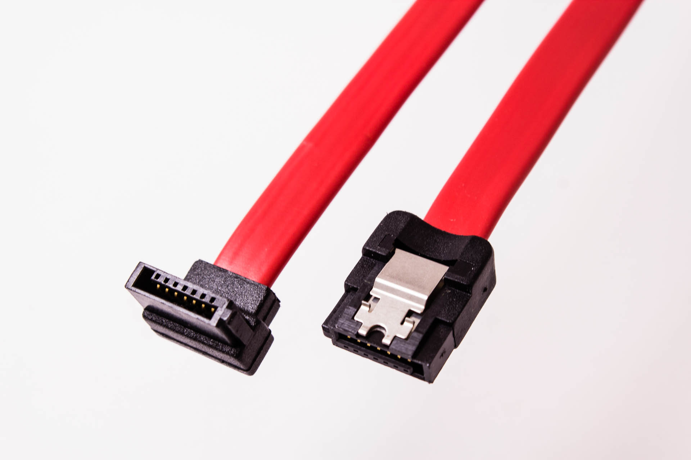

Serial ATA (SATA, abbreviated from Serial AT Attachment) is a computer bus interface that connects host bus adapters to mass storage devices such as hard disk drives, optical drives, and solid-state drives. Serial ATA succeeded the earlier Parallel ATA (PATA) standard to become the predominant interface for storage devices.

- Hard disk drive (HDD)

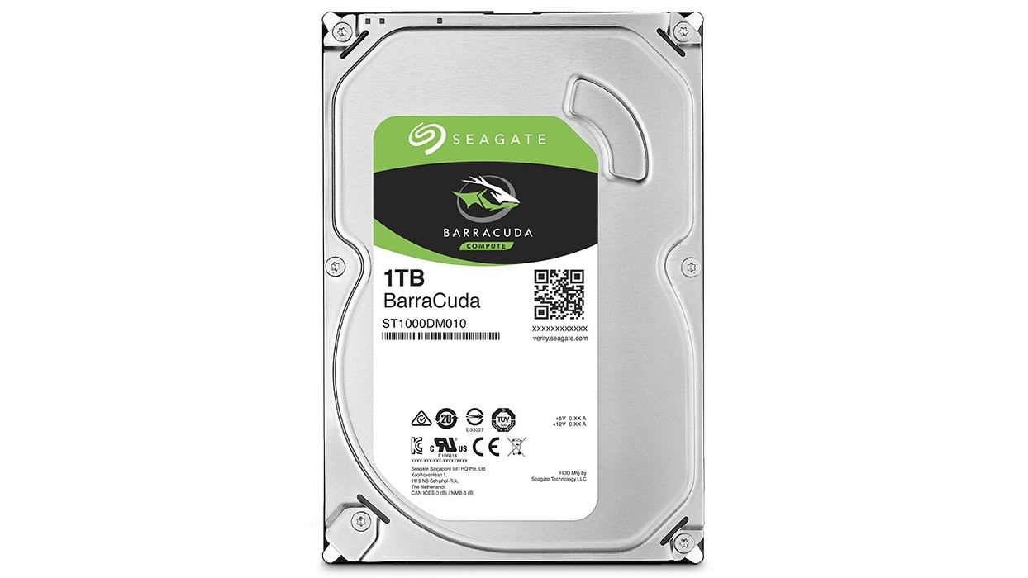

A hard disk drive (HDD), hard disk, hard drive, or fixed disk is an electro-mechanical data storage device that stores and retrieves digital data using magnetic storage and one or more rigid rapidly rotating platters coated with magnetic material. The platters are paired with magnetic heads, usually arranged on a moving actuator arm, which read and write data to the platter surfaces. Data is accessed in a random-access manner, meaning that individual blocks of data can be stored and retrieved in any order. HDDs are a type of non-volatile storage, retaining stored data even when powered off.
Example: Seagate Barracuda 3.5" 1TB (ST1000DM010)

- Solid-state drive (SSD)

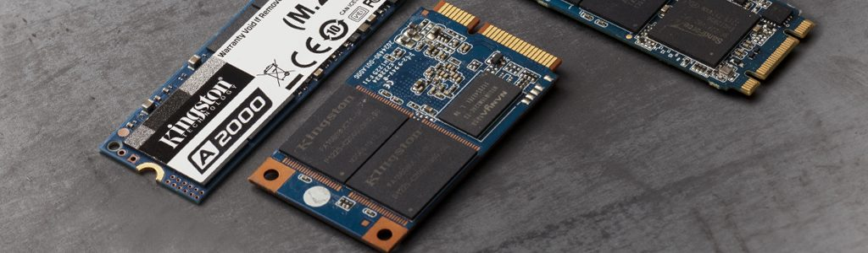

A solid-state drive (SSD) is a solid-state storage device that uses integrated circuit assemblies to store data persistently, typically using flash memory, and functioning as secondary storage in the hierarchy of computer storage. It is also sometimes called a solid-state device or a solid-state disk, even though SSDs lack the physical spinning disks and movable read–write heads used in hard disk drives (HDDs) and floppy disks. Compared with electromechanical drives, SSDs are typically more resistant to physical shock, run silently, and have quicker access time and lower latency.
Example: 1. SAMSUNG 970 EVO PLUS 1TB INTERNAL PCI EXPRESS 3.0 X4 (NVME) SOLID STATE DRIVE WITH V-NAND TECHNOLOGY
2. Samsung 860 EVO SSD 250GB/ 500GB / 1TB 2.5" SATA III Internal SSD

- RAM (Random-Access-Memory)
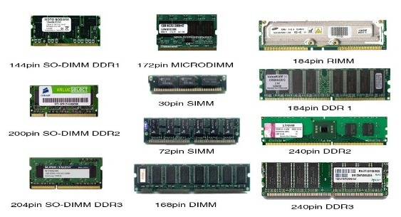
Random-access memory is a form of computer memory that can be read and changed in any order, typically used to store working data and machine code. A random-access memory device allows data items to be read or written in almost the same amount of time irrespective of the physical location of data inside the memory. In contrast, with other direct-access data storage media such as hard disks, CD-RWs, DVD-RWs and the older magnetic tapes and drum memory, the time required to read and write data items varies significantly depending on their physical locations on the recording medium, due to mechanical limitations such as media rotation speeds and arm movement.

RAM contains multiplexing and demultiplexing circuitry, to connect the data lines to the addressed storage for reading or writing the entry. Usually more than one bit of storage is accessed by the same address, and RAM devices often have multiple data lines and are said to be "8-bit" or "16-bit", etc. devices.
Example: G.Skill Trident Z RGB 16 GB (2 x 8 GB) DDR4-4266 CL19 Memory

- Heat sink
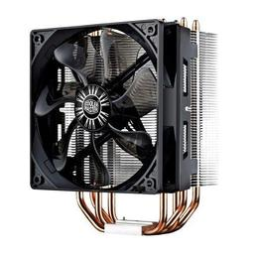
A heat sink is a passive heat exchanger that transfers the heat generated by an electronic or a mechanical device to a fluid medium, often air or a liquid coolant, where it is dissipated away from the device, thereby allowing regulation of the device's temperature. In computers, heat sinks are used to cool CPUs, GPUs, and some chipsets and RAM modules. Heat sinks are used with high-power semiconductor devices such as power transistors and optoelectronics such as lasers and light emitting diodes (LEDs), where the heat dissipation ability of the component itself is insufficient to moderate its temperature.
Example: Cooler Master Hyper 212 EVO 82.9 CFM Sleeve Bearing CPU Cooler

- Power Supply (Power Supply Unit/PSU)
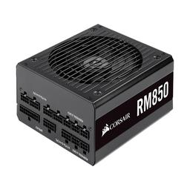
A power supply converts mains AC to low voltage regulated DC power for the internal components of a computer. Modern personal computers universally use switched-mode power supplies. Some power supplies have a manual switch for selecting input voltage, while others automatically adapt to the mains voltage.

Most modern desktop personal computer power supplies conform to the ATX specification, which includes form factor and voltage tolerances. While an ATX power supply is connected to the mains supply, it always provides a 5-volt standby (5VSB) power so that the standby functions on the computer and certain peripherals are powered. ATX power supplies are turned on and off by a signal from the motherboard. They also provide a signal to the motherboard to indicate when the DC voltages are in spec, so that the computer can safely power up and boot. The most recent ATX PSU standard is version 2.31 as of mid-2008.
Example: Corsair RM (2019) 850 W 80+ Gold Certified Fully Modular ATX Power Supply

- CD-ROM
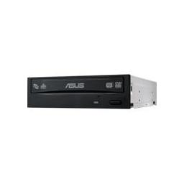Example: Asus DRW-24B1ST/BLK/B/AS DVD/CD Writer

A CD-ROM compact disc read-only memory) is a pre-pressed optical compact disc that contains data. Computers can read—but not write to or erase—CD-ROMs.

PART C - “Step-by-step PC Assembly”

STEP 1 – Preparation
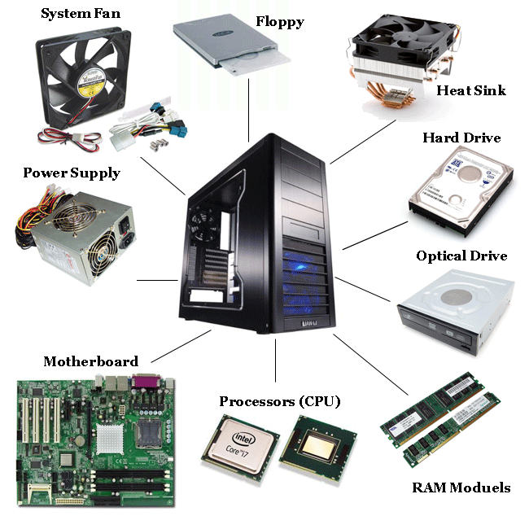

Prepare everything that required to assemble a PC such as motherboard, hard disk, processor, power supply, optical drive, RAM, graphics card, system fan (case fan) and heat sink (CPU fan), etc. Do not forget the screwdriver and screws.

STEP 2 – Open the case
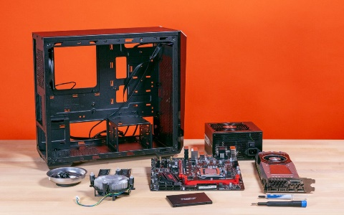

Open the PC case and prepare to assemble.

STEP 3 – Out-of-case installation
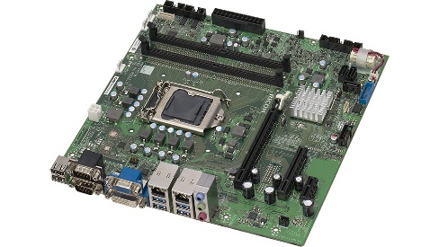

Prepare a motherboard for out-of-case installation (install everything outside the case). To avoid damaging the components, use the anti-static wrist band when assembling the components.
*Hold the motherboard with its plastic components and NOT the circuit board!
STEP 4 – Install the processor into motherboard
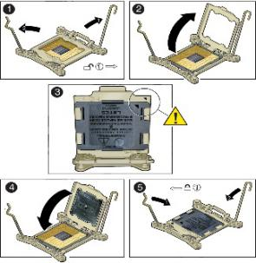

Intel uses Land Grid Array to hold the processor against an array delicate pins using a metal lid, unhook the lever beside and install the processor into it.
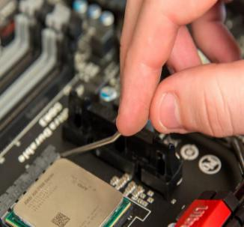

The AMD system uses a ZIF or Zero Insertion Force socket that traps the CPU's delicate pins and place, again use the lever beside this to unlock the socket then insert the processor.
There should be a triangular shape marking at one corner of the processor. There will also be a dot or another triangular shape marking on the motherboard. Align the processor with the two markings to nest the processor correctly. Give it a wiggle to make sure it is in right place.

STEP 5 – Apply heat paste to the top of processor
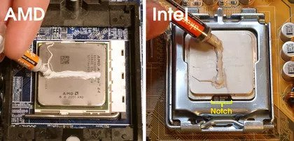

This will fill in the spaces between the top of the processor and the heat sink. For AMD processors, apply a thin 1mm line horizontally above the AMD logo. For Intel processors, a line going vertically up from the cap notch will do, apart from for Core 2 Quad models where the line should go horizontally parallel with the notch.
*Clean any old thermal paste on the processor that may be applied by the manufacturer.
*Clean it with rubbing alcohol.
STEP 6 – Install heat sink (CPU fan) on motherboard
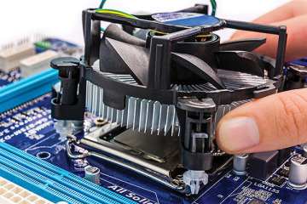

Set the fan modular on the CPU with mounting tabs aligned. Pull the locking rod down on the fan assembly to lock into place. Connect the fan assembly’s power connector to the motherboard. If there are screws, screw it diagonally and it is not recommended to screw all the way down at first. Screw until there is a little resistance and screw the next screw diagonally. After the four screws have only a little resistance, screw it tight.

STEP 7 – Mount memory (RAM)
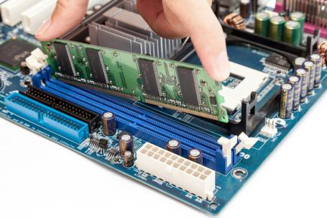

Set the RAM board in the socket. Check to see that notch in the board is in the correct location. If it is not, turn it around 180̊. Press firmly on both ends of the board to set it into the socket. Make sure the tabs lock into place. You should hear a click when the RAM stick is inserted correctly.
*All RAM must have the same clocking speed.
*Make sure if you have more than two slots the RAM is installed in slots of matching color – on a quad channel this is usually 1 & 3 or 2 & 4. If there is only one memory card and it is in the top slot.

STEP 8 – Insert M.2 SSD onto motherboard
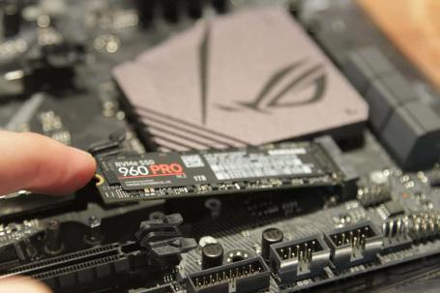
Remove the mounting screw located across from the M.2 slot. Gently push the M.2 SSD into its slot, paying attention to the notch. The M.2 SSD will naturally stand at an angle when inserted. Press down and hold the M.2 SSD while replace the mounting screw that was removed before this, it will secure the M.2 SSD in place.

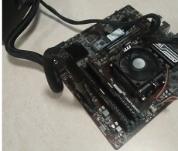
STEP 9 – Test Core Components

Doing the test quickly to check the parts that installed so far are all working smooth. It requires you to temporarily plug in the PSU and jump-start the motherboard with your screwdriver, it can save your time because it's harder to do troubleshooting (or uninstall something) when everything is already fitted in the case.

STEP 10 – Insert motherboard into case
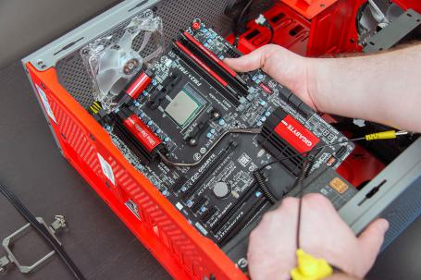
Install standoffs in the case. The standoffs screw into the motherboard mounting holes. Check the screw hole locations on the motherboard for exact placement. Lower the motherboard into the case and install the screws.

STEP 11 – Insert graphics card onto motherboard
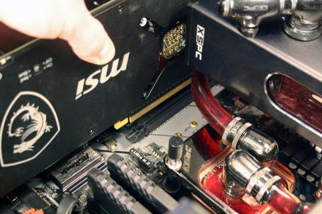
Remove the requisite number of PCIe backing plates. Gently slotting the graphics card into the PCIe slot and make sure that the I/O plate on the back of the card slots into the PCIe back plate correctly. Shall hear the clip at the end of the PCIe slot click when it is installed. Make sure to screw in the backplate screws to hold it firmly place.

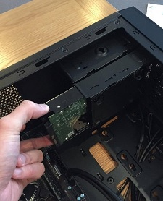
STEP 12 – Mount 2.5’’ SSD/3.5” HDD In Case

Install the 2.5” SSD or HDD at the allocated location. Connect the SATA cable from the SSD/HDD to the motherboard.

STEP 13 – Mount case fan
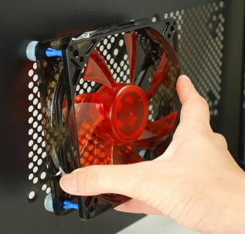
Align the mounting holes by holding the case fan to the mounting pad on the inside of the case. The case fan needs to be mounted so that it blows air out of the case. Insert the screws from the outside of the case and tighten. Remember to place the fan accordingly to which way you want the air to come in and which way to go out.
STEP 14 – Install power supply in case
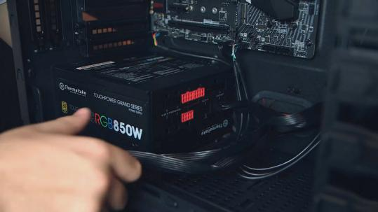
Align the mounting holes in the case and power supply. Insert screws and tighten. Connect all power cables such as P1 (PC Main / ATX connector), P4 (EPS Connector), PCI-E Connector (6-pin en 6+2 pin), Molex (4 Pin Peripheral Connector) and SATA Connector.

STEP 15 – Connect cables
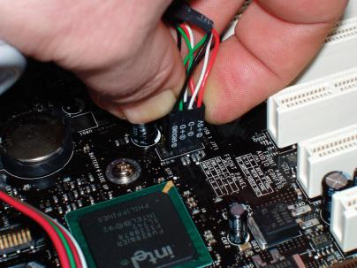
The motherboard has two power connections, and there are two connectors specifically for drives. The other connectors will run fans and other devices. Data cables connect drives and front panel devices to the motherboard.

STEP 16 – Last checks & boot the PC
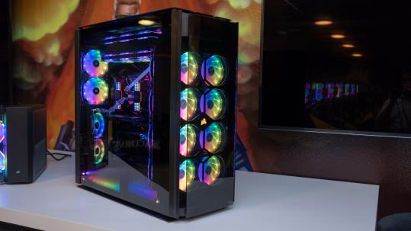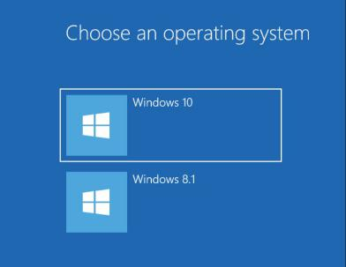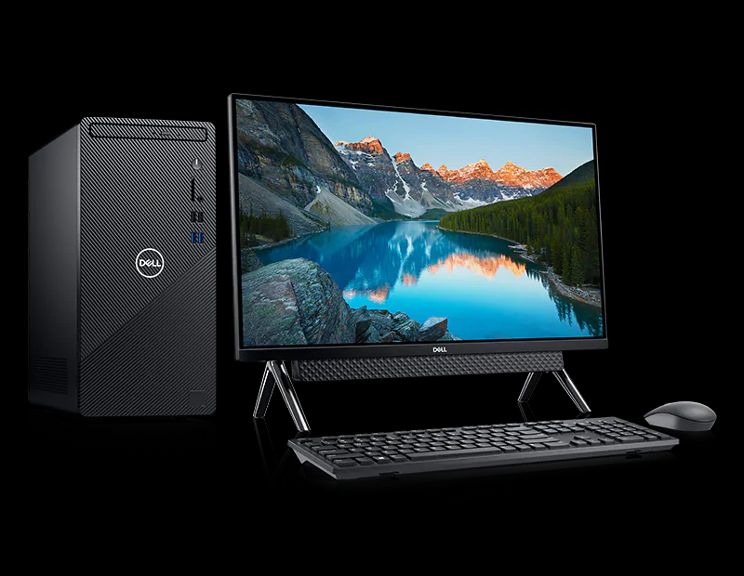
Install the side panels on the case. Connect the power supply and connect the PC to a monitor via VGA or HDMI cable. Connect the keyboard and the mouse to the I/O ports. Run the system’s BIOS and check everything is running and correctly detecting such as the temperature of the CPU and if all the RAM and CPU has been detected. Install the operating system via USB or CD to the PC.

