

UNIVERSITI TEKNOLOGI MALAYSIA, JOHOR BAHRU
FACULTY OF COMPUTING,
SEMESTER 1, SESSION 2020/2021

PROJECT LAB 4

TOPIC : MINI PROJECT XEROX MACHINE
NAME : GUI YU XUAN A20EC0039
MEK ZHI QING A20EC0077
WOON ZI JIAN A20EC0171
ZEREEN TEO HUEY HUEY A20EC0173
YEAR/COURSE : 2020/2021 SECBH- BACHELOR OF COMPUTER SCIENCE
(BIOINFORMATIC)
SUBJECT : SECR 1013-01 DIGITAL LOGIC
LECTURER : MR. FIROZ BIN YUSUF PATEL DAWOODI

Dedication & Acknowledgement
Firstly, we would like to thank Mr. Firoz Bin Yusuf Patel Dawoodi for teaching us in Semester 1 Year 2020/2021. Throughout his teaching lesson on the online class by using Webex platform, we can gain a lot of knowledge about digital logic which are very useful in our future. Mr Firoz is a very good lecturer in teaching us since he is very patient in teaching us by repeating the important point during our class and this action is keep our mind ongoing. When we have some question, he can answer us as soon as possible. Same in this final project, Mr Firoz has given some explanation to make us more understand about the project since we are not face-to-face to do the lab work and hence, he cannot guide our project beside us. Although we loss the chance to having the lab experience in school, we had learnt to use Deeds Simulator to finish our project.
Besides, we need to thank all of the people who help us along this final project. To make sure this project can be submitted in time, all of the group member active in discussing and share our information in the WhatsApp group. We would like to thanks to each other group member in giving our cooperation in this final project.

Table of Contents
Dedication & Acknowledgement | i
Background | 1
Problem | 1
Proposed Solution | 1
Components & Requirements | 3
System Implementation | 4
Conclusion | 7
References | 8
Appendices | 8

Background
For this project, we have used 4 different components which are:
a) 4-bit decoder
b) 4-bit count up counter
c) 4-bit comparator
d) clock enabler

Problem
Firstly, users need to switch on the button to start the xerox machine. Before the xerox machine start its operation, users need to enter a 4-digit password which is predefined by the owner. The xerox machine will only continue its operation if the passwords correct. If the passwords correct, all of the LED light will light up and users can move to next stage. At the next stage, users can choose between 2 functions which are print or scan the document. Then, the users can choose to have the document in landscape or portrait style, black and white only or colour document. When the users done for choosing the properties, they need to enter the number of copies they want. There will be a counter to count the number of copies and show the numbers on the 7-segment display. A comparator is used to compare the number of copies entered by the users and numbers of copy that is done. When the two number is the same, the machine will stop its operation.

Proposed Solution
The block diagram of the required components is shown in Figure 1. The power button must be turned on to enable the Xerox machine. After that, users must insert a 4 digit password to proceed to the next step. A decoder is used to confirm whether the password is correct. If the password entered is wrong, then the user is unable to proceed to the next step. The password is required to protect the documents that send to the photocopier and prevent unauthorized use of the photocopier. Once the password is correct, the LED will be turned on then the user can proceed to the next step.
Then, users must select functions whether to scan or to print. Furthermore, users must select the printing properties such as black and white print, colour print, portrait, and landscape. A multiplexer is used to let the users select their choices and a demultiplexer is used to indicate the choice. The LED light will light up to show the functions and printing properties selected by users.
Next, three core components such as 4-bit counter (4-bit JK positive edge count-up counter), 4-bit comparator and clock enabler are required to determine the number of copies and the amount that had been produced. The 4-bit counter is used to determine the number of copies that had been produced while the 4-bit switches are used to determine the number of copies. The 4-bit comparator is used to compare the number of copies and the amount that had been produced. Once the amount that had been produced has met the number of copies, then clock enable will be disabled and stop the counter from counting.
Thus, users must enter the number of copies by using 4-bit switches, which allow the number from 0 to 16 and 7-segment displays will show the number. For the 4-bit counter, PRESET and CLEAR must set to 1. 7-segment display is connected to the counter to show the number of copies that had been produced. 4-bit comparator will compare the number of copies and the amount that had been produced. If the amount that had been produced does not meet the number of copies that had been entered, then the photocopier will continue the process until the values of the 4-bit counter and 4-bit switched are the same.

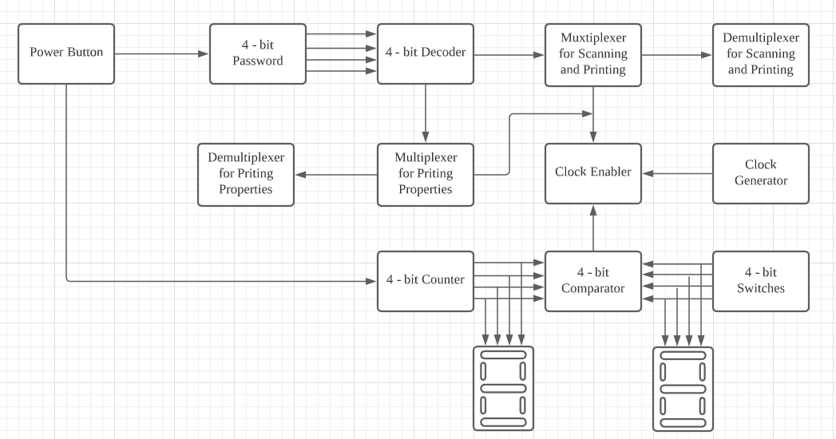

Figure 1 Block diagram of a complete system of the machine.

Components & Requirement
- 4-bit Decoder
- To ensure the password entered is correct

- Multiplexer
- To let the users select the functions and printing properties

- Demultiplexer
- To determine the choices that had been selected by users

- Clock Enable
- To enable the printing and process and disable the printing process when the number of copies has met that the amount that had been produced

- 4-bit Comparator
- To compare the number of copies that had been entered and the number of copies that had been produced

- 4-bit Counter (4-bit JK positive edge count-up counter)
- To count the number of copies that had been produced

- 4-bit Switches
- To enter the number of copies that required

- 7-Segment Displays
- To display the number of copies that required and the amount that had been produced

System Implementation
- Decoder
We used a 4-bit decoder to create a set of passwords for our photocopy machine. Each decoder is connected to the power switch and an AND gate with a LED on the output, which means the decoder will only be activated when the power button is on, and the LED lights up. When the user enters the wrong password, the LED will not light up, and the machine could not run. The user must enter the correct password in order to activate and start to run the machine.

- Multiplexer
A multiplexer is used to let the users choose the printing properties themselves. There are 3 multiplexers in this machine. The first multiplexer is used to let the user choose between scan and print, where 0 indicates scanning and 1 indicates printing. The second multiplexer is used to let users choose the output in either portrait or landscape mode. The 0 is represented portrait mode while 1 is representing landscape mode. The third multiplexer is to let users choose between colour and black and white option. The 0 indicates the colour option, while 1 indicates a black and white option. All of these properties are connected to a 4-bit decoder, where the users have to enter the password correctly then only can access these steps.

- Demultiplexer
The demultiplexer is linked to the multiplexer output, so this component is used to determine the user's properties.

- Input Switch
For users to input the number of copies they want, there are 4 switches. There was a single bit represented by each of the switches, CNT0, CNT1, CNT2 and CNT2. CNT0 represented the LSB while CNT3 represented the MSB. The user can only input values from 0 to 16. A 7-segment display and comparator are connected to the output of the input switch.

- 4-bit count-up Counter
The 4-bit counter that we use is 4-bit JK positive edge count-up counter. The counter starts to count based on the clock enabler. It will start counting if the J and K input is connected to high input. When the power button is activated, passwords enter correctly, and the clock enabler is being active. It will stop when the clock pulse is no longer received or reached the number of copies input by the user.

- 4-bit comparator
The comparator uses four 2-input XOR gates to compare values from 2 sources, which are the input switches and the counter. The XOR gates compare the least significant bit (LSB) of the 2 sources. The output will be 0 if they are the same, and it is sent to the NOT gate and converted into 1. For the second, third and fourth XOR gates, the same principle applies. The signal will then be sent from all four gates to a NAND gate to convert it to the opposite signal. Therefore, when all XOR gates receive the same input from the input switches and the counter, the photocopying machine is stopped by sending output 0 to the clock enabler.

- Clock Enabler
The clock enabler is set up by using 3-input AND gate. The input of the AND gate is the signal sent by the properties, clock source and signal sent from power button. When three of the inputs are high, the enabler can only be activated. Once the number of copies and printed copies is met, it can stop the machine from running.

- 7-Segment Display
7-Segment Display is used to display the number by converting binary code received into decimal. Two 7-Segment Display is used. One of them is used to show the input number of copies while the other is used to show the number of printed copies.

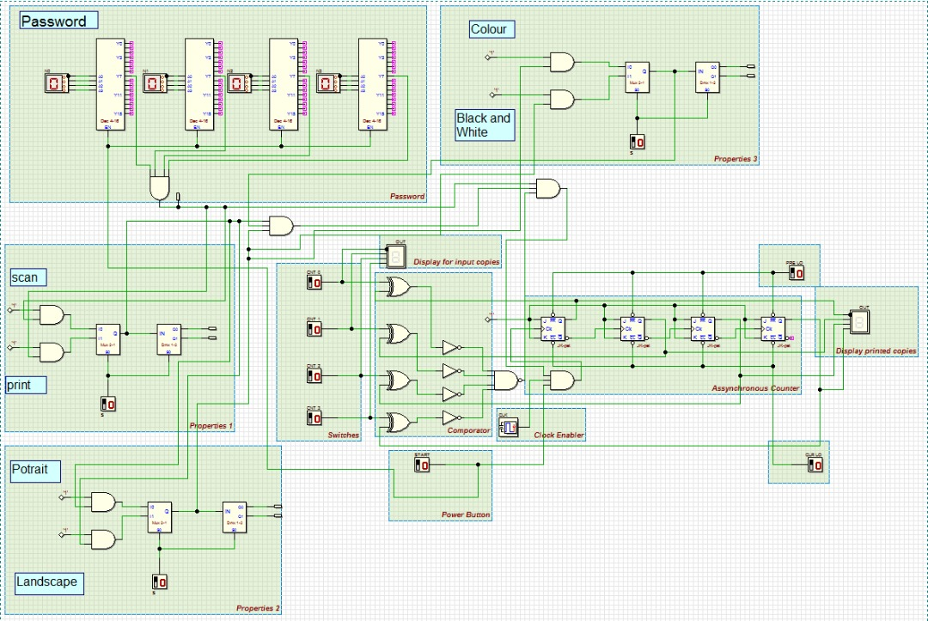
Figure 2: The Drawing of Deeds

Conclusion
In conclusion, we proposed a photocopy machine by using the Deeds Simulator based on our objective and problem that carry out. This machine can only function when the user key in the true password which already set in the machine. After that, user can print their own document with the properties support by the machine. Throughout this mini project, we are more understand about the component use in this circuit design. Based on our knowledge, we are able to build up the design of photocopy machine in the Deeds Simulator. However, we do not have the experience to carry out a circuit since we all are not in campus.
Besides, we also gain the experience in using the Deeds Simulator application since it is very important to us to carry out the build up process of the circuit and also test for the final output based on the circuit we had done. This will help us to double check whether our circuit is true or false based on our knowledge.
However, due to the pandemic now, we cannot do the physical lab work for the course. Therefore, this becomes a shortness for us since we have not chance to exposed ourselves in the physical component of circuit and only know their theoretical knowledge. We hope that we have the chance to do the lab work in reality after the COVID-19 pandemic to improve our physical skill on the circuit and deeper understanding toward the components used.
Lastly, we would like to thank again to Mr Firoz and our group member which support us during the project.

Reference
- Abd. Bahrim Yusoff, Mazleena Salleh, Mohd Foad Rohani, Ismail Fauzi Isnin, Marina Arshad, Raja Zahilah Raja Mohd Radzi, Firoz Yusuf Patel Dawoodi, Siti Hajar Othman, Mohd Murtadha Mohamad, Muhalim Mojamed Amin. (2018). Laboratory Manual Digital Logic (Fifth Edition). Johor, Malaysia. Desktop Publisher.

Appendices
Task | Name | Time
Acknowledgement and Conclusion | Zereen Teo Huey Huey | 1 Hour
Background and Problem | Mek Zhi Qing | 1 Hour
Proposed Solution and Component & requirement | Gui Yu Xuan | 1 Hour
System Implementation | Woon Zi Jian | 1 Hour
 | Total time spend: | 4 Hours

Table 1 Tasks performed by member and hours had been spent


Figure 3 Drawing Deeds

Figure 4 Group Working Together

