Alumni Sharing Session (Inspiring Work experience & Covid19 Pandemic Challenge)

T
he talks General Information:

The conversation consisted of relating perspectives to students and problems in work Pandemic COVID-19. The debate contains tips and tricks to master before entering the business can land a decent job, showing students the best way and good practices. That needs to be continued. It provides some students Guidance on protecting our jobs and Manage it and inspires students of Engineering in Software to still understand Encouraging progress along the way. Students encouraged their talents and trust, which are highly regarded industry characteristics.

T
he purpose of the talk:

As a Software Engineering student, we have lots of option to make our career effective in a good way. Now the world is almost dependent on virtual sites and digital platforms. Why should we make our-self skilled and practical? Because it will help us get a good job and better life, but it is not too easy. Now the situation is not good, and we have a terrible time. It is challenging to manage a job, even people losing their job. But don't be hopeless. The person who has skill and experience on the virtual platform, especially Software Engineering students and IT students, can make their way and know better. Some people work from home, even different a company hiring engineers and specialists. They are actually looking for skilled and experienced people who can do their best. Many companies are looking for a skilled person and not for those who got a CGPA of more than 3.5 but didn't have any skill or experience, participation in a competition, thesis and practical knowledge, etc. For making our-self perfect for a perfect job, there is no way without practicing. Sometimes people may feel bored by doing nonstop work, but we have to find out how to enjoy working and leading a corporate life. But we need a workforce. The COVID-19 pandemic is, first and foremost, a human catastrophe that has taken place across the globe. People experience unparalleled disruption levels both in their homes and neighborhoods and in their careers. According to employees, if there's a silver lining in all of this, it's because companies and executives are stepping up in crucial places. Focusing on the workforce may make the way easier. We acknowledged that organizations had done well to resolve urgent safety and stability issues. Yet full return includes an organizational dedication to a wider spectrum of needs and the strongest drivers of work experience, productivity, and well-being. For decades, need-based motivational theories have stressed the importance of addressing workers' motivation and behavior. Applied to employee experience management, companies should aim to meet the larger workforce's most important and significant needs while taking note of various segments and individuals' specific needs. Our analysis found a close correspondence between employees' reported needs and the main causes of their dedication, well-being, and work performance.

C
hronological Structure of talk:

With an introduction session, the talk started. The moderator, Dr. Johanna Ahmad, asked the three-panel members to introduce themselves. The panel members recognized themselves as holding positions in the field related to Data Science. The session is followed by a self-introduction of Dr. Johanna Ahmad herself. An interview session led by Dr. Johanna Ahmad, the moderator, soon followed the session. Certain of the highlights:
1. How can we secure our job or career?
Try to gain relevant experience by participating in competitions and events at all times. Engage in freelance training to acquire valuable technical skills, and always be engaged in internships. Be proactive during internships by offering ideas and opinions that the company might find interesting and absorb us as permanent employees.
2. How will our employability be improved?
We ought to be proactive and sometimes interested in studying emerging technology. Don't just confine yourself and fail to think. As a young professional, we would strengthen both our technological and soft competencies. There are easily available online classes and educational programs that teach us new hard skills. Communication skills and teamwork also play an important part in working as a business unit.
Open-ended question and answer session
Question: Does CGPA apply for good work?
Answer: CGPA shall be held at any degree not to be filtered into the company's selection process. However, technological and soft skills can also be based rather than focusing exclusively on CGPA.

Question: How are you inspired in the world of information technology?
Answer: Love will help you get better at your work. We learn new things every day and continue to inspire us not to have this opportunity for everybody. Be thrilled with new initiatives and how our culture will be influenced.

S
ummary:

The hour-long meeting presented real-world insights and ideas about how you can gain successful qualifications in your university life and, after that, get promising jobs (requirements, procedures, etc.). E.g., a recent UTM graduate, Tanjong Keong, who was also honored with the Chancellor's award, talked about his job after graduation. He shared how he used to compete in numerous tournaments and acquired comprehensive practical knowledge and appearance, including individuality, which also gave him tremendous technical skills. These qualifications qualified him to participate in the Vitrox interview. He also shares his coding talents as a recent graduate without prior work experience as he passed the academic examination. Then Zamarul's alumnus had to say another lie. In his internship, he shared how he worked as a permanent employee in his industrial formation business, offering ideas and thoughts on the development of dashboard tracking, as he had tonnes of data every day. And after his jobs are frozen, his proposals gave him the status of a permanent worker. Finally, Qistina, the 3rd Alumnus of the case, played her role, including her full-time job for the organization she was interning. Her boss gave her job for her hard work, including collecting social media information and interpreting these facts into a dashboard for consumers, which she also used to enhance branding.

R
eflection:
Alaa Salah:
• The talk was so inspiring and full of great motivation speech, and what I learned to form the talk is that it is not what we achieve in life. It is what we overcome. Also, we have to work to become, not to acquire. I loved the talk so much.



Emran:

• The conversation was overall Extremely descriptive and insightful. The alumni invited were visible and can share their experiences, And the audience looks very well. During the address, Dr. Johanna Ahmad, moderator, was important and significant Only up to the mark. However, I agree that the talk More graphic features could be enhanced by to help the media with the use of slides. My key picks from the debate are, we can't just concentrate as a software developer at our university alone. Soft and technological skills Equally essential. There is much to be gained from participate and be proactive in contests. Support people and share our thoughts.

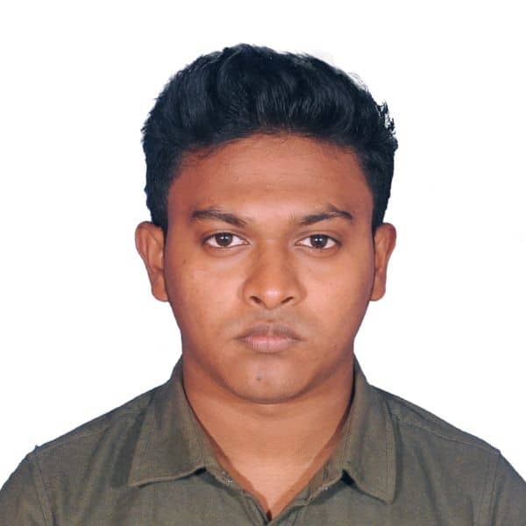

Ashraf:

• It was an interesting conversation for me. The students offered us real-life experiences that I hope support us in the long term. Although the dialogue gave us so much knowledge and ideas, it might have been a little easier if punctuality was held. The lesson I have learned from this talk is that I can improve my skills through numerous competitions during my university days instead of just cocooning to university graduates to work in the industry.

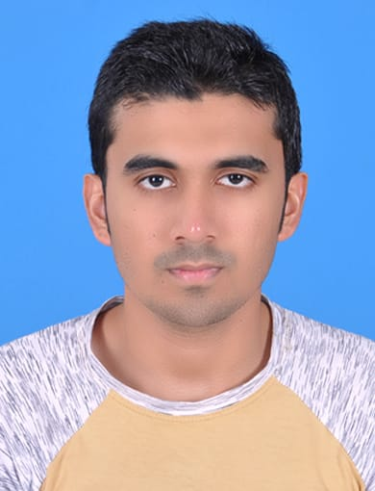

Sourav Ahmed:

• Their main term was how to be professional and get experience during graduation. It like GPA is doesn't matter but make yourself skilled and experienced.



